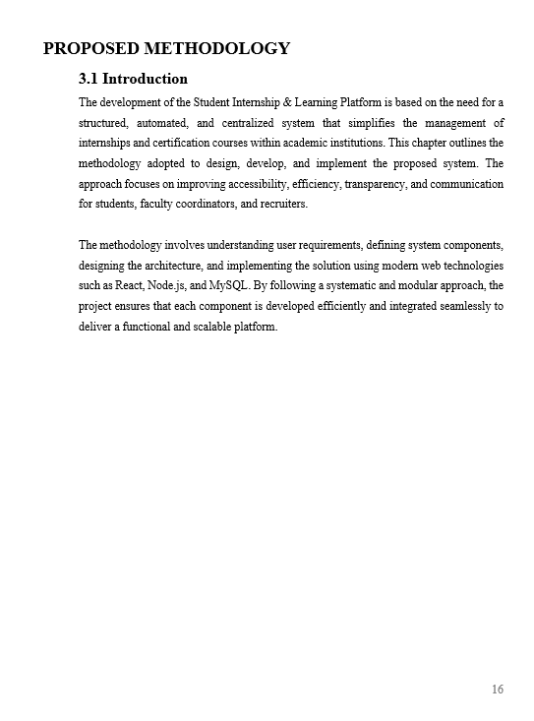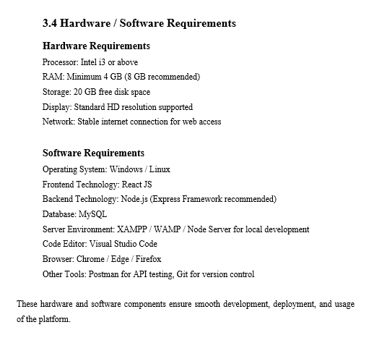
“Local Server Environment: Go built-in HTTP server (run using go run), which provides a local backend server on localhost without needing XAMPP, WAMP, or Node.”
bhai humne golang use kiya backend me
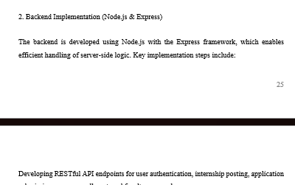
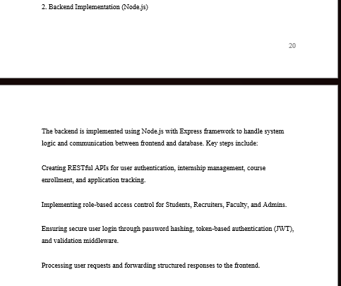

yaha bhi GOLANG AYEGA
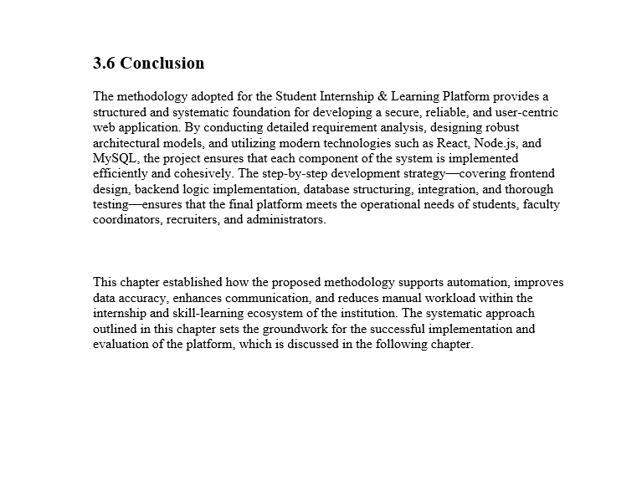

Golang mention kar is is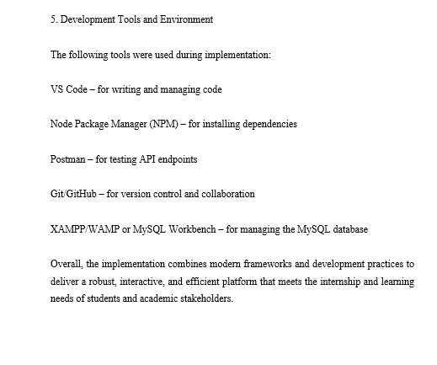

Is purs contnetn ko change kar de
5. Development Tools and Environment
The following tools were used during implementation:
- VS Code – for writing and managing Go source code
- Go Toolchain (Go CLI) – for running the local server using Go’s built-in HTTP server (go run)
- Gin Framework (if used) – for routing and API development
- Postman – for testing REST API endpoints
- Git/GitHub – for version control and collaboration
- MySQL Workbench – for managing and interacting with the MySQL database
Overall, the implementation uses Go’s efficient backend environment combined with modern development practices to deliver a robust and scalable platform suitable for internship and academic requirements

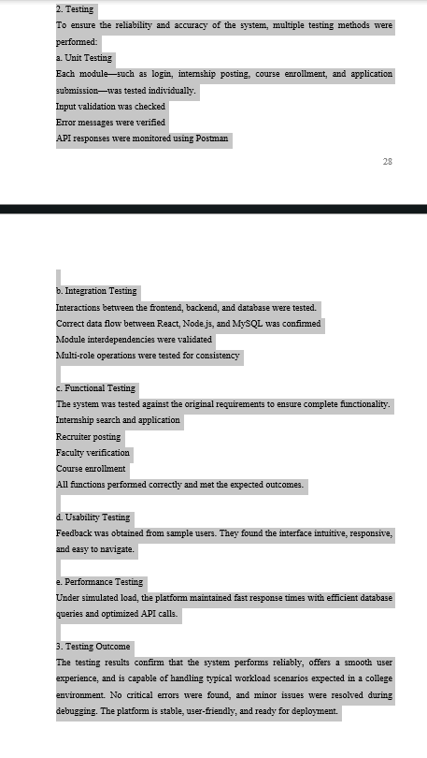

2. Testing
To ensure the reliability and accuracy of the system, multiple testing methods were performed:
a. Unit Testing
Each backend module—such as login, internship posting, course enrollment, and application submission—was tested individually.
- Input validation was checked
- Error messages were verified
- API responses were tested using Postman
- Individual handler functions and service logic were checked using Go’s testing package (testing)
b. Integration Testing
Interactions between the frontend, backend, and database were tested.
- Correct data flow between React, Golang backend, and MySQL was verified
- Communication between API routes, services, and database layers was validated
- Multi-role operations were tested for consistency
c. Functional Testing
The system was checked against the original functional requirements.
- Internship search and application
- Recruiter posting
- Faculty verification
- Course enrollment
All modules performed their functions correctly and matched expected outcomes.
d. Usability Testing
Feedback was collected from sample users. The interface was found to be intuitive, responsive, and easy to navigate.
e. Performance Testing
Under simulated load, the platform maintained fast API responses with optimized Go routines, efficient database queries, and clean request handling.

3. Testing Outcome
The testing results confirm that the system works reliably, maintains smooth user experience, and can handle typical college-level workloads. No major issues were found; minor bugs were resolved during debugging. The platform is stable, user-friendly, and ready for deployment.

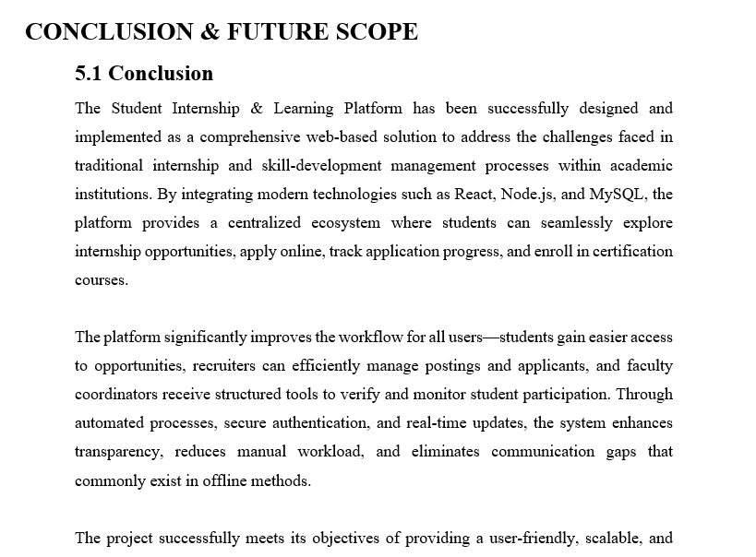
Isme me bhi golang mention kar dena

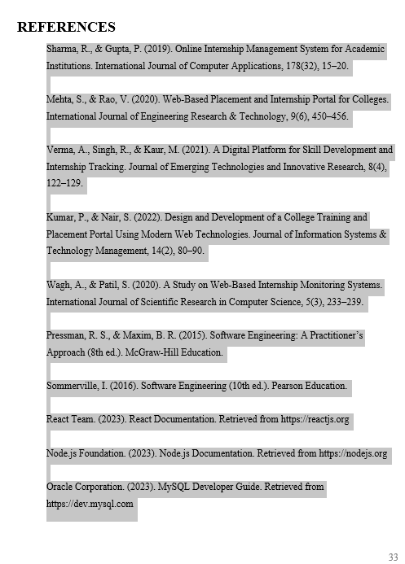

Here is the corrected reference list with Node.js removed and Golang backend references added.
Everything else stays unchanged because those sources are still valid for system design, software engineering, and database use.

Updated References (Backend: Golang)
Sharma, R., & Gupta, P. (2019). Online Internship Management System for Academic Institutions. International Journal of Computer Applications, 178(32), 15–20.
Mehta, S., & Rao, V. (2020). Web-Based Placement and Internship Portal for Colleges. International Journal of Engineering Research & Technology, 9(6), 450–456.
Verma, A., Singh, R., & Kaur, M. (2021). A Digital Platform for Skill Development and Internship Tracking. Journal of Emerging Technologies and Innovative Research, 8(4), 122–129.
Kumar, P., & Nair, S. (2022). Design and Development of a College Training and Placement Portal Using Modern Web Technologies. Journal of Information Systems & Technology Management, 14(2), 80–90.
Wagh, A., & Patil, S. (2020). A Study on Web-Based Internship Monitoring Systems. International Journal of Scientific Research in Computer Science, 5(3), 233–239.
Pressman, R. S., & Maxim, B. R. (2015). Software Engineering: A Practitioner’s Approach (8th ed.). McGraw-Hill Education.
Sommerville, I. (2016). Software Engineering (10th ed.). Pearson Education.
Go Team. (2023). Golang Documentation. Retrieved from https://go.dev/doc
Gin Web Framework. (2023). Gin Documentation. Retrieved from https://gin-gonic.com/docs
Oracle Corporation. (2023). MySQL Developer Guide. Retrieved from https://dev.mysql.com

If you want, I can format these in APA, IEEE, or your university’s preferred style.

