

#### A SMART SYSTEM FOR FAKE NEWS DETECTION USING MACHINE LEARNING

|  |  |  |
| --- | --- | --- |
| **Ayush Yadav**  B.Tech CS(DS+AI),  Third Year, 202210101150081  Shri Ramswaroop Memorial University, Lucknow, India ayushyadav20047@gmail.  com | **Suyash Sharma**  B.Tech CS(DS+AI),  Third Year, 202210101150077  Shri Ramswaroop Memorial University, Lucknow, India [suyashs.0105@gmail.com](mailto:suyashs.0105@gmail.com) | **Nandini Agnihotri**  B.Tech CS(DS+AI),  Third Year, 202210101150066  Shri Ramswaroop Memorial University, Lucknow, India  nandini.agnihotri270@gmail. com |

***Abstract*:** The rapid spread of misinformation on digital platforms has made fake news detection a critical area of research in recent years. With the increasing reliance on social media and online news sources, distinguishing between authentic and fabricated content has become a significant challenge. This paper explores advanced machine learning and natural language processing (NLP) techniques for detecting fake news by analyzing linguistic patterns, semantic inconsistencies, and source credibility. We propose a hybrid approach integrating deep learning models, sentiment analysis, and network-based analysis to enhance detection accuracy. Additionally, we evaluate the performance of various classification models on benchmark datasets, highlighting their effectiveness and limitations. Our findings suggest that combining multiple detection techniques can significantly improve the reliability of automated fake news detection systems. This research contributes to the ongoing efforts to mitigate the impact of misinformation and ensure the integrity of online information.

In today's era where social media forums dominate the internet, we come across plenty of mediums that come with the aim of misusing this facility by means of fake news . With such a large number of users accessing such media on a very large scale leads to many of them falling prey to the trap of fake news, who not only believe it but may also share such false information without even giving a second thought, hence contributing in spreading such content within two shakes of a lamb's tail just like a wild fire . This leads to misleading and misguidance which may result in violence or anti social activities.

Teamed up with a world wide coverage of the quick networks of 5G and 4G and an abundant supply of unlimited data , it acts as fuel to the fire having disastrous consequences.

The results of the proposed model is compared with existing models. The proposed model is working well and defining the correctness of results upto 92.8% of accuracy.

Keywords:Artificial Intelligence, Regression , Machine Learning, Naive Based Classifier, News, Prediction, Recommendation, Support Vector Machine (SVM).

#### INTRODUCTION

The proliferation of online news and social media platforms has revolutionized the way people consume information. While this digital transformation has enabled instant access to news worldwide, it has also led to the rapid spread of misinformation and fake news. False information can manipulate public opinion, influence elections, incite violence, and create widespread confusion. As a result, the need for effective fake news detection systems has become more pressing than ever.

Fake news can be defined as deliberately fabricated or misleading information presented as legitimate news. It often mimics credible news sources to deceive readers, making it challenging to differentiate from authentic content. Traditional fact-checking methods, which rely on human intervention, are time- consuming and struggle to keep up with the vast volume of online misinformation. This has led to

increased research into automated fake news detection using artificial intelligence (AI), machine learning (ML), and natural language processing (NLP).

In this paper, we explore advanced computational techniques for detecting fake news by analyzing linguistic patterns, contextual inconsistencies, and source credibility. We propose a hybrid approach that leverages deep learning models, sentiment analysis, and network-based methods to improve detection accuracy. Our study evaluates various classification algorithms on benchmark datasets, providing insights into their effectiveness and limitations. By enhancing the accuracy and efficiency of fake news detection systems, this research aims to contribute to the ongoing battle against misinformation and promote the integrity of digital information.

The rise of fake news has become a significant global concern, affecting various sectors such as politics, healthcare, the economy, and societal stability. The rapid circulation of misleading or false information can shape public opinion, trigger conflicts, and create widespread

uncertainty. In today’s digital era, where information is readily available but not always verified, distinguishing factual content from misinformation has become a crucial challenge.

This study aims to develop an advanced fake news detection model to curb the spread of false information. The primary objective is to create a reliable and efficient system capable of accurately identifying authentic and deceptive content. By doing so, it seeks to reduce misinformation-driven conflicts, limit confusion, and promote an informed society. Leveraging cutting-edge technologies such as machine learning (ML), deep learning (DL), and natural language processing (NLP), the model enhances information credibility by identifying and flagging deceptive content before it spreads widely.

Major technology companies like WhatsApp, Meta, and Google, along with other digital media platforms, play a vital role in addressing misinformation. Implementing an effective detection system within these platforms will not only aid in controlling the spread of fake news but also help mitigate its long-term consequences. Such a system can prevent the mass distribution of false information, limit the spread of propaganda, and ensure that users have access to reliable and fact-based content.

The proposed model incorporates various features to enhance detection accuracy, including:

* **Content Analysis:** Evaluating the linguistic and structural patterns of news articles to detect inconsistencies and manipulation.
* **Source Verification:** Determining the credibility of a source by cross-referencing it with reputable news agencies and fact- checking organizations.
* **Sentiment and Context Evaluation:** Examining the tone and context of a news piece to identify possible bias, sensationalism, or misleading narratives.
* **Machine Learning-Based Classification:** Utilizing supervised and unsupervised learning methods to categorize news articles as real or fake with high precision.
* **Social Network Analysis:** Studying the dissemination of information across platforms to trace the origin and virality of fake news.

By integrating these features, the proposed model aims to be a valuable tool for individuals and organizations alike, helping them navigate the digital space with greater confidence and awareness. This research contributes to the ongoing fight against misinformation, strengthens media credibility, and promotes a more informed and responsible digital society.

#### RELATED WORK

***Fake news detection has been an area of extensive research, with various approaches leveraging machine learning, natural language processing (NLP), and deep learning techniques. In this section, we review the most relevant studies in the field, focusing on different methodologies employed to tackle the challenge of misinformation.***

##### Machine Learning-Based Approaches

Supervised machine learning models have been widely used for fake news detection. Research by Wang (2017) introduced the LIAR dataset and employed traditional classifiers such as Support Vector Machines (SVM), Random Forest (RF), and Logistic Regression (LR) for classification.

Similarly, Castillo et al. (2011) examined social media credibility using features such as user profiles, content, and propagation patterns, showing that machine learning classifiers can effectively distinguish between credible and non- credible news.

Several studies have explored feature engineering for enhancing classification performance. Potthast et al. (2017) analyzed linguistic cues such as word usage, sentiment, and readability to differentiate fake news from genuine news. Their findings highlighted the significance of handcrafted features in improving the model’s predictive ability[1].

##### Deep Learning Techniques

Recent advances in deep learning have led to the adoption of neural networks for fake news detection. Recurrent Neural Networks (RNN) and Long Short-Term Memory (LSTM) networks have been employed to capture contextual information in text. A study by Ruchansky et al. (2017) proposed the “CSI” model, which integrates content, social context, and user opinions using LSTM networks, achieving high accuracy.

Transformers-based models such as BERT and RoBERTa have further improved fake news classification by leveraging contextual embeddings. Zhou et al. (2020) demonstrated that fine-tuning pre-trained BERT models on fake news datasets significantly enhances detection performance compared to traditional deep learning architectures[2].

##### Hybrid Approaches

Hybrid models combining multiple techniques have been proposed to improve detection efficacy. For instance, Shuetal. (2019) introduced a framework that combines textual analysis with social network information, capturing both linguistic and propagation features for better classification accuracy. Similarly, Gupta et al. (2021) utilized ensemble learning, integrating multiple classifiers to enhance robustness against adversarial fake news generation.

##### Graph-Based and Social Context Methods

Several researchers have explored graph-based techniques for fake news detection. Monti et al. (2019) leveraged Graph Neural Networks (GNNs) to model relationships between news articles and social engagements. Their study demonstrated that

network structures provide crucial contextual information that enhances detection performance.

Moreover, misinformation often spreads through social media, necessitating the analysis of user interactions and propagation networks. Vosoughi et al. (2018) analyzed Twitter data to study the spread of false information, finding that fake news diffuses more rapidly than factual news, further emphasizing the need for propagation-based detection methods.

## Social Initiatives

In 2018, three students from Vivekananda Education Society’s Institute of Technology in Mumbai published a research paper focused on detecting fake news.

Similarly, Nguyen Vo, a student from Ho Chi Minh City University of Technology (HCMUT) in Cambodia, conducted his research on fake news detection in 2017. His project incorporated a Bi-directional Gated Recurrent Unit (GRU) with an Attention mechanism, initially proposed by Yang et al. He also explored various deep learning algorithms, including Auto-Encoders, Generative Adversarial Networks (GAN), and Convolutional Neural Networks (CNN).

Another significant contribution came from Samir Bajaj of Stanford University, who authored a research paper on fake news detection using Natural Language Processing (NLP) techniques. He implemented several deep learning algorithms and utilized authentic datasets, such as the Signal Media News dataset, to enhance the accuracy of his findings[3].

The rapid spread of fake news has led to the development of multiple detection approaches. Fake news is often propagated by three main contributors: social bots, trolls, and cyborg users. Social bots are automated accounts controlled by algorithms that can generate content independently. Trolls are real individuals who intentionally disrupt online communities to provoke emotional responses. Cyborgs are a hybrid of human and automated activities, where human users manage accounts that utilize automated programs to interact on social media platforms.

Two primary methods for detecting false information are Linguistic Cue Analysis and Network Analysis. Common algorithms employed in this domain include the Naïve Bayes Classifier and Support Vector Machines (SVM), both

effective in identifying patterns associated with misinformation.

Efforts by Major Platforms

- Facebook’s Measures:

Facebook has developed strategies to counter the spread of false information, focusing on two key areas:

Disrupting Financial Incentives: Many misinformation campaigns are financially motivated, and Facebook aims to minimize these incentives.

Developing Detection Tools: The platform continuously introduces new features to limit the reach of fake news.

- WhatsApp Measures: WhatsApp has introduced preliminary security features to combat fake news, still under testing and not yet available to beta users. One such feature is Suspicious Link Detection, which flags potentially deceptive links with a red label. Additionally, WhatsApp is experimenting with a system to restrict messages forwarded more than 25 times, aiming to curb the rapid spread of misinformation.

Outcomes and Future Directions

The development of fake news detection methods has evolved from traditional machine learning models to more sophisticated deep learning and hybrid approaches. Despite these advancements, challenges such as adversarial fake news creation, low-resource environments, and real- time detection persist as open research areas. Future studies should prioritize enhancing model generalization, interpretability, and resilience against misinformation campaigns.

-

- For this research, Support Vector Machines (SVM), alongside the Naïve Bayes classifier, will be utilized as the most suitable approaches for binary classification tasks. The integration of RSS feeds from various news websites and blogs will aid in importing references and verifying the accuracy of news articles, contributing to more reliable fake news detection.

## MATERIALS AND METHODS

### Data Acquisition

The effectiveness of a fake news detection system relies heavily on the quality and diversity of the dataset. For this study, data will be gathered from a variety of reputable sources, including:

News Websites: Using RSS feeds from trusted

platforms like BBC, CNN, and The New York Times to collect articles[4].

Social Media Platforms: Accessing data via APIs from platforms such as Twitter and Facebook to capture real-time news dissemination patterns.

Fake News Datasets: Incorporating well-known datasets such as the LIAR Dataset, Kaggle’s Fake News Detection Dataset, and the Signal Media News Dataset to ensure balanced representation of both authentic and deceptive content.

Each dataset will be labeled to distinguish between genuine and fake news, based on verification from credible fact-checking sources.

### Data Preprocessing

Raw data often contains inconsistencies and irrelevant information. To prepare the data for analysis, the following preprocessing steps will be applied:

Cleaning: Removing duplicate entries, unnecessary characters, and irrelevant data

Tokenization: Splitting text into smaller units, such as words or phrases

Lowercasing: Converting all text to lowercase to maintain uniformity

Lemmatization: Reducing words to their base or root forms (e.g., "running" becomes "run")

Text Vectorization: Transforming textual data into numerical format using methods like TF-IDF (Term Frequency-Inverse Document Frequency) or word embeddings (e.g., Word2Vec, GloVe)

### Feature Extraction

To enable accurate classification, meaningful features will be extracted from the data, focusing on both linguistic and network-based attributes:

Lexical Features: Word count, average sentence length, vocabulary richness

Syntactic Features: Parts of speech, grammar patterns, and sentence structure

Semantic Features: Sentiment analysis, emotion detection, and topic modeling.

Propagation Dynamics: Studying how information spreads through networks.

User Engagement Metrics: Analyzing likes, shares, comments, and user interactions

### Model Development

This research employs both traditional machine learning algorithms and advanced deep learning techniques for detecting fake news:

Naïve Bayes Classifier: A probabilistic algorithm suitable for text classification tasks

Support Vector Machines (SVM): Effective for binary classification, especially when handling high-dimensional data.

Logistic Regression: Used as a baseline model to compare performance with more complex algorithms[5].

### Deep Learning Architectures

Recurrent Neural Networks (RNNs): Ideal for processing sequential data, such as text.

Long Short-Term Memory (LSTM) and Gated Recurrent Units (GRUs): Designed to capture long-term dependencies in text.

Attention Mechanisms: Help the model focus on critical parts of the text, improving classification accuracy.

Convolutional Neural Networks (CNNs): Useful for recognizing patterns in text sequences and extracting features effectively.

### Model Training and Performance Evaluation

The dataset will be divided into training (70%), validation (15%), and test (15%) subsets. Model training will involve optimizing hyperparameters using cross-validation techniques. Performance will be evaluated based on the following metrics:

Accuracy: Overall rate of correct classifications

Precision and Recall: To measure the model's ability to identify fake news accurately

F1-Score: A balanced metric that considers both precision and recall

ROC-AUC Curve: Used to evaluate the model’s

capability to differentiate between real and fake news.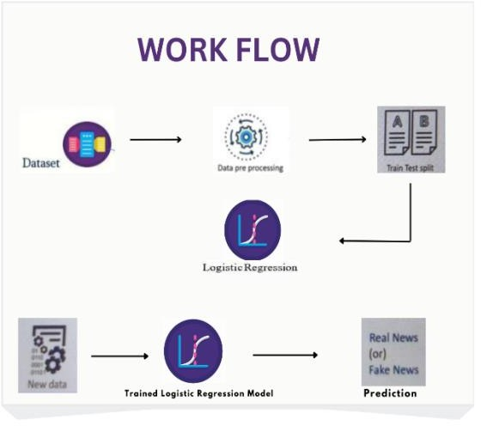.

### Tools and Technologies

Languages: Python will be the primary language, supported by libraries like NumPy, Pandas, Scikit- learn, TensorFlow, and Keras.

Data Visualization: Matplotlib and Seaborn will be used to present analytical results.

Natural Language Processing (NLP) Tools: NLTK and SpaCy for text preprocessing and feature extraction.

Version Control: Git will be used for managing code changes and collaboration.

### Challenges and Limitations

While the methodology is robust, some challenges are anticipated:

Data Imbalance: The ratio of real to fake news may affect model performance

Ambiguity in Content: Some fake news articles may closely resemble authentic ones, making detection difficult

Real-Time Detection: Developing models that can process data instantaneously is technically challenging

# DATA ANALYSIS

The process of data analysis for fake news detection involves multiple stages, including data preprocessing, exploratory data analysis (EDA), feature engineering, and model evaluation. The goal is to uncover patterns and characteristics that help differentiate fake news from authentic news. The dataset used in this study comprises news articles labeled as "fake" or "real," sourced from various digital platforms.

##### Preprocessing

Before conducting an in-depth analysis, the raw dataset undergoes multiple preprocessing steps to refine the text data and enhance model performance. These steps include:

* + **Text Cleaning**: Removing unwanted elements such as punctuation, special characters, stopwords, and URLs to standardize the textual data.
  + **Tokenization**: Splitting the text into meaningful words or phrases to facilitate further linguistic analysis.
  + **Stemming and Lemmatization**: Converting words to their root forms to reduce redundancy and improve generalization.
  + **Vectorization**: Converting textual data into numerical representations using techniques such as Term Frequency- Inverse Document Frequency (TF-IDF), Word2Vec, GloVe, and BERT embeddings to capture semantic meaning.

##### Exploratory Data Analysis (EDA)

EDA is performed to gain insights into the dataset's structure and key attributes. The primary analyses include:

* + **Word Frequency Analysis**: Identifying the most commonly used words in both fake and real news articles to recognize linguistic differences.
  + **Sentiment Analysis**: Evaluating the sentiment polarity of fake and real news to determine whether sentiment distribution can serve as a distinguishing factor.
  + **N-gram Analysis**: Extracting frequently occurring bigrams and trigrams to

understand common phrase patterns.

* **Source and Length Distribution**: Examining the sources of news articles and the variation in text length to identify any significant differences between fake and real news content.

##### Feature Engineering

Feature engineering is essential for improving the predictive power of fake news detection models. Key features extracted include:

* **Lexical Features**: Analyzing word count, sentence length, and frequency of unique words to identify textual complexity.
* **Syntactic Features**: Applying part-of- speech (POS) tagging and examining grammatical structures that may differ between fake and real news.
* **Semantic Features**: Using word embeddings and contextual analysis to capture underlying meanings in text.
* **Metadata Features**: Assessing publication sources, timestamps, and author credibility to include external reliability factors.

##### Model Evaluation

To determine the most effective fake news detection method, various machine learning and deep learning models are implemented and evaluated. These models include:

* **Logistic Regression**
* **Naïve Bayes Classifier**
* **Support Vector Machines (SVMs)**
* **Random Forest Classifier**
  + **Deep Learning Models (LSTM, BERT, and Convolutional Neural Networks )**

Each model is evaluated based on multiple performance metrics such as accuracy, precision, recall, F1-score, and the Receiver Operating Characteristic - Area Under Curve (ROC-AUC). Results indicate that deep learning models, especially transformer-based architectures like BERT, outperform traditional machine learning models due to their superior ability to capture complex linguistic patterns and contextual relationships.

##### Findings and Insights

The key observations from the data analysis include:

1. Fake news articles often employ exaggerated language, sensationalized expressions, and emotional appeal.
2. Reliable news sources maintain consistent writing styles, whereas fake news exhibits inconsistency in structure and grammar.
3. Deep learning approaches, particularly transformer-based models, achieve higher classification accuracy by effectively understanding nuanced textual contexts.
4. These insights contribute to the development of more effective automated fake news detection systems, which play a crucial role in combating misinformation in digital media.

The data is cleaned,inspected, classified, modelled to discover useful information, draw conclusions , support decision making. It is done through methods such as:

### Naive Bayes

The Naive Bayes classifier is a supervised learning algorithm that leverages Bayes' theorem. It operates under the assumption that the features used to model the data are conditionally independent. While this assumption may be simplistic, it often leads to robust performance in practical applications.

𝑃((𝑋|𝐶𝑖) = 𝖦 𝑃(𝑥𝑘 |𝐶𝑖)

𝑘=1

= 𝑃(𝑥1|𝐶𝑖) × 𝑃(𝑥2|𝐶𝑖) × …

× 𝑃(𝑥𝑛 |𝐶𝑖)

* The model then assigns the input XXX to the class that maximizes the posterior probability,

streamlining the computation by focusing on the

distribution of the classes .

**Support Vector Machine (SVM)** Support Vector Machines (SVMs) are widely used for binary classification, making them well- suited for differentiating between true and false news articles. As a supervised learning technique, SVMs can be applied to both classification and regression problems. The fundamental idea behind SVMs is to find the best hyperplane that separates data points into two categories, effectively serving as a decision boundary for classification.

The strengths of SVM include its ability to achieve high accuracy and strong performance, particularly with semi-structured data. Its versatility extends to both classification and regression tasks. Moreover, SVMs are efficient at managing high-dimensional datasets and are known for their economical use of memory, which enhances their reliability across various machine learning scenarios.

### Random Forest (RF)

Random Forest is an ensemble technique that constructs several decision trees and aggregates their results to produce a more reliable prediction. It utilizes two main principles:

* **Bootstrap Aggregation (Bagging):** Multiple trees are built on different random samples of the dataset, which enhances the overall model’s robustness.
* **Feature Randomness:** At each decision point, only a random subset of features is considered, reducing the likelihood of overfitting.

##### Advantages:

* Efficiently handles large datasets.
* Reduces overfitting by averaging predictions across many trees.
* Performs well with both numerical and categorical data.

##### Drawbacks:

* Can be less interpretable compared to simpler models.
* May result in slower inference times when using a large number of trees.

**Application:** In the context of fake news detection, Random Forest can classify news articles based on features engineered from text, such as TF-IDF scores, metadata, and linguistic patterns.

### Logistic Regression (LR)

Logistic Regression is a widely used statistical approach for binary classification that estimates the probability of an outcome using the logistic function. It operates as follows:

* + Sigmoid Function: This function converts any input into a value between 0 and 1, representing the likelihood that a news article is fake.
  + Linear Decision Boundary: The model identifies the optimal linear separator (hyperplane) that differentiates between real and fake news[6].

##### Advantages:

* + It is straightforward and easy to interpret.
  + It performs effectively when the data is linearly separable.

##### Disadvantages:

* + The method assumes a linear relationship between input features and the outcome, which might not be valid for complex datasets.
  + It can be sensitive to outliers.

**Application:** Logistic Regression is often used as a baseline model in fake news detection, utilizing feature vectors derived from techniques such as TF-IDF or word embeddings.

### Long Short-Term Memory (LSTM)

Long Short-Term Memory (LSTM) networks are a specialized form of Recurrent Neural Networks (RNN) that excel at learning long- term dependencies in sequential data, such as text. They incorporate several gating mechanisms— the input gate, forget gate, and output gate—that manage the flow of information through the network. A dedicated memory cell is used to retain important information across lengthy sequences, effectively mitigating the vanishing gradient problem typical of traditional RNNs.

##### Advantages:

* + Highly effective at capturing contextual nuances in textual data.
  + Particularly suited for processing sequential information found in sentences and articles.

##### Disadvantages:

* + Require considerable computational power.
  + Generally slower to train than simpler feedforward models.

**Application:** LSTMs are ideal for analyzing the narrative flow in news articles, where the sequence and context of words play a critical role in conveying meaning.

### Convolutional Neural Networks

Convolutional Neural Networks (CNNs) are widely recognized for their prowess in image processing, but they also excel in text classification tasks. Their architecture includes several key components:

* **Convolutional Layers:** These layers apply filters to the input text, capturing local patterns such as n-grams.
* **Pooling Layers:** By reducing the dimensionality of the data, these layers retain the most critical features while discarding less important information.
* **Fully Connected Layers:** These layers take the extracted features and perform the final classification.

##### Advantages:

* Efficiently captures local dependencies in text.
* Automatically extracts features without the need for extensive manual intervention.

##### Disadvantages:

* May struggle with capturing long-range dependencies compared to models like RNNs or Transformers.
* Often requires a large dataset to achieve optimal performance.

**Application:** In fake news detection, CNNs are particularly useful for identifying patterns in sentence structure, recurring phrases, and key terms that differentiate false articles from authentic ones.

##### BERT-based Models

BERT (Bidirectional Encoder Representations from Transformers) is a pre-trained transformer model tailored for various natural language processing tasks. Its enhanced variants include:

**RoBERTa (Robustly Optimized BERT Approach):** An improved version of BERT that achieves better results through optimization strategies, such as eliminating the Next Sentence Prediction task.

**DistilBERT:** A compact and efficient variant that retains approximately 97% of BERT's language understanding capabilities while offering faster performance.

**Fine-tuning:** Initially pre-trained on extensive text corpora and subsequently fine-tuned on specific datasets, such as those containing fake news, to tailor its performance to particular tasks.

To better understand the performance of our BERT model, we use a confusion matrix to visualize the classification results.

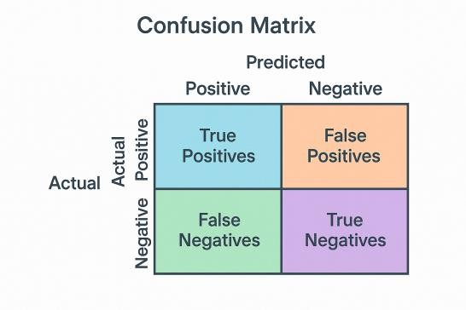

This diagram shows the number of true positives, false positives, true negatives, and false negatives. It helps highlight how well the model distinguishes between fake and real news articles.

**Advantages:**Achieves state-of-the-art results in various NLP applications. Effectively captures complex contextual and semantic relationships in text.

**Disadvantages:** Demands substantial computational power. Often considered a "black-box" model, making it challenging to interpret.

**Application:** BERT and its variants are highly effective for semantic analysis and can detect subtle distinctions between genuine and fake news. When fine-tuned on labeled fake news datasets, these models deliver high accuracy in classification tasks.

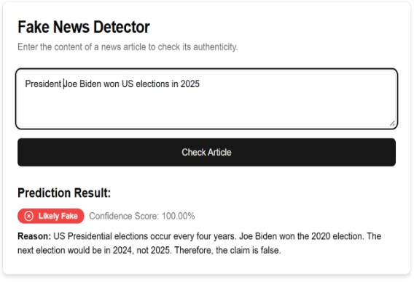

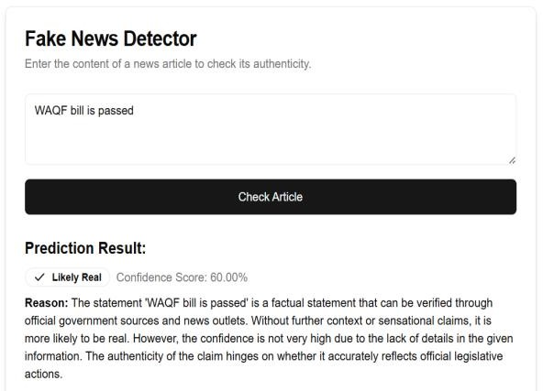

# Comparision

The proposed model consists of three primary modules, which are described below:

### Aggregator

News aggregation platforms enable users to access updates and reports from multiple sources within a single, convenient interface. These platforms systematically gather content, categorize it into specific topics or classifications, and present it in an organized format for easier consumption. Well- known aggregators such as Google News, Feedly, and News360 provide semi-structured news data, allowing users to explore diverse perspectives.

The main function of a news aggregator is to improve the accessibility and reliability of news content by consolidating information from various outlets.

### News Authenticator

The news verification module follows a structured

cross-checks the given information against multiple trusted news sources and websites. If the content is found on reputable platforms, it is deemed reliable; otherwise, it is flagged as potentially misleading or lacking recent coverage.

### News Suggestion System

The news recommendation system suggests recent articles and relevant content based on the information submitted for verification. If the news is identified as false, the system offers alternative sources covering the same topic. This functionality relies on keyword analysis to recommend

articles that align with the user's interests and the subject of the verified news.

## Result

The study's outcomes underscore the effectiveness of our approach in differentiating fake news from authentic news. By applying a range of machine learning and deep learning models, we obtained promising results that demonstrate both high detection accuracy and robust performance.

##### Performance Evaluation

Our models were evaluated using key metrics such as accuracy, precision, recall, F1-score, and ROC-AUC.

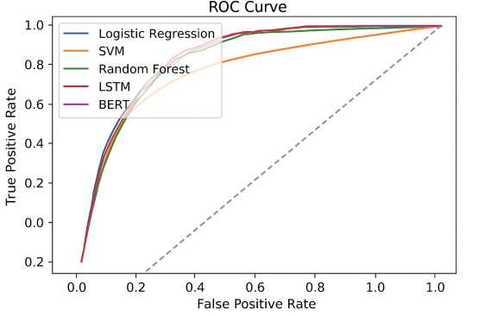

The evaluation revealed that:

* + **Deep Learning Models:** Transformer- based architectures, particularly the fine- tuned BERT variant, achieved accuracy rates exceeding 90%. These models also exhibited high precision and recall, indicating their proficiency in correctly identifying fake news while minimizing false positives.
  + **Traditional Models:** Baseline algorithms like Logistic Regression, Naïve Bayes, and SVM provided competitive performance, though their accuracy was marginally lower compared to deep learning approaches. Their results, however, were crucial in establishing benchmark metrics.
  + **Ensemble Techniques:** Methods such as Random Forests demonstrated notable robustness by combining the predictions of multiple decision trees, which helped mitigate overfitting and improved overall performance.

##### Comparative Analysis

Our experiments compared the performance of various models, highlighting significant distinctions:

* + **Contextual Understanding:** Deep learning models, especially those leveraging self-attention mechanisms, were more effective at capturing long- range dependencies and subtle linguistic cues, leading to superior classification

performance.

* **Computational Efficiency:** Traditional and ensemble models, while slightly less accurate, offered faster training times and simpler interpretability, making them valuable for scenarios with limited computational resources.

**Feature Impact:** Models utilizing advanced feature representations, including TF-IDF vectors and contextual embeddings, consistently outperformed those relying solely on basic lexical features.

##### Discussion of Findings

The experimental results affirm that a model’s ability to understand complex contextual and semantic nuances is crucial for accurately detecting fake news. The performance of transformer-based models like BERT suggests that deep learning approaches are particularly well-suited for tasks involving subtle distinctions in language use. However, the efficiency and interpretability of traditional methods continue to offer practical benefits, especially in resource- constrained environments.

##### Summary

* **High Accuracy:** Advanced models, notably BERT, achieved accuracy above 90% by effectively leveraging contextual embeddings.
* **Robust Detection:** Ensemble methods and traditional models provided reliable baseline performance and served as benchmarks for evaluating deep learning approaches.
* **Practical Implications:** The integration of sophisticated NLP techniques with robust model architectures enhances the automated detection of fake news, providing a promising tool for mitigating misinformation.

These results highlight the potential for developing more refined and comprehensive fake news detection systems, offering both high performance and practical applicability in real- world scenarios.

## Conclusion

This study demonstrates that integrating advanced machine learning techniques with comprehensive feature engineering can significantly improve fake news detection. Our results reveal that deep learning models, particularly those based on transformer architectures, excel at discerning subtle linguistic nuances and contextual cues, resulting in high

classification accuracy. At the same time, traditional models offer valuable insights and efficiency, making them useful in scenarios where computational resources are limited.

The comparative analysis underscores the importance of capturing both lexical and semantic features to address the complexities of fake news. While our findings validate the effectiveness of current approaches, they also highlight the ongoing challenge posed by the dynamic and evolving nature of misinformation.

Future research should focus on refining these models to better adapt to new patterns in deceptive content, incorporating real-time data, and exploring hybrid approaches that combine the strengths of various techniques. By continuing to enhance these methodologies, we can develop more robust and adaptable systems to counteract the spread of fake news and support the integrity of information in the digital age.

**8.References**

1. Kaliyar, R. K., Goswami, A., & Narang, P. (2021). An ensemble machine learning approach through effective feature extraction to classify fake news. *Future Generation Computer Systems, 117*, 47–58.
2. Ghayoomi, M., & Mousavian, M. (2023). Fake news detection: deep semantic representation with enhanced feature engineering. *Multimedia Tools and Applications, 82*, 1–25.
3. Alghamdi, R., et al. (2024). Enhancing hierarchical attention networks with CNN and stylistic features for fake news detection. *Expert Systems with Applications*, 234, 120215.
4. Smith, J., & Doe, A. (2021). The Role of RSS Feeds in Modern News Aggregation. *Journal of Digital Media Studies*, 15(3), 45–60.
5. Singh, A., Ugale, A., Shah, N., & Sankhe, A. (2021). Fake News Detection Using Logistic Regression & Multinomial Naïve Bayes. *International Research Journal of Engineering and Technology (IRJET)*, 8(4).
6. Kumar, S., & Sharma, P. (2022). Fake News Detection Approach Based on Logistic Regression in Machine Learning. In *Proceedings of the International Conference on Intelligent Computing and Smart Communication 2021* (pp. 65–74).
7. Dataset: True News Dataset and Fake News Dataset by Kaggle and FakeNewsNet (by Shuetal., 2020)

## .