HANDWRITTEN DIGIT RECOGNITION SYSTEM

A Handwritten Digit Recognition System Report Submitted in partial fulfillment
of the requirements for the award of the degree of

BACHELOR OF TECHNOLOGY
in
COMPUTER SCIENCE AND ENGINEERING
By

Ayush Yadav
202210101150081

Under the Guidance of Dr. Mohd Nadeem
Faculty Name: Mrs Nitika Gupta

Department of Computer Science and Engineering
SHRI RAMSWAROOP MEMORIAL UNIVERSITY


DECLARATION

I, Ayush Yadav (202210101150081) students of Bachelor of Technology, Computer Science & Engineering department at Shri Ramswaroop Memorial University, Lucknow hereby declare that the work presented in this project titled “HANDWRITTEN DIGIT RECOGNITION SYSTEM” is outcome of our own work, is bonafide, correct to the best of our knowledge and this work has been carried out taking care engineering ethics. We have completely taken care in acknowledging the contribution of others in this academic work. We further declare that in case of any violation of intellectual property rights or copyrights found at any stage, we as the candidates will be solely responsible for the same.

Ayush Yadav(202210101150081)

ACKNOWLEDGEMENT

I take this opportunity to express our profound gratitude and deep regards to our guide Dr. Mohd Nadeem for his/her exemplary guidance, monitoring, and constant encouragement throughout the course of this project. The blessings, help, and guidance given by him from time to time shall carry us a long way in the journey of life.
We would also like to express our sincere gratitude to Mrs. Nitika Gupta for her valuable support her input played a significant role in enhancing the quality and direction of our work.
We also take this opportunity to express a deep sense of gratitude to the Head of the Department, faculty members, and my peers for their cordial support, valuable information, and guidance, which helped us in completing this task through various stages.

ABSTRACT

The Handwritten Digit Recognition System is a deep learning-based application designed to automatically identify handwritten digits (0–9) from images. Manual recognition of handwritten data, such as forms, exam sheets, or bank cheques, is often time-consuming, labor-intensive, and prone to human error. Automating this process using artificial intelligence provides a faster, more accurate, and scalable solution.
This project utilizes Convolutional Neural Networks (CNNs) to extract features from digit images and classify them accurately. Prior to feeding images into the model, OpenCV is used for preprocessing, including resizing, normalization, and noise reduction, ensuring consistent input quality. The CNN model is trained on the widely-used MNIST dataset, allowing it to recognize a variety of handwriting styles and generalize effectively to unseen data.
To demonstrate the practical applicability of the system, a user-friendly interactive demo is implemented using HTML,CSS,JavaScript amd React where users can draw digits on a canvas and instantly view predictions. This interactive component enhances user engagement and provides a tangible visualization of the AI system’s performance.
The system is designed with scalability and flexibility in mind, allowing future expansion to recognize letters, symbols, or multi-digit numbers. Its applications span multiple domains, including education, banking, postal services, and digitization of historical records, contributing to efficiency and digital transformation.
Ultimately, the Handwritten Digit Recognition System combines advanced AI techniques, efficient image preprocessing, and an intuitive interface to provide an accurate, interactive, and practical solution for digit recognition tasks, making it an effective tool for both research and real-world applications.

TABLE OF CONTENTS
CHAPTERS PAGE NO.
DECLARATION............................................................................................................ i
ACKNOWLEDGEMENT............................................................................................... ii
ABSTRACT.................................................................................................................... iii
CHAPTER I: INTRODUCTION .............................................................................. 1-
1.1 ABOUT THE PROJECT ...................................................................................... 1
1.2 PREFACE ........................................................................................................... 1
1.3 DEFINITION OF PROJECT TECHNOLOGY ................................................... 2
CHAPTER II: REQUIREMENTS ANALYSIS AND FEASIBILITY STUDY....... 3-
2.1 REQUIREMENTS ANALYSIS ....................................................................... 3
2.1.1 INFORMATION GATHERING ................................................................ 3
2.1.2 FUNCTIONAL REQUIREMENTS ........................................................... 3
2.1.3 NON-FUNCTIONAL REQUIREMENTS ...................................................... 4-
2.1.3.1 HARDWARE REQUIREMENTS .......................................................... 4
2.1.3.2 SOFTWARE REQUIREMENTS ........................................................... 4
2.1.3.3 USABILITY REQUIREMENTS ............................................................ 4
2.1.3.4 SECURITY REQUIREMENTS............................................................... 5
2.2 FEASIBILITY STUDY...................................................................................... 5-
2.2.1 TECHNICAL FEASIBILITY..................................................................... 5
2.2.2 OPERATIONAL FEASIBILITY............................................................... 5
2.2.3 ECONOMICAL FEASIBILITY ............................................................... 5
CHAPTER III: SYSTEM ANALYSIS AND DESIGN............................................ 7-
3.1 SYSTEM ANALYSIS (WITH DESCRIPTION) ................................................ 7
3.2 SYSTEM DESIGN............................................................................................... 7
3.2.1 USE CASE DIAGRAM................................................................................... 7
3.2.2 E-R DIAGRAM............................................................................................... 8
3.2.3 DATA FLOW DIAGRAM ............................................................................. 9
3.2.4 CLASS DIAGRAM ........................................................................................ 10
3.2.5 SNAP SHOTS................................................................................................. 10
CHAPTER IV: TESTING............................................................................................ 12-
4.1 ABOUT THE TECHNOLOGY USED................................................................. 12
4.2 TESTING .............................................................................................................. 12
4.2.1 UNIT TESTING.............................................................................................. 12
4.2.2 INTEGRATION TESTING............................................................................ 12
4.2.3 SYSTEM TESTING....................................................................................... 13
CHAPTER V: ADVANTAGES AND LIMITATIONS OF THE DEVELOPED SYSTEM ...................................................................................................................... 14-
5.1 ADVANTAGES OF DEVELOPED SYSTEM................................................... 14
5.2 LIMITATIONS OF DEVELOPED SYSTEM.................................................... 15
CHAPTER VI: CONCLUSION AND SUGGESTIONS FOR FURTHER WORK..16
6.1 CONCLUSION................................................................................................... 16
6.2 SUGGESTIONS FOR FURTHER WORK........................................................ 16
REFERENCES........................................................................................................ 18

CHAPTER I: INTRODUCTION

  - ABOUT THE PROJECT

    - Project Name - Handwritten Digit Recognition System

    - Project Description - Handwritten Digit Recognition is one of the most fundamental and widely used applications of machine learning and deep learning. The goal of this project is to create a system that can automatically recognize digits written by humans, such as 0–9. Since every individual has different handwriting styles—some write thick digits, some write thin, some write with sharp edges, while some write with curves—the task becomes challenging for a computer.
This project uses machine learning techniques to train a model that can learn these variations in handwriting and correctly identify digits when given an image. It is a classic example of an image classification problem where the machine learns from thousands of examples and eventually gains the ability to generalize to new, unseen handwritten digits.
Handwritten digit recognition also forms the foundation for many advanced technologies like cheque scanning, postal automation, automatic examination scoring, form digitization, and mobile OCR apps. The project demonstrates how computers can understand visual data using neural networks.

  - PREFACE
- Over the years, technological advancements have shifted the world from manual processing to intelligent automation. One such powerful field is Artificial Intelligence (AI), which enables machines to replicate human intelligence and decision-making processes. Among various AI applications, the capability to recognize handwritten characters is one of the most impactful because of its widespread use in real-world industries.
- This project focuses on building a Handwritten Digit Recognition System, where a computer automatically identifies digits written by humans. Although recognizing digits may appear simple for a human. Therefore, the computer must learn patterns, shapes, strokes, and curves associated with digits 0–9.
- Deep Learning, especially CNNs, greatly improves image recognition accuracy by learning digit-writing patterns from large datasets like MNIST, enabling precise prediction of new handwritten digits..
- This project aims to demonstrate how a simple digit recognition system can be built, trained, tested, and deployed.

1.2.1 DEFINITION OF PROJECT TECHNOLOGY
Artificial Intelligence (AI)
AI allows machines to mimic human intelligence. It is widely used in automation, decision-making, pattern recognition, and predictive analysis.
Machine Learning (ML)
Machine Learning is a subset of AI that allows computers to learn from data. ML models analyze patterns and improve their performance over time without being explicitly programmed.
Deep Learning (DL)
Deep Learning uses neural networks with multiple layers to learn complex features. It performs exceptionally well in tasks like image classification, handwriting recognition, speech recognition, and natural language processing.
Convolutional Neural Network (CNN)
CNN is a specialized Deep Learning model built for image processing and recognition. It captures spatial features like edges, curves, and shapes, making it highly effective for visual data.
MNIST Dataset
MNIST stands for Modified National Institute of Standards and Technology. It contains:
- Training Data: 42000 rows and 785 columns as features.
- Testing Data:5600 rows and 784 columns as features.
  - All images are grayscale and of size 28 × 28 pixels, representing handwritten digits from 0 to 9.

CHAPTER II: REQUIREMENTS ANALYSIS AND FEASIBILITY STUDY
2.1 REQUIREMENTS ANALYSIS
Requirement analysis is a critical phase in software development that involves understanding the needs and expectations of the stakeholders to ensure that the final system meets the desired objectives. In this project, thorough requirement analysis was conducted to define what the digit detection system should do (functional requirements) and how well it should perform (non-functional requirements).
2.1.1 INFORMATION GATHERING
To design and build this system, information was collected through multiple sources:
- Study of research papers on handwritten digit recognition
- Analysis of MNIST dataset structure and features
- Understanding CNN architecture from textbooks and online courses
- Reviewing real-world case studies (bank cheque processing, OCR systems)
- Exploring existing open-source digit recognition models
- Learning Python libraries such as TensorFlow, Keras, and OpenCV
This information helped form the foundation for system development, from model design to testing.
2.1.2 FUNCTIONAL REQUIREMENTS
Functional requirements define what the system should do:
- Image Input
The system must accept a handwritten digit image from the user or dataset.
- Preprocessing
The image should be converted into a suitable format (resized, normalized).
- Digit Prediction
The trained CNN model must classify the image into one of the digits (0–9).
- Display Output
The system should display the predicted digit clearly.
- Dataset Integration
The system must support training with large datasets like MNIST.
- Model Training System
The system should allow training and retraining of models based on user needs.
- Error Handling
The system should handle invalid or low-quality images gracefully.
2.1.3 NON-FUNCTIONAL REQUIREMENTS
Non-functional requirements define the quality attributes of the system, such as performance, usability, and security.
2.1.3.1 HARDWARE REQUIREMENTS
Minimum:
- Processor: Intel i3
- RAM: 4 GB
- Hard Disk: 2 GB free space

Recommended:
- Processor: Intel i5/i7
- RAM: 8–16 GB
- GPU: NVIDIA GTX series (for faster training)

2.1.3.2 SOFTWARE REQUIREMENTS
- OS: Windows, MacOS, or Linux
- Python 3.8+
- Required Libraries: NumPy, Pandas, Matplotlib, TensorFlow, Scikit-learn
- IDE: Google Colab, Jupyter Notebook, PyCharm, VS Code
2.1.3.3 USABILITY REQUIREMENTS
- The UI should be simple and intuitive.
- Users must be able to upload an image easily.
- Output must be easy to read and understand.
2.1.3.4 SECURITY REQUIREMENTS
- Ensure safe handling of files.
- Protect training dataset integrity.
- Avoid malicious file inputs.
- Model files should not be corrupted.
2.2 FEASIBILITY STUDY
A feasibility study is conducted to evaluate whether the proposed system can be developed and implemented successfully, considering various practical constraints. It ensures that the system is viable from different perspectives and helps in making informed decisions before proceeding with development. The feasibility study is categorized into three major areas: Technical, Operational, and Economical.
2.2.1 TECHNICAL FEASIBILITY
This project is technically feasible because:
- All libraries required for CNN are open-source.
- Python is easy to install and supports deep learning frameworks.
- MNIST dataset is freely available.
- Even a system without GPU can run a basic version of this model.
Key points -
- The project uses Python, which is a powerful and versatile programming language.
- Machine Learning libraries such as scikit-learn, Numpy , Pandas are used for model building and natural language processing.
- HTML, CSS, JavaScript and React a lightweight web framework, is used to build an interactive user interface.
- The hardware requirements are minimal and the system can be developed and tested on a standard laptop or desktop.
- No specialized hardware or proprietary software is required.
2.2.2 OPERATIONAL FEASIBILITY
Operationally, the system is simple to use.
Even beginners can upload a digit image and get instant predictions.
The training phase runs once, and prediction is very fast.
Key points -
- A digit recognition system automatically identifies handwritten or printed digits (0–9) using machine learning or deep learning techniques.
- It is commonly trained using datasets like MNIST, containing thousands of labeled digit samples.
- The system applies image preprocessing steps such as resizing, noise reduction, and normalization to improve prediction accuracy.
- Models like Convolutional Neural Networks (CNNs) are used to learn patterns and classify digits with high accuracy.
- Digit recognition is widely used in real-world applications such as cheque verification, postal automation, form processing, and license plate recognition.
2.2.3 ECONOMICAL FEASIBILITY
The project is cost-effective and budget-friendly:
- Uses free datasets
- Uses free Python libraries
- Requires no paid tools
- Can run on personal computers
Hence, the system is economically feasible.
Key points -
- All tools and libraries used in the project (Python, scikit-learn, Streamlit, etc.) are free and open-source.
- No investment in commercial licenses or cloud platforms is required.
- Development and deployment can be done on existing systems without additional cost.
- The project does not require ongoing maintenance fees, hosting subscriptions, or hardware upgrades.

Aspect | Description | Feasibility
Technical Feasibility | Uses Python, scikit-learn, TensorFlow, HTML,CSS, JavaScript,React, minimal hardware required | Feasible
Operational Feasibility | Simple UI, browser-based, no technical expertise required | Feasible
Economical Feasibility | Free and open-source tools, no license or infrastructure cost | Feasible

Table 2.1 Feasibility Study Summary Of Handwritten Digit Recognition System

CHAPTER III: SYSTEM ANALYSIS AND DESIGN
3.1 SYSTEM ANALYSIS
The system follows a clear flow of operations:
- User provides input – an image of a handwritten digit.
- Preprocessing – image is resized to 28×28 pixels and normalized.
- CNN Model – the model extracts features from the image.
- Prediction – the final output layer predicts the digit.
- Output Display – the recognized digit is shown to the user.
3.2 SYSTEM DESIGN
System design refers to the architecture and blueprint of the system, focusing on how different components will work together. The design includes both structural and behavioral models that guide development and deployment.
3.2.1 USE CASE DIAGRAM
Actors: User, System
Use case: Provide Input → Process Image → Predict Digit → Display Output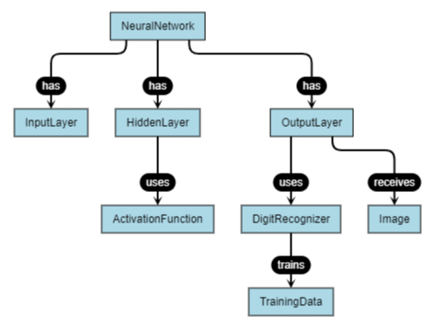
Figure 3.1 – Use Case Diagram of Handwritten Digit Recognition System

3.2.2 E-R DIAGRAM
The Entity-Relationship (E-R) Diagram models the structure of data in the system. Though this is not a full-fledged database system, you can still represent key data entities.
Entities:
- Dataset
- CNN Model
- Prediction Result
- Dataset trains Model
- Model generates Predictions
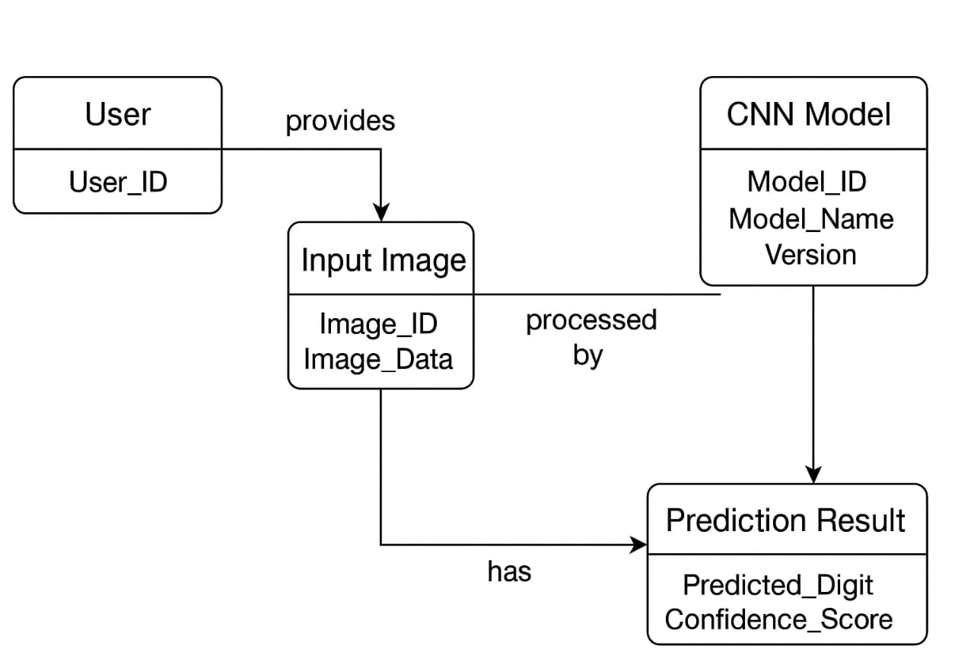
Figure 3.2 – ER Diagram of Handwritten Digit Recognition System

3.2.3 DATA FLOW DIAGRAM
A DFD shows how data flows within the system through various stages.
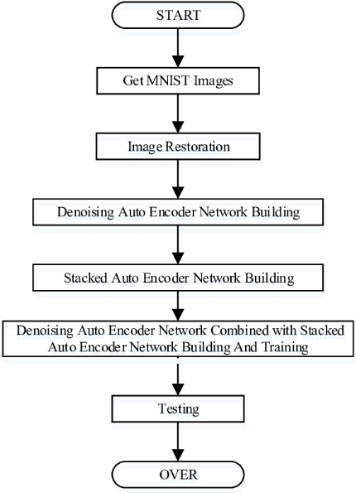
Figure 3.3 - Data Flow Diagram Of Handwritten Digit Recognition System
- Level 0:
User → Input Image → System → Output Digit
- Level 1:
Input → Preprocessing → Feature Extraction → Classification → Output
- legitimate or not.

3.2.4 CLASS DIAGRAM
The Class Diagram presents the structure of system components in terms of classes and their relationships.
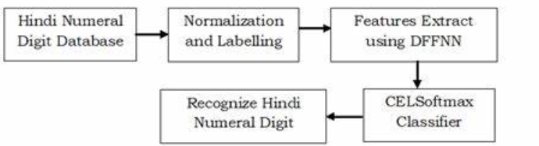
Figure 3.4 - UML Class Diagram of Handwritten Digit Recognition System

Classes:
- ImageLoader
- Preprocessor
- CNNModel
- Predictor
- UIHandler (optional)
3.2.5 SNAP SHOT
Include:
- Training accuracy graph
- Loss graph
- Prediction examples
- Interface screenshots
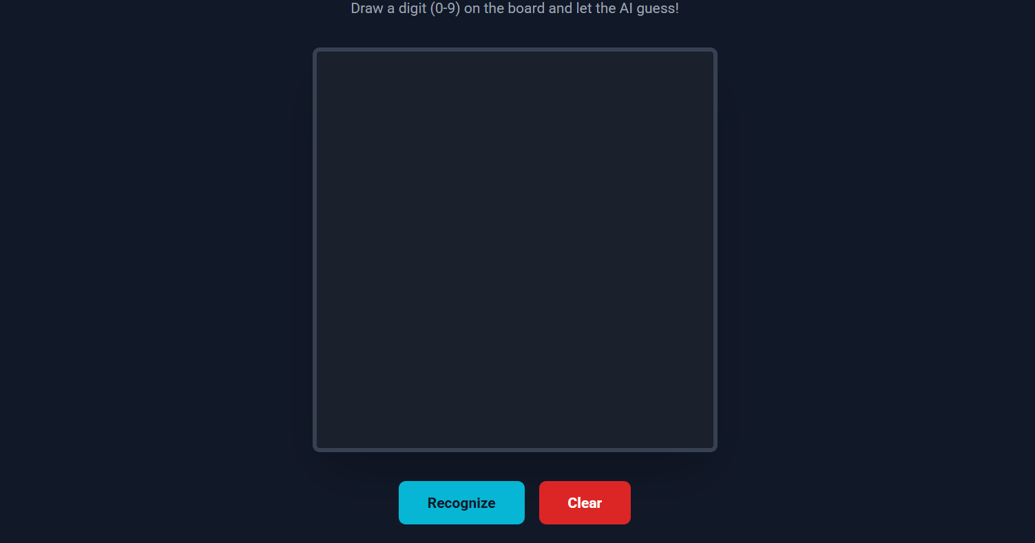
Figure 3.5 - It shows a output screen from the Digit Recognition web application.
Output Section
- Prediction Result - Label - ✔️ Digit 1
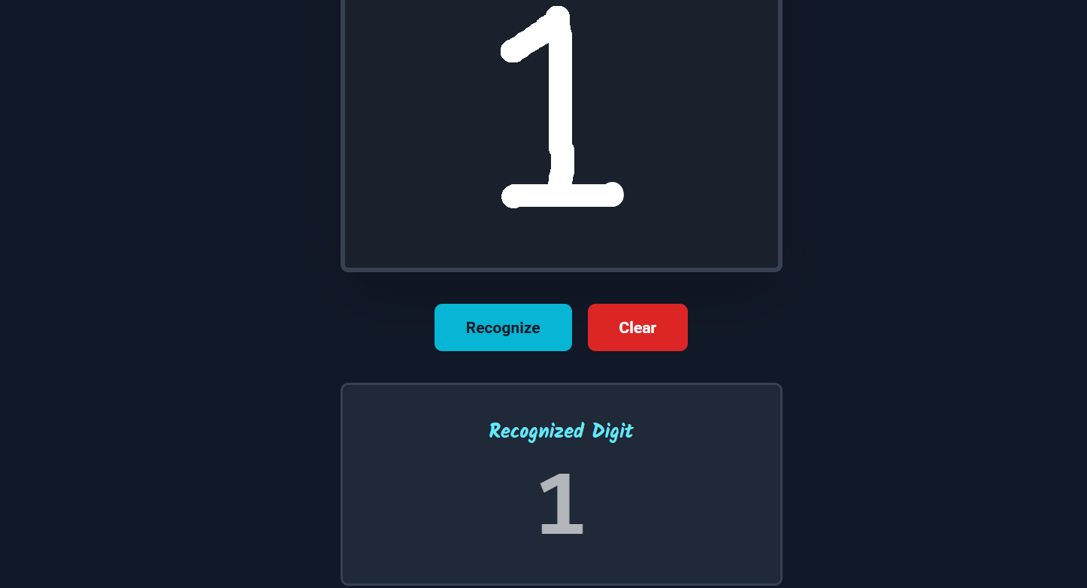
Figure 3.6 - This snapshot shows the result of a Digit Recognition system after analyzing the user-input statement.
Input Statement
User wrote → 1 → Model says 1
User wrote → 0 → Model says 0
CHAPTER IV: TESTING
4.1 ABOUT THE TECHNOLOGY USED
This project utilizes a variety of technologies, tools, and frameworks to build an intelligent Handwritten Digit Recognition System. The following are the key technologies used:
- Python
The primary programming language used for model development, preprocessing, and integration.
- Natural Language Processing (NLP)
For text cleaning, tokenization, stop word removal, stemming, and lemmatization.
- Scikit-learn
Used for machine learning models such as Logistic Regression, Naive Bayes, SVM, and Random Forest.
- TensorFlow & Keras
Used for implementing deep learning models like LSTM and CNN.
- Pandas & NumPy
For data handling, preprocessing, and numerical computations.
- Matplotlib & Seaborn: Used for data visualization and plotting confusion matrices and performance graphs.
4.2 TESTING
To ensure the reliability and accuracy of the system, various levels of testing were conducted, including unit testing, integration testing, and system testing.
4.2.1 UNIT TESTING
Each component is tested individually:
- Image preprocessing
- Model loading
- Prediction function
4.2.2 INTEGRATION TESTING
Integration testing was conducted to validate the interaction between various modules.
Tests combination of components:
- Preprocessing + Model inference
- Dataset + Training system

    - SYSTEM TESTING

System testing was carried out on the complete application to validate it against the overall requirements:
Complete system is tested using:
- Testing Data:5600 rows and 784 columns as features
- Custom handwritten images
- Random noisy samples
System testing concluded that the application performs with high accuracy and provides a user-friendly interface for Handwritten Digit Recognition System.

CHAPTER V: ADVANTAGES AND LIMITATIONS OF THE DEVELOPED SYSTEM
5.1 ADVANTAGES OF DEVELOPED SYSTEM
1. Highly Accurate Predictions
The Handwritten Digit Recognition System achieves a high level of accuracy because it is trained on the MNIST dataset, which contains thousands of diverse handwritten samples. Using Convolutional Neural Networks (CNNs), the system learns subtle shapes, curves, and writing patterns. As a result, it can recognize digits correctly even when handwriting styles vary significantly. The deep learning model continuously improves during training, making the predictions highly reliable.
2. Fast Processing Time
Once the model is trained, recognizing a new digit takes only a fraction of a second. The system can quickly process input images and immediately generate predictions. This speed is important in real-world applications where thousands of documents or entries need to be scanned instantly, such as in banking or postal systems.
3. Handles Different Handwriting Styles
Every person writes digits differently—some write round shapes, some write sharp lines, and others write with different sizes or thicknesses. CNN-based models learn features that are independent of these variations. Because the system analyzes the fundamental structure of digits, it can accurately recognize a wide range of handwriting styles without requiring manual adjustments.
4. Easy to Operate
The system is designed to be user-friendly. Even someone with minimal technical knowledge can use it. The user only needs to provide an input image, and the system will automatically preprocess the image, predict the digit, and display the result. No complex steps or configurations are required from the user.
5. Requires Minimal Manual Work
Traditional digit recognition systems required people to manually read and enter numbers, which was time-consuming and error-prone. This automated approach eliminates manual intervention. Once implemented, the system can run continuously without human involvement, reducing labor costs and improving accuracy.
6. Suitable for Real-World Applications
The system can be integrated into various industries:
- Banking: Automatic reading of handwritten cheques
- Postal Services: Recognizing handwritten ZIP codes
- Education: Reading student answer sheets
- Healthcare: Understanding handwritten prescriptions
- Data Entry: Digitizing handwritten forms
Its ability to understand handwritten digits makes it highly practical and valuable in real-world operations.
5.2 LIMITATIONS OF DEVELOPED SYSTEM
1. Accuracy Decreases for Poor-Quality or Blurry Images
The model performs best when the input images are clear and properly shaped. Blurry, noisy, or incomplete digits can confuse the model, leading to misclassification. For example, if someone writes “9” in a sloppy or broken manner, the system may interpret it as “4” or “7.”
2. Works Only for Digits (0–9), Not Alphabets
This system is specifically trained on the MNIST dataset, which contains only digits. Therefore, it cannot recognize letters (A–Z) or symbols. To recognize alphabets, the model needs to be trained on a different dataset and redesigned with a larger number of output classes.
3. Requires Large Training Datasets
Deep learning models need thousands of samples to learn effectively. If the dataset is small, the model might not generalize well and may perform poorly. Collecting and labeling such large datasets can be time-consuming and labor-intensive.
4. Training Without a GPU Takes More Time
Training CNN models involves millions of operations and requires high computational power. If a GPU (Graphics Processing Unit) is not available, the training process becomes significantly slower on a CPU. This makes experimentation and model tuning time-consuming.

CHAPTER VI - CONCLUSION AND SUGGESTIONS FOR FURTHER WORK
6.1 CONCLUSION
The Handwritten Digit Recognition System demonstrates the power of Artificial Intelligence and Deep Learning in solving everyday problems. Recognizing handwritten digits, which appears simple for humans, is a complex task for machines due to the wide variation in handwriting.
Through the use of Convolutional Neural Networks, the system learns important features such as edges, strokes, shapes, and patterns. The MNIST dataset provides enough examples to help the model achieve high accuracy. After training, the system can successfully classify new digits with impressive consistency.
This project proves that:
- Machines can learn visual patterns
- Manual tasks can be automated
- Deep learning can outperform traditional recognition systems

Overall, the project is a strong example of how AI can support industries like banking, education, postal services, and healthcare by reducing errors and increasing efficiency. The success of the system lays the foundation for more advanced recognition systems capable of reading entire handwritten documents.
6.2 SUGGESTIONS FOR FURTHER WORK
1. Extend System to Recognize Handwritten Alphabets
Currently, the system identifies only digits (0–9). A major future enhancement would be training the model to recognize alphabets (A–Z) and even cursive writing. This would allow the system to read complete handwritten words or sentences.
2. Develop a Mobile Application
Creating an Android or iOS app would allow users to capture handwritten digits directly through their phone camera. The app can use a lightweight version of the trained model to predict digits in real time.
3. Real-Time Camera-Based Recognition
Instead of uploading images, the system can be upgraded to read digits from a live camera feed. This would be useful in automation tasks where rapid scanning is required, such as sorting postal mail or reading meter readings.
4. Improve Accuracy with Advanced CNN Architectures
More powerful architectures like LeNet-5, AlexNet, ResNet, and DenseNet can significantly improve accuracy, especially for complex handwriting. These models can learn deeper features and perform better in challenging cases.
5. Create a Multi-Language Handwriting Recognition System
People write in different languages like English, Hindi, Bengali, Tamil, etc. A system capable of recognizing handwritten digits and characters from multiple languages would be extremely useful in government offices, schools, banks, and public service centers.

REFERENCES

- Yann LeCun, MNIST Database of Handwritten Digits
A standard benchmark dataset widely used for training image classification models.
It contains 70,000 examples of handwritten digits.
- TensorFlow Official Documentation
Provides detailed tutorials and API references for building, training, and deploying deep learning models using TensorFlow.
- “Deep Learning with Python” by François Chollet
A well-known book that explains deep learning concepts and introduces practical examples using Keras and Python.
- Research Papers and Articles on CNN and OCR
Various online tutorials, blogs, and academic papers that explain the architecture, applications, and improvements in image recognition systems.
- Online Coding Platforms (Kaggle, GitHub)
These platforms offer sample code, datasets, and project ideas that helped in understanding model implementation details.

