using System;

using System.Collections.Generic;

class question

{

public static void Main()

{

string a;

int i,j,k,t;

t = int.Parse(Console.ReadLine());

for( k = 0; k < t;k++){

j=0;

a = Console.ReadLine();

for(i=0;i<a.Length;i++)

{

if(a[i]=='A'||a[i]=='E'||a[i]=='I'||a[i]=='O'||a[i]=='U'||a[i]=='a'||a[i]=='e'||a[i]=='i'||a[i]=='o'||a[i]=='u')

j++;

}

Console.WriteLine(j.ToString());

}

}

}

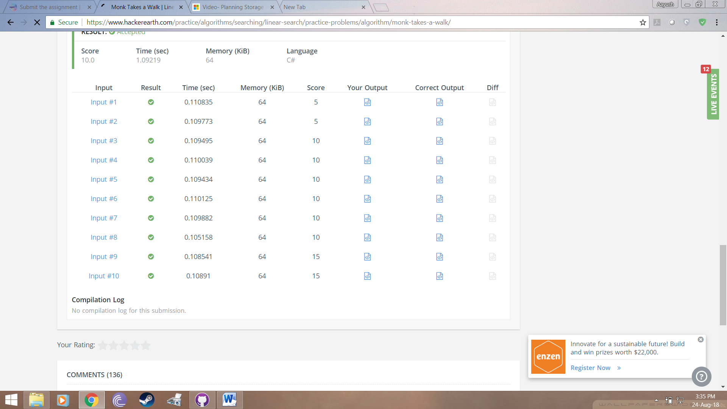

2.

class question{

public static void Main(){

int i,j,k,l,c,c1;

string s;

int t;

t = int.Parse(Console.ReadLine());

for( k = 0; k < t;k++){

{ c=0;

c1=0;

s = Console.ReadLine();

l = s.Length;

for(i=0;i<l;i++)

{

if(i<=l-7)

{

if(s[i]=='S'&&s[i+1]=='U'&&s[i+2]=='V'&&s[i+3]=='O'&&s[i+4]=='J'&&s[i+5]=='I'&&s[i+6]=='T')

c1++;

}

if(i<=l-4)

{

if(s[i]=='S'&&s[i+1]=='U'&&s[i+2]=='V'&&s[i+3]=='O')

c++;

}

}

c=c-c1;

if(c<0)

c=0;

Console.WriteLine("SUVO = " + c + " SUVOJIT = " + c1);

}}

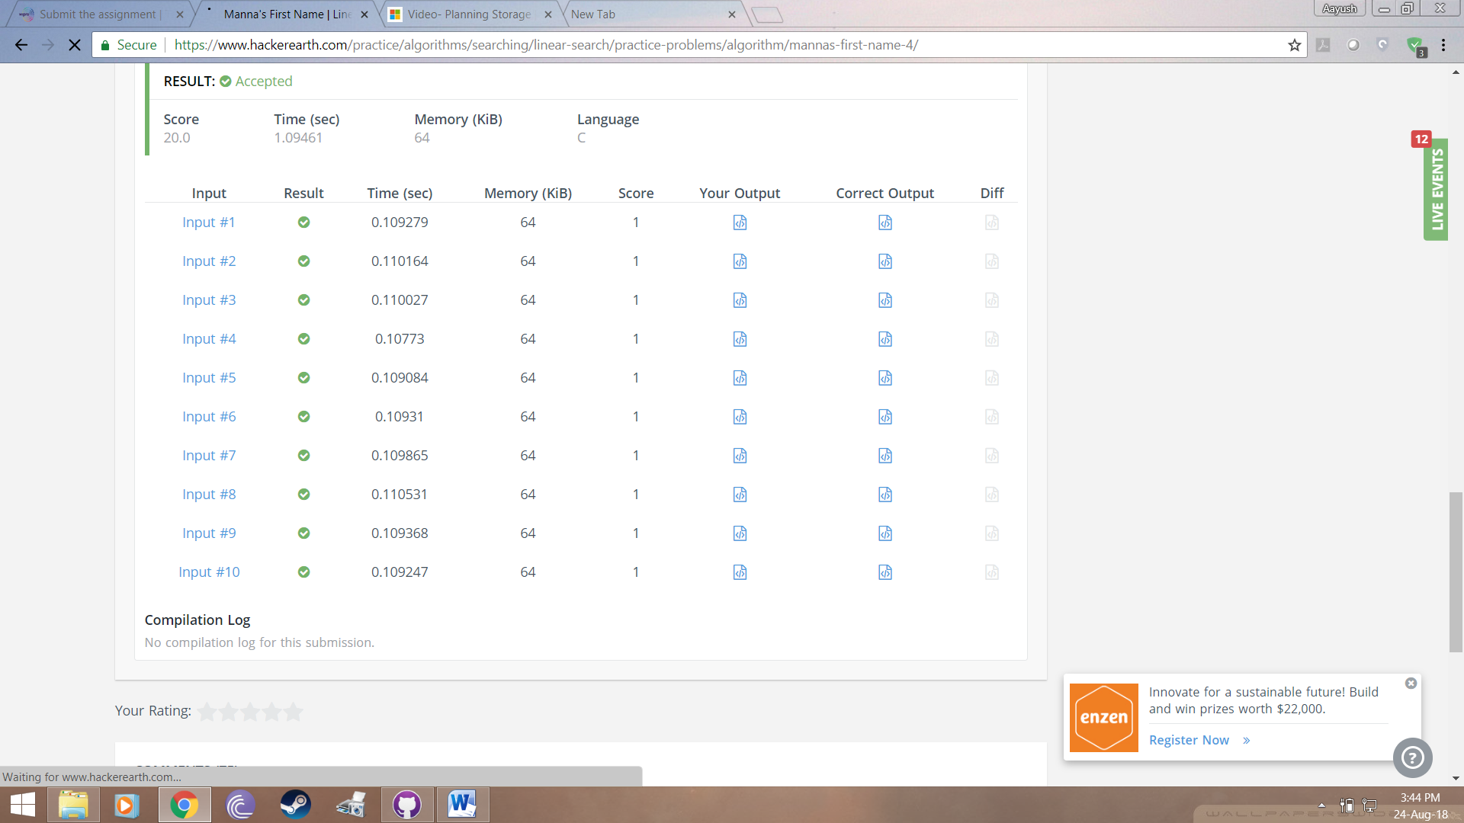

3.

using System;

namespace RoundUpCheck

{

class Program

{

static void Main(string[] args)

{

string currentStr;

string finalString = "";

int testCaseCount;

testCaseCount = Convert.ToInt32(Console.ReadLine());

for (int i = 0; i < testCaseCount; i++)

{

currentStr = Console.ReadLine();

if (currentStr.Contains("21"))

{

finalString += "The streak is broken!\n";

}

else

{

if (Convert.ToInt32(currentStr) % 21 == 0)

{

finalString += "The streak is broken!\n";

}

else

{

finalString += "The streak lives still in our heart!\n";

}

}

}

Console.WriteLine(finalString);

Console.ReadLine();

}

}

}

