Project Report

On

Medicine Delivery website

Submitted by:

1-Pratham Panjwani (201500511)

2-Ayush Yadav(201500186)

3-Prachi Chaudhary(201500481)

4-Vishal Sharma(201550153)

5-Yogendra Kumar(201500831)

6-Gautam Singh(201500257)

7-Pratiksha Gupta(201500514)

8-Akriti Panwar(201500065)

9-Subhrat Jain(201500711)



Overview:

The Online Medicine Delivery website is totally on based technology .we uses HTML,CSS and JS in this project .The Interface and Controls of this website are very simple for the user.

The website Contains user side from where the user can easily order its medicines.

Objective:

The main objectives of this Delivery System are:

Order your Medicine – This system will help customers in ordering their medicines and consultation with the doctor. It will be very easy and comfortable for user to order medicine from anywhere.

Online Payment– This system will give the option to the customer for online payment. This will make the medicine buying experience cash-free.

Better Knowledge– The user will get to know the items available in the stock.

Improves Efficiency–This system will make things easier for staff as the whole ordering process is done by the customer only.

Code

Html code:

<!DOCTYPE html>

<html lang="en">

  <head>

    <meta charset="UTF-8" />

    <meta http-equiv="X-UA-Compatible" content="IE=edge" />

    <meta name="viewport" content="width=device-width, initial-scale=1.0" />

    <title>Medicine Deivery Website</title>

<link rel="stylesheet" href="https://unpkg.com/swiper@7/swiper-bundle.min.css"/>

<link rel="stylesheet" href="https://cdnjs.cloudflare.com/ajax/libs/font-awesome/5.15.4/css/all.min.css"/>

<link rel="stylesheet" href="./style.css" />

  </head>

  <body>

    <header class="header">

      <a href="#" class="logo"><i class="fa-solid fa-Doctor"></i>Medi+Kit</a>

      <nav class="navbar">

        <a href="#home">Home</a>

        <a href="#categories">Services for you</a>

        <a href="#products">Products</a>

        <a href="#features">Lab Tests</a>

        <a href="#review">Reviews</a>

        <a href="#Contact">Contact</a>

      </nav>

      <div class="icons">

        <div class="fas fa-bars" id="menu-btn"></div>

        <div class="fas fa-search" id="search-btn"></div>

        <div class="fas fa-shopping-cart" id="cart-btn"></div>

        <div class="fas fa-user" id="login-btn"></div>

      </div>

      <form action="" class="search-form">

        <input type="search" id="search-box" placeholder="search here..." />

        <label for="search-box" class="fas fa-search"></label>

      </form>

      <div class="shopping-cart">

        <div class="box">

          <img src="./Images/dolo.jpg" alt="" width="150px" />

          <i class="fas fa-trash"></i>

          <div class="content">

            <h3>dolo</h3>

            <span class="price">Rs:35</span>

            <span class="quantity">Qty : 1</span>

          </div>

        </div>

        <div class="box">

          <i class="fas fa-trash"></i>

          <img src="./Images/volini.jpg" alt="" />

          <div class="content">

            <h3>Volini</h3>

            <span class="price">Rs: 120</span>

            <span class="quantity">Qty : 1</span>

          </div>

        </div>

        <div class="box">

          <i class="fas fa-trash"></i>

          <img src="./Images/paracetamol.jpg" alt="" />

          <div class="content">

            <h3>paracetamol</h3>

            <span class="price">Rs:30</span>

            <span class="quantity">Qty : 1</span>

          </div>

        </div>

        <div class="total">Total:185</div>

        <a href="#" class="btn">checkout</a>

      </div>

      <form action="" class="login-form">

        <h3>login now</h3>

        <input type="email" placeholder="your email" class="box" />

        <input type="password" placeholder="your password" class="box" />

        <p>forget your password <a href="#">click here</a></p>

        <p>don't have an account <a href="#">create now</a></p>

        <input type="submit" value="login now" class="btn" />

      </form>

    </header>

    <section class="home" id="home">

      <div class="content">

        &nbsp;

        &nbsp;

        <h3>Order your Medicine Online <span>Only on </span> <br> <br> Medi+Kit</h3>

        <h2>Medi+Kit Number One!! #ForyourfirstOrder</h2>

        <h2>Get your medicine within 20 minutes</h2>

        <h2>Order Now!!</h2>

        <br />

        <br />

        <a href="#" class="btn">Shop Now</a>

      </div>

    </section>

    <section class="categories" id="categories">

      <h1 class="heading"> <span>Services For Customer</span></h1>

      <div class="box-container">

        <div class="box">

          <img src="./Images/covid.png" alt="" />

          <h3>Book doctor by sympyoms!</h3>

          <a href="#" class="btn">Book Now</a>

        </div>

        <div class="box">

          <img src="./Images/vacc2.png" alt="" />

          <h3>Book Covid Vaccination</h3>

          <a href="#" class="btn">Book Now</a>

        </div>

        <div class="box">

          <img src="./Images/doc con.webp" alt="" />

          <h3>One Tap Consult @250</h3>

          <a href="#" class="btn">Book Now</a>

        </div>

      </div>

    </section>

    <section class="products" id="products">

      <h1 class="heading"><span> Products!!</span></h1>

      <div class="swiper product-slider">

        <div class="swiper-wrapper">

          <div class="swiper-slide box">

            <img src="./Images/skin care.jpg" alt="" />

            <h3>Skin Care products</h3>

            <div class="price">Rs:700-1000</div>

            <div class="stars">

              <i class="fas fa-star"></i>

              <i class="fas fa-star"></i>

              <i class="fas fa-star"></i>

              <i class="fas fa-star"></i>

              <i class="fas fa-star-half-alt"></i>

            </div>

            <a href="#" class="btn">add to cart</a>

          </div>

          <div class="swiper-slide box">

            <img src="./Images/Patanjali Products.jpg" alt="" />

            <h3>Patanjali Products</h3>

            <div class="price">On MRP</div>

            <div class="stars">

              <i class="fas fa-star"></i>

              <i class="fas fa-star"></i>

              <i class="fas fa-star"></i>

              <i class="fas fa-star"></i>

              <i class="fas fa-star-half-alt"></i>

            </div>

            <a href="#" class="btn">add to cart</a>

          </div>

          <div class="swiper-slide box">

            <img src="./Images/Omg3.jfif" alt="" />

            <h3>Omega-3 Capsule</h3>

            <div class="price">Rs:30</div>

            <div class="stars">

              <i class="fas fa-star"></i>

              <i class="fas fa-star"></i>

              <i class="fas fa-star"></i>

              <i class="fas fa-star"></i>

              <i class="fas fa-star-half-alt"></i>

            </div>

            <a href="#" class="btn">add to cart</a>

          </div>

          <div class="swiper-slide box">

            <img src="./Images/baby.jpg" alt="" />

            <h3>Baby Products</h3>

            <div class="price">ON MRP</div>

            <div class="stars">

              <i class="fas fa-star"></i>

              <i class="fas fa-star"></i>

              <i class="fas fa-star"></i>

              <i class="fas fa-star"></i>

              <i class="fas fa-star-half-alt"></i>

            </div>

            <a href="#" class="btn">add to cart</a>

          </div>

        </div>

      </div>

      <div class="swiper product-slider">

        <div class="swiper-wrapper">

          <div class="swiper-slide box">

            <img src="./Images/Syrup.png" alt="" />

            <h3>Syrup</h3>

            <div class="price">ON MRP</div>

            <div class="stars">

              <i class="fas fa-star"></i>

              <i class="fas fa-star"></i>

              <i class="fas fa-star"></i>

              <i class="fas fa-star"></i>

              <i class="fas fa-star-half-alt"></i>

            </div>

            <a href="#" class="btn">add to cart</a>

          </div>

          <div class="swiper-slide box">

            <img src="./Images/oilll.jpg" alt="" />

            <h3>Hair Products</h3>

            <div class="price">ON MRP</div>

            <div class="stars">

              <i class="fas fa-star"></i>

              <i class="fas fa-star"></i>

              <i class="fas fa-star"></i>

              <i class="fas fa-star"></i>

              <i class="fas fa-star-half-alt"></i>

            </div>

            <a href="#" class="btn">add to cart</a>

          </div>

          <div class="swiper-slide box">

            <img src="./Images/Vitam.jpg" alt="" />

            <h3>Vitamin products</h3>

            <div class="price">ON MRP</div>

            <div class="stars">

              <i class="fas fa-star"></i>

              <i class="fas fa-star"></i>

              <i class="fas fa-star"></i>

              <i class="fas fa-star"></i>

              <i class="fas fa-star-half-alt"></i>

            </div>

            <a href="#" class="btn">add to cart</a>

          </div>

          <div class="swiper-slide box">

            <img src="./Images/Mask.jpg" alt="" />

            <h3>Masks</h3>

            <div class="price">On MRP</div>

            <div class="stars">

              <i class="fas fa-star"></i>

              <i class="fas fa-star"></i>

              <i class="fas fa-star"></i>

              <i class="fas fa-star"></i>

              <i class="fas fa-star-half-alt"></i>

            </div>

            <a href="#" class="btn">add to cart</a>

          </div>

        </div>

      </div>

    </section>

    <section class="features" id="features">

      <h1 class="heading"><span>Our features</span></h1>

      <div class="box-container">

        <div class="box">

          <img src="./Images/Mankind_Serving_Life.png" alt="" />

          <h3 id="fresh">Top Brands</h3>

          <p>

            Lorem, ipsum dolor sit amet consectetur adipisicing elit. Deserunt,

            earum!

          </p>

          <a href="#" class="btn">Book Now</a>

        </div>

        <div class="box">

            <img src="./Images/lab.jpg" alt="" width="150px" />

            <h3>Lab Tests</h3>

            <p>

              Lorem, ipsum dolor sit amet consectetur adipisicing elit. Deserunt,

              earum!

            </p>

            <a href="#" class="btn">Book Now</a>

          </div>

          <div class="box">

            <img src="./Images/doc.jpg" alt="" width="150px" />

            <h3>Consult a Doctor</h3>

            <p>

              Lorem, ipsum dolor sit amet consectetur adipisicing elit. Deserunt,

              earum!

            </p>

            <a href="#" class="btn">Book Now</a>

          </div>

        <div class="box">

          <img src="./Images/freedelivery.webp" alt="" width="150px" />

          <h3>free delivery</h3>

          <p>

            Lorem, ipsum dolor sit amet consectetur adipisicing elit. Deserunt,

            earum!

          </p>

          <a href="#" class="btn">Book Now</a>

        </div>

        <div class="box">

          <img src="./Images/Jio-logo.jpg" alt="" />

          <h3>easy payments</h3>

          <p>

            Lorem, ipsum dolor sit amet consectetur adipisicing elit. Deserunt,

            earum!

          </p>

          <a href="#" class="btn">Book Now</a>

        </div>

      </div>

    </section>

    <section class="review" id="review">

      <h1 class="heading"><span>Customer's review</span></h1>

      <div class="swiper review-slider">

        <div class="swiper-wrapper">

          <div class="swiper-slide box">

            <img src="./Images/virat.jpg" alt="" />

            <p>

              Lorem ipsum dolor sit, amet consectetur adipisicing elit. Unde

              sunt fugiat dolore ipsum id est maxime ad tempore quasi tenetur.

            </p>

            <h3>Virat Kohli</h3>

            <div class="stars">

              <i class="fas fa-star"></i>

              <i class="fas fa-star"></i>

              <i class="fas fa-star"></i>

              <i class="fas fa-star"></i>

              <i class="fas fa-star-half-alt"></i>

            </div>

          </div>

          <div class="swiper-slide box">

            <img src="./Images/hri.jpg" alt="" width="100px" />

            <p>

              Lorem ipsum dolor sit, amet consectetur adipisicing elit. Unde

              sunt fugiat dolore ipsum id est maxime ad tempore quasi tenetur.

            </p>

            <h3>Hritik Roshan</h3>

            <div class="stars">

              <i class="fas fa-star"></i>

              <i class="fas fa-star"></i>

              <i class="fas fa-star"></i>

              <i class="fas fa-star"></i>

              <i class="fas fa-star-half-alt"></i>

            </div>

          </div>

          <div class="swiper-slide box">

            <img

              src="./Images/srk.jpg"

              alt=""

            />

            <p>

              Lorem ipsum dolor sit, amet consectetur adipisicing elit. Unde

              sunt fugiat dolore ipsum id est maxime ad tempore quasi tenetur.

            </p>

            <h3>Shahrukh khan</h3>

            <div class="stars">

              <i class="fas fa-star"></i>

              <i class="fas fa-star"></i>

              <i class="fas fa-star"></i>

              <i class="fas fa-star"></i>

              <i class="fas fa-star-half-alt"></i>

            </div>

          </div>

          <div class="swiper-slide box">

            <img

              src="./Images/dhoni.jpg"

              alt=""

            />

            <p>

              Lorem ipsum dolor sit, amet consectetur adipisicing elit. Unde

              sunt fugiat dolore ipsum id est maxime ad tempore quasi tenetur.

            </p>

            <h3>M.S.Dhoni</h3>

            <div class="stars">

              <i class="fas fa-star"></i>

              <i class="fas fa-star"></i>

              <i class="fas fa-star"></i>

              <i class="fas fa-star"></i>

              <i class="fas fa-star-half-alt"></i>

            </div>

          </div>

        </div>

      </div>

    </section>

<section class="footer">

      <div class="box-container">

        <div class="box">

          <h3>Useful links</h3>

          <a href="#" class="links">

            <i class="fas fa-arrow-right"></i> Home

          </a>

          <a href="#" class="links">

            <i class="fas fa-arrow-right"></i> Lab Tests

          </a>

          <a href="#" class="links">

            <i class="fas fa-arrow-right"></i> Products

          </a>

          <a href="#" class="links">

            <i class="fas fa-arrow-right"></i>Services For You

          </a>

          <a href="#" class="links">

            <i class="fas fa-arrow-right"></i> Review

          </a>

          <a href="#" class="links">

            <i class="fas fa-arrow-right"></i> Contacts

          </a>

        </div>

        <div class="box">

          <h3>Contacts </h3>

          <a href="#" class="links">

            <i class="fas fa-phone"></i> +123-456-7890

          </a>

          <a href="#" class="links">

            <i class="fas fa-phone"></i> +111-222-3333

          </a>

          <a href="#" class="links">

            <i class="fas fa-envelope"></i>MediKit108@gmail.com

          </a>

          <a href="#" class="links">

            <i class="fas fa-map-marker-alt"></i> Lucknow, India-226012

          </a>

        </div>

        <div class="box">

          <h3>Newsletter</h3>

          <p>Do visit on our website</p>

          <input type="email" placeholder="your email" class="email" />

          <input type="submit" value="subscribe" class="btn" />

          <img src="./Images/payment.png" class="payment-img" alt="" />

        </div>

      </div>

    </section>

    <script src="https://unpkg.com/swiper@7/swiper-bundle.min.js"></script>

    <script src="./script.js"></script>

  </body>

</html>

Css code:

@import url('https://fonts.googleapis.com/css2?family=Poppins:wght@100;300;400;500;600&display=swap');

:root{

    --blue:#98e9ea;

    --black:#130f40;

    --light-color:#666;

    --box-shadow:0 .5rem 1.5rem rgba(0,0,0,.1);

    --border:.2rem solid rgba(0,0,0,.1);

    --outline:.1rem solid rgba(0,0,0,.1);

    --outline-hover:.2rem solid var(--black);

}

*{

    font-family: 'Poppins', sans-serif;

    margin:0;

    padding:0;

    box-sizing: border-box;

    outline: none; border:none;

    text-decoration: none;

    text-transform: capitalize;

    transition: all .2s linear;

}

html{

    font-size: 62.5%;

    overflow-x: hidden;

    scroll-behavior: smooth;

    scroll-padding-top: 7rem;

}

body{

    background:#eee;

}

section{

    padding:2rem 9%;

}

.heading{

    text-align: center;

    padding:2rem 0;

    padding-bottom: 3rem;

    font-size: 3.5rem;

    color:var(--black);

}

.heading span{

    background:rgb(89, 185, 220);

    color:#fff;

    display: inline-block;

    padding:.5rem 3rem;

    clip-path: calc(100% 0, 93% 50%, 100% 99%, 0% 100%, 7% 50%, 0% 0%);

}

.btns{

    margin-top: 1rem;

    display: inline-block;

    padding:.8rem 3rem;

    font-size: 1.7rem;

    border-radius: .5rem;

    border:.2rem solid var(--black);

    color:var(--black);

    cursor: pointer;

    background: none;

    position: relative;

    left: 510px;

    bottom: 134px;

}

.btn{

    margin-top: 1rem;

    display: inline-block;

    padding:.8rem 3rem;

    font-size: 1.7rem;

    border-radius: .5rem;

    border:.2rem solid var(--black);

    color:var(--black);

    cursor: pointer;

    background: none;

}

.btn:hover{

    background:rgb(89, 185, 220);

    color:#fff;

}

.header{

    position: fixed;

    top:0; left:0; right: 0;

    z-index: 1000;

    display: flex;

    align-items: center;

    justify-content: space-between;

    padding:2rem 9%;

    background:#fff;

    box-shadow: var(--box-shadow);

}

.header .logo{

    font-size: 2.5rem;

    font-weight: bolder;

    color:var(--black);

}

.header .logo i{

    color:rgb(89, 185, 220);

}

.header .navbar a{

    font-size: 1.7rem;

    margin:0 1rem;

    color:var(--black);

}

.header .navbar a:hover{

    color:rgb(89, 185, 220);

}

.header .icons div{

    height: 4.5rem;

    width: 4.5rem;

    line-height: 4.5rem;

    border-radius: .5rem;

    background: #eee;

    color:var(--black);

    font-size: 2rem;

    margin-left: .3rem;

    cursor: pointer;

    text-align: center;

}

.header .icons div:hover{

    background: rgb(89, 185, 220);

    color:#fff;

}

#menu-btn{

    display: none;

}

.header .search-form{

    position: absolute;

    top:110%; right:-110%;

    width: 50rem;

    height:5rem;

    background: #fff;

    border-radius: .5rem;

    overflow: hidden;

    display: flex;

    align-items: center;

    box-shadow: var(--box-shadow);

}

.header .search-form.active{

    right:2rem;

    transition: .4s linear;

}

.header .search-form input{

    height:100%;

    width:100%;

    background: none;

    text-transform: none;

    font-size: 1.6rem;

    color:var(--black);

    padding:0 1.5rem;

}

.header .search-form label{

    font-size: 2.2rem;

    padding-right: 1.5rem;

    color:var(--black);

    cursor: pointer;

}

.header .search-form label:hover{

    color:rgb(89, 185, 220);

}

.header .shopping-cart{

    position: absolute;

    top:110%; right:-110%;

    padding:1rem;

    border-radius: .5rem;

    box-shadow: var(--box-shadow);

    width:35rem;

    background: #fff;

}

.header .shopping-cart.active{

    right:2rem;

    transition: .4s linear;

}

.header .shopping-cart .box{

    display: flex;

    align-items: center;

    gap:1rem;

    position: relative;

    margin:1rem 0;

}

.header .shopping-cart .box img{

    height:10rem;

}

.header .shopping-cart .box .fa-trash{

    font-size: 2rem;

    position: absolute;

    top:50%; right:2rem;

    cursor: pointer;

    color:var(--light-color);

    transform: translateY(-50%);

}

.header .shopping-cart .box .fa-trash:hover{

    color:rgb(89, 185, 220);

}

.header .shopping-cart .box .content h3{

    color:var(--black);

    font-size: 1.7rem;

    padding-bottom: 1rem;

}

.header .shopping-cart .box .content span{

    color:var(--light-color);

    font-size: 1.6rem;

}

.header .shopping-cart .box .content .quantity{

    padding-left: 1rem;

}

.header .shopping-cart .total{

    font-size: 2.5rem;

    padding:1rem 0;

    text-align: center;

    color:var(--black);

}

.header .shopping-cart .btn{

    display: block;

    text-align: center;

    margin:1rem;

}

.header .login-form{

    position: absolute;

    top:110%; right:-110%;

    width:35rem;

    box-shadow: var(--box-shadow);

    padding:2rem;

    border-radius: .5rem;

    background: #fff;

    text-align: center;

}

.header .login-form.active{

    right:2rem;

    transition: .4s linear;

}

.header .login-form h3{

    font-size: 2.5rem;

    text-transform: uppercase;

    color: var(--black);

}

.header .login-form .box{

    width: 100%;

    margin:.7rem 0;

    background:#eee;

    border-radius: .5rem;

    padding:1rem;

    font-size: 1.6rem;

    color:var(--black);

    text-transform: none;

}

.header .login-form p{

    font-size: 1.4rem;

    padding:.5rem 0;

    color:var(--light-color);

}

.header .login-form p a{

    color:rgb(221, 30, 30);

    text-decoration: underline;

}

.home{

    display: flex;

    align-items: center;

    justify-content: center;

    background: url("https://png.pngtree.com/thumb_back/fh260/back_our/20190625/ourmid/pngtree-blue-minimalist-medical-banner-image_261515.jpg") no-repeat;

    background-position: center;

    background-size: cover;

    padding-top: 17rem;

    padding-bottom: 10rem;

}

.home .content{

    text-align: center;

    width:60rem;

}

.home .content h3{

    color:var(--black);

    font-size: 3rem;

    position: relative;

    bottom: 80px;

}

.home .content h3 span{

    color:rgb(189, 37, 181);

}

.home .content p{

    color:var(--light-color);

    font-size: 1.7rem;

    padding:1rem 0;

    line-height: 1.8;

}

.features .box-container{

    display: grid;

    grid-template-columns: repeat(auto-fit, minmax(30rem, 1fr));

    gap:1.5rem;

}

.features .box-container .box{

    padding:3rem 2rem;

    background: #fff;

    outline: var(--outline);

    outline-offset: -1rem;

    text-align: center;

    box-shadow: var(--box-shadow);

}

.features .box-container .box:hover{

    outline: var(--outline-hover);

    outline-offset: 0rem;

}

.features .box-container .box img{

    margin:1rem 0;

    height: 15rem;

}

.features .box-container .box h3{

    font-size: 2.5rem;

    line-height: 1.8;

    color:var(--black);

}

.features .box-container .box p{

    font-size: 1.5rem;

    line-height: 1.8;

    color:var(--light-color);

    padding:1rem 0;

}

.products .product-slider{

    padding:1rem;

}

.products .product-slider:first-child{

    margin-bottom: 2rem;

}

.products .product-slider .box{

    background: #fff;

    border-radius: .5rem;

    text-align: center;

    padding:3rem 2rem;

    outline-offset: -1rem;

    outline: var(--outline);

    box-shadow: var(--box-shadow);

    transition: .2s linear;

}

.products .product-slider .box:hover{

    outline-offset: 0rem;

    outline: var(--outline-hover);

}

.products .product-slider .box img{

    height:20rem;

}

.products .product-slider .box h3{

    font-size: 2.5rem;

    color:var(--black);

}

.products .product-slider .box .price{

    font-size: 2rem;

    color:var(--light-color);

    padding:.5rem 0;

}

.products .product-slider .box .stars i{

    font-size: 1.7rem;

    color:rgb(243, 243, 32);

    padding:.5rem 0;

}

.categories .box-container{

    display: grid;

    grid-template-columns: repeat(auto-fit, minmax(26rem, 1fr));

    gap:1.5rem;

}

.categories .box-container .box{

    padding:3rem 2rem;

    border-radius: .5rem;

    background:#fff;

    box-shadow: var(--box-shadow);

    outline:var(--outline);

    outline-offset: -1rem;

    text-align: center;

}

.categories .box-container .box:hover{

    outline:var(--outline-hover);

    outline-offset: 0rem;

}

.categories .box-container .box img{

    margin:1rem 0;

    height:15rem;

}

.categories .box-container .box h3{

   font-size: 2rem;

   color:var(--black);

   line-height: 1.8;

}

.categories .box-container .box p{

    font-size: 1.7rem;

    color:var(--light-color);

    line-height: 1.8;

    padding:1rem 0;

}

.review .review-slider{

    padding:1rem;

}

.review .review-slider .box{

    background: #fff;

    border-radius: .5rem;

    text-align: center;

    padding:3rem 2rem;

    outline-offset: -1rem;

    outline: var(--outline);

    box-shadow: var(--box-shadow);

    transition: .2s linear;

}

.review .review-slider .box:hover{

    outline:var(--outline-hover);

    outline-offset: 0rem;

}

.review .review-slider .box img{

    height:10rem;

    width:10rem;

    border-radius: 50%;

}

.review .review-slider .box p{

    padding:1rem 0;

    line-height: 1.8;

    color:var(--light-color);

    font-size: 1.5rem;

}

.review .review-slider .box h3{

    padding-bottom: .5rem;

    color:var(--black);

    font-size: 2.2rem;

}

.review .review-slider .box .stars i{

    color:rgb(243, 243, 32);

    font-size: 1.7rem;

}

.footer{

    background: #fff;

}

.footer .box-container{

    display: grid;

    grid-template-columns: repeat(auto-fit, minmax(25rem, 1fr));

    gap:1.5rem;

}

.footer .box-container .box h3{

    font-size: 2.5rem;

    color:var(--black);

    padding:1rem 0;

}

.footer .box-container .box h3 i{

    color:rgb(89, 185, 220);

}

.footer .box-container .box .links{

    display: block;

    font-size: 1.5rem;

    color:var(--light-color);

    padding:1rem 0;

}

.footer .box-container .box .links i{

    color:rgb(89, 185, 220);

    padding-right: .5rem;

}

.footer .box-container .box .links:hover i{

    padding-right: 2rem;

}

.footer .box-container .box p{

    line-height: 1.8;

    font-size: 1.5rem;

    color:var(--light-color);

    padding:1rem 0;

}

.footer .box-container .box .share a{

    height:4rem;

    width:4rem;

    line-height:4rem;

    border-radius: .5rem;

    font-size: 2rem;

    color:var(--black);

    margin-right: .2rem;

    background: #eee;

    text-align: center;

}

.footer .box-container .box .share a:hover{

    background:rgb(89, 185, 220);

    color: #fff;

}

.footer .box-container .box .email{

    width: 100%;

    margin:.7rem 0;

    padding:1rem;

    border-radius: .5rem;

    background: #eee;

    font-size: 1.6rem;

    color:var(--black);

    text-transform: none;

}

.footer .box-container .box .payment-img{

    margin-top: 2rem;

    height: 3rem;

    display: block;

}

.footer .credit{

    text-align: center;

    margin-top: 2rem;

    padding:1rem;

    padding-top: 2.5rem;

    font-size: 2rem;

    color:var(--black);

    border-top: var(--border);

}

.footer .credit span{

    color:rgb(89, 185, 220);

}

@media (max-width:991px){

    html{

        font-size: 55%;

    }

    .header{

        padding:2rem;

    }

    section{

        padding:2rem;

    }

}

@media (max-width:768px){

    #menu-btn{

        display: inline-block;

    }

    .header .search-form{

        width:90%;

    }

    .header .navbar{

        position: absolute;

        top:110%; right:-110%;

        width:30rem;

        box-shadow: var(--box-shadow);

        border-radius: .5rem;

        background: #fff;

    }

    .header .navbar.active{

        right:2rem;

        transition: .4s linear;

    }

    .header .navbar a{

        font-size: 2rem;

        margin:2rem 2.5rem;

        display: block;

    }

}

@media (max-width:450px){

    html{

        font-size: 50%;

    }

    .heading{

        font-size: 2.5rem;

    }

    .footer{

        text-align: center;

    }

    .footer .box-container .box .payment-img{

        margin: 2rem auto;

    }

}

Javascript code:

let searchForm = document.querySelector('.search-form');

document.querySelector('#search-btn').onclick = () =>{

    searchForm.classList.toggle('active');

    shoppingCart.classList.remove('active');

    loginForm.classList.remove('active');

    navbar.classList.remove('active');

}

let shoppingCart = document.querySelector('.shopping-cart');

document.querySelector('#cart-btn').onclick = () =>{

    shoppingCart.classList.toggle('active');

    searchForm.classList.remove('active');

    loginForm.classList.remove('active');

    navbar.classList.remove('active');

}

let loginForm = document.querySelector('.login-form');

document.querySelector('#login-btn').onclick = () =>{

    loginForm.classList.toggle('active');

    searchForm.classList.remove('active');

    shoppingCart.classList.remove('active');

    navbar.classList.remove('active');

}

let navbar = document.querySelector('.navbar');

document.querySelector('#menu-btn').onclick = () =>{

    navbar.classList.toggle('active');

    searchForm.classList.remove('active');

    shoppingCart.classList.remove('active');

    loginForm.classList.remove('active');

}

window.onscroll = () =>{

    searchForm.classList.remove('active');

    shoppingCart.classList.remove('active');

    loginForm.classList.remove('active');

    navbar.classList.remove('active');

}

var swiper = new Swiper(".product-slider", {

    loop:true,

    spaceBetween: 20,

    autoplay: {

        delay: 7500,

        disableOnInteraction: false,

    },

    centeredSlides: true,

    breakpoints: {

      0: {

        slidesPerView: 1,

      },

      768: {

        slidesPerView: 2,

      },

      1020: {

        slidesPerView: 3,

      },

    },

});

var swiper = new Swiper(".review-slider", {

    loop:true,

    spaceBetween: 20,

    autoplay: {

        delay: 7500,

        disableOnInteraction: false,

    },

    centeredSlides: true,

    breakpoints: {

      0: {

        slidesPerView: 1,

      },

      768: {

        slidesPerView: 2,

      },

      1020: {

        slidesPerView: 3,

      },

    },

});

Output:

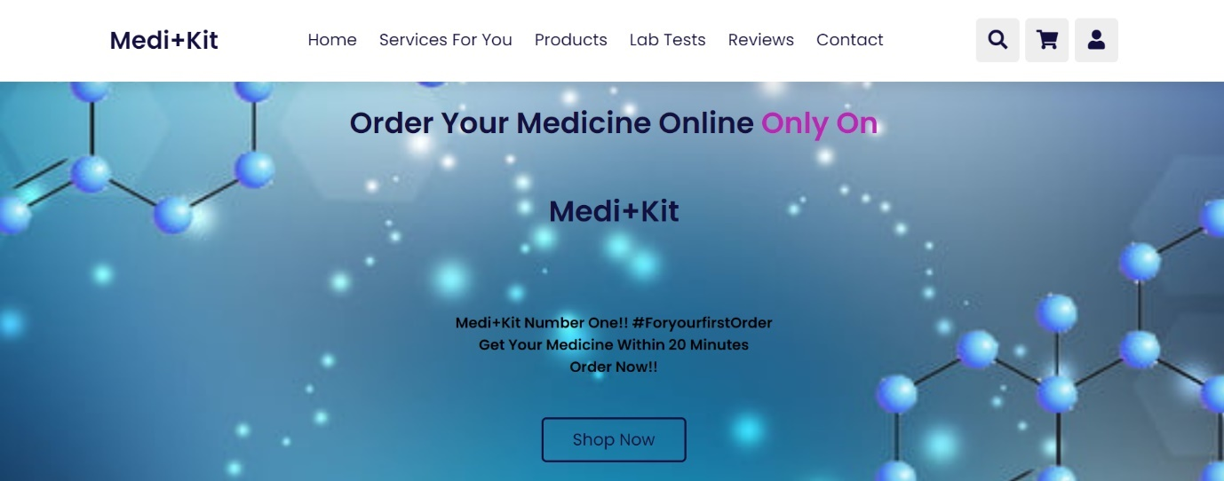



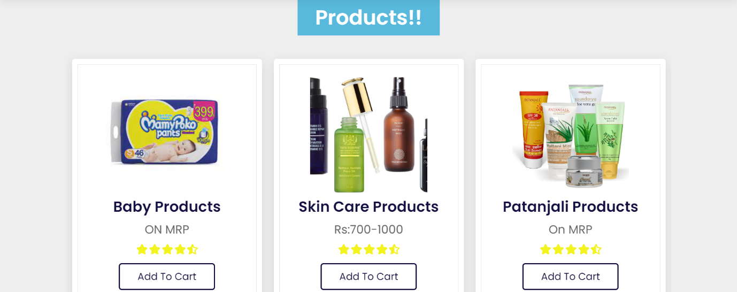

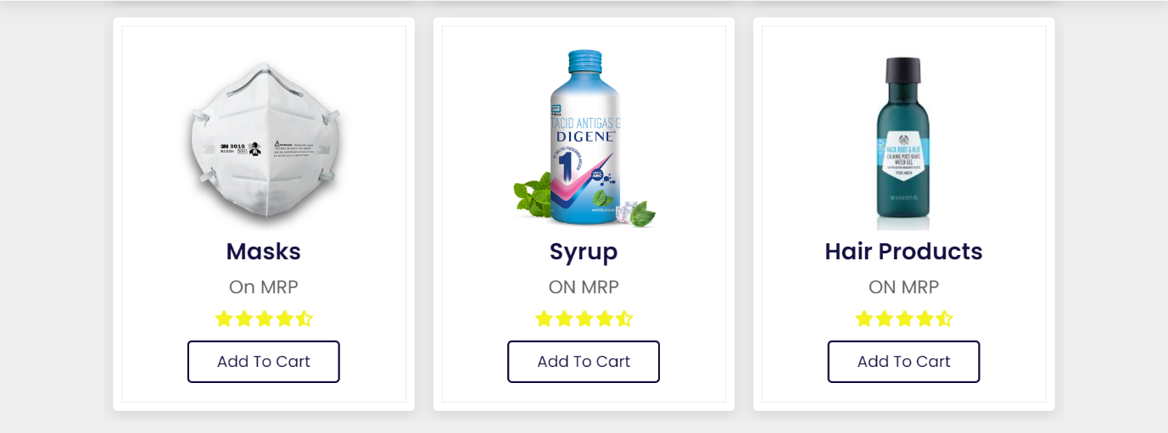



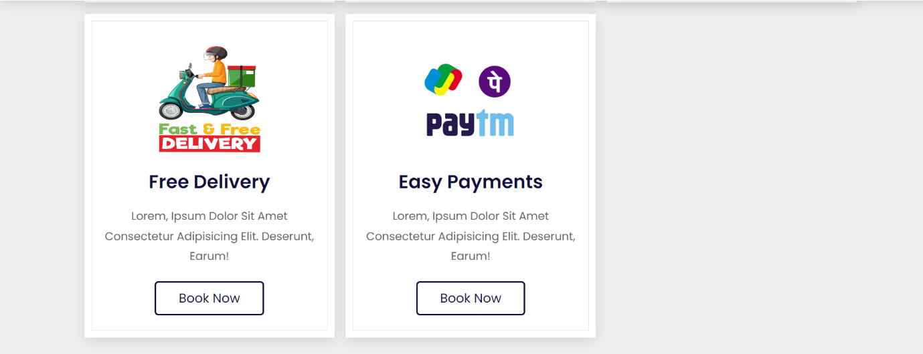

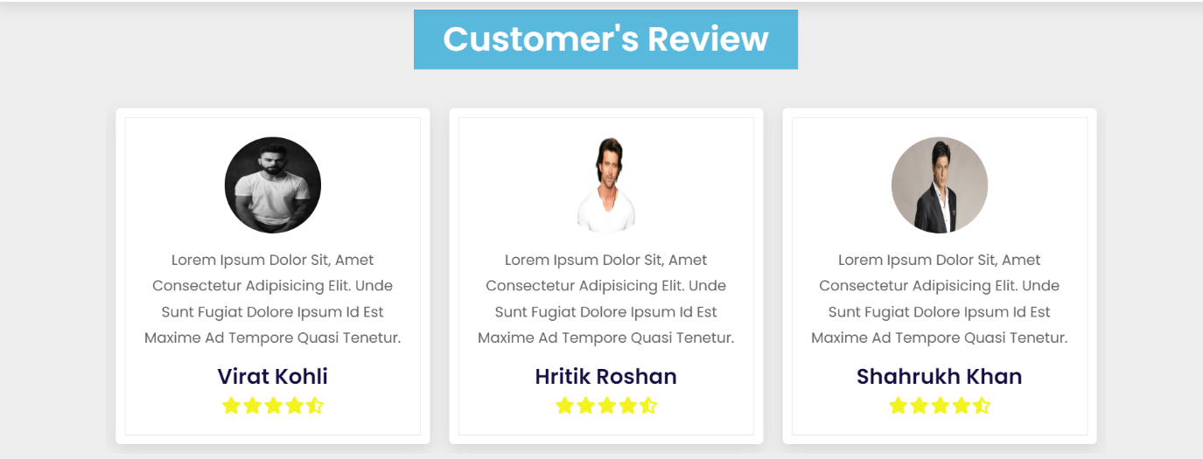

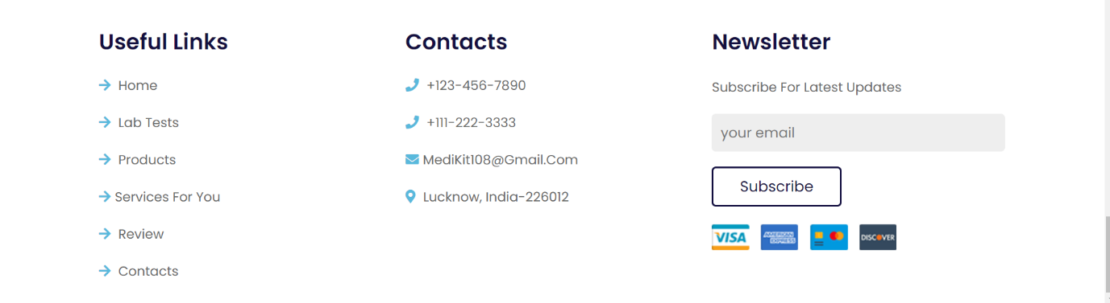

Live link of website:

<https://ayushyadav3010.github.io/Final_project_Web_Development/>

Conclusion:

We have successfully completed the web development project using HTML,CSS and JAVASCRIPT.