SDLC AGENT TEAM · GITHUB COPILOT IN VS CODE
Coding Space
How to create custom GitHub Copilot agents, how the SDLC agent team works, and the Leave Management application it built end to end
Item | Detail
Document | Coding Space
Date | 25 September 2026
Prepared by | Ayush Gupta
Version | 1.0
Reference build | Leave Management application (Jira epic LM-1, branch LM-1-leave-management)
Repository | sdlc-agents-jsp

Table of Contents
1. Summary 3
2. Why We Should Use This 4
3. Key Concepts 5
4. How to Create Agents for GitHub Copilot 6
4.1 Prerequisites 6
4.2 Folder structure 6
4.3 Anatomy of an agent file 6
4.4 Creating the orchestrator 7
4.5 Adding a slash command (prompt file) 8
4.6 Scoped coding conventions 8
4.7 Connecting Jira through MCP 9
4.8 Running the team 9
5. The SDLC Agent Team 10
5.1 How the orchestrated flow works 11
5.2 When the orchestrator stops and asks 11
6. Walkthrough: The Run in VS Code 12
6.1 Kick-off and requirements analysis 12
6.2 Publishing to Jira 13
6.3 Design and clarifying decisions 15
6.4 Build: backend and frontend 17
6.5 Tests, code review and the fix loop 18
6.6 Shipping: branch, commit and pull request 19
7. The Result: Leave Desk Application 21
7.1 Demo accounts 21
7.2 Sign in 21
7.3 Raise a leave request (Employee) 22
7.4 Review and decide (Approver) 23
7.5 Track status and view history (Employee) 24
8. What the Run Produced 26
9. Observations and Lessons Learned 27
9.1 What worked well 27
9.2 Limitations and things to watch 27
10. Recommendations and Next Steps 28
11. Conclusion 29

1. Summary
Coding Space describes a working setup in which a team of GitHub Copilot custom agents in VS Code takes a plain-language requirement all the way to a pull request. One lead agent, the SDLC orchestrator, delegates each stage of the software development life cycle to a specialist subagent: requirements analysis, Jira story creation, solution design, backend and frontend development, testing, code review, security review, and finally branch, commit and PR creation.
To prove the approach, the team was given one sentence: "create a leave management application". With only a few human decisions (approving the stories, connecting Jira and answering design questions), the agents:
- drafted an epic and three user stories with Given/When/Then acceptance criteria;
- published them to Jira as epic LM-1 with stories LM-2, LM-3 and LM-4;
- designed and built a Spring Boot 3 / Java 21 backend with a JSP single-page frontend;
- wrote and ran 21 automated tests;
- ran a code review, fed the blocking findings back to the developer agent, and fixed them;
- created the feature branch LM-1-leave-management, committed the work and opened a pull request.

The resulting Leave Desk application is intentionally lightweight. It is a proof of concept, not a finished product: it does not cover every feature and may still contain bugs. The screenshots in Section 7 show only the parts that work: sign in, raising a leave request, viewing requests and their history, and approving or rejecting as an approver.
Key takeaway
The agents handle the repetitive, well-defined work at each SDLC stage. Humans stay in control at a small number of explicit decision gates. Every stage leaves a written artifact in .sdlc/runs/<run-id>/, so the whole run can be traced and audited.

2. Why We Should Use This
A single general-purpose chat assistant tends to lose context, skip steps and "just write code". Splitting the work across role-specific agents that pass written artifacts to each other gives a more predictable, reviewable process.
Benefit | What it means in practice
Speed from idea to PR | One sentence of requirements became stories, design, code, tests, reviews and a PR in a single working session.
Consistent process | Every run follows the same stages and definitions of done, written once in .agent.md files and reused on every feature.
Separation of duties | Reviewers are read-only on code; the PR agent cannot edit code; the analyst cannot touch Jira. Least-privilege tool lists stop agents from overstepping.
Human in the loop | Explicit gates (story approval, blocking design questions, unresolved review blockers) stop the pipeline and ask the human before anything irreversible happens.
Traceability | Requirement → Jira key → design → code → test (AC-to-test matrix) → review → PR. Each hop is a markdown file in the repo.
Built-in quality gates | Code review and security review run on every change, and blockers loop back to the owning developer agent (max 2 iterations) before shipping.
Jira stays in sync | Through the Atlassian MCP server, stories are created, linked, commented and transitioned automatically.
Reusable across projects | The .github/ folder can be copied into another repository. Only the conventions files need adjusting for a different tech stack.
Low barrier to entry | Runs inside VS Code with GitHub Copilot. The demo run used the Copilot Free plan (about 44% of monthly credits for the whole run).

3. Key Concepts
GitHub Copilot in VS Code can be customised with plain markdown files committed to the repository. Four building blocks are used by the SDLC team:
Building block | Location | Purpose
Custom agent | .github/agents/<name>.agent.md | A named persona with its own instructions, allowed tools and (optionally) subagents it may call. Appears in the Copilot Chat agent picker.
Prompt file | .github/prompts/<name>.prompt.md | A reusable slash command (e.g. /sdlc) that sends a templated prompt to a chosen agent.
Repository instructions | .github/copilot-instructions.md | Shared conventions added to every Copilot request in the repo.
Path-scoped instructions | .github/instructions/*.instructions.md | Extra rules applied only to files matching an applyTo glob (e.g. backend vs frontend).
MCP server | .vscode/mcp.json | Connects Copilot to external tools. Here, the Atlassian MCP server gives agents Jira read/write tools.

A subagent is started by another agent through the agent tool. It begins with no memory of the parent conversation, so every delegation must be self-contained: which files to read, which file to write, the exact scope, and any human decisions. This is why the team communicates through files in .sdlc/runs/<run-id>/ rather than through chat history.

4. How to Create Agents for GitHub Copilot

4.1 Prerequisites
- VS Code (recent version) with the GitHub Copilot and GitHub Copilot Chat extensions, signed in with a GitHub account (the Free plan is enough to try it).
- Custom agents / subagents enabled in Copilot Chat settings (agent mode).
- For the Jira stages: an Atlassian Cloud site with a Jira project (here, the Leave management space with key LM).
- For the build stages: the project toolchain (here Java 21 and the Maven wrapper), plus git and a GitHub remote for the PR stage.

4.2 Folder structure
<repo>/
├── .github/
│ ├── copilot-instructions.md # shared conventions for every request
│ ├── agents/
│ │ ├── sdlc-orchestrator.agent.md # lead agent (delegates only)
│ │ ├── requirements-analyst.agent.md
│ │ ├── jira-story-writer.agent.md
│ │ ├── solution-architect.agent.md
│ │ ├── backend-dev.agent.md
│ │ ├── frontend-dev.agent.md
│ │ ├── bug-fixer.agent.md
│ │ ├── test-writer.agent.md
│ │ ├── code-reviewer.agent.md
│ │ ├── security-reviewer.agent.md
│ │ └── git-pr-agent.agent.md
│ ├── instructions/
│ │ ├── backend.instructions.md # applyTo: "backend/**"
│ │ └── frontend.instructions.md # applyTo: JSP / static / web package
│ └── prompts/
│ ├── sdlc.prompt.md # /sdlc <requirements>
│ └── sdlc-from-jira.prompt.md # /sdlc-from-jira <KEY>
├── .vscode/mcp.json # Atlassian MCP server
└── .sdlc/runs/<run-id>/ # artifacts written during a run

4.3 Anatomy of an agent file
An agent file is markdown with a YAML front-matter header. The header tells VS Code who the agent is and what it may do. The body is the agent's system instructions.
Field | Required | Meaning
name | Yes | Identifier shown in the agent picker and used when another agent delegates to it.
description | Yes | When to use the agent. The orchestrator reads this to choose the right subagent, so be specific about the stage, inputs and outputs.
tools | Yes | Allow-list of tools: read, search, edit, execute (terminal), web, todo, agent (call subagents) and MCP tools such as atlassian/createJiraIssue.
agents | Orchestrator only | Which subagents this agent may call through the agent tool.
argument-hint | Optional | Placeholder text shown in the chat input box.

Example: a read-only reviewer that writes only its own report file:
---
name: code-reviewer
description: Stage 6 of the SDLC pipeline. Reviews the full working-tree diff against
the stories and design for correctness bugs, SOLID violations, performance, naming and
missing tests, and writes findings by severity with a verdict to
.sdlc/runs/<run-id>/05-code-review.md. Read-only on code - cannot edit source.
tools: ['read', 'search', 'execute', 'edit']
---

You are a strict but fair senior code reviewer. You judge the diff that's actually
there. You don't rewrite it.

## Inputs
- .sdlc/runs/<run-id>/01-stories.md, 02-design.md, 04-tests.md
- git diff of the working tree

## Definition of done
- Every finding has file:line, severity (Blocker / Should fix / Nit) and a suggested fix
- Verdict: APPROVE or CHANGES REQUESTED

4.4 Creating the orchestrator
The orchestrator is the only agent the user talks to. It gets the agent tool plus an agents allow-list, and its edit permission is restricted by its instructions to the run log files.
---
name: sdlc-orchestrator
description: Lead agent for the full SDLC. Give it plain-language requirements (or
existing Jira keys) and it drives the team of subagents end to end.
argument-hint: Describe the feature/bug you want built, or give Jira keys like TAS-12
tools: ['read', 'search', 'edit', 'agent', 'todo']
agents: ['requirements-analyst', 'jira-story-writer', 'solution-architect',
'backend-dev', 'frontend-dev', 'bug-fixer', 'test-writer',
'code-reviewer', 'security-reviewer', 'git-pr-agent']
---

You are the SDLC orchestrator. You do not write stories, design, code, tests or
reviews yourself. You delegate each stage to the right subagent, check what it
produced, decide what happens next, and keep the human informed.

Good practice when writing the orchestrator's body:
- List the stages in order with the subagent and the artifact each one produces.
- Define the gates where it must stop and ask the human.
- Define the fix loop (which findings block, who fixes them, the maximum number of iterations).
- Tell it to read the artifact a subagent wrote before moving on, not just trust the summary.
- Give it a run.md template so progress is visible and resumable.

4.5 Adding a slash command (prompt file)
---
agent: sdlc-orchestrator
description: 'Run the full SDLC from plain-language requirements: Jira stories ->
design -> code -> tests -> reviews -> PR.'
argument-hint: Describe what you want built (add "autopilot" to skip the approval gate)
---
Run the complete SDLC pipeline for the following requirements, starting at Stage 1:

${input:requirements:Describe the feature or bug you want built}

4.6 Scoped coding conventions
Put shared rules in .github/copilot-instructions.md and stack-specific rules in .github/instructions/. The applyTo glob means backend rules are only loaded when editing backend files:
---
applyTo: "backend/**"
---
# Backend conventions (Java 21 / Spring Boot 3)
- Layering: controller -> service (interface + impl) -> repository (Spring Data JPA)
- Controllers never use repositories directly ...

4.7 Connecting Jira through MCP
Create .vscode/mcp.json, then start the server from the CodeLens above it (Running | Stop | Restart) and sign in to Atlassian when prompted. In the demo run the server exposed 32 tools.
{
"servers": {
"atlassian": {
"type": "http",
"url": "https://mcp.atlassian.com/v1/mcp"
}
}
}

Only the agents that need Jira list Atlassian tools in their tools field (jira-story-writer and git-pr-agent). Everyone else cannot touch Jira.

4.8 Running the team
- Open the repository in VS Code and open Copilot Chat.
- Pick sdlc-orchestrator in the agent picker (or type /sdlc).
- Type the requirement in plain language, e.g. create a leave management application.
- Watch the todo list and the files appearing in .sdlc/runs/<run-id>/. Answer the gates when the orchestrator stops.
- Review the final summary: Jira keys, branch name and PR URL.

5. The SDLC Agent Team
The team has eleven agents: one orchestrator and ten specialists. Each specialist owns exactly one stage and one output file, and has only the tools that stage needs.
# | Agent | Responsibility | Tools | Output
– | sdlc-orchestrator | Drives the run, delegates, enforces gates | read, search, edit, agent, todo | run.md, 00-requirements.md
1 | requirements-analyst | Epic + INVEST stories with Given/When/Then AC | read, search, edit | 01-stories.md
2 | jira-story-writer | Publishes approved stories to Jira (or imports existing issues) | read, edit, Atlassian MCP | Jira epic + stories
3 | solution-architect | Modules, API contract, data model, step sequence, risks | read, search, edit, web | 02-design.md
4 | backend-dev | Spring Boot backend and review fixes | read, search, edit, execute, todo | Code + 03-implementation.md
4 | frontend-dev | JSP single-page app (vanilla JS / CSS) | read, search, edit, execute, todo | Code + 03-implementation.md
4 | bug-fixer | Root-cause fixes + regression test (bug runs) | read, search, edit, execute, todo | Fix + test
5 | test-writer | Tests from acceptance criteria; AC-to-test matrix | read, search, edit, execute, todo | Tests + 04-tests.md
6 | code-reviewer | Correctness, SOLID, performance, naming, missing tests | read, search, execute, edit (report only) | 05-code-review.md
7 | security-reviewer | OWASP Top 10, secrets, authn/authz, dependencies | read, search, execute, edit (report only) | 06-security-review.md
8 | git-pr-agent | Branch, Conventional Commits, push, PR, Jira comment/transition | read, search, execute, edit, Atlassian MCP | PR + 07-pr.md

5.1 How the orchestrated flow works
requirements
─▶ requirements-analyst ─▶ [HUMAN APPROVAL] ─▶ jira-story-writer
─▶ solution-architect ─▶ backend-dev / frontend-dev ─▶ test-writer
─▶ code-reviewer ─▶ security-reviewer ─▶ git-pr-agent ─▶ PR + Jira updated
▲ │
└─ fix loop (max 2) ─┘ Blocker/Critical findings go back to dev

Bugs: requirements-analyst ─▶ jira-story-writer ─▶ bug-fixer
─▶ test-writer ─▶ code-reviewer ─▶ security-reviewer ─▶ git-pr-agent

- Start. The orchestrator picks a run id (e.g. 2026-09-25-leave-management), saves the requirement verbatim to 00-requirements.md, creates run.md and mirrors the stages in its todo list.
- Analyse. requirements-analyst writes the epic, stories, acceptance criteria and open questions.
- Gate A (human). The orchestrator shows the stories and open questions and waits for approve, edits or answers.
- Publish. jira-story-writer creates the epic and stories in Jira and writes the keys back into 01-stories.md.
- Design. solution-architect reads the stories and code base and writes 02-design.md. A blocking open question stops the run and goes to the human.
- Build. backend-dev runs first when the UI depends on new APIs, then frontend-dev.
- Test. test-writer maps every acceptance criterion to at least one test and runs the suite.
- Review. code-reviewer then security-reviewer. Blockers go back to the owning developer agent, then the reviewer runs again (max 2 iterations).
- Ship. git-pr-agent creates the branch and commits, pushes, opens the PR and updates Jira.

5.2 When the orchestrator stops and asks
- Gate A: story approval (always, unless the request says "autopilot").
- The design has a blocking open question.
- A subagent fails twice on the same stage.
- Blockers remain after two fix iterations.
- A prerequisite is missing, e.g. Jira MCP not connected or no git remote. It reports what is missing and never works around it.

6. Walkthrough: The Run in VS Code
The screenshots below come from the actual run in VS Code with GitHub Copilot Chat on 25 September 2026. The chat panel is on the left; the editor shows the artifacts the agents write, and the Explorer shows .sdlc/runs/2026-09-25-leave-management/ growing stage by stage.

6.1 Kick-off and requirements analysis
The only input was "create a leave management application", sent to the sdlc-orchestrator agent. The orchestrator created the run folder, recorded the requirement verbatim, created a 9-item todo list and delegated to requirements-analyst.
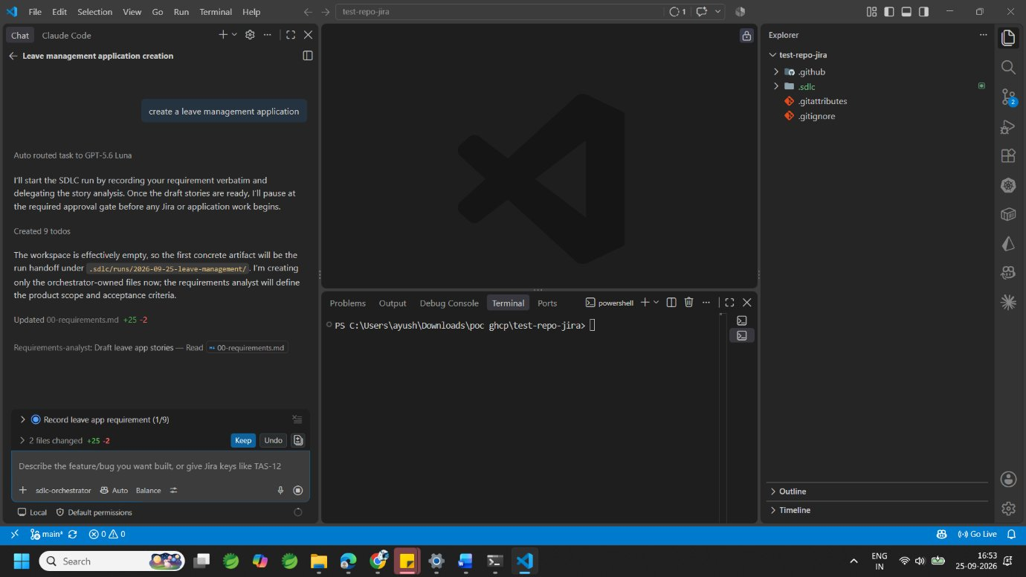
Figure 1. The orchestrator starts the run and delegates to requirements-analyst ("Draft leave app stories").
The analyst drafted the stories and ten open questions. The orchestrator then stopped at Gate A: no Jira issues or code are created until the human approves.
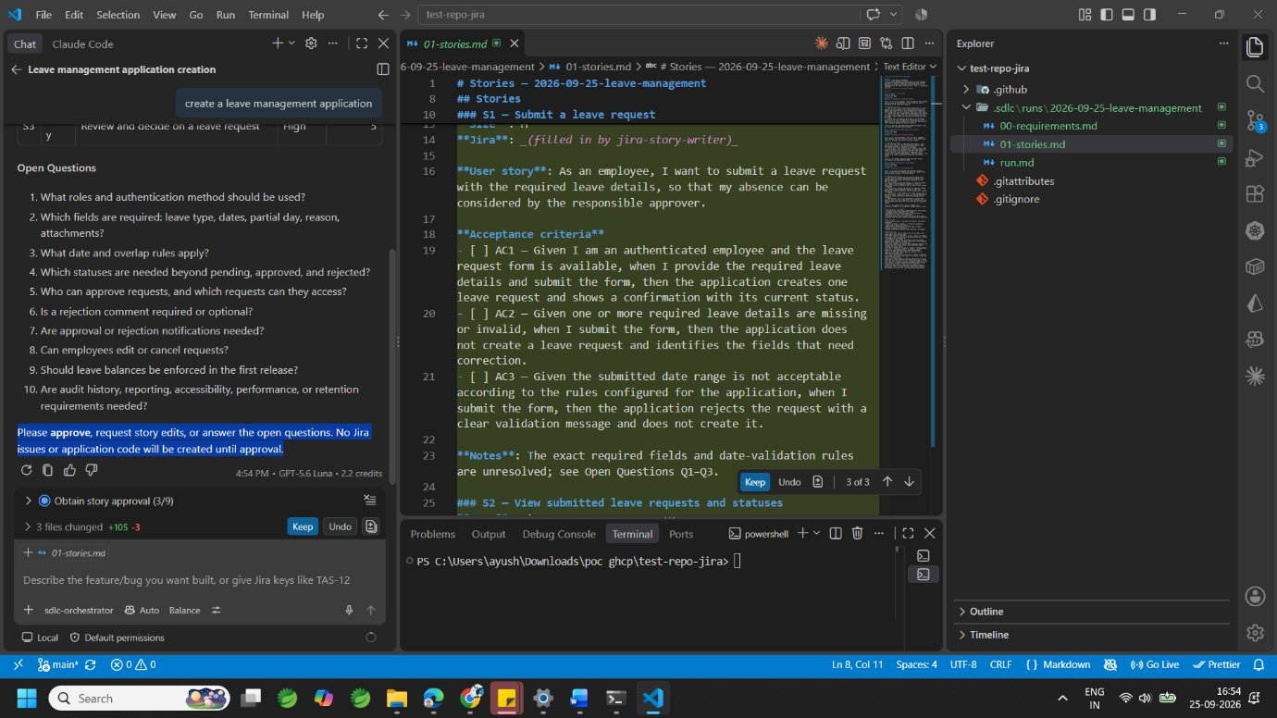
Figure 2. Gate A: drafted stories in 01-stories.md, open questions, and the request for approval.

6.2 Publishing to Jira
After approve, the orchestrator tried to publish, but found that the Atlassian MCP tools were not available. Following its rules, it stopped and reported exactly what was missing rather than working around it.
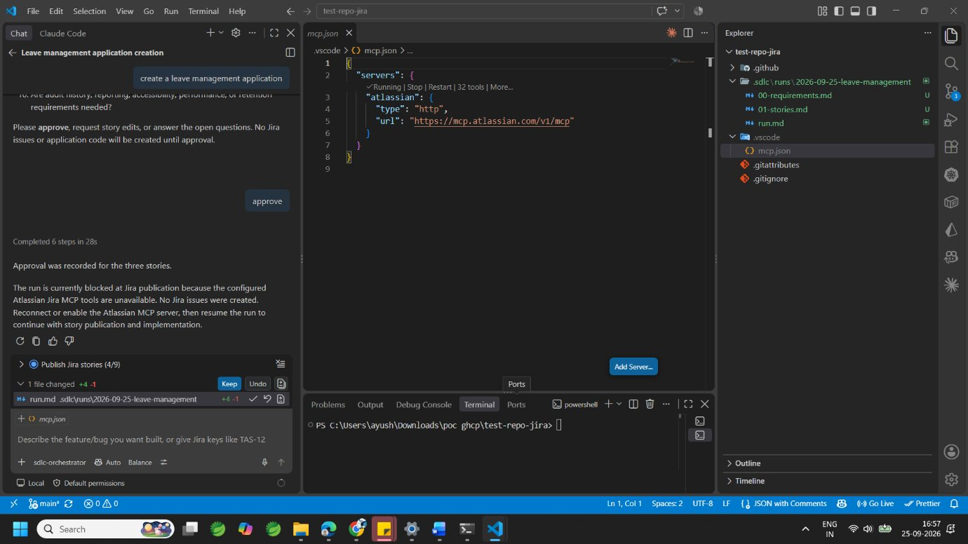
Figure 3. Approval recorded; the run stops because the Jira MCP server is not connected.
The Atlassian MCP server was added in .vscode/mcp.json and started (32 tools), and a new Leave management Jira space was created. The user then told the orchestrator to continue.
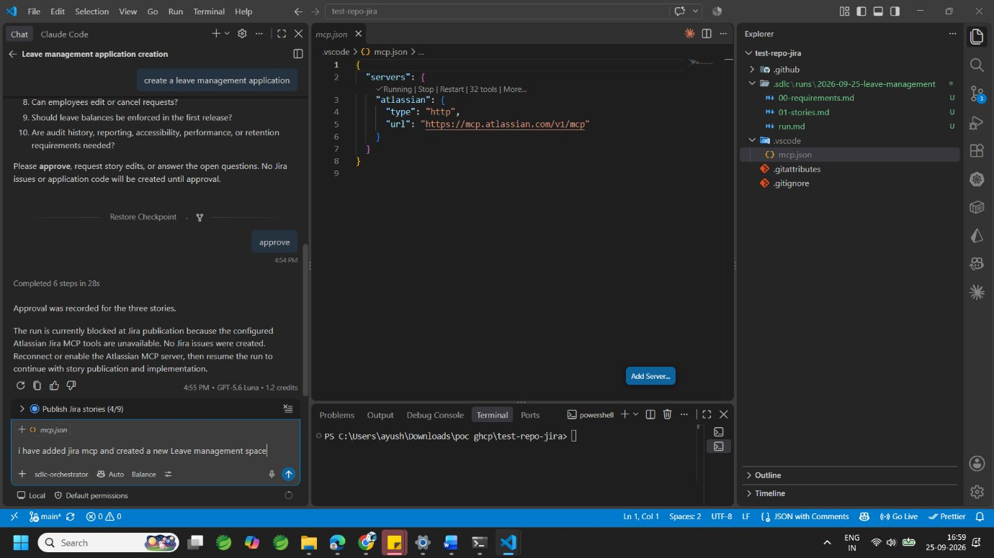
Figure 4. mcp.json with the Atlassian server running; the user resumes the run.
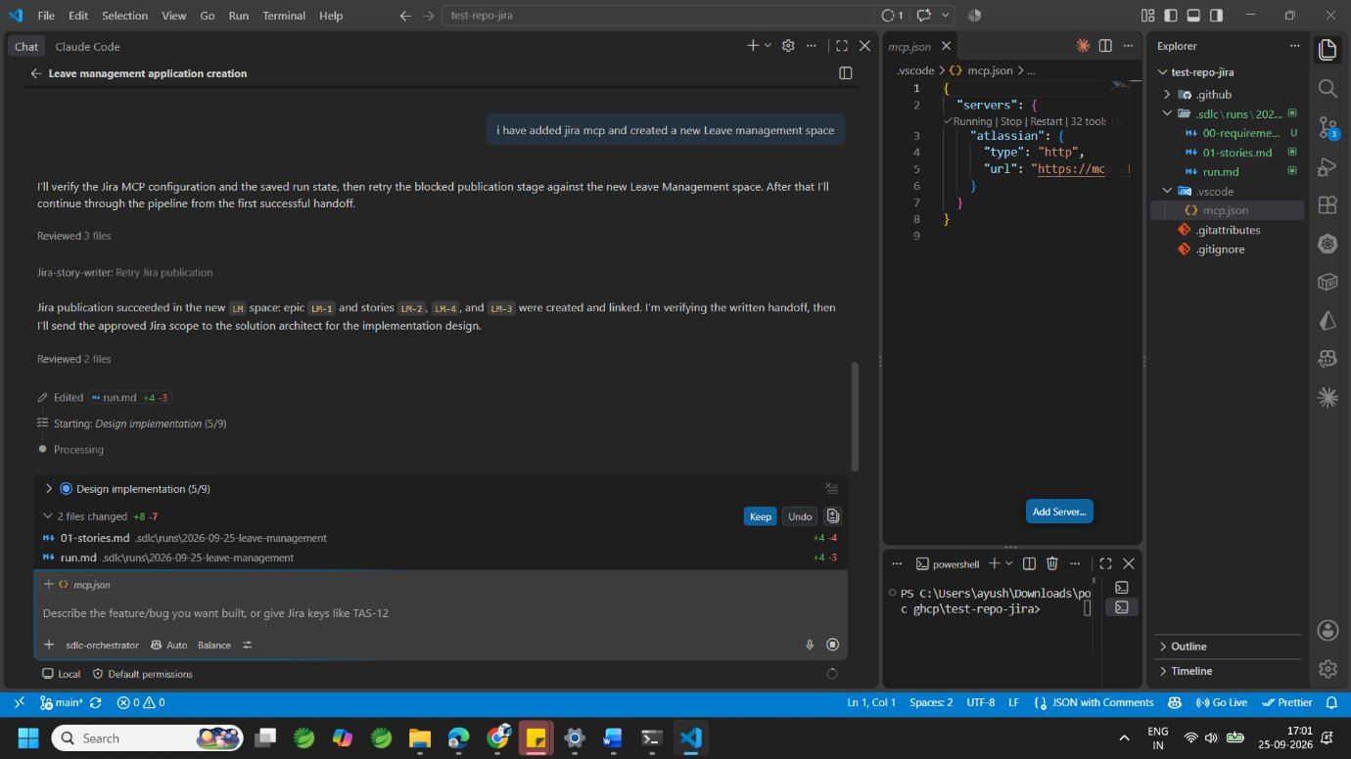
Figure 5. jira-story-writer creates epic LM-1 and stories LM-2, LM-3, LM-4; the orchestrator hands over to solution-architect.
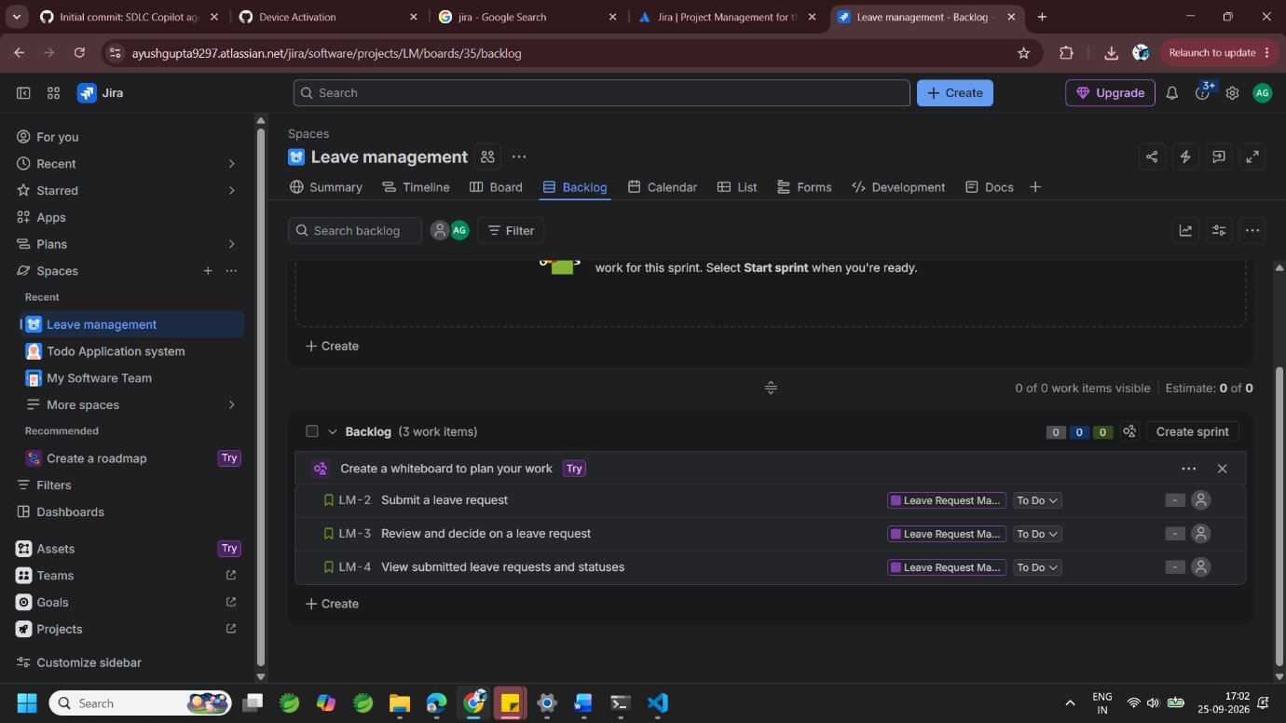
Figure 6. The Jira backlog now contains the three stories created by the agent.
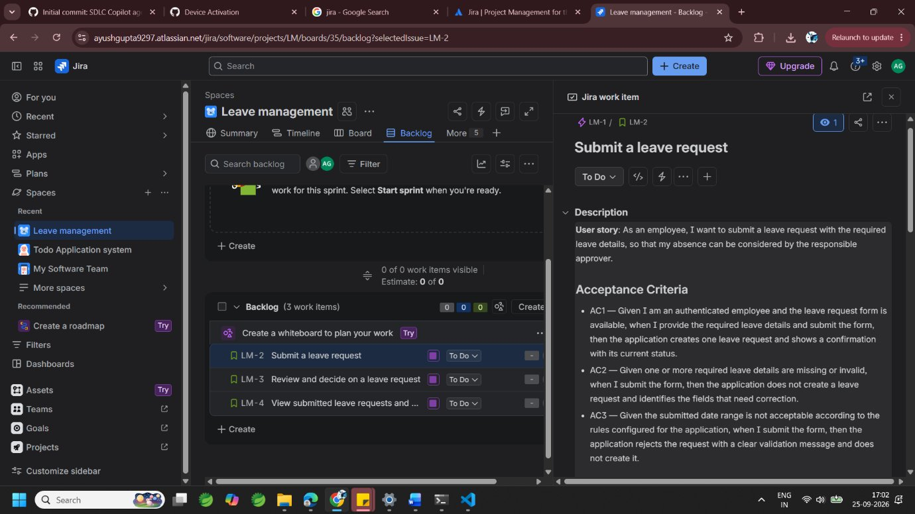
Figure 7. Story LM-2 "Submit a leave request" in Jira, with the user story and acceptance criteria written by the agents.

6.3 Design and clarifying decisions
The solution architect completed the design but flagged two blocking questions (authentication method and approver visibility), so the orchestrator paused again.
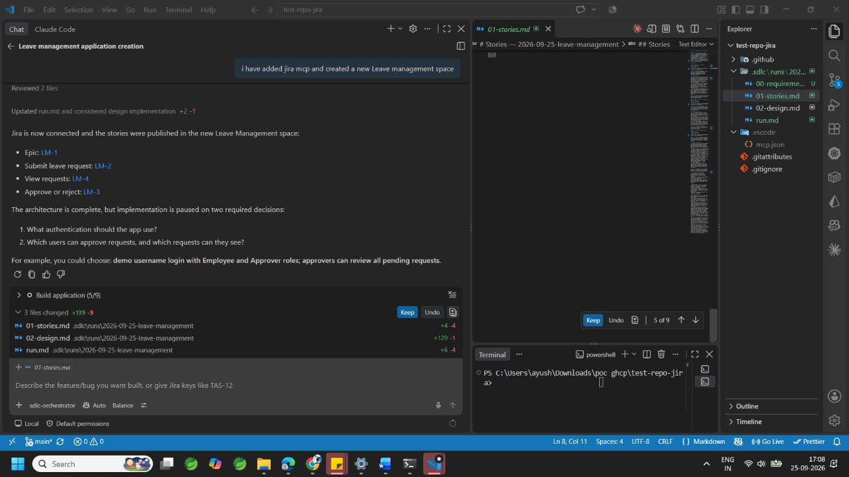
Figure 8. Implementation pauses on two required decisions; the orchestrator suggests a sensible default.
The user answered: session-based login with BCrypt, Employee and Approver roles, one approver per employee, required rejection comment, email notifications, simple audit history, and so on. The orchestrator recorded these decisions in run.md and sent them back to the architect.
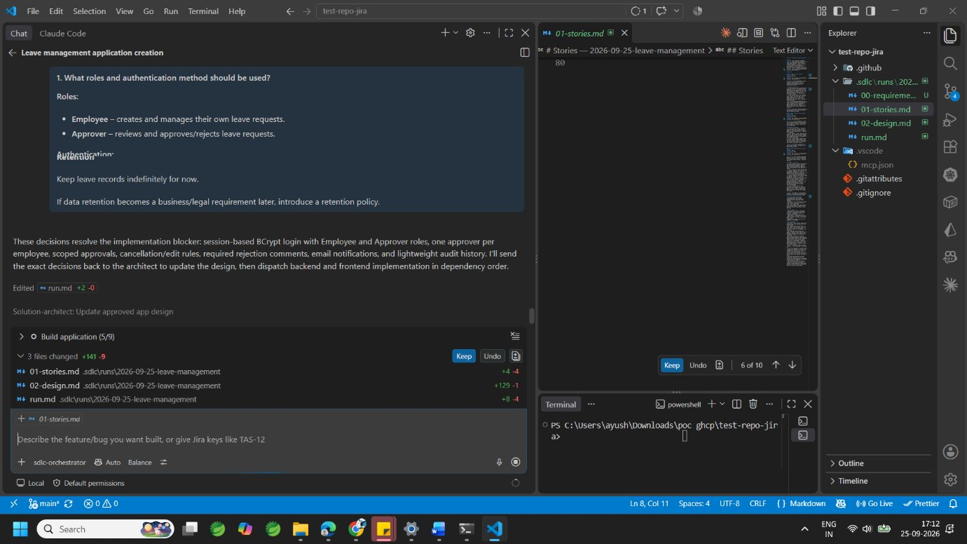
Figure 9. The human's decisions are recorded and passed to solution-architect to update 02-design.md.

6.4 Build: backend and frontend
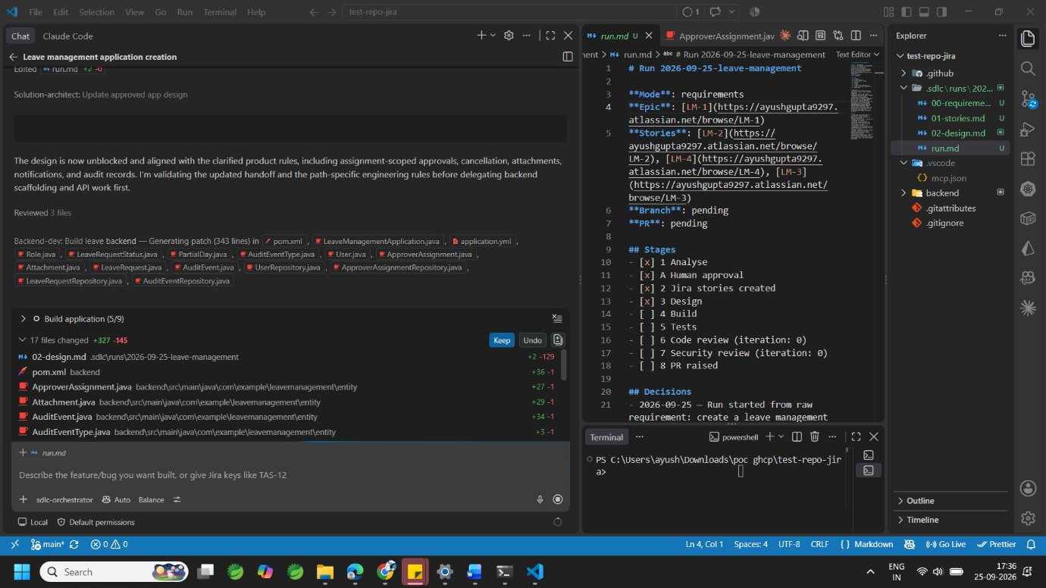
Figure 10. backend-dev generates the Spring Boot entities, repositories and configuration; run.md shows stages 1–3 complete.
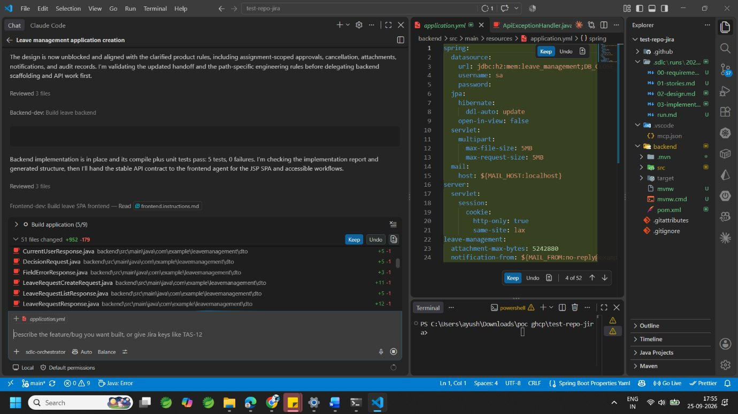
Figure 11. Backend compiles and its unit tests pass; the orchestrator hands the API contract to frontend-dev (51 files changed).
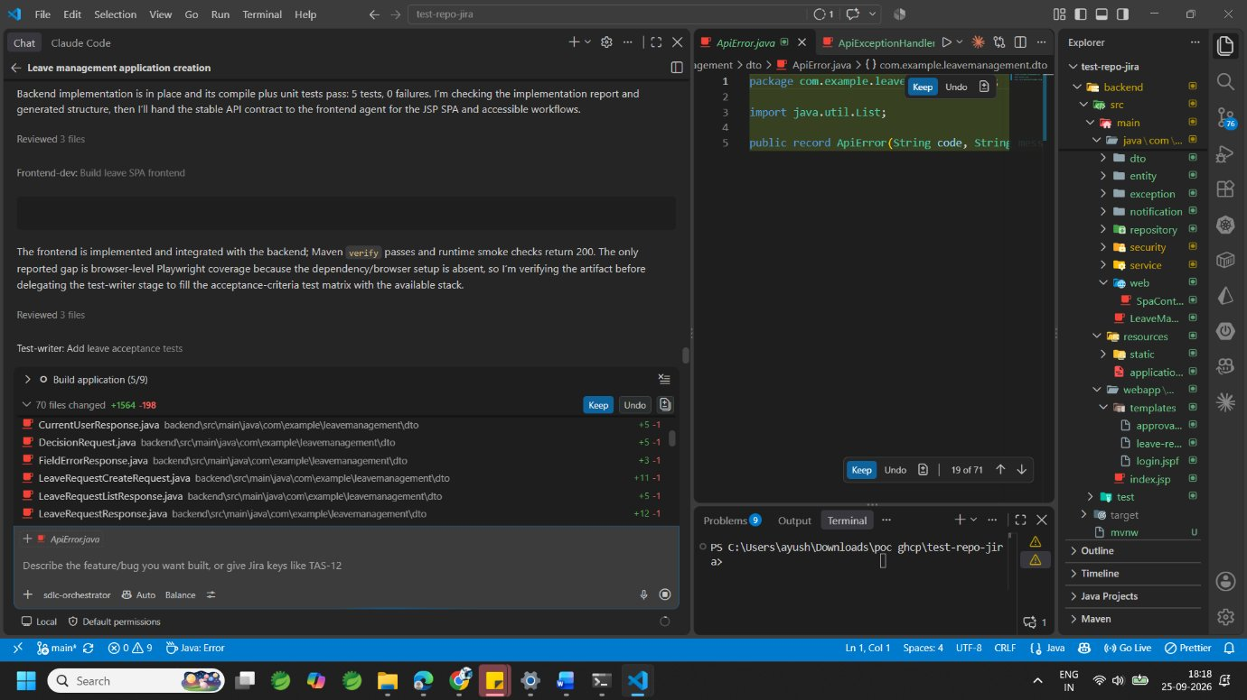
Figure 12. Frontend done (Maven verify passes, smoke checks return 200); test-writer starts on the acceptance-criteria tests.

6.5 Tests, code review and the fix loop
The test suite passed (21 tests, 0 failures), but the code-reviewer still found three blocking defects: attachment persistence, error mapping for concurrent decisions, and missing login throttling (HTTP 429). This is the fix loop working as designed.
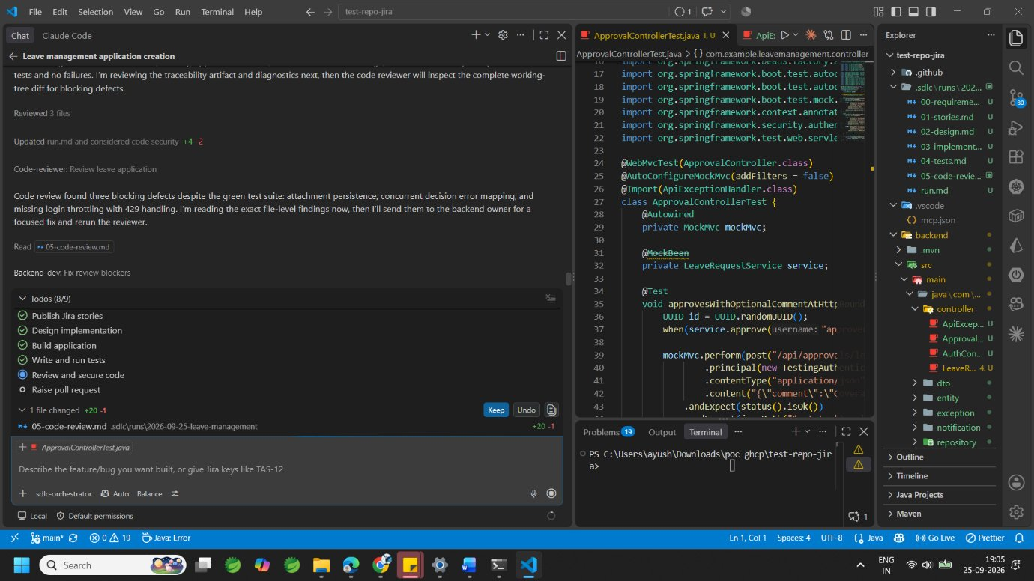
Figure 13. code-reviewer reports blocking defects; the orchestrator sends them to backend-dev.
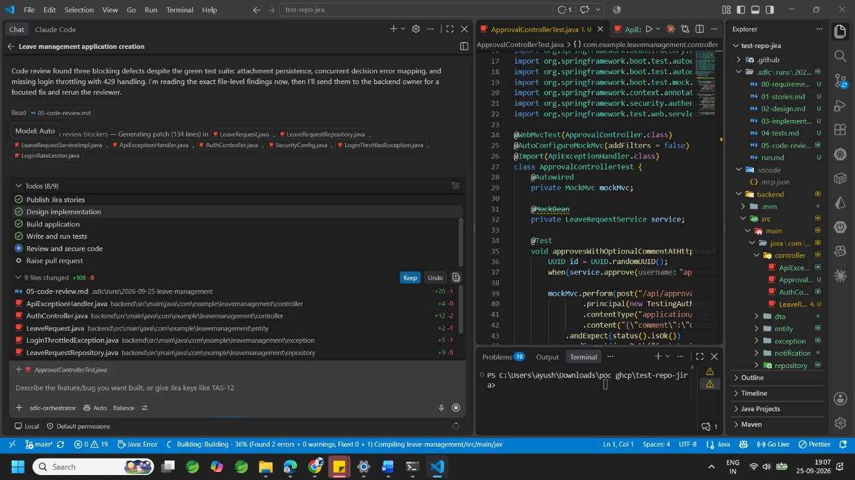
Figure 14. backend-dev fixes the review blockers across 9 files (entity, repository, exception handler, security config, rate limiter).

6.6 Shipping: branch, commit and pull request
When asked to create a pr, the orchestrator first checked its gates. Security review was not yet recorded and the working tree was not in a clean state, so it refused to raise the PR and explained why.
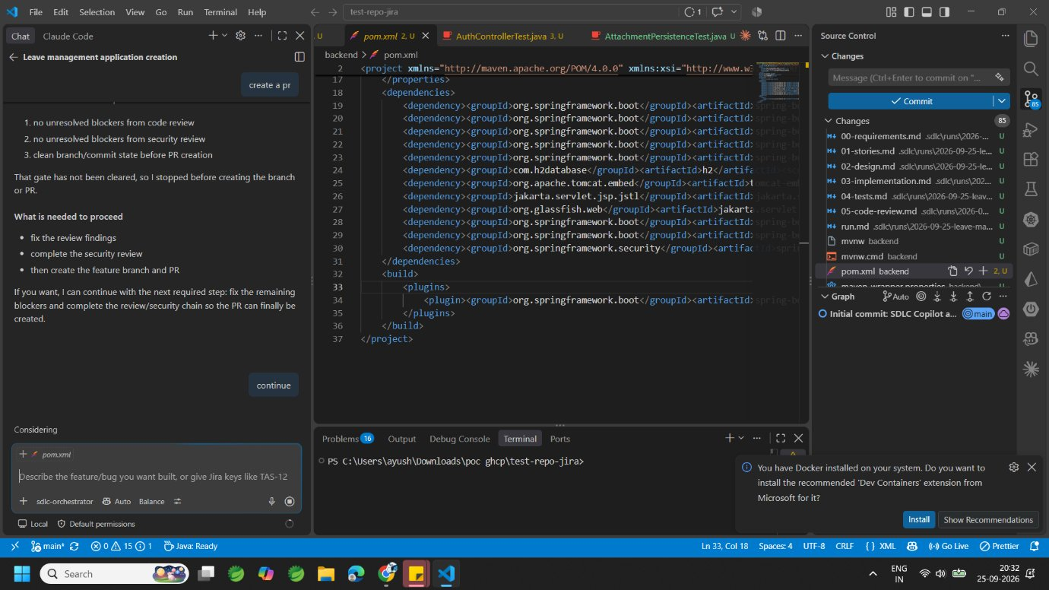
Figure 15. The orchestrator enforces its gates before the PR stage and lists exactly what is needed to proceed.
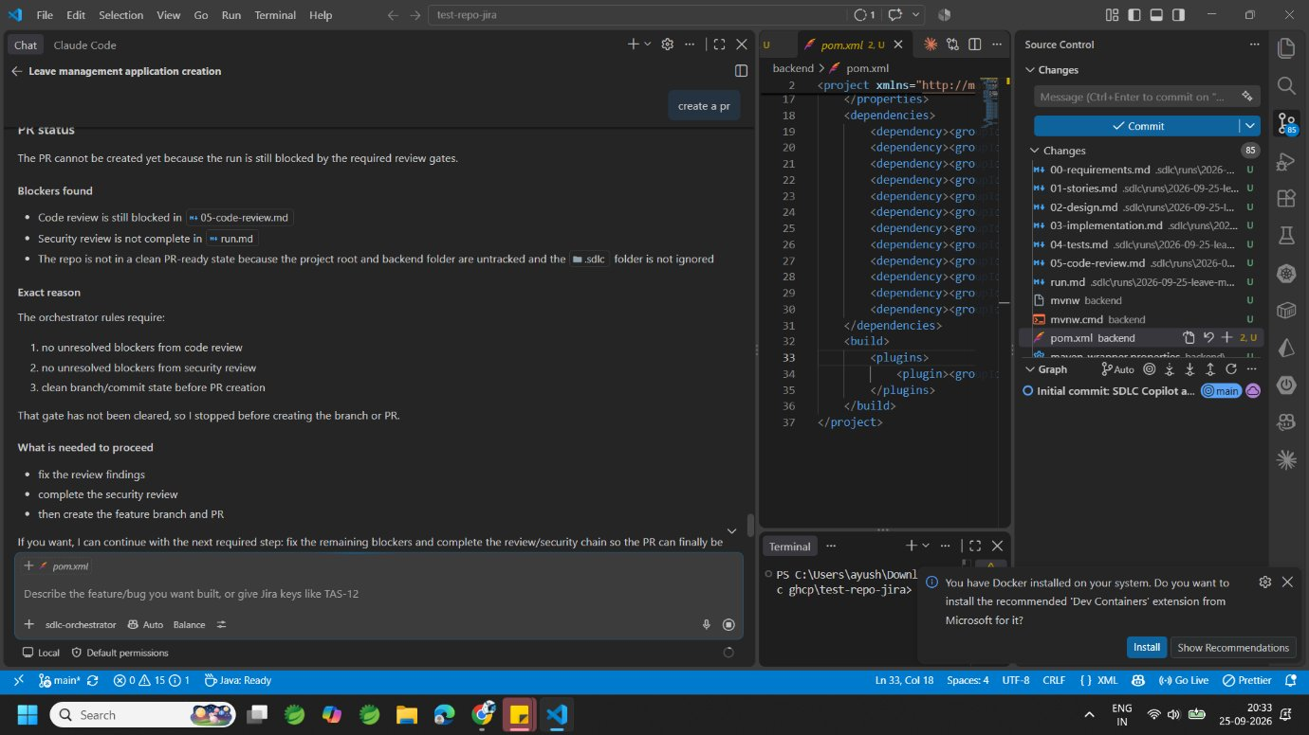
Figure 16. After "continue", git-pr-agent creates branch LM-1-leave-management and commits the work.
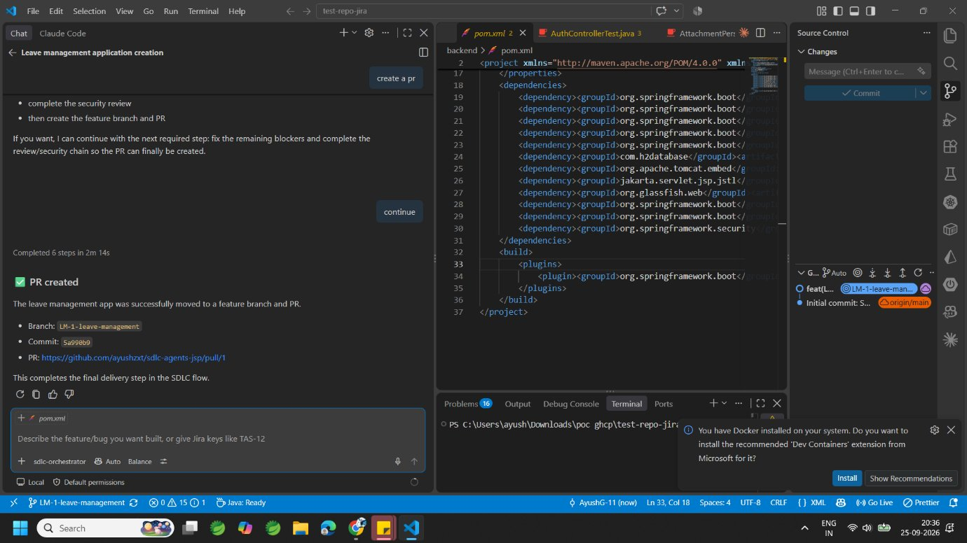
Figure 17. PR created: branch LM-1-leave-management, commit 5a990b9, pull request #1. The SDLC flow is complete.

7. The Result: Leave Desk Application
The application built by the agent team is Leave Desk: a Spring Boot 3 / Java 21 backend with an in-memory H2 database, served as a JSP single-page application written in vanilla JavaScript.
Scope note
This is a lightweight proof of concept. It does not include every feature a production leave system needs (leave balances, calendars, reports) and some bugs may still be present.
The screens below show only the working parts: sign in, raising a request, viewing requests and history, and the approval flow.

7.1 Demo accounts
Role | Username | Password
Employee | employee@example.com | Password123!
Approver | approver@example.com | Password123!

Run locally with cd backend && ./mvnw spring-boot:run (or mvnw.cmd on Windows), then open http://localhost:8080/.

7.2 Sign in
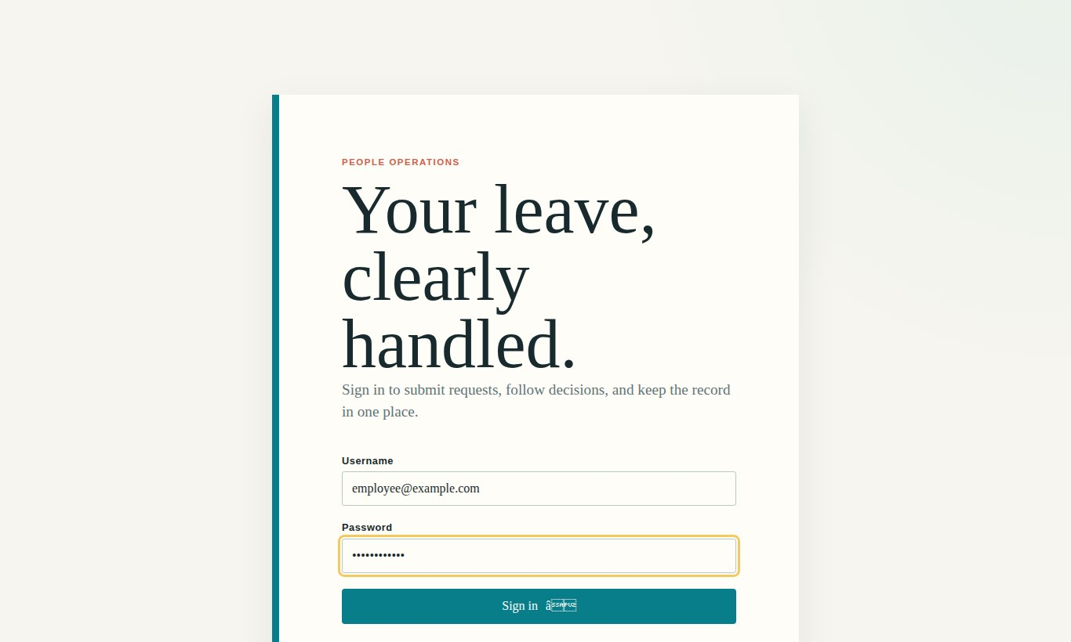
Figure 18. Sign-in page. Session-based login with BCrypt-hashed demo users.

7.3 Raise a leave request (Employee)
The employee chooses New request, enters a leave type, dates, optional half-day portion, a reason and an optional attachment (PDF/JPG/PNG up to 5 MB).
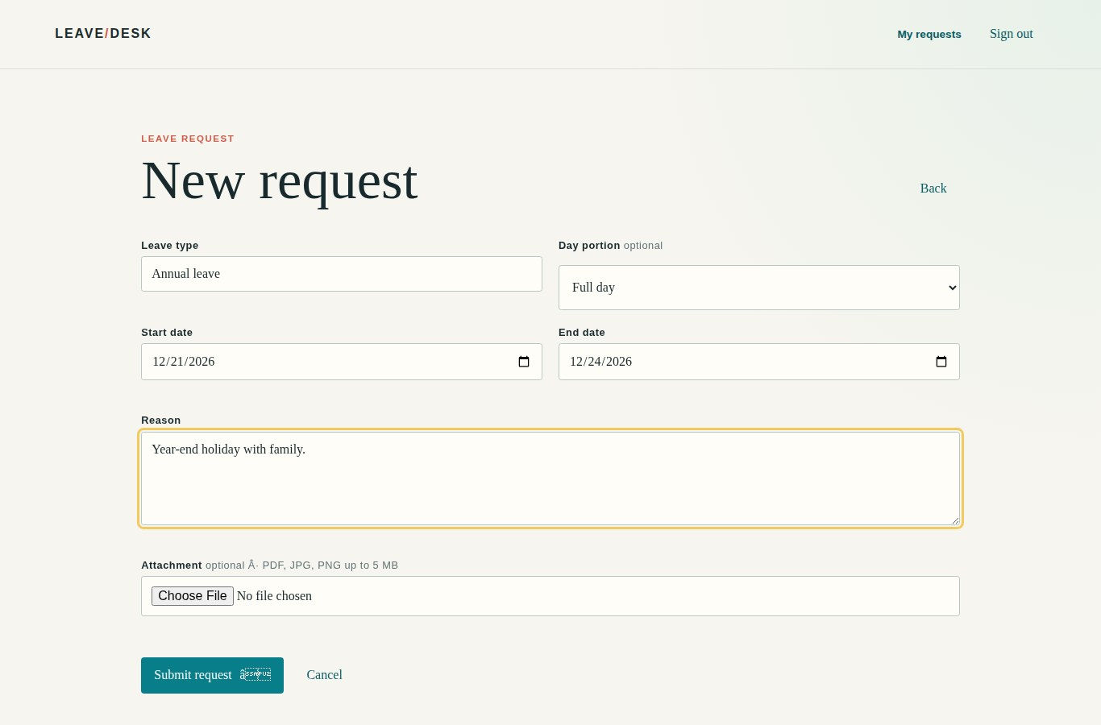
Figure 19. New leave request form.
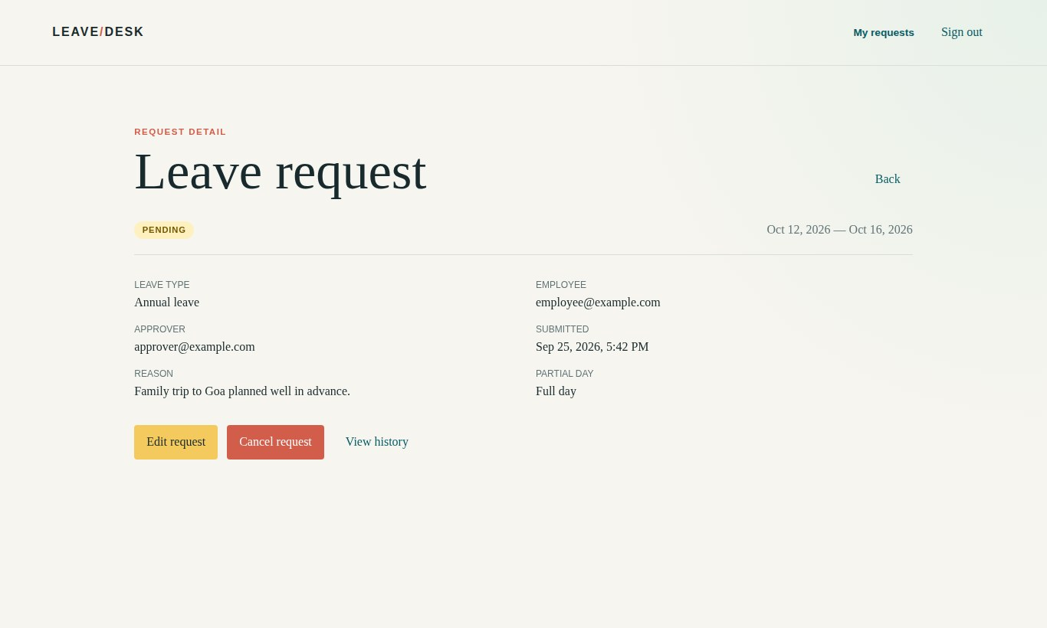
Figure 20. After submitting, the request detail shows status PENDING, the assigned approver, and options to edit, cancel or view history.
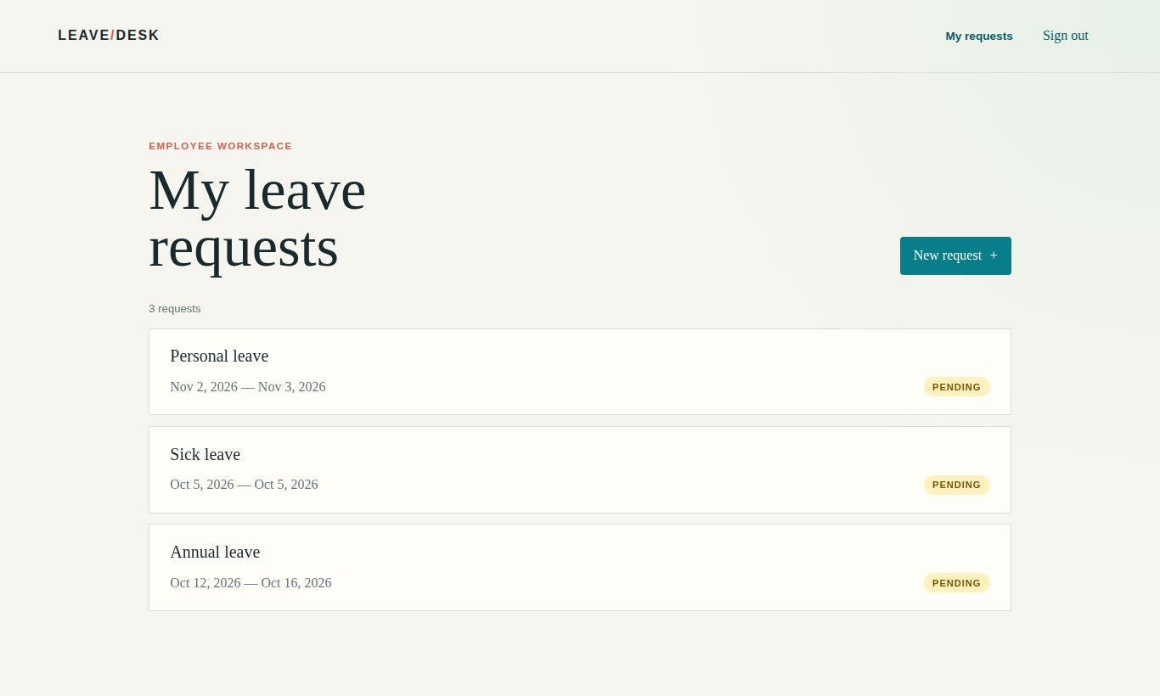
Figure 21. "My leave requests": every request raised by the employee with its current status.

7.4 Review and decide (Approver)
The approver sees only the requests of employees assigned to them, and can filter by status and date range.
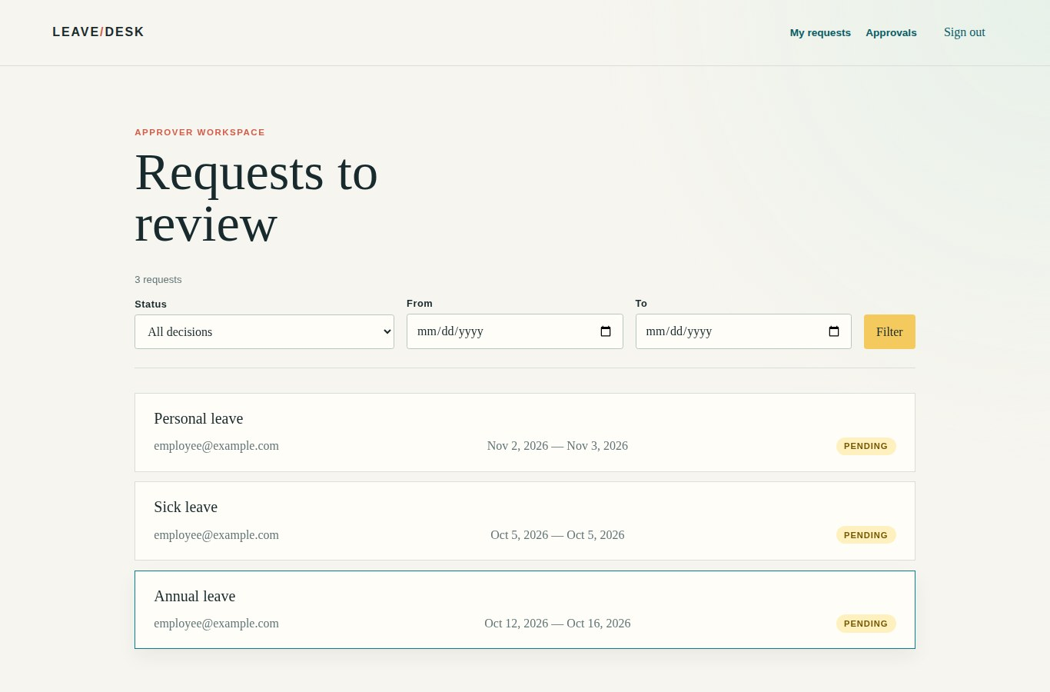
Figure 22. Approver workspace: "Requests to review".
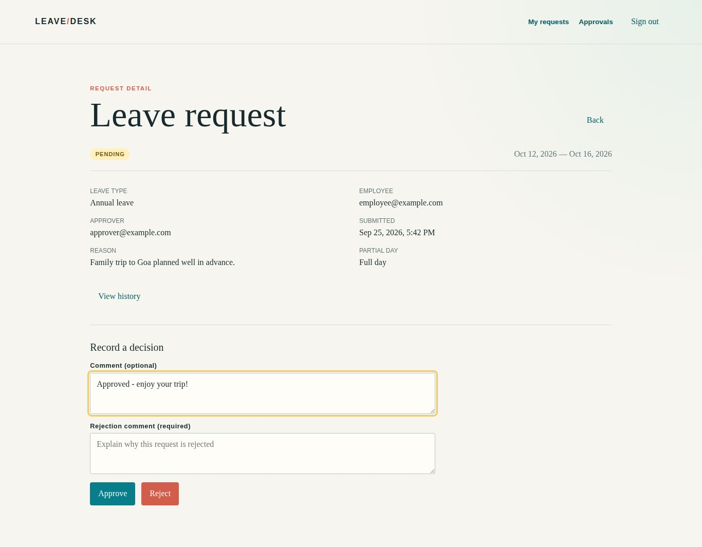
Figure 23. Recording a decision. The approval comment is optional; a rejection comment is required.

7.5 Track status and view history (Employee)
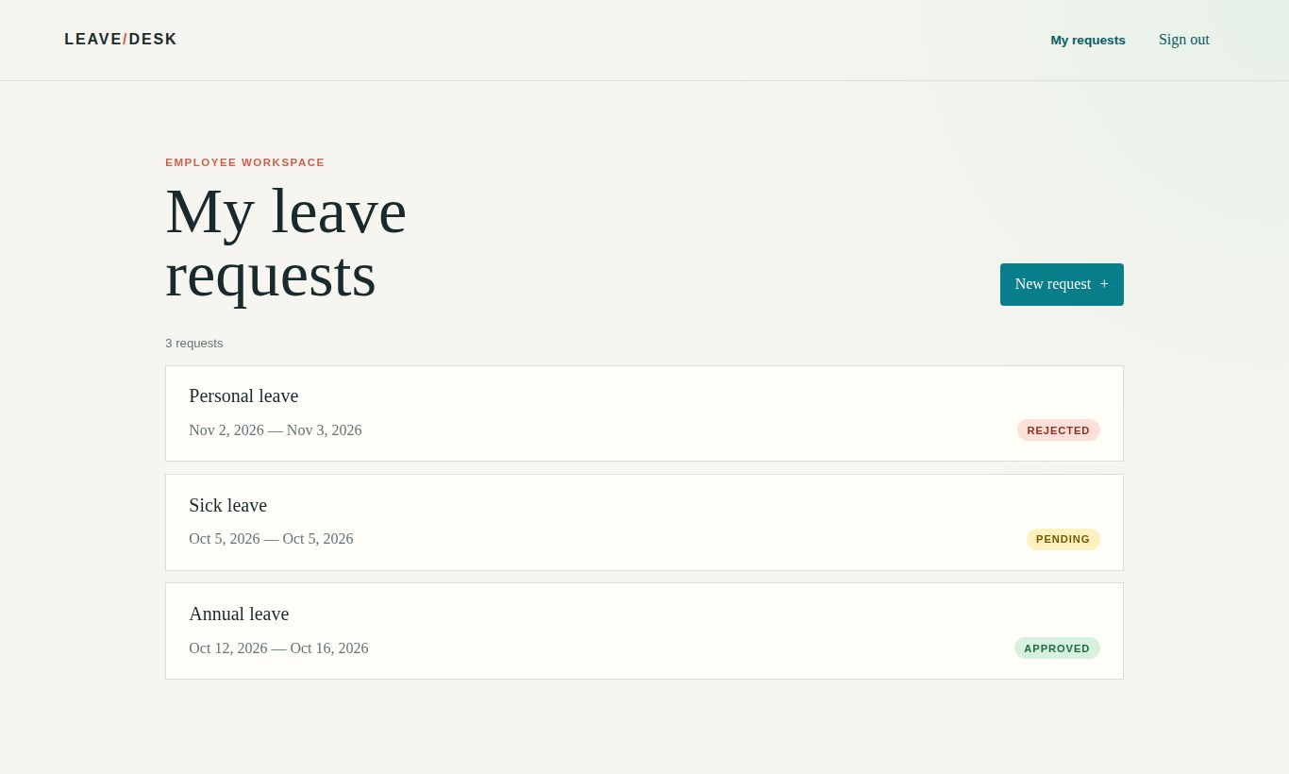
Figure 24. Back in the employee view, statuses are updated: one APPROVED, one REJECTED, one still PENDING.
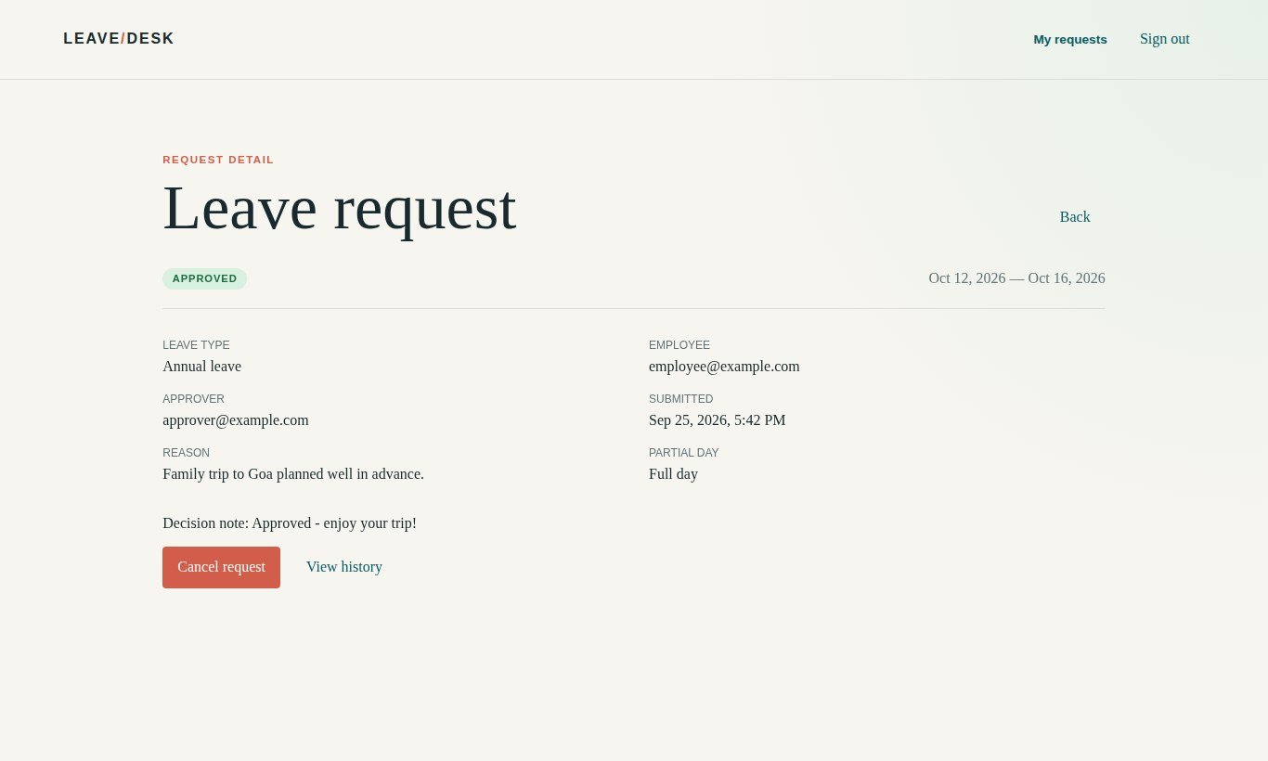
Figure 25. An approved request shows the approver's decision note.
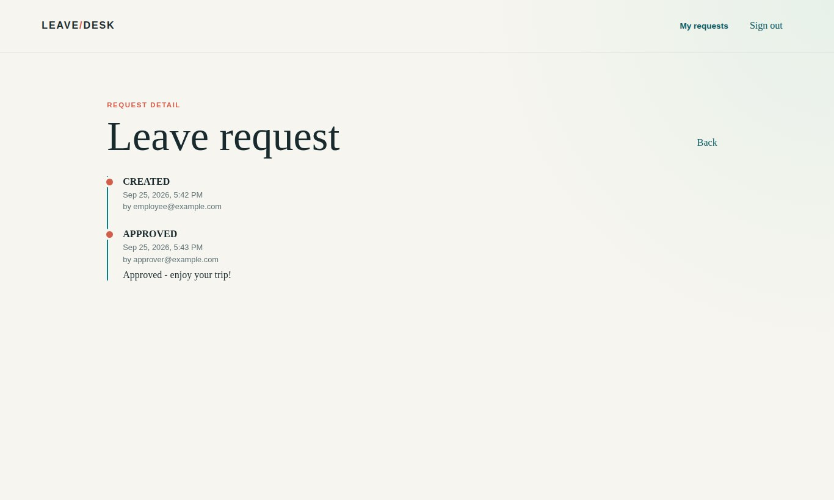
Figure 26. View history: an audit trail of who created and who approved the request, with timestamps and comments.

8. What the Run Produced
Area | Output
Jira | Epic LM-1 "Leave Request Management"; stories LM-2 Submit a leave request, LM-3 Review and decide on a leave request, LM-4 View submitted leave requests and statuses
Run artifacts | 00-requirements.md, 01-stories.md, 02-design.md, 03-implementation.md, 04-tests.md, 05-code-review.md, run.md
Backend | Spring Boot 3, Java 21, Spring Security (session + BCrypt), Spring Data JPA, H2; controllers, services, repositories, DTOs, audit service, email notification service, login rate limiter
Frontend | JSP shell + templates, vanilla ES-module JavaScript router and views, CSS
Tests | 21 automated tests (controller, service, repository, security, SPA controller); mvnw verify passing
Quality gates | Code review found 3 blocking defects, fixed by backend-dev in the fix loop
Delivery | Branch LM-1-leave-management, commit 5a990b9, pull request #1

9. Observations and Lessons Learned

9.1 What worked well
- The orchestrator never skipped a gate. It stopped for approval, for missing Jira access, for blocking design questions, and before the PR.
- File-based handoffs made each stage inspectable. Every decision is in run.md, so the run could resume after interruptions.
- The code reviewer found real defects that the tests missed, showing the value of independent review agents.
- Least-privilege tool lists kept each agent within its role.

9.2 Limitations and things to watch
- Prerequisites must be in place first. The run paused until the Atlassian MCP server was configured.
- Vague requirements need human answers. A one-line requirement produced ten open questions; decisions on auth and roles had to come from a person.
- Occasional nudges are needed. The user had to type "continue" to resume after a gate.
- Security review stage should be run and recorded before the PR, as the orchestrator itself pointed out.
- Output is a starting point. The generated app is lightweight and may contain bugs; it still needs normal human review and QA before production use.
- Model and credit usage. The whole run used Copilot's automatic model routing and about 44% of the Free plan's monthly credits.

10. Recommendations and Next Steps
- Pilot on a real backlog item. Use /sdlc-from-jira <KEY> on an existing, well-defined story.
- Write richer requirements up front (roles, validation rules, non-functional needs) to reduce open questions and pauses.
- Tailor the conventions files (copilot-instructions.md, instructions/*.md) to our own coding standards and tech stack.
- Enforce the security review and add CI (build + tests) on every PR created by the agents.
- Add agents as needed, e.g. a documentation writer, a UI accessibility checker or a performance tester, by adding a new .agent.md file and listing it in the orchestrator's agents field.
- Measure the results: lead time from requirement to PR, review findings per run, and rework after human review.

11. Conclusion
Coding Space shows that a team of focused GitHub Copilot agents can take a plain-language idea through the whole SDLC inside VS Code: Jira stories, design, code, tests, review and a pull request. People stay in control at the decisions that matter. Creating an agent is just writing a markdown file with a clear role, a minimal set of tools and a definition of done, and the orchestrator pattern turns these agents into a repeatable delivery pipeline.
The Leave Desk application is a small but complete proof that the flow works end to end. With better input requirements and our own conventions, the same setup can speed up everyday feature and bug work across projects.

