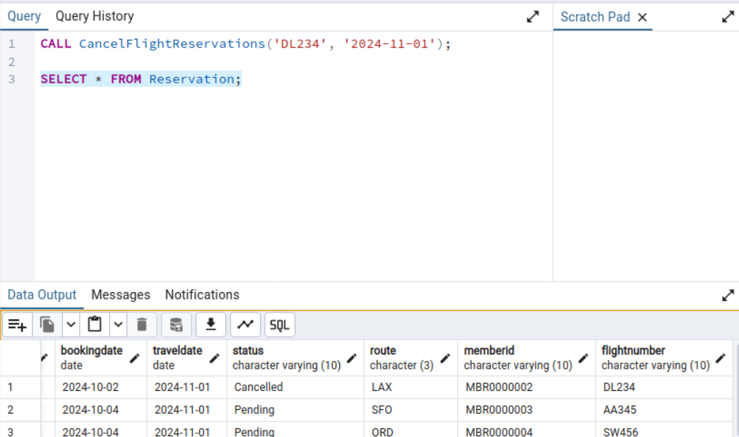--SP #1:Cancel Flight Reservation

CALL CancelFlightReservations('AF123', '2024-11-01');

SELECT * FROM Reservation;

--SP #2:Update Seat Availability

CALL UpdateSeatStatus('01A', 'Available');

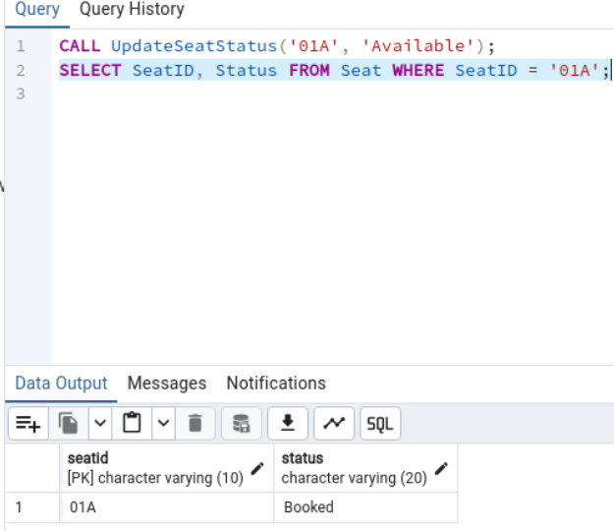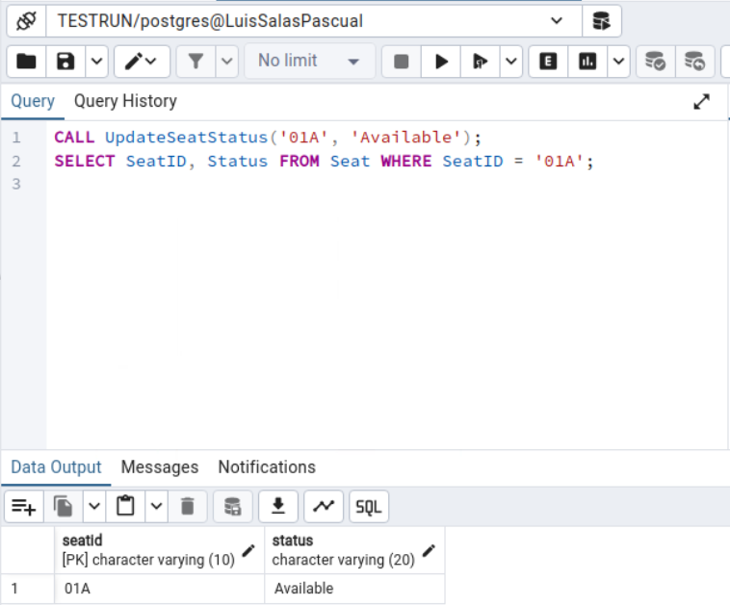SELECT SeatID, Status FROM Seat WHERE SeatID = '01A';

--SP #3: Insert Reservation

CALL InsertReservation(

'RSV0000011',

'XYZ123',

'2024-11-01',

'2024-11-15',

'Pending',

'JFK',

'MBR0000001',

'UA123');

SELECT * FROM Reservation WHERE ReservationID = 'RSV0000011';

SP #4: Function to Calculate Airline Total Revenue  
  
SELECT CalculateTotalRevenue('AFR');

Views #1:

SELECT * FROM DelayedFlightsWithCustomers LIMIT 5;

Views #2:

SELECT * FROM FlightCrewBookingDetails LIMIT 5;

Views #3:

SELECT * FROM PaymentAggregationByDestination LIMIT 5;

Views #4:

SELECT * FROM MemberContactInfo LIMIT 5;

Trigger #1: Before Insert validate flight times

INSERT INTO Flight (FlightNumber, FlightDate, DepartureTime, ArrivalTime, Status, AirlineID, AircraftID)

VALUES ('UA789', '2024-11-23', '2024-11-23 14:00:00', '2024-11-23 13:00:00', 'Scheduled', 'UAL', 'AC00000001');

Triggers #2: AFTER UPDATE trigger to log payment status changes

UPDATE Payment SET Status = 'Failed' WHERE PaymentID = 'PMT0001';

SELECT * FROM Payment_Audit WHERE PaymentID = 'PMT0001';

Triggers #3: BEFORE DELETE trigger to prevent deletion of confirmed reservations

-- First, let's check current crew member

SELECT * FROM Crew WHERE CrewID = 'CRW0000003';

-- Delete the crew member

DELETE FROM Crew WHERE CrewID = 'CRW0000003';

-- Check the audit log

SELECT * FROM Crew_Deletion_Log;

Triggers #4: AFTER INSERT trigger to automatically assign seats

INSERT INTO Reservation (ReservationID, PNRNumber, BookingDate, TravelDate, Status, Route, MemberID, FlightNumber)

VALUES ('RSV0000012', 'XYZ999', '2024-11-01', '2024-11-01', 'Confirmed', 'JFK', 'MBR0000003', 'DL234');

SELECT FlightNumber, SeatID, Status

FROM Seat WHERE FlightNumber = 'DL234';