**PRIMAL RESEARCH IDEAS IN SCIENCE AND MANAGEMENT**

**PRISM - 2022**

**Covering letter**

Paper Title: WILDLIFE DETECTION AND EVALUATION FROM CAMERA-TRAP IMAGES USING DEEP LEARNING

Disclosures:

1. I/We hereby confirm that author/s are students (UG/PG/PhD) or PhD scholars or staff from research organizations
2. The submitted idea is not have been previously presented / published or submitted for consideration elsewhere.

**Corresponding author**

Name : Vighnesh Manoj Manjrekar

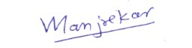Signature :

Date : 27-11-2022

**Author 2** **Author 3**

Name : Ruchita Pradeep Sonawale Name : Ayush Alok Shukla

Signature : 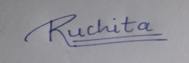 Signature :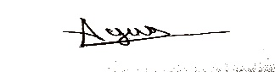

Date : 27-11-2022 Date :27-11-2022