Homework #3
Deadline: November 19, 2025 @23:59
Submissions: (1) PDF version of this file
(2) .ipynb file (backup/support file only)
Only the PDF will be graded. The .ipynb file is for reference or verification only.
Download data in colab link below:
https://colab.research.google.com/drive/1YyMPZbfaJNlNaB5My1__ZYiVmGUcPBtr?usp=sharing

IMPORTANT! (1) Before submitting the python file, please make sure it can be successfully compiled and correctly in its format name
(2) The scores will be 0 for all students whose source codes/writing are very similar to each other.
1. (10 points) Image Augmentation (no need to put in COLAB)
From image classification in object recognition lecture, the self-learning features are capable of learning object patterns using deep neural networks. However, you may require large number of datasets for a model to learn. Study image augmentation, which can be used to expand the size of the training dataset. Design 5 modified versions of an original image using knowledge from image processing class, so you can use them for model learning. Implement 5 different image variations for general object classification task using the example and the template below.
The example below is a modified version of an original image using rotation which can have variations in terms of orientation angle of an image from 0-360 degrees.
You should use a kitty image and one additional selected image and displayed in the table below. Also once call your python file, it should show the results of your 5 different modified versions of the original image.
Original image | Kitty.jpg  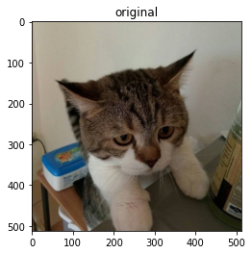 | Your selected image

No. | Modification Techniques & applied images (kitty.jpg and your selected image) | Purpose and key parameters
0 | Example: Rotation  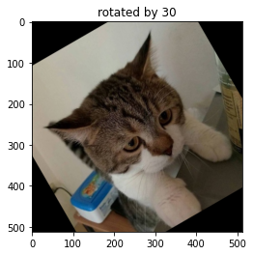 | Rotation can imitate the real dataset that the object can be varied in orientations.  Variations: angles in range of [-30,30]
Code:
// you can write your own designed augmentation techniques
data_transform = transforms.Compose([
transforms.RandomRotation((-30,30)),
transforms.ToTensor(),
])
1
 | Code:
2
 | Code:
3
 | Code:
4
 | Code:
5
 | Code:

2. Thailand’s coin currency consists of several denominations: 1, 2, 5, and 10 Baht coins. Each coin has a unique size and color that can be used for identification. Specifically, the 1 Baht coin is small and silver in color, the 2 Baht coin is medium-sized and gold, the 5 Baht coin is larger and silver, and the 10 Baht coin is the largest, featuring a bicolor design with a silver rim and a gold center. To assist in automating the coin counting process, you are required to develop an image processing algorithm capable of detecting and counting Thai coins from a given image. The program should be able to identify the denomination of each coin based on its size and color, count the number of coins for each denomination, and calculate both the total number of coins and the total monetary value in Baht. The output should include the number of coins for each denomination, the total number of coins, and the total value in Baht. In addition, a resulting image should be generated to visually present the detected coins, annotated with bounding circles or boxes and labeled text using functions as the example shown below
Note: your algorithm does not have to be 100% accurate; you should explain your results.

Original image | Your results / number of counted spores
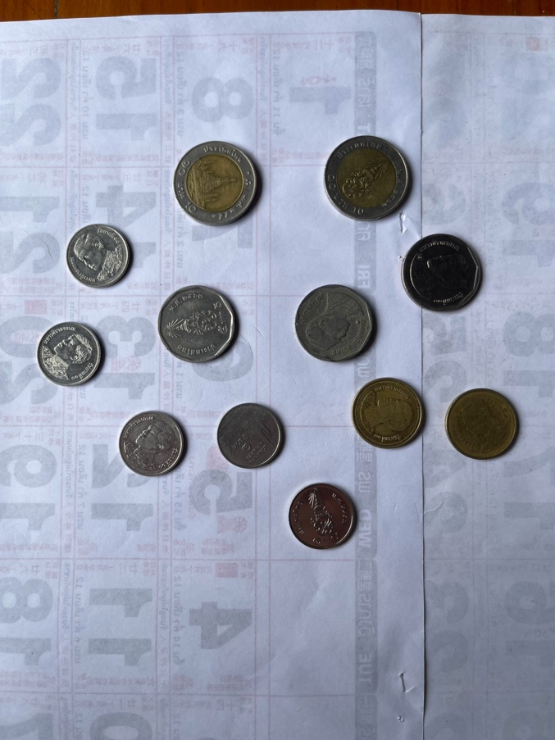  Coin_1.png | EXAMPLE  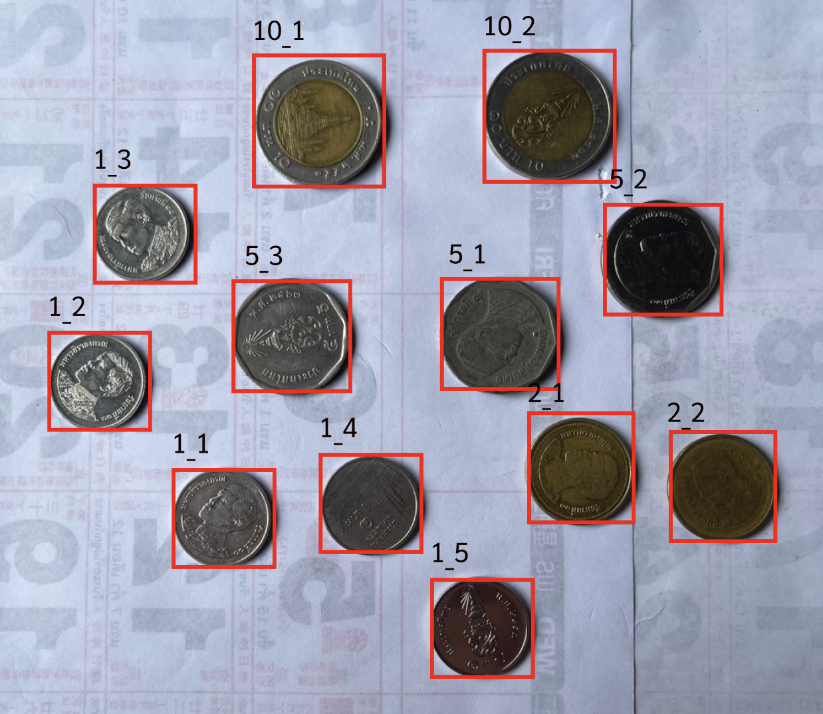  Result:  1 Bath = 5 Coins, 2 Bath = 2 Coins  5 Bath = 2 Coins, 10 Bath = 2 Coins  Total 11 Coins, 39 Baths

2.1) Describe steps of your algorithm
Steps | Description and purposes
1
2
3

2.2) Results
Original image | Your results / number of counted spores

Coin_1.png
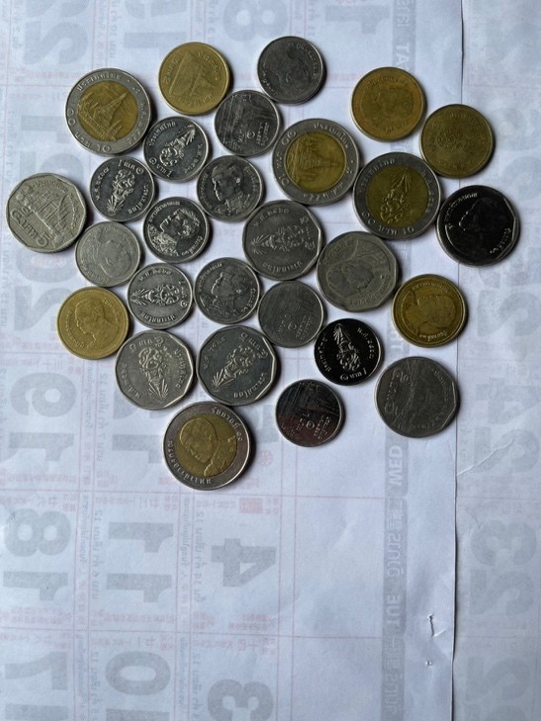
Coin_2.png
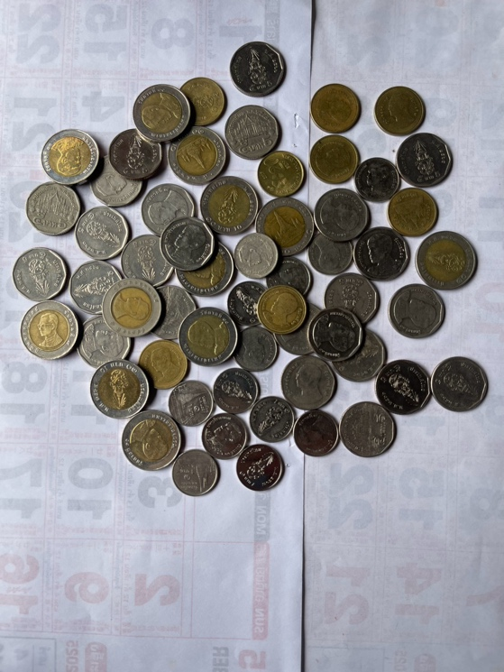
Coin_3.png
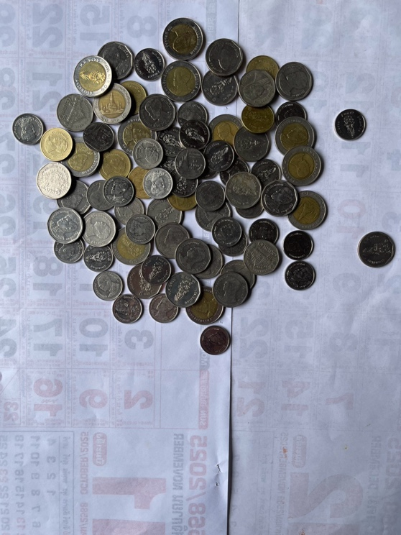
Coin_4.png

3. In the Colab link above, you have the ViT model code from our class.
3.1) Write code to visualize which parts of the image the model focuses on (e.g., attention map or heatmap). You may overlay the attention on the original image. Show at least one example image for each digit from 0 to 9 in the table provided below.

Number | Heatmap / Attention map
0
1
2
3
4
5
6
7
8
9

3.2) Write a short explanation in your own words (English or Thai).
Describe what your visualization shows, which parts the model attends to, and what you learned.
Pure AI-generated text (e.g., directly copied from ChatGPT or other tools) will not be accepted.
Code:

Explanation:

3.3) [This bonus task is open to everyone — students who wish to improve their midterm score or earn over 100% for this assignment]
Compare the model’s performance or attention visualization when you change one of the key Transformer parameters, such as, number of heads, depth (number of encoder layers), hidden dimension or MLP ratio
You may show differences in:
- Accuracy or loss
- Visualization of attention maps
- Model behavior (e.g., more or less focused regions)
- Explain briefly what you observe from these changes.
Write a short explanation (≤ 100 words) describing what you learned.
Practice (Do not submit)

4) Pyricularia Oryzae, rice blast fungus can cause rice blast disease. To identify the possibility of the occurrence of rice blast disease, the density of the spores of Pyricularia Oryzae can be calculated. Plant pathologist knows that you studied image processing, so they have asked you to help them automatically count the number of spores using image processing. They have provided two image samples below for you to develop an algorithm to count them. You should provide your results in terms of num_count and resulted_image (labeled count) (you can use cv2.rectangle(…) and cv2.putText(…) functions) as the example shown below
Note: your algorithm does not have to be 100% accurate; you should explain your results.
Original image | Your results / number of counted spores
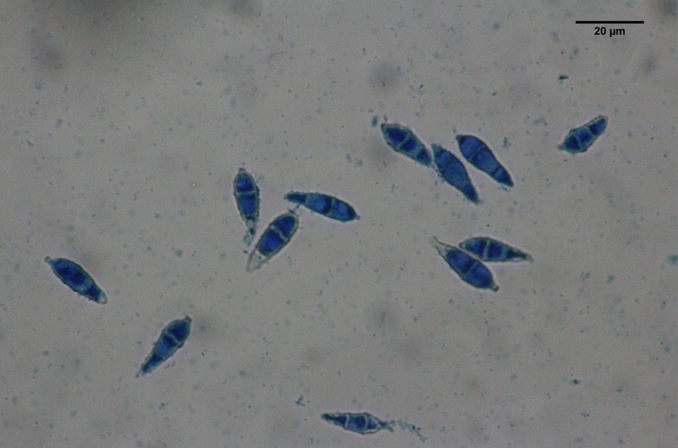  pyri02.png | EXAMPLE  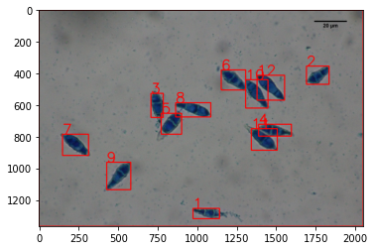  num_count = 12

4.1) Describe steps of your algorithm
Steps | Description and purposes
1
2
3

4.2) Results
Original image | Your results / number of counted spores

pyri01.png
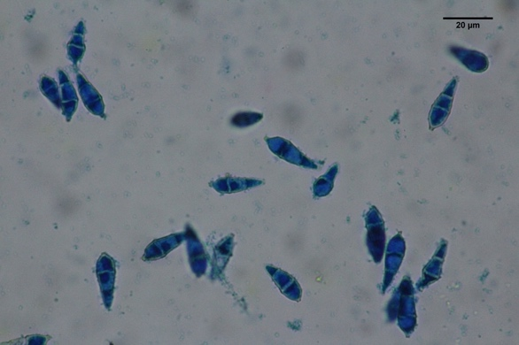
pyri02.png
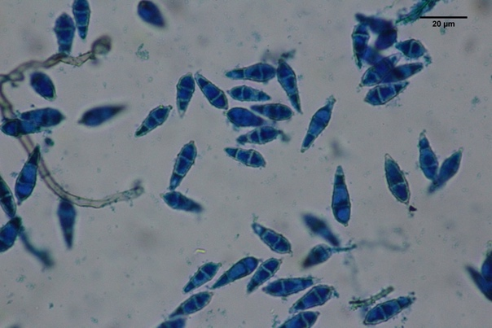
pyri03.png
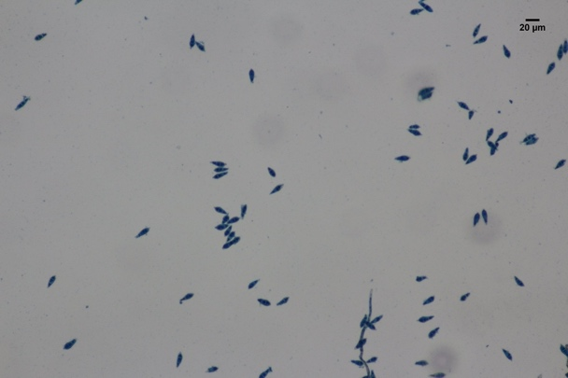
Pyri04.png

4.3) Analyze the results.
Hint: in terms of how accurate is your technique, any further improvement can be done?

5. The "Gemini star" refers to the brightest stars within the constellation of Gemini, which is one of the twelve zodiac constellations. Gemini is best known for its two brightest stars, Castor and Pollux, which are often called the "twins" due to the mythology behind the constellation.
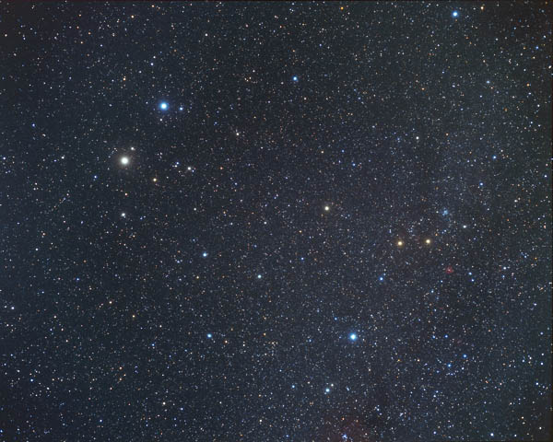
Fig. 3.1 Gemini stars
The line of stars in Gemini stretches from Pollux and Castor down to their "feet," represented by dimmer stars. The formation appears like two parallel stick figures standing side by side, connected by their heads.

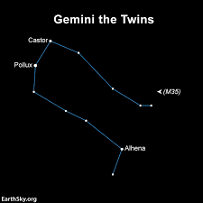
Figure 3.2 The line of stars in Gemini
To achieve this, use image processing techniques about erosion and dilation techniques from morphological image processing, enhance a specific star in an astronomical image. The challenge is to extract the main star (or stars) by reducing background noise and enhancing the desired features.
The final result should show only the stars of Gemini to shine bright without others as seen in Fig. 3.2, without a connection line. The stars should maintain its original size or similar.
The Original image | Your Result Image
!gdown 1F4gZPU5KUboFBJ7cVPHIrJyfrRcwJj92

Explain Your Code about Erosion and Dilation below

