Homework #2
Submissions: (1) PDF version of this file
(2) .ipynb file; template in the link below
COLAB TEMPLATE:
https://colab.research.google.com/drive/1vXUwb4AcX3vDvUTgzqP_1ag3aSHq7OvT?usp=sharing
(Only problem 1-3 will be graded)

Use these commands in colab to download the images.
!wget https://drive.google.com/uc?id=1o0UMPTyUFzX9CaQp-BwYXgkCho1Zo6yL -O kitty55.png
!wget https://drive.google.com/uc?id=1_-_yN30miNhzR9ZC5DHTiljH6LVq4hZz -O clean_cat.png
!wget https://drive.google.com/uc?id=1LEwFRI2vjSqQEd68lYwyuJ4JyJYPQX2m -O blurry_noisy_cat.png
!wget https://drive.google.com/uc?id=1lnO_PK81O54bLBUprBlo8-2x9smWYDcP -O moodeng.jpg
!wget https://drive.google.com/uc?id=1L5UFU_RyD5BAapUBc2HGl-RKtfgVGQKr -O moodeng2.jpg

1. (2 points) Apply Gaussian low pass filter in frequency domain on “Kitty55.png” image which has $M x N$ pixels. Find the minimum cutoff frequency (C) that still maintain the total image power $P_{T}$ more than 99%. Where the total image power, $P_{T}$ is calculated by summing the components of spectrum power at each point $(u,v)$, for $u = 1,2,…. M-1$ and $v = 1,2,…, N-1$
$$P_{T}= \sum_{u=0}^{M-1}{\sum_{v=0}^{N-1}{P(u,v)}}$$

$P\left(u,v\right)$ is the spectrum power provided in the lecture slides
$α$ percent of the image power can be calculated from 100 x $P_{T_f}$ / $P_{T_org}$, where $P_{T_org}$ is the total image power of the original image and $P_{T_f}$ of the filtered image

Put your results in the blank box below
Cutoff frequency (C) =
$α$ =

Original Image (“kitty55.png”) | Fourier Spectrum of the original image
Fourier Spectrum of the filtered image | Filtered images ($P_{T}$ > 99%)

2. Using only the concepts and techniques from Lecture 4-6, analyze the given image (moodeng2.jpg) and describe how it can be improved. Show your improvement process step by step, applying the appropriate methods discussed in these lectures. For each step, explain what you are doing and why this step helps enhance the image, and discuss the changes observed in the image after each step.
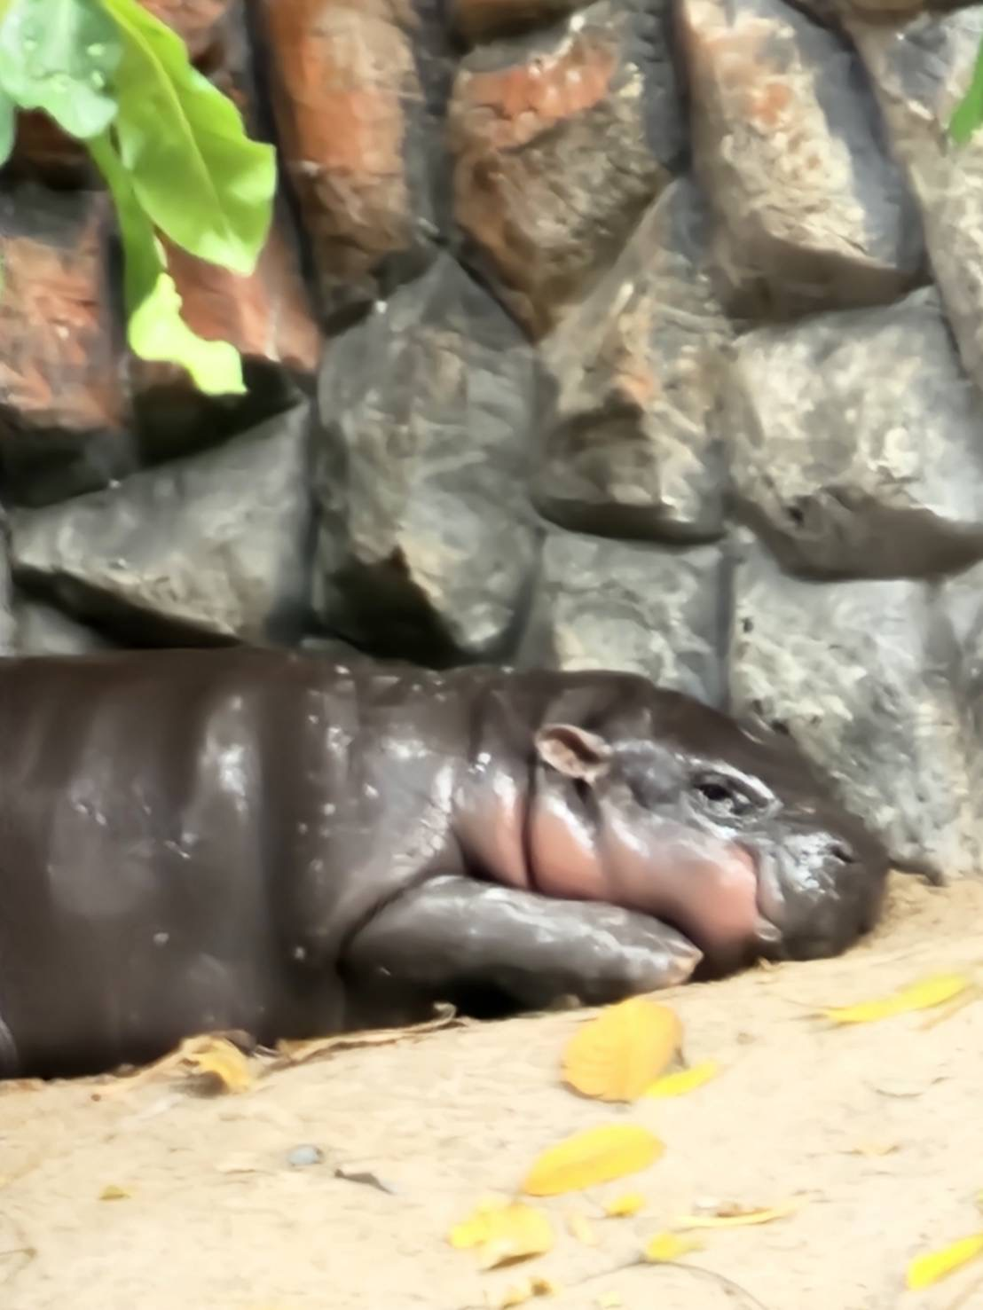
moodeng2.jpg

3. Write a paragraph (300-400 words) to summarize three image applications using frequency analysis in your own words and add the references trustworthy references from sources like IEEE, Elsevier, Springer, ACM, and other reputable academic publishers. (excluded from the total word count).

Practice (Do not submit)

4. Problem: Restoring blurry and noisy image
You are provided with a blurred and noisy of cat image blurry_noisy_cat.png and a clean reference image clean_cat.png. You have to restore the image using the Wiener Filter and compute the Structural Similarity Index (SSIM) between the restored image and the clean reference image.
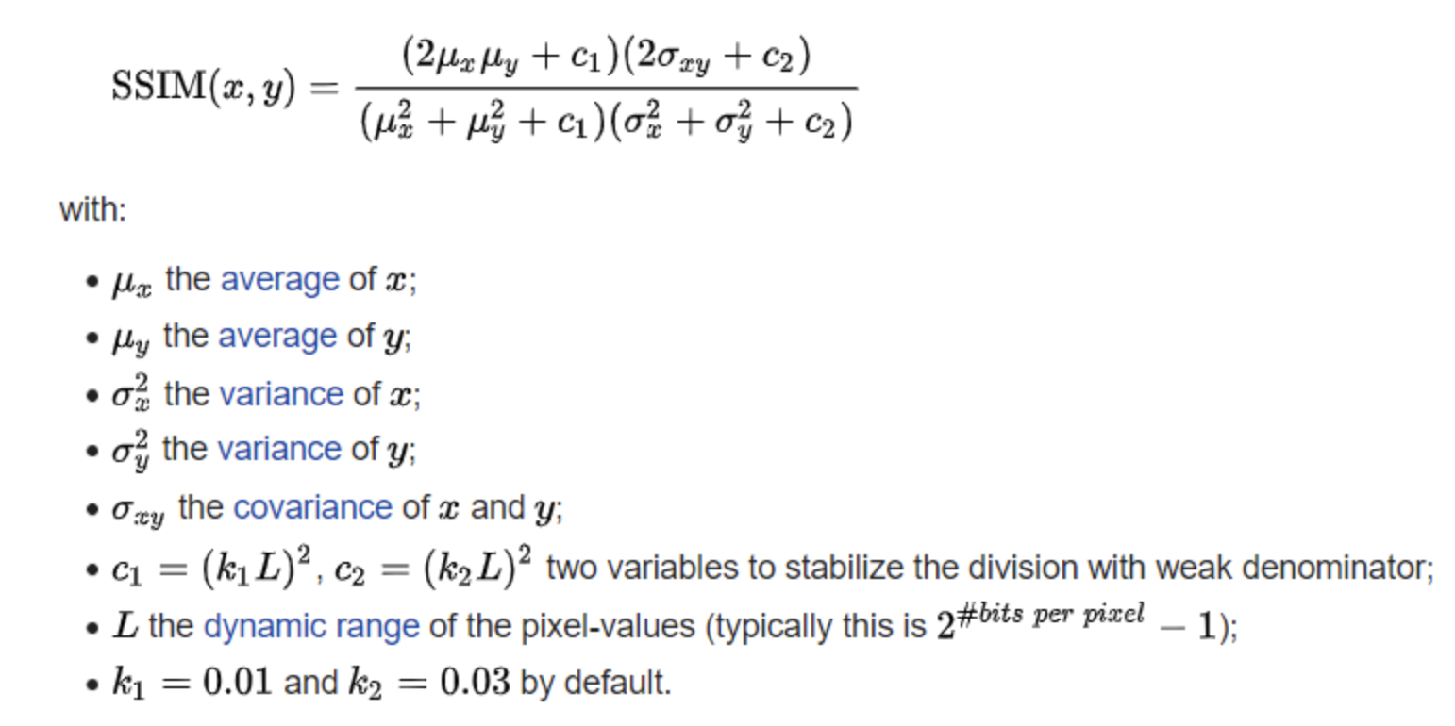

SSIM Overview:
The Structural Similarity Index (SSIM) is a perceptual metric that quantifies the similarity between two images. It considers changes in luminance, contrast, and structure to measure how close the restored image is to the original clean image. SSIM values range from -1 to 1, where:
- 1 indicates perfect similarity.
- 0 indicates no similarity.
- Negative values indicate dissimilarity.
(Hint: this metric is available inside skimage.metrics )
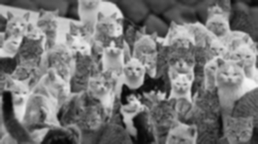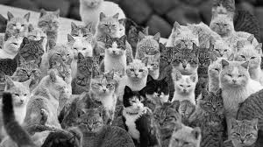
Blurry Noisy Cat Clean Cat Image

Show how to restore the image using Wiener Filter from noise and blur effects and display the result (don’t worry if the output is not perfect, just select the best one in your thought),

Structural Similarity Index (SSIM) of the restored image

5. WAVELETS AND MULTIRESOLUTION PROCESSING
5.1 You are provided with Nong Moo Deng image moodeng.jpg. Your task is to perform multi-level wavelet decomposition using the Discrete Wavelet Transform (DWT) and analyze the different layers of decomposition. The DWT breaks the image into four sub-bands: Approximation, Horizontal details, Vertical details, and Diagonal details. You will progressively decompose the image into three levels, visualizing the components at each level.
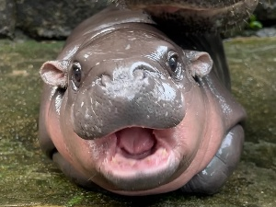

Your Wavelet Decomposition Level & Thresholding :
Original Image  Level J | Horizontal Detail Image | Vertical Detail  Image | Diagonal Detail  Image
Level J-1
Level J-2
Level J-3

5.2 For level J-1, remove the right half of the three components - horizontal, vertical and diagonal details - of the ‘moodeng’ image and then apply inverse Discrete Wavelet Transform to reconstruct the original-sized image with a blur on the right half. You can blur the right side of the image using a grayscale image, but you will receive a 1-point bonus for producing an RGB output.

Explain your method and provide the output results

