PUST UNIVERSITY
FACULTY OF MEDICINE AND HEALTH SCIENCE
COURSE: ANATOMY 1
ASSIGNMENT:
ANATOMICAL LOCATION OF THE HEART
PREPARED BY: GROUP ONE
Student Name | Role
Fardowsa Caabi Mohamed | Group Leader
Bishaaro Mohamed Daahir | Member
Maryan Abdiwali Ahmed | Member
Sundus Mohamed Xasan | Member
Fraxiyo Mohamed Mohamuud | Member

SUBMITTED TO: Mr. Abdirishiid
DATE OF SUBMISSION: 24/05/2026

1. Introduction
The heart is the central organ of the cardiovascular system. It pumps blood throughout the body and supplies oxygen and nutrients to all tissues. Understanding where the heart is located in the body is a basic and essential skill for any student of medicine or health science. This assignment explores the anatomical location of the heart, its relationship to surrounding structures, its internal chambers, and its clinical importance.

2. Definition of the Heart
The heart is a hollow, muscular organ that acts as a pump to circulate blood through the pulmonary and systemic circuits of the body. It is roughly the size of a person's closed fist and weighs approximately 250–350 grams in adults. The heart is enclosed in a protective sac called the pericardium, which prevents friction during beating and holds the heart in place inside the chest.

3. Anatomical Position of the Heart
The heart is located in the thoracic cavity, between the two lungs, in a region called the mediastinum. More specifically, it lies in the middle mediastinum. Its position is slightly to the left of the midline of the body. The apex (pointed bottom tip) of the heart is directed downward and to the left, pointing toward the left fifth intercostal space, at the midclavicular line. The base (upper, broader part) faces upward and to the right, toward the right shoulder.
In the standard anatomical position, the heart sits behind the sternum (breastbone), in front of the esophagus and vertebral column, above the diaphragm, and between the right and left lungs.
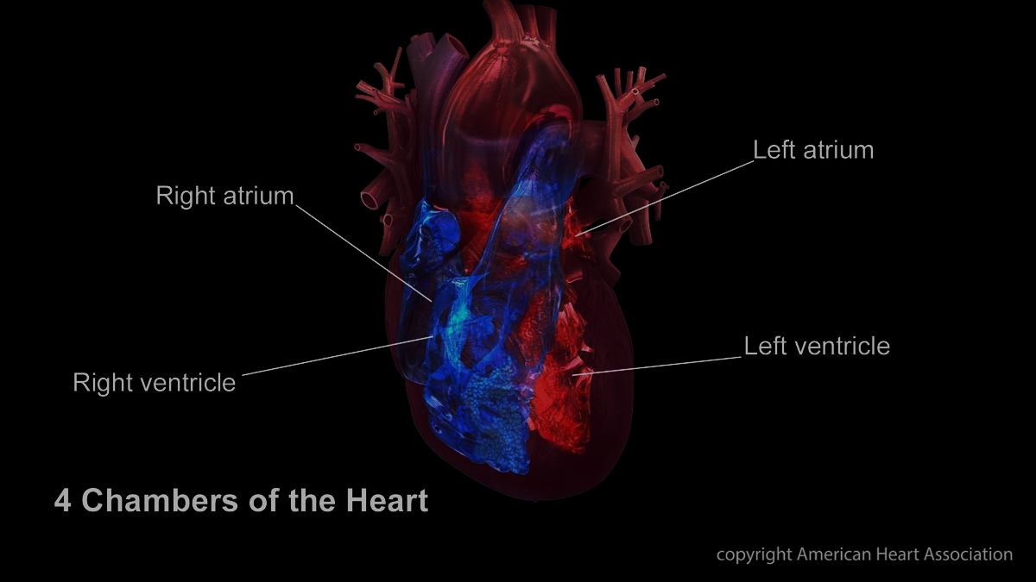

4. Relation to Nearby Structures
The heart shares close anatomical relationships with several important structures:
- Lungs: The right and left lungs lie on either side of the heart. The lungs partially wrap around the heart, and the cardiac impressions (indentations) on the lungs are caused by the heart's position.
- Diaphragm: The inferior surface of the heart rests on the diaphragm, a dome-shaped muscle that separates the thoracic cavity from the abdominal cavity. The diaphragm supports the heart from below.
- Sternum: The sternum (breastbone) lies directly in front of the heart. It provides bony protection to the heart and the great blood vessels. During cardiac arrest, chest compressions are applied to the sternum to manually pump the heart.

5. Chambers of the Heart
The heart is divided into four chambers, which work together to pump blood efficiently:
- Right Atrium: Receives deoxygenated blood from the body through the superior and inferior vena cava.
- Right Ventricle: Pumps deoxygenated blood to the lungs via the pulmonary artery for oxygenation.
- Left Atrium: Receives oxygenated blood from the lungs through the pulmonary veins.
- Left Ventricle: The most muscular chamber. It pumps oxygenated blood to the entire body through the aorta.

6. Clinical Importance
Knowing the exact anatomical location of the heart is vital in clinical practice. Clinicians use this knowledge in many situations:
- Auscultation: Doctors listen to heart sounds using a stethoscope placed at specific anatomical sites on the chest wall.
- Cardiopulmonary Resuscitation (CPR): Chest compressions are applied precisely over the sternum to pump the heart during cardiac arrest.
- Electrocardiography (ECG): Electrodes are placed at precise anatomical locations on the chest and limbs to record the heart's electrical activity.
- Chest X-ray Interpretation: Radiologists rely on knowledge of the heart's normal position to identify enlargement or displacement caused by disease.

