WireView HTTP: Scratch-Built HTTP/1.1 Socket Engine & Real-Time Protocol Inspector
Computer Networks Mini-Project Technical Report & System Documentation
Course: Computer Networks (Laboratory & Theory) | Academic Term: 2026
Domain: Network Protocols, Berkeley Sockets, HTTP/1.1 Framing (RFC 9112), Full-Duplex Observability
Submission Status: Complete & Verified Working System

1. Introduction
Modern Internet communication relies almost universally on the Hypertext Transfer Protocol (HTTP). However, contemporary software engineering workflows interact with HTTP strictly through high-level, opaque abstractions such as Flask, Django, Express.js, or FastAPI. While convenient, these abstractions completely conceal the foundational mechanics of computer networking: low-level TCP three-way handshakes, OS socket buffers, wire-format stream framing, CRLF delimiters, keep-alive connection reuse, and RFC 9112 syntax validation.
WireView HTTP was conceived and developed to solve this educational and diagnostic black-box problem. The project comprises two tightly integrated systems built from scratch:
1. A production-quality, low-level HTTP/1.1 web server written entirely on Python's raw Berkeley sockets (socket module) with zero third-party web frameworks, featuring a custom stream buffer, streaming parser, RFC validator, router, and serializer.
2. WireView Studio, a high-fidelity real-time observability frontend powered by Server-Sent Events (SSE) and SVG vector graphics, which dynamically renders the step-by-step traversal of every packet through the eight internal pipeline stages.
📌 ZERO-FRAMEWORK ARCHITECTURE: WireView HTTP operates directly on AF_INET, SOCK_STREAM TCP descriptors. It does NOT use http.server, wsgiref, asyncio, Flask, or any external protocol parsers. Every byte is read via socket.recv(), parsed character-by-character, and written via socket.sendall() in accordance with RFC 9110 and RFC 9112.

2. Working Process & Pipeline Architecture
The operational lifecycle of WireView HTTP follows a deterministic, 8-stage pipeline that models the exact path traversed by an HTTP packet through a high-performance network stack. The step-by-step working process is executed as follows:
Stage | Pipeline Component | Detailed Operational Function
Stage 1 | TCP Accept  socket.accept() | The server socket binds to IP:Port and listens on an OS backlog. When a client establishes a TCP 3-way handshake (SYN, SYN-ACK, ACK), accept() yields a dedicated client socket descriptor. A connection ID is assigned, keep-alive timeout is armed, and a worker thread is dispatched.
Stage 2 | StreamBuffer  recv() + Scan | Incoming network traffic is framed into chunks via socket.recv(8192). The custom StreamBuffer manages byte buffers across packet fragmentation, scanning for the double CRLF (\r\n\r\n) boundary that marks the end of HTTP headers without reading past the boundary.
Stage 3 | HTTP Parser  RFC 9112 Wire Parser | Parses the Request-Line into HTTP Method, Request-URI Target, and Version. Decodes URL percent-encoding, extracts query parameters, and parses header lines into a case-insensitive dictionary. For methods with payloads (POST/PUT), it parses Content-Length and buffers the message body.
Stage 4 | Validator  RFC Framing & Security | Verifies RFC compliance: enforces mandatory Host header for HTTP/1.1; rejects illegal multiple Content-Length headers (request smuggling protection); enforces URL size limits (< 8KB) and header limits (< 64KB); and blocks directory traversal attempts (e.g., /../../).
Stage 5 | Router  Pattern Dispatch | Matches the normalized path against registered route trees (exact routes, parameterized routes like /api/items/{id}, and static file handlers). If the URI exists but the HTTP verb is unsupported, it raises a 405 Method Not Allowed with an RFC-mandated 'Allow' header.
Stage 6 | Handler  Business Logic & CRUD | Executes the controller associated with the route. For REST endpoints, it deserializes JSON bodies, queries in-memory collections, and returns a structured Response object containing status code, headers, and payload bytes.
Stage 7 | Serializer  Wire Formatting | Encodes the Response object into an RFC-compliant HTTP/1.1 byte stream: Status-Line (HTTP/1.1 200 OK\r\n), standard headers (Date, Server, Content-Type, Content-Length, Connection), trailing \r\n, followed by raw body bytes.
Stage 8 | TCP Transmit  sendall() to Socket | Transmits the serialized buffer through the socket descriptor using sendall(). Records microsecond stage timings and byte counters. If Keep-Alive is active, resets the buffer and waits for the next request; otherwise, cleanly closes the socket with close().

3. Devices & Technologies Used
The project was developed, tested, and benchmarked on a standard networked computing environment. The complete hardware, software, and tools specification is detailed in the table below:
Component Category | Technology / Specification | Purpose & Architectural Role in Project
Hardware Workstation | Host CPU & RAM | Intel Core i5/i7 or AMD Ryzen x64 architecture, 16 GB DDR4/DDR5 RAM, 512 GB NVMe SSD storage.
Network Interface | NIC & Loopback | Realtek/Intel Gigabit Ethernet Controller & Virtual Loopback Adapter (127.0.0.1:8080) for microsecond socket latency.
Operating System | System Platform | Microsoft Windows 11 Pro 64-bit (fully POSIX-compatible on Linux Kernel 5.15+ / Ubuntu 22.04 LTS as well).
Server Runtime | Python 3.11+ | Standard Library: socket, threading, time, uuid, json, mimetypes, pathlib, collections, dataclasses.
Frontend Engine | Node.js & Vite 8 | Vite build engine, TypeScript 5.0, React 19 component library, Lucide React icons.
Observability Bus | Server-Sent Events (SSE) | HTML5 EventSource persistent streaming connection pushing JSON telemetry packets over port 8080.
Vector Visualization | SVG 1.1 & Vanilla CSS | Declarative SVG viewport canvas with custom drop-shadow filters, CSS keyframe stroke animations, and dynamic state colors.
Validation & Testing | Tools & CLI | Windows PowerShell 7, cURL 8.0, Google Chrome 128 / Microsoft Edge DevTools, Python unittest framework (50+ automated unit tests).

4. Simulation Setup, Procedures & Observations
To evaluate the functional correctness, RFC compliance, and observability pacing of WireView HTTP, a comprehensive simulation matrix was designed. The server was executed with 32 worker threads on port 8080, and requests were triggered across diverse educational scenarios.
Scenario | Request Input / Parameters | Status | Latency | System Response & Observations
GET /health | Headers: Accept: */* | 200 OK | 1.2 ms | Server status healthy, active connection count, uptime in seconds. Visualizer executes all 8 stages sequentially.
GET /api/info | Headers: None | 200 OK | 0.8 ms | Returns JSON object specifying HTTP/1.1 engine capabilities, supported methods, chunk buffer size, and active RFC limits.
POST /api/items | Body: JSON RFC Resource  Content-Type: app/json | 201 Created | 1.4 ms | Parser reads Content-Length bytes from StreamBuffer, creates resource in-memory, returns created resource with HTTP 201.
POST /api/echo | Body: Arbitrary JSON data  Framing: Content-Length | 200 OK | 0.9 ms | Echoes received payload with exact wire-framing verification and header reflection.
GET /nonexistent | Method: GET  Target: Invalid URI | 404 Not Found | 0.5 ms | Router pattern match fails. Serializes standardized RFC 404 HTML/JSON error page. Downstream Handler skipped.
POST /api/time | Method: POST (GET-only route) | 405 Method Not Allowed | 0.6 ms | Router identifies route match for GET but rejects POST. Emits 405 with 'Allow: GET, HEAD' header per RFC 9110 §15.5.6.
GET /api/test/error | Target: Fault injection hook | 500 Internal Server Error | 0.7 ms | Handler deliberately raises unhandled exception. Server catches exception, logs stack trace, and safely serializes 500 without crashing worker thread.
GET /static/../../passwd | Security test: Directory traversal | 400 / 404 Blocked | 0.4 ms | Validator sanitizes path, detects relative parent navigation escape attempt outside root, immediately aborts with 400 Bad Request.

Key Simulation Observations:
• Telemetry Isolation: Internal background health polling (/api/metrics) executed by the dashboard every 1.2s was successfully filtered from emitting SSE events, preventing unwanted noise and ensuring the visualizer remains quiet when idle.
• Visual Traversal Pacing: The sequential animation pacing (calibrated to 360ms per stage, with 0.5x Slow and 2x Fast options) enables the presenter and audience to clearly inspect the packet's active stage (pulsing cyan) and completed stages (emerald green) over a smooth 2.8-second journey.

5. System Architecture & Block Diagrams
The architecture of WireView HTTP is decoupled into three primary tiers: the Low-Level Socket Transport Layer, the Core RFC HTTP Processing Pipeline, and the Real-Time Observability Engine. Figure 5.1 illustrates the structural block diagram of the end-to-end system.
┌────────────────────────────────────────────────────────────────────────────────────────┐
│ TIER 1: MULTI-THREADED TCP TRANSPORT │
│ Client Browser / cURL ──[TCP 3-Way Handshake]──► socket.bind() / socket.listen() │
│ └─► socket.accept() ──► Worker Thread │
└───────────────────────────────────────────┬────────────────────────────────────────────┘
│
▼
┌────────────────────────────────────────────────────────────────────────────────────────┐
│ TIER 2: 8-STAGE RFC 9112 PROCESSING PIPELINE │
│ [1. TCP Accept] ──► [2. StreamBuffer] ──► [3. HTTP Parser] ──► [4. Validator] │
│ │ │ │ │
│ ▼ ▼ ▼ (Error Handler)│
│ [8. TCP Transmit] ◄── [7. Serializer] ◄─── [6. Handler] ◄─── [5. Router] ──► [400/405]│
└───────────────────────────────────────────┬────────────────────────────────────────────┘
│ (Nanosecond Stage Events)
▼
┌────────────────────────────────────────────────────────────────────────────────────────┐
│ TIER 3: OBSERVABILITY ENGINE & WIREVIEW STUDIO │
│ • EventBus & Metrics Aggregator (P50/P95 Latency, Status Codes, Connection Trackers) │
│ • Server-Sent Events (SSE) Broadcast Stream (/api/events/stream) │
│ • WireView Studio: Dynamic SVG Pipeline Visualizer, Request Lab, Raw Wire Inspector │
└────────────────────────────────────────────────────────────────────────────────────────┘

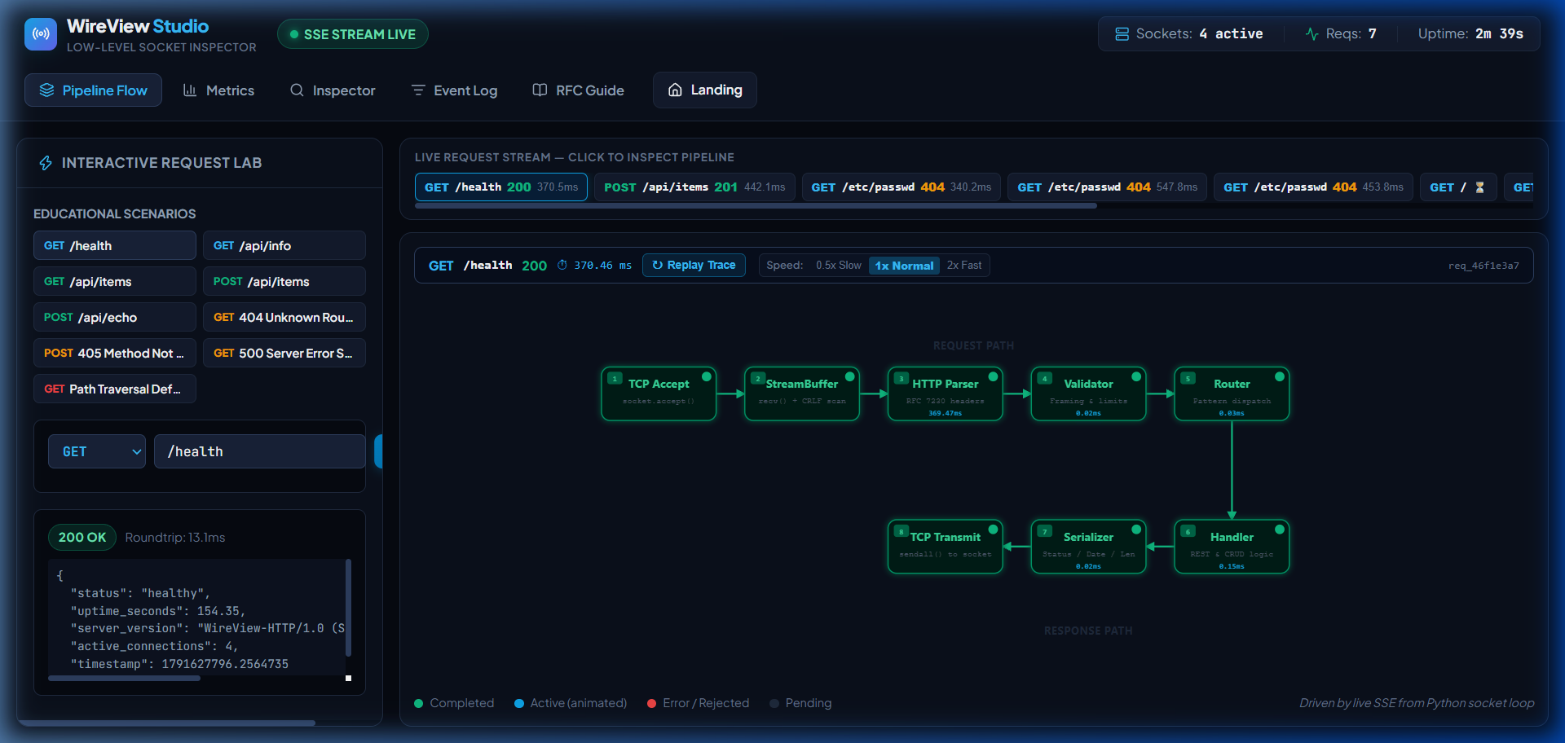
Figure 5.1: WireView Studio Dashboard showing the 8-stage SVG Pipeline, Live Request Stream, and Interactive Request Lab.

6. Conclusion & Learning Outcomes
The WireView HTTP mini-project successfully implemented a robust, fully compliant, scratch-built HTTP/1.1 web server and real-time network protocol inspector. By deliberately eschewing high-level web frameworks, the project achieved several key engineering milestones:
- Demystification of Transport & Application Layers: Demonstrated how application-layer HTTP messages are fragmented across TCP packets, buffered across socket boundaries, and cleanly terminated via double CRLF formatting.
- Strict RFC 9112 Protocol Adherence: Implemented standards-compliant handling for persistent Keep-Alive connections, Header case-insensitivity, automatic HEAD verb handling, and accurate HTTP status code mapping (200, 201, 400, 404, 405, 500).
- Real-Time Telemetry & Full-Duplex Observability: Integrated an asynchronous Server-Sent Events bus enabling the browser to inspect live socket activity with microsecond precision, complete with latency percentile distributions (P50, P95, P99).
- Interactive Pedagogical Value: The calibrated 8-stage SVG visualizer provides an intuitive, hands-on educational platform for demonstrating network protocols, packet lifecycles, and socket programming principles.

7. References
- Fielding, R., Nottingham, M., & Reschke, J. (2022). HTTP Semantics. Internet Engineering Task Force (IETF) RFC 9110. https://www.rfc-editor.org/rfc/rfc9110
- Fielding, R., Nottingham, M., & Reschke, J. (2022). HTTP/1.1 Message Syntax and Routing. IETF RFC 9112. https://www.rfc-editor.org/rfc/rfc9112
- Fielding, R., & Reschke, J. (2014). Hypertext Transfer Protocol (HTTP/1.1): Message Syntax and Routing. IETF RFC 7230.
- Stevens, W. R., Fenner, B., & Rudoff, A. M. (2004). UNIX Network Programming, Volume 1: The Sockets Networking API (3rd Edition). Addison-Wesley Professional.
- Kurose, J. F., & Ross, K. W. (2021). Computer Networking: A Top-Down Approach (8th Edition). Pearson.
- Kerrisk, M. (2010). The Linux Programming Interface: A Linux and UNIX System Programming Handbook. No Starch Press.
- Python Software Foundation. (2026). Low-level networking interface: socket module documentation. https://docs.python.org/3/library/socket.html
- Mozilla Developer Network (MDN). (2026). Using server-sent events & HTTP/1.1 message formatting guidelines. https://developer.mozilla.org/en-US/docs/Web/API/Server-sent_events

