# CHAPTER 1. PERFORMANCE MEASUREMENT AND TOOLS

* Measure what: 记录平均时间与分位数时间。You need one “order of magnitude" more samples than the target percentile. For percentiles from 0{99, you need 100 samples minimum. You need 1,000 samples for 99.9th percentile, 10,000 samples for 99.99th percentile, and so on
* JITed and release mode
* Visual Studio测并发：Concurrency Visualizer (Tools j Extensions and Updates. . . menu).
* ETW
  + Event Tracing for Windows and this is the operating system's way of logging all interesting events in an extremely fast, effcient manner.
  + Chapter 8
* Visual Studio Profiler

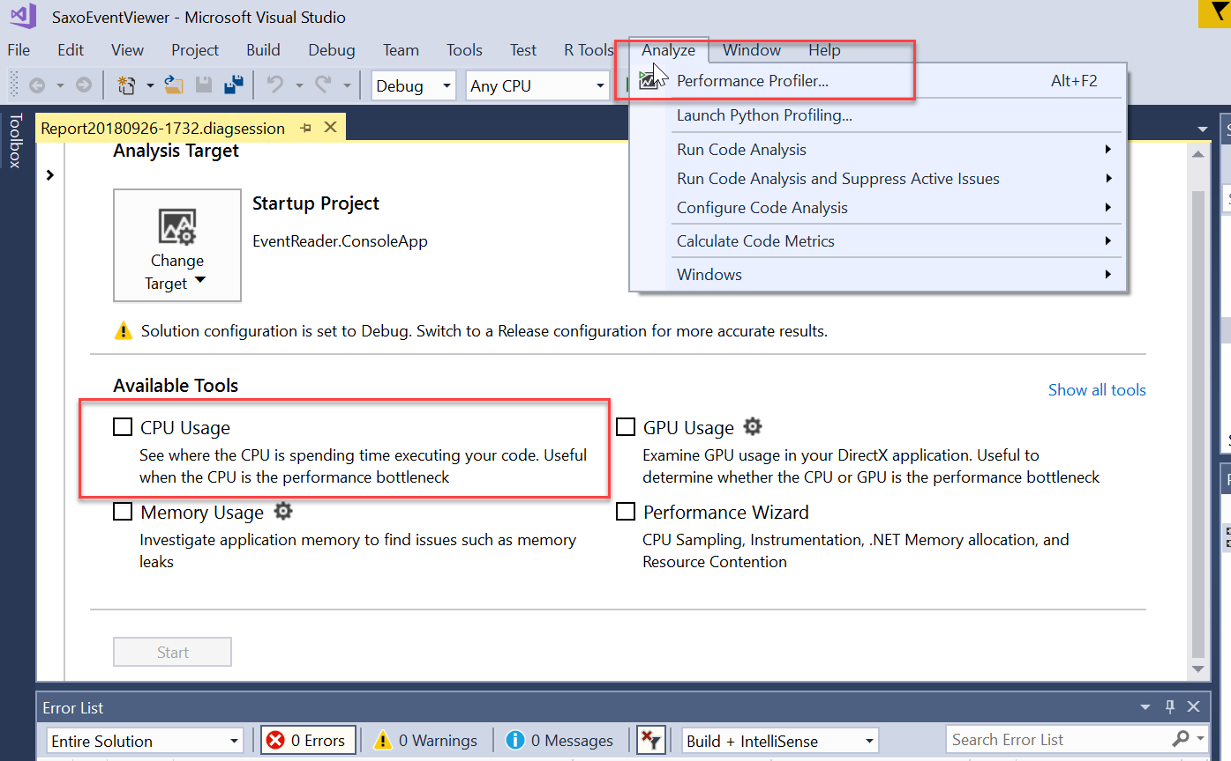

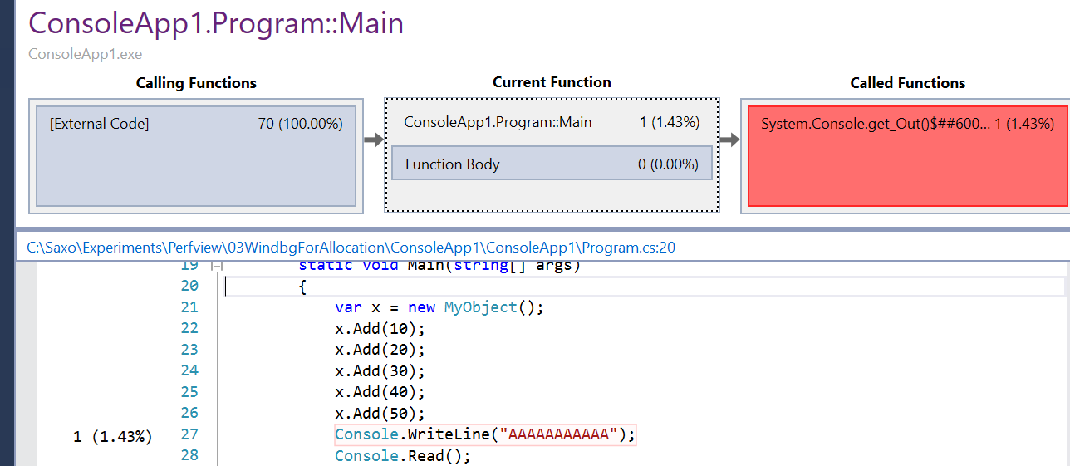

CPU Usage Method Call/Callee Diagram. Shows the most expensive parts of a method.

* 单独使用VS的Profiler——VsPerf.exe

For Visual Studio 2017, the executable is VsPerf.exe and is located in C:\Program Files (x86)nMicrosoft Visual Studion2017、EnterprisenTeam Tools\Performance Tools.

To collect data from the command line with this tool:

1. Navigate to the installation folder (or add the folder to your path)

2. Run: VsPerfCmd.exe /Start:Sample /Output:outputfile.vsp

3. Run the program you want to pro_le

4. Run: VsPerfCmd.exe /Shutdown

* Profiling四种模式

Sample: 采样方法，适合CPU集中，对IO集中方法没用

Trace：记录每个方法的时间

Coverage: which lines of your code were executed. This is a nice feature to have when running tests to see how much of your product the tests cover.

Concurrency: This mode can tell you if your threads are being blocked due to contention. Chapter 4

* Performance Counter —— PerfMon.exe

P20 Key concepts

* ETW Events

Events are produced by providers.There are providers for nearly every subsystem in Windows, such as the CPU, disk, network, firewall, memory, and many, many more.