Single Page App

# Javascript模块化—Require.js

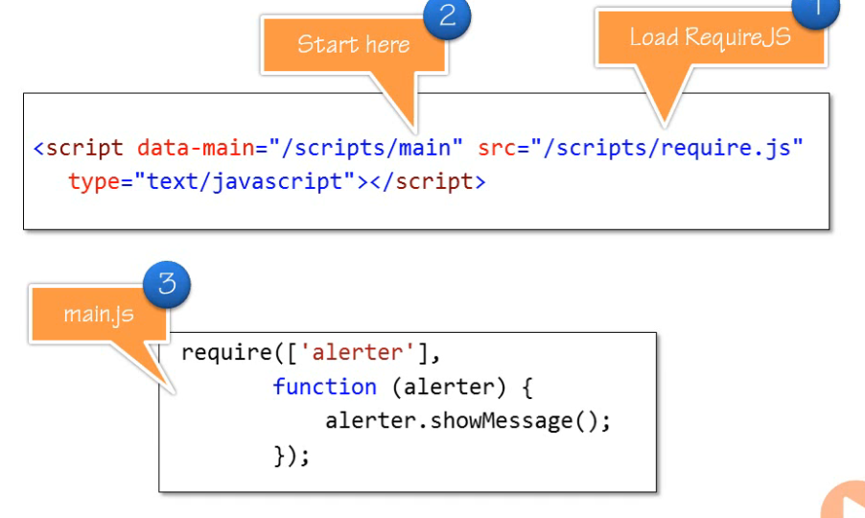

# KnockoutJS—debug

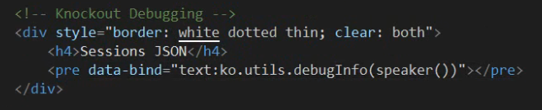

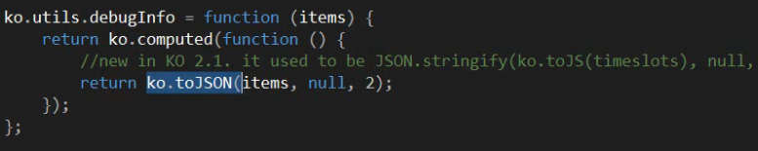

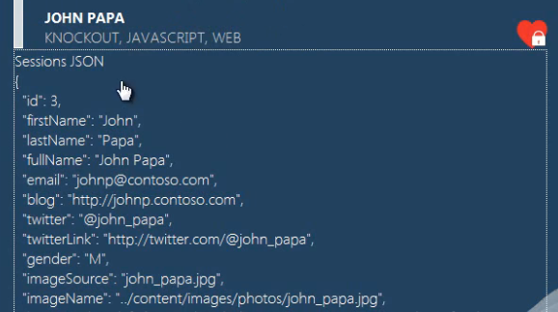

# Navigation

Sammy.js