O’Sullivan Communications (**OSC**) is a comprehensive in-house operation offering multilingual products and services. Services include project management, copywriting, editing, translation and localization, design, desktop publishing and layout services, programming, pre-press, print production and fulfillment. OSC linking all facets of the process under one roof using Identity Server for Single Sign On.

**CGS Services:-**

* Created Authentication Server for Single Sign on (SSO) and Integrate with Electronic Menu Management Information System (EMMIS) and Content Management System (CMS).
* Implemented Role based authentication and Themes for customized settings.
* Created Multi-tenant application and configured with Authentication Server (SSO).

**OSCId (Identity Server)**

OscId is a light-weight security token service Web API. It has out-of-the-box support for user management using the ASP.NET membership and roles provider, but provides extensibility points to integrate arbitrary user databases. Various protocols like simpleHTTP, OAuth, WsTrust handles requests, make use of the OscId engine for token issuance and emit the corresponding response. Protocol support can be extended by adding new implementations to the host and using the common engine for the heavy lifting. The core runtime takes care of enforcing security policy and token issuance whereas the data repositories abstract the underlying user and configuration store. By providing custom implementations of these repositories, OscId can be adapted to arbitrary user management and configuration systems.

* Multiple protocols support (WS-Trust, WS-Federation, OAuth2, HTTP GET)
* Easy to integrate with ASP.NET membership, roles and profile.
* Extensibility points to customize configuration and user management handling.

**Technical Summary:-**

* Creating Identity server and integrating with other application for SSO.
* Creating and Mapping Relying parties in identity server.
* Integrating Asp.net and MVC application with OSCID server
* Implementing membership and custom profiles configuration
* Multi-tenant integration for SSO.
* Developed Web Forms using C#, ASP.NET and Used AJAX in some web forms.
* Deployment of Application on Test and Production Server and handled many production issues and enhancement to the existing live portals.
* Responsible for validations in front-end interface and designing the controllers.
* Providing Database, Spreadsheet & Web Technology expertise to assist teams with local initiatives where appropriate.

**Environment:**-

ASP.NET4.0/4.5, Microsoft Visual Studio. NET 2012, C#, SQL Server 2008, IIS 7.0.

**Sample UI screen shots:-**

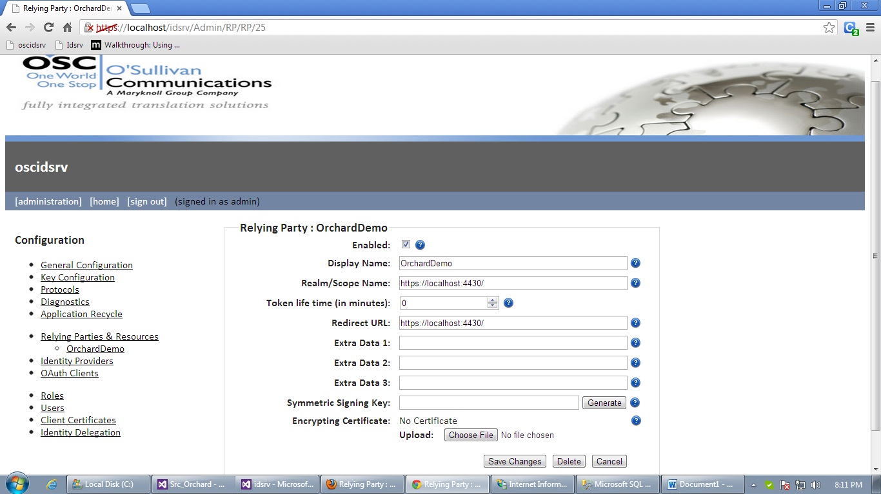

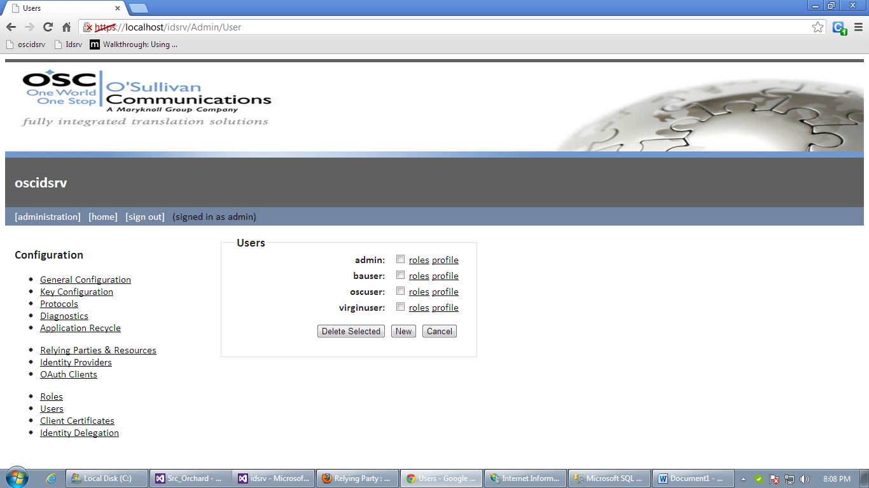

**Electronic Menu Management Information System (EMMIS):-**

EMMIS stores, administers and outputs an abundance of management information and production resources essential to printed menu management. It is customized to clients’ requirements, and utilized to manage food information, corresponding flights and routings, production and shipping data.

* Electronically calculates the exact number of menus to print and deliver each month based on flight information.
* Assigns the correct menu to its corresponding flight, route and meal codes.
* Measures and compares current flight schedules to previously existing data for accuracy and inconsistencies.
* Interactive, live and shared between our U.S. and U.K. offices
* Electronically generates printing forms and layouts to minimize waste and maximize efficiencies.
* Maintains databases of all design specifications and their applications.

**Technical Summary:-**

The Menu Viewer application integrated with SSO Login. The user authenticated done through OSCId SSO Server. The User request authenticated from OSCId server and redirected to Menu Viewer application. Application gets the token from OSCID SERVER and persisted in browser cookies. We have used Asp.net membership in Menu Viewer application. After authentication from OSCID SERVER user mapped with Asp.net membership. After user mapping details are fetched from database and persisted in application. To implement the user’s rights we used custom provider. The Custom profile maintains the basic information of user and their company details in database. Application gets the user details and company details from the database according to user to implement Role based authentication. Role management implemented by using company. For ex, OSC, Virgin Atlantic and British Airline are company. We redirected to the User Interface depending on company. OSC Company users can able to access all Menu Viewer. The user from OSC Company can view Menu Viewer UI and will get the full permission. We created one dropdown for OSC users to access all Menu Viewer. We created separate Base Class Provider for authorizing and assigning data depending on user and roles. We created themes for each Menu Viewer. Based on Company themes are populated and assigned dynamically. If the BA user logged in means we used BA theme to create a BA Menu Viewer logo and header information and wise versa.

**Environment:**-

ASP.NET4.0/4.5, Microsoft Visual Studio. NET 2012, C#, SQL Server 2008,OSCID Server for SSO, IIS 7.0.

**Sample UI Screen shots:-**

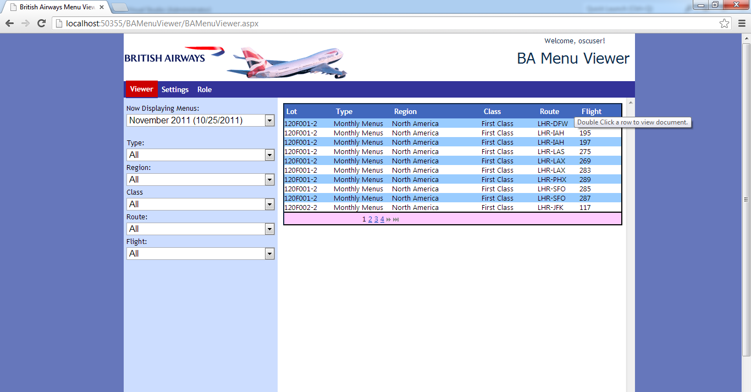

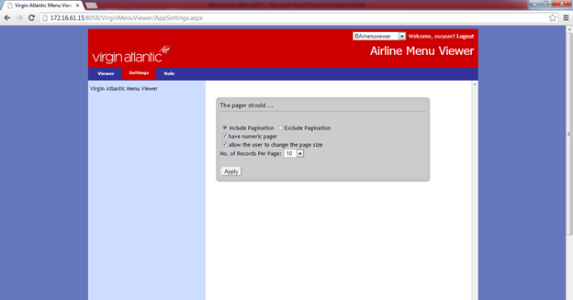

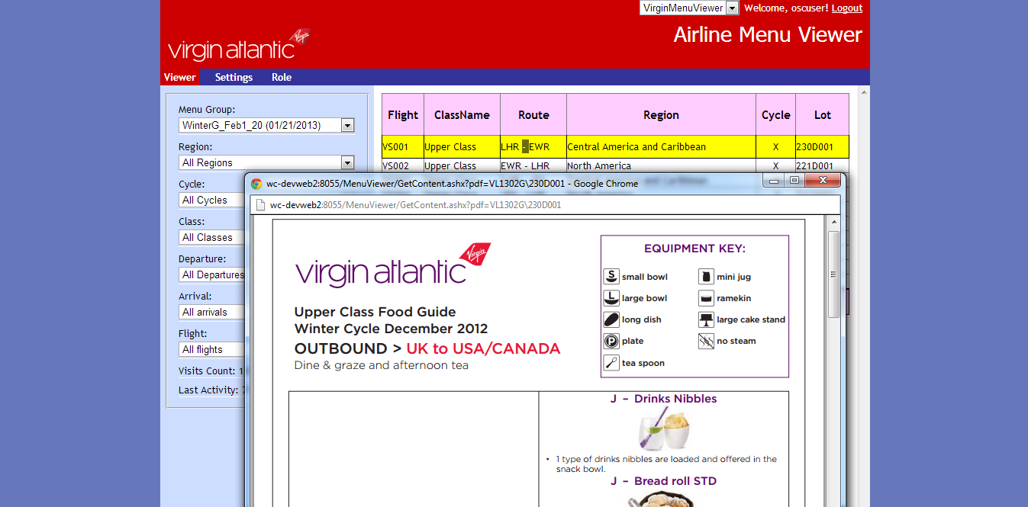

**British Airways Chef’s Chat**

Chef’s Chat is a custom built system for British Airways designed to offer document editing and workflow among vendors in a single collaborative arrangement. It operates entirely using a web browser without the need for any special installations on client computers. For a user to access the system they must first request a login. Once a user requested access, their information will be forwarded to an access administrator. If the access administrator approves access, the user will be notified by email of their account information. Once logged in you will come to the Chef’s Chats Navigator Screen. There you will have access to selecting rotations and individual chats. Double clicking on any chat item will open the chat for preview. To facilitate creating and editing documents, templates have been created that reflect the styles used in the Chef’s Chats document. A template is a pre-built section of a document that provides format structure and allowing the user to fill in the content. Working with templates allows a user to benefit from a format structure that would otherwise be difficult to create in an HTML editing environment.

**Environment:**-

ASP.NET4.0, Microsoft Visual Studio. NET 2012, C#, SQL Server 2008, Webservices, WCF Service, JQuery, Ajax, OSCID Server for SSO, IIS 7.0.

**Sample Screen Shots:-**

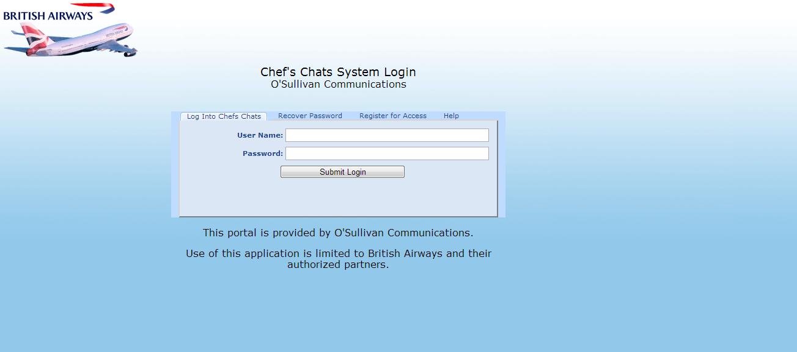

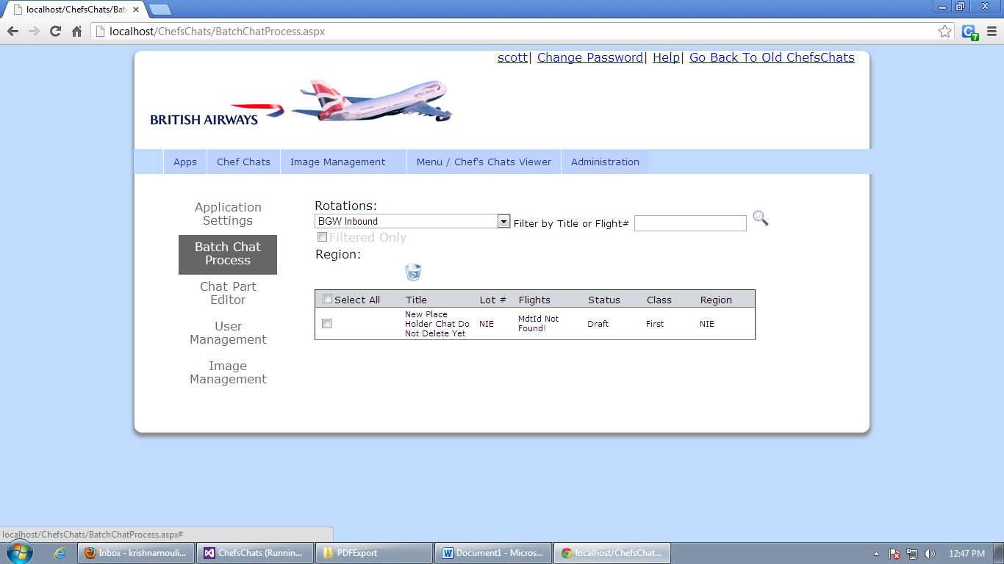

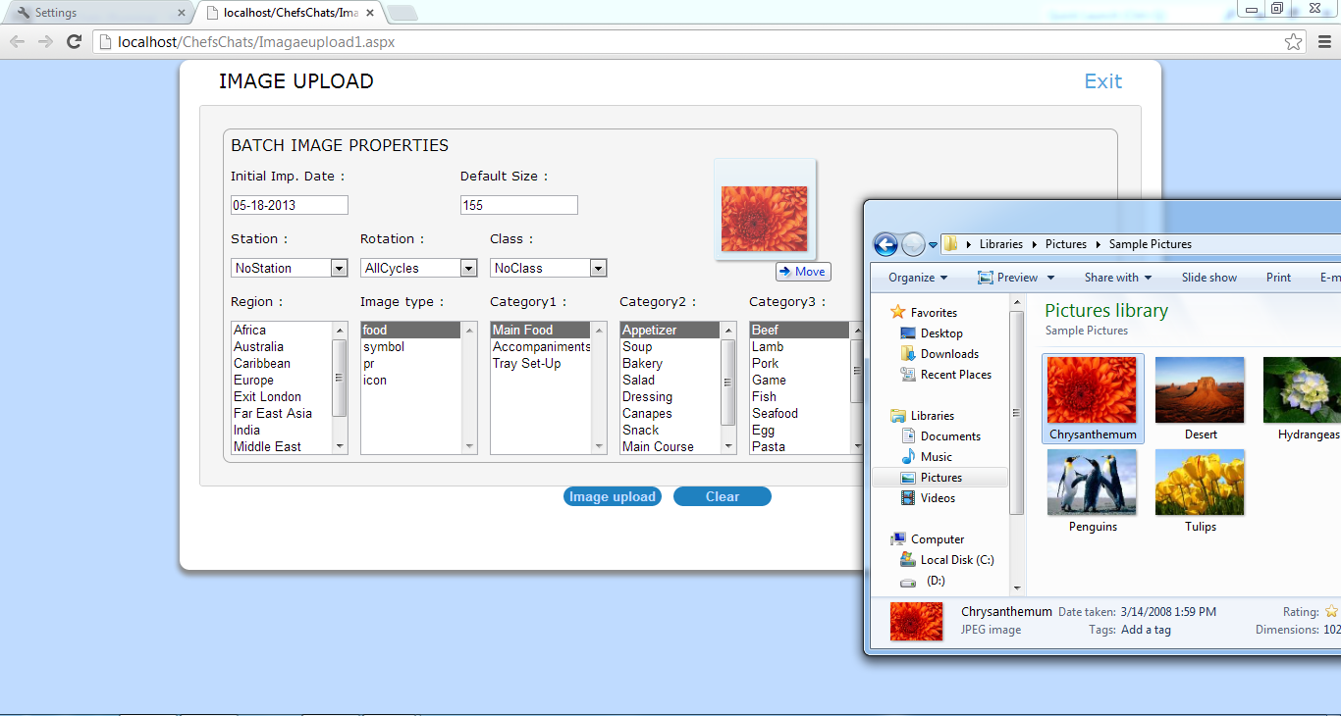

**Fleet Tracking System**

Fleet tracking system allows you to simplify and optimize your work in just by clicks. Helps to view the current map position of all your company vehicles equipped with a GPS tracker. Vehicle status displayed in different colors: stopped vehicle, moving vehicle, motor running, etc. pinpoint the vehicle closest to a specific address to [assign it to the next job](http://www.visirun.com/index.php/en/gps-fleet-management-solutions/communication). select a specific vehicle with just one click of the mouse to [**s**end messages](http://www.visirun.com/index.php/en/gps-fleet-management-solutions/communication) to the driver, obtain instant information about the vehicle’s speed, and check routes and the driver’s “on the job” time. View GPS tracker equipped vehicles according to vehicle typology (vans, trailers, transporters, etc.), load capacity, user-defined area, etc. Using the Fleet tracking system you can check routes and stopovers, analyze hours claimed by drivers and driving styles, and much more. Easily check goods delivery, maintenance, and technical operations by highlighting your Points of Interest (POIs) on the maps.Fleet trackers let you optimize the activities of operators, cut back overall costs, and improve management time and costs thanks to direct, real-time communication with your drivers

**Environment:**-

ASP.NET4.0, Microsoft Visual Studio. NET 2012, C#, SQL Server 2008, Webservices, WCF Service, JQuery, Ajax, Reporting, IIS 7.0.

**Sample UI screen shots:-**

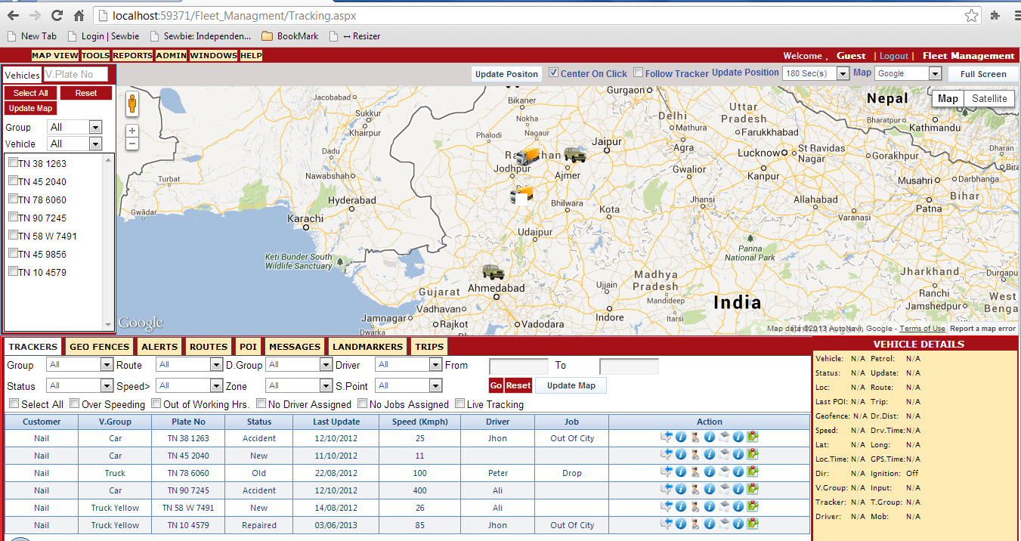

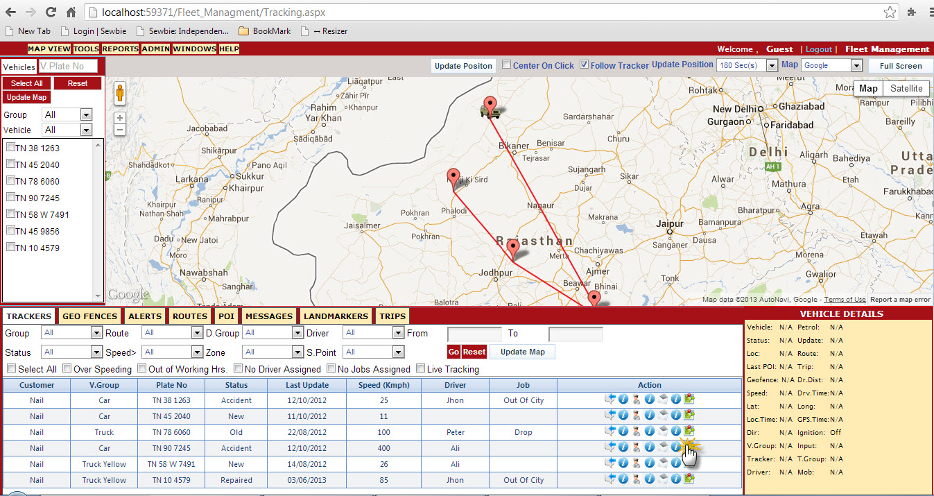

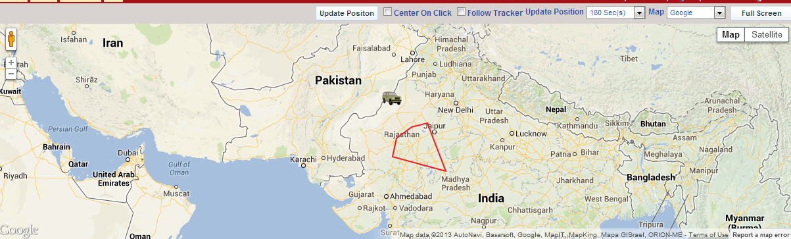

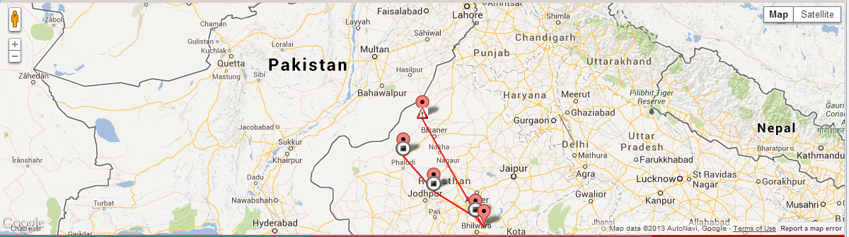

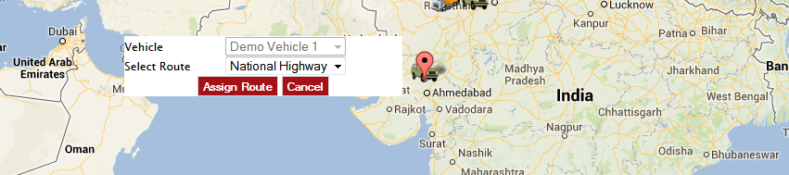

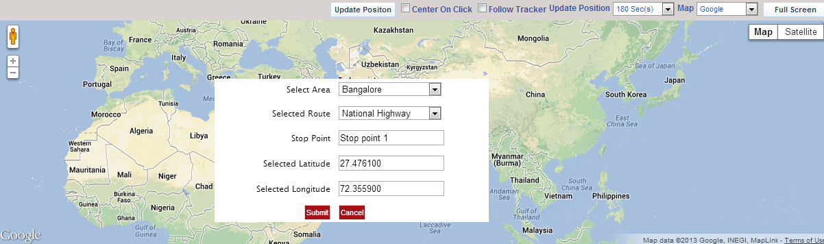

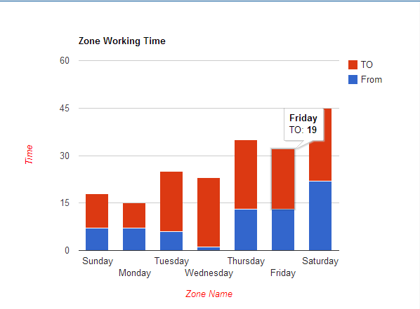

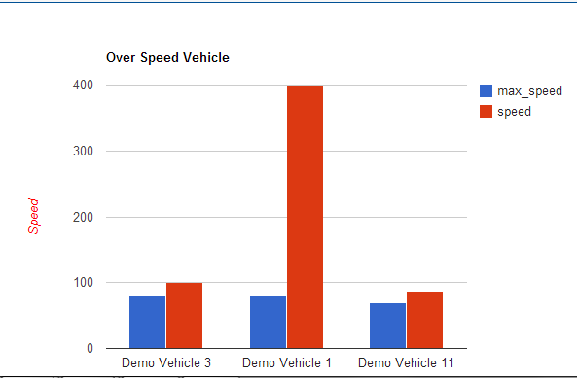

**Content Management System (CMS) – Orchard**

## Custom content management system (CMS) helps to organize projects in a media-independent environment. This system has been designed to allow admin and clients to collaborate on many levels in the content creation process.

* Essentially aims at helping you build web sites from existing pieces.
* With the use of a standard Web browser you can access your content and make real-time edits and additions.

