SINGLY LINKED LIST

PROGRAM

#include <iostream>
using namespace std;
struct node {
int data;
node *next;
};
node *head = NULL;
void insert(int value) {
node *newnode = new node;
newnode->data = value;
newnode->next = NULL;
if (head == NULL) {
head = newnode;
} else {
node *temp = head;
while (temp->next != NULL) {
temp = temp->next;
}
temp->next = newnode;
}
}
void deleteNode() {
if (head == NULL) {
cout << "List is Empty\n";
return;
}
node *temp = head;
head = head->next;
delete temp;
}
void traverse() {
node *temp = head;
while (temp != NULL) {
cout << temp->data << " ";
temp = temp->next;
}
cout << endl;
}
void display() {
node *temp = head;
cout << "List: ";
while (temp != NULL) {
cout << temp->data << " -> ";
temp = temp->next;
}
cout << "NULL" << endl;
}
int main() {
insert(10);
insert(20);
insert(30);
display();
cout << "Traverse: ";
traverse();
deleteNode();
cout << "After Deletion: ";
display();
return 0;
}

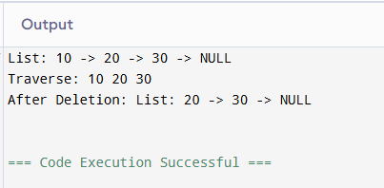

DOUBLY LINKED LIST

PROGRAM

#include <iostream>
using namespace std;
struct node{
int data;
node *next, *prev;
};
node *head = NULL;
void insert(int value){
node *newnode = new node;
newnode->data = value;
newnode->next = NULL;
newnode->prev = NULL;
if (head == NULL) {
head = newnode;
}
else
{
node *temp = head;

while (temp->next != NULL){
temp = temp->next;
}
temp->next = newnode;
newnode->prev = temp;
}
}
void deletenode(){
if (head == NULL) {
cout << "List is empty" << endl;
return;
}
node *temp = head;
head = head->next;
if (head != NULL) {
head->prev = NULL;
}
delete temp;
}
void traverse(){
node *temp = head;
while (temp != NULL){
cout << temp->data << " ";
temp = temp->next;
}
cout << endl;
}
void display()
{
node *temp = head;
cout << "List: ";
while (temp != NULL)
{
cout << temp->data << " <-> ";
temp = temp->next;
}
cout << "NULL" << endl;
}
int main()
{
insert(10);
insert(20);
insert(30);
display();
cout << "Traverse: ";
traverse();
deletenode();
cout << "After deletion:" << endl;
display();
return 0;
}

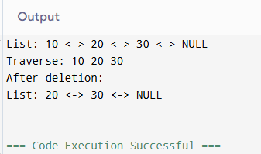

CIRCULAR LINKED LIST

PROGRAM

#include <iostream>
using namespace std;
struct node{
int data;
node *next;
};
node *head = NULL;
void insert(int value){
node *newnode = new node;
newnode->data = value;
if (head == NULL) {
head = newnode;
newnode->next = head;
}
else {
node *temp = head;
while (temp->next != head){
temp = temp->next;
}
temp->next = newnode;
newnode->next = head;
}
}
void deletenode(){
if (head == NULL){
cout << "List is empty" << endl;
return;
}
if (head->next == head) {
delete head;
head = NULL;
return;
}
node *last = head;
while (last->next != head) {
last = last->next;
}
node *temp = head;
head = head->next;
last->next = head;
delete temp;
}
void traverse(){
if (head == NULL) {
cout << "List is empty" << endl;
return;
}
node *temp = head;
do{
cout << temp->data << " ";
temp = temp->next;
} while (temp != head);
cout << endl;
}
void display(){
if (head == NULL)
{
cout << "List: NULL" << endl;
return;
}
node *temp = head;
cout << "List: ";
do{
cout << temp->data << " -> ";
temp = temp->next;
} while (temp != head);
cout << " HEAD " << endl;
}
int main()
{
insert(10);
insert(20);
insert(30);
display();
cout << "Traverse: ";
traverse();
deletenode();
cout << "After deletion:" << endl;
display();
return 0;
}
