#include<iostream>
#include<string>
using namespace std;
int main(){
string str;
cout<<"Enter a string :";
getline(cin,str);
int n=str.length();
for(int i=0;i<n/2;i++){
char temp=str[i];
str[i]=str[n-i-1];
str[n-i-1]=temp;
}
cout<<"Reversed String :"<<str<<endl;
return 0;

}

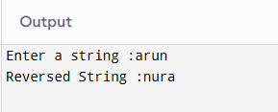

#include <iostream>
#include <string>
#include <algorithm>
using namespace std;

int main()
{
string str, word;

cout << "Enter a Sentence: ";
getline(cin, str);

str += ' '; // Add a space at the end

for (int i = 0; i < str.length(); i++)
{
if (str[i] == ' ')
{
reverse(word.begin(), word.end());
cout << word << " ";
word = "";
}
else
{
word += str[i];
}
}

return 0;
}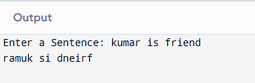

#include <iostream>
#include <string>
#include <stack>
using namespace std;

int main()
{
string exp;
cout << "Enter postfix expression: ";
cin >> exp;

stack<int> s;

for (char ch : exp)
{
if (isdigit(ch))
{
s.push(ch - '0');
}
else
{
int val2 = s.top();
s.pop();

int val1 = s.top();
s.pop();

switch (ch)
{
case '+':
s.push(val1 + val2);
break;

case '-':
s.push(val1 - val2);
break;

case '*':
s.push(val1 * val2);
break;

case '/':
s.push(val1 / val2);
break;
}
}
}

cout << "Result = " << s.top() << endl;

return 0;
}
