1.READ AND DISPLAY ARRAY ELAMENT

#include <iostream>
using namespace std;
int main() {
int arr[100],n;
cout<<"enter the number element :";
cin>>n;
cout<<"entr array element";
for(int i=0;i<n;i++){
cin>>arr[i];
}
cout<<"array element are :";
for(int i=0;i<n;i++){
cout<<arr[i]<<" ";
}
return 0;
}

OUTPUT:

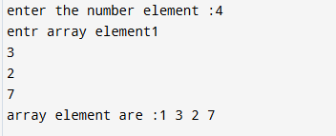

2. SEARCH AN ELEMENT IN AN ARRAY(LINEAR SEARCH)

#include <iostream>
using namespace std;
int main() {
int arr[100],n,key;
bool found=false;
cout<<"enter the number element :";
cin>>n;
cout<<"entr array element :";
for(int i=0;i<n;i++){
cin>>arr[i];
}
cout<<"enter the search element:";
cin>>key;
for(int i=0;i<n;i++){
if(arr[i]==key){
cout<<"element found at position :"<<i+1;
found=true;
break;
}
}
if(! found){
cout<<"element not found";
}
return 0;
}
OUTPUT:

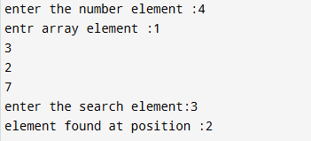

3. REVERSE AN ARRAY

#include <iostream>
using namespace std;
int main() {
int arr[100],n;
cout<<"enter the number element :";
cin>>n;
cout<<"entr array element :";
for(int i=0;i<n;i++){
cin>>arr[i];
}
cout<<" reversed array is :";
for(int i=n-1;i>=0;i--){
cout<<arr[i]<<"";
}
return 0;

}

OUTPUT:

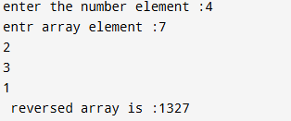

1.FIND SMALLEST AND LARGEST ELEMENT

#include <iostream>
using namespace std;
int main() {
int arr[100],n;

cout<<"enter the number element :";
cin>>n;
cout<<"enter array element :";
for(int i=0;i<n;i++){
cin>>arr[i];
}

int smallest=arr[0];
int largest = arr[0];
for(int i=0;i<n;i++){
if(arr[i]<smallest)
smallest=arr[i];
if(arr[i]>largest)
largest=arr[i];
}
cout<<"smallest= "<<smallest<<endl;
cout<<"largest="<<largest<<endl;

return 0;

}

OUTPUT:

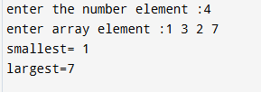

2.MERGE TWO ARRAY

#include <iostream>
using namespace std;
int main() {
int a[100],b[100],c[100],n1,n2;

cout<<"enter the size of first array :";
cin>>n1;
cout<<"enter first array element :";
for(int i=0;i<n1;i++){
cin>>a[i];
}
cout<<"enter the size of second array :";
cin>>n2;
cout<<"enter second array element :";
for(int i=0;i<n2;i++){
cin>>b[i];
}

for(int i=0;i<n1;i++){
c[i]=a[i];

}

for(int i=0;i<n2;i++){
c[i+n1]=b[i];
}
cout<<"merged array:\n";
for(int i=0;i<n1+n2;i++)
cout<<c[i]<<" ";
return 0;
}

OUTPUT:
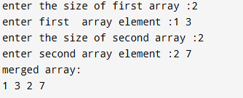

3.FIND THE SUM OF ALL ELEMENTS

#include <iostream>
using namespace std;
int main() {
int arr[100],n,sum=0;
cout<<"enter the number element :";
cin>>n;
cout<<"entr array element :";
for(int i=0;i<n;i++){
cin>>arr[i];
}

for(int i=0;i<n;i++){
sum+=arr[i];
}
cout<<"sum="<<sum;
return 0;
}

OUTPUT:

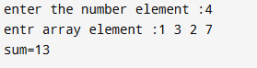

4. READ AND DISPLAY 2D ARRAY

#include <iostream>
using namespace std;
int main() {
int arr[10][10],r,c;
cout<<"Enter row and column :";
cin>>r>>c;
cout<<"enter array element :";
for(int i=0;i<r;i++){
for(int j=0;j<c;j++)
cin>>arr[i][j];
}
cout<<"matrix :\n";
for(int i=0;i<r;i++){
for(int j=0;j<c;j++){
cout<<arr[i][j]<<" ";
}
cout<<endl;
}
return 0;
}

OUTPUT:
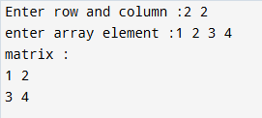

5.RTANSPOSE OF A MATRIX

#include <iostream>
using namespace std;
int main() {
int arr[10][10],r,c;
cout<<"Enter row and column :";
cin>>r>>c;
cout<<"enter array element :";
for(int i=0;i<r;i++){
for(int j=0;j<c;j++)
cin>>arr[i][j];
}
cout<<" Transpose matrix :\n";
for(int i=0;i<r;i++){
for(int j=0;j<c;j++){
cout<<arr[j][i]<<" ";
}
cout<<endl;
}
return 0;
}

OUTPUT:

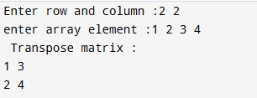

6.REVERSE A 2D ARRAY

#include <iostream>
using namespace std;
int main() {
int arr[10][10],r,c;
cout<<"Enter row and column :";
cin>>r>>c;
cout<<"enter array element :";
for(int i=0;i<r;i++){
for(int j=0;j<c;j++)
cin>>arr[i][j];
}
cout<<" Revetsed matrix :\n";
for(int i=r-1;i>=0;i--){
for(int j=c-1;j>=0;j--){
cout<<arr[j][i]<<" ";
}
cout<<endl;
}
return 0;
}

OUTPUT:
