NAME: G.Ayyappa venkata sai

Reg no: 192372111

Course : Theory of computations (CSA1303)

Exercise 1
Write a C program to simulate a Deterministic Finite Automata (DFA) for the given language representing strings that start with a and end with a

Code:
#include <stdio.h> #include <string.h> int main() {
char str[100]; scanf("%s", str); int n = strlen(str);
if (str[0] == 'a' && str[n - 1] == 'a') printf("Accepted");
else
printf("Rejected"); return 0;
}

Output:

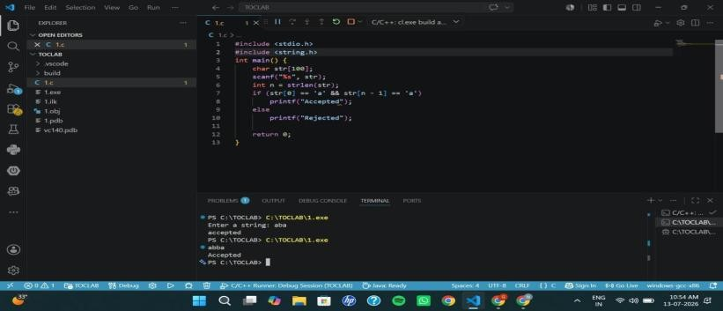

Exercise 2
Write a C program to simulate a Deterministic Finite Automata (DFA) for the given language representing strings that start with 0 and end with 1

Code:
#include <stdio.h> #include <string.h> int main() {
char str[100]; scanf("%s", str); int n = strlen(str);
if (str[0] == '0' && str[n - 1] == '1') printf("Accepted");
else
printf("Rejected"); return 0;
}

Output:
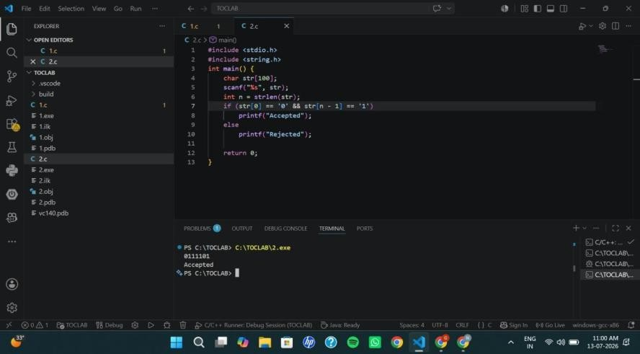

Exercise 3
Write a C program to check whether a given string belongs to the language defined by a Context Free Grammar (CFG)
S → 0A1 A → 0A | 1A | ε

Code:
#include <stdio.h> #include <string.h> int main() {
char str[100]; int len;
printf("Enter a string: "); scanf("%s", str);
len = strlen(str);
if (len >= 2 && str[0] == '0' && str[len - 1] == '1') printf("String Accepted");
else
printf("String Rejected"); return 0;
}

Output:
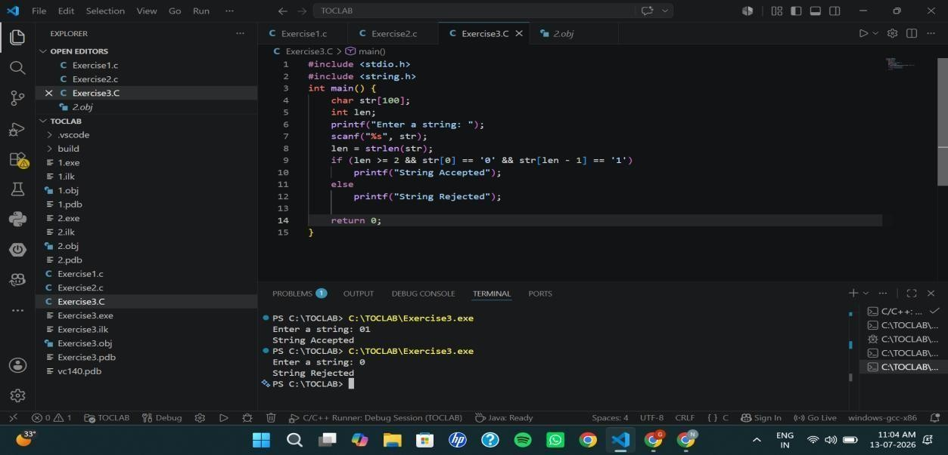

Exercise 4
Write a C program to check whether a given string belongs to the language defined by a Context Free Grammar (CFG)
S → 0S0 | 1S1 | 0 | 1 | ε

Code:
#include <stdio.h> #include <string.h> int main() {
char str[100];
int i, len, flag = 1;
printf("Enter a binary string: "); scanf("%s", str);
len = strlen(str);
for (i = 0; i < len / 2; i++) { if (str[i] != str[len - i - 1]) {
flag = 0; break;
}
}
if (flag)
printf("String Accepted"); else
printf("String Rejected"); return 0;
}

Output:
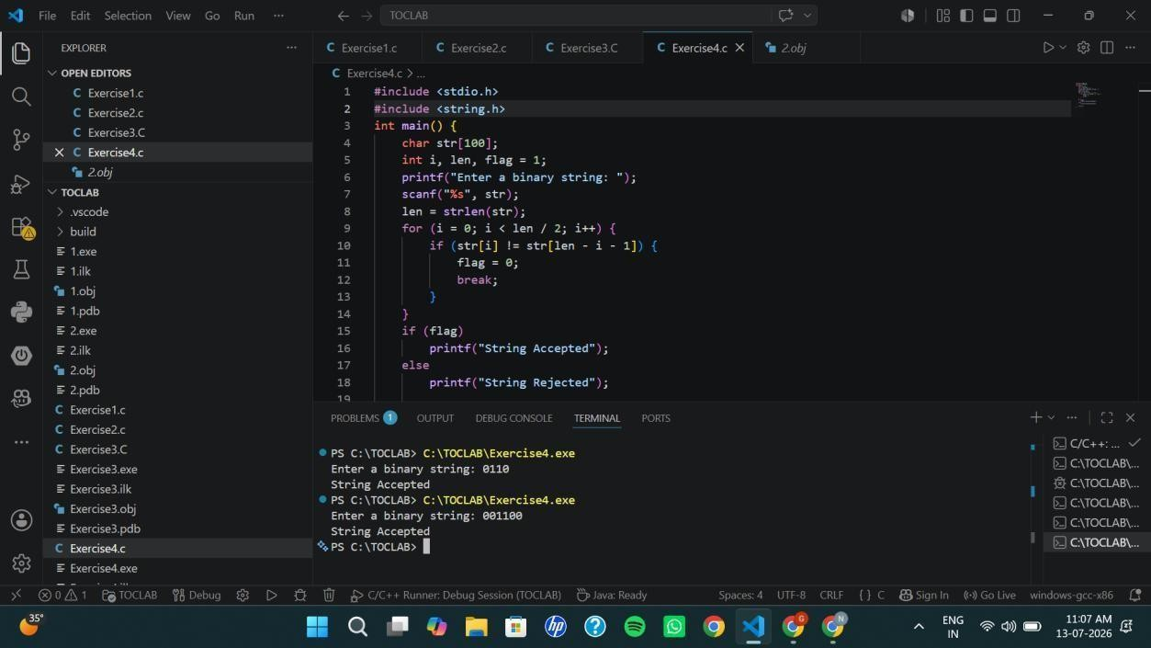

Exercise 5
Write a C program to check whether a given string belongs to the language defined by a Context Free Grammar (CFG)
S → 0S0 | A A → 1A | ε

Code:
#include <stdio.h> #include <string.h> int main() {
char s[100];
int i, n, count = 0; printf("Enter string: "); scanf("%s", s);
n = strlen(s);
while (s[count] == '0') count++;
for (i = count; i < n - count; i++) { if (s[i] != '1') {
printf("Rejected"); return 0;
}
}
if (count * 2 <= n) printf("Accepted");
else
printf("Rejected"); return 0;
}

Output:

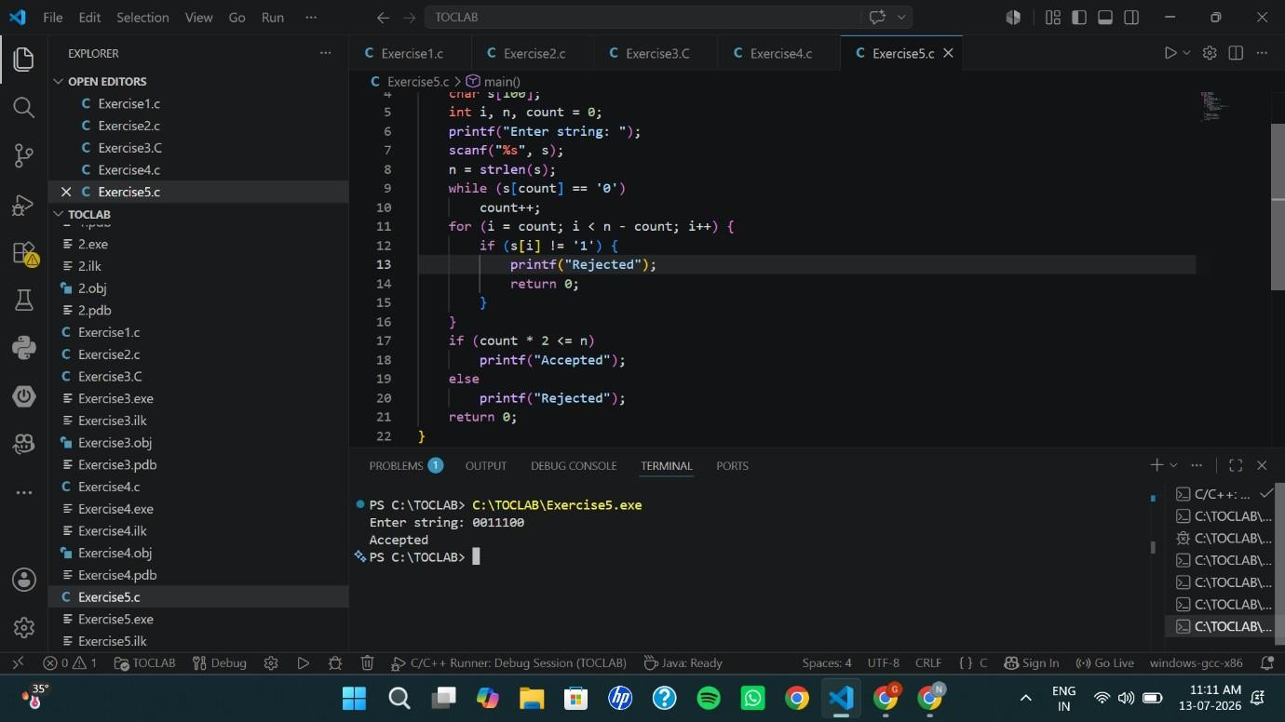

Exercise 6
Write a C program to check whether a given string belongs to the language defined by a Context Free Grammar (CFG)
S → 0S1 | ε

Code:
#include <stdio.h> #include <string.h> int main() {
char s[100]; int i, n; scanf("%s", s); n = strlen(s);
for(i = 0; i < n/2; i++)
if(s[i] != '0' || s[n-i-1] != '1') break;
if(i == n/2 && n%2 == 0) printf("Accepted");
else
printf("Rejected");
}

Output:
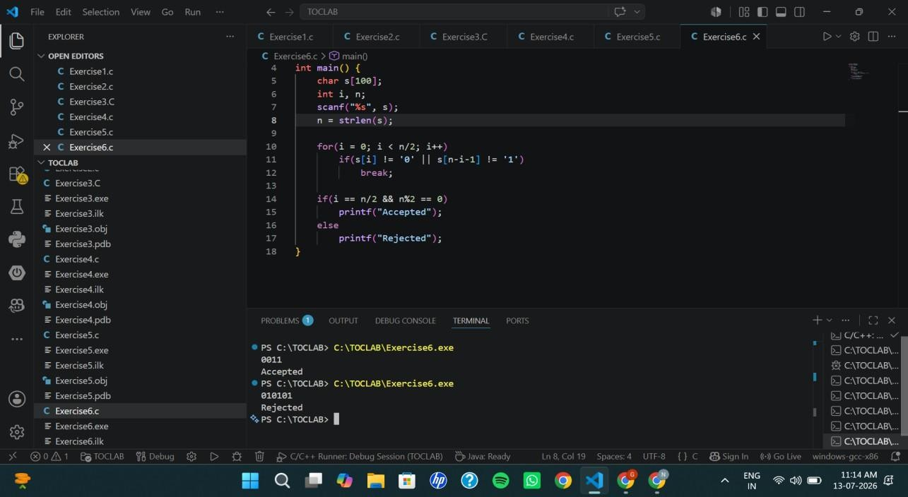

Exercise 7
Write a C program to check whether a given string belongs to the language defined by a Context Free Grammar (CFG)
S → A101A, A → 0A | 1A | ε

Code:
#include <stdio.h> #include <string.h> int main() {
char s[100]; scanf("%s", s);
if (strstr(s, "101")) printf("Accepted");
else
printf("Rejected"); return 0;
}

Output:
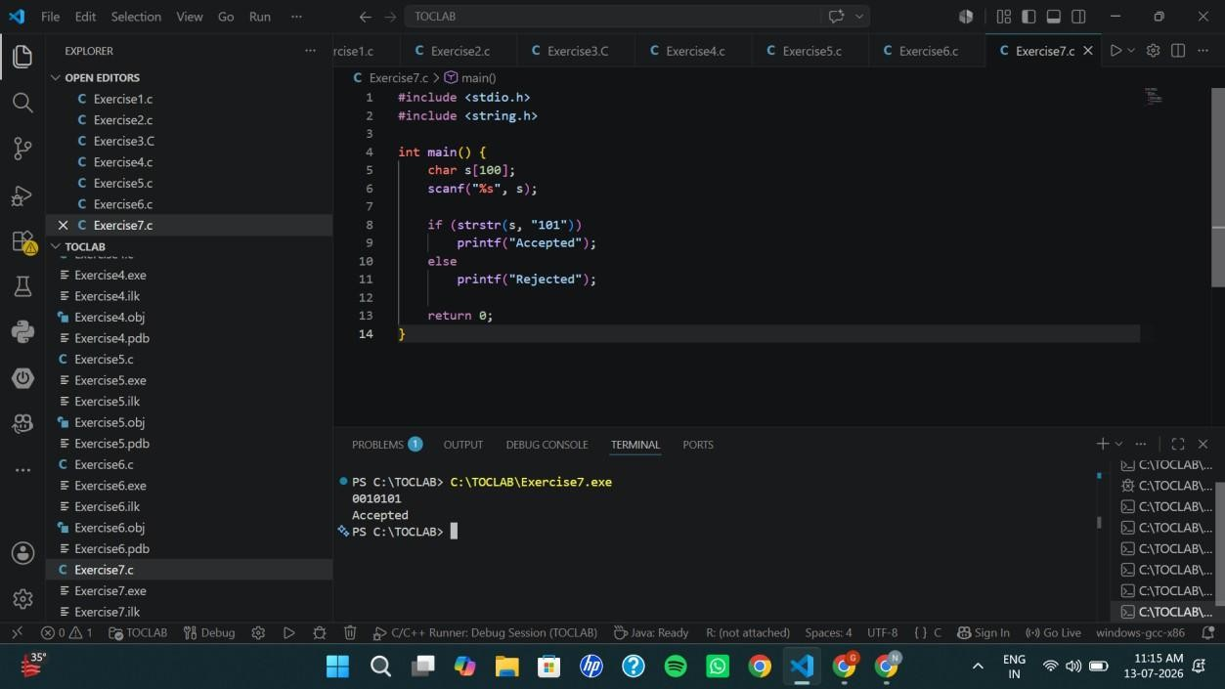

Exercise 8:
Write a C program to simulate a Non-Deterministic Finite Automata (NFA) for the given languagerepresenting strings that start with b and end with a

Code:
#include <stdio.h> #include <string.h>
int main() { char str[100]; int len;

printf("Enter the string: "); scanf("%s", str);

len = strlen(str);

// NFA Acceptance Condition
if (len > 0 && str[0] == 'b' && str[len - 1] == 'a') printf("String Accepted by NFA\n");
else
printf("String Rejected by NFA\n");

return 0;
}

Output:
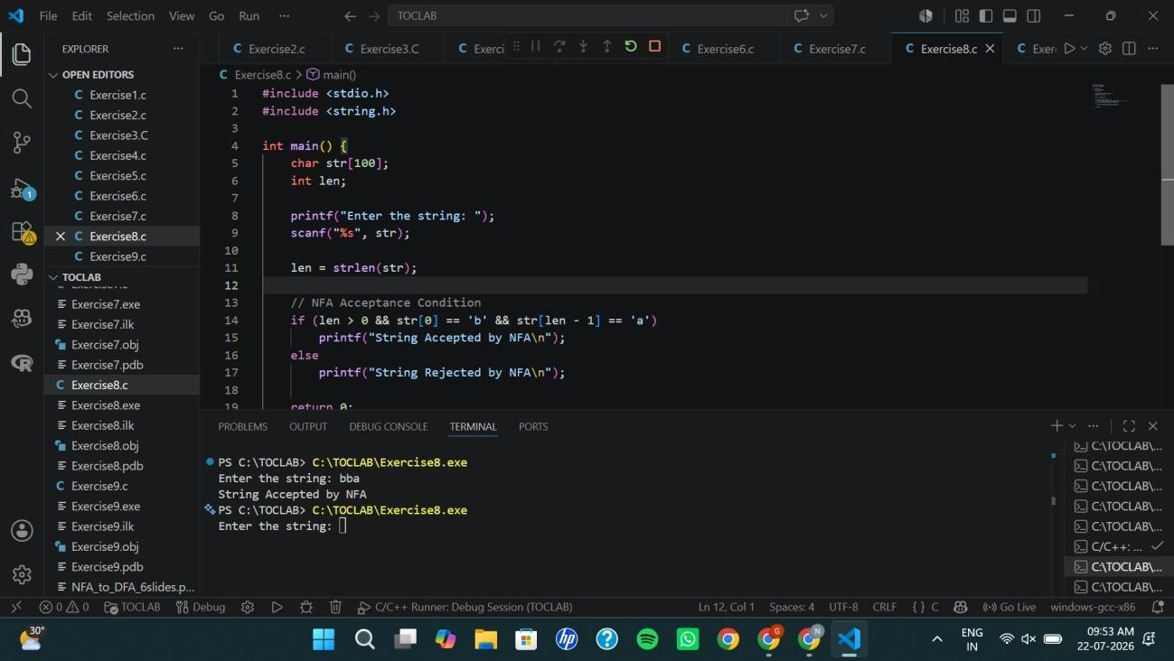

Exercise 9
Write a C program to simulate a Non-Deterministic Finite Automata (NFA) for the given languagerepresenting strings that start with o and end with 1

Code:
#include <stdio.h> #include <string.h>

int main() { char str[100]; int len;

printf("Enter the string: "); scanf("%s", str);

len = strlen(str);

// NFA Acceptance Condition
if (len > 0 && str[0] == '0' && str[len - 1] == '1') printf("String Accepted by NFA\n");
else
printf("String Rejected by NFA\n");

return 0;
}

Output:
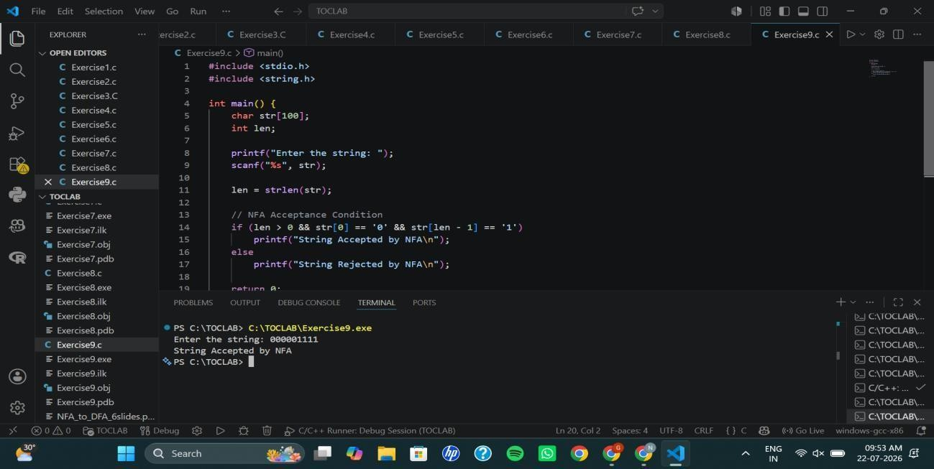

Exercise 10
Write a C program to find ε -closure for all the states in a Non-Deterministic Finite Automata (NFA) with ε -moves.

Code:
#include <stdio.h> int main() {
int n, e[10][10]; int i, j;
printf("Enter number of states: "); scanf("%d", &n);
printf("Enter epsilon transition matrix:\n"); for(i = 0; i < n; i++) {
for(j = 0; j < n; j++) { scanf("%d", &e[i][j]);
}
}
for(i = 0; i < n; i++) {
printf("\nE-Closure(q%d) = { q%d", i, i); for(j = 0; j < n; j++) {
if(e[i][j] == 1)
printf(", q%d", j);
}
printf(" }\n");
}
return 0;
}

Output:
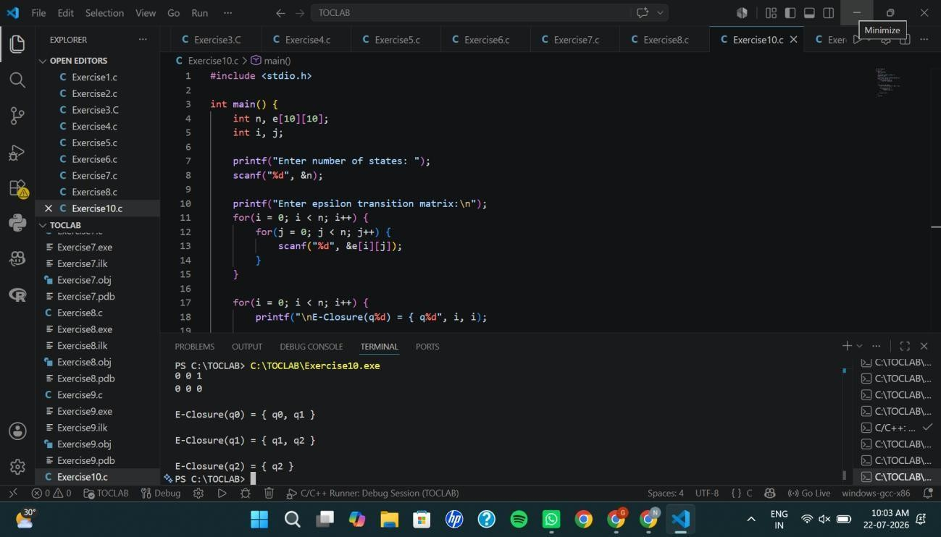

Exercise 11:
Write a C program to find ε -closure for all the states in a Non-Deterministic Finite Automata (NFA) with ε -moves.

Code:
#include <stdio.h> int main() {
int n, e[10][10]; int i, j;
printf("Enter number of states: "); scanf("%d", &n);
printf("Enter epsilon transition matrix:\n"); for(i = 0; i < n; i++) {
for(j = 0; j < n; j++) { scanf("%d", &e[i][j]);
}
}
for(i = 0; i < n; i++) {
printf("\nE-Closure(q%d) = { q%d", i, i); for(j = 0; j < n; j++) {
if(e[i][j] == 1)
printf(", q%d", j);
}
printf(" }\n");
}
return 0;
}

Output


Exercise 12: Output :
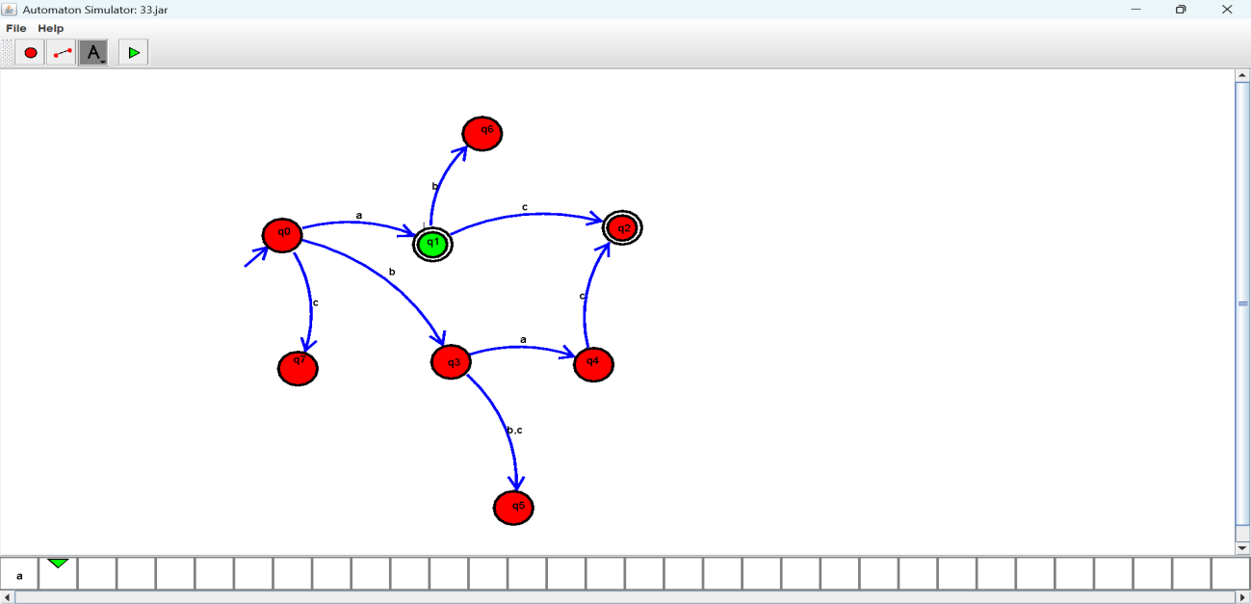

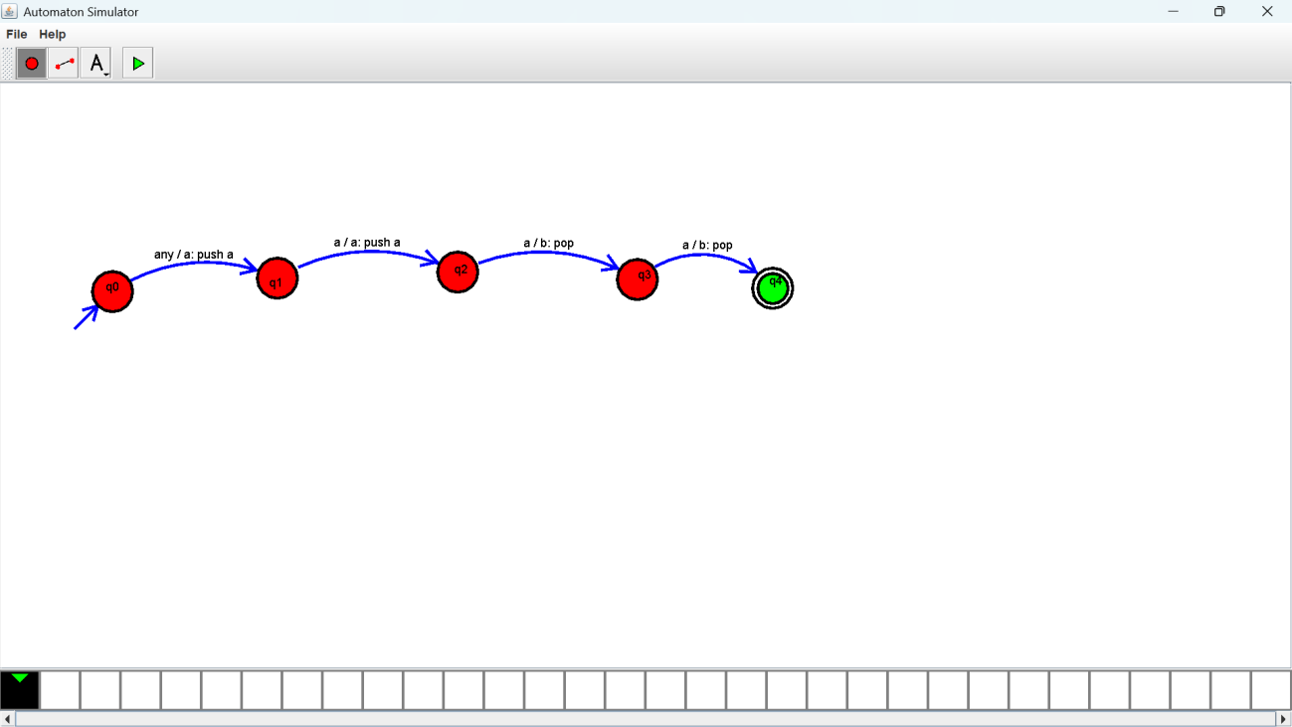
Exercise 13: Output :

Exercise 14: Output :

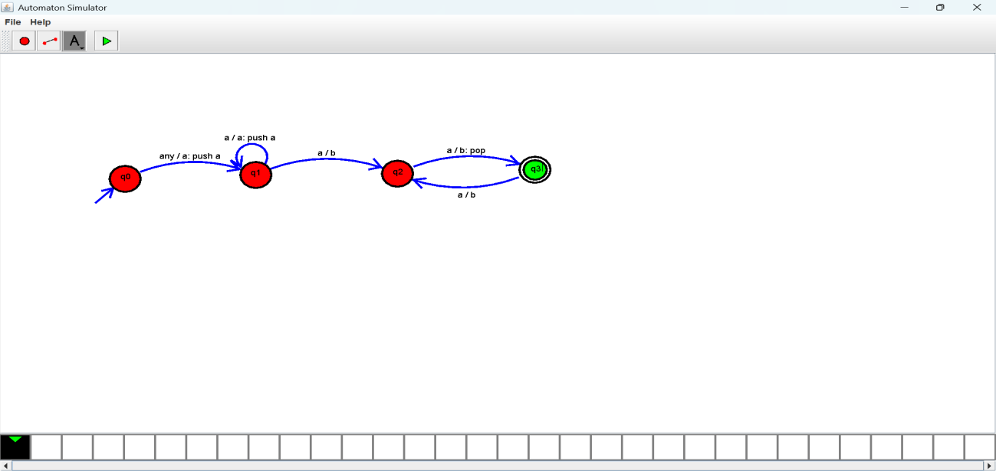

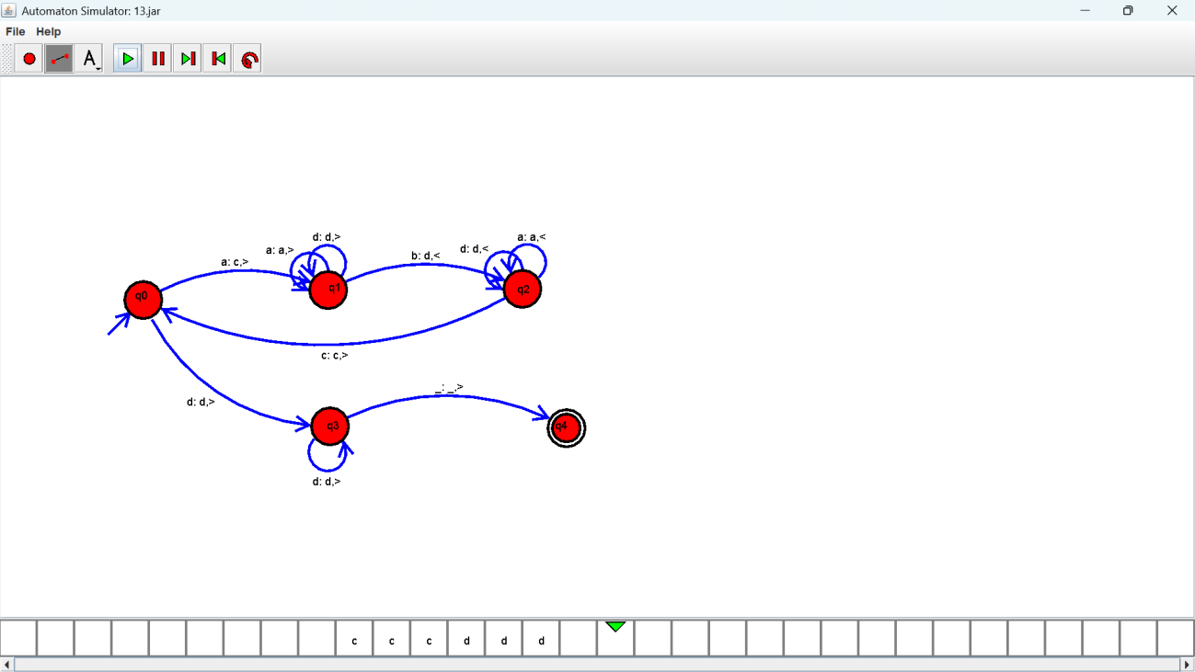
Exercise 15: Output :

Exercise 16: Output :

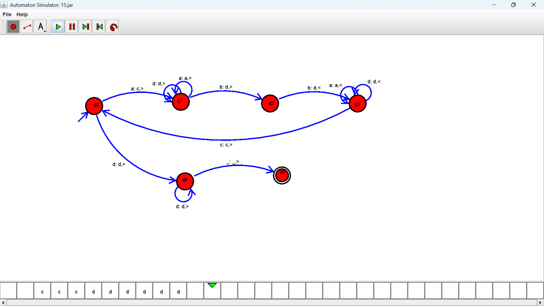

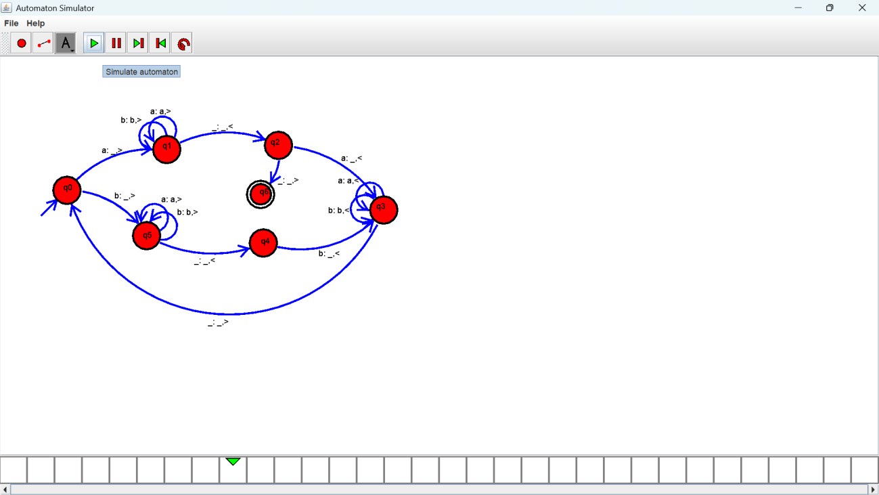
Exercise 17: Output :

Exercise 18: Output :

Exercise 19: Output :
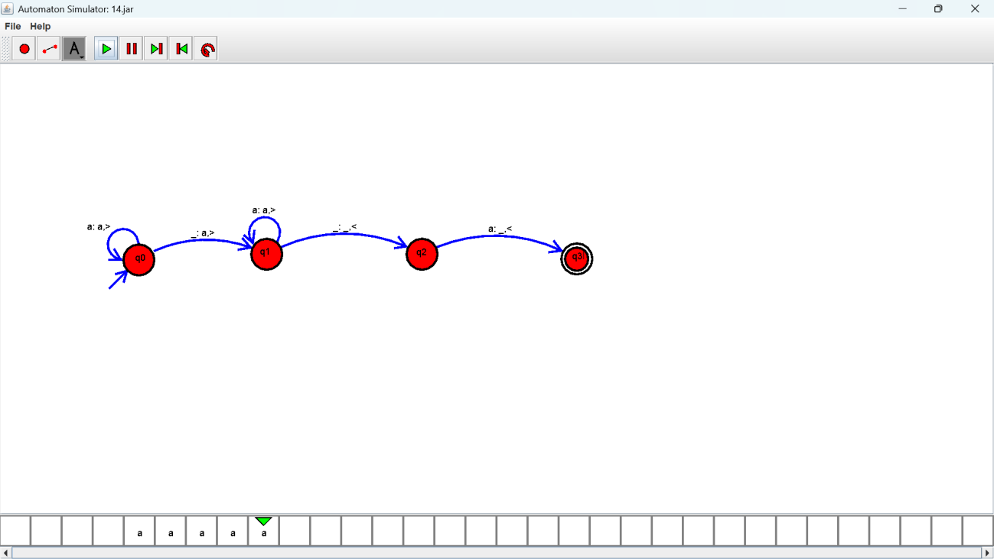

Exercise 20:
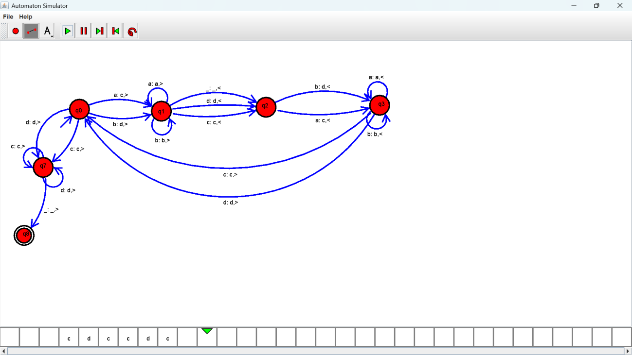

Output :

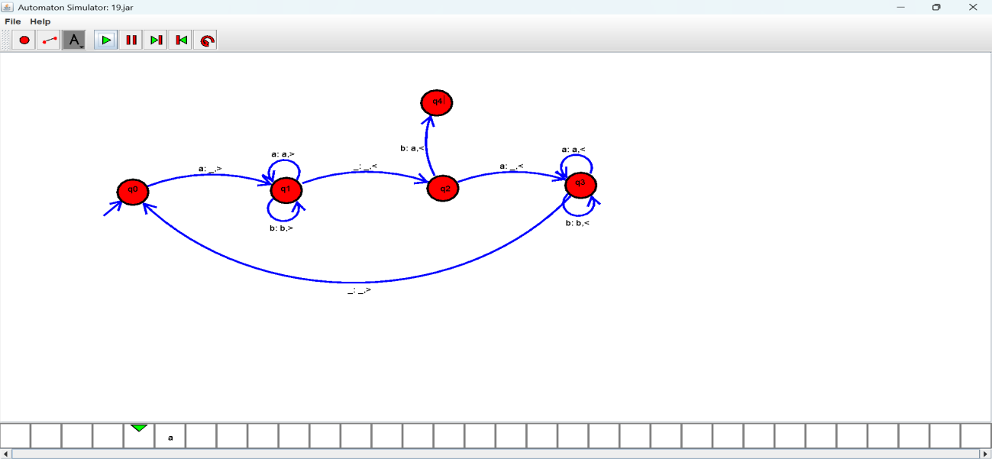

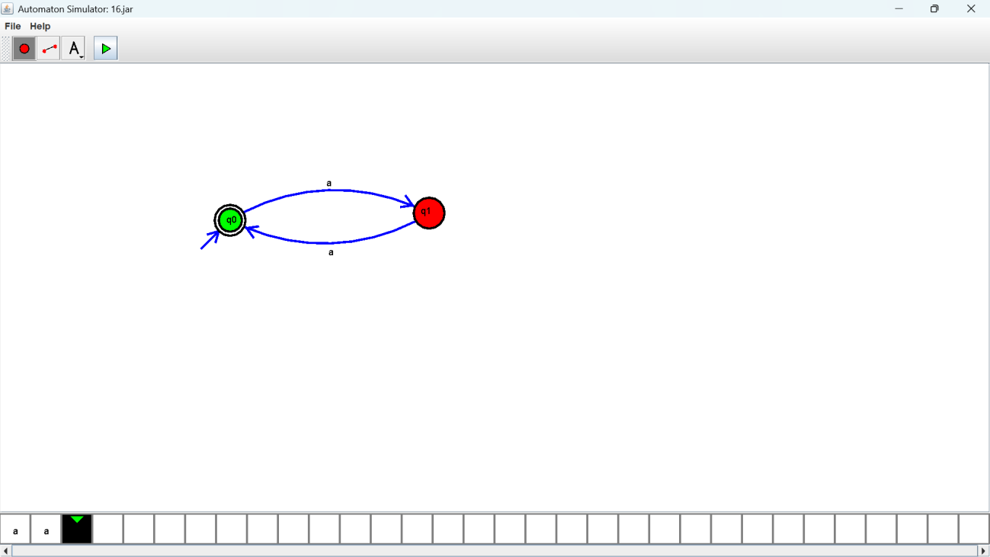
Exercise 21: Output :

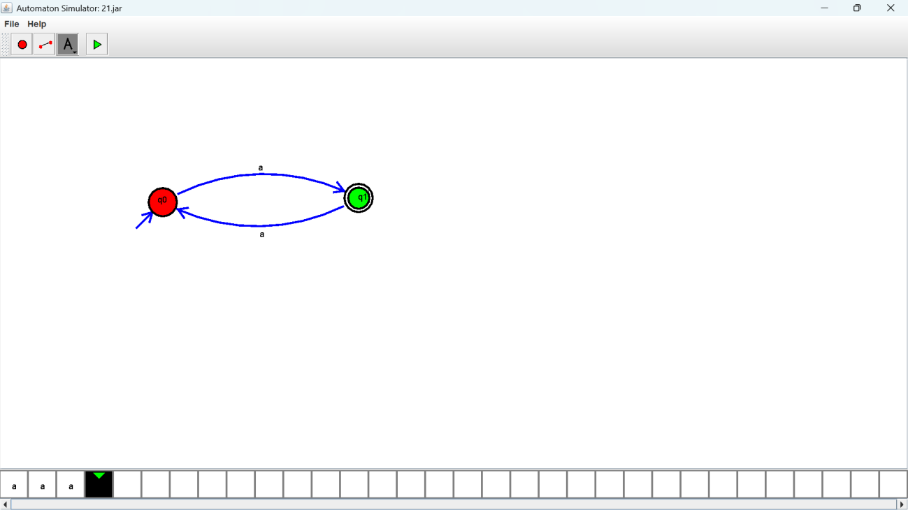
Exercise 22: Output :

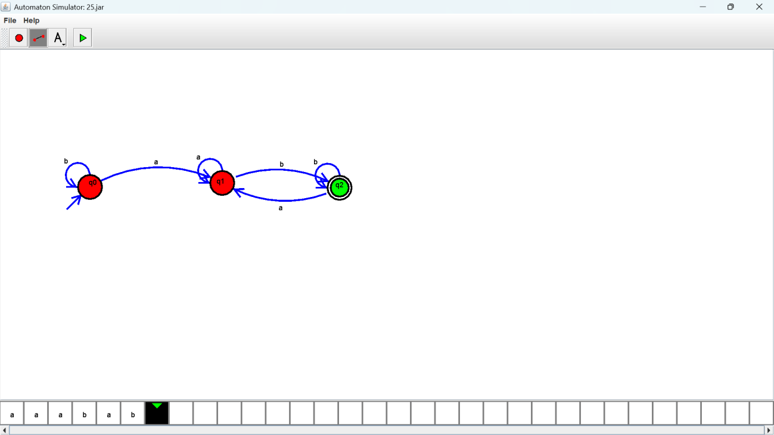
Exercise 23: Output :

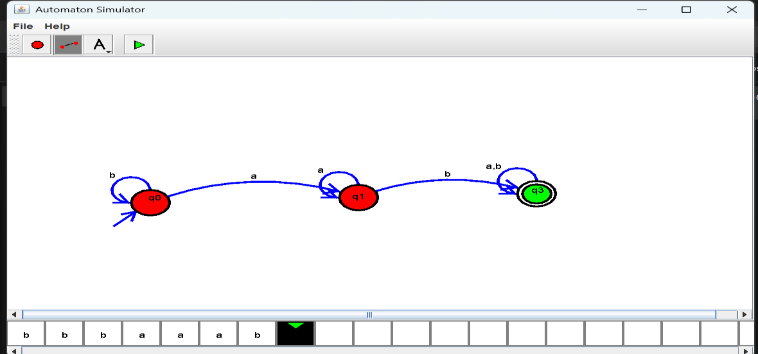
Exercise 24: Output :

Exercise 25: Output :

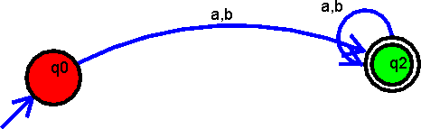

Exercise 26: Output :

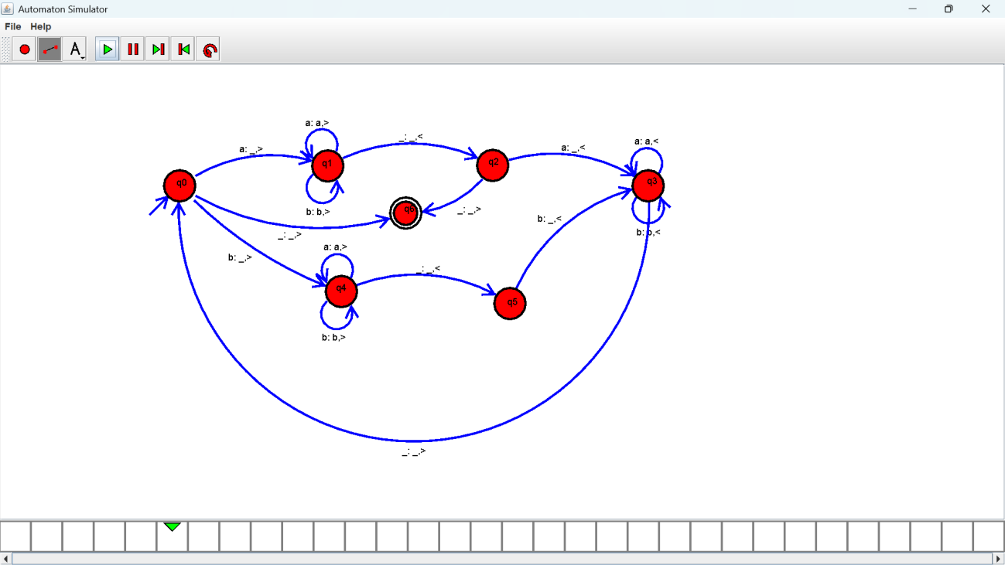

Exercise 27: Output :

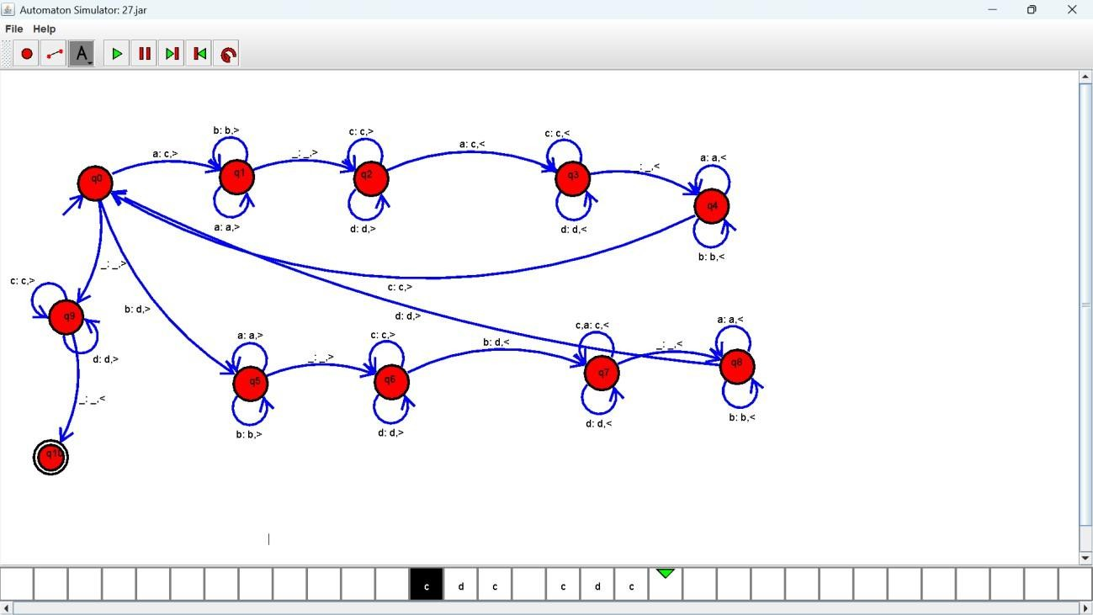

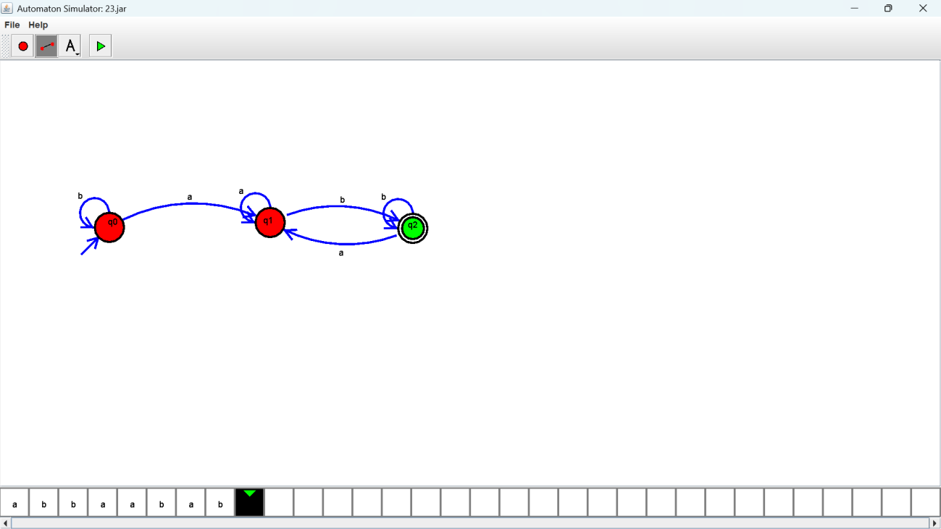
Exercise 28: Output :

Exercise 29: Output :
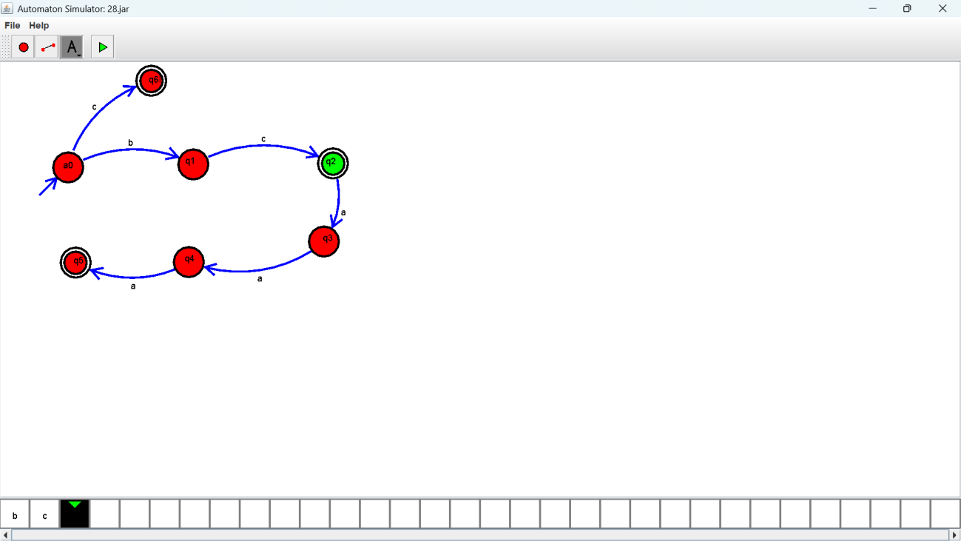

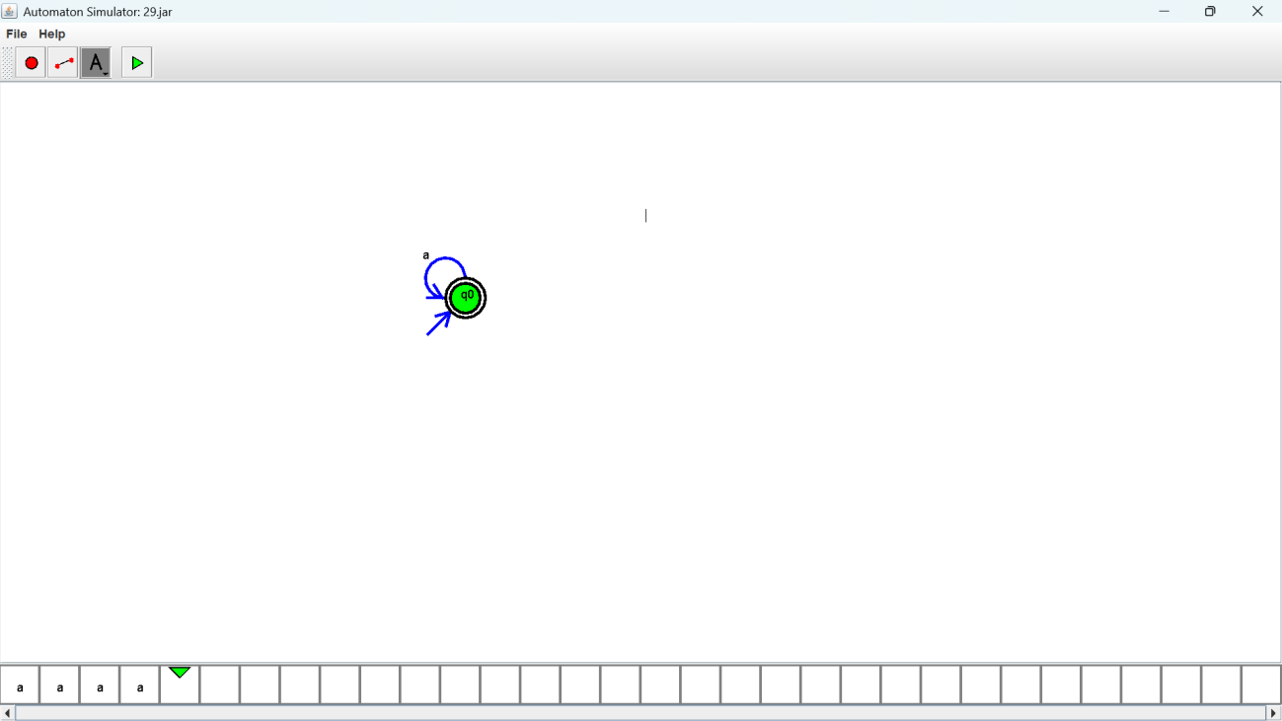
Exercise 30: Output :

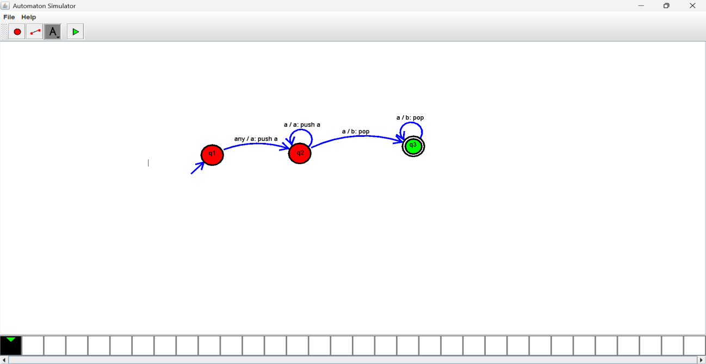
Exercise 31: Output :


Exercise 32: Output :

Exercise 33: Output :
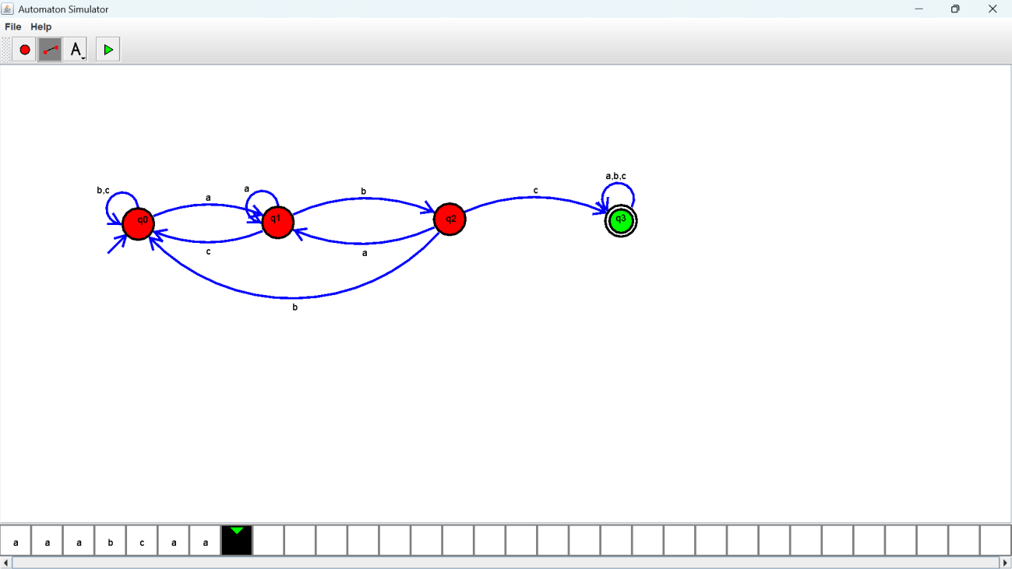

Exercise 34: Output :
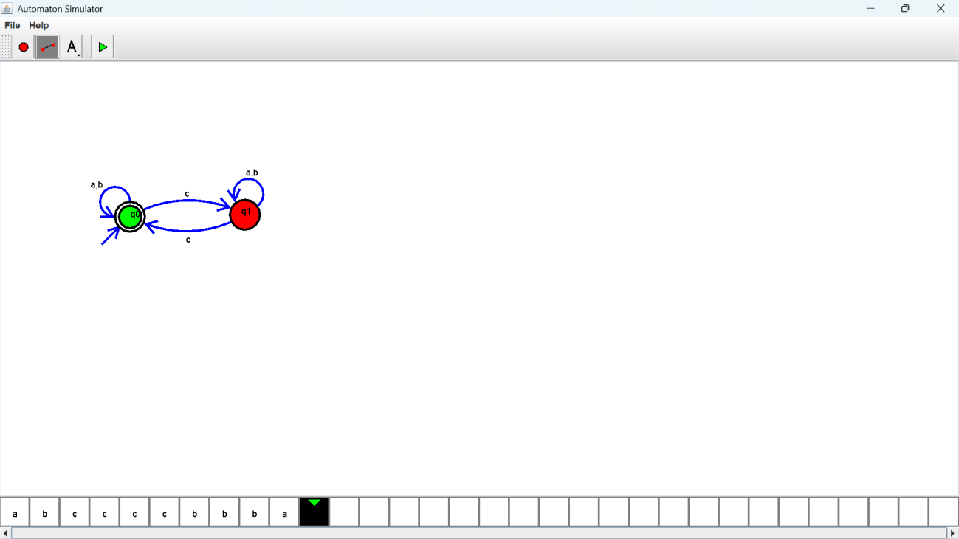

Exercise 35: Output :
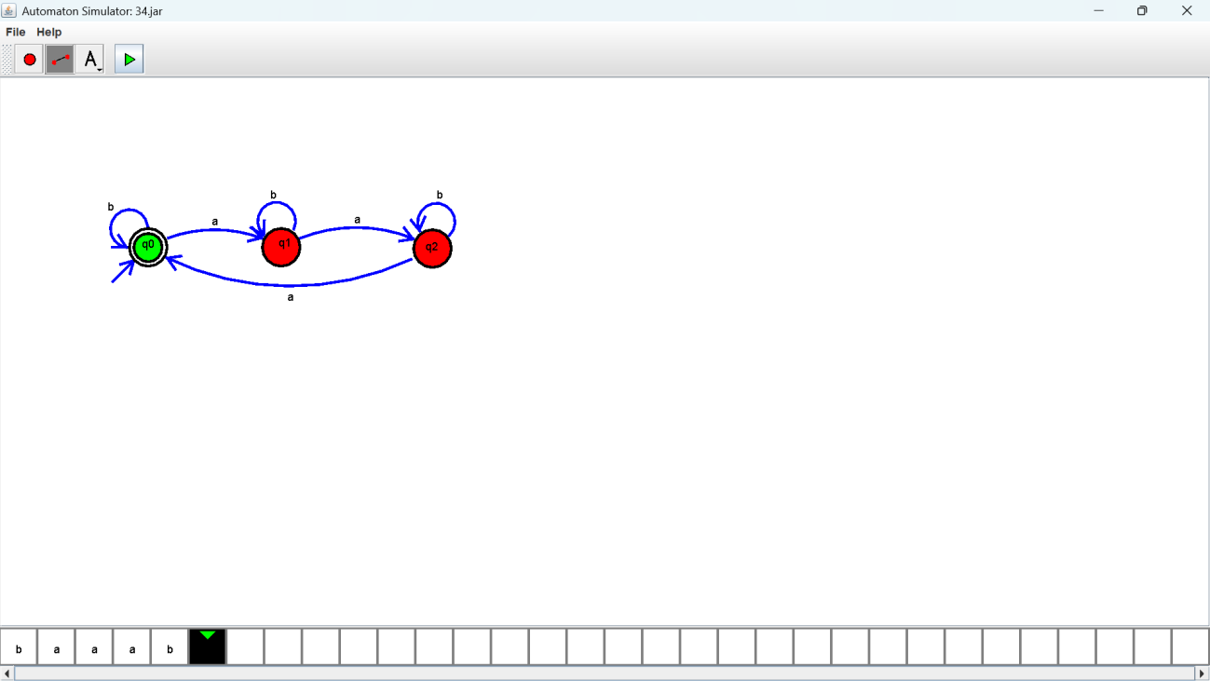

Exercise 36: Output :
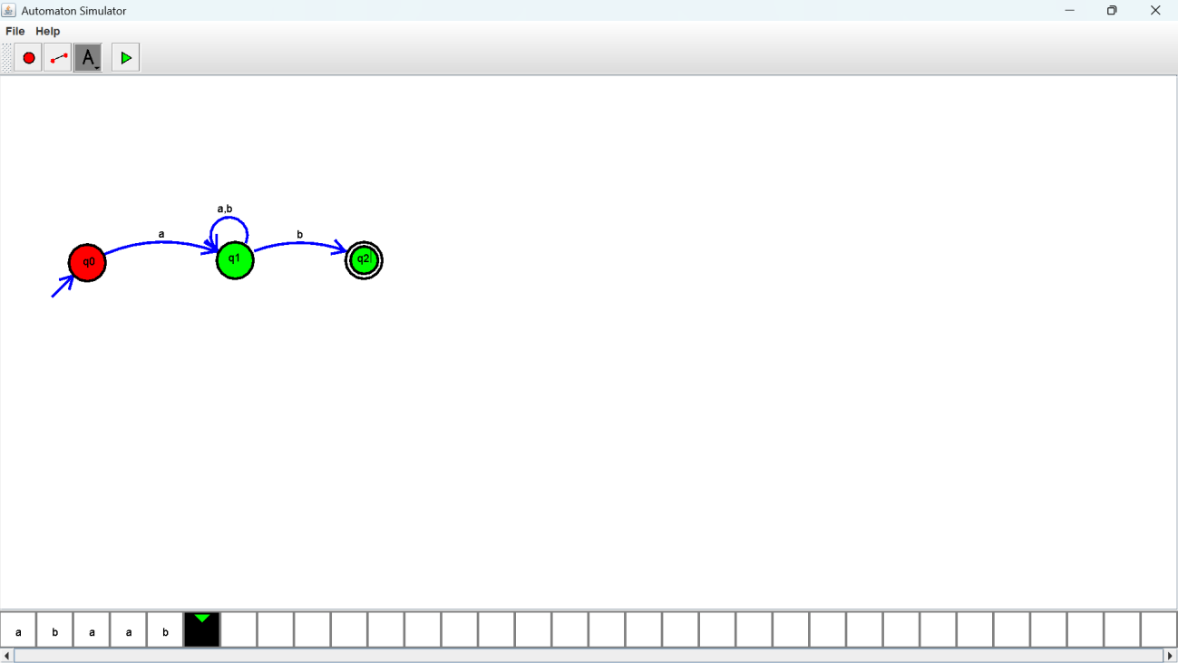

Exercise 37: Output :
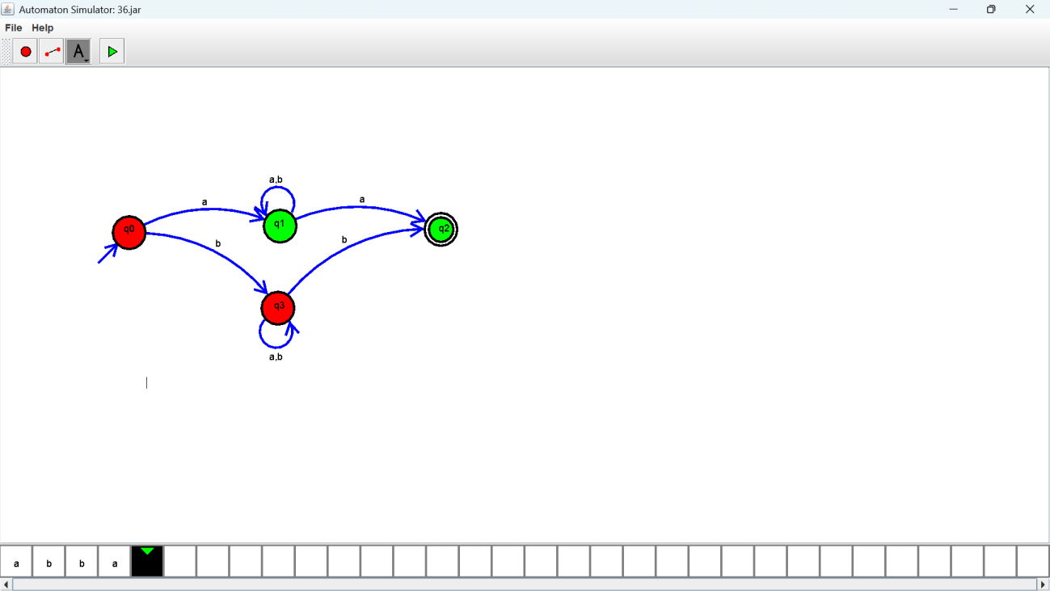

Exercise 38: Output :
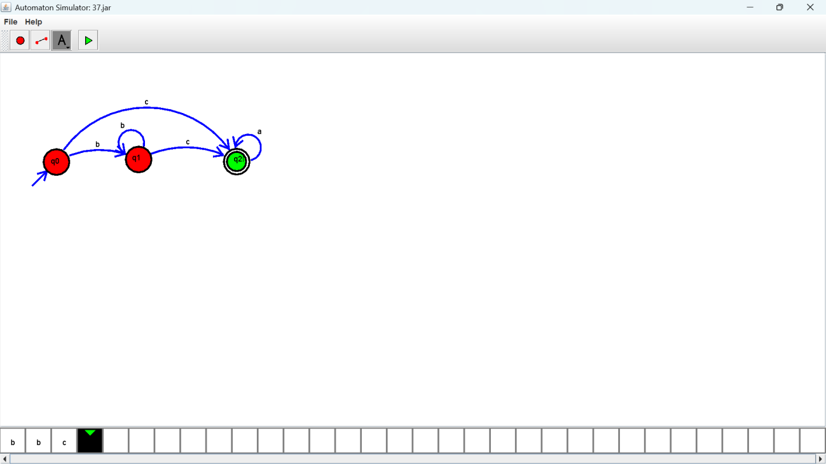

Exercise 39: Output :
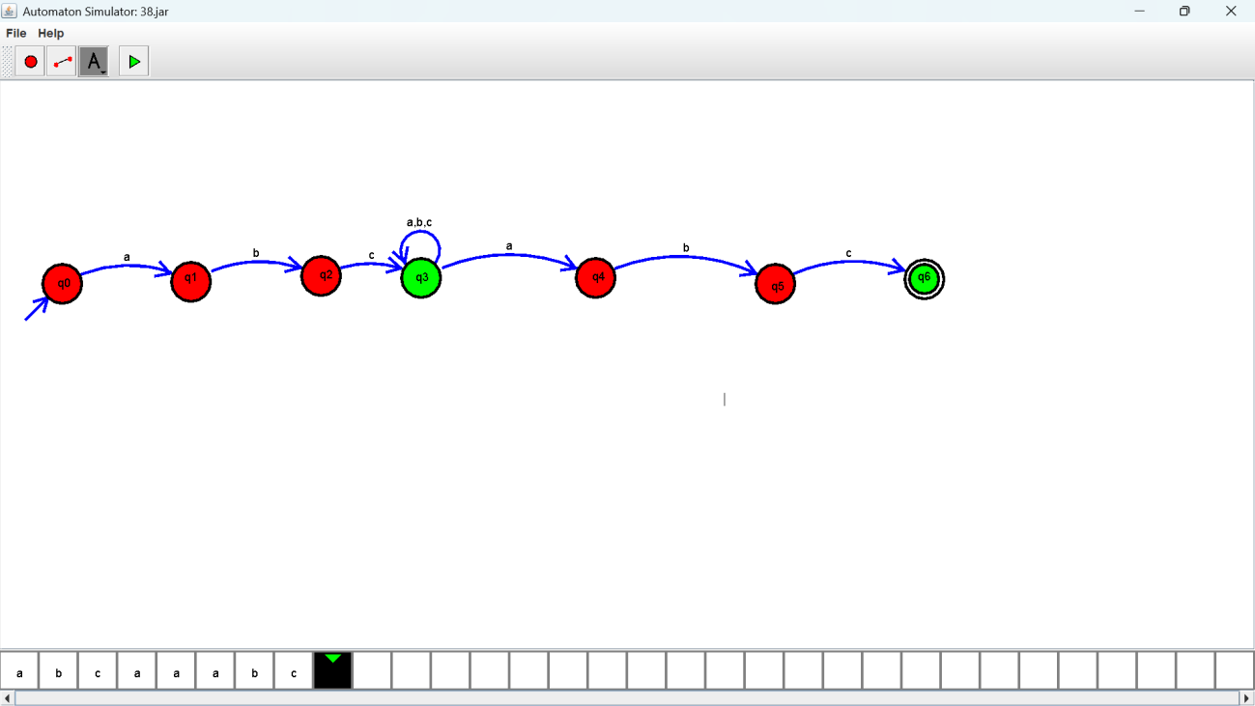

Exercise 40: Output :
