ASSIGNMENT-1

G. Ayyappa venkata sai

Rg.no : 192372111

1. Two Sum

Given an array of integers nums and an integer target, return indices of the two numbers such that they add up to target. You may assume that each input would have exactly one solution, and you may not use the same element twice. You can return the answer in any order.

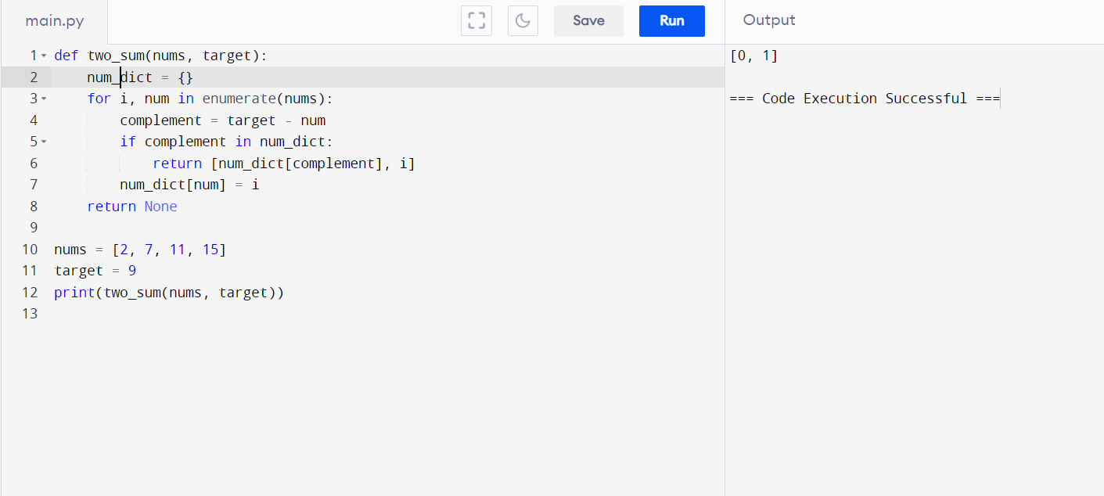

1. Add Two Numbers

You are given two non-empty linked lists representing two non-negative integers. The digits are stored in reverse order, and each of their nodes contains a single digit. Add the two numbers and return the sum as a linked list. You may assume the two numbers do not contain any leading zero, except the number 0 itself.

class ListNode:

def __init__(self, val=0, next=None):

self.val = val

self.next = next

def addTwoNumbers(l1, l2):

dummy = ListNode()

current, carry = dummy, 0

while l1 or l2 or carry:

val1, val2 = (l1.val if l1 else 0), (l2.val if l2 else 0)

carry, out = divmod(val1 + val2 + carry, 10)

current.next = ListNode(out)

current = current.next

l1, l2 = (l1.next if l1 else None), (l2.next if l2 else None)

return dummy.next

def create_linked_list(lst):

dummy = ListNode()

current = dummy

for number in lst:

current.next = ListNode(number)

current = current.next

return dummy.next

def linked_list_to_list(node):

result = []

while node:

result.append(node.val)

node = node.next

return result

l1 = create_linked_list([2, 4, 3])

l2 = create_linked_list([5, 6, 4])

result = addTwoNumbers(l1, l2)

print(linked_list_to_list(result))

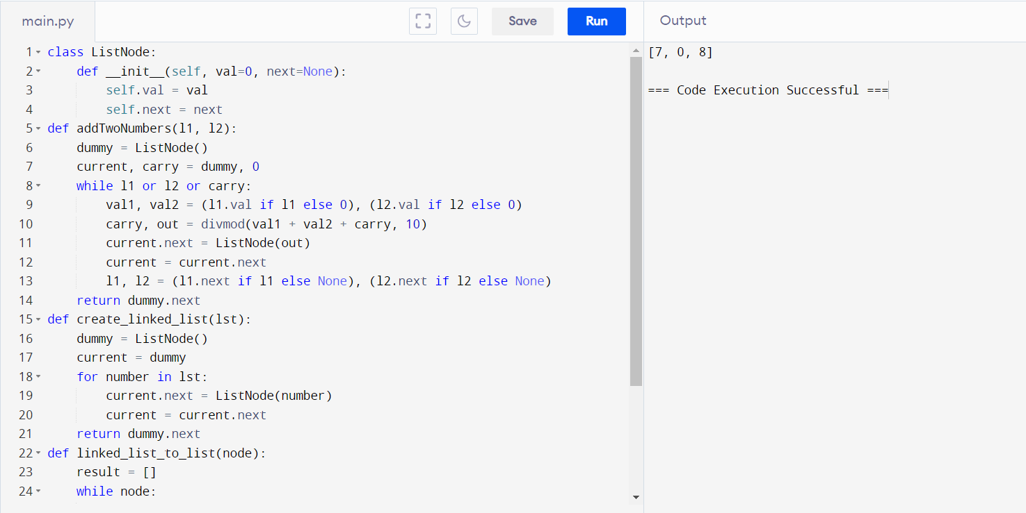

1. Longest Substring without Repeating Characters

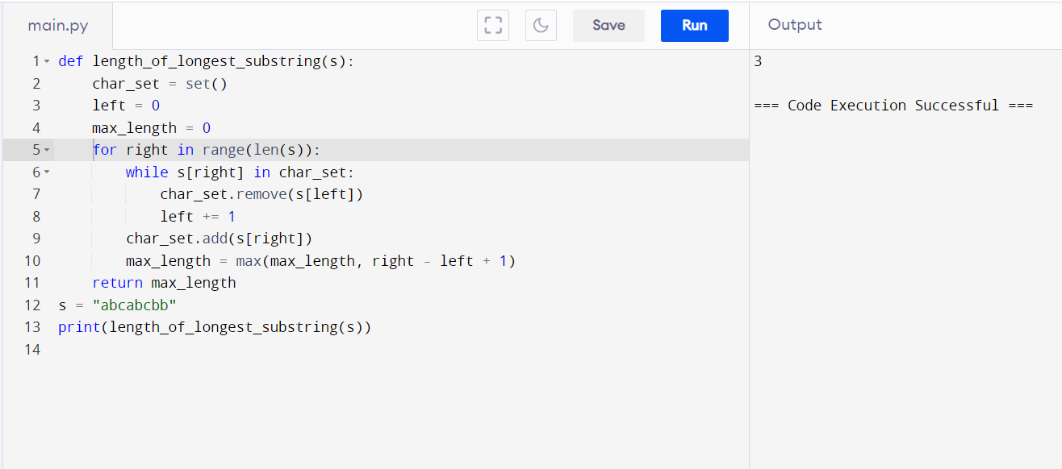Given a string s, find the length of the longest substring without repeating characters.

1. Median of Two Sorted Arrays

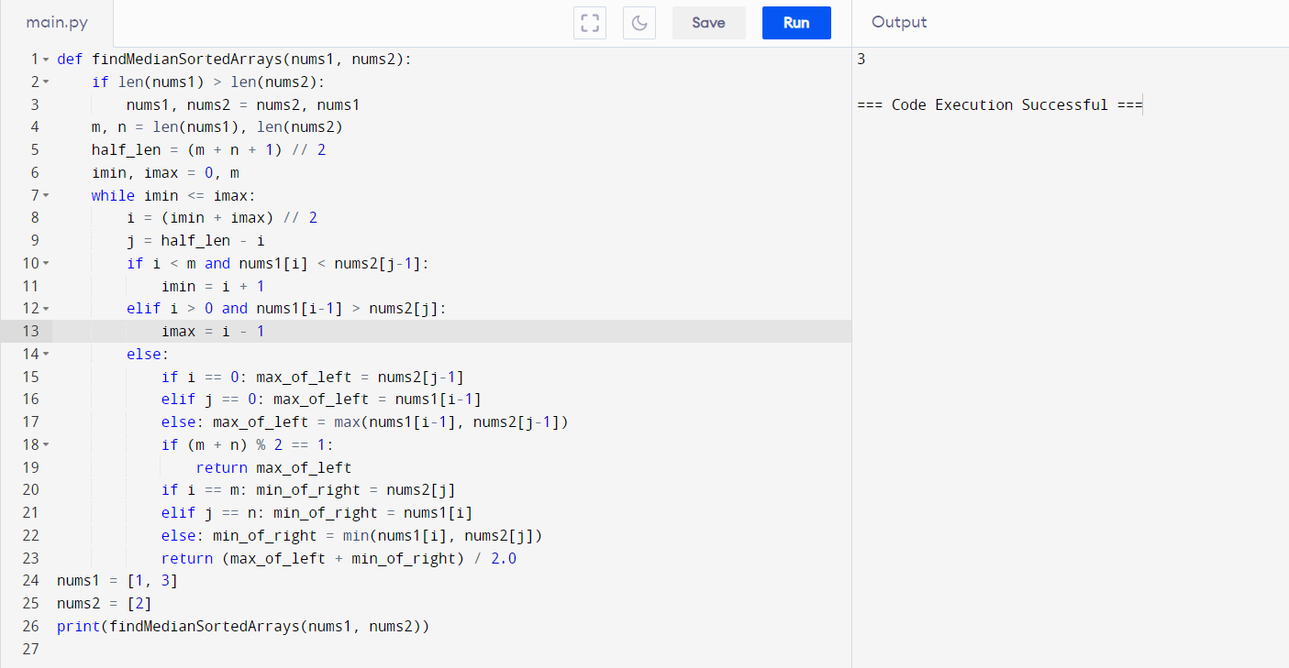 Given two sorted arrays nums1 and nums2 of size m and n respectively, return the median of the two sorted arrays. The overall run time complexity should be O(log (m+n)).

1. Longest Palindromic Substring

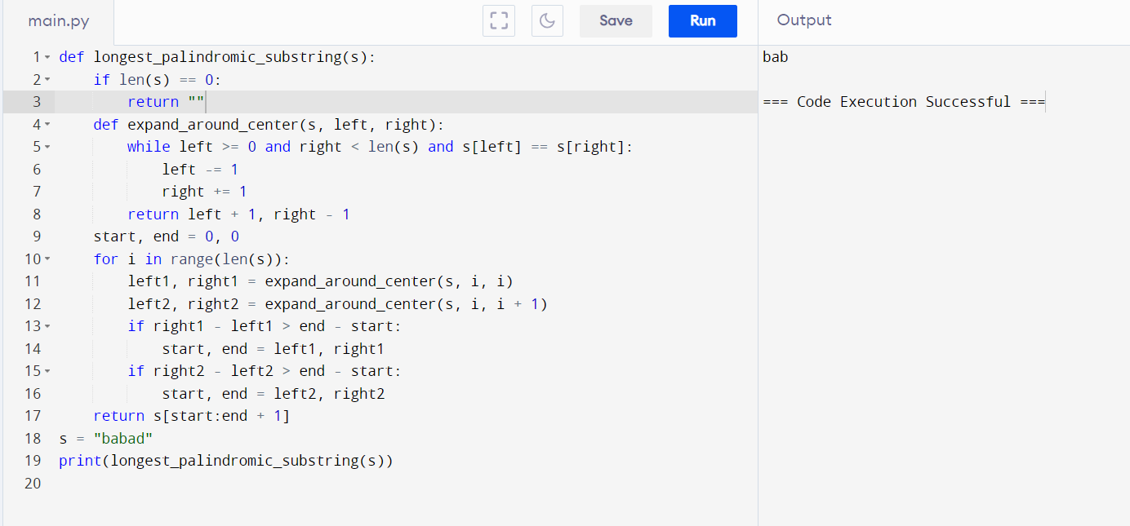Given a string s, return the longest palindromic substring in s.

1. Zigzag Conversion

The string "PAYPALISHIRING" is written in a zigzag pattern on a given number of rows like this: (you may want to display this pattern in a fixed font for better legibility) P A H N A P L S I I G Y I R And then read line by line: "PAHNAPLSIIGYIR" Write the code that will take a string and make this conversion given a number of rows: string convert(string s, int numRows);

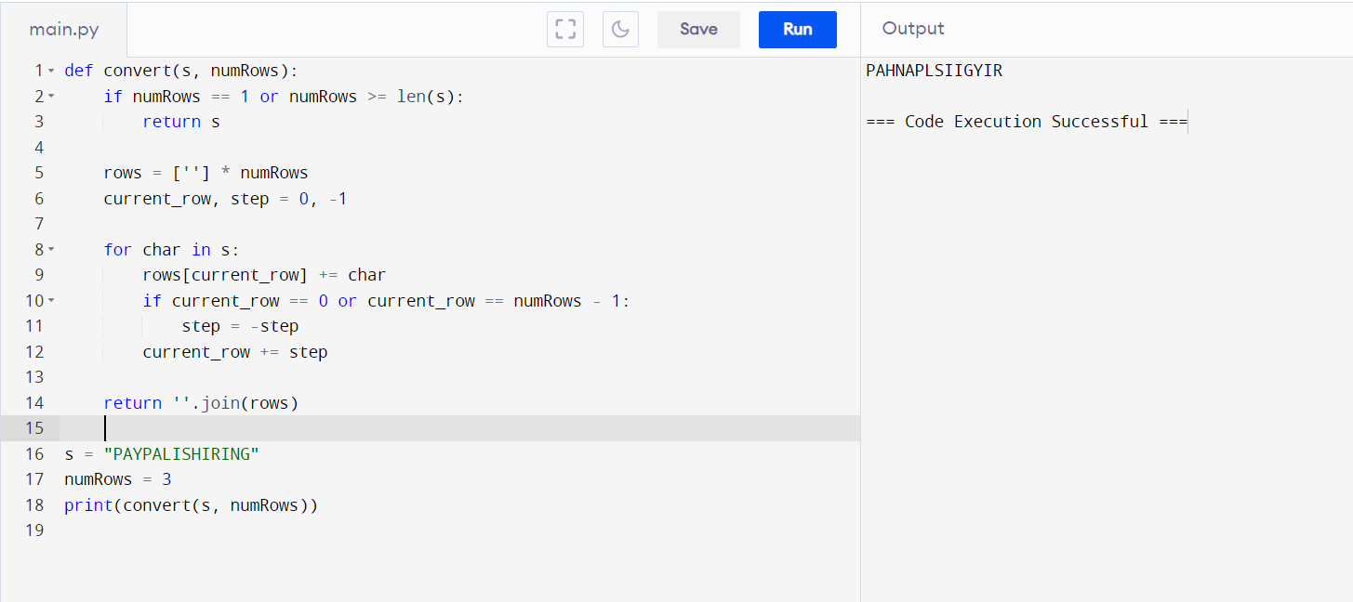

1. Reverse Integer

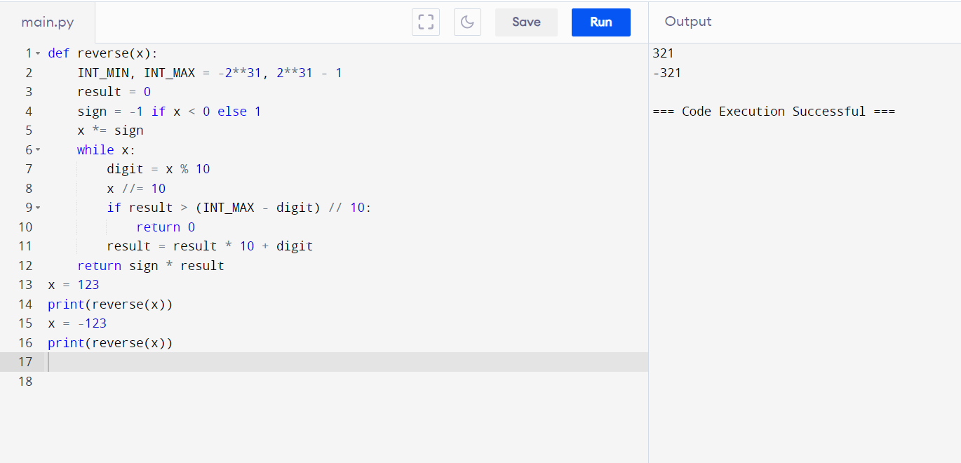Given a signed 32-bit integer x, return x with its digits reversed. If reversing x causes the value to go outside the signed 32-bit integer range [-231, 231 - 1], then return 0. Assume the environment does not allow you to store 64-bit integers (signed or unsigned).

1. String to Integer

Implement the myAtoi(string s) function, which converts a string to a 32-bit signed integer

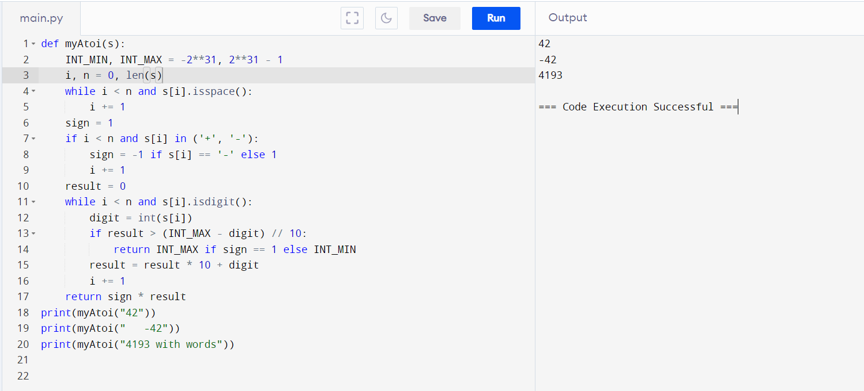

1. Palindrome Number

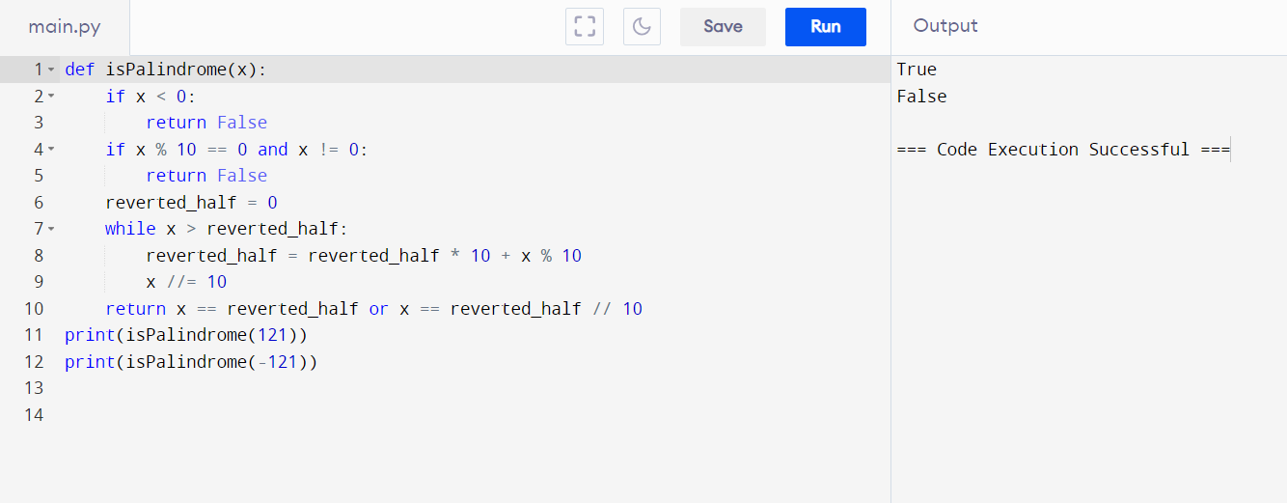 Given an integer x, return true if x is a palindrome, and false otherwise.

1. Regular Expression Matching

Given an input string s and a pattern p, implement regular expression matching with support for '.' and '*' where: ● '.' Matches any single character. ● '*' Matches zero or more of the preceding element. The matching should cover the entire input string (not partial).

