Ingress

What is an Ingress?
- In Kubernetes, an Ingress is an object that allows access to your Kubernetes services from outside the Kubernetes cluster. You configure access by creating a collection of rules that define which inbound connections reach which services.
- This lets you consolidate your routing rules into a single resource. For example, you might want to send requests to example.com/api/v1/ to an api-v1 service, and requests to example.com/api/v2/ to the api-v2 service. With an Ingress, you can easily set this up without creating a bunch of LoadBalancers or exposing each service on the Node.

Kubernetes Ingress vs LoadBalancer vs NodePort
These options all do the same thing. They let you expose a service to external network requests. They let you send a request from outside the Kubernetes cluster to a service inside the cluster.
NodePort
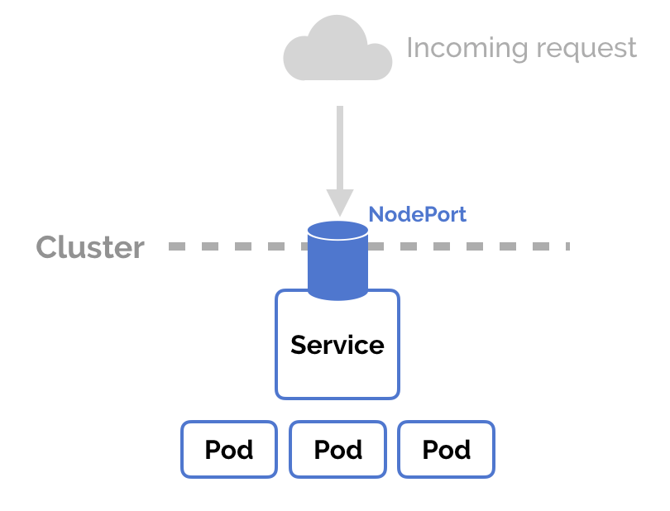
- NodePort is a configuration setting you declare in a service’s YAML. Set the service spec’s type to NodePort. Then, Kubernetes will allocate a specific port on each Node to that service, and any request to your cluster on that port gets forwarded to the service.
- This is cool and easy, it’s just not super robust. You don’t know what port your service is going to be allocated, and the port might get re-allocated at some point.
LoadBalancer
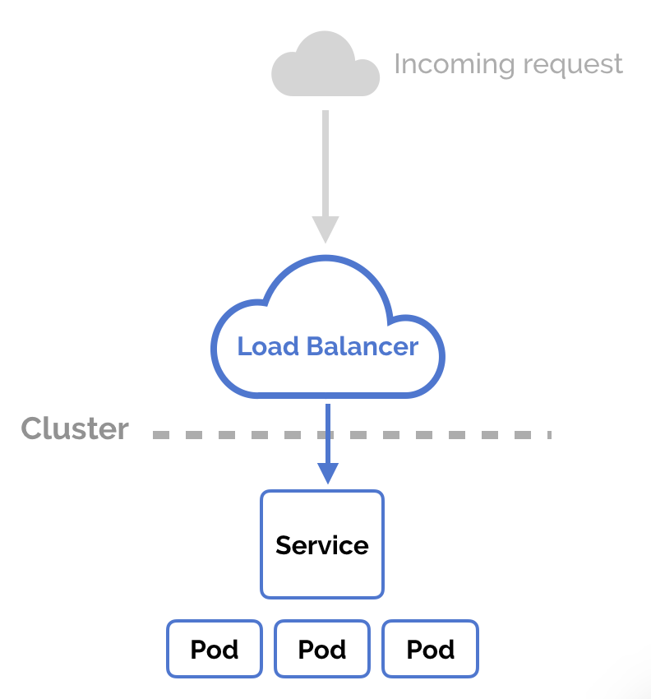
- You can set a service to be of type LoadBalancer the same way you’d set NodePort— specify the type property in the service’s YAML. There needs to be some external load balancer functionality in the cluster, typically implemented by a cloud provider.
- This is typically heavily dependent on the cloud provider—GKE creates a Network Load Balancer with an IP address that you can use to access your service.
- Every time you want to expose a service to the outside world, you have to create a new LoadBalancer and get an IP address.
Ingress
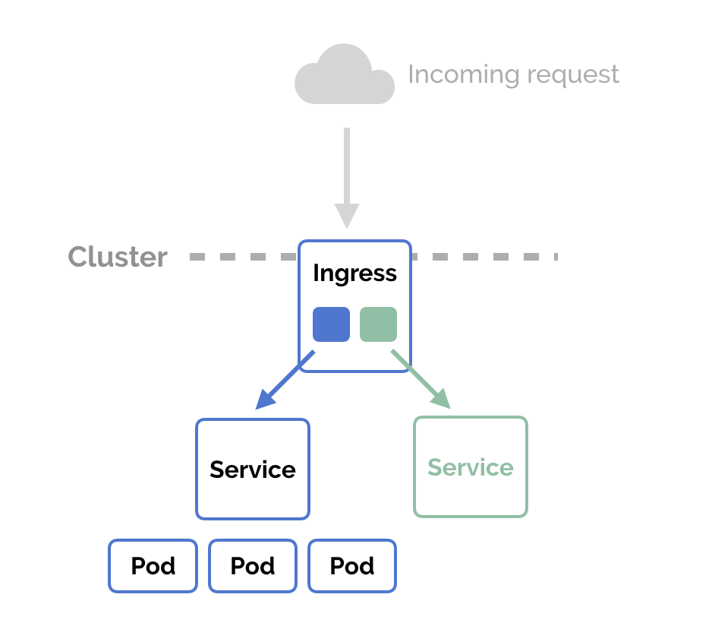
- NodePort and LoadBalancer let you expose a service by specifying that value in the service’s type. Ingress, on the other hand, is a completely independent resource to your service. You declare, create and destroy it separately to your services.
- This makes it decoupled and isolated from the services you want to expose. It also helps you to consolidate routing rules into one place.
- The one downside is that you need to configure an Ingress Controller for your cluster. But that’s pretty easy
2. Why Ingress exists
Without Ingress:
- You expose every app using:
  - NodePort ❌ (ugly ports)
  - LoadBalancer ❌ (expensive, one LB per service)
With Ingress:
- One LoadBalancer
- Multiple services
- Clean URLs
- TLS termination
Client
↓
LoadBalancer / NodePort
↓
Ingress Controller (nginx, traefik, etc.)
↓
Ingress Resource (rules)
↓
Service
↓
Pod

Ingress itself does nothing
- It is just a set of rules
- The real worker is the Ingress Controller
Ingress will NOT work unless you have a controller installed.
Common controllers:
- NGINX Ingress Controller (most popular)
- Traefik
- HAProxy
- Cloud provider ingress (AWS ALB, GCP)

Browser
↓
Google Cloud HTTP(S) Load Balancer
↓
GKE Ingress
↓
Service (NodePort)
↓
Pod (nginx)

Best practice in GKE
spec:
type: NodePort
- Required for Ingress plumbing
- Invisible to end users
- Safe and correct
Yes, you still need type: NodePort (or ClusterIP) for the Service, even when using Ingress.
👉 You do NOT manually use the NodePort.
👉 In GKE, Ingress uses the NodePort behind the scenes.

Can I use ClusterIP instead?
In standard Kubernetes / NGINX Ingress:
✅ Yes, ClusterIP is enough
In GKE (GCE Ingress):
⚠️ Historically NodePort is required
Modern GKE may auto-convert, but best practice is still NodePort unless using:
- NEG (Network Endpoint Groups)
- GKE Gateway API
Key change with NGINX Ingress
👉 You do NOT need type: NodePort anymore.
👉 ClusterIP is enough (and preferred).

Why?
NGINX Ingress runs inside the cluster as Pods and:
- It can reach ClusterIP services directly
- It does not rely on cloud load balancers talking to nodes
- Traffic flow becomes:
Ingress Type | Service type needed
GKE (GCE) Ingress | NodePort
NGINX Ingress Controller | ClusterIP
1️⃣ Path-based routing
- Routes traffic based on the URL path (the part after the domain).
- Example from your Ingress:
- Path-based routing allows you to route incoming HTTP requests to different Services based on the URL path.
- Both Services can use port 80, but Ingress decides which Service to send traffic to based on the path.

Route-based routing vs Path-based
- Route-based is often a broader term, meaning “route the request based on some condition.”
- In Kubernetes Ingress, route rules are typically path-based and/or host-based.
  - Host-based routing: routes based on the domain name (host: example.com)
  - Path-based routing: routes based on the URL path (path: /app)
So in your example, since you only specified /app and no host, it is path-based routing.

Ingress port ingress portcontainer port
Ingress port match to the ingress port. Ingress port searches the Ingress target port. Ingress target port match to container port

2️⃣ Examples
A) Prefix
paths:
- path: /apple
pathType: Prefix
backend:
service:
name: apple-service
port:
number: 80
- Matches: /apple, /apple/green, /apple/fruit/list
- Does not match: /apples (because /apples is not a prefix of /apple/)
Use case: Most common, good for routing to apps with a path base.

B) Exact
paths:
- path: /apple
pathType: Exact
backend:
service:
name: apple-service
port:
number: 80
- Matches: /apple
- Does not match: /apple/green, /apple/fruit
- Use case: When you want only a single exact path to route traffic.

C) ImplementationSpecific
paths:
- path: /apple
pathType: ImplementationSpecific
backend:
service:
name: apple-service
port:
number: 80
- Behavior depends on the Ingress controller (e.g., NGINX treats it like Prefix)
- Matches: Often /apple, /apple/green, /apple/fruit
- Not guaranteed across different controllers
Use case: Rarely recommended unless you know the Ingress controller’s behavior.
• If you do NOT want regex
👉 use pathType: Prefix (or Exact)
• If you DO want regex
👉 use pathType: ImplementationSpecific
Prefix = string match
ImplementationSpecific = controller-defined (regex allowed)

2️⃣ Host-based routing + DNS
What is Host-based routing?
Host-based routing means routing traffic based on the domain name (Host header), not the URL path.
Example:
- apple.example.com → apple service
- banana.example.com → banana service
This is handled by Ingress, using the host: field.
What role does DNS play?
DNS maps the domain name to the Ingress IP address.
So DNS does not route traffic — it only points the domain to the Ingress.
Host-based vs Path-based routing
Feature | Host-based | Path-based
Domain based | ✅ | ❌
Single domain, many apps | ❌ | ✅
Multiple domains, one IP | ✅ | ❌
SEO-friendly | ✅ | ⚠️
Bonus: HTTPS with Host-based routing
TLS works per host:
tls:
- hosts:
- apple.example.com
- banana.example.com
secretName: example-tls
One-line summary
DNS points domains to the Ingress IP, and Ingress routes traffic based on the Host header.
#domain name based and we need to add this urls in A record of dns then only we can access

3️⃣ HTTPS / TLS in nginx Ingress

The TLS section in an NGINX Ingress is used to enable HTTPS for your applications.
Purpose of TLS in NGINX Ingress
- Encrypt traffic between clients and your cluster
  - Without TLS → traffic is HTTP → plain text → anyone on the network could see sensitive data (passwords, tokens, API keys).
  - With TLS → traffic is HTTPS → encrypted using SSL/TLS.
- Authentication and trust
  - A TLS certificate ensures that clients (browsers, apps) can verify they are connecting to the real server (your domain) and not an imposter (prevents man-in-the-middle attacks).
- Compliance and SEO
  - Many regulations (like PCI-DSS, GDPR) require HTTPS for sensitive data.
  - Search engines prefer HTTPS sites.
How it works in NGINX Ingress
- You define a TLS secret in Kubernetes with your certificate (.crt) and private key (.key).
- In your Ingress manifest, you reference this secret under the tls section along with the corresponding host(s
When a client connects via HTTPS:
- NGINX Ingress terminates TLS at the Ingress controller.
- Decrypts the traffic and forwards it to your service (usually over HTTP internally).

Benefits
Benefit | Explanation
Encryption | Protects sensitive data in transit
Authentication | Ensures clients connect to the correct server
Compliance | Required by security standards/regulations
SEO & Browser Trust | Modern browsers mark HTTP-only sites as “Not secure”
Ingress Controllers and Ingress Resources
- Kubernetes supports a high level abstraction called Ingress, which allows simple host or URL based HTTP routing. An ingress is a core concept (in beta) of Kubernetes, but is always implemented by a third party proxy. These implementations are known as ingress controllers. An ingress controller is responsible for reading the Ingress Resource information and processing that data accordingly. Different ingress controllers have extended the specification in different ways to support additional use cases.
- Ingress is tightly integrated into Kubernetes, meaning that your existing workflows around kubectl will likely extend nicely to managing ingress. Note that an ingress controller typically doesn’t eliminate the need for an external load balancer — the ingress controller simply adds an additional layer of routing and control behind the load balancer.

