1.If you click delete of a particular task, remaining tasks aslo removing.

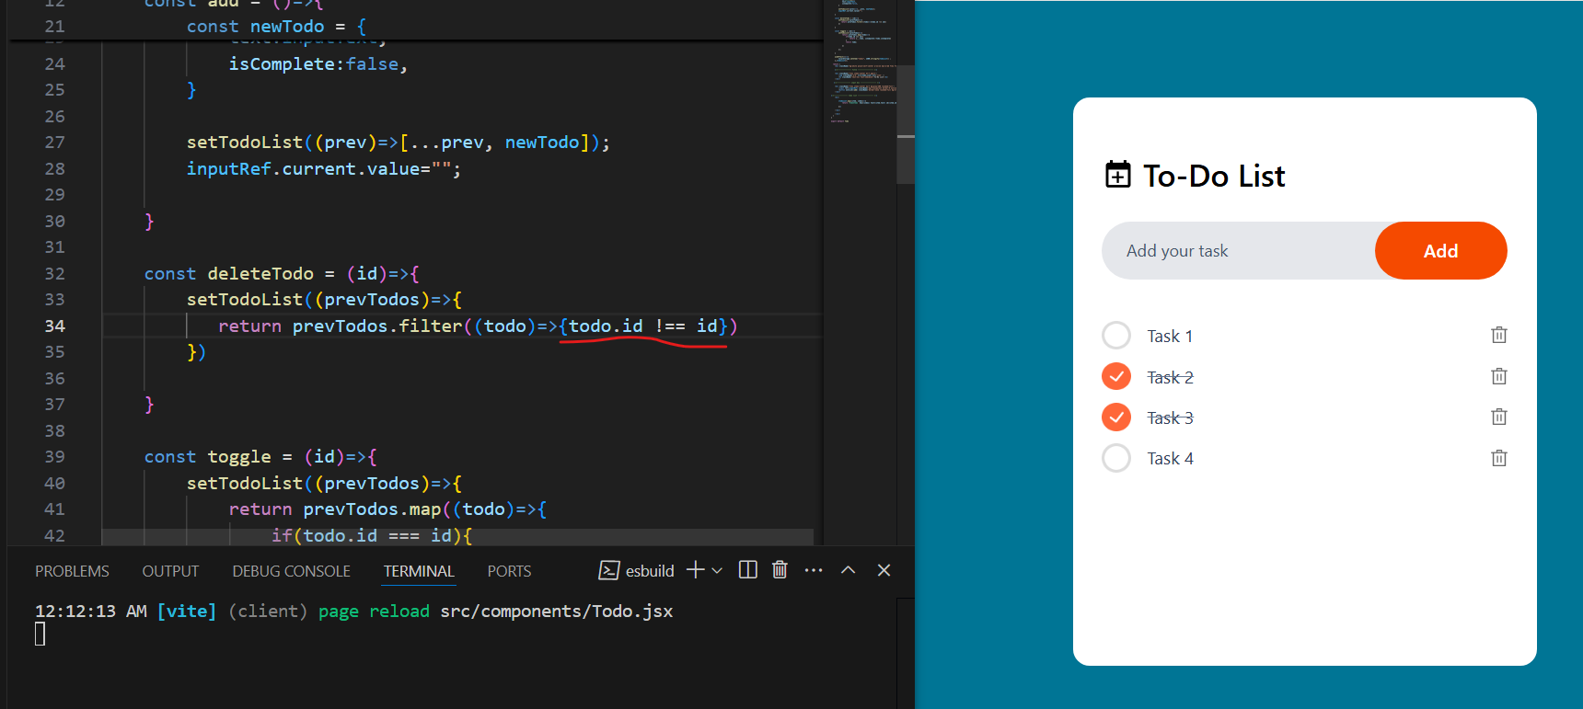

Solution: Remove curly braces.

