Host Setup

mosquitto broker setup:

In Ubuntu terminal

$ sudo add-apt-repository ppa:mosquitto-dev/mosquitto-ppa
$ sudo apt-get update
$ sudo apt-get install mosquitto
$ sudo apt-get install mosquitto-clients

After installing edit the /etc/mosquitto/mosquitto.conf to be like below:

# Place your local configuration in /etc/mosquitto/conf.d/
#
# A full description of the configuration file is at
# /usr/share/doc/mosquitto/examples/mosquitto.conf.example

persistence true
persistence_location /var/lib/mosquitto/

log_dest file /var/log/mosquitto/mosquitto.log

include_dir /etc/mosquitto/conf.d
listener 1883
allow_anonymous true
protocol mqtt

QT Setup:

$ sudo add-apt-repository ppa:beineri/opt-qt-5.14.0-bionic
$ sudo apt update
$ sudo apt-get install qt514-meta-full
$ sudo source /opt/qt514/bin/qt514-env.sh

QT Mqtt setup:

$ git clone -b 5.14.0 git://code.qt.io/qt/qtmqtt.git
$ git checkout 5.14.0

$ cd qtmqtt

Using QtCreator open the project qtmqtt.pro
right click on project
select clean
run qmake

And now in terminal
$ make
$ make install
Building for target setup:

$ sudo apt update

$ sudo apt install gawk wget git diffstat unzip texinfo gcc build-essential chrpath socat cpio python3 python3-pip python3-pexpect xz-utils debianutils iputils-ping python3-git python3-jinja2 libegl1-mesa libsdl1.2-dev python3-subunit mesa-common-dev zstd liblz4-tool file locales

$ sudo locale-gen en_US.UTF-8

$ mkdir your_dir
$ cd your_dir
$ repo init -u https://github.com/ayyappanmuthu05/repo_test.git
$ repo sync

$ cd path to your_dir/sources/meta-mmts-rpi3
$ . mmts_rpi3_setup_environment.sh

Note: there is a space between . and script file name and it is must ,otherwise after executing the script it will not land in the build folder.

$ bitbake mmts-rpi3-base

After building

Check SDCard adapter drive using the command
$ df -h

If it is /dev/sdbX where X is any number then in terminal

$ sudo umount /dev/sdb

# Flash SD card with the generated image
$ sudo dd if=path-to-sdimg of=/dev/sdb

$ sudo umount /dev/sdb

Place SD card rpi3 sd card slot.

Setting up in the target rpi3:

Connecting USB to TTL RS232 Converter to the board

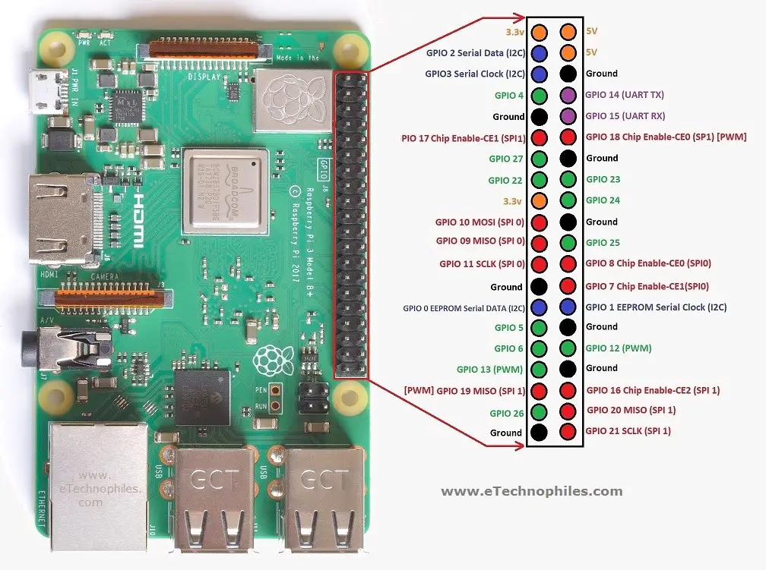
Connect Rx pin of the USB TTL converter to GPIO 14 referring the picture above.
Connect Tx pin of the USB TTL converter to GPIO 15 and
ground pin of the USB TTL Converter to Ground of the board.

After Connecting the USB port of the TTL converter to host machine, setup minicom by typing
in the terminal as

$ sudo minicom -s

and ensure the following settings

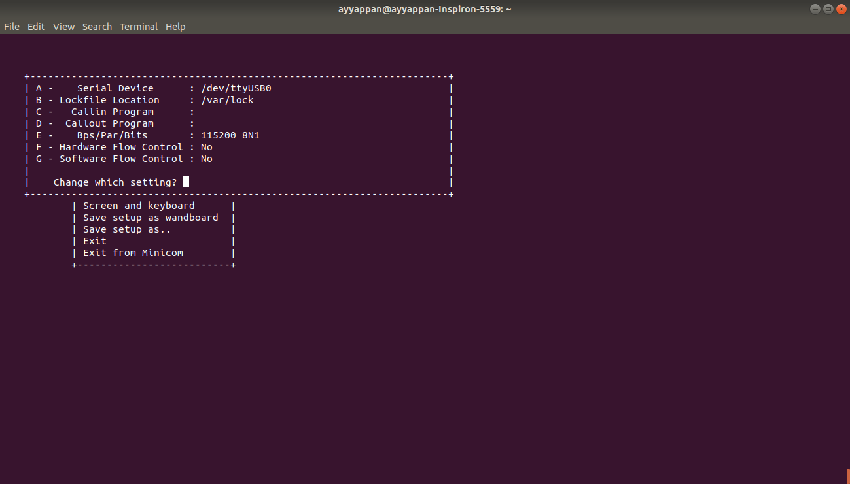
After ensuring the settings press Enter and scroll down to Exit and press enter.

Then you will be landed into the UART Console.

If preferred save the settings before Exit and for the next time you can connect to the minicom by

$ sudo minicom name-of-the-setting

Connect the board’s power USB cable to host machine.

You will see the bootup and console logs in the minicom console.

After login prompt was seen, enter the username as root and no password is required.

After turning on the Wifi Hotspot perform the following steps.

In the console prompt of the target

1. Connect to the linux device.
# sudo connmanctl

2. Enable Wifi:
connmanctl> enable wifi

3. Scan for Wifi networks:

connmanctl> scan wifi
Scan completed for wifi

4.Show available Wifi services:

connmanctl> services

5.Turn on the agent:

connmanctl> agent on
Agent registered

6.Connect to the service of interest:
Copy network ID of interest from step 4 and paste after ‘connect’.

connmanctl> connect wifi_CA7DDDxxxxxx_xxxxxxyyyyyyyyzzzzzzzz_managed_psk

7.Enter Wifi password:

Passphrase?

8.Quit:

connmanctl> quit

9.Test:
The wireless network is ready after about 30 seconds.
View IP addresses:

# ifconfig

10.Test the network connection by pinging Google:

# ping google.com

