Installing Git

- Install Git on server

Command : sudo yum install -y git

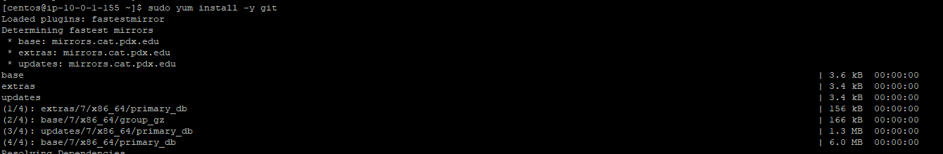
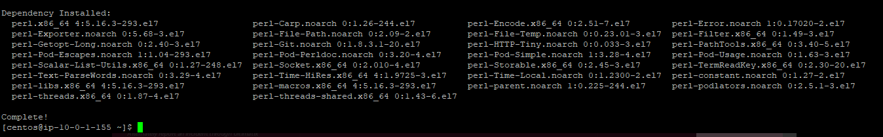

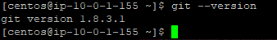

2.Configure git to connect to the git account

- Generate Keypair to add to the Git

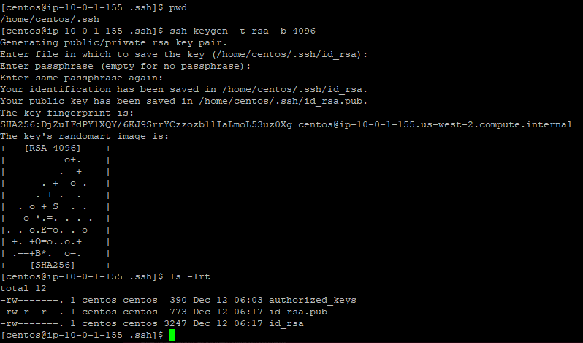

- Add the public key to Git account

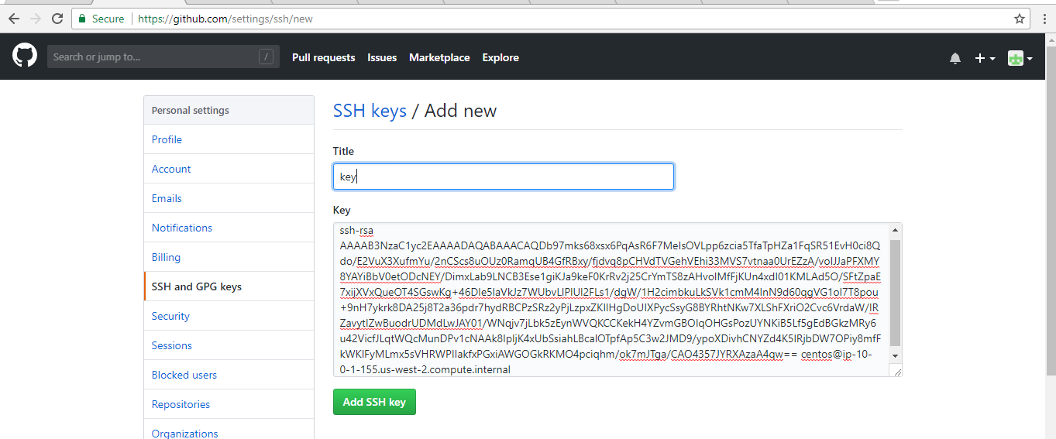

iii. Add global parameters

git config --global user.name "ayyappanpads"
git config --global user.email "ayyappan.padalingam@gmail.com"

- Cloning the Git repository/project to server
i. From repository please copy the SSH Path

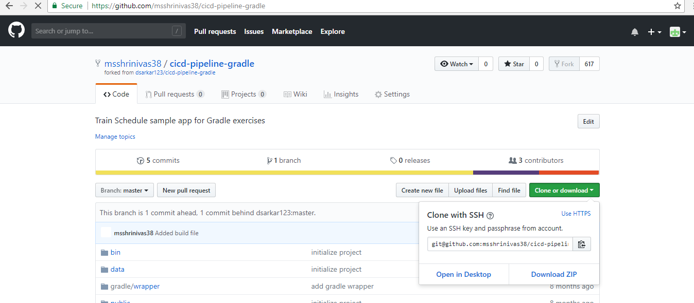

- Clone in server

git clone git@github.com:msshrinivas38/cicd-pipeline-gradle.git

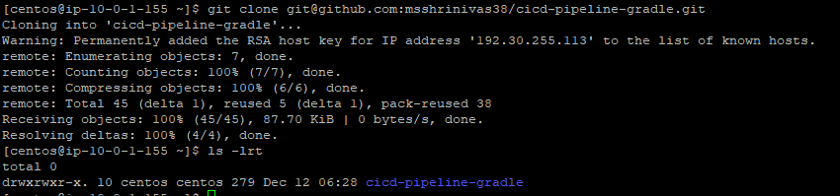
Now repository is available in server locally to edit the code

4. Edit the code
i. Create a branch in case multiple developers working on project to merge the code easily

- Add the edited files to git branch/master to change in repository
- Commit the git to reflect the changes
- Push the git branch.master to reflect in repository

Gradle Installation

- Clone the Gradle package from git

- Install Java in unix required for Gradle

--Install Java in Unix

sudo yum -y install unzip java-1.8.0-openjdk

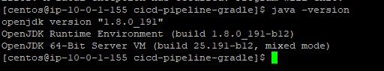
3. Build - to setup the gradle

--./gradlew build

It will download the gradle ZIP and unzip and setup for only first time
Next time if we run, it will not download. Just it will re-setup

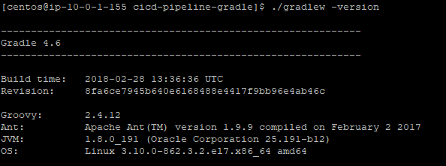
--

Initiate Gradle

-- [centos@ip-10-0-1-251 cicd-pipeline-gradle]$ ./gradlew init

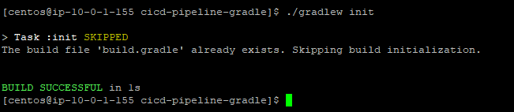

5. Write the Build code

-- Edit your build.gradle to enter the plugins ( Already existing code )

plugins { id "com.moowork.node" version "1.2.0"
}

node {
download=true
version="9.11.1"
npmVersion="5.6.0"

}

task zip(type: Zip) {
from ('.') {
include "*"
include "bin/**"
include "data/**"
include "node_modules/**"
include "Public/**"
include "routes/**"
include "views/**"
}
destinationDir(file("dist"))
baseName "sampleapp"
}

task build
build.dependsOn npm_build
npm_build.dependsOn npmInstall
build.dependsOn zip
zip.dependsOn npm_build

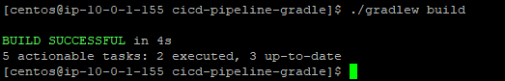

--- vi .gitignore

add below line after node_modules

dist

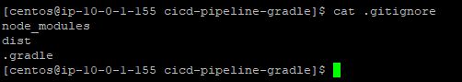

- Jenkins Installation and Configuration

Install epel-release and jenkins

sudo yum -y install epel-release

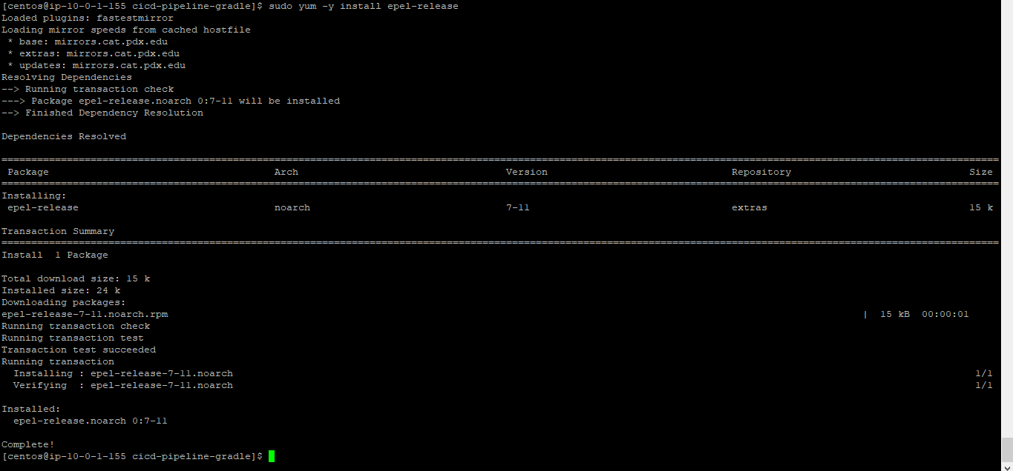

sudo yum install -y wget

sudo wget -O /etc/yum.repos.d/jenkins.repo http://pkg.jenkins-ci.org/redhat-stable/jenkins.repo

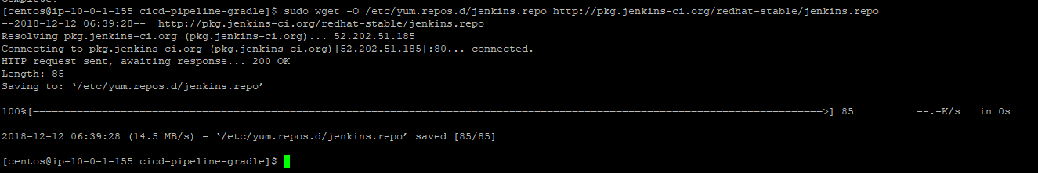

sudo rpm --import https://jenkins-ci.org/redhat/jenkins-ci.org.key

sudo yum install -y jenkins-2.121.1

sudo systemctl enable jenkins

sudo systemctl start jenkins

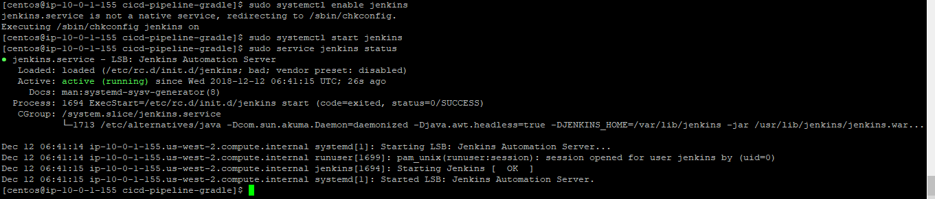

Jenkins is started now, please open the console for it in browser

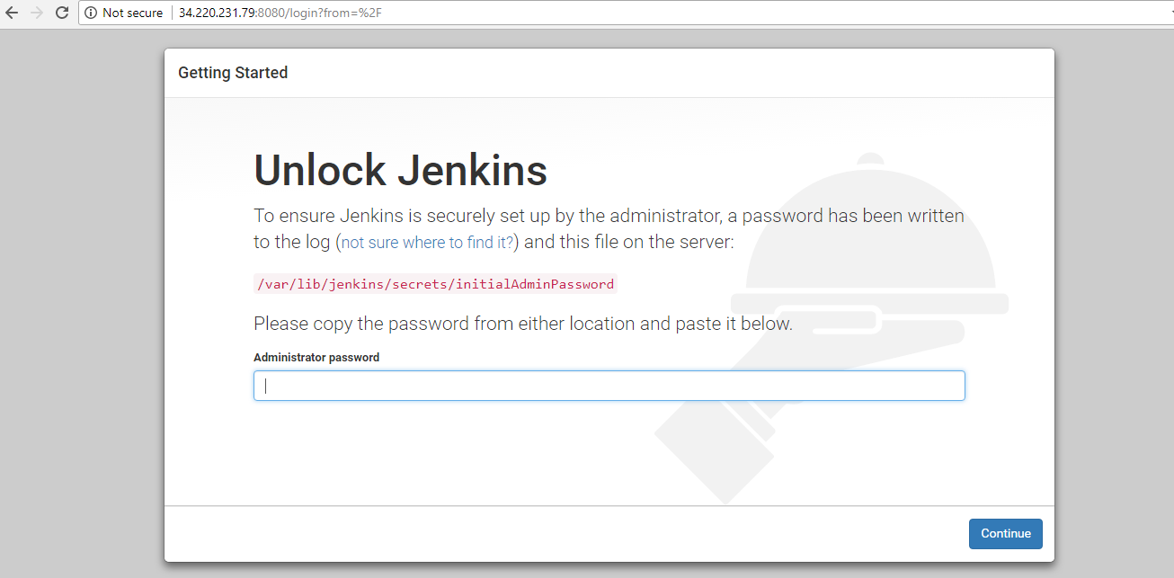
Install suggested plugins

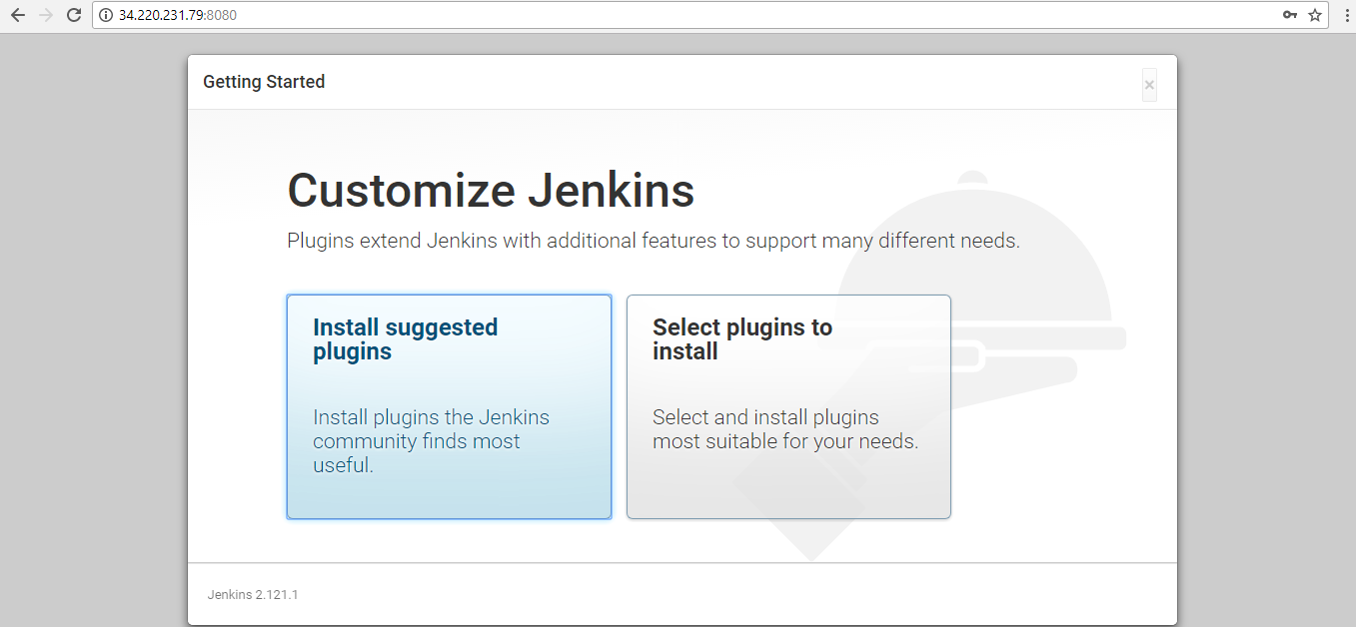

It will install all the required tools

Now create jobs in Jenkins

- Free style project

In freestyle kind of project, using GUI gradle script execution will be defined. Please see below settings applied

Click on “New Item”

Select the FreeStyle project

- Pipeline Project :

In Pipeline configuration, pipeline will be created based on the jenking code written in Jenkinsfile in the GitHub repo

Below is the sample of it for gradle build

Jenkinsfile

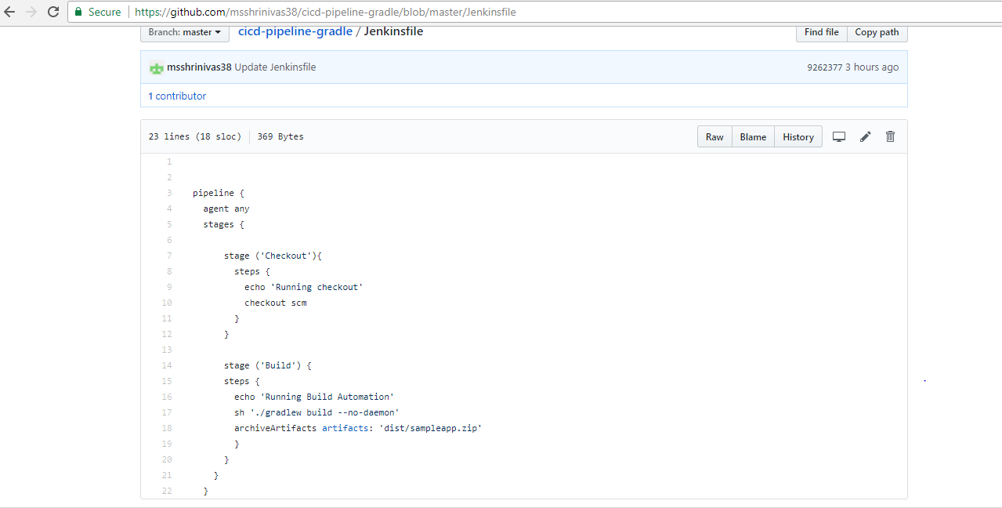

Click on “New Item”

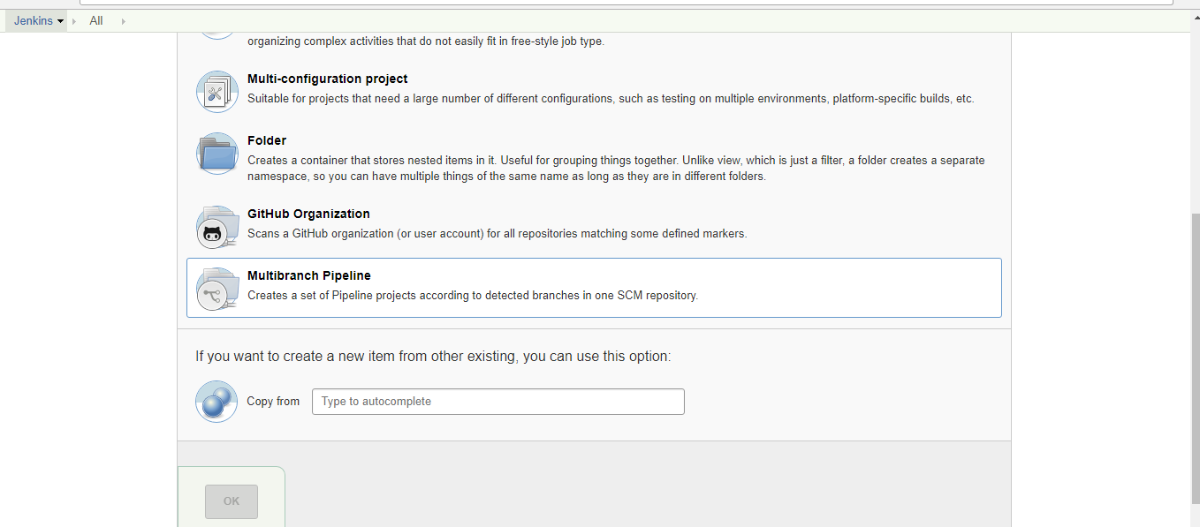

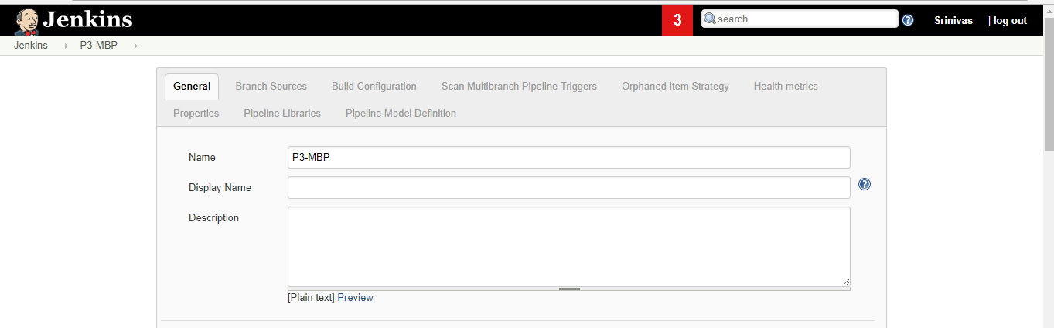

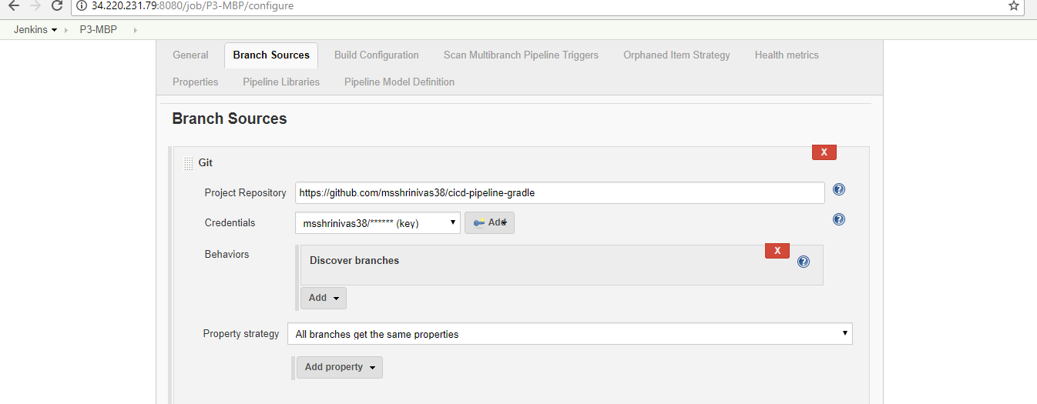
For Credential create the key as below and add it.

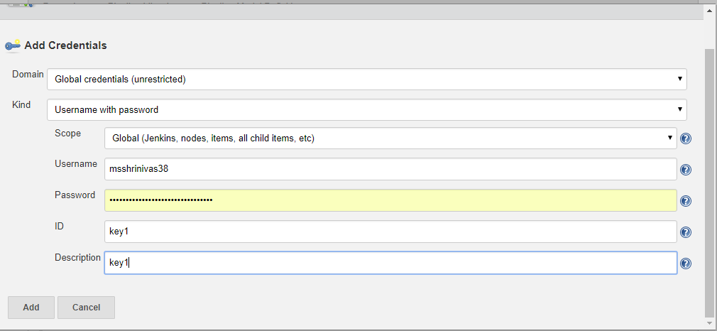

Save the Configuration. It will automatically trigger the build

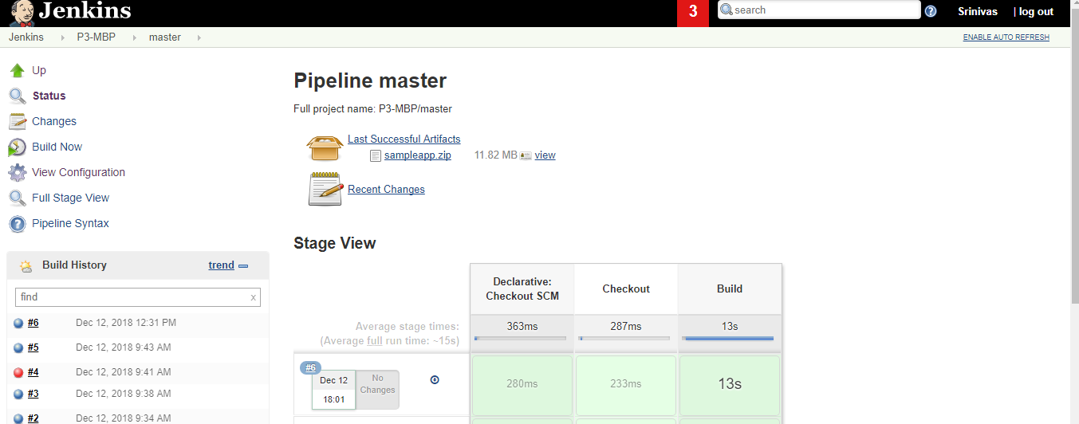

Below is the Jenkins code for Maven ( Java and Maven automatic installation from Jenkins stages )

In order to set the automatic installation of plugins, please set up below

Jenkins -> Manage Jenkins -> Global Tool Configuration

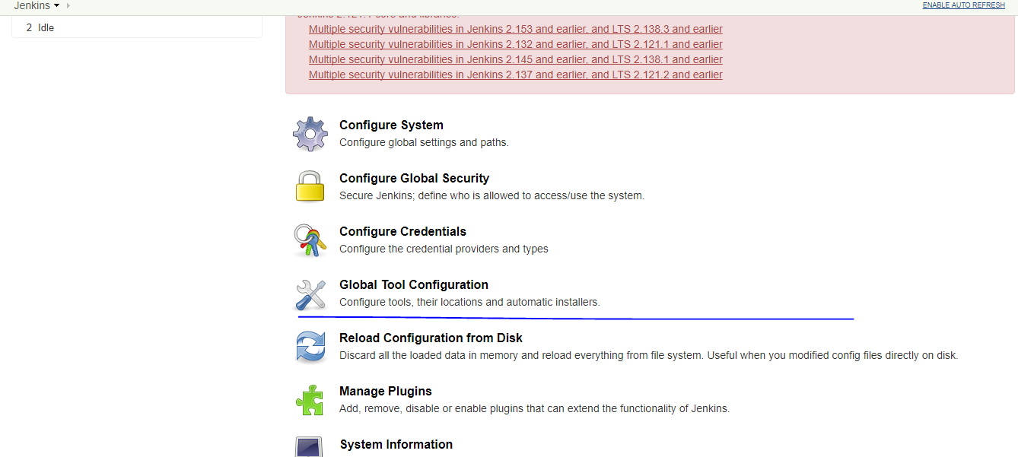

In JDK Sections

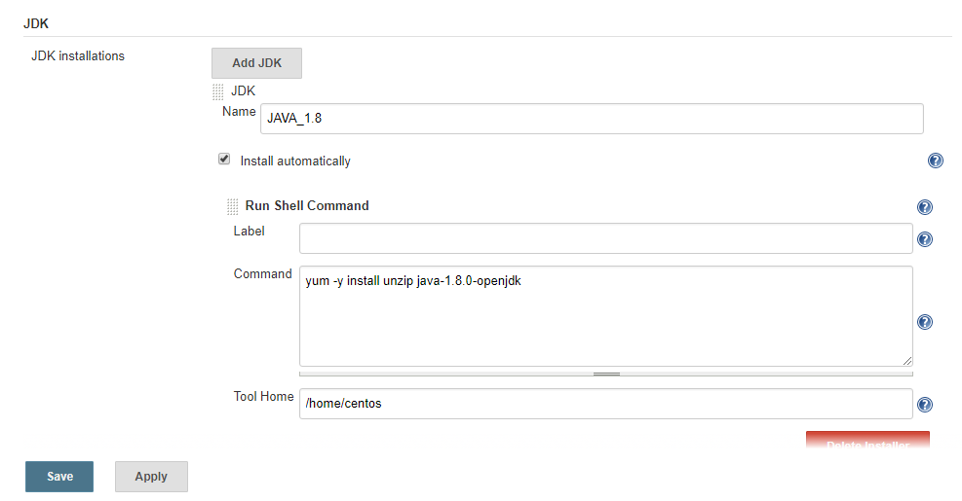

In Maven Section

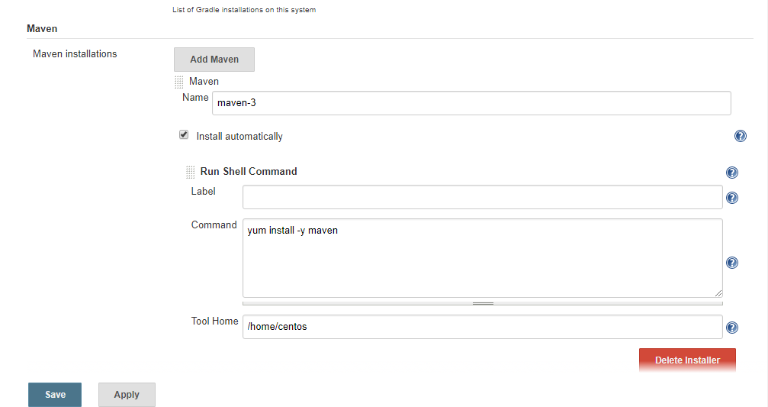

Create Jenkinsfile as below

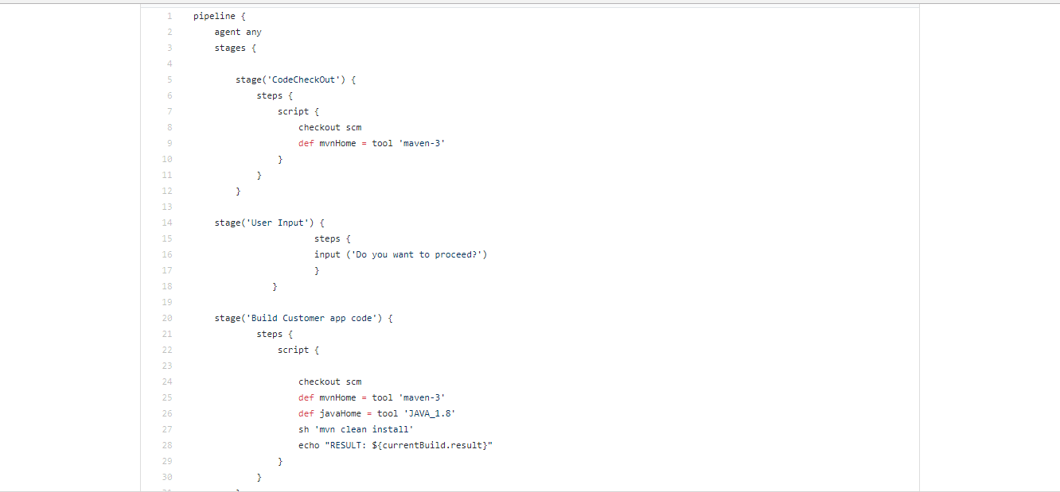

Create Pipeline or MultiBranchPipeline project

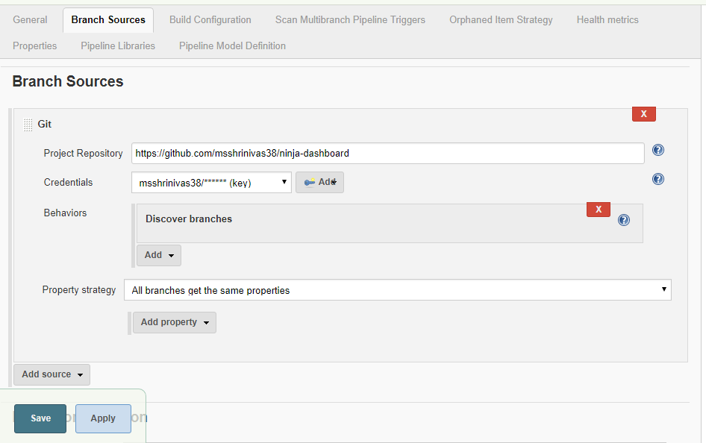
Save and build

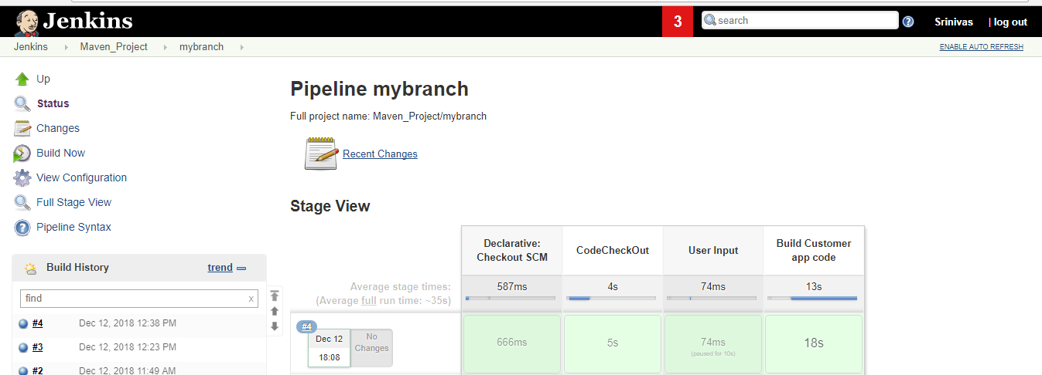
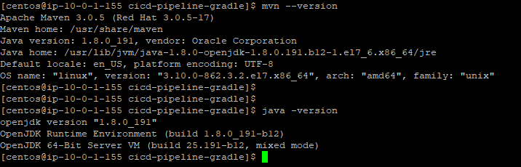
Maven and Java will be automatically installed in the server.
Docker

Install Docker
sudo yum install docker
sudo systemctl start docker
sudo systemctl status docker
sudo systemctl enable docker
sudo systemctl status docker

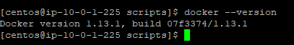

sudo docker run hello-world
<< Run the image as container >>
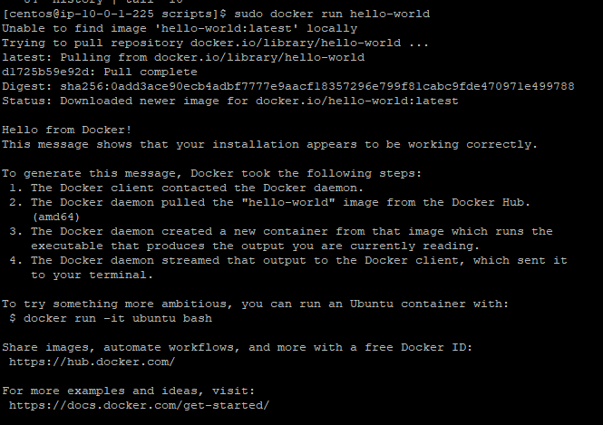

Create Docker acount

Change docker to root user

[centos@ip-10-0-1-225 scripts]$ sudo groupadd docker
[centos@ip-10-0-1-225 scripts]$ sudo usermod -aG docker $USER
[centos@ip-10-0-1-225 scripts]$ exit
logout
There are stopped jobs.
[centos@ip-10-0-1-225 scripts]$ sudo systemctl restart docker
[centos@ip-10-0-1-225 scripts]$

resatrt the session

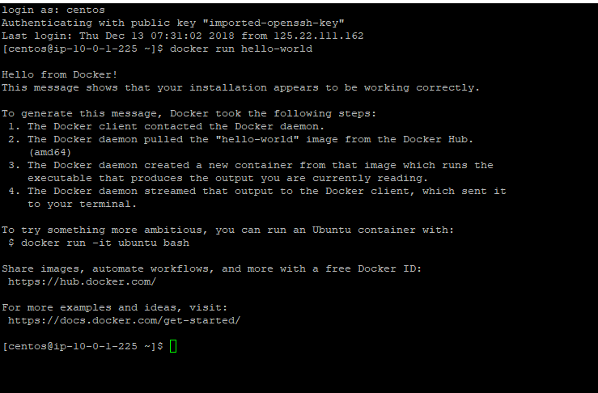

List images in docker

docker images

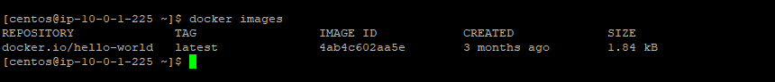

2. Clone the git repo into server

git clone git@github.com:msshrinivas38/cicd-pipeline-gradle.git

[centos@ip-10-0-1-225 cicd-pipeline-gradle]$ docker build -t msshrinivas38/sampleapp .

[centos@ip-10-0-1-225 cicd-pipeline-gradle]$ docker images
REPOSITORY TAG IMAGE ID CREATED SIZE
msshrinivas38/sampleapp latest 36acfef88f4c 16 seconds ago 931 MB
docker.io/node carbon 3b7ecd51ffe5 9 days ago 889 MB
docker.io/hello-world latest 4ab4c602aa5e 3 months ago 1.84 kB

run the image

[centos@ip-10-0-1-225 cicd-pipeline-gradle]$ docker run -p 8081:8080 -d msshrinivas38/sampleapp
c226046d61fbb82f2285eaf300f3ef0340b746b46ff63169adaadbb33a1cf96f

Container is runnig now
[centos@ip-10-0-1-225 cicd-pipeline-gradle]$ docker ps
CONTAINER ID IMAGE COMMAND CREATED STATUS PORTS NAMES
c226046d61fb msshrinivas38/sampleapp "npm start" 23 seconds ago Up 22 seconds 0.0.0.0:8081->8080/tcp kickass_cori
[centos@ip-10-0-1-225 cicd-pipeline-gradle]$

to remove docker

[centos@ip-10-0-1-225 cicd-pipeline-gradle]$ docker images
REPOSITORY TAG IMAGE ID CREATED SIZE
msshrinivas38/sampleapp latest 1622b59eb108 27 seconds ago 931 MB
<none> <none> 36acfef88f4c 27 minutes ago 931 MB
docker.io/node carbon 3b7ecd51ffe5 9 days ago 889 MB
docker.io/hello-world latest 4ab4c602aa5e 3 months ago 1.84 kB
[centos@ip-10-0-1-225 cicd-pipeline-gradle]$

[centos@ip-10-0-1-225 cicd-pipeline-gradle]$ docker rmi 36acfef88f4c -f
Deleted: sha256:36acfef88f4cb50101aec7436db98af28e8ffa42c8153cce542941c9328d8308
Deleted: sha256:98dcdb7d31c1b82ab03f25154684bff39676c24911d1babbf5b3b9b5cdae4825
Deleted: sha256:c26c13692829c00bd12b6de668fe0fb503a6680d7113148951ebfc74db565f94
[centos@ip-10-0-1-225 cicd-pipeline-gradle]$

[centos@ip-10-0-1-225 cicd-pipeline-gradle]$ docker images
REPOSITORY TAG IMAGE ID CREATED SIZE
msshrinivas38/sampleapp latest 1622b59eb108 About a minute ago 931 MB
docker.io/node carbon 3b7ecd51ffe5 9 days ago 889 MB
docker.io/hello-world latest 4ab4c602aa5e 3 months ago 1.84 kB
[centos@ip-10-0-1-225 cicd-pipeline-gradle]$

[centos@ip-10-0-1-225 cicd-pipeline-gradle]$ docker run -p 8081:3000 -d msshrinivas38/sampleapp
ad13d178608d3e53223c36af22a4ad4c0eb57d27ef01253517527b605dc4ab09
[centos@ip-10-0-1-225 cicd-pipeline-gradle]$ docker ps
CONTAINER ID IMAGE COMMAND CREATED STATUS PORTS NAMES
ad13d178608d msshrinivas38/sampleapp "npm start" 9 seconds ago Up 7 seconds 0.0.0.0:8081->3000/tcp zen_kirch
[centos@ip-10-0-1-225 cicd-pipeline-gradle]$

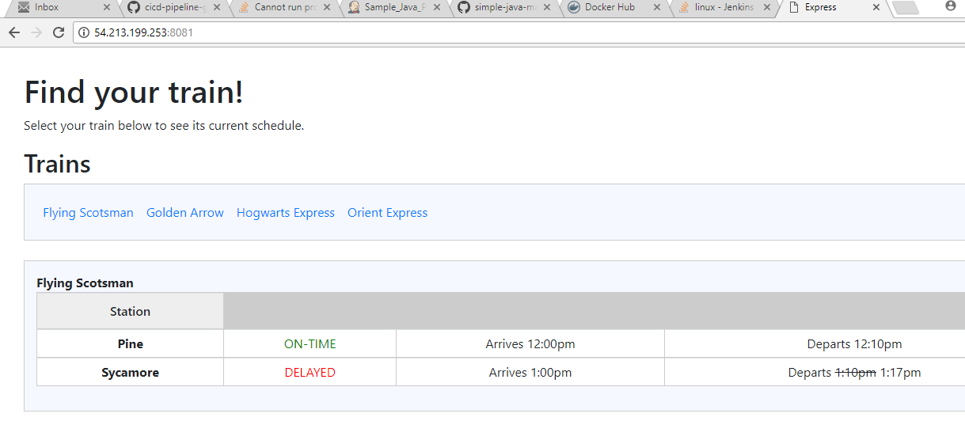
Note : In run command, 8081:3000 8081 is server port and 3000 is container port where app is running.

Containarizing Jenkins application in Docker

- Create folder jenkins_container and put a Dockerfile with content as below

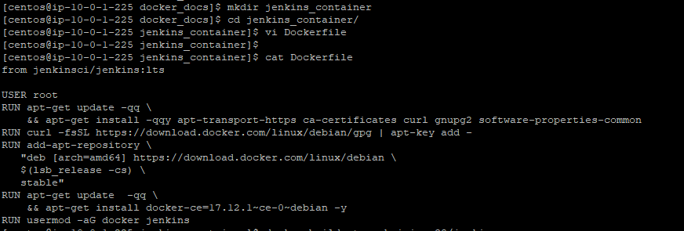
- Build the image

[centos@ip-10-0-1-225 jenkins_container]$ docker build -t msshrinivas38/jenkins .
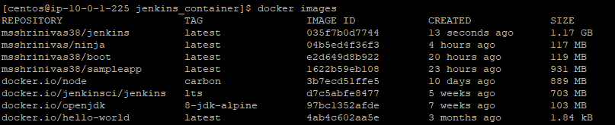

- Run the image to create a container and pass parameter for persistent volume

[centos@ip-10-0-1-225 jenkins_container]$ docker run -p 3002:8080 -d msshrinivas38/jenkins -v /var/run/docker.sock:/var/run/docker.sock jenkins-docker

sudo docker run -p 8080:8080 -v /var/run/docker.sock:/var/run/docker.sock -d ayyappanpads/17jenkinsapp
Same volume is shared between Base machine and jenkins-docker container

If not done none of the docker commands will work inside the jenkins-docker container

[centos@ip-10-0-1-225 jenkins_container]$ docker exec -it 56d951e3fb0e bash

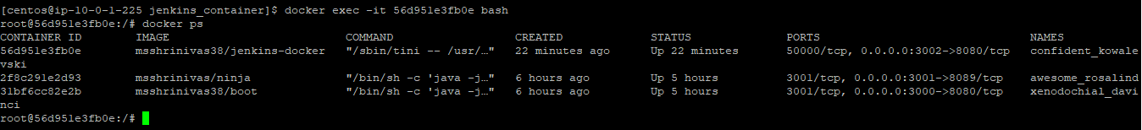

- Inorder to push the image to docker hub, please use below command from base machine

Login to docker hub account

docker login --username=msshrinivas38 --email=ms.shrinivas38@gmail.com

docker push msshrinivas38/jenkins-docker

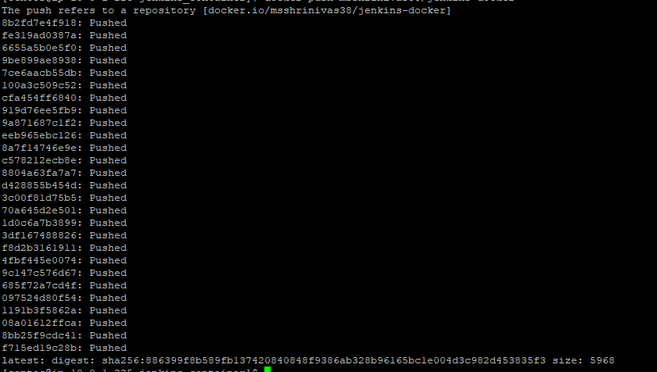

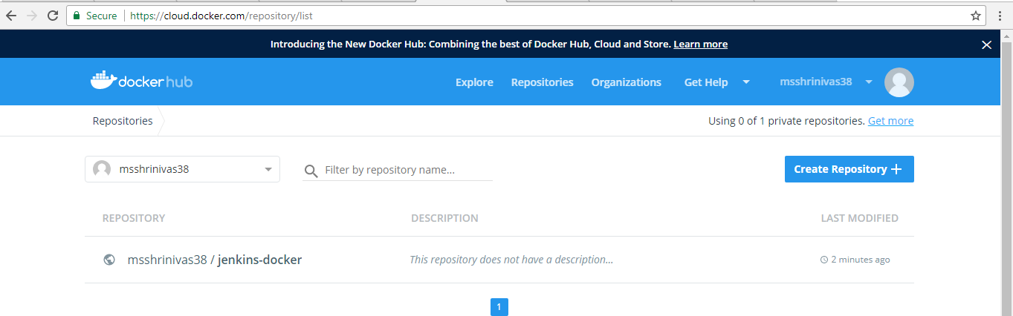

Manage Jenkins
Configure system
Global Parameter
Environmrnt variables

