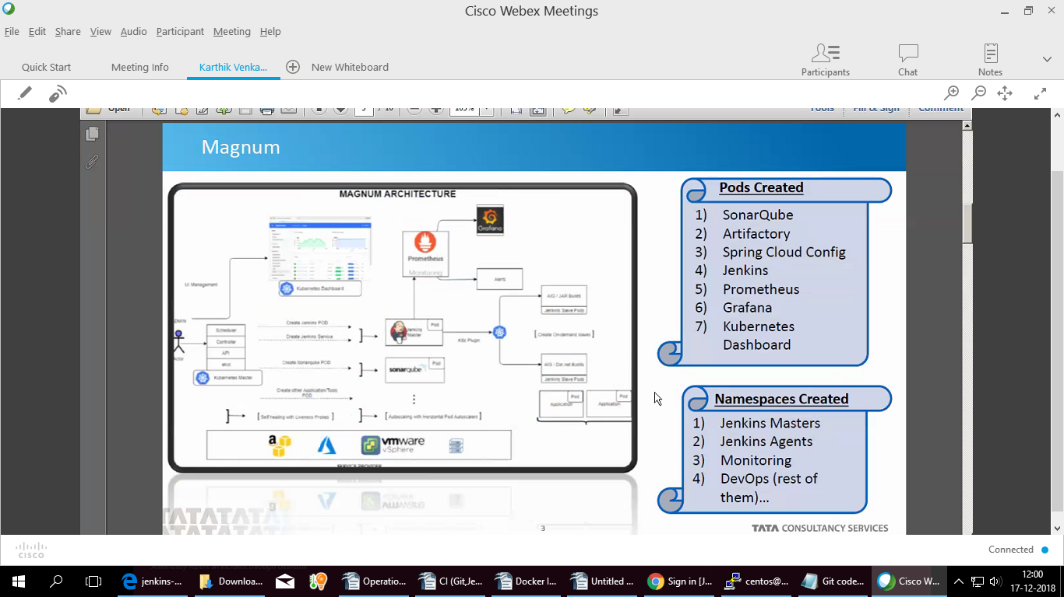
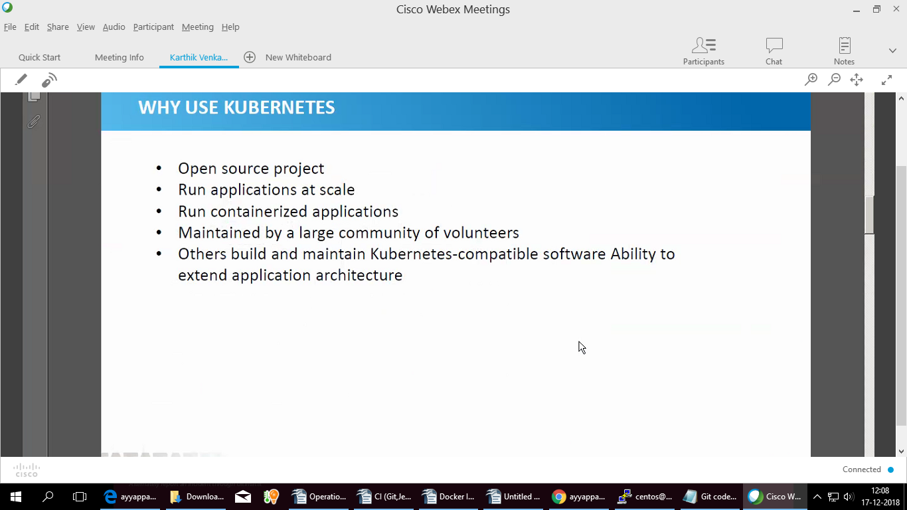
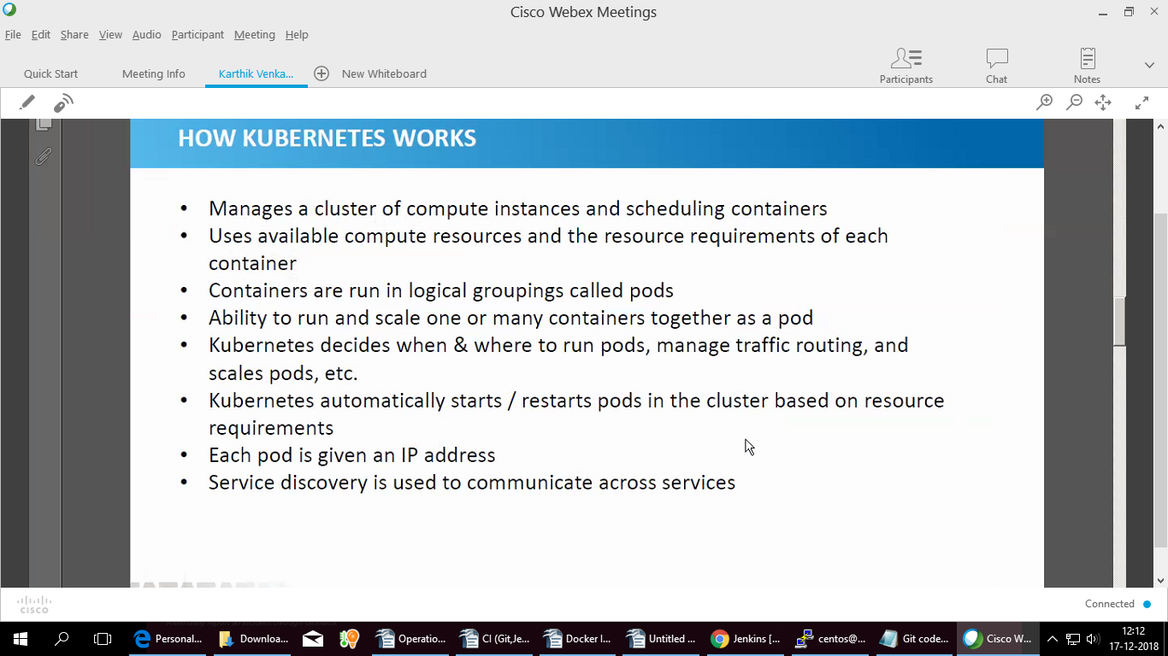
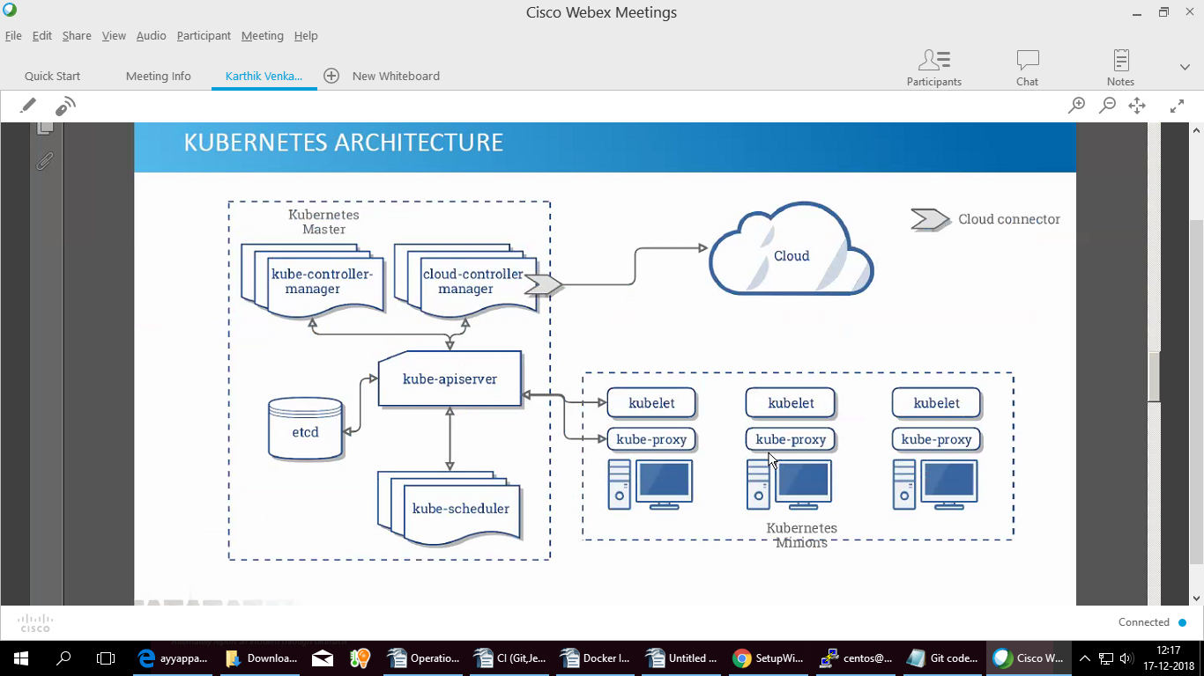
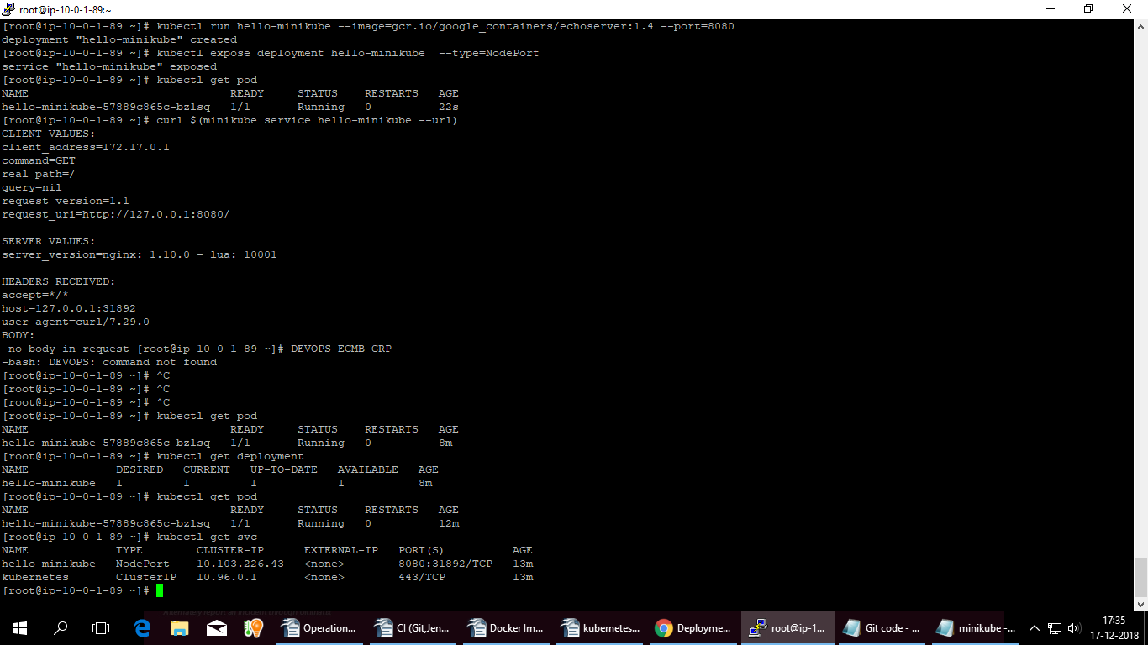

1 export PATH=$PATH:/usr/local/bin/
2 yum update
3 yum install yum-utils device-mapper-persistent-data lvm2
4 yum-config-manager --add-repo
5 yum-config-manager --add-repo
6 https://download.docker.com/linux/centos/docker-ce.repo
7 yum install docker-ce
8 systemctl start docker
9 systemctl enable docker
10 docker -v
11 curl -LO https://storage.googleapis.com/kubernetes-release/release/v1.8.7/bin/linux/amd64/kubectl
12 chmod +x ./kubectl
13 mv ./kubectl /usr/local/bin/kubectl
14 kubect version
15 kubect -version
16 systemctl status docker
17 docker -v
18 kubect version
19 curl -Lo minikube https://storage.googleapis.com/minikube/releases/v0.23.0/minikube-linux-amd64 && chmod +x minikube && sudo mv minikube /usr/local/bin/
20 kubectl run hello-minikube --image=gcr.io/google_containers/echoserver:1.4 --port=8080
21 kubectl version
22 kubectl run hello-minikube --image=gcr.io/google_containers/echoserver:1.4 --port=8080
23 https://storage.googleapis.com/minikube/releases/v0.23.0/minikube-linux-amd64 && chmod +x minikube && sudo mv minikube /usr/local/bin/
24 curl -Lo minikube https://storage.googleapis.com/minikube/releases/v0.23.0/minikube-linux-amd64 && chmod +x minikube && sudo mv minikube /usr/local/bin/
25 minikube start --vm-driver=none
26 kubectl run hello-minikube --image=gcr.io/google_containers/echoserver:1.4 --port=8080
27 kubectl expose deployment hello-minikube --type=NodePort
28 kubectl get pod
29 curl $(minikube service hello-minikube --url)
30 DEVOPS ECMB GRP
31 kubectl get pod
32*
33 kubectl get pod
34 kubectl get svc
35 history

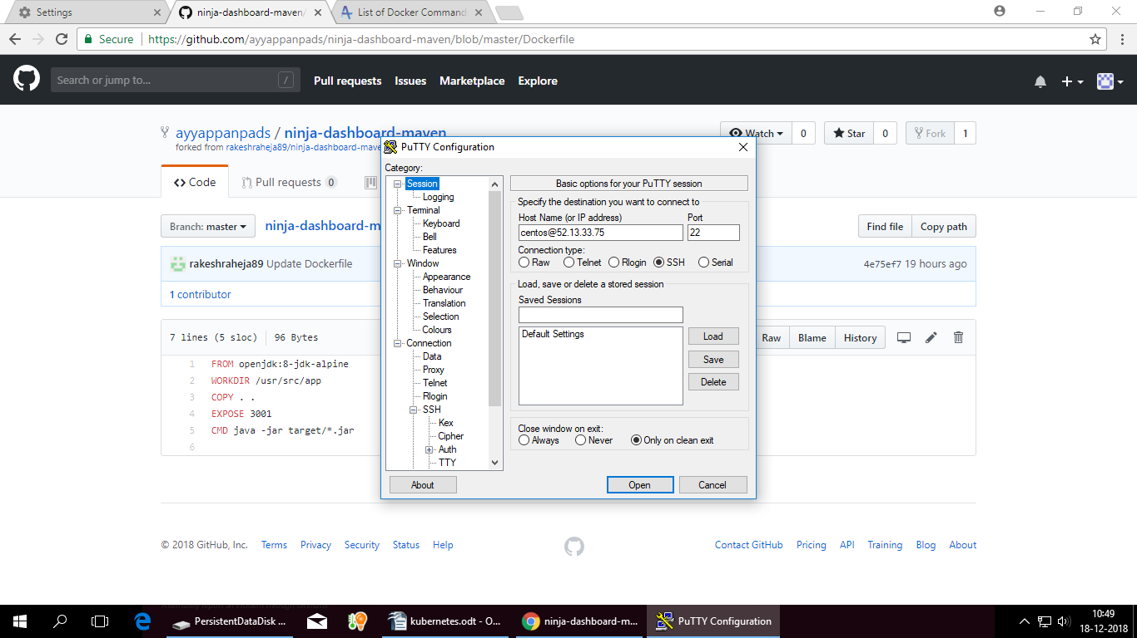
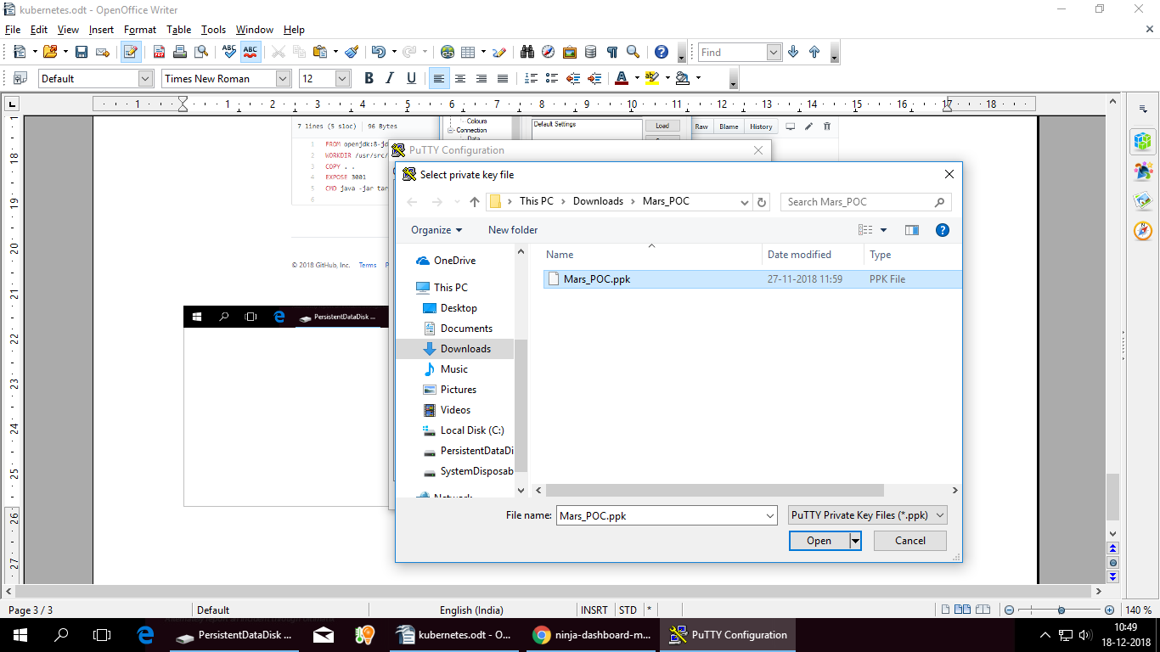
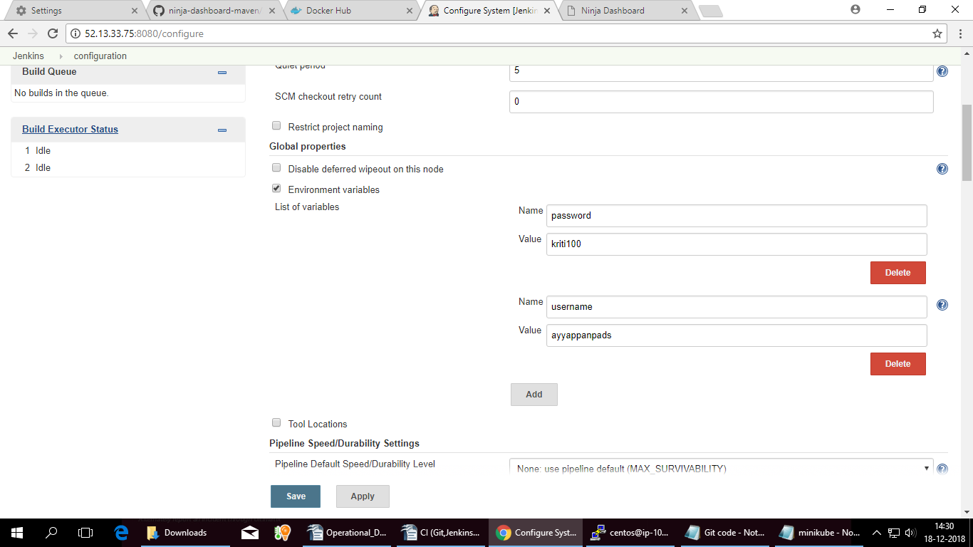
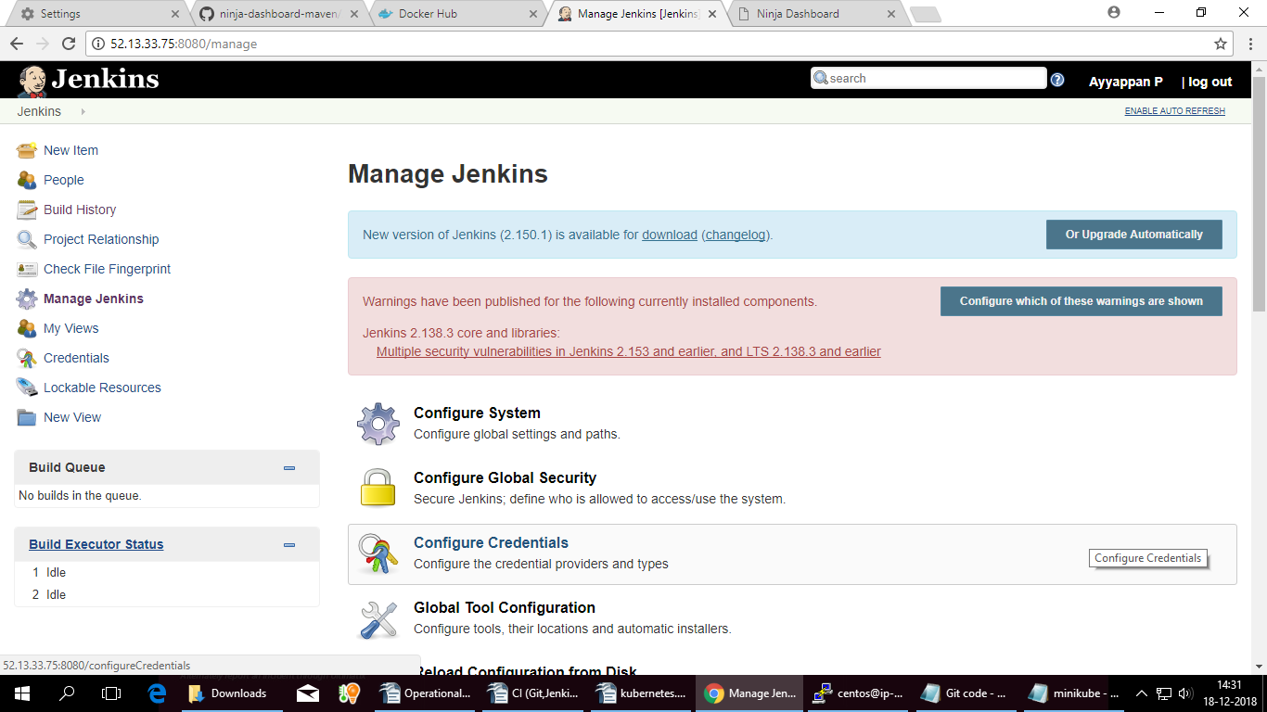

Go to manage plug ins
