ER (Entity Relationship) Diagram in DBMS

* ER model stands for an Entity-Relationship model. It is a high-level data model. This model is used to define the data elements and relationship for a specified system.
* It develops a conceptual design for the database. It also develops a very simple and easy to design view of data.
* In ER modeling, the database structure is portrayed as a diagram called an entity-relationship diagram.

**For example,** Suppose we design a school database. In this database, the student will be an entity with attributes like address, name, id, age, etc. The address can be another entity with attributes like city, street name, pin code, etc and there will be a relationship between them.

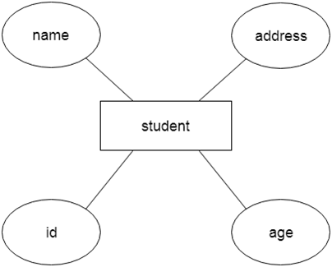

Component of ER Diagram

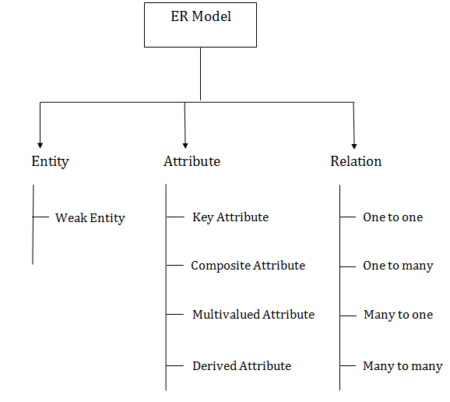

1. Entity:

An entity may be any object, class, person or place. In the ER diagram, an entity can be represented as rectangles.

Consider an organization as an example- manager, product, employee, department etc. can be taken as an entity.

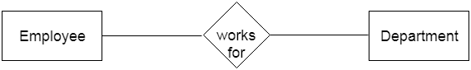

**a. Weak Entity**

An entity that depends on another entity called a weak entity. The weak entity doesn't contain any key attribute of its own. The weak entity is represented by a double rectangle.

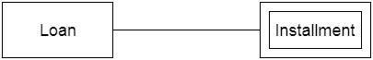

2. Attribute

The attribute is used to describe the property of an entity. Eclipse is used to represent an attribute.

**For example,** id, age, contact number, name, etc. can be attributes of a student.

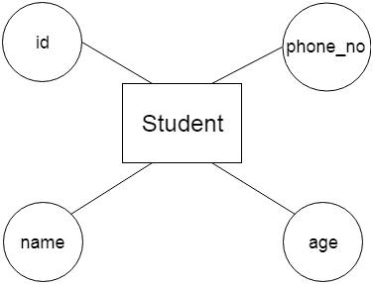

**a. Key Attribute**

The key attribute is used to represent the main characteristics of an entity. It represents a primary key. The key attribute is represented by an ellipse with the text underlined.

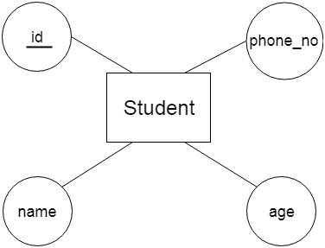

**b. Composite Attribute**

An attribute that composed of many other attributes is known as a composite attribute. The composite attribute is represented by an ellipse, and those ellipses are connected with an ellipse.

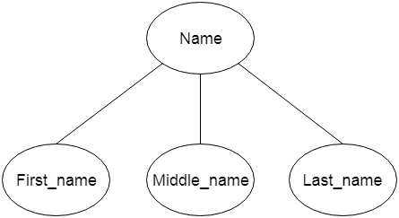

**c. Multivalued Attribute**

An attribute can have more than one value. These attributes are known as a multivalued attribute. The double oval is used to represent multivalued attribute.

**For example,** a student can have more than one phone number.

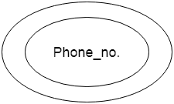

**d. Derived Attribute**

An attribute that can be derived from other attribute is known as a derived attribute. It can be represented by a dashed ellipse.

**For example,** A person's age changes over time and can be derived from another attribute like Date of birth.

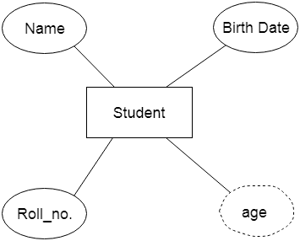

3. Relationship

A relationship is used to describe the relation between entities. Diamond or rhombus is used to represent the relationship.

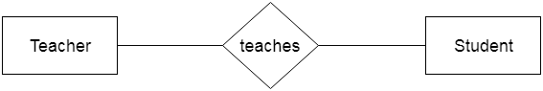

Types of relationship are as follows:

**a. One-to-One Relationship**

When only one instance of an entity is associated with the relationship, then it is known as one to one relationship.

**For example,** A female can marry to one male, and a male can marry to one female.

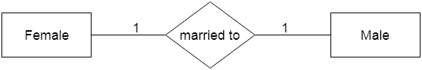

**b. One-to-many relationship**

When only one instance of the entity on the left, and more than one instance of an entity on the right associates with the relationship then this is known as a one-to-many relationship.

**For example,** Scientist can invent many inventions, but the invention is done by the only specific scientist.

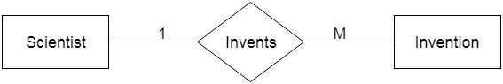

**c. Many-to-one relationship**

When more than one instance of the entity on the left, and only one instance of an entity on the right associates with the relationship then it is known as a many-to-one relationship.

**For example,** Student enrolls for only one course, but a course can have many students.

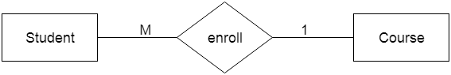

**d. Many-to-many relationship**

When more than one instance of the entity on the left, and more than one instance of an entity on the right associates with the relationship then it is known as a many-to-many relationship.

**For example,** Employee can assign by many projects and project can have many employees.

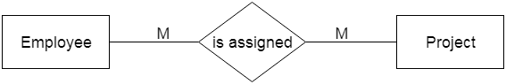

# Notation of ER diagram

Database can be represented using the notations. In ER diagram, many notations are used to express the cardinality. These notations are as follows:

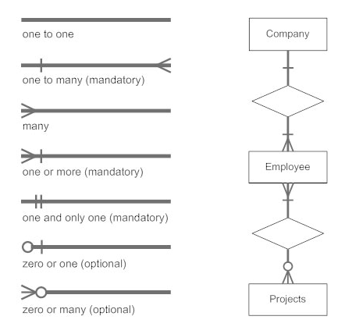

**Fig: Notations of ER diagram**

Normalization

A large database defined as a single relation may result in data duplication. This repetition of data may result in:

* Making relations very large.
* It isn't easy to maintain and update data as it would involve searching many records in relation.
* Wastage and poor utilization of disk space and resources.
* The likelihood of errors and inconsistencies increases.

So to handle these problems, we should analyze and decompose the relations with redundant data into smaller, simpler, and well-structured relations that are satisfy desirable properties. Normalization is a process of decomposing the relations into relations with fewer attributes.

What is Normalization?

* Normalization is the process of organizing the data in the database.
* Normalization is used to minimize the redundancy from a relation or set of relations. It is also used to eliminate undesirable characteristics like Insertion, Update, and Deletion Anomalies.
* Normalization divides the larger table into smaller and links them using relationships.
* The normal form is used to reduce redundancy from the database table.

Why do we need Normalization?

The main reason for normalizing the relations is removing these anomalies. Failure to eliminate anomalies leads to data redundancy and can cause data integrity and other problems as the database grows. Normalization consists of a series of guidelines that helps to guide you in creating a good database structure.

**Data modification anomalies can be categorized into three types:**

* **Insertion Anomaly:** Insertion Anomaly refers to when one cannot insert a new tuple into a relationship due to lack of data.
* **Deletion Anomaly:** The delete anomaly refers to the situation where the deletion of data results in the unintended loss of some other important data.
* **Updatation Anomaly:** The update anomaly is when an update of a single data value requires multiple rows of data to be updated.

Types of Normal Forms:

Normalization works through a series of stages called Normal forms. The normal forms apply to individual relations. The relation is said to be in particular normal form if it satisfies constraints.

**Following are the various types of Normal forms:**

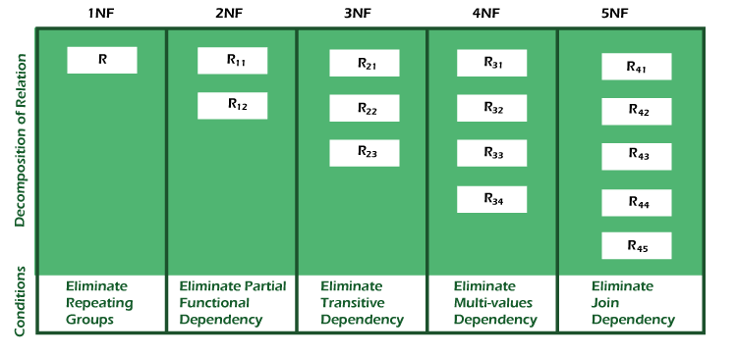

|  |  |
| --- | --- |
| **Normal Form** | **Description** |
| [1NF](https://www.javatpoint.com/dbms-first-normal-form) | A relation is in 1NF if it contains an atomic value. |
| [2NF](https://www.javatpoint.com/dbms-second-normal-form) | A relation will be in 2NF if it is in 1NF and all non-key attributes are fully functional dependent on the primary key. |
| [3NF](https://www.javatpoint.com/dbms-third-normal-form) | A relation will be in 3NF if it is in 2NF and no transition dependency exists. |
| BCNF | A stronger definition of 3NF is known as Boyce Codd's normal form. |
| [4NF](https://www.javatpoint.com/dbms-forth-normal-form) | A relation will be in 4NF if it is in Boyce Codd's normal form and has no multi-valued dependency. |
| [5NF](https://www.javatpoint.com/dbms-fifth-normal-form) | A relation is in 5NF. If it is in 4NF and does not contain any join dependency, joining should be lossless. |

Advantages of Normalization

* Normalization helps to minimize data redundancy.
* Greater overall database organization.
* Data consistency within the database.
* Much more flexible database design.
* Enforces the concept of relational integrity.

Disadvantages of Normalization

* You cannot start building the database before knowing what the user needs.
* The performance degrades when normalizing the relations to higher normal forms, i.e., 4NF, 5NF.
* It is very time-consuming and difficult to normalize relations of a higher degree.
* Careless decomposition may lead to a bad database design, leading to serious problems.

First Normal Form (1NF)

* A relation will be 1NF if it contains an atomic value.
* It states that an attribute of a table cannot hold multiple values. It must hold only single-valued attribute.
* First normal form disallows the multi-valued attribute, composite attribute, and their combinations.

**Example:** Relation EMPLOYEE is not in 1NF because of multi-valued attribute EMP_PHONE.

|  |  |  |  |
| --- | --- | --- | --- |
| **EMP_ID** | **EMP_NAME** | **EMP_PHONE** | **EMP_STATE** |
| 14 | John | 7272826385, 9064738238 | UP |
| 20 | Harry | 8574783832 | Bihar |
| 12 | Sam | 7390372389, 8589830302 | Punjab |

**EMPLOYEE table:**

The decomposition of the EMPLOYEE table into 1NF has been shown below:

|  |  |  |  |
| --- | --- | --- | --- |
| **EMP_ID** | **EMP_NAME** | **EMP_PHONE** | **EMP_STATE** |
| 14 | John | 7272826385 | UP |
| 14 | John | 9064738238 | UP |
| 20 | Harry | 8574783832 | Bihar |
| 12 | Sam | 7390372389 | Punjab |
| 12 | Sam | 8589830302 | Punjab |

Second Normal Form (2NF)

* In the 2NF, relational must be in 1NF.
* In the second normal form, all non-key attributes are fully functional dependent on the primary key

**Example:** Let's assume, a school can store the data of teachers and the subjects they teach. In a school, a teacher can teach more than one subject.

**TEACHER table**

|  |  |  |
| --- | --- | --- |
| **TEACHER_ID** | **SUBJECT** | **TEACHER_AGE** |
| 25 | Chemistry | 30 |
| 25 | Biology | 30 |
| 47 | English | 35 |
| 83 | Math | 38 |
| 83 | Computer | 38 |

In the given table, non-prime attribute TEACHER_AGE is dependent on TEACHER_ID which is a proper subset of a candidate key. That's why it violates the rule for 2NF.

To convert the given table into 2NF, we decompose it into two tables:

**TEACHER_DETAIL table:**

|  |  |
| --- | --- |
| **TEACHER_ID** | **TEACHER_AGE** |
| 25 | 30 |
| 47 | 35 |
| 83 | 38 |

**TEACHER_SUBJECT table:**

|  |  |
| --- | --- |
| **TEACHER_ID** | **SUBJECT** |
| 25 | Chemistry |
| 25 | Biology |
| 47 | English |
| 83 | Math |
| 83 | Computer |

Third Normal Form (3NF)

* A relation will be in 3NF if it is in 2NF and not contain any transitive partial dependency.
* 3NF is used to reduce the data duplication. It is also used to achieve the data integrity.
* If there is no transitive dependency for non-prime attributes, then the relation must be in third normal form.

A relation is in third normal form if it holds atleast one of the following conditions for every non-trivial function dependency X → Y.

1. X is a super key.
2. Y is a prime attribute, i.e., each element of Y is part of some candidate key.

**Example:**

**EMPLOYEE_DETAIL table:**

|  |  |  |  |  |
| --- | --- | --- | --- | --- |
| **EMP_ID** | **EMP_NAME** | **EMP_ZIP** | **EMP_STATE** | **EMP_CITY** |
| 222 | Harry | 201010 | UP | Noida |
| 333 | Stephan | 02228 | US | Boston |
| 444 | Lan | 60007 | US | Chicago |
| 555 | Katharine | 06389 | UK | Norwich |
| 666 | John | 462007 | MP | Bhopal |

**Super key in the table above:**

* 1. {EMP_ID}, {EMP_ID, EMP_NAME}, {EMP_ID, EMP_NAME, EMP_ZIP}....so on

**Candidate key:** {EMP_ID}

**Non-prime attributes:** In the given table, all attributes except EMP_ID are non-prime.

Here, EMP_STATE & EMP_CITY dependent on EMP_ZIP and EMP_ZIP dependent on EMP_ID. The non-prime attributes (EMP_STATE, EMP_CITY) transitively dependent on super key(EMP_ID). It violates the rule of third normal form.

That's why we need to move the EMP_CITY and EMP_STATE to the new <EMPLOYEE_ZIP> table, with EMP_ZIP as a Primary key.

**EMPLOYEE table:**

|  |  |  |
| --- | --- | --- |
| **EMP_ID** | **EMP_NAME** | **EMP_ZIP** |
| 222 | Harry | 201010 |
| 333 | Stephan | 02228 |
| 444 | Lan | 60007 |
| 555 | Katharine | 06389 |
| 666 | John | 462007 |

**EMPLOYEE_ZIP table:**

|  |  |  |
| --- | --- | --- |
| **EMP_ZIP** | **EMP_STATE** | **EMP_CITY** |
| 201010 | UP | Noida |
| 02228 | US | Boston |
| 60007 | US | Chicago |
| 06389 | UK | Norwich |
| 462007 | MP | Bhopal |

s

Boyce Codd normal form (BCNF)

* BCNF is the advance version of 3NF. It is stricter than 3NF.
* A table is in BCNF if every functional dependency X → Y, X is the super key of the table.
* For BCNF, the table should be in 3NF, and for every FD, LHS is super key.

**Example:** Let's assume there is a company where employees work in more than one department.

**EMPLOYEE table:**

|  |  |  |  |  |
| --- | --- | --- | --- | --- |
| **EMP_ID** | **EMP_COUNTRY** | **EMP_DEPT** | **DEPT_TYPE** | **EMP_DEPT_NO** |
| 264 | India | Designing | D394 | 283 |
| 264 | India | Testing | D394 | 300 |
| 364 | UK | Stores | D283 | 232 |
| 364 | UK | Developing | D283 | 549 |

**In the above table Functional dependencies are as follows:**

1. EMP_ID  →  EMP_COUNTRY
2. EMP_DEPT  →   {DEPT_TYPE, EMP_DEPT_NO}

**Candidate key: {EMP-ID, EMP-DEPT}**

The table is not in BCNF because neither EMP_DEPT nor EMP_ID alone are keys.

To convert the given table into BCNF, we decompose it into three tables:

**EMP_COUNTRY table:**

|  |  |
| --- | --- |
| **EMP_ID** | **EMP_COUNTRY** |
| 264 | India |
| 264 | India |

**EMP_DEPT table:**

|  |  |  |
| --- | --- | --- |
| **EMP_DEPT** | **DEPT_TYPE** | **EMP_DEPT_NO** |
| Designing | D394 | 283 |
| Testing | D394 | 300 |
| Stores | D283 | 232 |
| Developing | D283 | 549 |

**EMP_DEPT_MAPPING table:**

|  |  |
| --- | --- |
| **EMP_ID** | **EMP_DEPT** |
| D394 | 283 |
| D394 | 300 |
| D283 | 232 |
| D283 | 549 |

**Functional dependencies:**

1. EMP_ID   →    EMP_COUNTRY
2. EMP_DEPT   →   {DEPT_TYPE, EMP_DEPT_NO}

**Candidate keys:**

**For the first table:** EMP_ID  
**For the second table:** EMP_DEPT  
**For the third table:** {EMP_ID, EMP_DEPT}

Now, this is in BCNF because left side part of both the functional dependencies is a key.