Software Engineering

The term **software engineering** is the product of two words, **software**, and **engineering**.

The **software** is a collection of integrated programs.

Software subsists of carefully-organized instructions and code written by developers on any of various particular computer languages.

Computer programs and related documentation such as requirements, design models and user manuals.

**Engineering** is the application of **scientific** and **practical** knowledge to **invent, design, build, maintain**, and **improve frameworks, processes, etc**.

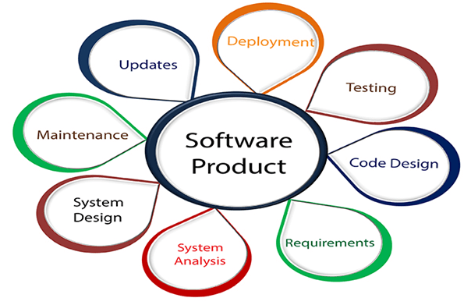

**Software Engineering** is an engineering branch related to the evolution of software product using well-defined scientific principles, techniques, and procedures. The result of software engineering is an effective and reliable software product.

Why is Software Engineering required?

Software Engineering is required due to the following reasons:

* To manage Large software
* For more Scalability
* Cost Management
* To manage the dynamic nature of software
* For better quality Management

Need of Software Engineering

The necessity of software engineering appears because of a higher rate of progress in user requirements and the environment on which the program is working.

* **Huge Programming:**It is simpler to manufacture a wall than to a house or building, similarly, as the measure of programming become extensive engineering has to step to give it a scientific process.
* **Adaptability:**If the software procedure were not based on scientific and engineering ideas, it would be simpler to re-create new software than to scale an existing one.
* **Cost:**As the hardware industry has demonstrated its skills and huge manufacturing has let down the cost of computer and electronic hardware. But the cost of programming remains high if the proper process is not adapted.
* **Dynamic Nature:**The continually growing and adapting nature of programming hugely depends upon the environment in which the client works. If the quality of the software is continually changing, new upgrades need to be done in the existing one.
* **Quality Management:** Better procedure of software development provides a better and quality software product.

Characteristics of a good software engineer

**The features that good software engineers should possess are as follows:**

Exposure to systematic methods, i.e., familiarity with software engineering principles.

Good technical knowledge of the project range (Domain knowledge).

Good programming abilities.

Good communication skills. These skills comprise of oral, written, and interpersonal skills.

High motivation.

Sound knowledge of fundamentals of computer science.

Intelligence.

Ability to work in a team

Discipline, etc.

Importance of Software Engineering

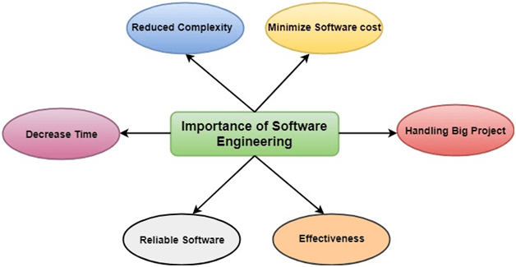

**The importance of Software engineering is as follows:**

1. **Reduces complexity:** Big software is always complicated and challenging to progress. Software engineering has a great solution to reduce the complication of any project. Software engineering divides big problems into various small issues. And then start solving each small issue one by one. All these small problems are solved independently to each other.
2. **To minimize software cost:** Software needs a lot of hardwork and software engineers are highly paid experts. A lot of manpower is required to develop software with a large number of codes. But in software engineering, programmers project everything and decrease all those things that are not needed. In turn, the cost for software productions becomes less as compared to any software that does not use software engineering method.
3. **To decrease time:** Anything that is not made according to the project always wastes time. And if you are making great software, then you may need to run many codes to get the definitive running code. This is a very time-consuming procedure, and if it is not well handled, then this can take a lot of time. So if you are making your software according to the software engineering method, then it will decrease a lot of time.
4. **Handling big projects:** Big projects are not done in a couple of days, and they need lots of patience, planning, and management. And to invest six and seven months of any company, it requires heaps of planning, direction, testing, and maintenance. No one can say that he has given four months of a company to the task, and the project is still in its first stage. Because the company has provided many resources to the plan and it should be completed. So to handle a big project without any problem, the company has to go for a software engineering method.
5. **Reliable software:** Software should be secure, means if you have delivered the software, then it should work for at least its given time or subscription. And if any bugs come in the software, the company is responsible for solving all these bugs. Because in software engineering, testing and maintenance are given, so there is no worry of its reliability.
6. **Effectiveness:** Effectiveness comes if anything has made according to the standards. Software standards are the big target of companies to make it more effective. So Software becomes more effective in the act with the help of software engineering.

# **Software Development Life Cycle (SDLC)**

A software life cycle model (also termed process model) is a pictorial and diagrammatic representation of the software life cycle. A life cycle model represents all the methods required to make a software product transit through its life cycle stages. It also captures the structure in which these methods are to be undertaken.

In other words, a life cycle model maps the various activities performed on a software product from its inception to retirement. Different life cycle models may plan the necessary development activities to phases in different ways. Thus, no element which life cycle model is followed, the essential activities are contained in all life cycle models though the action may be carried out in distinct orders in different life cycle models. During any life cycle stage, more than one activity may also be carried out.

## Need of SDLC

The development team must determine a suitable life cycle model for a particular plan and then observe to it.

Without using an exact life cycle model, the development of a software product would not be in a systematic and disciplined manner. When a team is developing a software product, there must be a clear understanding among team representative about when and what to do. Otherwise, it would point to chaos and project failure. This problem can be defined by using an example. Suppose a software development issue is divided into various parts and the parts are assigned to the team members. From then on, suppose the team representative is allowed the freedom to develop the roles assigned to them in whatever way they like. It is possible that one representative might start writing the code for his part, another might choose to prepare the test documents first, and some other engineer might begin with the design phase of the roles assigned to him. This would be one of the perfect methods for project failure.

A software life cycle model describes entry and exit criteria for each phase. A phase can begin only if its stage-entry criteria have been fulfilled. So without a software life cycle model, the entry and exit criteria for a stage cannot be recognized. Without software life cycle models, it becomes tough for software project managers to monitor the progress of the project.

## SDLC Cycle

SDLC Cycle represents the process of developing software. SDLC framework includes the following steps:

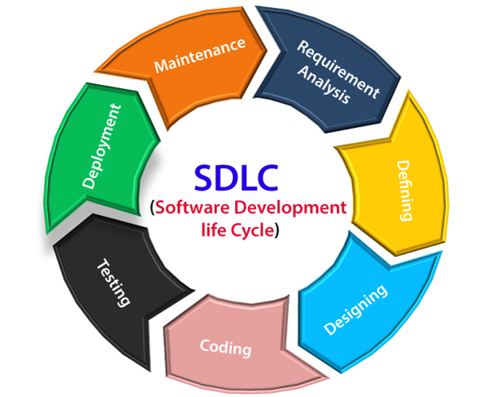

## The stages of SDLC are as follows:

**Stage1: Planning and requirement analysis**

Requirement Analysis is the most important and necessary stage in SDLC.

The senior members of the team perform it with inputs from all the stakeholders and domain experts or SMEs in the industry.

Planning for the quality assurance requirements and identifications of the risks associated with the projects is also done at this stage.

Business analyst and Project organizer set up a meeting with the client to gather all the data like what the customer wants to build, who will be the end user, what is the objective of the product. Before creating a product, a core understanding or knowledge of the product is very necessary.

**For Example**, A client wants to have an application which concerns money transactions. In this method, the requirement has to be precise like what kind of operations will be done, how it will be done, in which currency it will be done, etc.

Once the required function is done, an analysis is complete with auditing the feasibility of the growth of a product. In case of any ambiguity, a signal is set up for further discussion.

Once the requirement is understood, the SRS (Software Requirement Specification) document is created. The developers should thoroughly follow this document and also should be reviewed by the customer for future reference.

**Stage2: Defining Requirements**

Once the requirement analysis is done, the next stage is to certainly represent and document the software requirements and get them accepted from the project stakeholders.

This is accomplished through "SRS"- Software Requirement Specification document which contains all the product requirements to be constructed and developed during the project life cycle.

**Stage3: Designing the Software**

The next phase is about to bring down all the knowledge of requirements, analysis, and design of the software project. This phase is the product of the last two, like inputs from the customer and requirement gathering.

**Stage4: Developing the project**

In this phase of SDLC, the actual development begins, and the programming is built. The implementation of design begins concerning writing code. Developers have to follow the coding guidelines described by their management and programming tools like compilers, interpreters, debuggers, etc. are used to develop and implement the code.

**Stage5: Testing**

After the code is generated, it is tested against the requirements to make sure that the products are solving the needs addressed and gathered during the requirements stage.

During this stage, unit testing, integration testing, system testing, acceptance testing are done.

**Stage6: Deployment**

Once the software is certified, and no bugs or errors are stated, then it is deployed.

Then based on the assessment, the software may be released as it is or with suggested enhancement in the object segment.

After the software is deployed, then its maintenance begins.

**Stage7: Maintenance**

Once when the client starts using the developed systems, then the real issues come up and requirements to be solved from time to time.

This procedure where the care is taken for the developed product is known as maintenance.

# **SDLC Models**

Software Development life cycle (SDLC) is a spiritual model used in project management that defines the stages include in an information system development project, from an initial feasibility study to the maintenance of the completed application.

There are different software development life cycle models specify and design, which are followed during the software development phase. These models are also called "**Software Development Process Models**." Each process model follows a series of phase unique to its type to ensure success in the step of software development.

**Here, are some important phases of SDLC life cycle:**

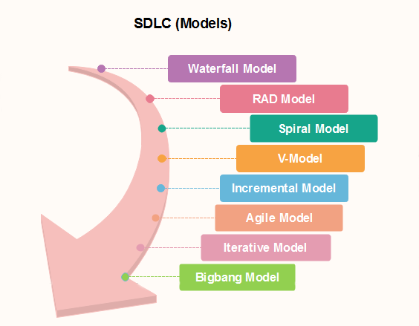

### [Waterfall Model](https://www.javatpoint.com/software-engineering-waterfall-model)

The waterfall is a universally accepted SDLC model. In this method, the whole process of software development is divided into various phases.

The waterfall model is a continuous software development model in which development is seen as flowing steadily downwards (like a waterfall) through the steps of requirements analysis, design, implementation, testing (validation), integration, and maintenance.

Linear ordering of activities has some significant consequences. First, to identify the end of a phase and the beginning of the next, some certification techniques have to be employed at the end of each step. Some verification and validation usually do this mean that will ensure that the output of the stage is consistent with its input (which is the output of the previous step), and that the output of the stage is consistent with the overall requirements of the system.

### [RAD Model](https://www.javatpoint.com/software-engineering-rapid-application-development-model)

RAD or Rapid Application Development process is an adoption of the waterfall model; it targets developing software in a short period. The RAD model is based on the concept that a better system can be developed in lesser time by using focus groups to gather system requirements.

* Business Modeling
* Data Modeling
* Process Modeling
* Application Generation
* Testing and Turnover

### [Spiral Model](https://www.javatpoint.com/software-engineering-spiral-model)

The spiral model is a **risk-driven process model**. This SDLC model helps the group to adopt elements of one or more process models like a waterfall, incremental, waterfall, etc. The spiral technique is a combination of rapid prototyping and concurrency in design and development activities.

Each cycle in the spiral begins with the identification of objectives for that cycle, the different alternatives that are possible for achieving the goals, and the constraints that exist. This is the first quadrant of the cycle (upper-left quadrant).

The next step in the cycle is to evaluate these different alternatives based on the objectives and constraints. The focus of evaluation in this step is based on the risk perception for the project.

The next step is to develop strategies that solve uncertainties and risks. This step may involve activities such as benchmarking, simulation, and prototyping.

### [V-Model](https://www.javatpoint.com/software-engineering-v-model)

In this type of SDLC model testing and the development, the step is planned in parallel. So, there are verification phases on the side and the validation phase on the other side. V-Model joins by Coding phase.

### [Incremental Model](https://www.javatpoint.com/software-engineering-incremental-model)

The incremental model is not a separate model. It is necessarily a series of waterfall cycles. The requirements are divided into groups at the start of the project. For each group, the SDLC model is followed to develop software. The SDLC process is repeated, with each release adding more functionality until all requirements are met. In this method, each cycle act as the maintenance phase for the previous software release. Modification to the incremental model allows development cycles to overlap. After that subsequent cycle may begin before the previous cycle is complete.

### [Agile Model](https://www.javatpoint.com/software-engineering-agile-model)

Agile methodology is a practice which promotes continues interaction of development and testing during the SDLC process of any project. In the Agile method, the entire project is divided into small incremental builds. All of these builds are provided in iterations, and each iteration lasts from one to three weeks.

Any agile software phase is characterized in a manner that addresses several key assumptions about the bulk of software projects:

1. It is difficult to think in advance which software requirements will persist and which will change. It is equally difficult to predict how user priorities will change as the project proceeds.
2. For many types of software, design and development are interleaved. That is, both activities should be performed in tandem so that design models are proven as they are created. It is difficult to think about how much design is necessary before construction is used to test the configuration.
3. Analysis, design, development, and testing are not as predictable (from a planning point of view) as we might like.

### [Iterative Model](https://www.javatpoint.com/software-engineering-iterative-model)

It is a particular implementation of a software development life cycle that focuses on an initial, simplified implementation, which then progressively gains more complexity and a broader feature set until the final system is complete. In short, iterative development is a way of breaking down the software development of a large application into smaller pieces.

### [Big bang model](https://www.javatpoint.com/software-engineering-big-bang-model)

Big bang model is focusing on all types of resources in software development and coding, with no or very little planning. The requirements are understood and implemented when they come.

This model works best for small projects with smaller size development team which are working together. It is also useful for academic software development projects. It is an ideal model where requirements are either unknown or final release date is not given.

### [Prototype Model](https://www.javatpoint.com/software-engineering-prototype-model)

The prototyping model starts with the requirements gathering. The developer and the user meet and define the purpose of the software, identify the needs, etc.

A '**quick design**' is then created. This design focuses on those aspects of the software that will be visible to the user. It then leads to the development of a prototype. The customer then checks the prototype, and any modifications or changes that are needed are made to the prototype.

Looping takes place in this step, and better versions of the prototype are created. These are continuously shown to the user so that any new changes can be updated in the prototype. This process continue until the customer is satisfied with the system. Once a user is satisfied, the prototype is converted to the actual system with all considerations for quality and security.

# **Waterfall model**

Winston Royce introduced the Waterfall Model in 1970.This model has five phases: Requirements analysis and specification, design, implementation, and unit testing, integration and system testing, and operation and maintenance. The steps always follow in this order and do not overlap. The developer must complete every phase before the next phase begins. This model is named "**Waterfall Model**", because its diagrammatic representation resembles a cascade of waterfalls.

**1. Requirements analysis and specification phase:** The aim of this phase is to understand the exact requirements of the customer and to document them properly. Both the customer and the software developer work together so as to document all the functions, performance, and interfacing requirement of the software. It describes the "what" of the system to be produced and not "how."In this phase, a large document called **Software Requirement Specification (SRS)** document is created which contained a detailed description of what the system will do in the common language.

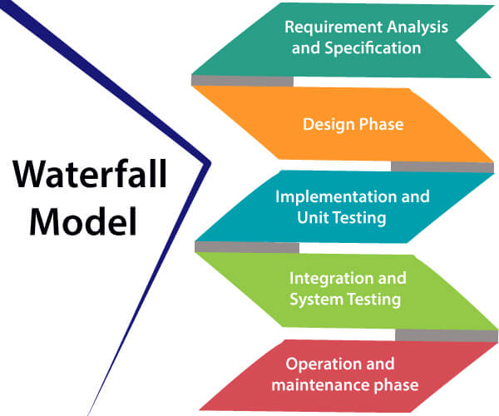

**2. Design Phase:** This phase aims to transform the requirements gathered in the SRS into a suitable form which permits further coding in a programming language. It defines the overall software architecture together with high level and detailed design. All this work is documented as a Software Design Document (SDD).

**3. Implementation and unit testing:** During this phase, design is implemented. If the SDD is complete, the implementation or coding phase proceeds smoothly, because all the information needed by software developers is contained in the SDD.

During testing, the code is thoroughly examined and modified. Small modules are tested in isolation initially. After that these modules are tested by writing some overhead code to check the interaction between these modules and the flow of intermediate output.

**4. Integration and System Testing:** This phase is highly crucial as the quality of the end product is determined by the effectiveness of the testing carried out. The better output will lead to satisfied customers, lower maintenance costs, and accurate results. Unit testing determines the efficiency of individual modules. However, in this phase, the modules are tested for their interactions with each other and with the system.

**5. Operation and maintenance phase:** Maintenance is the task performed by every user once the software has been delivered to the customer, installed, and operational.

## When to use SDLC Waterfall Model?

Some Circumstances where the use of the Waterfall model is most suited are:

* When the requirements are constant and not changed regularly.
* A project is short
* The situation is calm
* Where the tools and technology used is consistent and is not changing
* When resources are well prepared and are available to use.

## Advantages of Waterfall model

* This model is simple to implement also the number of resources that are required for it is minimal.
* The requirements are simple and explicitly declared; they remain unchanged during the entire project development.
* The start and end points for each phase is fixed, which makes it easy to cover progress.
* The release date for the complete product, as well as its final cost, can be determined before development.
* It gives easy to control and clarity for the customer due to a strict reporting system.

## Disadvantages of Waterfall model

* In this model, the risk factor is higher, so this model is not suitable for more significant and complex projects.
* This model cannot accept the changes in requirements during development.
* It becomes tough to go back to the phase. For example, if the application has now shifted to the coding phase, and there is a change in requirement, It becomes tough to go back and change it.
* Since the testing done at a later stage, it does not allow identifying the challenges and risks in the earlier phase, so the risk reduction strategy is difficult to prepare.

# **RAD (Rapid Application Development) Model**

RAD is a linear sequential software development process model that emphasizes a concise development cycle using an element based construction approach. If the requirements are well understood and described, and the project scope is a constraint, the RAD process enables a development team to create a fully functional system within a concise time period.

RAD (Rapid Application Development) is a concept that products can be developed faster and of higher quality through:

Gathering requirements using workshops or focus groups

* Prototyping and early, reiterative user testing of designs
* The re-use of software components
* A rigidly paced schedule that refers design improvements to the next product version
* Less formality in reviews and other team communication

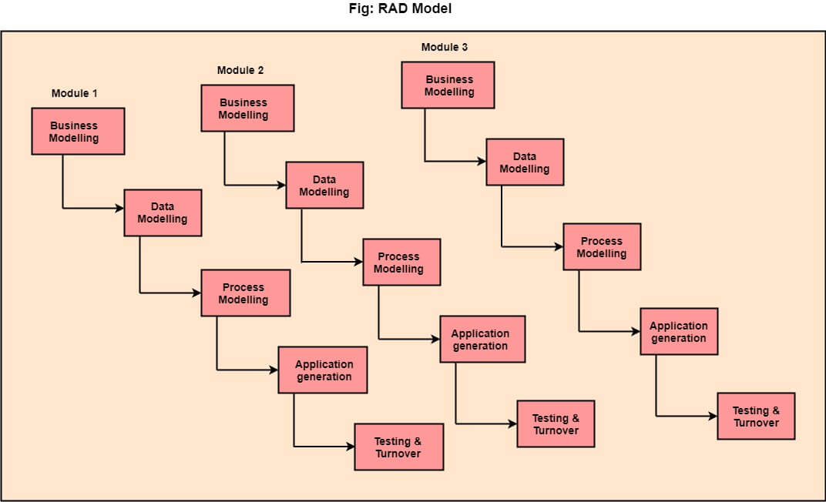

## The various phases of RAD are as follows:

**1.Business Modelling:** The information flow among business functions is defined by answering questions like what data drives the business process, what data is generated, who generates it, where does the information go, who process it and so on.

**2. Data Modelling:** The data collected from business modeling is refined into a set of data objects (entities) that are needed to support the business. The attributes (character of each entity) are identified, and the relation between these data objects (entities) is defined.

ADVERTISEMENT

**3. Process Modelling:** The information object defined in the data modeling phase are transformed to achieve the data flow necessary to implement a business function. Processing descriptions are created for adding, modifying, deleting, or retrieving a data object.

**4. Application Generation:** Automated tools are used to facilitate construction of the software; even they use the 4th GL techniques.

**5. Testing & Turnover:** Many of the programming components have already been tested since RAD emphasis reuse. This reduces the overall testing time. But the new part must be tested, and all interfaces must be fully exercised.

## When to use RAD Model?

* When the system should need to create the project that modularizes in a short span time (2-3 months).
* When the requirements are well-known.
* When the technical risk is limited.
* When there's a necessity to make a system, which modularized in 2-3 months of period.
* It should be used only if the budget allows the use of automatic code generating tools.

## Advantage of RAD Model

* This model is flexible for change.
* In this model, changes are adoptable.
* Each phase in RAD brings highest priority functionality to the customer.
* It reduced development time.
* It increases the reusability of features.

## Disadvantage of RAD Model

* It required highly skilled designers.
* All application is not compatible with RAD.
* For smaller projects, we cannot use the RAD model.
* On the high technical risk, it's not suitable.
* Required user involvement.

# **Spiral Model**

The spiral model, initially proposed by Boehm, is an evolutionary software process model that couples the iterative feature of prototyping with the controlled and systematic aspects of the linear sequential model. It implements the potential for rapid development of new versions of the software. Using the spiral model, the software is developed in a series of incremental releases. During the early iterations, the additional release may be a paper model or prototype. During later iterations, more and more complete versions of the engineered system are produced.

**The Spiral Model is shown in fig:**

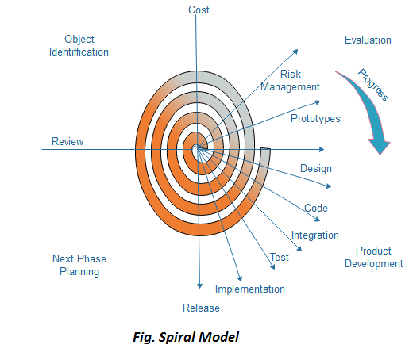

**Each cycle in the spiral is divided into four parts:**

**Objective setting:** Each cycle in the spiral starts with the identification of purpose for that cycle, the various alternatives that are possible for achieving the targets, and the constraints that exists. Backward Skip 10sPlay Skip 10s

**Risk Assessment and reduction:** The next phase in the cycle is to calculate these various alternatives based on the goals and constraints. The focus of evaluation in this stage is located on the risk perception for the project.

**Development and validation:** The next phase is to develop strategies that resolve uncertainties and risks. This process may include activities such as benchmarking, simulation, and prototyping.

**Planning:** Finally, the next step is planned. The project is reviewed, and a choice made whether to continue with a further period of the spiral. If it is determined to keep, plans are drawn up for the next step of the project.

The development phase depends on the remaining risks. For example, if performance or user-interface risks are treated more essential than the program development risks, the next phase may be an evolutionary development that includes developing a more detailed prototype for solving the risks.

The **risk-driven** feature of the spiral model allows it to accommodate any mixture of a specification-oriented, prototype-oriented, simulation-oriented, or another type of approach. An essential element of the model is that each period of the spiral is completed by a review that includes all the products developed during that cycle, including plans for the next cycle. The spiral model works for development as well as enhancement projects.

## When to use Spiral Model?

* When deliverance is required to be frequent.
* When the project is large
* When requirements are unclear and complex
* When changes may require at any time
* Large and high budget projects

## Advantages

* High amount of risk analysis
* Useful for large and mission-critical projects.

## Disadvantages

* Can be a costly model to use.
* Risk analysis needed highly particular expertise
* Doesn't work well for smaller projects.

# **V-Model**

V-Model also referred to as the Verification and Validation Model. In this, each phase of SDLC must complete before the next phase starts. It follows a sequential design process same as the waterfall model. Testing of the device is planned in parallel with a corresponding stage of development.

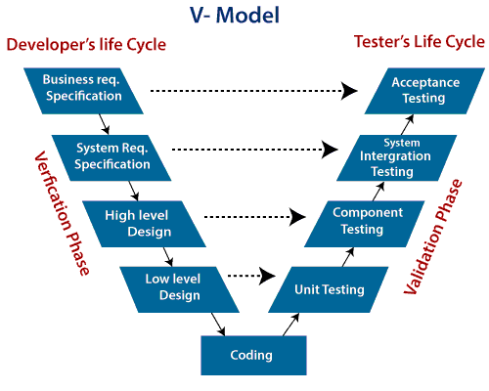

**Verification:** It involves a static analysis method (review) done without executing code. It is the process of evaluation of the product development process to find whether specified requirements meet.

**Validation:** It involves dynamic analysis method (functional, non-functional), testing is done by executing code. Validation is the process to classify the software after the completion of the development process to determine whether the software meets the customer expectations and requirements.

So V-Model contains Verification phases on one side of the Validation phases on the other side. Verification and Validation process is joined by coding phase in V-shape. Thus it is known as V-Model.

**There are the various phases of Verification Phase of V-model:**

1. **Business requirement analysis:** This is the first step where product requirements understood from the customer's side. This phase contains detailed communication to understand customer's expectations and exact requirements.
2. **System Design:** In this stage system engineers analyze and interpret the business of the proposed system by studying the user requirements document.
3. **Architecture Design:** The baseline in selecting the architecture is that it should understand all which typically consists of the list of modules, brief functionality of each module, their interface relationships, dependencies, database tables, architecture diagrams, technology detail, etc. The integration testing model is carried out in a particular phase.
4. **Module Design:** In the module design phase, the system breaks down into small modules. The detailed design of the modules is specified, which is known as Low-Level Design
5. **Coding Phase:** After designing, the coding phase is started. Based on the requirements, a suitable programming language is decided. There are some guidelines and standards for coding. Before checking in the repository, the final build is optimized for better performance, and the code goes through many code reviews to check the performance.

**There are the various phases of Validation Phase of V-model:**

1. **Unit Testing:** In the V-Model, Unit Test Plans (UTPs) are developed during the module design phase. These UTPs are executed to eliminate errors at code level or unit level. A unit is the smallest entity which can independently exist, e.g., a program module. Unit testing verifies that the smallest entity can function correctly when isolated from the rest of the codes/ units.
2. **Integration Testing:** Integration Test Plans are developed during the Architectural Design Phase. These tests verify that groups created and tested independently can coexist and communicate among themselves.
3. **System Testing:** System Tests Plans are developed during System Design Phase. Unlike Unit and Integration Test Plans, System Tests Plans are composed by the client?s business team. System Test ensures that expectations from an application developer are met.
4. **Acceptance Testing:** Acceptance testing is related to the business requirement analysis part. It includes testing the software product in user atmosphere. Acceptance tests reveal the compatibility problems with the different systems, which is available within the user atmosphere. It conjointly discovers the non-functional problems like load and performance defects within the real user atmosphere.

## When to use V-Model?

* When the requirement is well defined and not ambiguous.
* The V-shaped model should be used for small to medium-sized projects where requirements are clearly defined and fixed.
* The V-shaped model should be chosen when sample technical resources are available with essential technical expertise.

## Advantage (Pros) of V-Model:

1. Easy to Understand.
2. Testing Methods like planning, test designing happens well before coding.
3. This saves a lot of time. Hence a higher chance of success over the waterfall model.
4. Avoids the downward flow of the defects.
5. Works well for small plans where requirements are easily understood.

## Disadvantage (Cons) of V-Model:

1. Very rigid and least flexible.
2. Not a good for a complex project.
3. Software is developed during the implementation stage, so no early prototypes of the software are produced.
4. If any changes happen in the midway, then the test documents along with the required documents, has to be updated.

# **Incremental Model**

Incremental Model is a process of software development where requirements divided into multiple standalone modules of the software development cycle. In this model, each module goes through the requirements, design, implementation and testing phases. Every subsequent release of the module adds function to the previous release. The process continues until the complete system achieved.

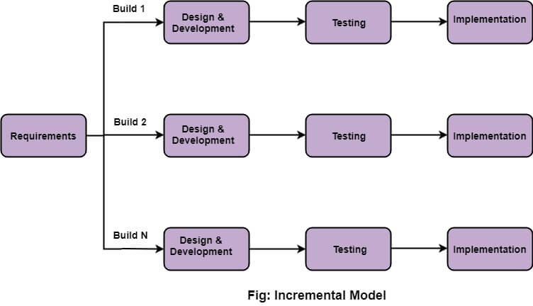

## The various phases of incremental model are as follows:

**1. Requirement analysis:** In the first phase of the incremental model, the product analysis expertise identifies the requirements. And the system functional requirements are understood by the requirement analysis team. To develop the software under the incremental model, this phase performs a crucial role.

**2. Design & Development:** In this phase of the Incremental model of SDLC, the design of the system functionality and the development method are finished with success. When software develops new practicality, the incremental model uses style and development phase.

**3. Testing:** In the incremental model, the testing phase checks the performance of each existing function as well as additional functionality. In the testing phase, the various methods are used to test the behavior of each task.

**4. Implementation:** Implementation phase enables the coding phase of the development system. It involves the final coding that design in the designing and development phase and tests the functionality in the testing phase. After completion of this phase, the number of the product working is enhanced and upgraded up to the final system product

## When we use the Incremental Model?

* When the requirements are superior.
* A project has a lengthy development schedule.
* When Software team are not very well skilled or trained.
* When the customer demands a quick release of the product.
* You can develop prioritized requirements first.

## Advantage of Incremental Model

* Errors are easy to be recognized.
* Easier to test and debug
* More flexible.
* Simple to manage risk because it handled during its iteration.
* The Client gets important functionality early.

## Disadvantage of Incremental Model

* Need for good planning
* Total Cost is high.
* Well defined module interfaces are needed.

# **Agile Model**

The meaning of Agile is swift or versatile."**Agile process model**" refers to a software development approach based on iterative development. Agile methods break tasks into smaller iterations, or parts do not directly involve long term planning. The project scope and requirements are laid down at the beginning of the development process. Plans regarding the number of iterations, the duration and the scope of each iteration are clearly defined in advance.

Each iteration is considered as a short time "frame" in the Agile process model, which typically lasts from one to four weeks. The division of the entire project into smaller parts helps to minimize the project risk and to reduce the overall project delivery time requirements. Each iteration involves a team working through a full software development life cycle including planning, requirements analysis, design, coding, and testing before a working product is demonstrated to the client.

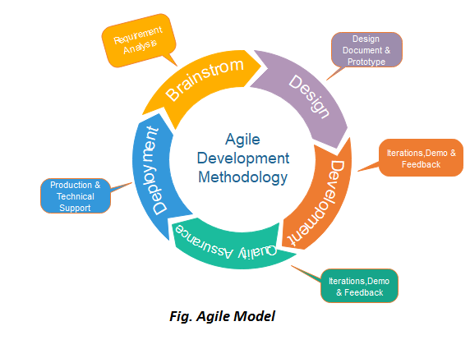

## Phases of Agile Model:

Following are the phases in the Agile model are as follows:

1. Requirements gathering
2. Design the requirements
3. Construction/ iteration
4. Testing/ Quality assurance
5. Deployment
6. Feedback

**1. Requirements gathering:** In this phase, you must define the requirements. You should explain business opportunities and plan the time and effort needed to build the project. Based on this information, you can evaluate technical and economic feasibility.

**2. Design the requirements:** When you have identified the project, work with stakeholders to define requirements. You can use the user flow diagram or the high-level UML diagram to show the work of new features and show how it will apply to your existing system.

**3. Construction/ iteration:** When the team defines the requirements, the work begins. Designers and developers start working on their project, which aims to deploy a working product. The product will undergo various stages of improvement, so it includes simple, minimal functionality.

**4. Testing:** In this phase, the Quality Assurance team examines the product's performance and looks for the bug.

**5. Deployment:** In this phase, the team issues a product for the user's work environment.

**6. Feedback:** After releasing the product, the last step is feedback. In this, the team receives feedback about the product and works through the feedback.

## Agile Testing Methods:

* Scrum
* Crystal
* Dynamic Software Development Method(DSDM)
* Feature Driven Development(FDD)
* Lean Software Development
* eXtreme Programming(XP)

### Scrum

SCRUM is an agile development process focused primarily on ways to manage tasks in team-based development conditions.

There are three roles in it, and their responsibilities are:

* **Scrum Master:** The scrum can set up the master team, arrange the meeting and remove obstacles for the process
* **Product owner:** The product owner makes the product backlog, prioritizes the delay and is responsible for the distribution of functionality on each repetition.
* **Scrum Team:** The team manages its work and organizes the work to complete the sprint or cycle.

## When to use the Agile Model?

* When frequent changes are required.
* When a highly qualified and experienced team is available.
* When a customer is ready to have a meeting with a software team all the time.
* When project size is small.

## Advantage(Pros) of Agile Method:

1. Frequent Delivery
2. Face-to-Face Communication with clients.
3. Efficient design and fulfils the business requirement.
4. Anytime changes are acceptable.
5. It reduces total development time.

## Disadvantages(Cons) of Agile Model:

1. Due to the shortage of formal documents, it creates confusion and crucial decisions taken throughout various phases can be misinterpreted at any time by different team members.
2. Due to the lack of proper documentation, once the project completes and the developers allotted to another project, maintenance of the finished project can become a difficulty.

# **Iterative Model**

In this Model, you can start with some of the software specifications and develop the first version of the software. After the first version if there is a need to change the software, then a new version of the software is created with a new iteration. Every release of the Iterative Model finishes in an exact and fixed period that is called iteration.

The Iterative Model allows the accessing earlier phases, in which the variations made respectively. The final output of the project renewed at the end of the Software Development Life Cycle (SDLC) process.

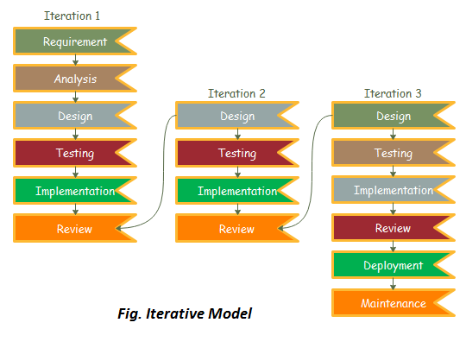

### The various phases of Iterative model are as follows:

**1. Requirement gathering & analysis:** In this phase, requirements are gathered from customers and check by an analyst whether requirements will fulfil or not. Analyst checks that need will achieve within budget or not. After all of this, the software team skips to the next phase.

**2. Design:** In the design phase, team design the software by the different diagrams like Data Flow diagram, activity diagram, class diagram, state transition diagram, etc.

**3. Implementation:** In the implementation, requirements are written in the coding language and transformed into computer programmes which are called Software.

**4. Testing:** After completing the coding phase, software testing starts using different test methods. There are many test methods, but the most common are white box, black box, and grey box test methods.

**5. Deployment:** After completing all the phases, software is deployed to its work environment.

**6. Review:** In this phase, after the product deployment, review phase is performed to check the behaviour and validity of the developed product. And if there are any error found then the process starts again from the requirement gathering.

**7. Maintenance:** In the maintenance phase, after deployment of the software in the working environment there may be some bugs, some errors or new updates are required. Maintenance involves debugging and new addition options.

## When to use the Iterative Model?

1. When requirements are defined clearly and easy to understand.
2. When the software application is large.
3. When there is a requirement of changes in future.

## Advantage(Pros) of Iterative Model:

1. Testing and debugging during smaller iteration is easy.
2. A Parallel development can plan.
3. It is easily acceptable to ever-changing needs of the project.
4. Risks are identified and resolved during iteration.
5. Limited time spent on documentation and extra time on designing.

## Disadvantage(Cons) of Iterative Model:

1. It is not suitable for smaller projects.
2. More Resources may be required.
3. Design can be changed again and again because of imperfect requirements.
4. Requirement changes can cause over budget.
5. Project completion date not confirmed because of changing requirements.

# **Big Bang Model**

In this model, developers do not follow any specific process. Development begins with the necessary funds and efforts in the form of inputs. And the result may or may not be as per the customer's requirement, because in this model, even the customer requirements are not defined.

This model is ideal for small projects like academic projects or practical projects. One or two developers can work together on this model.

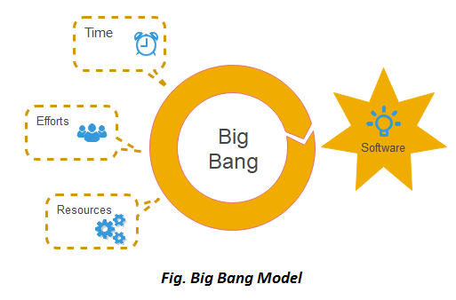

## When to use Big Bang Model?

As we discussed above, this model is required when this project is small like an academic project or a practical project. This method is also used when the size of the developer team is small and when requirements are not defined, and the release date is not confirmed or given by the customer.

## Advantage(Pros) of Big Bang Model:

1. There is no planning required.
2. Simple Model.
3. Few resources required.
4. Easy to manage.
5. Flexible for developers.

## Disadvantage(Cons) of Big Bang Model:

1. There are high risk and uncertainty.
2. Not acceptable for a large project.
3. If requirements are not clear that can cause very expensive.

# **Prototype Model**

The prototype model requires that before carrying out the development of actual software, a working prototype of the system should be built. A prototype is a toy implementation of the system. A prototype usually turns out to be a very crude version of the actual system, possible exhibiting limited functional capabilities, low reliability, and inefficient performance as compared to actual software. In many instances, the client only has a general view of what is expected from the software product. In such a scenario where there is an absence of detailed information regarding the input to the system, the processing needs, and the output requirement, the prototyping model may be employed.

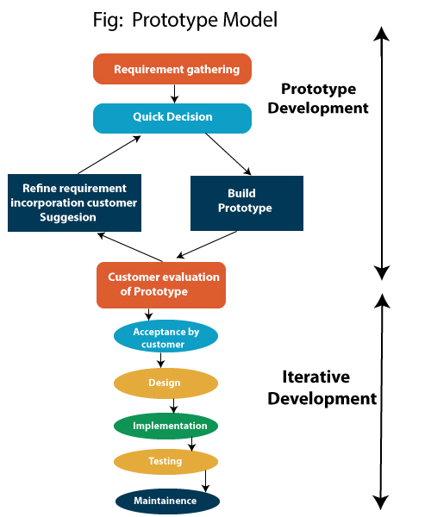

## Steps of Prototype Model

1. Requirement Gathering and Analyst
2. Quick Decision
3. Build a Prototype
4. Assessment or User Evaluation
5. Prototype Refinement
6. Engineer Product

## Advantage of Prototype Model

1. Reduce the risk of incorrect user requirement
2. Good where requirement are changing/uncommitted
3. Regular visible process aids management
4. Support early product marketing
5. Reduce Maintenance cost.
6. Errors can be detected much earlier as the system is made side by side.

## Disadvantage of Prototype Model

1. An unstable/badly implemented prototype often becomes the final product.
2. Require extensive customer collaboration
   * Costs customer money
   * Needs committed customer
   * Difficult to finish if customer withdraw
   * May be too customer specific, no broad market
3. Difficult to know how long the project will last.
4. Easy to fall back into the code and fix without proper requirement analysis, design, customer evaluation, and feedback.
5. Prototyping tools are expensive.
6. Special tools & techniques are required to build a prototype.
7. It is a time-consuming process.