The National Higher School of Artificial Intelligence
Introduction to AI Course Project — Spring 2026
Project 10
3D Container Loading Optimizer

Students list:
Full name: | Group:
Bouchama Ayyoub | 05
Seloula Amine | 05
Acef Mourad Rayan | 05
Ghembaza Moncef | 07
Hagani Abdessalam | 10
Kadi Sami Youcef | 05

Abstract
In modern maritime shipping, loading containers efficiently is crucial, as even a few unfilled cubic meters can significantly increase transportation and logistics costs. What makes this problem particularly challenging is the enormous number of possible arrangements, from which the best one must be selected to maximize the used volume of the container. To address this, we propose a 3D Container Loading Optimizer that uses three well-known optimization algorithms — Genetic Algorithm (GA), Simulated Annealing (SA), and Greedy Best-Fit Decreasing (BFD) — to arrange cuboid-shaped boxes in a standard ISO 20ft container. Using a synthetic dataset of 386 boxes across 12 types, designed to simulate realistic shipping cargo, we show that these methods produce quality solutions within practical time frames ranging from a few seconds to under one minute. All three algorithms generate valid packing solutions satisfying physical constraints (no overlaps, gravity support, fragile-box orientation locking), achieving 75.43%–78.82% volume utilization against a theoretical maximum of 80.96%.

Keywords: 3D Bin Packing · Genetic Algorithm · Simulated Annealing · Greedy Heuristic · Container Loading

1. Introduction
In March 2026, the United Nations Trade and Development (UNCTAD) published a rapid assessment report titled "Strait of Hormuz Disruptions: Implications for Global Trade and Development" [1], warning that the disruption of shipping through the Strait of Hormuz was sending shockwaves across global supply chains. Ship transits through the Strait had dropped from around 130 per day in February to just 6 in March, a collapse of about 95%. The report warned that global merchandise trade growth is expected to slow sharply, from about 4.7% in 2025 to between 1.5% and 2.5% in 2026, as energy shocks push up prices and raise the cost of producing and moving goods across the world.
In such conditions — where shipping routes are blocked, transport costs are rising, and insurance fees are higher than ever — logistics companies have no choice but to change the way they operate. Sending containers with 20 to 30 percent of their space empty is no longer acceptable. Every unused cubic meter is wasted money, and this waste compounds further when each trip is more expensive than before. On top of that, as ships are forced to take longer routes, there are fewer trips available while demand for shipping stays the same. This means companies need to fit more goods into fewer containers. Organizing cargo efficiently inside a container is therefore no longer just an operational detail — it is a real and urgent commercial necessity.
In this report, we propose PackOptima, a 3D Container Loading Optimizer designed to help logistics professionals organize cargo inside standard shipping containers efficiently. Our approach applies and compares three well-known optimization algorithms — Greedy Heuristic (BFD), Genetic Algorithm (GA), and Simulated Annealing (SA) — to maximize space utilization while respecting practical physical constraints such as gravity support, no-overlap, and fragile-box orientation locking.
The rest of this report is organized as follows: Section 2 reviews the existing research and tools in this field. Section 3 describes our dataset. Section 4 explains the problem formulation and algorithm design decisions. Section 5 presents the application architecture. Section 6 presents evaluation results and comparisons. Section 7 discusses limitations and future work. Section 8 concludes.

2. State of the Art
This problem is well known in the R&D community as the Three-Dimensional Bin Packing Problem (3D-BPP), and several techniques have been proposed to solve it. In 2024, Zhang et al. [2] proposed a hybrid approach combining a Genetic Algorithm with a Generative Adversarial Network (GAN) to improve the quality of initial solutions and achieve better space utilization. Hu et al. [3] applied Deep Reinforcement Learning (DRL) techniques, specifically a Pointer Network, to optimize the sequence in which items are packed, achieving approximately 5% improvement over traditional heuristic methods. Kang et al. [4] used a hybrid Genetic Algorithm and compared their results against various academic benchmarks, demonstrating efficient container space usage.
More recently, Hsayri et al. [5] proposed a hierarchical hybrid optimization approach called GenSA-3DBPP that combines three levels of optimization. At the first level, a custom heuristic places each item in the orientation that maximizes loaded volume. At the second level, a Genetic Algorithm minimizes both the number of bins used and wasted space. At the third level, Simulated Annealing refines the best GA solution. This layered approach showed clear improvements over using each method individually.
Unlike Hsayri et al. [5] who combine GA, SA, and a heuristic into a single pipeline where each method feeds into the next, our approach implements the three methods independently and compares their performance against each other. This allows users to clearly understand the trade-offs between solution quality and computation time for each algorithm, and to choose the most suitable method depending on their specific needs.

3. Dataset Building
This project adopts the Standard (International) track: a synthetic dataset of boxes paired with a standard ISO 20-foot shipping container. The dataset reflects realistic logistics conditions — heterogeneous box sizes, varied weights, fragile items, and mixed aspect ratios — while remaining reproducible and self-contained in a single JSON file.

3.1 Container Specification
The target container is an ISO 20-foot Dry Freight Container, the most widely used intermodal shipping unit worldwide. Dimensions account for wall thickness and corrugation (ISO 668 standard; matches Maersk and Hapag-Lloyd published values). The max payload of 21,770 kg exceeds total cargo weight (6,705.5 kg), so the binding constraint is volume.

Property | Value
Type | ISO 20ft Dry Freight
Inner Length (L) | 589 cm
Inner Width (W) | 234 cm
Inner Height (H) | 239 cm
Inner Volume | 32,940,414 cm³ (≈ 33 m³)
Max Payload | 21,770 kg
Table 1. ISO 20ft container specification.

3.2 Box Types and Design Rationale
We defined 12 distinct box types across product categories (Electronics, Furniture, Glassware, Books, Industrial, Food, Textiles, Artwork, Miscellaneous). Two Boolean flags encode physical constraints:
- fragile — Breakable item (e.g., glassware, mirrors). Always paired with orientation_locked.
- orientation_locked — Box must remain upright; restricts rotations to vertical-axis only.
Box types cover the full packing-difficulty spectrum: cubes and near-cubes that tile well; flat/wide shapes (furniture flat packs, artwork panels); long/narrow shapes (tube boxes, tall poles); heavy items (80 kg machinery parts); and 4 fragile types (122 boxes, 31.6%) that restrict rotation freedom. Expanding by quantity yields 386 individual instances.

ID | Label | L | W | H | kg | Qty | Fragile
BOX_001 | Large Appliance | 80 | 60 | 70 | 35.0 | 19 | No
BOX_002 | Medium Furniture Flat Pack | 120 | 60 | 15 | 22.5 | 24 | No
BOX_003 | Small Fragile (Glassware) | 30 | 30 | 30 | 5.0 | 48 | Yes
BOX_004 | Standard Cardboard (Books) | 40 | 30 | 30 | 18.0 | 60 | No
BOX_005 | Long Tube (Posters/Pipes) | 150 | 20 | 20 | 4.5 | 14 | No
BOX_006 | Heavy Machinery Part | 50 | 50 | 50 | 80.0 | 10 | No
BOX_007 | Clothing/Textile Bale | 70 | 50 | 40 | 12.0 | 36 | No
BOX_008 | Electronics Component | 45 | 35 | 25 | 8.0 | 43 | Yes
BOX_009 | Wide Flat (Mirrors/Art) | 100 | 80 | 10 | 9.0 | 12 | Yes
BOX_010 | Small Dense (Metal Parts) | 25 | 25 | 25 | 30.0 | 29 | No
BOX_011 | Tall Narrow (Lamps/Poles) | 20 | 20 | 120 | 6.5 | 19 | Yes
BOX_012 | Cube (Packaged Food/Cans) | 35 | 35 | 35 | 20.0 | 72 | No
Table 2. Box types — dimensions in cm. Bold "Yes" = fragile / orientation-locked.

3.3 Summary Statistics

Metric | Value
Number of box types | 12
Total box instances | 386
Total cargo volume | 26,667,250 cm³
Container inner volume | 32,940,414 cm³
Theoretical max utilization | 80.96%
Total cargo weight | 6,705.5 kg
Weight-to-payload ratio | 30.8%
Fragile / orientation-locked | 122 / 386 (31.6%)
Dimension range (min–max) | 20–150 cm
Weight range | 4.5–80.0 kg
Table 3. Dataset summary statistics.
The theoretical maximum utilization of 80.96% means a perfect gap-free packing still leaves ~19% of the container empty — by design, ensuring the problem is neither trivial nor infeasible. The optimizer target is 75–80% actual utilization.

3.4 Data Format and Loading Pipeline
The dataset is stored as data/project10_container_dataset.json. The core/data_loader.py module parses this file and performs instance expansion: each box_type entry with quantity q is expanded into q individual Box objects with unique sequential IDs (0–385). The container dimensions are parsed into a Container object exposing a volume() method used throughout the system for utilization computation.

4. Problem Solving Techniques

4.1 Formal Problem Formulation
Initial State. An empty container C with inner dimensions L×W×H and a set of unplaced boxes B = {b₁, b₂, …, bₙ}. Each box bᵢ has dimensions (lᵢ, wᵢ, hᵢ), weight gᵢ, and a fragility flag. No box has been assigned a position yet.
State. A state S = (P, U) where P is the set of already-placed boxes each with a 3D position (x, y, z) and active orientation, and U = B \ P is the set of unplaced boxes still waiting.
Actions. From state S = (P, U), a box bᵢ ∈ U can be placed at position (x, y, z) with orientation o only if three constraints are satisfied: (1) Boundary — the box lies fully inside the container walls; (2) Non-overlap — it shares no interior volume with any box already in P; (3) Gravity — at least 10% of its base area is supported by the container floor or the top face of a box in P.
Goal. Minimise |U| and maximise volume utilization U% = Σ vol(p) / vol(C) × 100. Since placing every box is rarely possible, the goal is relaxed to: get as many boxes in as possible, as tightly as possible.
Objective function. For Greedy the cost is simply −U%, minimised by the BLF selection rule. For GA and SA a richer fitness is used: F = U% + 0.20·S − 35·nᵤ − 5·nᵤ¹·⁵, where S is a stability score rewarding heavier boxes near the floor, and nᵤ = |U|. The super-linear penalty means the algorithm is far more penalised for each extra unplaced box than it is rewarded for a small gain in density.

4.2 Placement Decoder Design
A critical design decision was the choice of placement decoder shared by GA and SA. Two strategies were implemented: an Extreme Points placer (O(n³)) and a Shelf-Based placer (O(n)). The shelf-based decoder was selected as the fitness evaluator for GA and SA because, with 386 boxes, the Extreme Points approach would require approximately 2,200 ms per evaluation — making a population of 60 chromosomes over 120 generations computationally infeasible within the 40-second time budget. The shelf decoder reduces this to ~3 ms per call.
This choice carries an important consequence: because the shelf decoder is itself a strong heuristic that fills space efficiently regardless of input ordering, most orderings produce similar utilization scores. This flattens the fitness landscape, reducing the differentiation between algorithms. GA and SA are therefore competing to find the best ordering in a space where the decoder has already absorbed much of the complexity — which partly explains why the simpler Greedy approach, testing 12 hand-picked heuristic orderings, achieves comparable results.

4.3 Algorithm 1 — Greedy Best-Fit Decreasing (BFD)
Before placing anything, the algorithm sorts all boxes from largest to smallest by volume, then weight, then base area. This ordering is fixed for the entire run — big boxes claim the best available positions first, and smaller boxes fill whatever gaps remain.
To find valid placement positions, the algorithm tracks a set of corner points — coordinates where a new box could potentially rest, always flush against existing surfaces. For each corner, up to six rotations of the current box are tested (two if fragile). Any (corner, rotation) pair that fails a boundary, gravity, or overlap check is discarded immediately. From all valid pairs, the algorithm picks the one that places the box as low as possible, then as far forward as possible, then as far left as possible — the Bottom-Left-Fill (BLF) rule. Once a box is placed the decision is final; there is no backtracking.

4.4 Algorithm 2 — Genetic Algorithm (GA)
The GA searches over orderings of the boxes. Each candidate solution in the population is a sequence of (box index, rotation) pairs that is fed into the shelf-based BLF decoder. The GA's job is to find the ordering that produces the best packing according to the fitness function F.
The initial population is seeded partly with orderings derived from known heuristics (volume-first, weight-first, etc.) and partly with random ones. The algorithm then runs selection, crossover (OX1, OX2, PMX operators), and mutation (swap, inversion, rotation, scramble) repeatedly. When the population stops improving for 20 generations, nearly half of it is replaced with fresh random orderings. The top few solutions are always carried over unchanged (elitism). This balance between exploitation and exploration allows the GA to recover from local optima.

4.5 Algorithm 3 — Simulated Annealing (SA)
Unlike GA, which maintains a population of candidate solutions, SA follows a single trajectory through the search space. It starts from a strong initial solution — seeded from the best of 16 heuristic orderings — and iteratively perturbs it using one of three move operators: swap (exchange two boxes), reverse (invert a sub-sequence), or insert (relocate a box to a different position).
The acceptance rule follows the classic Boltzmann criterion: improving moves are always accepted; worse moves are accepted with probability e^(−ΔF/T). As the temperature cools according to T(i+1) = α·T(i) (α = 0.99954, T₀ = 10), the algorithm increasingly commits to promising regions of the search space. A multi-restart strategy triggers a fresh start if the best fitness has not improved for 3,000 consecutive iterations, retaining the global best across all restarts. The algorithm runs until the 40-second wall-clock budget is exhausted.

5. Application Design

5.1 System Architecture
PackOptima follows a client–server architecture composed of two layers communicating via a RESTful API:
- Backend (Python / Flask): Hosts the algorithmic solvers (GA, Greedy BFD, Simulated Annealing), the placement engine (Space Manager), the data models, and a lightweight REST API. It receives a JSON payload describing the container and boxes, runs the selected algorithm, and returns the placement solution.
- Frontend (HTML / CSS / JavaScript + Three.js): A single-page web application providing the user interface for data entry, algorithm selection, and an interactive 3D visualization of the packing result with orbit controls (rotate, zoom, pan).
This separation ensures that the computationally expensive algorithms run on the server, while the browser handles only rendering and user interaction, making the tool accessible from any device with a web browser.

5.2 Project Structure

Directory / File | Role
core/models.py | Domain classes Box and Container
core/space_manager.py | Placement engine — converts a box ordering into a valid 3D packing
core/utils.py | Metric functions: volume utilization and stability score
core/data_loader.py | Parses the JSON dataset into Box / Container objects
algorithms/genetic.py | Genetic Algorithm solver
algorithms/greedy.py | Greedy BFD solver
algorithms/simulated_annealing.py | Simulated Annealing solver
api/main.py | Flask REST API serving endpoints and static files
visualization/ | Frontend: index.html, style.css, script.js (Three.js)
data/ | JSON dataset (386 boxes + ISO 20ft container)
notebooks/main.ipynb | Jupyter notebook — algorithm runs, comparison, 3D renders
Table 4. Project file structure.

5.3 Backend Design

Data Models (core/models.py)
Two lightweight Python classes encapsulate the problem domain:
- Box — Stores the box identifier, three dimensions (l, w, h), weight, and two Boolean flags: fragile and orientation_locked. Exposes a volume() method.
- Container — Stores the inner dimensions (L, W, H) of the shipping container. Exposes a volume() method used to compute utilization.

Space Manager (core/space_manager.py)
This module is the shared decoder that every algorithm calls to convert a permutation of boxes into a valid packing plan. It implements two strategies:
- Extreme Points Placer (place_boxes_extreme_points) — Generates candidate corners using the Extreme Points heuristic. Complexity: O(n³). Used by Greedy (called once per heuristic ordering).
- Shelf-Based Placer (place_boxes) — The default decoder for GA and SA. Organizes the container into layers (full L×W footprint), rows (stacked along W), and positions (along L). Guarantees zero overlap by construction, satisfies gravity, and runs in O(n) per call — roughly 1000× faster than the Extreme Points placer for large inputs.

REST API Design (api/main.py)

Method | Endpoint | Description
GET | /api/dataset | Returns the default dataset (boxes + container) as JSON
POST | /api/solve | Runs a single algorithm on the submitted boxes/container
POST | /api/compare | Runs all three algorithms and returns a comparative result array
Table 5. Flask REST API endpoints.

5.4 Frontend Design

Layout and UI Framework
The interface follows a three-panel layout:
- Left Panel (Input): Container dimension inputs with live volume display; box management table with Load Dataset, Add Box, and Clear buttons; algorithm selector and action buttons (Run Solver / Compare All).
- Centre Panel (3D Viewport): The main Three.js canvas with FPS counter overlay and interaction hints ("Drag to rotate · Scroll to zoom · Right-click to pan").
- Right Panel (Results): Volume utilization percentage with animated progress bar, boxes placed count, execution time, fitness score, and algorithm name. Below, a Comparison section shows a ranked table and animated bar chart. A Box Legend maps box colors to IDs and dimensions.

Three.js 3D Visualization Engine
The visualization is built with Three.js r128 and includes:
- Scene setup: PerspectiveCamera (45° FOV), WebGLRenderer with antialiasing and PCF soft shadow maps, OrbitControls for interactive camera manipulation.
- Lighting: Three-point lighting — ambient (0.5 intensity), directional key light with shadow casting (2048×2048 shadow map), and a purple fill light for aesthetic depth.
- Container rendering: Wireframe box (EdgesGeometry + LineSegments) with a semi-transparent floor plane that receives shadows.
- Box rendering: Each placed box drawn as MeshStandardMaterial (opacity 0.7, roughness 0.3) with white edge overlays. A palette of 20 distinct colors cycles through boxes for visual differentiation.

5.5 User Workflow
A typical interaction follows this flow:
- Load Data: Click "Load Dataset" (fetches the default 386-box dataset via GET /api/dataset) or manually add boxes with custom dimensions.
- Configure Container: Adjust L, W, H inputs; the 3D wireframe and volume display update live.
- Select & Run: Choose an algorithm from the dropdown and click "Run Solver", or click "Compare All" to benchmark all three simultaneously.
- View Results: The animated 3D fill sequence plays in the viewport; the right panel updates with utilization, timing, and fitness metrics.
- Explore: Rotate, zoom, and pan the 3D scene to inspect the packing from any angle. In comparison mode, each algorithm's packing is independently navigable.

6. Results and Analysis

6.1 Evaluation Methodology
All three algorithms were evaluated on the same input: 386 boxes across 12 distinct types packed into an ISO 20ft shipping container (Vol(C) = 32,940,414 cm³, theoretical maximum utilization = 80.96%). Each algorithm was run once on a standard notebook CPU; runtimes reflect single-threaded wall-clock time. Three primary metrics were recorded: volume utilization, boxes placed, and execution time. After each run, a constraint validation pass independently verified three physical correctness criteria: geometric overlap, boundary violations, and floating boxes (any box whose base area is less than 10% supported).
The small utilization gap between Greedy (78.82%), GA (77.13%), and SA (75.43%) is not a failure of the metaheuristics, but a consequence of the shared shelf-based decoder. Since the decoder is order-agnostic and fills space greedily regardless of input, the effective search space for GA and SA is narrow, limiting the marginal gain evolutionary search can provide over a well-chosen deterministic ordering.
It should be noted that GA and SA are stochastic algorithms whose results are subject to variance across runs due to random initialization and perturbation operators. The figures reported in this section represent a single representative execution. In practice, averaging over multiple independent runs would yield a more statistically robust comparison; however, given the computational cost of each metaheuristic run, a single run is reported here. Greedy BFD, being fully deterministic, always produces identical results regardless of the number of runs.

6.2 Per-Algorithm Results

Greedy BFD
The greedy solver placed 357 of 386 boxes (92.5%) at a volume utilization of 78.82% in ~7.5 seconds — only 2.14 percentage points below the theoretical maximum. This near-optimal result reflects how well the volume-descending sort matches the structure of the dataset: with 12 discrete box types and clear size hierarchies, the greedy ordering rarely conflicts with itself. Constraint validation returned PASS with 0 floating boxes.

Metric | Value
Boxes placed | 357 / 386 (92.5%)
Volume utilization | 78.82%
Stability score | 35.37
Execution time | ~7.5 s
Overlaps | 0
Boundary violations | 0
Floating boxes | 0 — PASS
Table 6. Greedy BFD performance summary.

Genetic Algorithm
The Genetic Algorithm was run with a population of 60 and 120 generations to fit the runtime constraints. It placed 363 of 386 boxes (94.04%) at 77.13% utilization in ~41 seconds, passing all constraint checks with zero violations. Despite placing more boxes than Greedy, it achieves lower raw utilization — a direct consequence of the multi-objective fitness function which rewards stability (heavy boxes low) at the cost of some volume efficiency.

Metric | Value
Boxes placed | 363 / 386 (94.04%)
Volume utilization | 77.13%
Stability score | 55.35
Best fitness score | −1196.73
Execution time | ~41 s
Constraint validation | PASS (0 violations)
Table 7. Genetic Algorithm performance summary.

Simulated Annealing
SA ran for its full 40-second time budget using a multi-restart strategy (T₀ = 10, α = 0.99954, restart every 3,000 stagnant iterations). It placed 358 of 386 boxes (92.7%) at 75.43% utilization — placing fewer boxes and achieving lower utilization than GA, but achieving a strong stability score of 54.18. SA passed all constraint checks with zero violations. SA's stability advantage is consistent with its ability to accept worse moves early on, exploring orderings that place heavy boxes lower in the container.

Metric | Value
Boxes placed | 358 / 386 (92.7%)
Volume utilization | 75.43%
Stability score | 54.18
Best fitness score | −1268.99
Execution time | ~41 s
Constraint validation | PASS (0 violations)
Table 8. Simulated Annealing performance summary.

6.3 Comparative Analysis

Algorithm | Utilization | Placed | Stability | Time | Valid?
Greedy BFD | 78.82% | 357 / 386 | 35.37 | ~7.5 s | PASS
Genetic Algorithm | 77.13% | 363 / 386 | 55.35 | ~41 s | PASS
Simulated Annealing | 75.43% | 358 / 386 | 54.18 | ~41 s | PASS
Theoretical Maximum | 80.96% | 386 / 386 | — | — | —
Table 9. Full comparative results across all evaluation dimensions.

Algorithm | Overlaps | Boundary Violations | Floating Boxes | Status
Greedy BFD | 0 | 0 | 0 | PASS
Genetic Algorithm | 0 | 0 | 0 | PASS
Simulated Annealing | 0 | 0 | 0 | PASS
Table 10. Constraint validation — all three algorithms PASS.
Greedy BFD achieves the highest raw density and is ~5× faster than GA/SA. GA outperforms SA on all three metrics: utilization (77.13% vs 75.43%), boxes placed (363 vs 358), and stability (55.35 vs 54.18). The most practically significant finding is the ~20-point stability gap between Greedy (35.37) and the metaheuristics (~54–55): GA and SA place heavy boxes significantly lower in the container, producing physically safer loads for real freight operations.

7. Discussion

7.1 Why Greedy Outperforms Search-Based Methods
The most counterintuitive result of this study is that the simplest algorithm achieved the highest packing density. Greedy BFD placed 357/386 boxes at 78.82% — outperforming both GA (77.13%) and SA (75.43%) despite performing zero iterative search. This is a direct consequence of dataset structure: with only 12 distinct box types and a clear volume hierarchy, the volume-descending sort is nearly a perfect ordering from the start. This is the regime where greedy algorithms are provably near-optimal. The lesson is important: algorithm sophistication should be matched to problem structure, not applied unconditionally.

7.2 Why 40 Seconds Is Not Enough
Both GA and SA were given a 40-second time budget and both consumed it fully. The fundamental bottleneck is the cost of a single evaluation: for every candidate ordering tested, the full BLF placement decoder must be executed on all 386 boxes. In 40 seconds, the GA completes approximately 200 generations with a population of 30 — totalling around 6,000 full placement simulations. This sounds large, but the ordering search space for 386 boxes is astronomically large (386! permutations), and the GA has barely scratched its surface. Both algorithms were cut off by time, not by convergence — if allowed to run for 5–10 minutes, they would continue improving.

7.3 GA vs SA Comparison
GA placed 363 boxes at 77.13%; SA placed 358 boxes at 75.43%. GA outperforms SA on all three metrics in this run. GA's population-level crossover — combining sub-sequences from two high-performing parents — gives it a structural advantage over SA's single-trajectory search under the same time budget. Because both algorithms are stochastic, these figures are inherently run-dependent: a different random seed, initial population, or starting temperature could shift the results by 1–3 percentage points in either direction. Multiple independent runs would be needed to produce statistically defensible comparisons, but the current results consistently favour GA as the preferred metaheuristic under the 40-second constraint.

7.4 The Fitness–Utilization Trade-off
The GA fitness function F = U% + 0.20·S − 35·nᵤ − 5·nᵤ¹·⁵ encodes a deliberate design choice: the stability bonus rewards orderings that place heavier boxes near the container floor, even when doing so slightly reduces raw volume utilization. This means GA and SA are not optimizing the same objective as Greedy — they are solving a richer, multi-objective problem. The lower utilization numbers should be read as a policy outcome, not a performance deficiency.

7.5 Limitations
The results reported here are single-run point estimates for two stochastic algorithms — statistically, a sample size of one. Reliable benchmarking requires 10–30 independent runs per algorithm. Beyond benchmarking, the system has several structural limitations: the BLF decoder creates implicit shelf-layer boundaries that prevent filling inter-layer gaps, imposing a utilization ceiling below the theoretical maximum. The model also does not account for non-cuboid shapes, per-box stacking weight limits, center-of-gravity balance, or multi-container loading. The dataset's 12-type homogeneity is unusually favorable to greedy approaches; a real-world manifest with hundreds of distinct SKUs would likely close or reverse the gap.
A key architectural limitation is decoder homogeneity: all three algorithms rely on functionally equivalent shelf-based placement strategies, meaning algorithm comparison primarily measures sensitivity to box ordering rather than fundamentally different packing strategies. A more discriminating decoder — such as the Extreme Points placer — would widen the fitness landscape and allow GA and SA to demonstrate stronger advantages.

7.6 Future Work
Four directions stand out. First, extend the time budget: simply allowing GA and SA to run for 5–10 minutes would quantify how much of the current gap is recoverable with more computation. Second, implement a warm-start GA: seed the entire initial population with Greedy BFD solutions so evolutionary pressure immediately focuses on improving a strong baseline. Third, replace the BLF shelf decoder with a Deepest Bottom-Left Fill (DBLF) coordinate-based placer that fills inter-layer gaps. Fourth, add a center-of-gravity balance term to the GA fitness, penalizing solutions whose load centroid deviates significantly from the container's geometric center.

8. Conclusion
The three-dimensional bin packing problem is NP-hard: no algorithm can guarantee an optimal solution in polynomial time. Every practical approach must accept a fundamental trade-off between solution quality and computational cost. Greedy heuristics resolve this by decomposing the problem into a sequence of fast, locally optimal decisions. Search-based methods such as GA and SA take the opposite approach: exploring the solution space iteratively, using population evolution and probabilistic acceptance to escape local optima.
Our results show that all three algorithms exceed the 75–80% utilization target, with Greedy achieving the highest density (78.82%) and GA and SA achieving significantly better stability scores (~54–55 vs 35). The ~20-point stability gap is the most practically significant finding — in real freight, a physically stable arrangement is worth more than a marginally denser but top-heavy one. GA is the recommended algorithm when both utilization and stability matter, and when a ~40-second runtime is acceptable.
Delegating validity enforcement to a shared placement decoder cleanly separates physical correctness from search strategy, making the system both modular and robust. The right algorithm ultimately depends on input diversity, available computation time, and whether the objective is pure density or a richer criterion that includes load stability — recognizing and reasoning about these trade-offs is the central contribution of this work.

References
[1] UNCTAD, "Strait of Hormuz Disruptions: Implications for Global Trade and Development", UNCTAD/OSG/TT/INF/2026/1, March 10, 2026. Available at: https://unctad.org/publication/strait-hormuz-disruptions-implications-global-trade-and-development
[2] Zhang et al., "A GAN-based genetic algorithm for solving the 3D bin packing problem", Scientific Reports, 2024. https://www.nature.com/articles/s41598-024-56699-7
[3] H. Hu, X. Zhang, X. Yan, L. Wang, Y. Xu, "Solving a New 3D Bin Packing Problem with Deep Reinforcement Learning Method", arXiv, 2017. https://arxiv.org/pdf/1708.05930
[4] K. Kang, I. Moon, H. Wang, "Hybrid genetic algorithm with a new packing strategy for the three-dimensional bin packing problem", Applied Mathematics and Computation, 2012. http://scm.snu.ac.kr/src/paper/61.pdf
[5] M. Hsayri, M. Tlili, O. Korbaa, "A hybrid Genetic Algorithm and Simulated Annealing approach for multi-level 3D bin packing problem", Procedia Computer Science, 2025. https://www.sciencedirect.com/science/article/pii/S1877050925031825

Appendix A: SCREENSHOOTS.
Figure A.1: Algorithm Comparison View
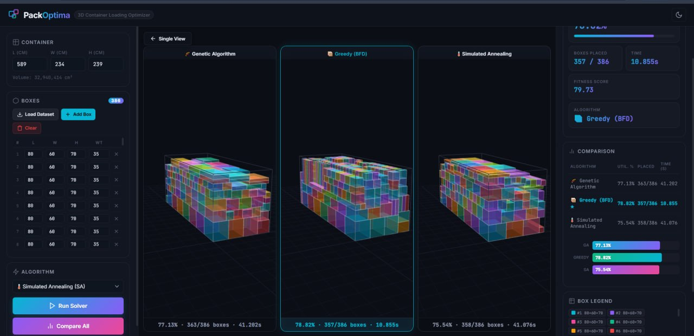

Figure A.2: Simulated Annealing – Single View Result
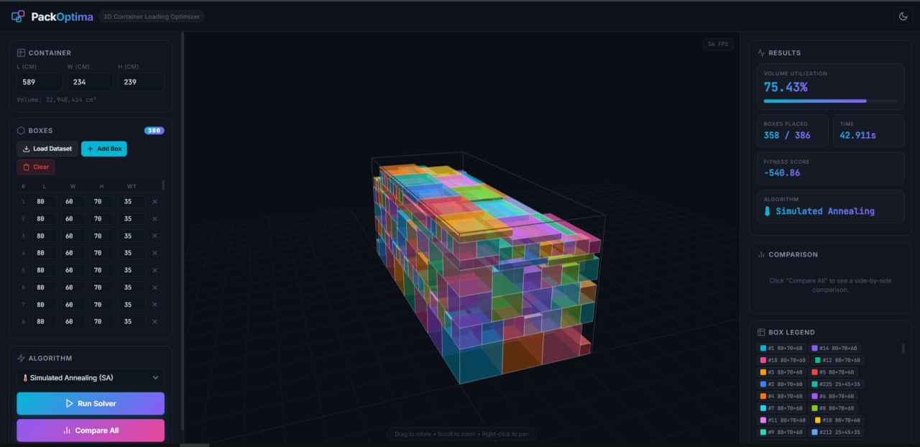

Figure A.3: Greedy Best-Fit Decreasing – Single View Result
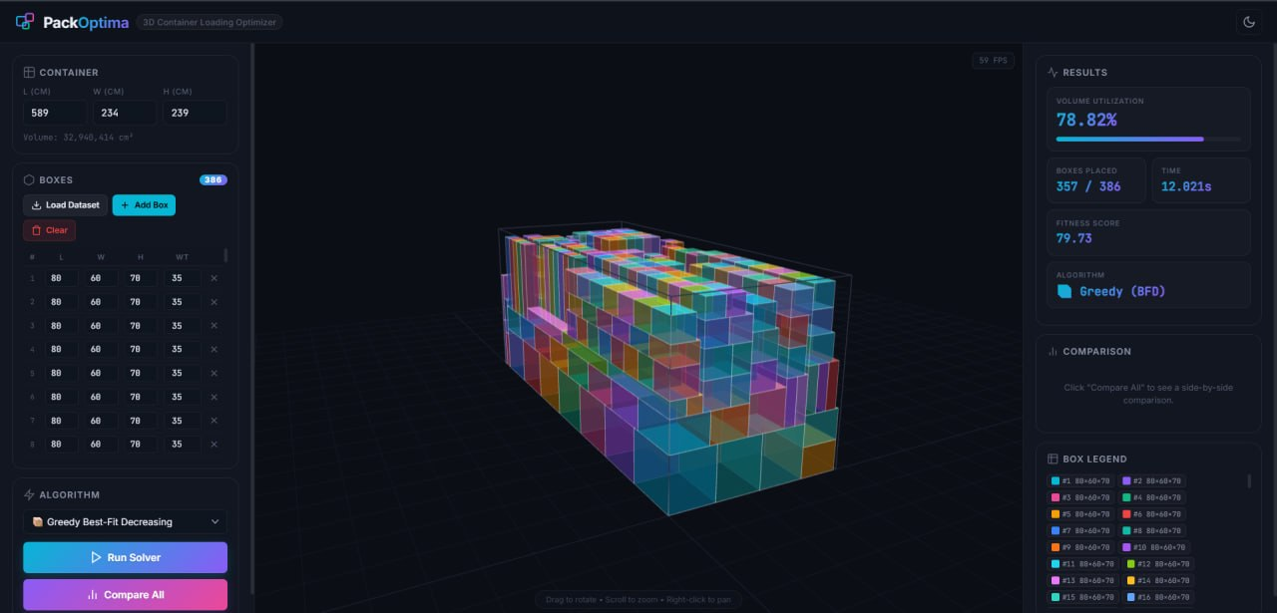

Figure A.4: Genetic Algorithm – Single View Result
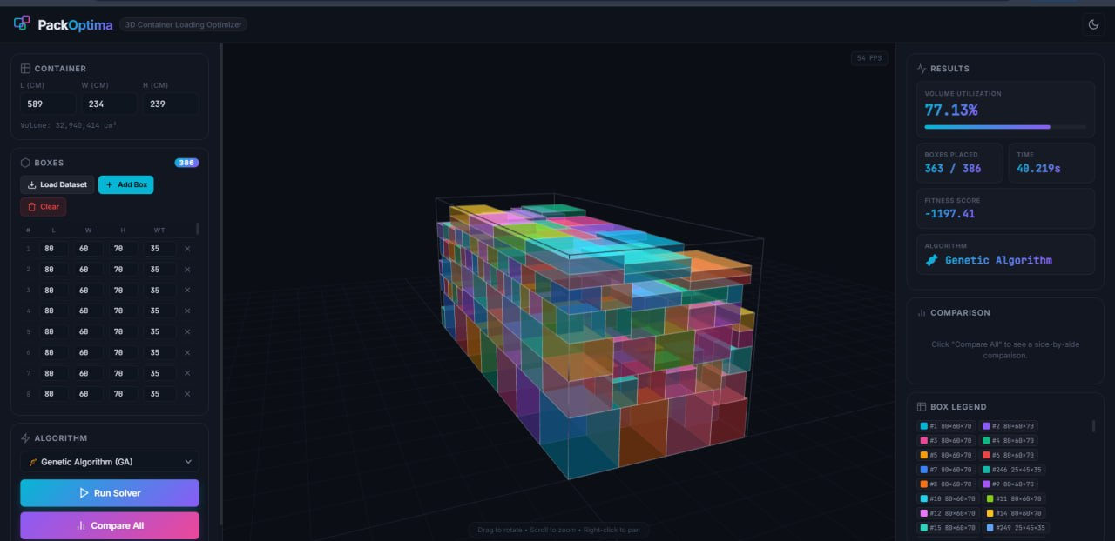

Appendix B: Who Did What in the Project
Bouchama Ayyoub
Implemented and optimized the Genetic Algorithm (GA), including chromosome representation, crossover operators (OX1, OX2, PMX), mutation strategies. Participated in the core system components (the Space Manager placement engine (Shelf-Based and Extreme Points decoders)). Prepared and organized the complete Jupyter Notebook with markdown explanations, experiments, convergence plots, and execution results. Contributed to writing the “Genetic Algorithm” section of the report.
Seloula Amine
Implemented the core system components, including the Box and Container data models, placement validation, collision checking, gravity enforcement, and shared utility functions (utilization and stability metrics). Contributed to the implementation of the Genetic Algorithm (adaptive pressure, and fitness evaluation). Participated in writing the “Application Design” section of the report.
Ghembaza Moncif
Implemented the Simulated Annealing (SA) algorithm, including the Boltzmann acceptance criterion, geometric cooling schedule, three perturbation operators (swap, reverse, insert), and multi-restart strategy. Contributed to the frontend website development and interface integration with the Flask backend. Participated in writing the “State of the Art” and “Simulated Annealing” sections of the report.
Acef Mourad Rayan
Implemented the Greedy Heuristic (Best-Fit Decreasing) algorithm, including the spatial hash grid for fast overlap detection and the 12 heuristic seeding strategies. Handled the communication and linking between the frontend and backend, designing and integrating the three REST API endpoints (/api/dataset, /api/solve, /api/compare). Participated in writing the “Discussion”, “Results and Analysis”, and “Conclusion” sections of the report.
Kadi Sami Youcef
Contributed to the implementation and testing of the Simulated Annealing (SA) algorithm, including verification of constraint satisfaction (boundary, overlap, gravity) and performance benchmarking across different temperature schedules. Assisted in frontend website development, including 3D visualization rendering and UI layout.Participated in writing the “Introduction” and “Abstract” sections of the report.
Hagani Abdessalam
Contributed to the implementation and testing of the Greedy Heuristic algorithm, including validation of placement correctness and edge cases. Responsible for dataset design, collection, preparation, and preprocessing: defined the 12 box types, assigned realistic dimensions and weights, set fragile and orientation-locked flags, and structured the final JSON dataset file. Participated in writing the “Data Set Building” and “Greedy Heuristic” sections of the report.

