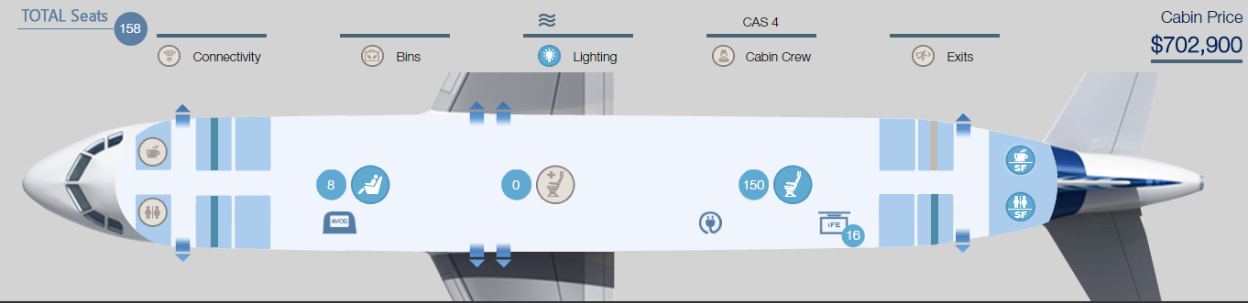

The cabin shall integrate the following features.

Category | Package Name | customization | Quantity | Price
Seating | AVOD | NA | 8 | $9,600
 | OVER HEAD Video Eco | NA | 16 | $144,000
 | In Seat Power Eco | NA | 150 | $54,000
 | Business Seats | NA | 8 | $64,000
 | Seats | NA | 150 | $0
Galley/Lavatory | Space Flex | Standard | 1 | $329,000
 | Wind Screen | NA | 1 | $29,000
Cabin Crew | OHCS Handrail | NA | 1 | $74,100

