From-m Chart 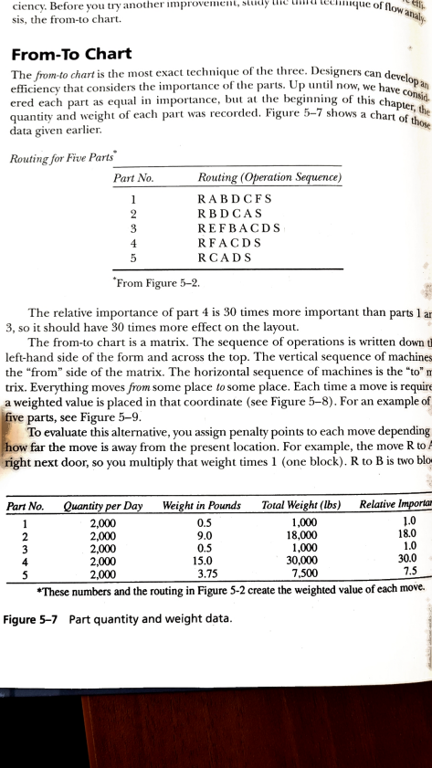

The }h)/? /-toc/l « /·/is (lre 111()s t e xacttc (lrtric lll(: ()I'tlrc · l l 11·c(:. I)(·sigı cTs c an d we lo p ah eHic ie ir c ytlrat co rrsi cl cr-s tlrc illlp Ol · tlı1c (: ()[' lırc ·IJIı· Ls .[Jptrı1til11()W, wehave C e re d e ac h pai-ta s eq\tlli l li ı 11p()I·tlllcc,\)tı l 111l l c·\)cgiı\ıliı1g ()I'this chapte \the

o n l i d .

qtlanht\· aild\\-eig}t of e ac ll 11-t\\r;181-CC()1· clc cl. Iigtı1-(: -7 s l 1(»ws a chart ofth o Q datagi\-ene ai-lie i-.

RoutingjorFine P{ırti'

Ptırt No. Routing (Ope rationS e({uence)

3 REFBACDS

From Fi₩e 5-2.

The re lative importanceof part4 is 30 titTie s more importantthan parts1 a n 3, so it should have 30 time s more effect on the layout.

T he from-to chart is a matrix. The se que nce of operationsis written down d left-hand side of the foi 111 and ac ross thetop.T he vertical seqLıenc e of mac hilıe s the"from"side of the matrix. T he horizontal se que nceof machine s is the°to"n trix. Everything movesNm some placeto some place .Each time a move i sre quir€ a weighted value is placed in that coordinate (se e Figure 5-8). For an e xample o f: @e parts,se e Figure5-9.

To e valuate this al temative, you assign penalty pointsto e ac h movedepending' how far the move is awayfrom the presentlocation. For-example,the move R tol iright next doo* so you multiplythat weighttime s l (one block). R to B is two b l o «

-=-' W

Pları No Qtmtity pe r Doy We ightin Po und s Total We ight (lbs) Re lotive Iwm

2,000 0.5

2,000 9.0

1?

2,000 0.5

2,000 15.0

I,000

18,000 1,000

30,000

1

2,000 3,75

345

7,500L & l :& 7

*the se numbe rs arıd the routingin Figure 5-2 c re a te the we ightedvalue of e a c h mo ve. Figure 7 Part quantityand weight data.

Flo w Analysis Techniq ues 145 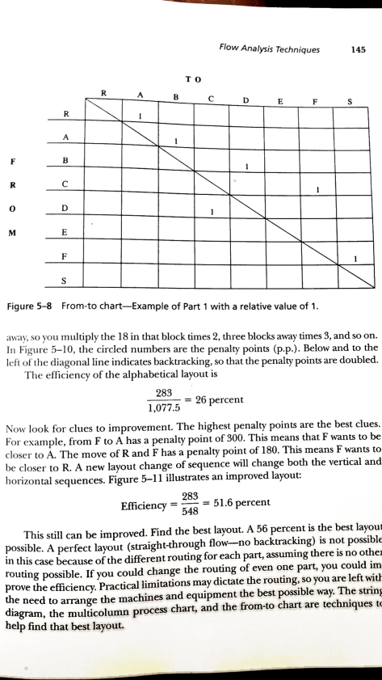

T O

R A B C D E F S

I

S Ilili L·l Figure 5-8 From-to chart-Example of Part 1 with a re lative vaıue of 1.

; lw; tv, s o you muldply me 18 in that block time s 2,thre e bloc ks awaytime s 3, and so on. l11 I.'ilirC 5-IO,the c irc led numbe rs are me penalty points (P·P·).Be low and to the l(· It ul lı}C dirgonalline indic ate s backtracking,so that the pe nalty pointsare double d. Tlrc · cfhciency of the alphabe dcal layoutis

283-=26 percent

1,077.5

Now ıook tbr c lue s toimprovement.The highest penalty pointsare the be st c lue s. I:01-Cxample,from F to A has a penalty pointof 300. This me ans that F wants to be c lose 1-to A. The move of R and F has a penalty pointof 180. This me ans F wants to b c close t-to R.A new layout changeof sequenc ewill changeboth the ve rtical and hor ilontal se que nce s.Fi₩e 5-11 iuustrate s an improved layout:

283

Efficiency=m=51.6percent

This still can be improved.Find the be st layout. A 56 percentis the be stıayour possible . A perfect layout (straight-throughflow-no backmcking)is not possible in this c ase be c ause ofthe dillerentroutingfor e ach part, assminB the re is no otheJ routing possible.If youcould changethe routing of evm one pari, youcouıd im prove the emciency. Practim limimtions maydictate the routing,so youare left witt the ne e d to amngethe machinesand equipmentthe be st possible way. Me striul diagram,the multicolumn proc e sscharL and the fiom-to chart are techniquest( help find that be stlayouL

"":: °I° IT7C.5'I° I° I·.','. +30 7.5 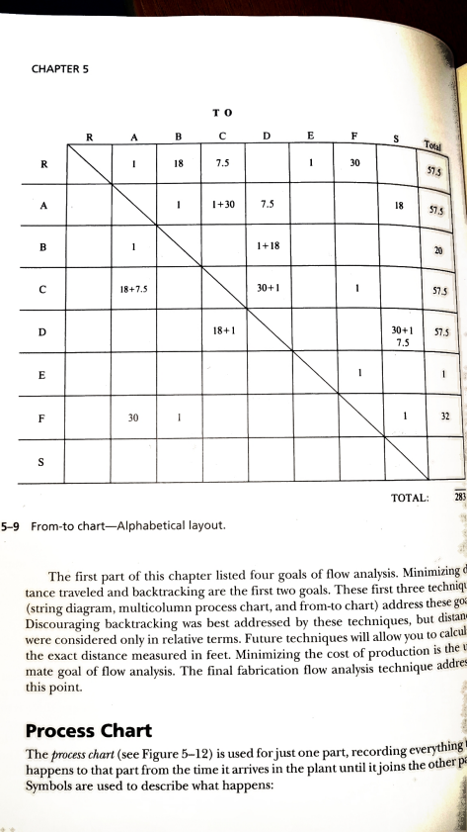

ıı■ 132

11lllllN

.''".''"'"'"''",".

The first part of this chapterliste d four goals of flow analysis. Minimizingd tance trave le d and backtracking are the first Hvo goals.The se fir s t thre e techniq u (string diagram, multicolumn proc e sschart, and from-to chaı-t) addre ss these g °f Discouraging backtrackingwas be st addre ssed bythe se te chnique s,but d i s ta n t we re conside re d onlyin re lative te rms. Futur e techniqueswill allow y°u to cal cul ; the e xact distanc e me asure d in fe e t. Minimizingthe c o s t ofproductionis the U mate goal of flow analysis.The final fabrication flow analysis techniquead d res this point.

Process Chart

The mcm c llart (se e Figure 5-12) is used forjustone part, recordinge verything\ happensto thatpartfrom the time it arrive s in the plant until itjolnsthe otbe r p a Symbolsare use d to de scribe what happens:

Flow Analysis mniques I 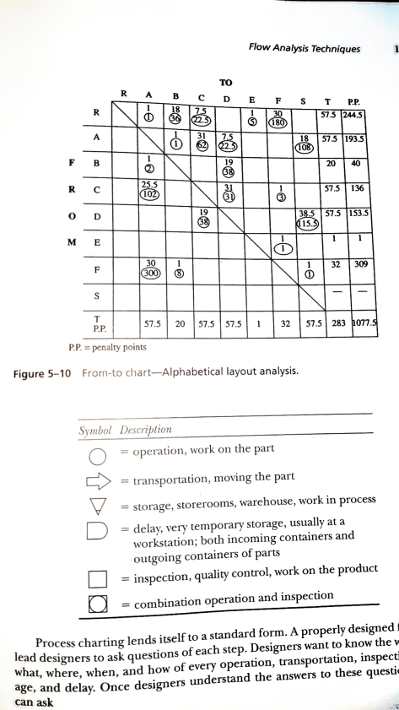

NR A B C D F_P S T P.P.

\1 1\' ı7ç

l\l: yK H\\A\* l l!ial

:,[l.. 1-1.°. 1."1'\"\."1."b'"1

''"u'"

'" ''""F''"'' "'"'"h.Be'"l'"y'"", lw:"

)} I)esniptiolı

ıı¢ VU(· ıJ LVL· T'" ''

S yınboı

operation,wol-k on thc parL

=transp°rtation, movingthe part

=storage,store r ooms, warehouse, work in proce ss

=delaY,V ei'temp°rary storage , usuallyat a

wol-ksta tion; both incomingcontainers and

outg° ingcontainersof parts

inspection, qualitycontrol, work on the product

=combination operationand inspection

=comDlılaUtlıı U Y-----

Proce ss chartinglends itselF to a standard form. A properlydesignedj lead desiwersto ask questionsof each step. Designerswant to know the V age, and delay. Once desiwersunderstandthe answe rsto the se questiI can ask

[k I I 1 in 1 R=ı, 1. \Il, P,p RE F B A C D

!.

l@

l@

T 1322057.557.557.557.5283548.0 P.P. 16757116106.510397.5 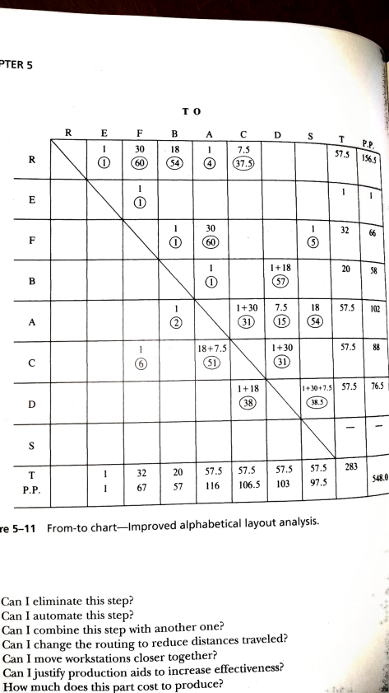

re 5-11 From-to chart-Improved aıphabeticaılayout anaıysis.

Can I eliminate this step?

Can I automate this step?

Can I combine this step Mth another one ?

Can I change the roudngto reduce distances traveled?

Can I move workstations closer together?

:-I

Can Ijusw producdonaids to increase effectiveness?

.

(

How much doe s this rcost to roduce? , I.. :