Lab2
>> load survivor
>> x

x =

37
52
90
56
58
45
66
75
36
68
100

% Although the values of boxplot in matlab is not %always exactly the same with our book,
% we can use it to see the general shape

>> boxplot(x,'o','h')
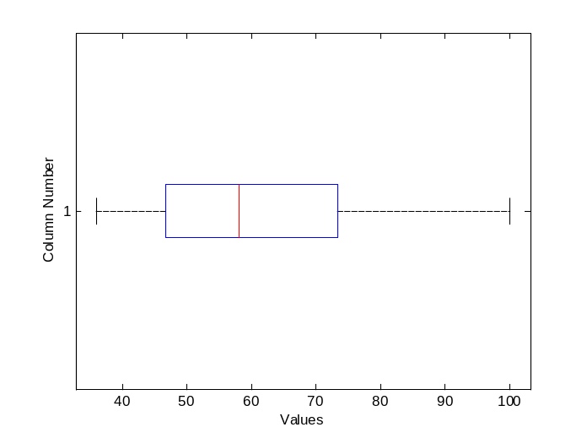
% For a more detailed interpretation on skewness,
% we should check the letter values.

>> let=letters(x)

let =

6.0000 58.0000 58.0000 58.0000
3.5000 48.5000 60.0000 71.5000
2.0000 37.0000 63.5000 90.0000
1.5000 36.5000 65.7500 95.0000
1.0000 36.0000 68.0000 100.0000

% Data is positively skewed (slightly) but the skewness is growing as we move towards the tails.

>> xL=let(2:4,2)

xL =

48.5000
37.0000
36.5000

>> xU=let(2:4,4)

xU =

71.5000
90.0000
95.0000

>> F=[xL(1);xU(1)]

F =

48.5000
71.5000

>> dF=F(2)-F(1)

dF =

23

>> lim=[F(1)-1.5*dF;F(2)+1.5*dF]

lim =

14
106

>> find(x<lim(1))

ans =

Empty matrix: 0-by-1

>> find(x>lim(2))

ans =

Empty matrix: 0-by-1

%There is no outlier in the data set

% Let’s try to find the right transformation to make the data symmetric

>> M=median(x)

M =

58

>> xaxis=((xU-M).^2+(M-xL).^2)/(4*M)

xaxis =

1.1746
6.3147
7.8933

>> yaxis=(xL+xU)/2-M

yaxis =

2.0000
5.5000
7.7500

>> plot(xaxis,yaxis,'*')
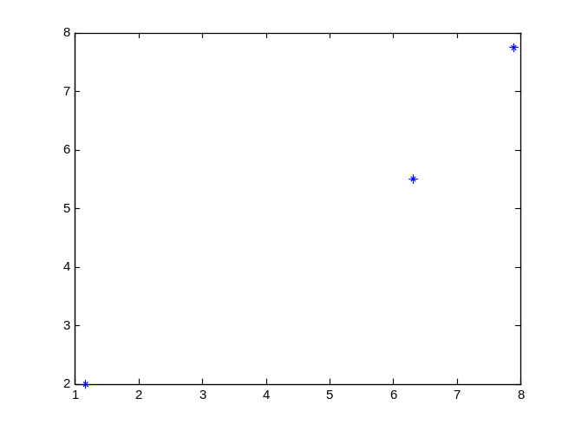

>> bperline=yaxis./xaxis

bperline =

1.7028
0.8710
0.9818

>> b=median(bperline)

b =

0.9818

>> p=1-b

p =

0.0182

% Then, it will be better to try p=0 and p=1/4 %transformations. Since p is very close to 0, log %transformation can work better. (Here, sample size %is very small, so the estimation of p is not very %reliable.)

>> logx=log10(x)

logx =

1.5682
1.7160
1.9542
1.7482
1.7634
1.6532
1.8195
1.8751
1.5563
1.8325
2.0000

>> letters(logx)

ans =

6.0000 1.7634 1.7634 1.7634
3.5000 1.6846 1.7692 1.8538
2.0000 1.5682 1.7612 1.9542
1.5000 1.5623 1.7697 1.9771
1.0000 1.5563 1.7782 2.0000

>> boxplot(logx,'o','h')

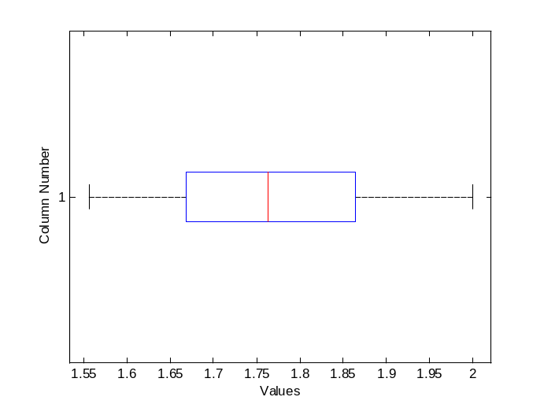

% log transformation works well here.

% Let’s try fourth root transformation (p=0.25)

>> fourthrootx=x.^(1/4)

fourthrootx =

2.4663
2.6853
3.0801
2.7356
2.7597
2.5900
2.8503
2.9428
2.4495
2.8716
3.1623

>> boxplot(fourthrootx,'o','h')
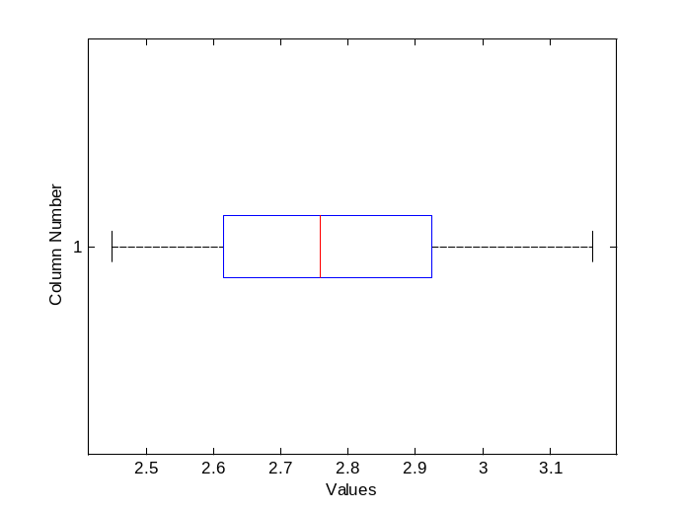

>> letters(fourthrootx)

ans =

6.0000 2.7597 2.7597 2.7597
3.5000 2.6377 2.7725 2.9072
2.0000 2.4663 2.7732 3.0801
1.5000 2.4579 2.7895 3.1212
1.0000 2.4495 2.8059 3.1623

% Fourth root transformation did not work as good as log transformation. The degree of skewness increases as we move towards the tails. The log transformation made the data set symmetric.

