Lab3

>> load matchedtransformations
>> x

x =

778
355
248
200
167
94
94
88
76
75
74
74
70
68
63

% Here, we decided to do log transformation

>> logx=log10(x)

logx =

2.8910
2.5502
2.3945
2.3010
2.2227
1.9731
1.9731
1.9445
1.8808
1.8751
1.8692
1.8692
1.8451
1.8325
1.7993

>> m=median(x)

m =

88

>> b=m/log10(exp(1))

b =

202.6275

>> a=m-b*log10(m)

a =

-306.0056

>> z=a+b*logx

z =

279.7863
210.7407
179.1761
160.2463
144.3778
93.8043
93.8043
88.0000
75.0989
73.9333
72.7521
72.7521
67.8619
65.3110
58.5902

% Let’s compare the original values, x, transformed values, logx, and the matched transformed values, z

>> [x logx z]

ans =

778.0000 2.8910 279.7863
355.0000 2.5502 210.7407
248.0000 2.3945 179.1761
200.0000 2.3010 160.2463
167.0000 2.2227 144.3778
94.0000 1.9731 93.8043
94.0000 1.9731 93.8043
88.0000 1.9445 88.0000
76.0000 1.8808 75.0989
75.0000 1.8751 73.9333
74.0000 1.8692 72.7521
74.0000 1.8692 72.7521
70.0000 1.8451 67.8619
68.0000 1.8325 65.3110
63.0000 1.7993 58.5902

>> boxplot(x,'o','h')

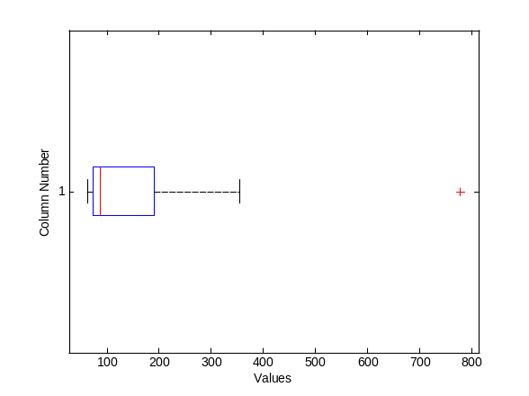

% There is an outlier on the positive side of the original variable.

>> boxplot(logx,'o','h')

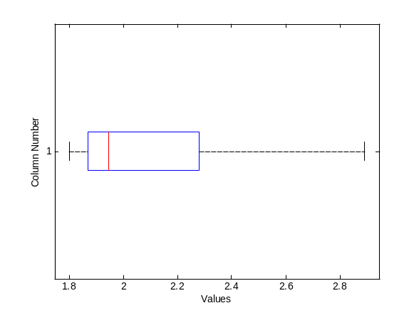

% By the logarithm transformation, we got rid of the outlier but there is a big difference between the original and transformed values. The distribution of the matched transformation z and logx are the same but there is just a location and scale shift. Thus, we can use z instead of logx and we have comparable values with the original values.

>> boxplot(z,'o','h')
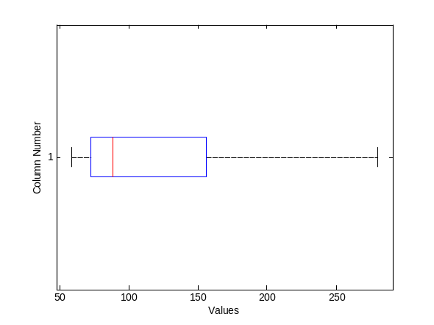

% We can see both plots together by the subplot command.

>> subplot(2,3,1)

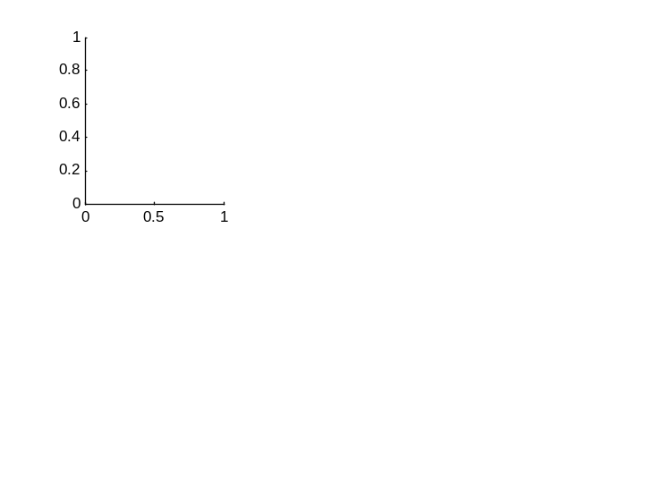
>> subplot(2,3,2)

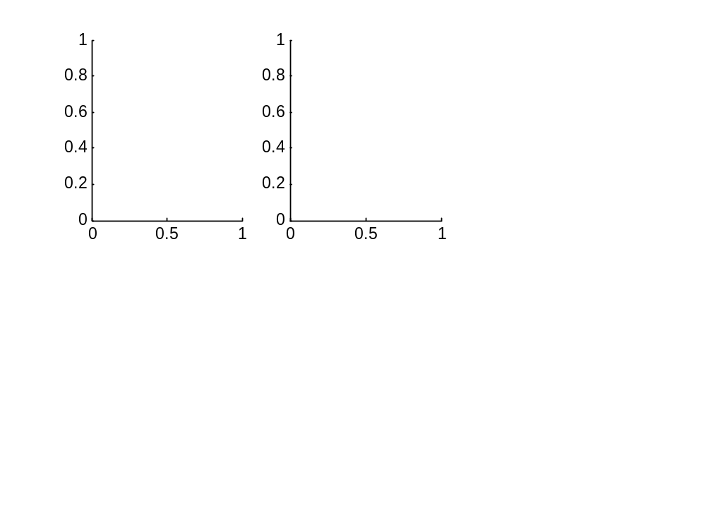
>> subplot(2,3,4)
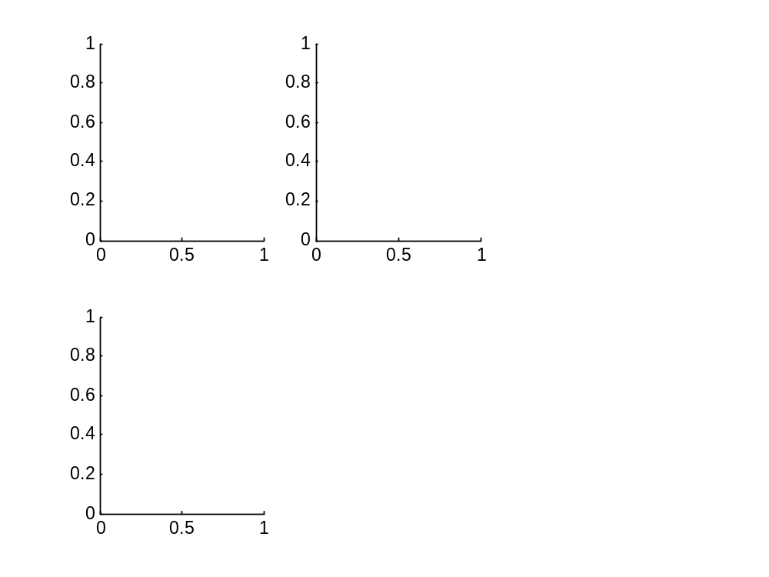

>> subplot(3,2,1)
>> histfit(x,20)
>> subplot(3,2,3)
>> histfit(logx,20)
>> subplot(3,2,5)
>> histfit(z,20)
>> subplot(3,2,2)
>> boxplot(x,'o','h')
>> subplot(3,2,4)
>> boxplot(logx,'o','h')
>> subplot(3,2,6)
>> boxplot(z,'o','h')

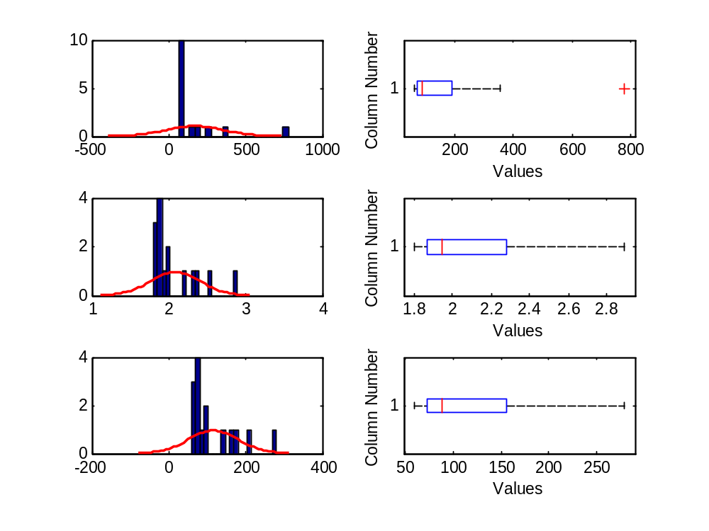

% We can also put titles for the plots

>> subplot(3,2,1)
>> title('Histogram of x')
>> subplot(3,2,3)
>> title('Histogram of logx')
>> subplot(3,2,5)
>> title('Histogram of z')
>> subplot(3,2,2)
>> title('Boxplot of x')
>> subplot(3,2,4)
>> title('Boxplot of logx')
>> subplot(3,2,6)
>> title('Boxplot of z')

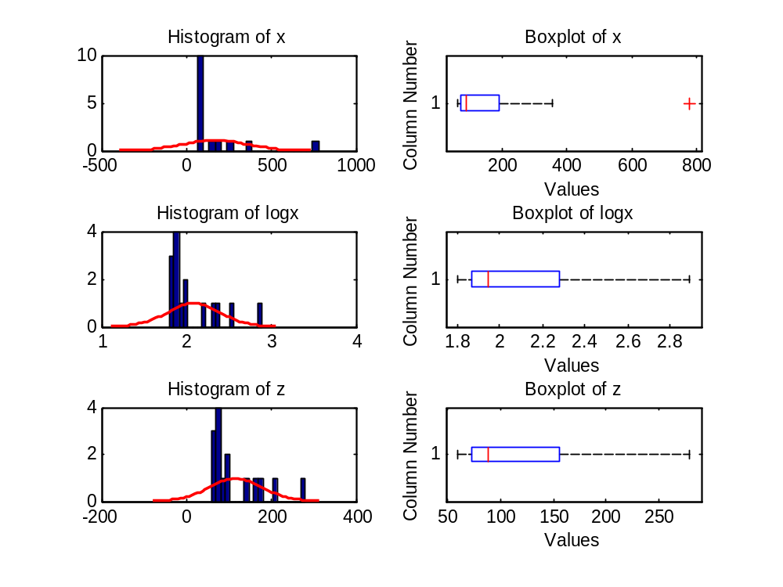

% What if we had square transformation? (Y=X²)

% T’(X)=2X, b=1/(2X)=1/(2*m), a=m-b*(m^2)

>> x2=x.^2;

>> b=1/(2*m)

b =

0.0057

>> a=m-b*m^2

a =

44

>> z=a+b*x2

z =

1.0e+003 *

3.4831
0.7601
0.3935
0.2713
0.2025
0.0942
0.0942
0.0880
0.0768
0.0760
0.0751
0.0751
0.0718
0.0703
0.0666

>> [x x2 z]

ans =

1.0e+005 *

0.0078 6.0528 0.0348
0.0036 1.2603 0.0076
0.0025 0.6150 0.0039
0.0020 0.4000 0.0027
0.0017 0.2789 0.0020
0.0009 0.0884 0.0009
0.0009 0.0884 0.0009
0.0009 0.0774 0.0009
0.0008 0.0578 0.0008
0.0008 0.0563 0.0008
0.0007 0.0548 0.0008
0.0007 0.0548 0.0008
0.0007 0.0490 0.0007
0.0007 0.0462 0.0007
0.0006 0.0397 0.0007

>> format short g
>> [x x2 z]

ans =

778 6.0528e+005 3483.1
355 1.2603e+005 760.05
248 61504 393.45
200 40000 271.27
167 27889 202.46
94 8836 94.205
94 8836 94.205
88 7744 88
76 5776 76.818
75 5625 75.96
74 5476 75.114
74 5476 75.114
70 4900 71.841
68 4624 70.273
63 3969 66.551

