Lab6

************************************************
Extra information and operations about the sorted values and their concomitants
************************************************

>> x=[7 10 6]’

x =

7
10
6

>> y=[15 12 9]’

y =

15
12
9

>> [x y]

ans =

7 15
10 12
6 9

>> [xs ind]=sort(x)

xs =

6
7
10

ind =

3
1
2

>> yc=y(ind)

yc =

9
15
12

>> [xs yc]

ans =

6 9
7 15
10 12

******************************************************
Here, xs’s are the sorted values and yc’s are the concomitants of the sorted x values. In regression, we will use this operation to sort the residuals and find the concomitants x and y values of the sorted residuals.
******************************************************

>> clear all
>> load mortality
>> format short g

>> regstats(mort,popden)
************************************************
Select coefficients, fitted values, residuals, leverage and studentized residuals on the pop up window
************************************************

>> beta

beta =

896.37
0.01135

***************************************************
The first model constructed is:
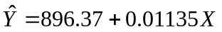

Here, Y:mort (mortality rate), X:popden (population density).

The leverage of the value with popden=9699 is very high. It means it has a potential to destroy the fitted line. We have to be careful with that observation.
**************************************************

>> plot(popden,leverage,'*')
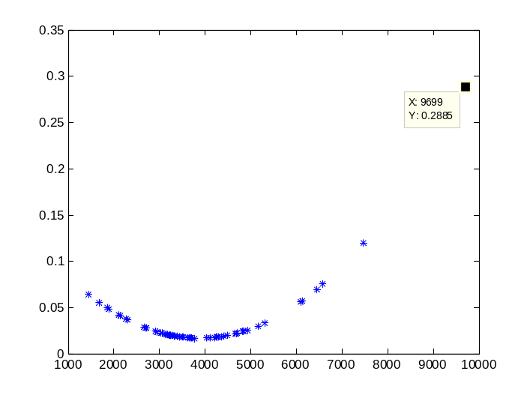
>> plot(popden,mort,'*')
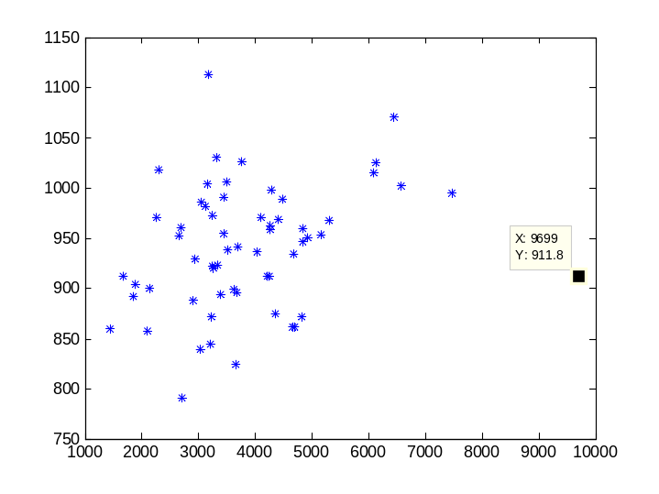

****************************************************
In the scatter plot the observation with popden=9699 is a very clear outlier. This is the same value having a high leverage. Thus, we have to discard this observation from the beginning. To find this observation we can use the ‘find’ function of Matlab.
******************************************************

>> find(popden==9699)

ans =

59

*********************************************
Now we find that the 59th value has to be discarded. We prefer not to alter the values of the original variables. Thus, we first create new variables with names x and y. We will then delete the outlier from x and y and continue the regression analysis. Please remind that if there is more than one outlier it is better to start deleting them from the bottom to the top since the data values will be shifted if you start from the top.
************************************************

>> x=popden;
>> y=mort;

************************************************
After deleting the 59th value, we apply the regression analysis again selecting coefficients, fitted values, residuals, leverage and studentized residuals. New matrices will be loaded with the names having index ‘1’.
*************************************************

>> regstats(y,x)

>> plot(x,r1,'*')
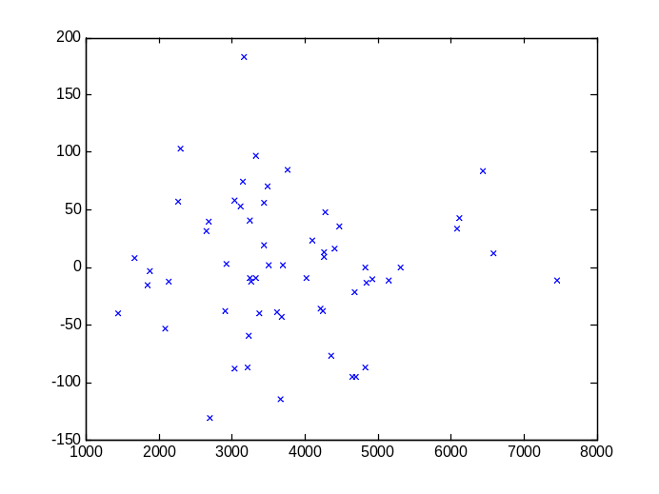

>>plot(yhat1,r1,'*')
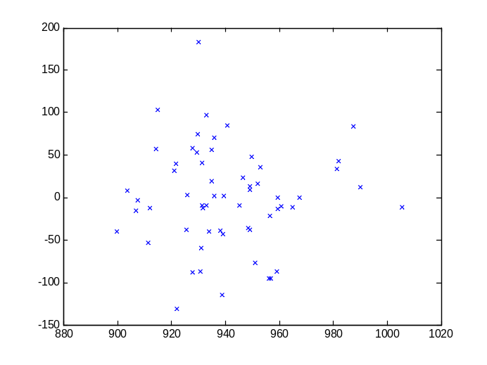
***************************************************
The residual plots show no systematic behaviour. This shows that the regression model is right. Now we will check for outliers by using the studentized residuals. ******************************************************

>> plot(x,studres1,'*')
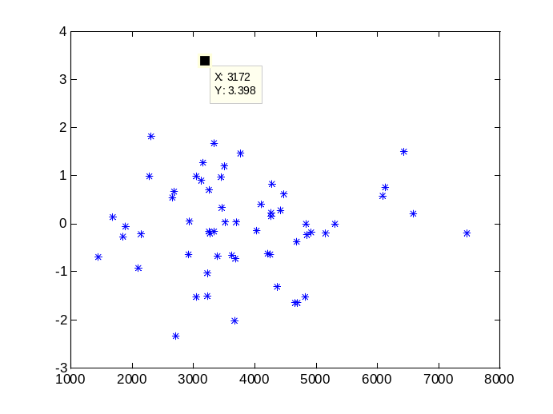

**************************************************
There is a value which is out of the band (-2.7,2.7). This value can be seen as an outlier also in boxplot and q-q plot. ****************************************************

>>boxplot(studres1)
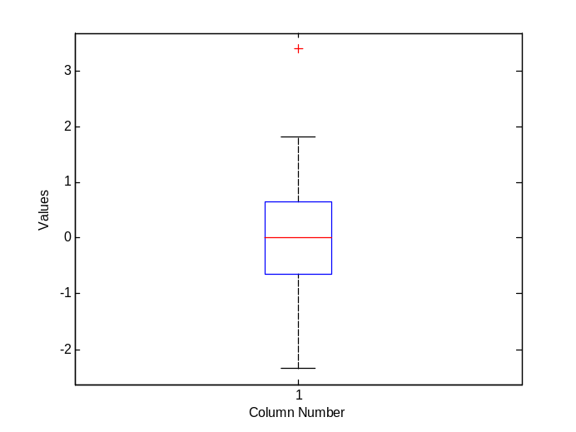

>> qqplot(studres1)
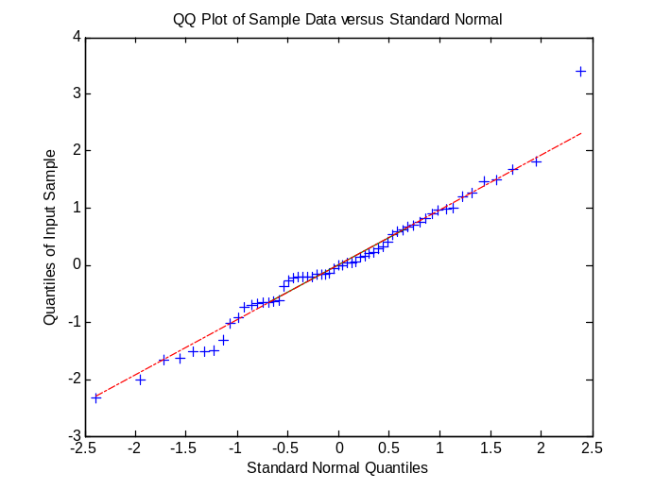

*****************************************************
We can easily find this observation by the function ‘sort’.
******************************************************

>> [sortedstudres1 ind]=sort(studres1)

sortedstudres1 =
-2.3384
-2.0132
-1.6559
-1.6486
-1.5231
-1.5163
-1.4990
-1.3179
-1.0225
-0.9291
-0.7368
-0.6956
-0.6790
-0.6596
-0.6488
-0.6366
-0.6142
-0.3735
-0.2625
-0.2273
-0.2162
-0.2048
-0.2011
-0.1969
-0.1748
-0.1648
-0.1619
-0.1533
-0.0584
-0.0035
0.0013
0.0307
0.0402
0.0536
0.1445
0.1606
0.2107
0.2213
0.2831
0.3262
0.4057
0.5374
0.5857
0.6156
0.6725
0.6955
0.7534
0.8204
0.9023
0.9617
0.9792
0.9924
1.1993
1.2731
1.4687
1.4975
1.6831
1.8137
3.3980

ind =
49
56
29
32
47
18
28
45
22
34
58
16
41
50
24
48
10
7
21
43
8
27
38
46
52
36
1
17
51
19
55
20
42
33
54
15
9
3
26
59
13
25
39
30
35
53
12
2
4
40
23
14
31
57
44
5
6
11
37

*****************************************************
The possible outlying observation if any, will be always at the top or bottom of the sorted residuals. By this way, we will easily find and discard the outliers. Now we will obtain the corresponding x and y values by using ind vector which gives the original positions of the sorted values. Let us call them xc and yc (concomitant)
****************************************************

>> xc=x(ind)
xc =

2702
3665
4700
4657
3033
4824
3214
4355
3226
2095
3678
1441
3387
3626
2909
4253
4213
4679
1844
4843
2140
3262
7462
5160
4923
3327
3243
4029
1883
4834
5308
3694
3508
2934
1671
4259
6582
4260
4412
3451
4101
2647
6092
4474
2682
3249
6122
4281
3125
3437
2269
3042
3497
3152
3768
6441
3325
2302
3172

>> yc=y(ind)

yc =

790.7
823.8
861.8
861.4
839.7
871.8
844.1
874.3
871.3
857.6
895.7
860.1
894
899.3
887.5
911.7
912.3
934.7
891.7
946.2
899.5
919.7
994.6
953.6
950.7
923.2
921.9
936.2
904.2
959.2
967.8
941.2
938.5
929.2
912.2
958.8
1002
962.4
968.7
954.4
970.5
952.5
1015
989.3
961
972.5
1025
997.9
982.3
991.3
971.1
986
1006
1004
1026
1071
1030
1018
1113

>> [sortedstudres1 xc yc]

ans =

-2.3384 2702 790.7
-2.0132 3665 823.8
-1.6559 4700 861.8
-1.6486 4657 861.4
-1.5231 3033 839.7
-1.5163 4824 871.8
-1.499 3214 844.1
-1.3179 4355 874.3
-1.0225 3226 871.3
-0.92915 2095 857.6
-0.73679 3678 895.7
-0.69565 1441 860.1
-0.67896 3387 894
-0.6596 3626 899.3
-0.64879 2909 887.5
-0.63658 4253 911.7
-0.6142 4213 912.3
-0.3735 4679 934.7
-0.26251 1844 891.7
-0.22727 4843 946.2
-0.21618 2140 899.5
-0.20477 3262 919.7
-0.20106 7462 994.6
-0.19693 5160 953.6
-0.17477 4923 950.7
-0.16478 3327 923.2
-0.16189 3243 921.9
-0.15327 4029 936.2
-0.058372 1883 904.2
-0.0034594 4834 959.2
0.0012532 5308 967.8
0.030653 3694 941.2
0.040232 3508 938.5
0.053595 2934 929.2
0.14453 1671 912.2
0.16061 4259 958.8
0.21069 6582 1002
0.22127 4260 962.4
0.28306 4412 968.7
0.32622 3451 954.4
0.40571 4101 970.5
0.53735 2647 952.5
0.58569 6092 1015
0.61556 4474 989.3
0.67255 2682 961
0.69545 3249 972.5
0.75341 6122 1025
0.82038 4281 997.9
0.90235 3125 982.3
0.96166 3437 991.3
0.97923 2269 971.1
0.99244 3042 986
1.1993 3497 1006
1.2731 3152 1004
1.4687 3768 1026
1.4975 6441 1071
1.6831 3325 1030
1.8137 2302 1018
3.398 3172 1113

*************************************************
In this stage, it is very easy to see that the outlier is the 37th observation which is at the bottom of the sorted residuals with value 3.3980. We delete this observation easily from the bottom line of xc and yc.
****************************************************

>> regstats(yc,xc)

**************************************************
Now, we again select coefficients, fitted values, residuals, leverage and studentized residuals. The matrices created here have the index ‘2’ at the end of their names. Let us check if the final model is fine.
****************************************************

>> boxplot(studres2)
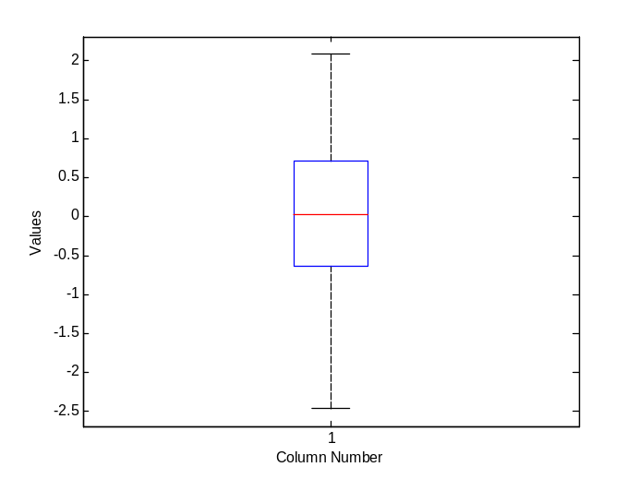
>> qqplot(studres2)
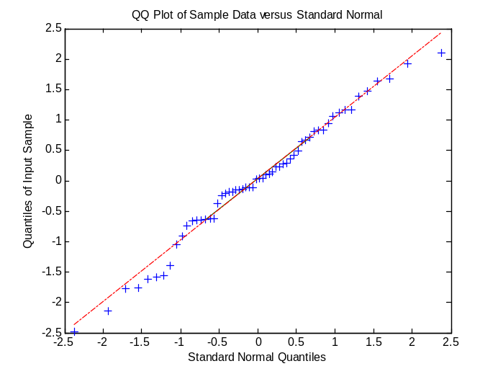

>> plot(yhat2,studres2,'*')
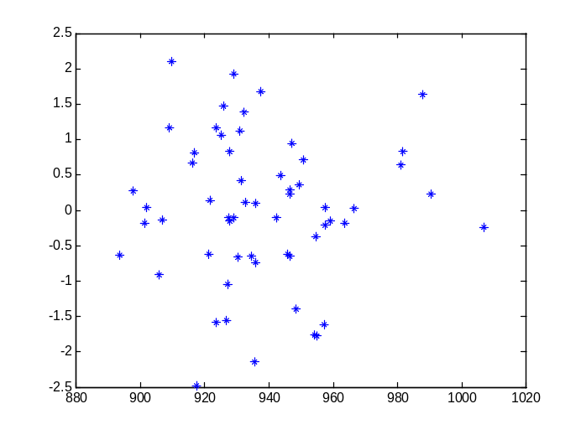

***************************************************
The final model is just fine and it is given below
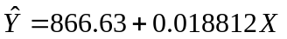
***************************************************

***************************************************
Finally we will compare the regression lines in the beginning and at the end of the analysis.
***************************************************

**************************************************
The graph contains the scatter plot, the first regression line (the red line) and the final regression line (the green line). From the graph given below we can see that the first regression line using the data set with outlier is highly affected by the outliers. It can not represent the bivariate data set. The final model seems to be fine.
**************************************************

>> plot(popden,mort,'*',popden,yhat,'r')
>> hold on
>> plot(xc,yhat2,'g')
>> hold off

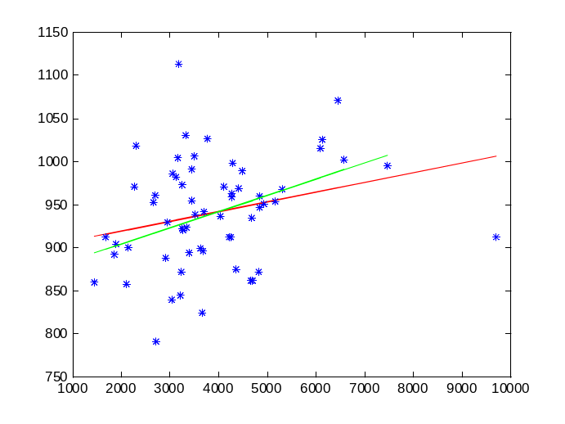
**************************************************
One can easily estimate the mean mortality rate for a given population density value by using the final model. For example for popden=9000, the estimated value is 1035.9
**************************************************

>> beta2(1)+beta2(2)*9000

ans =

1035.9

