**Assignment#1**

**Saad Ahmad**

**(20P-0051) CS-4A**

**Code:**

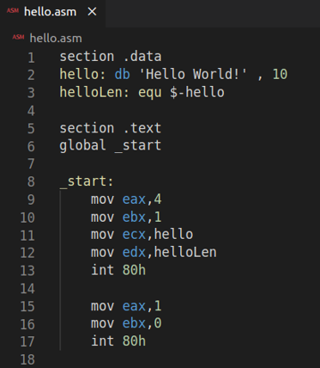

**Terminal Commands:**

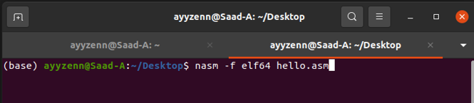



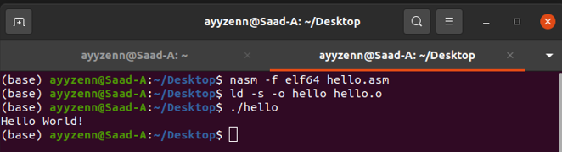

**What is int 80h?**

Int 80h is an interrupt used to make system calls to the kernel by other programs. The kernel is notified about which system call the program wants to make, by examining the value in the register EAX.

It doesn’t really interrupt the kernel… it interrupts the processor from executing our code and tells the processor to switch to the kernel.

**\*** A system call is a way for programs to interact with the operating system. A computer program makes a system call when it makes a request to the operating system’s kernel.