**Saad Ahmad**

**20P-0051**

**BS (CS) – 4A**

**Code #1**

Using **int 80h**

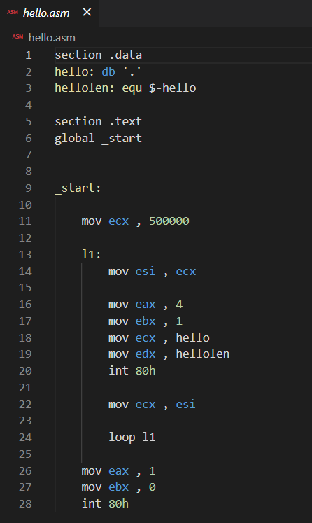

**Code #2**

Using **syscall**

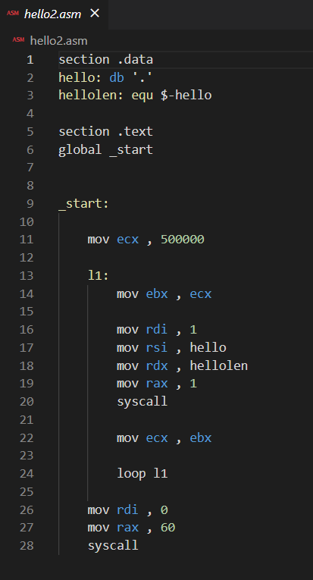

**Terminal commands:**

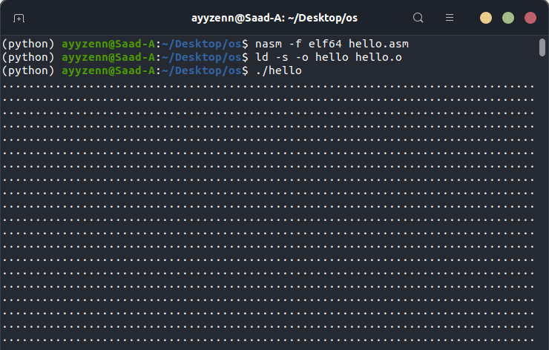

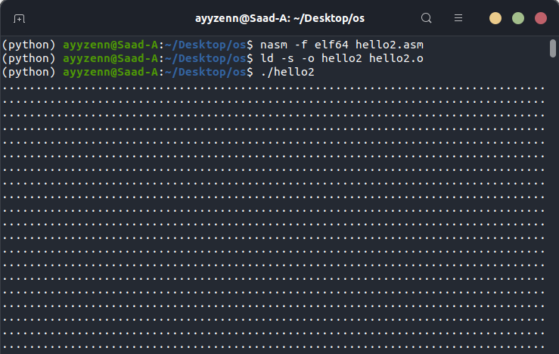

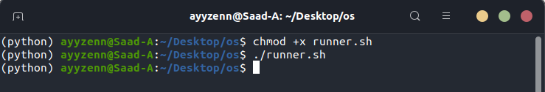

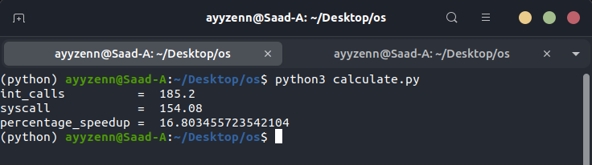

**Number of experiments run (N):** 50

**Average “user time” for hello (int-based calls) (I):** 185.2

**Average ‘user time’ for hello2 (syscall-based calls) (S):** 154.08

**Percentage speedup [(I-S)*100/I]:** 16 .803455723542104

**Code for calculating average for int, syscall and percentage speed up is given below:**

def numbers(file_name):

list1 = []

list2 = []

list3 = []

with open(file_name, 'r') as f:

for i in f:

if i == '\n':

continue

else:

list1.append(i)

for j in list1:

if j[0] == 'u':

list2.append(j)

else:

continue

for i in list2:

num = int(i[9:12])

list3.append(num)

sum_all = 0

for i in list3:

sum_all += i

result = sum_all/50

return result

int_calls = numbers("hello.txt")

syscall = numbers("hello2.txt")

print("int_calls = " , int_calls)

print("syscall = " , syscall)

percentage_speedup = (int_calls - syscall) * 100 / int_calls

print("percentage_speedup = " , percentage_speedup)