**Assignment # 3**

**Saad Ahmad**

**(20P-0051)**

**BS(CS) – 4A**

**Code:**

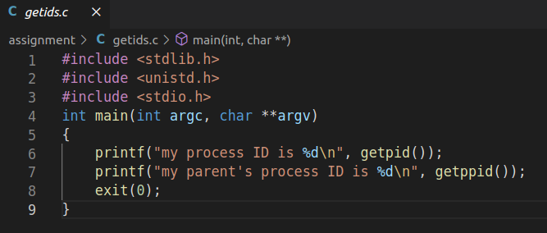

**Output:**

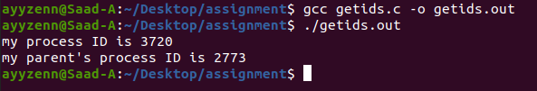

**Code:**

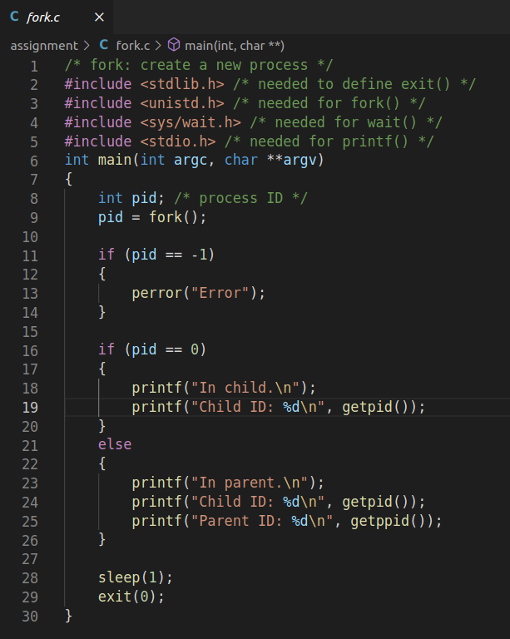

**Output:**

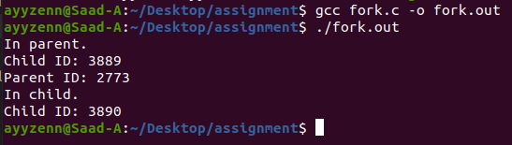

**Code:**

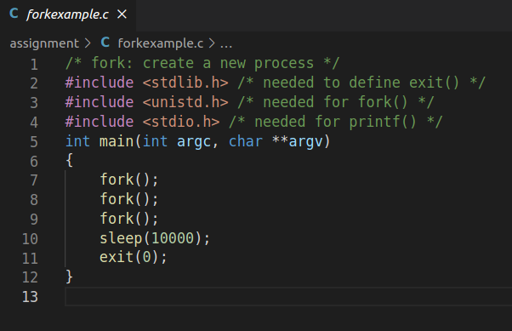

**Output:**

