**Assignment #4**

**Saad Ahmad**

**(20P-0051)**

# Task 1

Part A) We had created two functions named as thread1 and thread2 and in main function we have created the threads using the pthread_create function and then pass it the arguments and it calls the function thread1 and thread2 respectively and print the string.

The pthread_join suspend the execution of the calling thread until the target *thread* terminates. After that it will continue its execution.

## Code:

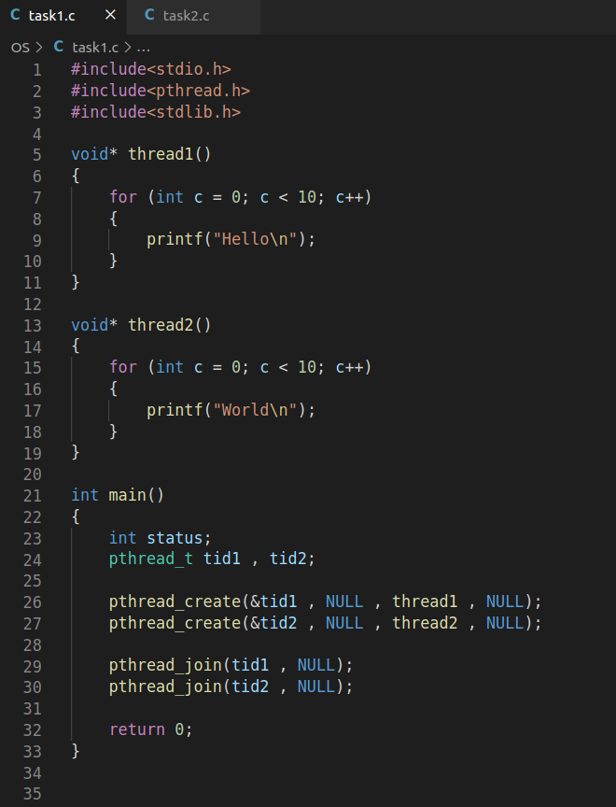

## Output:

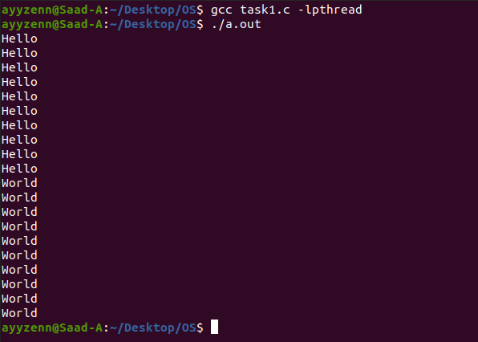

## Part B)

## Code:

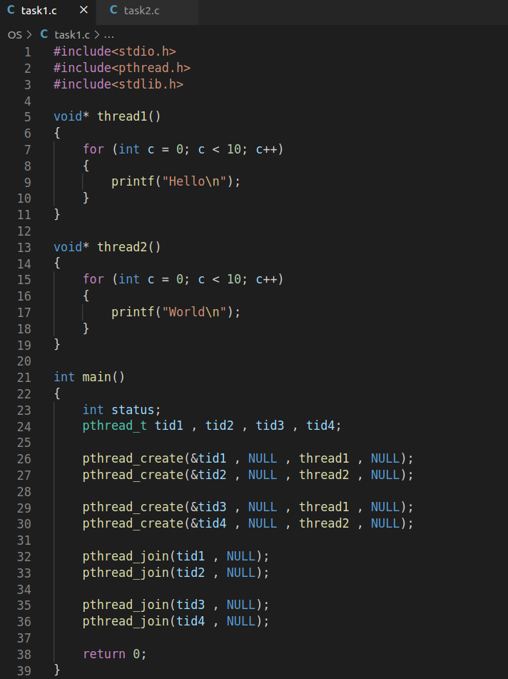

## Output:

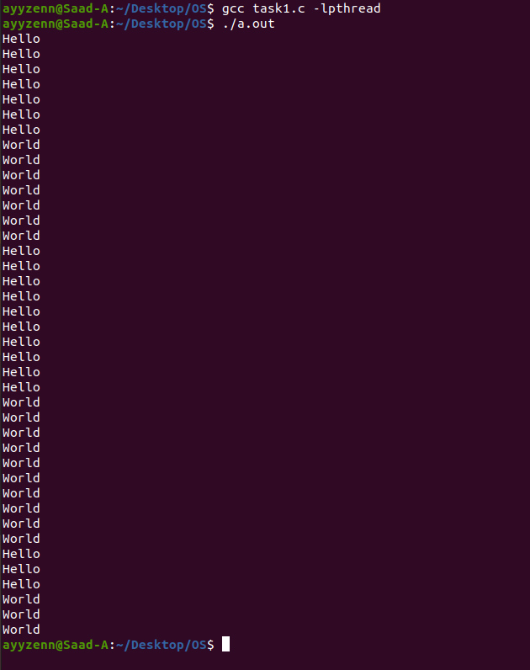

# Task 2

## Part A)

## Code:

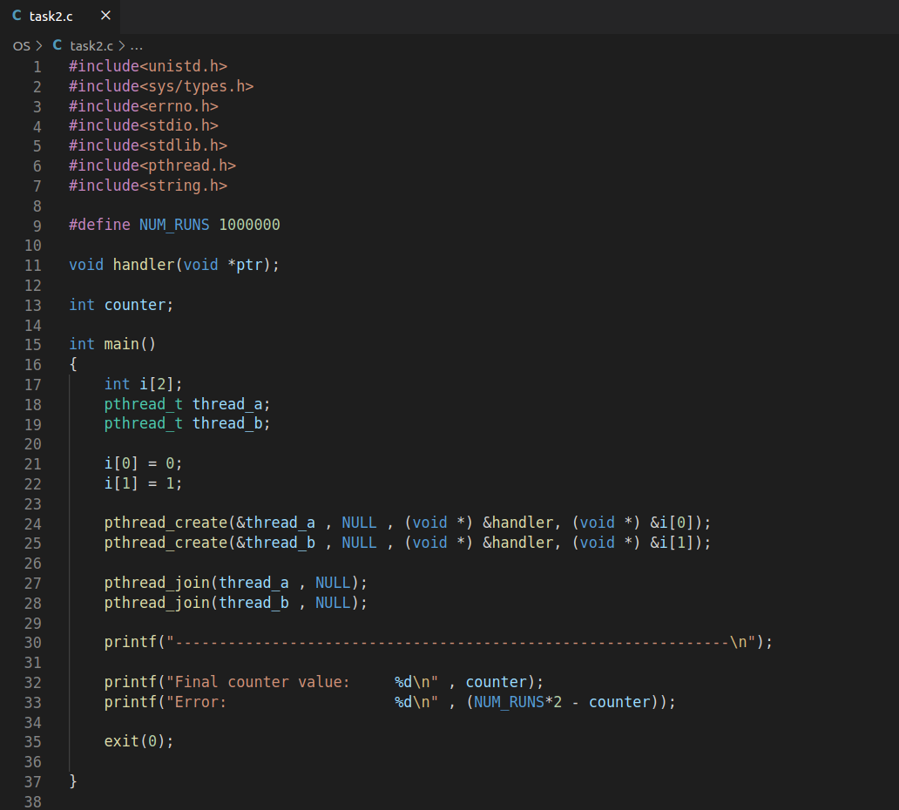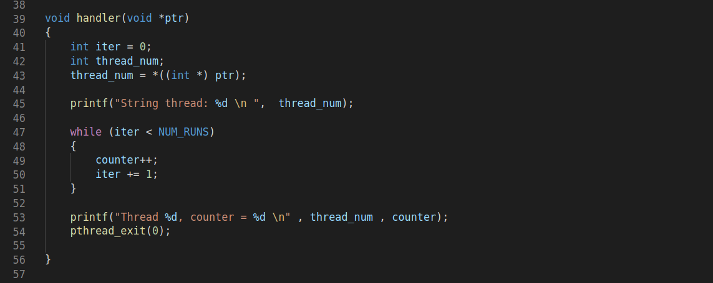

## Output:

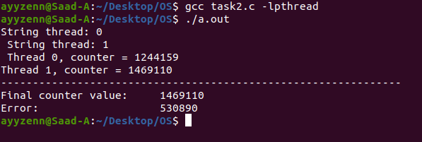

## Part B)

1. The value of counter variable should be **2000000**
2. The value I get is **1469110**
3. Error is **530890** and it is varied by different values like 540443, 956441, 848464, 531317.
4. User time is **0m0.024s**