**Assignment#5**

**Saad Ahmad**

**(20P-0051)**

**Code:**

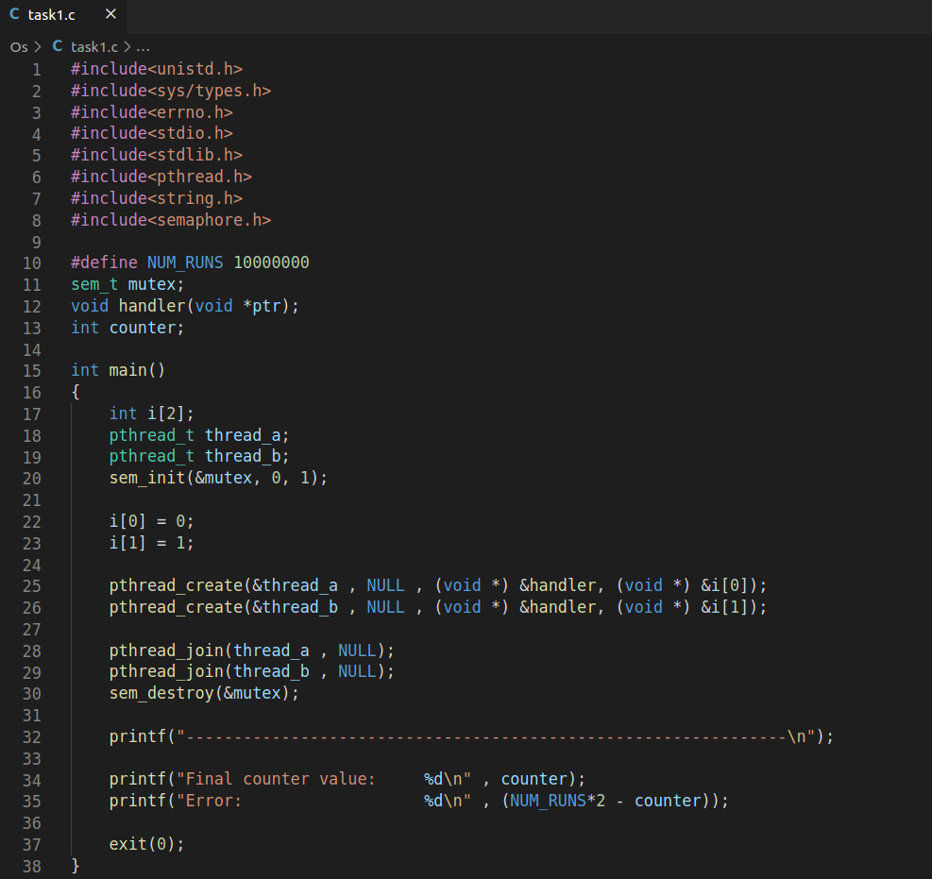

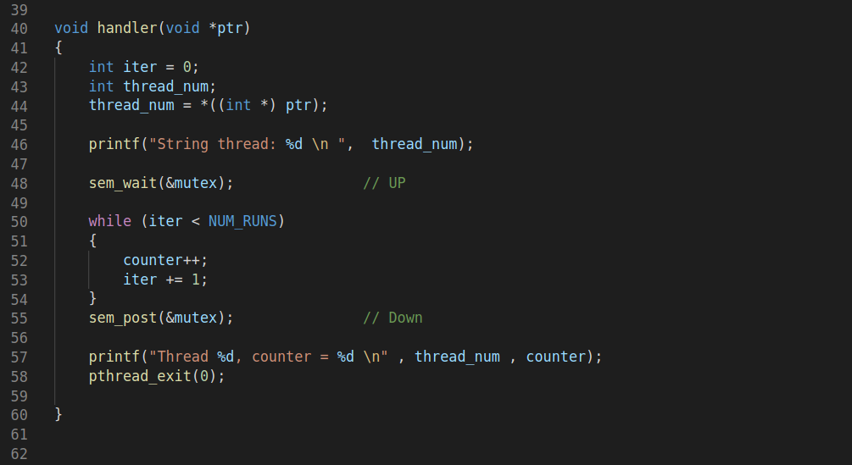

**Output:**

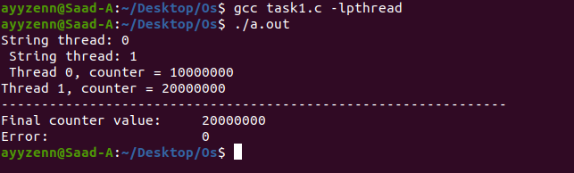

**Explanation:**

When thread 1 enter the critical region then the value of mutex is set 0 and if there is pre-emption then the thread 2 in put to sleep. And until the thread 1 has completed his process the thread 2 will remain in sleep state.