**Assignment#6**

**Saad Ahmad**

**(20P-0051)**

**Code:**

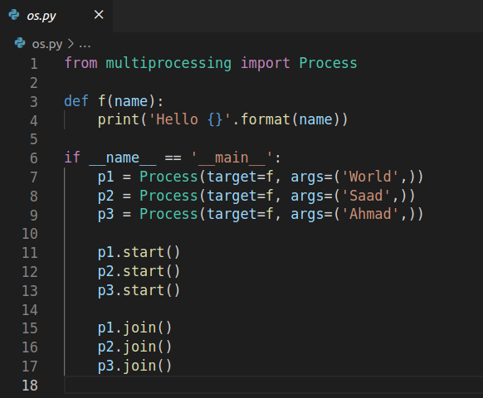

**Output:**

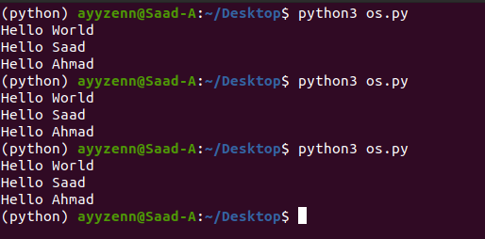

**Explanation:**

Process function take the two arguments i.e., function name and function parameters and create a process, after that process is started and is then connected with the main process using the join function. If join is not used then if main process is completed it will be terminated and it will also terminate the child process as well whether it is completed or not.