**Lab 7**

**To Demonstrate the Working of a Digital Comparator**

***Note: You may draw all the logic diagrams with hand and paste the pictures here or on logicly software with your name, roll number & section mentioned in your workspace. Make sure that all of your connections are clearly visible and distinguishable. In logicly, use “text” label to point out/show all your inputs & outputs***

**Tasks**

1. **Construct a logic circuit for a 2 bit magnitude comparator Also write the Boolean expression for output(s). Simulate your circuit in logicly software.**

**Hint: Take 2 bits of each input i.e. A1A0 & B1B0**

2-Bit Magnitude Comparator

1. Truth Table

|  |  |  |  |  |
| --- | --- | --- | --- | --- |
| **A1B1** | **AoBo** | **A > B** | **A < B** | **A = B** |
| A > B | * | 1 | 0 | 0 |
| A < B | * | 0 | 1 | 0 |
| A = B | A > B | 1 | 0 | 0 |
| A = B | A < B | 0 | 1 | 0 |
| A = B | A = B | 0 | 0 | 1 |

1. Boolean Expression (Simplified)

**A > B :** A1B1**’** + X1AoBo**’**

**A < B :** A1**’**B1 + X1Ao**’**Bo

**A = B :** X1 Xo where X = (A ⊕ B)**’**

1. Logic Diagram

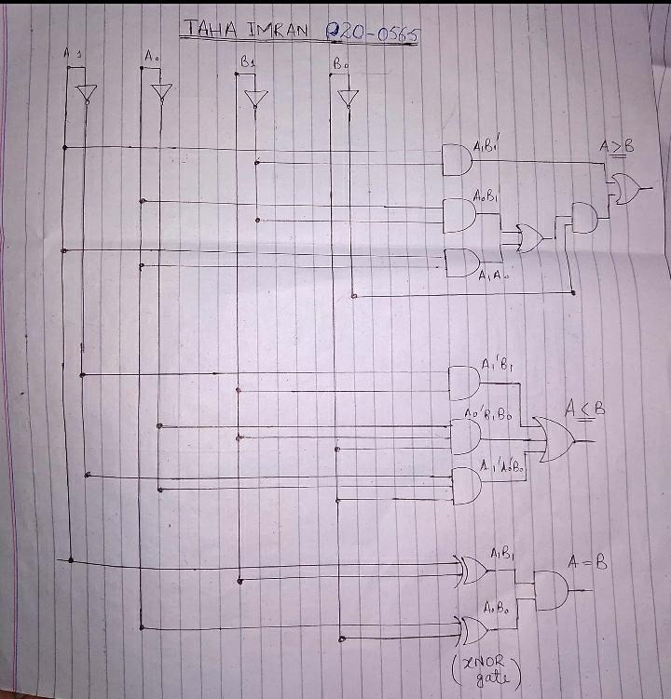

1. Software Simulation (Show here your results for each combination that gives a high output)

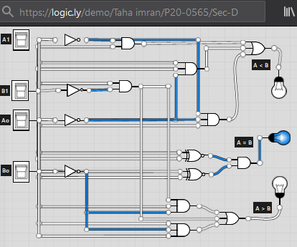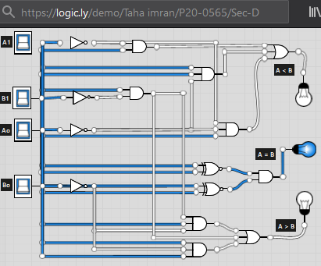

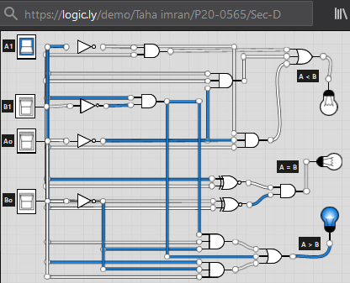

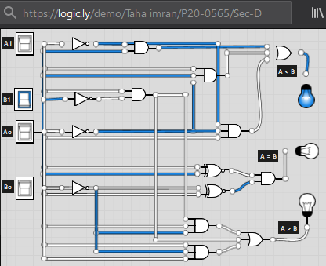

1. **Construct a logic circuit for a 4-bit magnitude comparator Also write the Boolean expression for output(s). Simulate your circuit in logicaly software.**

**You may take help from the logic diagram available on the Internet and compare it with yours for better understanding.**

**The logic circuit should be hand drawn (neatly) with all necessary labels (inputs/outputs).**

4-Bit Magnitude Comparator

1. Truth Table

|  |  |  |  |  |  |  |
| --- | --- | --- | --- | --- | --- | --- |
| **A3B3** | **A2B2** | **A1B1** | **AoBo** | **A > B** | **A < B** | **A = B** |
| A3 > B3 | * | * | * | 1 | 0 | 0 |
| A3 < B3 | * | * | * | 0 | 1 | 0 |
| A3 = B3 | A2 > B2 | * | * | 1 | 0 | 0 |
| A3 = B3 | A2 < B2 | * | * | 0 | 1 | 0 |
| A3 = B3 | A2 = B2 | A1 > B1 | * | 1 | 0 | 0 |
| A3 = B3 | A2 = B2 | A1 < B1 | * | 0 | 1 | 0 |
| A3 = B3 | A2 = B2 | A1 = B1 | Ao > Bo | 1 | 0 | 0 |
| A3 = B3 | A2 = B2 | A1 = B1 | Ao < Bo | 0 | 1 | 0 |
| A3 = B3 | A2 = B2 | A1 = B1 | Ao = Bo | 0 | 0 | 1 |

1. Boolean Expression

**A > B :** A3B3**’** + X3A2B2**’**+ X3 X2A1B1**’+** X3 X2 X1AoBo**’**

**A < B :** A3**’**B3 + X3A2**’**B2+ X3 X2A1**’**B1**+** X3 X2 X1Ao**’**Bo

**A = B :** X3 **.** X2 . X1 . Xo where X = (A ⊕ B)**’**

1. Logic Diagram

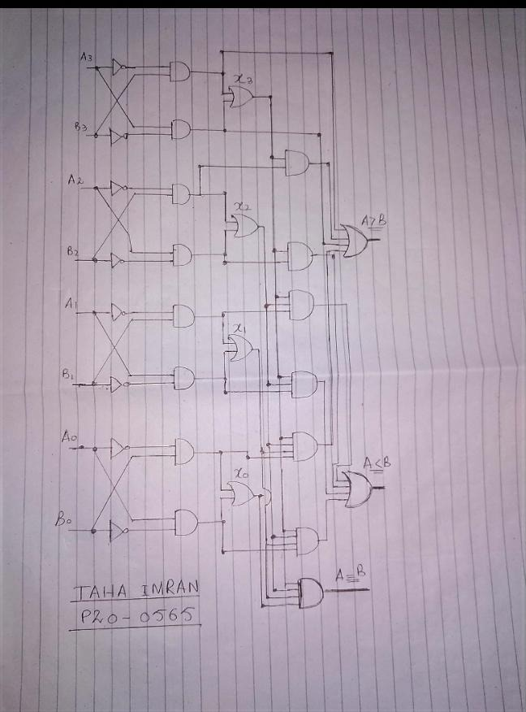

1. Software Simulation (Show here your results for each combination that gives a high output)

