**SYSTEM REQUIREMENTS SPECIFICATION**

**MOODLE 3.0 DEVELOPMENT ON UBUNTU**

**14.04**

**PREPARED BY**

AIZAH ANAS BT AZLEN

**SUPERVISED BY**

BAHAGIAN TEKNOLOGI MAKLUMAT (BTM),

SELANGOR INTERNATIONAL ISLAMIC UNIVERSITY COLLEGE (KUIS)

Table of Contents

Table of Contents ii

Revision History ii

1. Introduction 1

1.1 Purpose- 4

1.2 Document Conventions 4

1.3 Intended Audience and Reading Suggestions 5

1.4 Project Scope 6

1.5 References 7

2. Overall Description 8

2.1 Project Perspective 8

2.2 Functional Requirement 8

2.2.1 Use Case Scenario 8

2.2.2 User Classes and Characteristic 14

2.3 Operating Environment 14

2.4 Design and Implementation Constraints 15

2.5 User Documentation 15

2.6 Assumptions and Dependencies 16

3. System Features 17

3.1 General System Features 17

3.2 Collaborative Tools and Activities 18

3.3 Course Development and Management Features 30

3.4 Administrative Features 35

3. External Interface Requirements 41

3.1 User Interfaces 41

3.2 Hardware Interfaces 41

3.3 Software Interfaces 41

3.4 Communications Interfaces 41

5. Other Nonfunctional Requirements 42

5.1 Performance Requirements 42

5.2 Safety Requirements 42

5.3 Security Requirements 42

5.4 Software Quality Attributes 42

6. Other Requirements 43

Revision History

|  |  |  |  |
| --- | --- | --- | --- |
| Revision No | Revision Date | Amended By | Description |
| 1.1 | 01/03/2017 | Aizah Anas bt Azlen | Initial |

**1.0 Introduction**

**1.1 Purpose**

The purpose of this section is to provide the reader with a general, background information and an insight into the web application of “Moodle 3.0 LMS on Ubuntu 14.04” and is to specify the requirements for Moodle 3.0 development.

**1.2 Document Conventions**

Acronyms and Abbreviations:

a. LMS : Learning Management System

b. SRS : Software Requirements Specification

c. UC : Use Case

d. SDD : Software Design Description

e. Policy : A proposed or adopted course or principle of action

f. Context : Defines the circumstance, such as time and location in which the policy is valid

**1.3 Intended Audience and Reading Suggestions**

The intended audience for the Moodle Software Requirement Specifications is the web administrator, academicians and the Education Industry comprising of Institute Heads, students and faculty who using or are interested to use the Moodle LMS.

Developer : If the developer wants to read, change, modify or add new requirements into the Moodle existing system, he/she must first consult this document, update the requirements in an appropriate manner and pass the information correctly to the other phases of the development process.

User : The user of this program reviews the specifications presented in this document determines if the software has all the suitable requirements and whether the software developer has implemented all of them.

**1.4 Project Scope**

Moodle LMS is a very useful web application for education industry. The target user for this project is Moodle administrator, student and lecturer of Selangor International Islamic University College (KUIS). The scope of this project is develop Moodle function as the below items and deliver the functionality of Moodle to Selangor International Islamic University College (KUIS):

* To setup Moodle learning management system in Ubuntu server 14.04
* Adapting and modifying the functions and criteria in myLMS to Moodle.
* To help the organization in the management of users (student/lecturer) using learning management system (myLMS) as learning and teaching tools.
* Management of online module content in all available formats. The content covers general module information, learning materials, and assessment.
* Communication among module participants in the form of email, blogging, commenting and feedback.
* A system of user accounts with an advanced access level system
* A knowledge base about the module content.
* A diary and a calendar

**1.5 References**

Appendix A : Glossary

This citation is used as a model of reference:

[IEEE Std 830-1998]

**2. 0. Overall Description**

**2.1 Project Perspective**

Moodle (acronym for Modular Object - Oriented Dynamic Learning Environment) is a free source e-learning software platform, also known as a Learning Management System, or Virtual Learning Environment (VLE). As of June 2013 it had a user base of 83,008 registered and verified sites, serving 70,696,570 users in 7.5+ million courses with 1.2+ million teachers. Some of the use-cases explains the Moodle development:

**2.2 Functional Requirement**

### 2.2.1 Use Case Scenario

**2.2.1.1 User Login**

|  |  |
| --- | --- |
| Purpose | User logs in to system using existing profile. |
| User | A user with an existing profile. |
| Input Data | Profile username and password. |
| Output Data | Corresponding page data. |
| Invariants | Profile table data and user information. |
| Pre-Conditions | User is not logged in to a profile, input profile exists in database, user password matches profile |
| Post-Conditions | User's computer has been supplied with appropriate cookie, page data is appropriate for selected profile |
| Basic Flow | Webpage looks up profile data and returns the matching cookie. Webpage is updated to match new user data. |
| Alternative Flow(s) | Invalid password, invalid username, or mismatched username and  password redirect to error message and previous page. |
| Business Rule | This allows users to log in to their profile from anywhere. |

**2.2.1.2 Content Sharing (Upload Files)**

A user logs into the system and is on any page and wants to share some content on a group/individual level.

|  |  |
| --- | --- |
| Purpose | A user wants to share some data (pdf, ppt etc). |
| User | A legitimate user logged into the system |
| Input Data | The file to be shared. |
| Output Data | File ready to download by other users. |
| Invariants | The file. |
| Pre-Conditions | User is Logged in; file exists on user's computer. |
| Post-Conditions | Any other person to whom the content was made available is able to download it. |
| Basic Flow | The user uploads a file to be shared using the upload box and selects a subset of other users of the group with whom the user wants to share the file. The file then gets uploaded to the server and desired users are able to download it after logging in. |

**2.2.1.3 Discussion Thread**

|  |  |
| --- | --- |
| Purpose | A user wants to start a discussion on a particular topic. |
| User | Any user of the Moodle website. |
| Input Data | Title and body of the discussion and the group in which the user wants to have the discussion. |
| Output Data | A discussion thread to which other users are able to view and comment. |
| Invariants | The discussion data. |
| Pre-Conditions | User is logged in and is a member of the group in which he wants to post. |
| Post-Conditions | A discussion thread to which other users are able to view and comment. |
| Basic Flow | User logs in, selects a group and submits the title and body of the discussion topic through a submission form. The data is then stored on the server and other group members will be able to view and respond. |

**2.2.1.4 Content Sharing (Download Files)**

|  |  |
| --- | --- |
| Purpose | A user wants download a particular file. |
| User | Any user of the Moodle site. |
| Input Data | Request to download a particular file. |
| Output Data | File is downloaded on user’s computer. |
| Invariants | The user and the file. |
| Pre-Conditions | User is logged in and the file must be shared with him or with the group which he is a member of. |
| Post-Conditions | The user has downloaded the file successfully. |
| Basic Flow | User logs in, selects the file which he wants to download. The file is then transferred from the server to the user’s computer. |

**2.2.1.5 Search Result**

|  |  |
| --- | --- |
| Purpose | A user wants download a particular file. |
| User | Any user of the Moodle site. |
| Input Data | The keyword. |
| Output Data | Search Results. |
| Invariants | The user and the portal itself. |
| Pre-Conditions | User is logged in. |
| Post-Conditions | Search results. |
| Basic Flow | User logs in, Enters the keyword in the search box, clicks the search button and gets the search results. |

**2.2.1.6 Blog Thread**

|  |  |
| --- | --- |
| Purpose | A user wants to start a Blog on a particular topic. |
| User | Any user of the Moodle site. |
| Input Data | Title and body of the Blog and the forum in which the user wants to  have the blog. |
| Output Data | Blog to which other users are able to view and comment. |
| Invariants | The Blog data |
| Pre-Conditions | User is logged in and is a member of the group in which he wants to post. |
| Post-Conditions | A Blog to which other users are able to view and comment. |
| Basic Flow | User logs in, selects a group and submits the title and body of the Blog topic through a submission form. The data is then stored on the server and other group members will be able to view and respond. |

**2.2.1.7 Notification**

|  |  |
| --- | --- |
| Purpose | To get notifications of assignments, deadlines and other important messages. |
| User | Any user of the Moodle site. |
| Input Data | User enables the notifications from settings. |
| Output Data | Notifications. |
| Invariants | The user and the portal itself. |
| Pre-Conditions | User has chosen to receive notifications. |
| Post-Conditions | User receives the desired notifications. |
| Basic Flow | User enables the desired notifications from settings and receives notifications. |

**2.2.1.8 Survey**

|  |  |
| --- | --- |
| Purpose | To start a survey for a particular topic. |
| User | Any user of the Moodle site. |
| Input Data | Title and body of the survey and the forum in which the user wants to have the blog. |
| Output Data | Survey to which other users are able to do the polling and see the results. |
| Invariants | The survey data. |
| Pre-Conditions | User is logged in and is a member of the group in which he wants to do the survey. |
| Post-Conditions | A survey to which other users are able to do the polling and view the data. |
| Basic Flow | User logs in, selects a group and submits the title and body of the survey topic through a submission form. The data is then stored on the server and other group members will be able to view and respond. |

**Context Attributes**

The policy framework allows also allows users to define context-aware policies. All the policy frameworks have implemented policies based on time and location. If the system time and location matches with the context attributes, then the policy is valid. Otherwise it is invalid and the next policy is considered.

**2.2.2 User Classes and Characteristics**

• Web Designers

A web designer is someone who engages in web design. Web design encompasses many different skills and disciplines in the production and maintenance of websites. The web designers can employ the techniques discussed in this document to optimize their websites.

* Education Community

This application is of great use to the education community who are currently using or are interested in using Moodle LMS.

* Physical Actors :

Student: The student is the one who login to moodle and then gets himself/herself enrolled in a course and take part in a quiz

* Teacher:

The teacher is the one who enforce policy on certain application while a quiz is being conducted

**2.3 Operating Environment**

OE-1: The Optimized Moodle LMS shall operate with the any web browser.

OE-2: The Moodle LMS shall operate on Linux and Ubuntu 14.04 operating system.

OE-3: The Optimized Moodle LMS is free of cost and can be accessed by any user.

**2.4 Design and Implementation Constraints**

CO-1: The system shall be developed using FireBug, HttpFox and IMacros extension for Firefox.

CO-2: The software shall be tested using Apache JMeter.

**2.6 User Documentation**

UD-1: The system shall provide an online link to the learning resources available on the Moodle Docs for the understanding of the user.

**2.5 Assumptions and Dependencies**

AS-1: The server used for Moodle LMS is Apache .

AS-2: The database used for Moodle LMS is MySQL5.5.31.

AS-3: The Moodle Version 3.0 is used to develop the system.

DE-1: The operation of the Optimized Moodle LMS depends on the number of concurrent users and the activities accessed.

**3.0 System Features**

**3.1 General System Features**

**3.1.1 Modern, Easy to Use Interface**

Designed to be responsive and accessible, the Moodle interface is easy to navigate on both desktop and mobile devices.

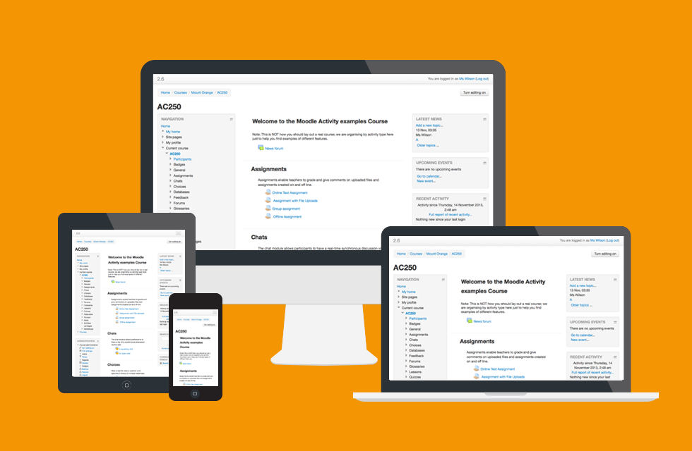

**3.1.2 Personalized Dashboards**

Organize and display courses the way you want, and view at a glance current tasks and messages.

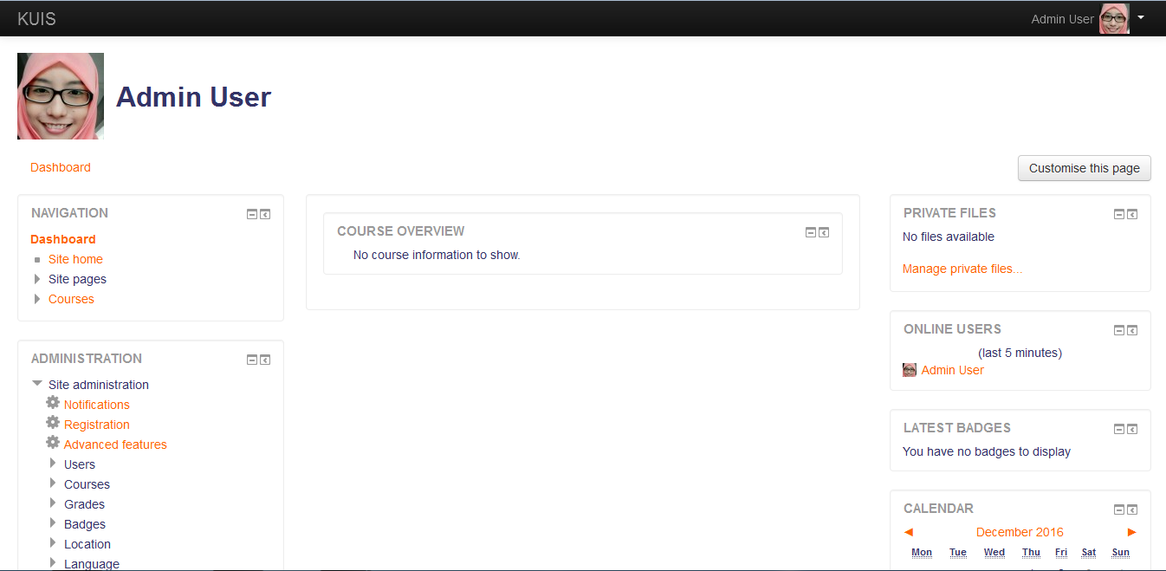

* 1. **Collaborative Tools And Activities**

**3.2.1 Grading Of Assignments**

The assignment activity module enables a teacher to communicate tasks, collect work and provide grades and feedback.

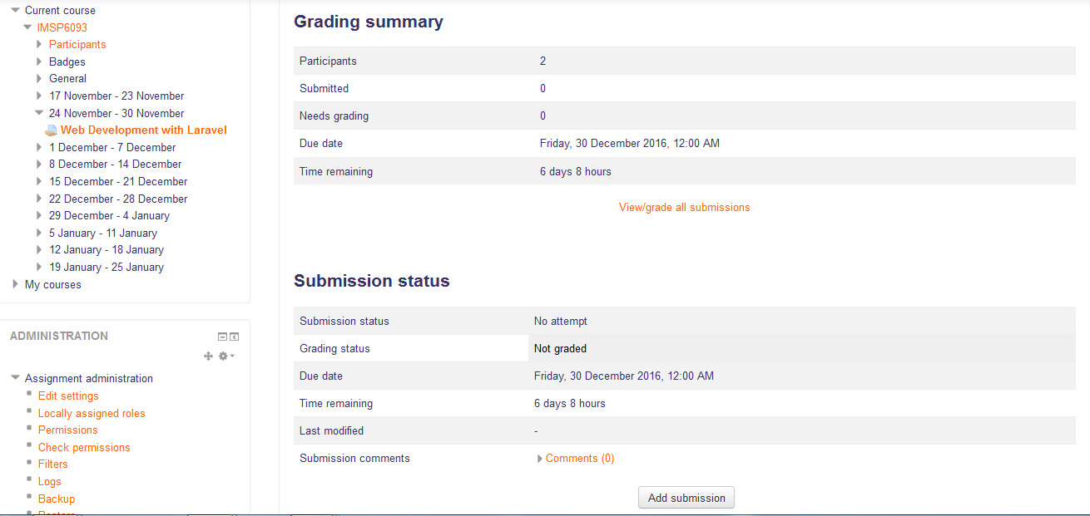

* + 1. **Chat**

The chat activity module enables participants to have text-based, real-time synchronous discussions.

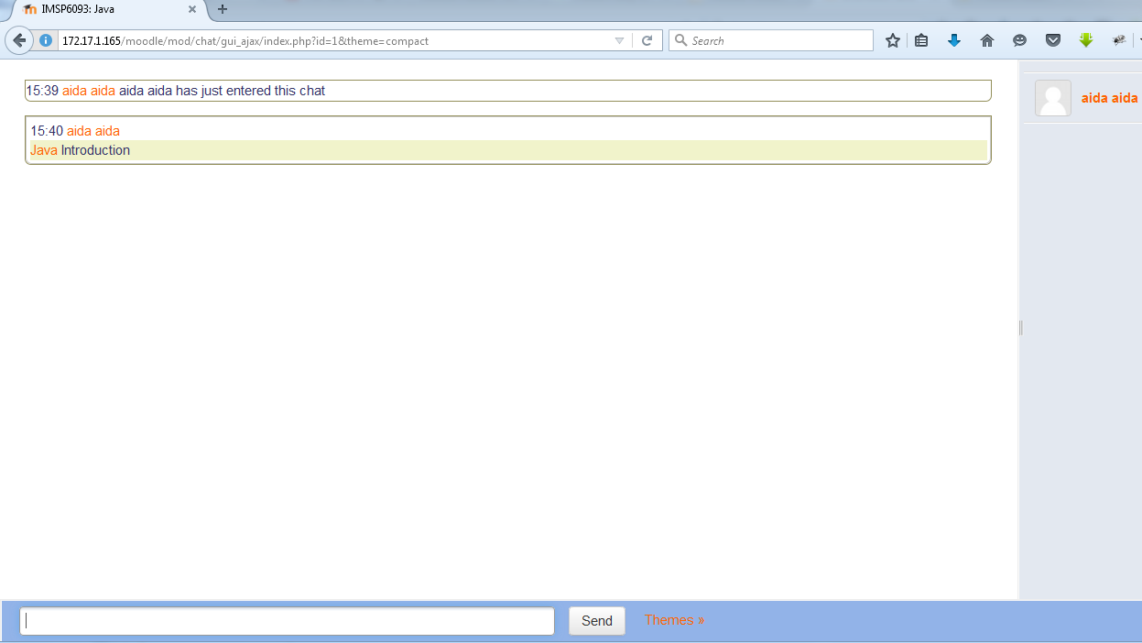

* + 1. **Choice**

The choice activity module enables a teacher to ask a single question and offer a selection of possible responses.

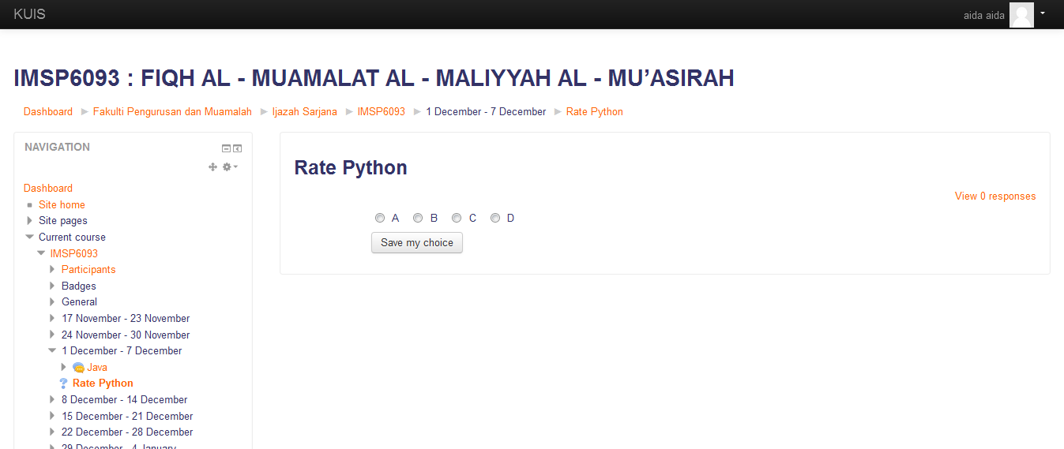

* + 1. **Database Activity Module**

The database activity module enables participants to create, maintain and search a collection of entries (i.e. records). The structure of the entries is defined by the teacher as a number of fields. Field types include checkbox, radio buttons, dropdown menu, text area, URL, picture and uploaded file.

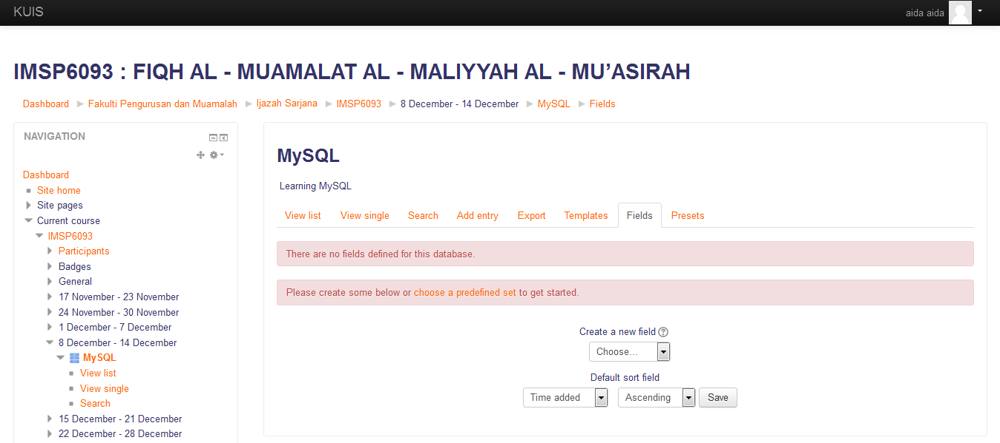

* + 1. **The External Tool Activity Module**

The external tool activity module enables students to interact with learning resources and activities on other web sites. For example, an external tool could provide access to a new activity type or learning materials from a publisher.

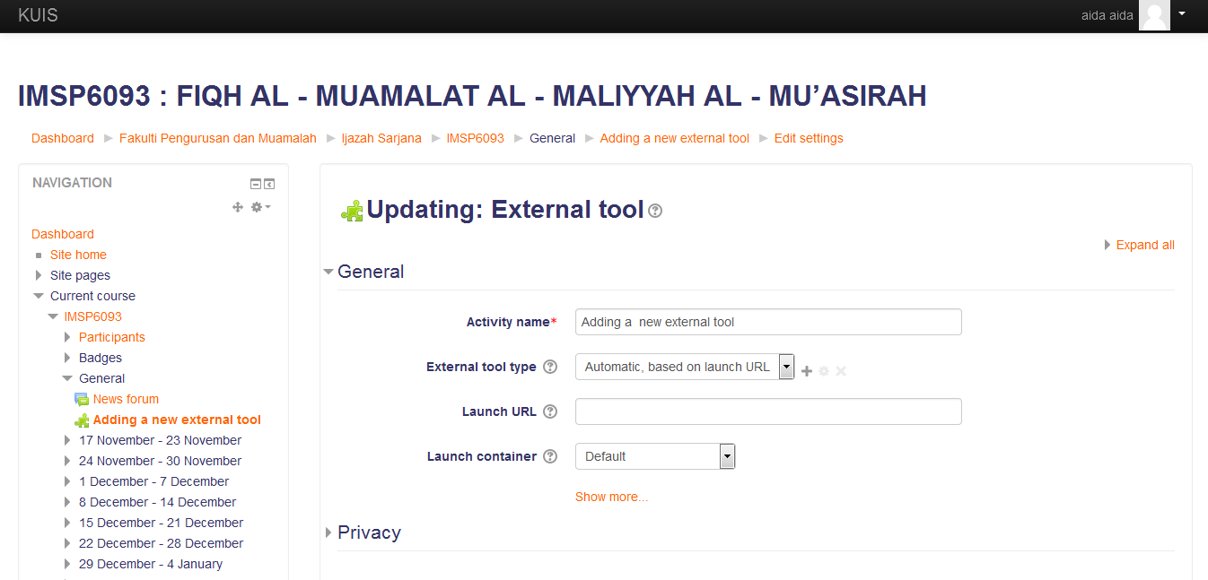

* + 1. **The Forum Activity**

The forum activity module enables participants to have asynchronous discussions i.e. discussions that take place over an extended period of time.

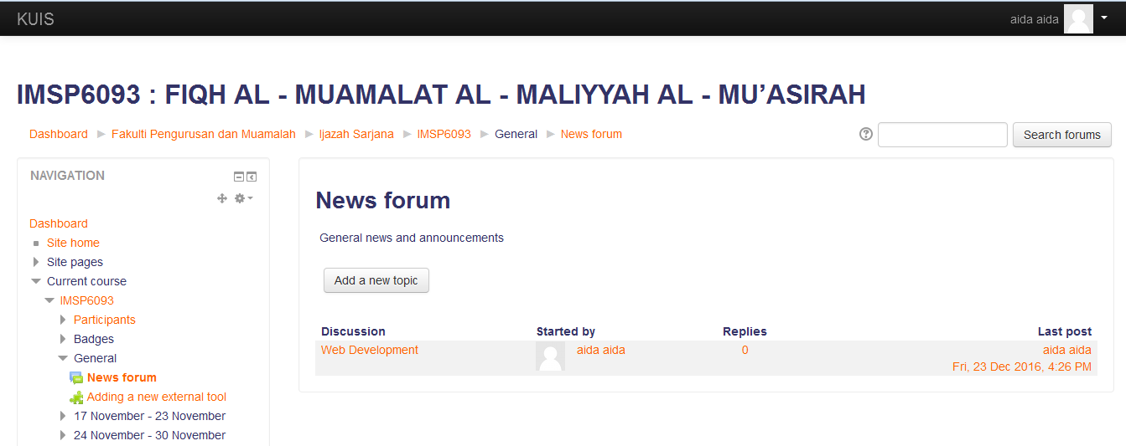

**Lecturer View of Forum**

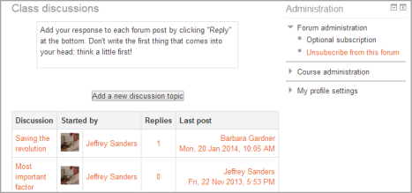

**Student view of Forum**

* + 1. **The glossary activity module**

Enables participants to create and maintain a list of definitions, like a dictionary, or to collect and organize resources or information.

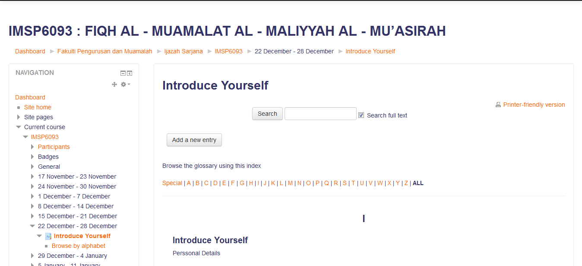

* + 1. **The lesson module**

Present a series of HTML pages to the student who is usually asked to make some sort of choice underneath the content area. The choice will send them to a specific page in the lesson.

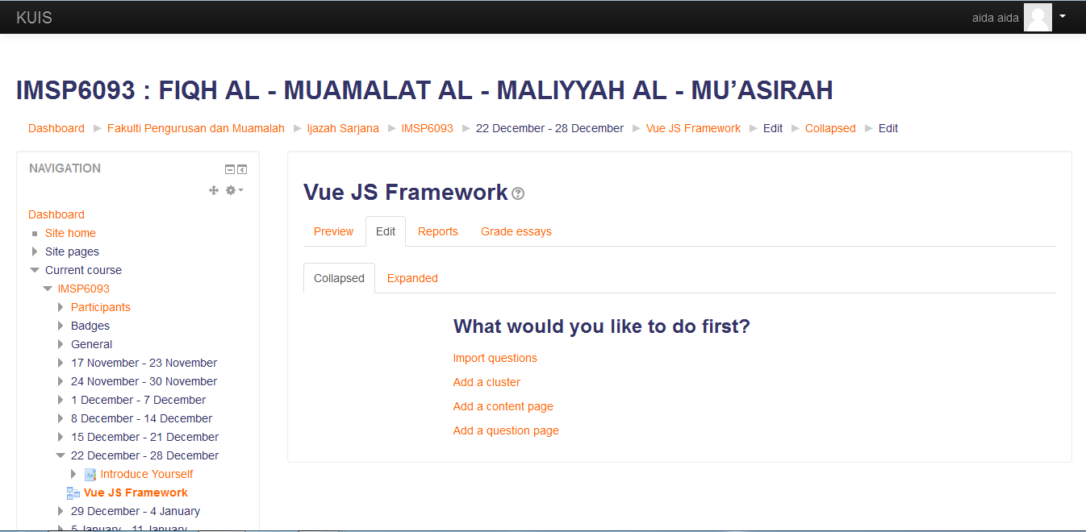

* + 1. **The Questionnaire Module**

The questionnaire module allows you to construct surveys using a variety of question types, for the purpose of gathering data from users.

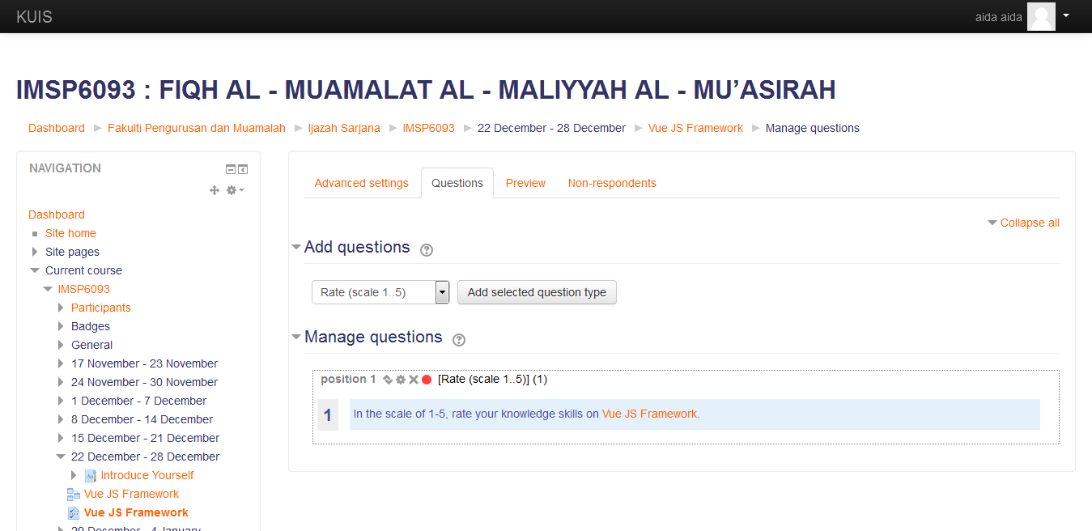

* + 1. **The Quiz Activity**

Enables a teacher to create quizzes comprising questions of various types, including multiple choice, matching, short-answer and numerical.

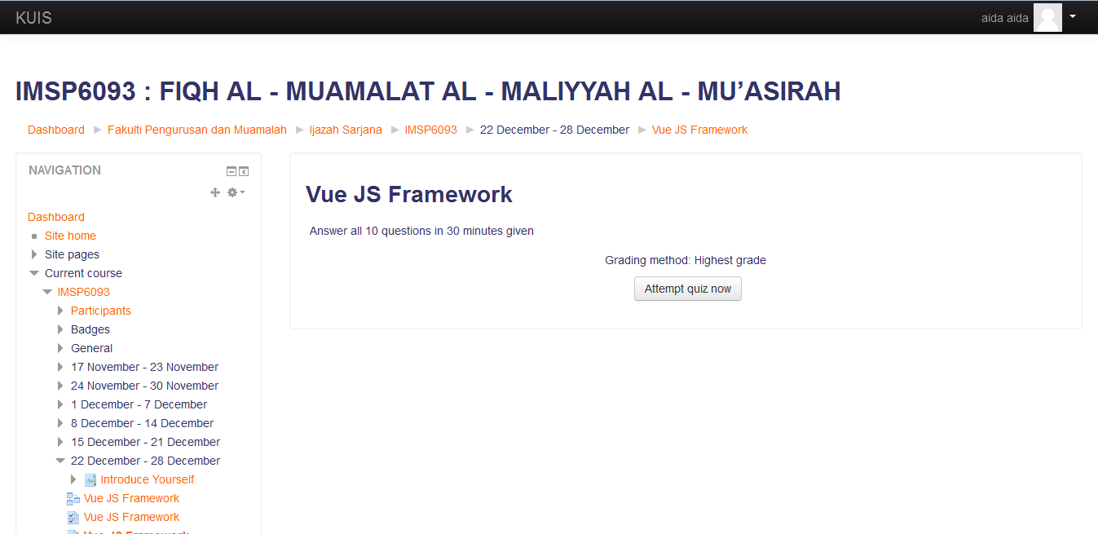

* + 1. **A SCORM Package**

Collection of files which are packaged according to an agreed standard for learning objects. The SCORM activity module enables SCORM or AICC packages to be uploaded as a zip file and added to a course

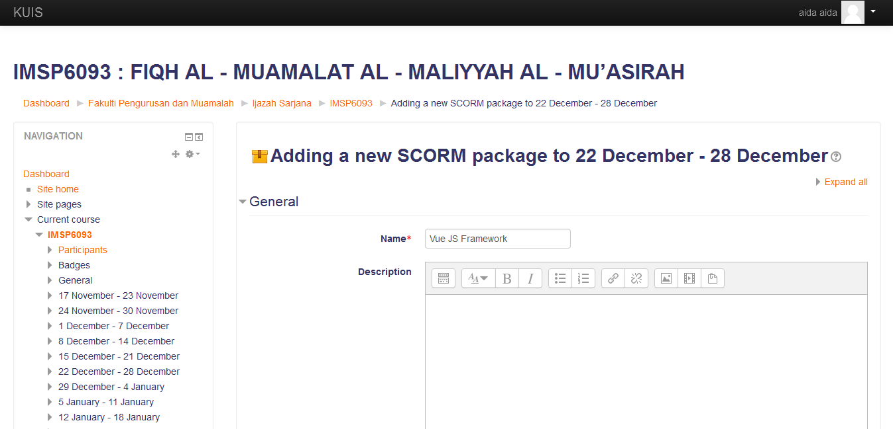

* + 1. **The Wiki Activity Module**

Enables participants to add and edit a collection of web pages. A wiki can be collaborative, with everyone being able to edit it, or individual, where everyone has their own wiki which only they can edit.

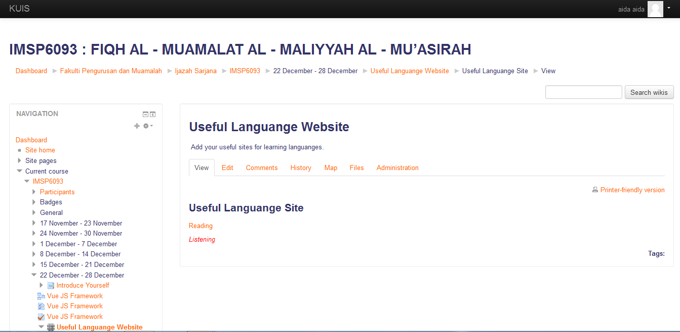

* + 1. **Workshop**

Workshop is a peer assessment activity with many options. Students submit their work via an online text tool and attachments. There are two grades for a student: their own work and their peer assessments of other students’ work.

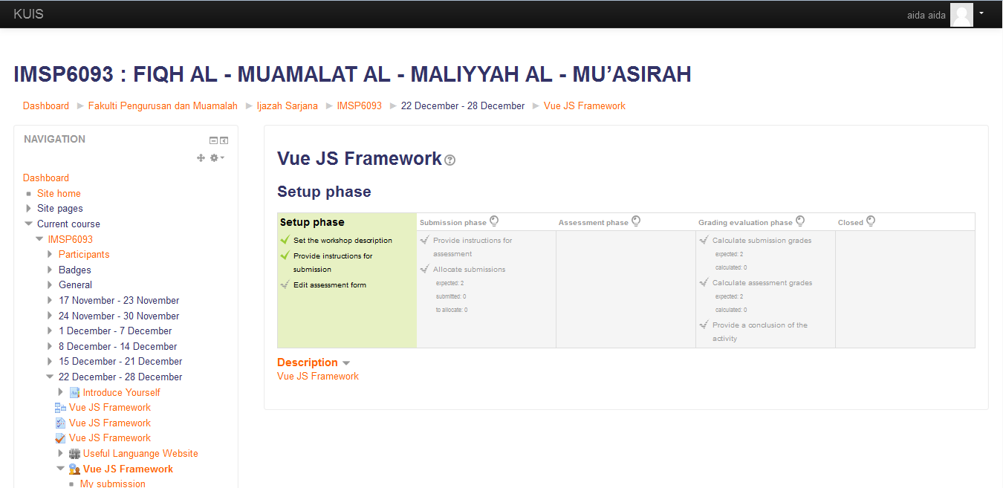

* + 1. **All In One Calender**

Moodle’s calendar tool helps you keep track of your academic or company calendar, course deadlines, group meetings, and other personal events.

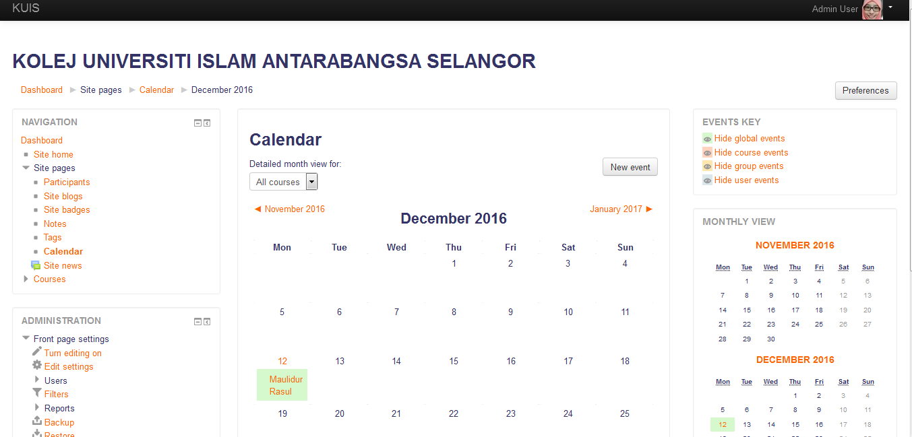

* + 1. **Convenient File Management Using Repositories**

Moodle provides an easy way for a teacher to present materials to their students. These materials may take the form of files such as word-processed documents or slideshow presentations.



* + 1. **Simple And Intuitive Text Editor**

Format text and conveniently add media and images with an editor that works across all web browsers and devices.



* + 1. **Notifications**

When enabled, users can receive automatic alerts on new assignments and deadlines, forum posts, and also send private messages to one another.

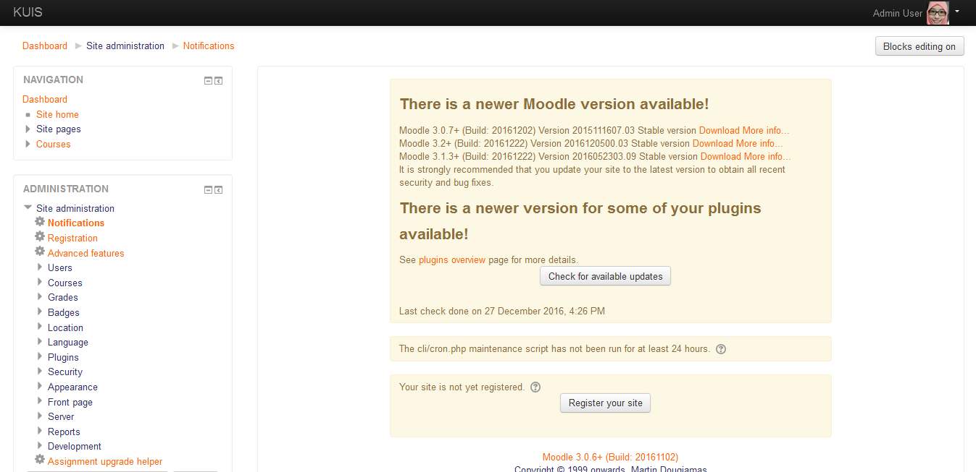

* + 1. **Track Progress**

Educators and learners can track progress and completion with an array of options for tracking individual activities or resources and at course level.

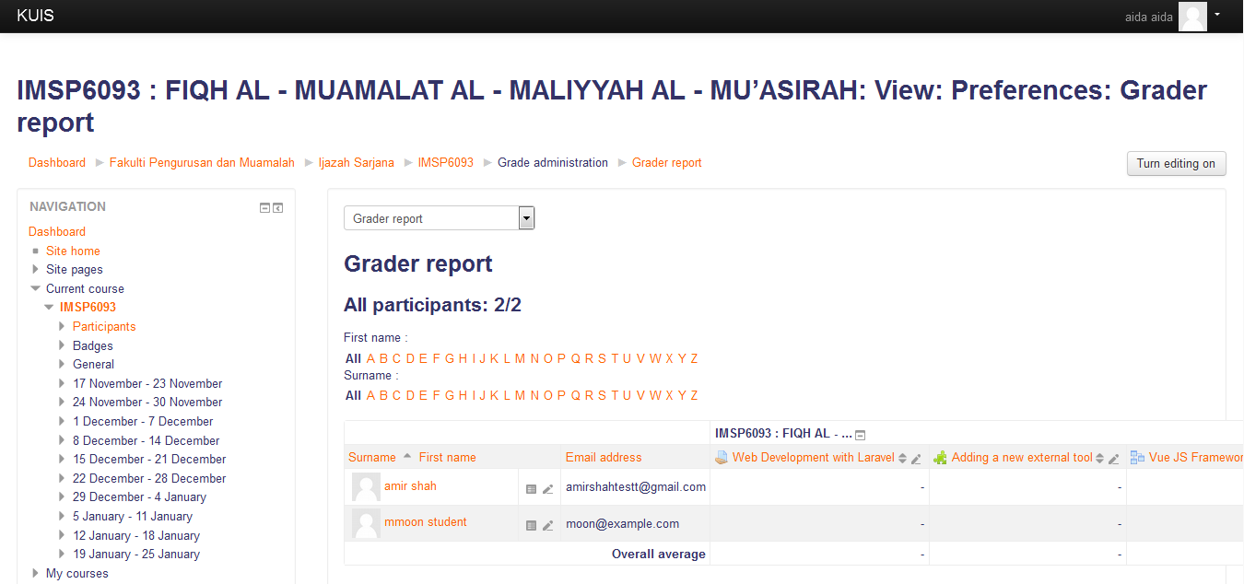

* 1. **Course Development & Management Features**
     1. **Direct Learning Path**

Design and manage courses to meet various requirements. Classes can be instructor-led, self-paced, blended or entirely online.

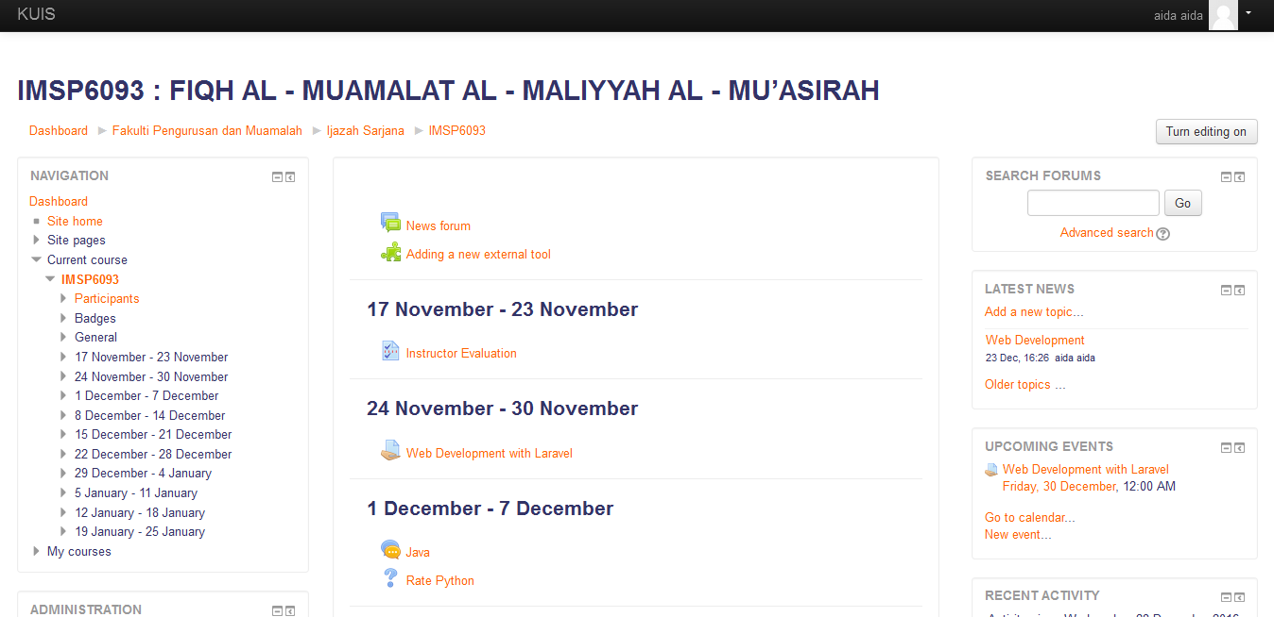

* + 1. **Embed External Resources And Multimedia**

Teach materials and include assignments from other sites and connect to the gradebook in Moodle.

* + - 1. **Book**

The book module enables a teacher to create a multi-page resource in a book-like format, with chapters and subchapters. Books can contain media files as well as text and are useful for displaying lengthy passages of information which can be broken down into sections.

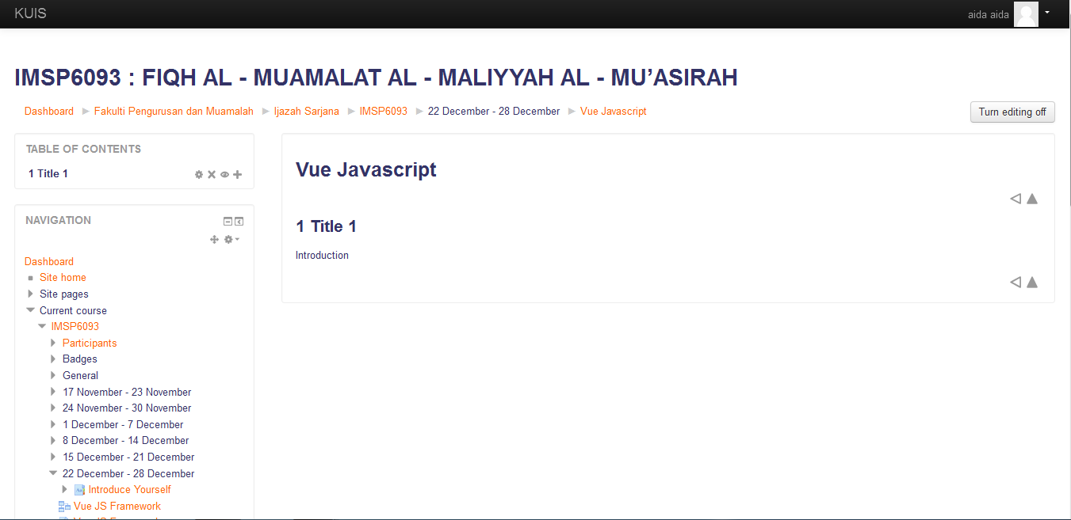

* + - 1. **File**

The file module enables a teacher to provide a file as a course resource. Where possible, the file will be displayed within the course interface; otherwise students will be prompted to download it. The file may include supporting files, for example an HTML page may have embedded images or Flash objects.

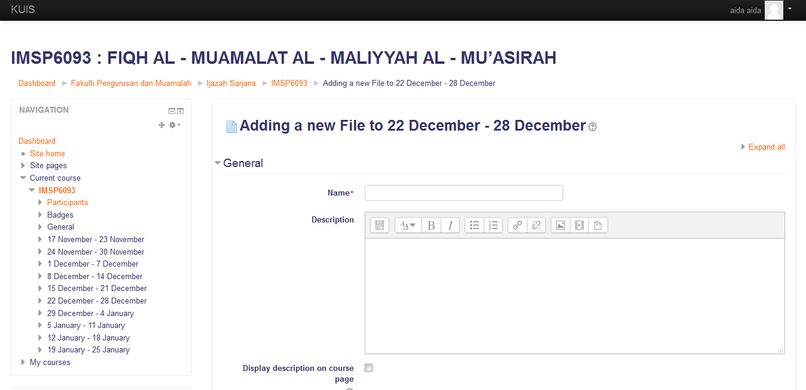

* + - 1. **Folder**

The folder module enables a teacher to display a number of related files inside a single folder, reducing scrolling on the course page. A zipped folder may be uploaded and unzipped for display, or an empty folder created and files uploaded into it.

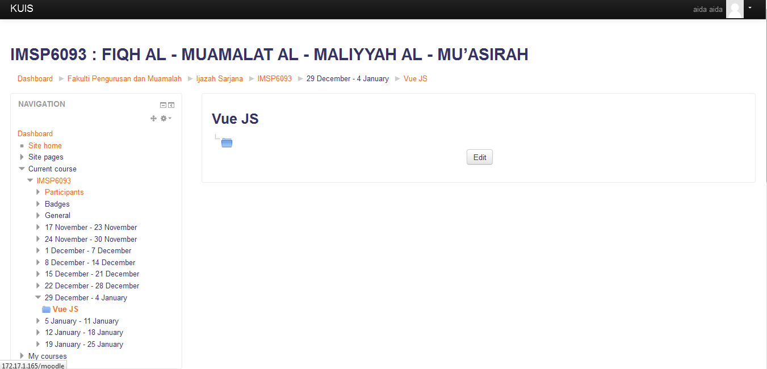

* + - 1. **IMS Content Package**

An IMS content package is a collection of files which are packaged according to an agreed standard so they can be reused in different systems. The IMS content package module enables such content packages to be uploaded as a zip file and added to a course as a resource.

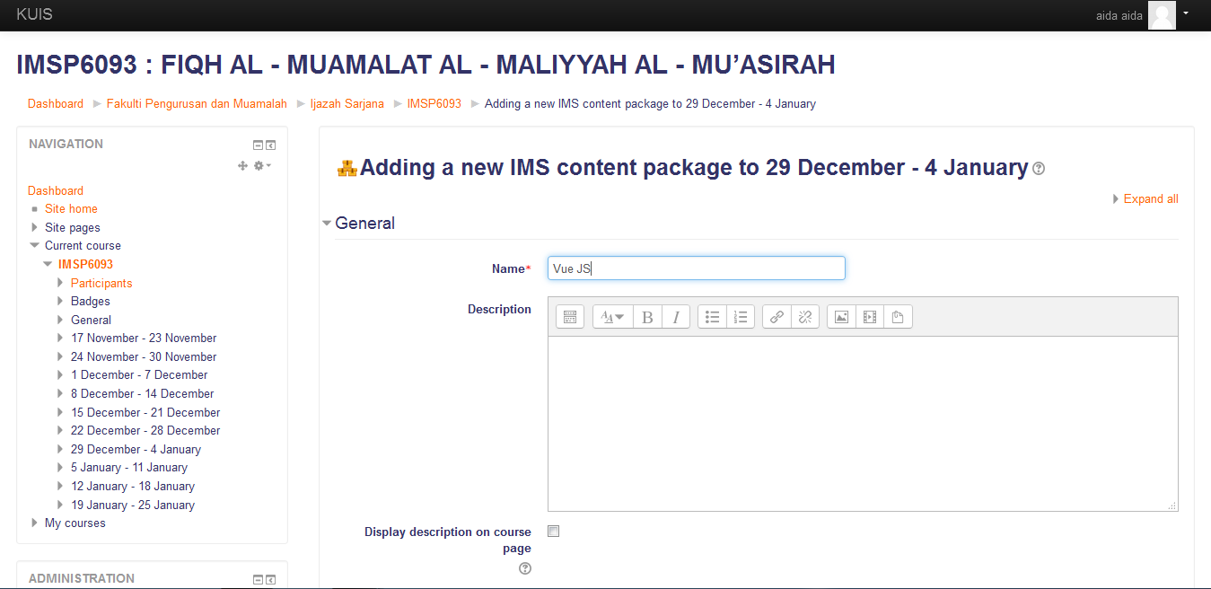

* + - 1. **Label**

The label module enables text and multimedia to be inserted into the course page in between links to other resources and activities. Labels are very versatile and can help to improve the appearance of a course if used thoughtfully.

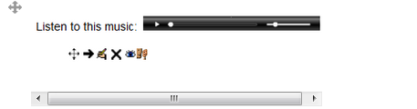

* + - 1. **Page**

The page module enables a teacher to create a web page resource using the text editor. A page can display text, images, sound, video, web links and embedded code, such as Google maps.

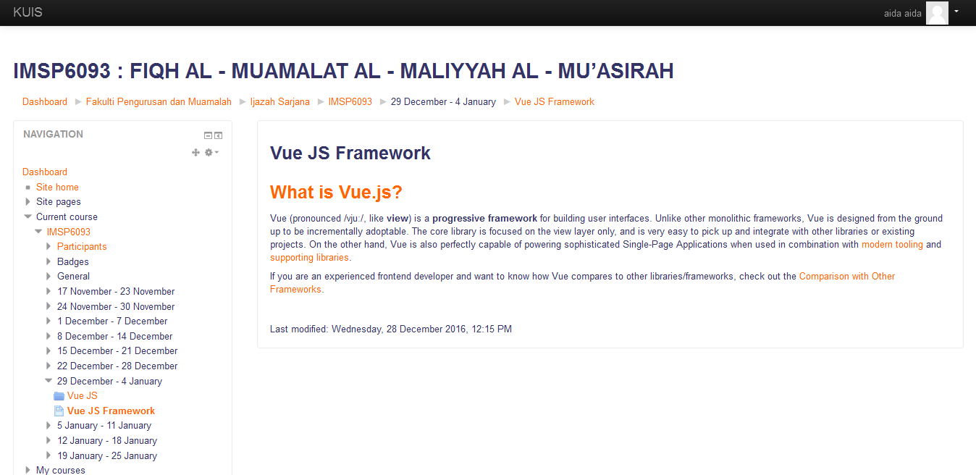

* + - 1. **URL**

The URL module enables a teacher to provide a web link as a course resource. Anything that is freely available online, such as documents or images, can be linked to; the URL doesn’t have to be the home page of a website.

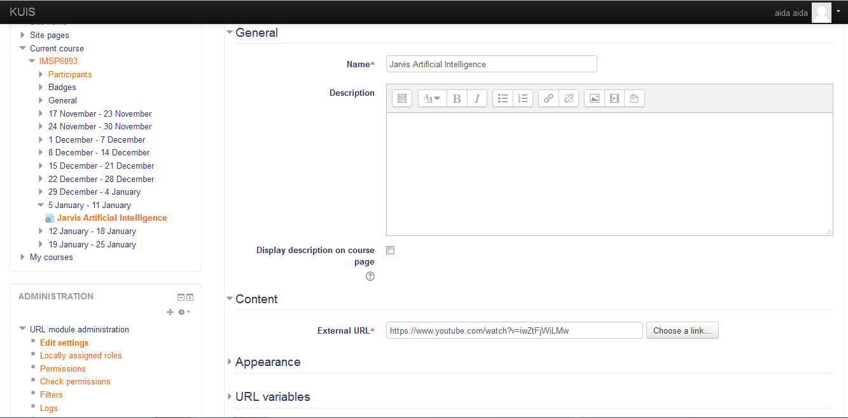

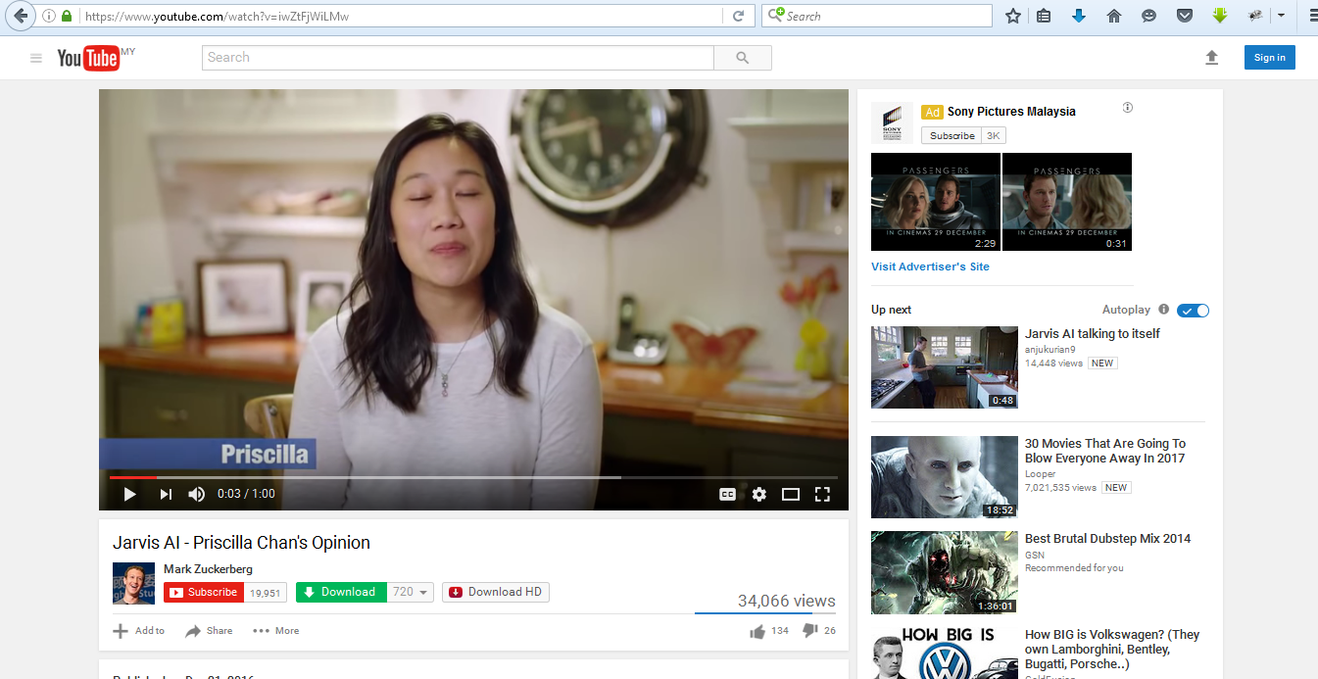

* 1. **Administrative Features**

**3.4.1 Customizable Site Design & Layout**

Easily customize a Moodle theme with your logo, colour schemes and much more –or simply design your own theme.

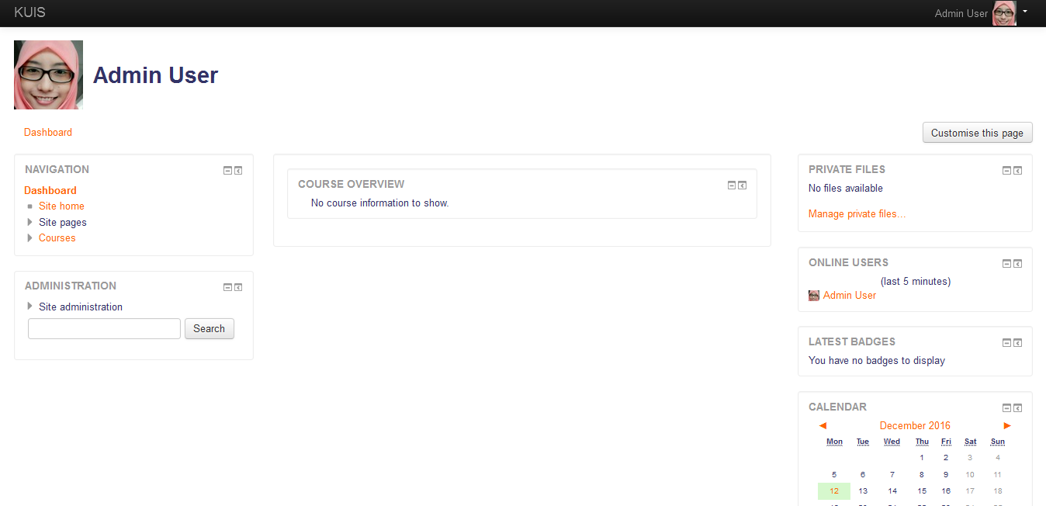

**3.4.2 Secure Authentication & Mass Enrollment**

Authentication and enrolment options to add and enroll users to your Moodle site and courses.

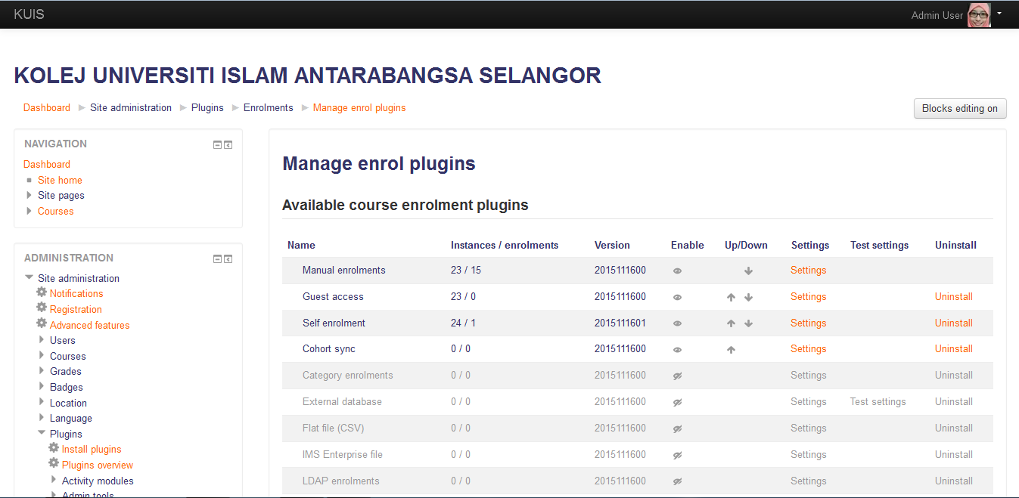

**3.4.3 Multilingual Capability**

Allow users to view course content and learn in their own language, or set it up for multilingual users and organizations.

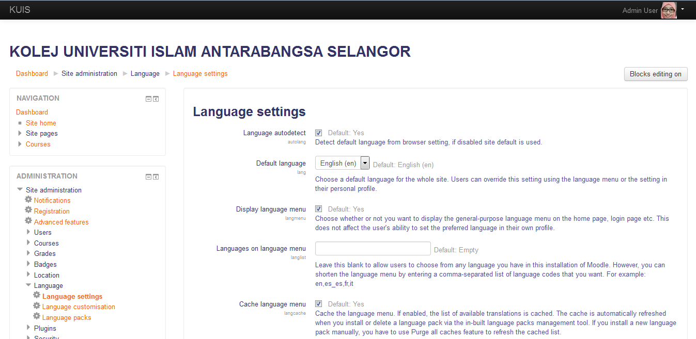

**3.4.4 Supports Open Standards**

Readily import and export IMS-LTI, SCORM courses and more into Moodle.



**3.4.5 High Interoperability**

Freely integrate external applications and content or create your own plugin for custom integrations. Moodle has a very good open web service API layer for third party application integration.

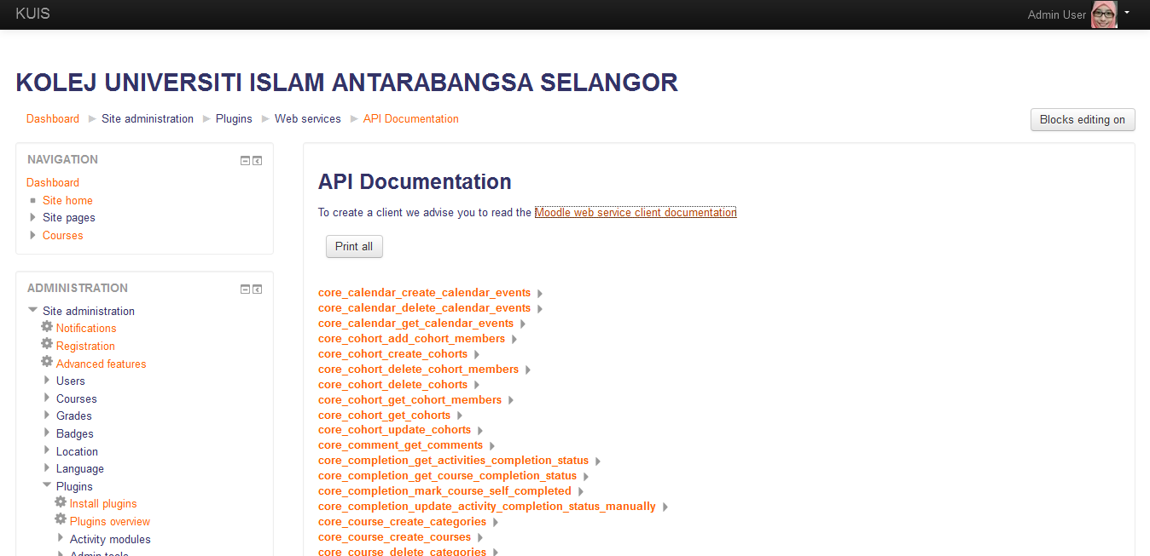

**3.4.6 Simple Add-ons And Plugin Management**

An add-on is an optional plugin for adding additional features and functionality to Moodle, such as new activities, new quiz question types, new reports, integrations with other systems and many more.

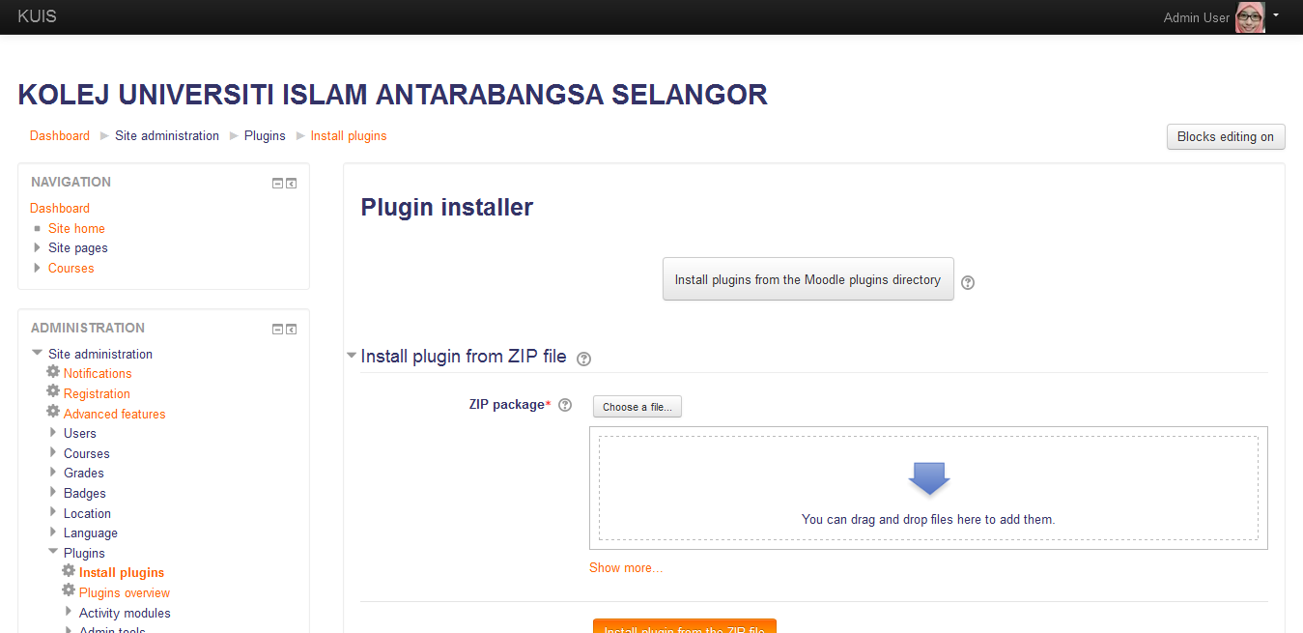

**3.4.7 Regular Security Updates**

Moodle is regularly updated with the latest security patches to help ensure your Moodle site is secure.



**3.4.8 Detailed Reporting & Logs**

View and generate reports on activity and participation at course and site level.

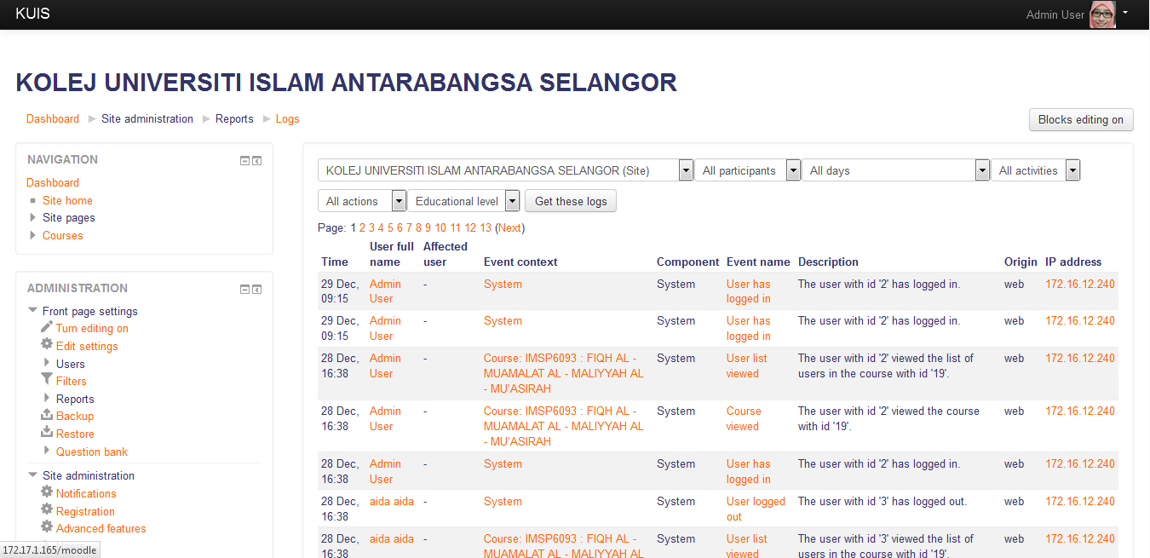

**3.4.9 Security & Privacy**

Security Overview

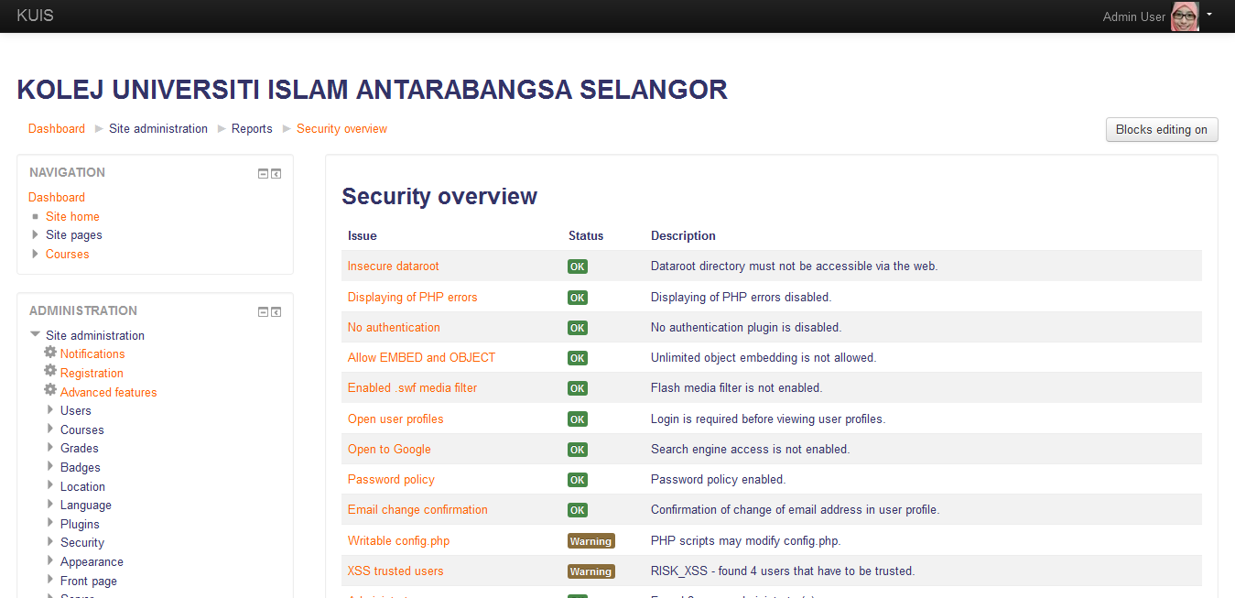

**4. External Interface Requirements**

**4.1 User Interfaces**

UI-1:The system shall provide all functionalities and activities supported by Moodle LMS

UI-2: The pages shall permit complete navigation and item selection.

UI-3: Provide User interface to add a context

**4.2 Hardware Interfaces**

HI-1: Processor1GHz or faster

HI-2: RAM 1GB (32bit) or 2GB (64bit)

HI-3: Hard disk space 16GB (32bit) or 20GB (64bit)

**4.3 Software Interfaces**

Apache Server and MySQL 5.5.31 and PHP 5 must be installed

**4.4 Communications Interfaces**

CI-1: The Moodle LMS shall use MySQL Database named “Moodle”

CI-2: The Moodle LMS shall be able to send emails to the users.

CI-3: The Moodle LMS uses PHP 5 to generate Moodle pages.

**5. Other Nonfunctional Requirements**

**5.1 Performance Requirements**

PE-1: Responses to queries shall take no longer than 3 milliseconds to load onto the screen after the user submits the query for 1 user.

PE-2: The system shall display confirmation messages to users within 4 miliseconds after the user submits information to the system.

**5.2 Safety Requirements**

Consistency: Checking the fact that all clients must be attached to one server, so there is an appropriate control of the information.

**5.3 Security Requirements**

SE-1: The files generated by the user are only accessible by the admin and application should store these files in MySQL database and must not share them.

**5.4 Software Quality Attributes**

Availability-1: The Moodle LMS shall be available to users all the time.

Availability-2: Checking that the system always has something to function and always pop up error messages in case of component failure.

Efficiency-1: The Moodle LMS shall generate the correct pages with an

accuracy of 99%.

Efficiency-2: Checking that the system provides the right tools to support all its

features.

**6. Other Requirements**

All the requirements have been specified

Appendix A: Glossary

Definitions:

1. Moodle:

Moodle (acronym for Modular Object-Oriented Dynamic Learning Environment) is a free source e-learning software platform, also known as a Learning Management System, or Virtual Learning Environment (VLE).

1. Web Application:

A web application is an application that is accessed by users over a network such as the Internet or an intranet.

1. Web Design:

Web design encompasses many different skills and disciplines in the production and maintenance of websites.

1. Web Designer:

A web designer is someone who engages in web design.

e. Web Optimization:

Website optimization is a phrase that describes the procedures used to optimize – or to design from scratch