**USER REQUIREMENTS SPECIFICATION**

**MOODLE 3.0 DEVELOPMENT ON UBUNTU 14.04**

**PREPARED BY**

AIZAH ANAS BT AZLEN

**SUPERVISED BY**

BAHAGIAN TEKNOLOGI MAKLUMAT (BTM),

SELANGOR INTERNATIONAL ISLAMIC UNIVERSITY COLLEGE (KUIS)

# DOCUMENT CONTROL

**Document location**

| Location |
| --- |
| Selangor International Islamic University College (KUIS) |

**Author**

| Position | Name | Contact no |
| --- | --- | --- |
| Intern Student | Aizah Anas Binti Azlen | 0129177266 |

**Revision history**

| Version | Issue date | Author/editor | Description/Summary of changes |
| --- | --- | --- | --- |
| 0.1 | 01/12/16 | Aizah Anas Binti Azlen | Draft |
| 0.2 | 15/12/16 | Aizah Anas Binti Azlen | Final URS |

**Reviewed by**

| Version | Issue date | Name | Position | Review date |
| --- | --- | --- | --- | --- |
| 0.1 | 15/12/16 | Mr. Azwarie Bin Mohd Yusof | Head Department of Information Technology Division | 01/01/17 |
| 0.2 | 15/12/16 | Ms. Mastura Binti Manap | Pegawai Teknologi Maklumat | 01/01/17 |
| 0.3 | 15/12/16 | Ms. Azrina Binti Hussin | Pegawai Teknologi Maklumat | 01/01/17 |
| 0.4 | 15/12/16 | Mr. Mohd Baihaqi Bin Ramli | Penolong Pegawai Teknologi Maklumat | 01/01/17 |

**Approvals**

| Version | Issue date | Name | Position | Approval date |
| --- | --- | --- | --- | --- |
| 0.1 | 15/12/16 | Mr. Azwarie Bin Mohd Yusof | Head Department of Information Technology Division | 01/01/17 |

**Related documents**

| Document | Location |
| --- | --- |
| Moodle Docs | https://**docs**.**moodle**.org/ |

# TABLE OF CONTENTS

1 INTRODUCTION 5

1.0 Objectives 5

1.1 History 5

1.2 Scope 6

1.2.1 Inclusions 6

1.2.2 Exclusions 6

1.3 Assumptions 7

2 Requirements 8

2.1 Functional Requirements 8

2.1.1 Process Flow 8

2.1.2 Use Case Scenario 10

2.1.2.1 User Login 10

2.1.2.2 Content Sharing (Upload File) 11

2.1.2.3 DiscussionThread 11

2.1.2.4 Content Sharing (Download File) 12

2.1.2.5 Search Result 12

2.1.2.6 Blog Thread 13

2.1.2.7 Notification 13

2.1.2.8 Survey 14

2.2 Non-Functional Requirements 15

3 References 17

3.1 Acronyms and Definitions 17

4 ACKNOWLEDGEMENT 18

4.1 Acknowledgement Of Acceptance 18

# INTRODUCTION

## Objectives

The objective of this user requirement specification (URS) is to inform the staff of the Bahagian Teknologi Maklumat, KUIS that will handle this Moodle of the general and specific requirements that will form the scope of Moodle 3.0 development. This URS provide a detailed specification that addresses the requirements of this URS. This URS should identify where their Moodle development features differs from the actual Moodle features, specifically where they are unable to meet these requirements.

## 1.1 History

This report will touch on project Moodle 3.0 Learning Management System Development on Ubuntu Server 14.04. Nowaday, the management use the old learning management system (myLMS) and there is some defect which can be modified. This Moodle system using a framework to ensure the system developed more effective. In myLMS, there are too many function or link to myLMS such as e-jadual, e-maps, report, eScholar and library that not related to learning management system. Beside, myLMS is not very responsive in mobile application. This may due to the system is developed before mobile application became famously used. In addition, myLMS is an old version system that cannot be update. The Apache, Mysql and middleware (LAMP) that been used by myLMS cannot be upgrade to a latest version engine

## 1.2 Scope

The scope of this Project include :

The target user for this project is Moodle administrator, student and lecturer of Selangor International Islamic University College (KUIS). The target system only covers area in Selangor International Islamic University College (KUIS).

### Inclusions

Lecturer and Student of KUIS.

### Exclusions

Staff of Bahagian Teknologi Maklumat (BTM), KUIS.

## 

## 1.3 Assumptions

Moodle 3.0 is properly installed and function as what the institution (KUIS) required. Moodle should replace the old version learning management system that is currently used (myLMS)

# REQUIREMENT

## 2.1 Functional Requirements

# 2.1.1 Process Flow

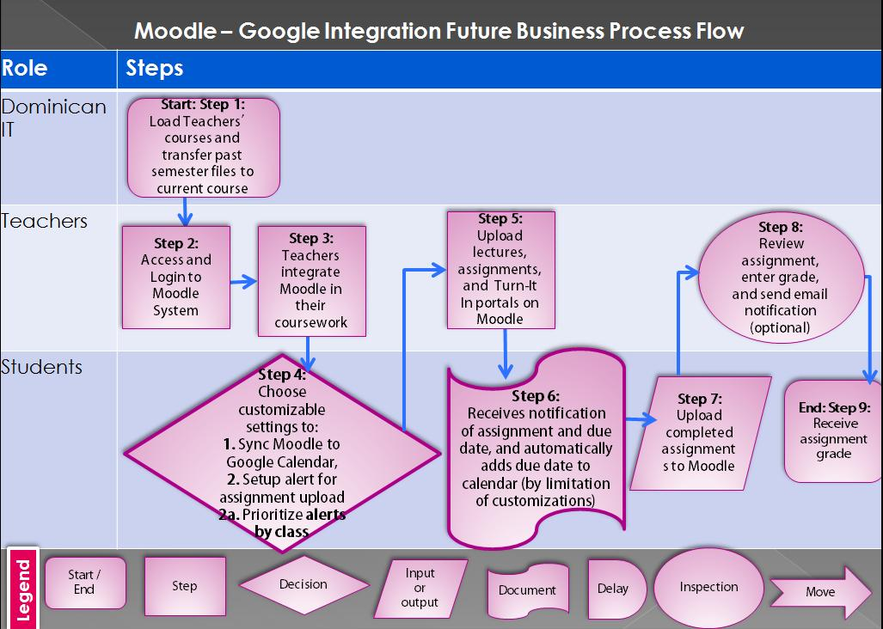

Figure 1‑1: Business Process Flow

## https://moodlegoogleint.files.wordpress.com/2012/11/updated-affinity-diagram.jpg

Figure 1‑1: Affinity Diagram

### 2.1.2 Use Case Scenario

**2.1.2.1 User Login**

|  |  |
| --- | --- |
| Purpose | User logs in to system using existing profile. |
| User | A user with an existing profile. |
| Input Data | Profile username and password. |
| Output Data | Corresponding page data. |
| Invariants | Profile table data and user information. |
| Pre-Conditions | User is not logged in to a profile, input profile exists in database, user  password matches profile |
| Post-Conditions | User's computer has been supplied with appropriate cookie, page data is appropriate for selected profile |
| Basic Flow | Webpage looks up profile data and returns the matching cookie. Webpage is updated to match new user data. |
| Alternative Flow(s) | Invalid password, invalid username, or mismatched username and  password redirect to error message and previous page. |
| Business Rule | This allows users to log in to their profile from anywhere. |

**2.1.2.2 Content Sharing (Upload Files)**

A user logs into the system and is on any page and wants to share some content on a group/individual level.

|  |  |
| --- | --- |
| Purpose | A user wants to share some data (pdf, ppt etc). |
| User | A legitimate user logged into the system |
| Input Data | The file to be shared. |
| Output Data | File ready to download by other users. |
| Invariants | The file. |
| Pre-Conditions | User is Logged in; file exists on user's computer. |
| Post-Conditions | Any other person to whom the content was made available is able to download it. |
| Basic Flow | The user uploads a file to be shared using the upload box and selects a subset of other users of the group with whom the user wants to share the file. The file then gets uploaded to the server and desired users are able to download it after logging in. |

**2.1.2.3 Discussion Thread**

|  |  |
| --- | --- |
| Purpose | A user wants to start a discussion on a particular topic. |
| User | Any user of the Moodle website. |
| Input Data | Title and body of the discussion and the group in which the user wants to have the discussion. |
| Output Data | A discussion thread to which other users are able to view and comment. |
| Invariants | The discussion data. |
| Pre-Conditions | User is logged in and is a member of the group in which he wants to post. |
| Post-Conditions | A discussion thread to which other users are able to view and comment. |
| Basic Flow | User logs in, selects a group and submits the title and body of the discussion topic through a submission form. The data is then stored on the server and other group members will be able to view and respond. |

**2.1.2.4 Content Sharing (Download Files)**

|  |  |
| --- | --- |
| Purpose | A user wants download a particular file. |
| User | Any user of the Moodle site. |
| Input Data | Request to download a particular file. |
| Output Data | File is downloaded on user’s computer. |
| Invariants | The user and the file. |
| Pre-Conditions | User is logged in and the file must be shared with him or with the group which he is a member of. |
| Post-Conditions | The user has downloaded the file successfully. |
| Basic Flow | User logs in, selects the file which he wants to download. The file is then transferred from the server to the user’s computer. |

**2.1.2.5 Search Result**

|  |  |
| --- | --- |
| Purpose | A user wants download a particular file. |
| User | Any user of the Moodle site. |
| Input Data | The keyword. |
| Output Data | Search Results. |
| Invariants | The user and the portal itself. |
| Pre-Conditions | User is logged in. |
| Post-Conditions | Search results. |
| Basic Flow | User logs in, Enters the keyword in the search box, clicks the search button and gets the search results. |

**2.1.2.6 Blog Thread**

|  |  |
| --- | --- |
| Purpose | A user wants to start a Blog on a particular topic. |
| User | Any user of the Moodle site. |
| Input Data | Title and body of the Blog and the forum in which the user wants to  have the blog. |
| Output Data | Blog to which other users are able to view and comment. |
| Invariants | The Blog data |
| Pre-Conditions | User is logged in and is a member of the group in which he wants to post. |
| Post-Conditions | A Blog to which other users are able to view and comment. |
| Basic Flow | User logs in, selects a group and submits the title and body of the Blog topic through a submission form. The data is then stored on the server and other group members will be able to view and respond. |

**2.1.2.7 Notification**

|  |  |
| --- | --- |
| Purpose | To get notifications of assignments, deadlines and other important messages. |
| User | Any user of the Moodle site. |
| Input Data | User enables the notifications from settings. |
| Output Data | Notifications. |
| Invariants | The user and the portal itself. |
| Pre-Conditions | User has chosen to receive notifications. |
| Post-Conditions | User receives the desired notifications. |
| Basic Flow | User enables the desired notifications from settings and receives notifications. |

**2.1.2.8 Survey**

|  |  |
| --- | --- |
| Purpose | To start a survey for a particular topic |
| User | Any user of the Moodle site. |
| Input Data | Title and body of the survey and the forum in which the user wants to have the blog. |
| Output Data | Survey to which other users are able to do the polling and see the results. |
| Invariants | The survey data. |
| Pre-Conditions | User is logged in and is a member of the group in which he wants to do the survey. |
| Post-Conditions | A survey to which other users are able to do the polling and view the data. |
| Basic Flow | User logs in, selects a group and submits the title and body of the survey topic through a submission form. The data is then stored on the server and other group members will be able to view and respond. |

## Non-Functional Requirements

## 1. Performance

Performance is very important for Moodle system. The system must be able to access and provide all services and functions anytime. The system must be able to connect to MySQL database to query the system data.

## 

## 2. Availability

The Moodle system must be 24/7 availability. The application and database have a daily centralized backup. All backup can be restored, once on system failure.

## 

## 3. Capacity Requirements

The capacity of the system must be defined as the total number of users in concurrent system. It’s including Student, Teacher, and University Staff who related the Moodle System. The system software and hardware can be support 30% capacity expands in the future.

## 

## 4. Security Requirements

All user personal data (e.g. personal information, assignment results….etc) is a confidential issue. The Moodle system must be allowed authorized users login only. Therefore, the user account in the system must be unique. All users must be registered and activated by the user account first. The MySQL database is only permit the connection form Moodle System.

# REFERENCES

## 3.0 Acronyms and Definitions

|  |  |
| --- | --- |
| **Acronym or Term** | **Definition** |
| LMS | Learning Management System |
| KUIS | Selangor International Islamic University College/  Kolej Universiti Islam Antarabangsa Selangor |
| BTM | Information Technology Division/  Bahagian Teknologi Maklumat |
| URS | User Requirement Specification |
| myLMS | My Learning Management System |
| Moodle | Modular Object-Oriented Dynamic Learning Environment |

# ACKNOWLEDGEMENT OF ACCEPTANCE

User Requirement Study

Moodle 3.0 Development On Ubuntu 14.04

This document has been reviewed and accepted by:

BTM, KUIS

|  |  |  |  |
| --- | --- | --- | --- |
| Name | Position | Signature | Date |
|  |  |  |  |
|  |  |  |  |