Process-Improvement Proposal
Vulnerability Finding Remediation Tracking at SafeX Solutions

Prepared by: Ayza Waseem
Group 40 — Mini-Project, Individual Week 2 Contribution
July 2026
This document is the standalone Week 2 module for the Process-Improvement Proposal track of Group 40's SafeX Solutions mini-project. It is scoped independently from teammates' Week 2 modules to avoid overlap: this piece looks at one operational process end-to-end and proposes a concrete, working fix for it.

1. Executive Summary
SafeX Solutions delivers cybersecurity services including vulnerability assessments and threat monitoring alongside web development and digital marketing work. This proposal targets one recurring inefficiency in service-delivery teams of this kind: once a vulnerability assessment is complete, findings are typically handed off as a static report with no shared, living record of what still needs fixing, who owns it, or by when.
The result is predictable critical issues that can sit unresolved for weeks because nobody is tracking a deadline against them, delivery leads have no fast way to answer “what's still open right now?”, and the same vulnerability sometimes reappears at the next assessment because it was never formally closed.
The proposed fix does not require new software, budget, or procurement approval: a shared Vulnerability Findings & Remediation Tracker built as a single Excel/Google Sheets workbook. Each finding gets a severity rating, an automatically calculated SLA due date, an owner, and a status and a live dashboard shows exactly how many findings are open, in progress, or overdue at any moment.

2. Objective
Identify one inefficient SafeX process and design a concrete, actionable improvement that a delivery team could adopt immediately with a working artifact that demonstrates the improvement in practice.

3. Current Process (As-Is)
Note on data: this exercise does not include access to SafeX's live client records, so the current-state description below is a representative, typical-industry baseline for how findings hand-off usually works at digital-services and cybersecurity firms of this size not an audited measurement of SafeX's actual numbers. Section 6 flags every estimate that should be recalibrated against real data once this tracker is piloted.
- An analyst completes a vulnerability assessment for a client engagement.
- Findings are written up into a static PDF or Word report.
- The report is emailed to the client's point of contact, often with an internal delivery-team copy.
- Remediation is followed up informally email threads, chat messages, or verbal check-ins with no single place tracking what's still outstanding.
- Without a shared record, low-priority findings quietly age past their real urgency, and some are only re-discovered at the next assessment cycle.

Where it breaks down
Problem | Root Cause | Consequence
No enforced deadline per finding | Severity is noted in the report but never converted into an actual due date | Critical issues can sit open for weeks with no trigger to escalate
No single source of truth | Status lives across emails, chat threads, and people's memory | Delivery lead can't answer “what's open?” without manually re-checking each thread
No ownership on record | Reports list findings, not assigned owners | Follow-up depends on someone remembering who was supposed to fix it
No audit trail | Nothing records when a finding was actually resolved | Hard to prove remediation to a client or auditor after the fact

4. Proposed Process (To-Be)
The fix keeps the parts of the process that already work (an analyst still runs the assessment and writes up each finding) and replaces only the hand-off and follow-up steps with a shared, structured record. Every finding gets logged once, with a severity-driven due date computed automatically, and a live dashboard replaces manual status-chasing.
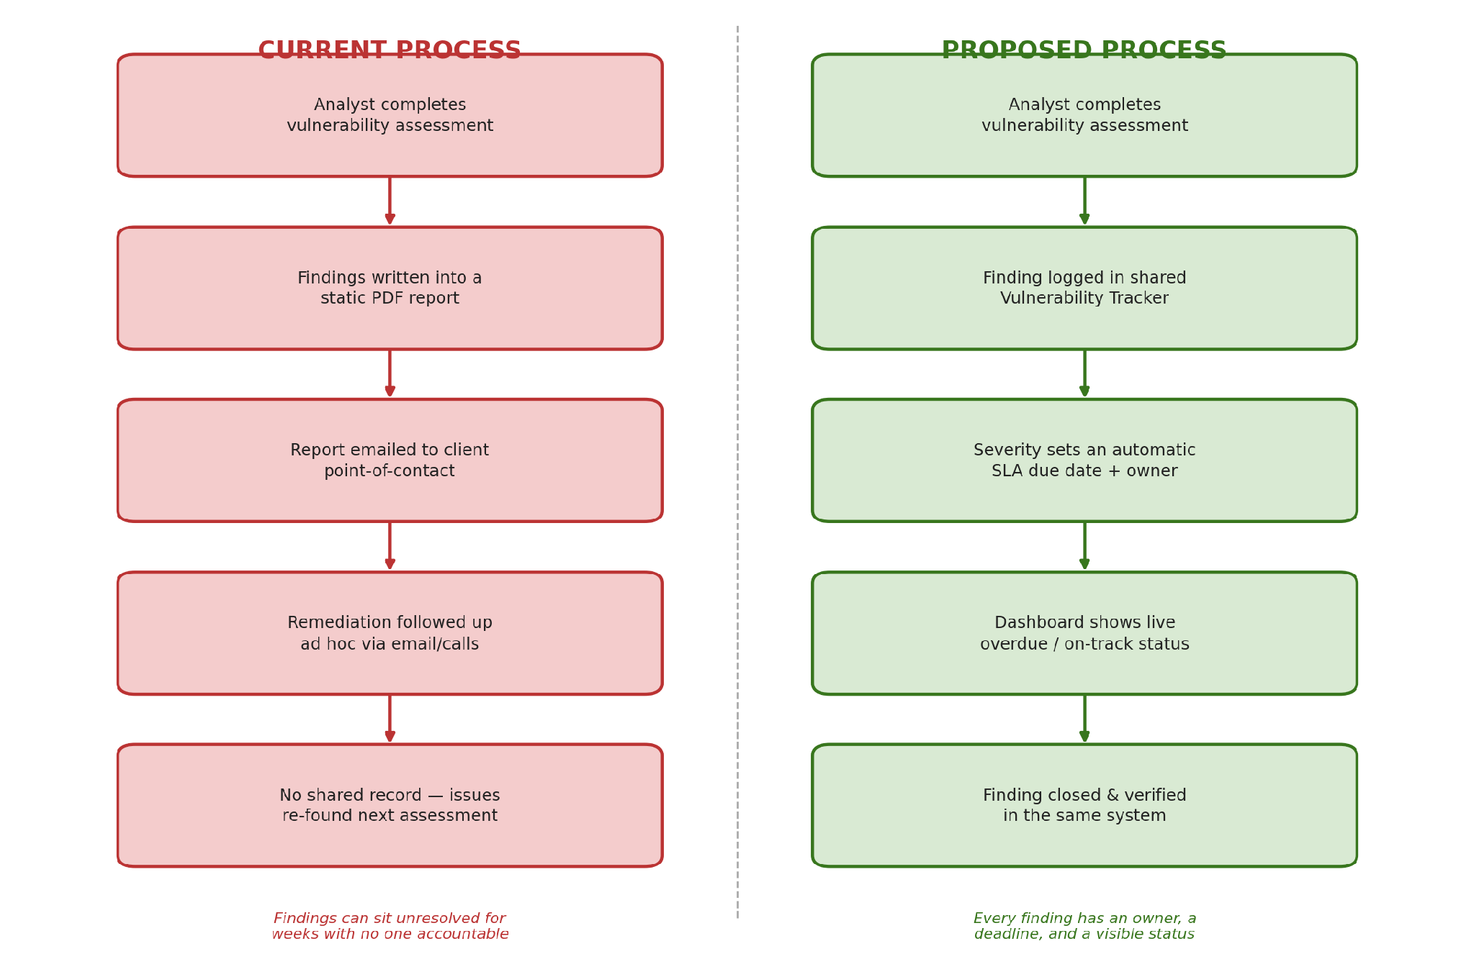
Figure 1. Current hand-off process (left) versus the proposed tracked process (right).

5. The Module: Vulnerability Findings & Remediation Tracker
The working module is a single spreadsheet workbook (“SafeX_Vulnerability_Tracker.xlsx”) built to match the required-technologies list for this task Excel or Google Sheets - so any delivery team can adopt it the same day, with no new tool to buy, license, or get IT approval for. It has four tabs:
- Read Me : what the workbook is and how to use it, at a glance.
- SLA Reference : the remediation deadline policy per severity (editable, so the policy is a setting, not something buried in a formula).
- Findings Log : one row per vulnerability finding; this is the only tab analysts type into.
- Dashboard :live counts and a chart, calculated automatically from the Findings Log.

5.1 Findings Log
Each finding records the client, affected asset, a description, severity, CVSS score, the date it was identified, the recommended fix, and an owner. Severity and Status are chosen from dropdown lists (data validation) so entries stay consistent. Two columns are calculated automatically: the SLA due date (looked up from the SLA Reference tab based on severity) and a days-remaining/overdue counter. Conditional formatting colours each row red once it's overdue, yellow when due within two days, green once resolved, and grey once verified closed so status is visible at a glance without reading every cell.
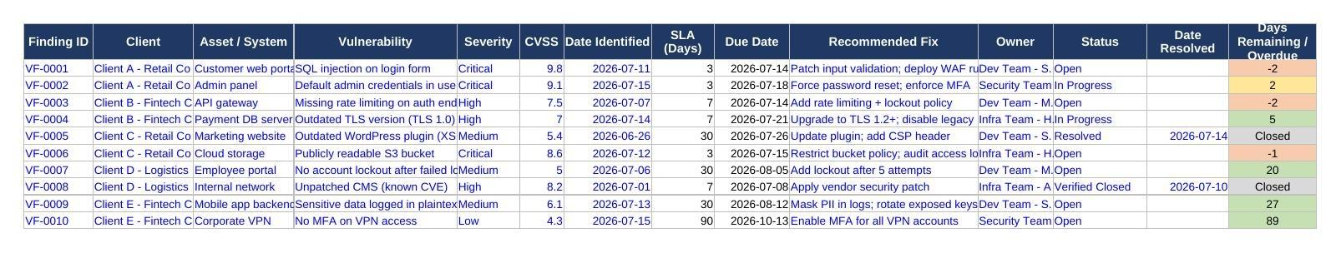
Figure 2. Findings Log, with sample data — note the automatic colour-coding by urgency.

5.2 Dashboard
The Dashboard reads directly from the Findings Log with formulas (COUNTIF/SUMPRODUCT), so it updates the moment a finding is added or its status changes — nobody has to build or refresh a report. It shows total findings, how many are open, in progress, resolved, and overdue, the percentage of open findings still within their SLA, and a chart of open findings by severity.
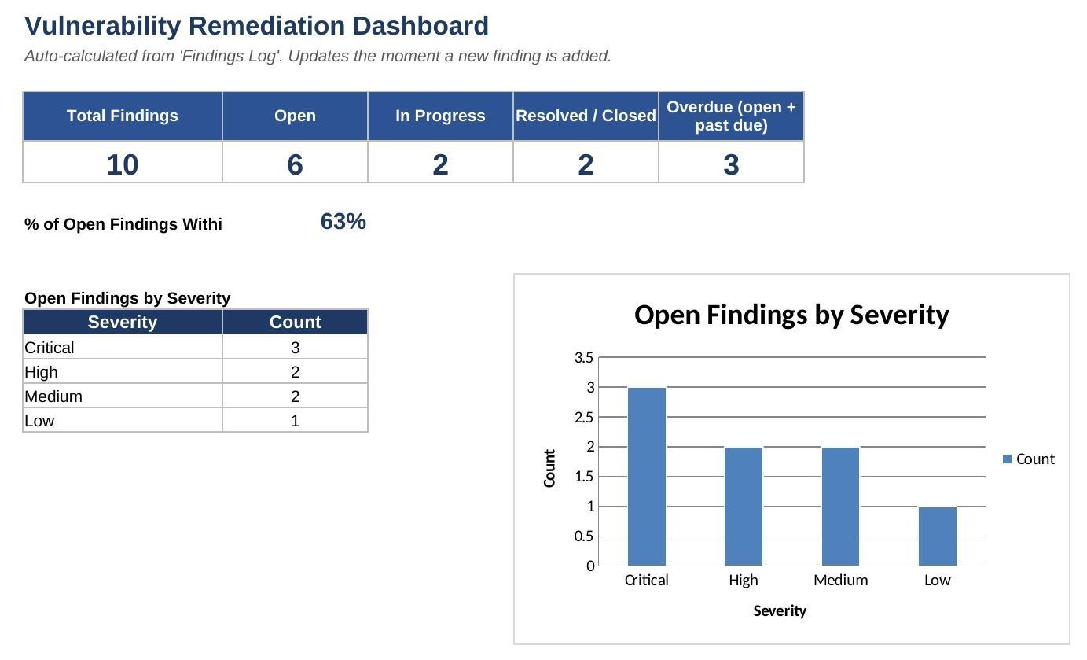
Figure 3. Dashboard, calculated live from the sample findings in Figure 2.

5.3 How to run / view it
- Open SafeX_Vulnerability_Tracker.xlsx in Excel, or upload it to Google Drive and open it with Google Sheets - both preserve the formulas and dropdowns.
- To log a new finding: go to the Findings Log tab, add a row below the last one, fill in the blue-font cells, and pick Severity and Status from the dropdowns.
- The due date and overdue counter calculate themselves - do not type into the black-font columns.
- Open the Dashboard tab at any time to see current totals; no manual refresh needed.
- To change remediation policy (e.g. give High severity 5 days instead of 7), edit the SLA Reference tab - every finding's due date recalculates automatically.

6. Expected Impact
These are informed targets for what the tracker should achieve, not a claim about SafeX's historical numbers -flagged here so they can be checked against real figures once the tracker runs for a few weeks.
Metric | Baseline (typical, unmanaged) | Target after rollout | Why it improves
Time to remediate a Critical finding | 2–4+ weeks, no enforced deadline | ≤ 3 business days (SLA-enforced) | Automatic due date + red flag removes reliance on memory or email follow-up
Findings dropped between assessment cycles | Not tracked; happens regularly | Near zero | Every finding lives in one persistent record instead of an inbox
Time to answer “what's still open?” | 15–30 min searching threads | < 1 minute (Dashboard glance) | Live dashboard replaces manual status-chasing
Audit / compliance readiness | Ad hoc, hard to reconstruct | Full timestamped record per finding | Status and resolution date are captured automatically as work happens

7. Implementation Plan
Phase | Action | Timeline
Pilot | Roll the tracker out to one delivery team and one active client engagement | Week 1
Feedback & tuning | Adjust SLA days, columns, or dropdown options based on what the pilot team finds awkward | Week 2
Team-wide rollout | Share the template with all delivery pods; run a 15-minute walkthrough | Week 3
Review | Compare actual remediation times against the Section 6 targets; consider adding lightweight automation (e.g. a Sheets-triggered email for overdue Criticals) if volume grows | Month 2

8. Risks & Mitigations
- Risk: analysts forget to update status. Mitigation: make a 2-minute tracker update part of the existing daily/weekly stand-up checklist, not an extra task.
- Risk: teams create their own duplicate copies. Mitigation: keep one shared master file with clear ownership of who can add rows to the SLA Reference policy tab.
- Risk: the workbook contains sensitive client vulnerability data. Mitigation: store it in an access-controlled shared drive, never email it externally, and share read-only dashboard views with clients rather than the full findings log.

9. Conclusion
Vulnerability findings only reduce client risk if they actually get fixed and that depends on tracking, not just reporting. This proposal replaces an email-and-memory hand-off with a shared, self-calculating tracker that costs nothing to adopt, fits inside tools the team already uses, and gives everyone from analyst to delivery lead the same live picture of what's outstanding.

