- 組員(組長放第一位)
B99201038 IM 3 侯凱元
B99902033 李竺軒
T01902201 赵恺
- 工作分配
  - Server
B99201038
  - Client
    - Core: T01902201
    - UI: B99902033
- 系統架構
  - 作業系統平台：
    - Server: Win32 (Tested On Win7 64, no guarantee on XP) with VC++ 2010 environment
    - Client: Linux (Tested On Ubuntu)
  - 使用之程式語言：
    - Server: C
    - Client: C
  - 程式檔案功用與介紹(包含實作了哪些功能)：
    - Register with ID, Password
    - Login / Logout
    - User Login / Logout Notification
    - Send / Receive Message (Single Receiver / Multiple Receiver / Broadcast)
    - Send / Receive File
    - Historical Message
  - Protocol 介紹：
    - Port: 7777
    - Endian: Little endian
    - Char Set: ANSI
    - Register
01 00 <id len (1 byte)> <id> <pwd len (1 byte)> <pwd>
Client want to register a new user with ID = <id>, Password = <pwd>.
    - Reg State
01 01 <Success (0)/ Fail (1) (1 byte)>
Server responses to the register request.
    - Login
01 02 <id len (1 byte)> <id> <pwd len (1 byte)> <pwd>
User login with ID = <id>, Password = <pwd>.
    - Login State
01 03 <Success (0)/ Fail (1) (1 byte)>
Server responses to the login request.
    - Logout
01 04
User in current session wants to logout.
    - Send Msg
02 00 <receiver sn (1 byte)> <msg len (1 byte)> <msg>
receiver sn = 255: boardcase
User in current session sends message <msg> to user with Sn = <sn>
Where sn = 255 means boardcase
    - Open file
02 01 <receiver sn (1 byte)> <fname len (1 byte)> <file name>
User in current session wants to send a file called <file name> to user with Sn = <sn>.
    - File Handle
02 02 <handle (4 byte)>
handle = 0xFFFFFFFF: Fail
Server returns a file handle to the client requesting to send file.
0xFFFFFFFF means invalid handle, all handles are in use.
    - File Request
02 03 <handle (4 byte)> <sender sn (1 byte)> <fname len (1 byte)> <file name>
Server ask the receiver of File Handle <handle> whether he wants to receive file called <file name> from user with Sn = <sn>.
    - File Response
02 04 <handle (4 byte)> <OK(0) / Reject (1) (1 byte)>
Receiver answers to server whether it wants to receive file of File Handle <handle>.
    - File content
02 05 <handle (4 byte)> <len (1 byte)> <content>
A part of file content of File Handle <handle>.
The content must be sent continuously.
This is used by both client and server.
    - Close handle
02 06 <handle (4 byte)>
The handle <handle> is closed.
This may happen when the file is completely sent or one of the send or receiver leaves or an error occurs.
This can be sent by the sender, receiver or server.
When a handle closed, send this message to the client that involved in this handle who did not trigger the close event.
    - User
03 00 <Sn (1 byte)> <id len (1 byte)> <id> <flag (1 byte)>
flag = 0: offline, 1: online
Server tells client that there is a user with Sn = <Sn>, ID = <id>, and whether he is online.
  - 操作流程與畫面截圖：
    - Server:
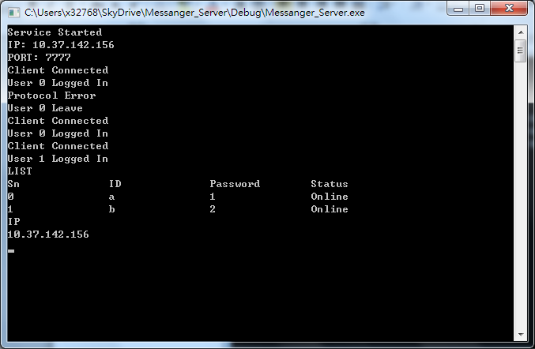
When Server starts, it prints its IP address and Port.
During service running, the events and errors is printed.
Server Commands:
LIST:
List all registered user.
EXIT:
Stop service and terminate server process.
IP:
Show server IP address
HELP:
Show instructions
DEBUG:
Show debug message
DEBUGOFF:
Hide debug message
    - Client:
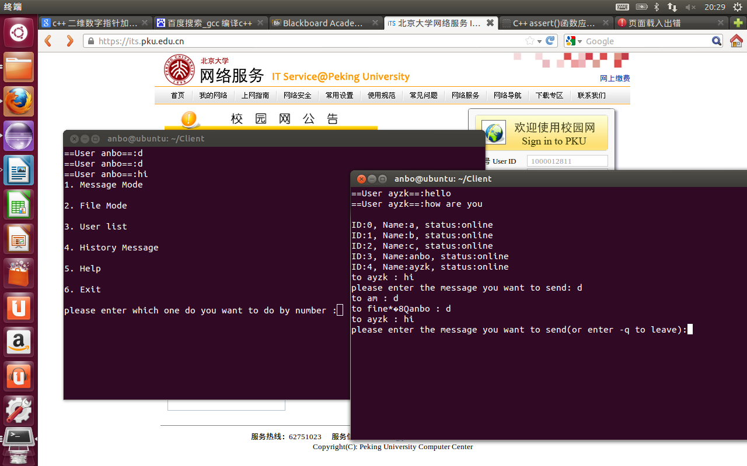
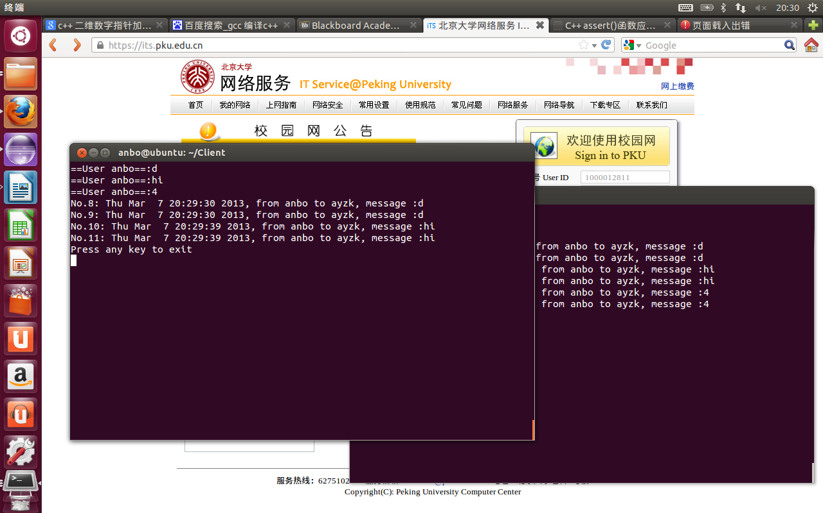
- 系統架設詳述
  - 編譯方式
    - Server:
Win32 API
Visual Studio 2010, use the solution file in the package
Set to Release mode using the drop box in the toolbar
Click on menu Build -> Rebuild Solution
The exe file is built in the release folder besides the Solution file
    - Client:
Just use gcc to compile
  - 執行方式
    - Server:
On Win32 environment, double click the exe file
If startup process successes, server will print its IP and port
You will see Service Started message on the screen
Server now listening for incoming clients
    - Client:
Use command line to enter the program
And will start to connect to server and let user login
Then wait for user to run the function.
  - 注意事項
    - Server:
VC++ 2010 runtime is needed
Total registered user limit is 255
Total concurrent file transmission limit is 1024
Message length limit is 256 bytes (header included)
    - Client:
Only can run on linux
- 遇到的問題與解決方式
    - Server:
Inter Thread Communication:
Each client corresponds to a server thread. When one needs to contact with another, its server thread must tell another thread to send the message. One way is to use Inter Thread Communication API provided by OS. But this is complex.
Our solution is to avoid Inter Thread Communication, when a server thread wants to interact with the client it’s not servicing; it temporary grabs the resource of that client and send the message to it directly. Each client have its own Mutex to prevent race condition. The protocol also designed to support asynchronized communication.
Dead Lock:
What if user a own his mutex, and is wait for user b, in the same time, user own his mutex and is waiting for user a, a deadlock.
The solution is to have a global mutex; a thread must release all mutex before waiting another one except that it owns the global mutex.
    - Client:
How to implement multithreading is a big problem for us because both of us don’t have the experience in multithreading , and we need a lot system program’s skill to be able to complete it including the mutex that shared by those threads , we need to be careful to not let any thread to occupy the mutex forever and cause other thread starvation . And design UI on linux is difficult as well , needs a lot of time and patience.

- 心得
    - Server:
It’s my first time to implement a server, the requirement of multithreading significantly increased the difficulty. In this project, I used many things told in the System Program and OS course, but never been used before, such as Mutex and Thread. I choose win32 as the platform because POSIX API is already told in the course, I want to learn different one, which may help on App development.
During this project, I also solved many problems that I encountered before but have no solution. It’s also a chance to practice and improve my programming skill of multithreading programs. Although the load is heavy, it’s worth.
    - Client:
It’s hard to design UI on linux based system since linux is designed to use command line to run the process and so it needs more time to think how to present it , and the more function we want to implement ,the more complicated will the UI be ,I think it needs to be very careful and need to know what may the user want when they run this process , therefore , I think it is a good experience to implement this program.

