ParkinsonPal
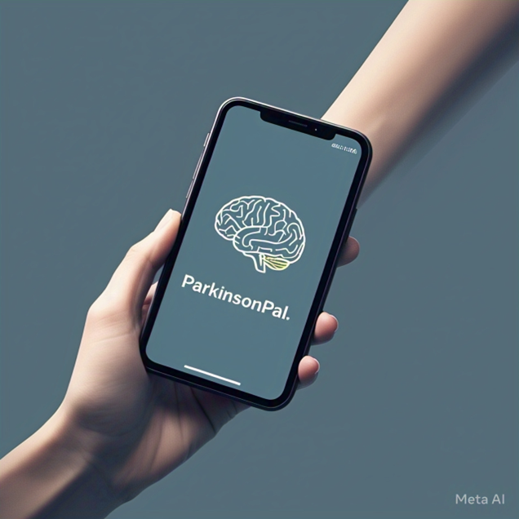
Group Number: 08
Group Name: UXperts
Group Representative: Hussain Sulaiman Zia 26100011@lums.edu.pk
Project Phase: Phase 4 - Evaluation

Contribution Statement
Name | Contribution statement (in ALL PHASES) | Your Picture
Azaan Imran | Contacted patients and physiotherapist  Conducted interviews  Video Editing and compression  Drawings  Findings  Lofi and Hifi | 
Hussain Sulaiman Zia | Contacted patients  Conducted interviews  Interview questionnaire design  Problem statement  Method plan, Needs and Desires  Lofi and Hifi | 
Muhammad Talha Muneer | Literature Review  Lofi and Hifi  Conducted interview  Questionnaire design  Measurements  Existing Products Material | 
Rumaan Mujtaba | Literature Review  Lofi and Hifi  Conducted interviews  Questionnaire Design  Usability Testing  Measurements | 
Zainab Humayun | Literature Review  Contacted Doctors and Patients  Conducted interviews  Lofi and Hifi  Questionnaire design  Testbook design  User research methods and findings | 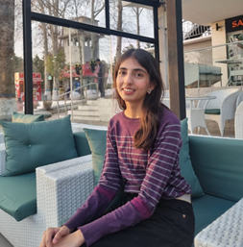
1. Literature Review
Design Shortages in Apps for Patients with Parkinson’s disease
1 INTRODUCTION
In this period of technological advancements and inclusivity, there has been vast research on making the world more accessible for those suffering from various diseases, hence, several assistive tools have emerged that aid people diagnosed with Parkinson's disease (PD). This includes mobile apps developed to help people with Parkinsons along with wearable devices designed for them.
A study conducted on digital interventions for Parkinson's Disease [1] helped gain valuable insights about the existing apps that aim to help patients. The paper explores the design and the different features of the existing apps; making observations about how most apps are directed towards the self-care of the patients. This includes medication reminders, exercise tracking, data collection, and also visual representations of the data trends. The study further emphasized that while most apps feature ‘self-maintenance’, it is not sufficient for the smooth tracking of patient data as they focus majorly on how people, diagnosed with PD, can ensure that they follow what they have been advised. The study included apps that monitored the motor symptoms but not the non-motor symptoms which mainly included disturbance in sleep, cognitive unfitness, and mood changes. This is a problem that needs to be addressed as these symptoms contribute a lot to the fitness of the patient. Failing to do so would result in patients going into depression and anxiety that would further deteriorate their health. Moreover, the study also explains how most existing mobile apps adhere only to medication reminders. It tells how physical activity is really important for the patients and how sometimes, they would be motivated enough to do the exercises but would be unable to follow the exercises correctly which again is a problem that could be addressed in our app. Provide an exercise plan for the users so they can learn and practice physical exercise wherever they want to. This would help them learn the exercises that are good for their movement.
Some apps provide these exercises for the users but then they are solely based on the exercise trait and don’t feature any other characteristics [2]. Continuing the same theme, there is another study conducted on the monitoring of Parkinson's patients remotely during the COVID-19 period [3]. The monitoring was done by repeated sampling of the current experiences and behaviours, also defined as ecological momentary assessment. The study discusses how the traditional monitoring of the patients could be ineffective in some cases such as noting down patterns or trends on a very day-to-day basis. As a result of this, using a smartphone to write a diary on the patient’s behaviour is much more beneficial. It records the severity of the patient, which is highly crucial when assessing the patient after a long time. Daily monitoring of the motor and non-motor symptoms leads to more precise information to the medical helpers which in result, leads to better and more accurate patient care. Conclusively, some apps exist out in the world that can be used for telemedicine and are yielding positive results but they, more or less, focus on one aspect of the disease, leaving the others.
A product that allows to achieve all of these, would most certainly be very appreciated and useful. In our research, we identify the current design gaps in the mobile apps for disease management and progression tracking. Not only that, we use our reviews of the currently existing apps to propose designs that we think could be a step in the direction of proper management of Parkinson’s disease.
2 BACKGROUND AND RELATED WORK
2.1 Symptom Studies
Researchers have conducted studies as well using the existing knowledge about the improvement of symptoms associated with Parkinson's. This is a very crucial understanding to have when designing an app for patients as it helps in finding out whether the given solution would affect the patients or not. A similar study, done regarding the physical exercise that aids in improving the conditions of the patients [4]. The study finds out that exercising leads to self-efficacy of the patients. Physical therapy of the patients leads to improvement in the motor symptoms thus leading to better motor control. The study further discusses that it also leads to improvement in non-motor symptoms as well. The data they collected showed that people who did exercise, reported a change for better in their non-motor symptoms such as mood and sleep, helping them to achieve a better quality of life. On the other hand, people whose activity was less or none, reported anxiety and depression. This information discussed is really necessary as it tells that providing a plan for people to follow would not only help their movement symptoms but also their non-movement symptoms. Retaining this information, we can aim to design technology that can help out the patients and help them improve their quality of life.
Secondly, people with Parkinson’s have difficulty with voice control and clear speech, their speech is soft and difficult to understand for most. Different programs using voice assisted technology (VAT) have been created to assist PD patients in daily tasks.
A research conducted on Parkinson’s patients reported about 80 percent of them to have experienced voice changes due to the disease signifying the need of VAT to enable communication among these patients [2]. It is reported that using VAT more than 70 percent of the PD patients were able to complete almost all digital tasks such as sending emails, using online apps or making video calls. VAT proved useful medically as well by making it easier to set reminders for medication and scheduling appointments with doctors. Despite facing speech difficulties, the majority of the patients report that they seldom had to repeat themselves while using voice assisted technology and were able to use it consistently, thereby supporting the accuracy of such technology.
Parkinson’s patients face trouble falling and staying asleep paired with limited mobility that makes it hard to turn over in bed causing agitating sleep disruptions. Sleep disorders such as insomnia, restless leg syndrome and REM (Rapid eye movement) sleep behaviour disorder are common among PD patients. Prescribed medications and mood instability worsen sleep patterns [5].
2.2 Existing Apps Usability
Today apps exist in order to help the patients with their physical activity as well for example, the existing app that aids patients with their physical activity is 9zest Mobile App. A study was conducted on the usability of the app to test out its efficacy on the patients diagnosed with PD [2]. Their methodology was to invite people who had downloaded the app to participate in the study being conducted for various aims and the data was then recorded and analyzed. The key findings of the study were that a majority of people were content with the app-guided exercises. They felt that not only were the exercises safe, but they were also very relevant to their condition. Another important finding to be noted is that most of the people also informed that they felt that they felt noticeable improvement in their condition by following the exercise programs given by the app. The study is crucial as it tells that there has been effective use of the exercises that are offered by the app.
To help cater similar issues, apps like Sleepio are designed to help PD patients. Sleepio is a digital cognitive therapy program that is personalized to the needs of the user, it builds slow and gradual week by week progress to make it easy for the user to keep up [6]. It sends helpful suggestions that are mostly basic and probably well known to the user already, however the cognitive exercises train its users to battle negative thought cycles that ultimately lead to mental relaxation thereby improving sleep.
Another study conducted on another one of the aforementioned apps related to sleeping disorders in PD patients.. The authors conducted research on the first app that was developed specifically for patients diagnosed with Parkinson's disease, known as SleepFit [7]. The study was done in collaboration with doctors to get better and accurate results of the usage of the app. The principal findings of the research highlight that the app was a success as it was very user interactive and since it was developed specifically for patients with PD, it took into account their input which made the app very user-friendly for them. Furthermore, the users found the app accessible as well, given the motor impairments as they could easily reach the target locations of their smartphones and navigate through the app. The app was beneficial as it took input from the users and could be used to monitor the sleeping patterns of users for their follow-up checkups.
Research has been done to assess the use of technology in improving the lifestyle of PD patients [8]; the findings supported the claim that the apps designed for patients with PD and similar neurological diseases, helped with physical activity as they proved useful for the patients to get better exercise adherence, refined movement metrics, reduced fatigue, educated the patients while also letting them monitor the treatment and the disease symptoms separately. However, it is reported that most of these apps were primarily focused on helping with physical symptoms with little support for cognition, education and overall quality of life. The research suggests that doctors, patients and caretakers should be closely involved with the design team when creating such applications allowing modifications to be made according to their needs and requirements. Additionally, the interface of these programs is designed considering high literacy groups while ignoring the user category that falls in the low literacy group, as a result only a restricted amount of users from the user group are able to effectively use the apps.
3 IDEAL DESIGN CHOICES
Furthermore, studies provide insights into the rationale behind app interface choices. A study conducted shows how health apps, that have a complex interface, are not suitable for some groups such as the elderly [9]. Since most of the people diagnosed with PD are elderly, the interface needs to be simple and easily accessible so it doesn’t obstruct the usage of the app. The study uses the phrase ‘digital literacy’ which will be kept in mind while designing the app for the patients. Digging a little deeper into the fine details, the study explains that once users are comfortable in sharing their data and personal information, they find the reminders of the apps to be very helpful. A feature such as setting goals and tracking them makes it much more interactive and personal for the user and helps promote self-efficacy. One of the ideal design choices would be to introduce the feature of logging and tracking of the symptoms of the patient. This would help the patient to view and compare their symptoms for a period of time so that they could be used to either self-analyse or show their medical doctor for better understanding of their symptoms. This has been accepted by the users, as this usability study states that The successful experience of self-monitoring had improved participants' self-efficacy ( Z = -3.634, P < .001) and medication adherence ( Z = -3.371, P = .001) [10].
Despite its benefits, Sleepio and similar programs like Calm have a user interface that is too complex for Parkinson’s patients. Elderly people struggle with the sign up and login due to poorly designed login pages, and the questionnaires that such apps have are mostly too long and technical for old people [11]. Users are asked to keep track of the time they go to bed and how long it takes for them to sleep, this can be inconvenient as users will have to keep looking at the watch til they nearly doze off to sleep. While these apps focus on sleep efficiency, they are not designed to help improve sleep duration which is a primary concern for Parkinson’s patients. Some of these apps have lengthy unskippable videos purposed to teach users improved methods to achieve a healthy sleep pattern, old people have trouble remaining focused on the video content due to its length or sometimes are unable to even watch it to the end. Voice assisted technology (VAT) though highly accurate is not affordable for all PD patients and a considerable group of PD patients will be unable to benefit from it. VAT is designed in a manner to cater needs of medium to high literacy groups, patients who are not literate will not be able to effectively use such technology as they may find it too complex. To cater this, our ideal design would be to create a simple but effective UI for the patients that would include contrast buttons, less clutter of information while still showing the important statistics. To further make the UI more friendly and interactive, introduction of icons will surely aid.
Furthermore, as established earlier, exercises and therapy is also a crucial feature to include in the app which would allow users to view videos that are categorically sorted. This would be beneficial to cater to the specific need of the user, making the UI more user-friendly. There are studies conducted that show that the users reported a significant increase in the total amount of exercise (baseline: mean 343.33, SD 206.70 min/week; 8-week follow-up: mean 693.10, SD 373.45 min/week; P<.001) [12]. Increasingly, another usable feature would be to allow users to play games to help stimulate cognition. As studies show, it is highly linked with the health of the patient, so it would be beneficial to introduce this feature and label it as an ideal design feature. A study conducted showed how usage of apps have significantly impacted the emotional well-being and the cognition of the patients diagnosed with Parkinson’s. It showed how emotional well being went from 47.02 to 46.63, indicating a change of -0.4 in the PDQ-39 score, indicating improvement. Not only that, it also indicated improvement in the cognition as well with PDQ-39 score going from 41.67 to 36.9, change of -4.76 [12].
Conclusively, an interactive design will be crucial to establish a more personalised experience for the users. Amalgamating all of these needs that are absent in other apps, we aim to design an app that fits all these requirements that would help patients diagnosed with PD to not only learn about their symptoms, but also aid them in taking care of themselves.
4 CONCLUSION
In our project, we aim to create an application to aid Parkinson’s patients. The user interface will be kept simple and the solutions offered will be specialised to the needs of Parkinson’s patients. Instead of just being able to communicate with an LLM, our users will be able to stay in direct contact with their doctors for medical support. Our project aims to provide complete experience for the patients, helping them in ways where other products lack. Keeping the demographics and other factors, our product can be very useful to even people with limited skills in their arsenal. Moving into an age of technology, our product can be used as telemedicine to provide services to the patients diagnosed with Parkinson’s so that not only are they able to promote their self-efficacy but also provide them with the health care they require.

2. Hi-fi Prototype (final version)
No change to the design of the app. Just added interaction through Figma features
- Made the medication manager more interactive by manipulating flows
New Flow:
- Click the plus to increase the Frequency to 2.
- Click Done.
- You will be taken to the Medicine Schedule.
- Click Edit.
- Click Add.
- Click Add Med.
- Click Done.
- In symptom tracking, created a component for the selection of the (1-5) emoji scale for the symptoms.
- Can now select the ratings for each symptom by clicking on the emojis.
Figma Link: https://www.figma.com/design/E0L2XanMxAwUJDKOXBzMUB/ParkinsonPal?node-id=224-310&t=Gkh2GfPLJKBsZpzw-1
3. Usability Test Planning
3.1. Purpose and objectives
When planning our app, we wanted to make it such that patients could utilize its features independently, without too much help from their family/caregivers.
The goal of our usability testing was to evaluate the acceptability and ease of use of ParkinsonPal, to understand whether users find the app relevant, comfortable, and beneficial enough to incorporate into their daily lives.
This testing was to help us see how comfortable users feel using the app, how relevant they find its features, and whether it’s something they’d actually want to use day-to-day. We were especially interested in seeing how users interacted with the app’s four key features: symptom tracking, medication reminders, exercise and therapy suggestions, and brain games. Which features were the most appreciated by users, which may need to be improved/reworked, and whether any features were seen as unnecessary or difficult to use.
Another important part of this test was checking how easy it was to get things done in the app — things like signing in, entering symptoms, setting up medication schedules, watching exercise videos, or playing games. We wanted to observe whether users can do these tasks smoothly and independently, or if they struggle at any point and required help.
Since many of our users may have tremors, vision difficulties, or other motor challenges, we also want to make sure our layout and design choices, like bigger buttons, simple language etc., work as intended.

3.2. Participants
Our target user group consists of patients in the early stages of Parkinson’s disease (PD) in Pakistan. We chose this group because early intervention can help better manage the progression of the disease and improve their quality of life. Patients in this stage start losing their independence, struggling with tremors, stiffness, and mild mobility issues. Many lack access to individualized care due to limited healthcare infrastructure and financial constraints. We wanted to focus on this group, hoping to develop an affordable, accessible solution that will help them maintain their independence, manage symptoms, and stay socially active.
We wanted to create an app that felt accessible, and practical, something that could help users manage their condition and stay active, even with minimal outside support.
To evaluate the acceptability and usability of ParkinsonPal, we conducted a small-scale, focused usability test with four participants. All participants were based in Lahore, Pakistan and were either self-managing their condition or receiving support from immediate family. All had been diagnosed with Parkinson’s disease and were in the early to mid stages of the condition.
Our participants varied in age, familiarity with technology, and symptom severity, which helped us evaluate the app’s flexibility and accessibility. All were elderly, ranging from mid 50s to early 80s, and varying degrees of comfort with smartphones. Some used their phones daily for apps like WhatsApp and YouTube but had rarely used health-related apps before. We also had a participant who had never used smartphones at all, which gave us crucial insight into how accessible our app truly is for people with little to no tech experience.
Most participants had mild to moderate symptoms such as tremors, stiffness, and slow movements, though one participant had more pronounced mobility issues and slurred speech. This small but diverse group helped us better understand the different ways people might interact with ParkinsonPal.
In addition to the patients, we also included two participants who did not have Parkinson’s. This was done to help us evaluate the general usability and design of the app, whether it felt easy to navigate and use even for someone unfamiliar with the context.
3.3. Scenarios and tasks
We included 6 tasks in our testbook for the participants. Firstly there was signup, then one task for each of the 4 main features of the app, and lastly one task for editing profile and logging out. The tasks were kept simple and guided, with most fields pre-filled to reduce cognitive load and keep the focus on app interaction.
Scenario 1: Getting Started
‘You’ve just installed ParkinsonPal for the first time after being diagnosed with Parkinson’s. The app is here to support your health and independence.’
Task: Skip the accessibility settings for now and register an account using the pre-filled form.
Scenario 2: Exploring Brain Games
‘Now that you're on the homepage, you want to try out the brain games designed to boost your mood and mental agility.’
Task: Open and play “Whack-a-Mole,” then return to browse other games before heading back to the homepage.
Scenario 3: Exercise and Therapy
‘The app recommends light, personalized exercises based on your symptoms and medication. You decide to explore the therapy section.’
Task: Watch a recommended video for tremors in full screen, then browse through the “Flexibility & Strength” category and play the video for shoulder rolls.
Scenario 4: Medication Management
‘You want to stay on top of your medications, so you decide to set up a schedule for them in the app.’
Task: Create a medication schedule, make a few edits (like changing dosages and deleting/adding a medicine), then explore your medication history for April and download the report.
Scenario 5: Tracking Symptoms
‘To help track your condition, the app allows you to log symptoms and review patterns over time.’
Task: Log your symptoms for today and edit yesterday’s entry. Then, view your symptom history and charts for April, check the log for a specific date (12th April), and download the monthly report.
Scenario 6: Profile & Sign Out
‘You’d like to review your profile details and make a quick update before logging out.’
Task: View and save your profile information, explore the app a bit more, and then sign out.

The full task instructions we used are in the testbook.

3.4. Test materials (only bullet points)
- Consent forms
- Pre-Testing Questionnaire
- Testbook
  - contained instructions, scenarios, and tasks
- Post-Testing Questionnaire (SUS Survey)

4. Usability Testing
4.1. Test Procedure
- App introduction given to users
- Consent form
- Pre-test questionnaire
- Camera setting
- Testbook
- test-book contained task-wise guidance
- test book did not contain any help regarding button flow
- Tasks were to be done by the user themselves
- Post-test questionnaire
- Users give app review
The app was tested by people affected with Parkinson's disease, some of whom had given an interview in the user research phase of the project as well. These patients were contacted a few days prior to the expected testing date to confirm availability on the specified date and time. They were informed of the estimated time duration of the testing, the placement of cameras, and were given a general description of the app as well.
On the day of the testing, the users were given an explanation of the purpose of the app and its main features. They were requested to sign a consent form allowing us to record the procedure. A pre-test questionnaire was given so we could gauge some information about the users e.g. whether or not they use smartphones. For those who allowed us to record, two cameras were set: one showing a top view from above the shoulder of the user to enable us to see user clicks, one showing a front view of the user so we could observe their expressions and gestures while using the app to account for any frustration or satisfaction the user feels while testing the app, a screen recording was also done on the testing screen so we could recheck the screen flow of the app during testing. In one case, we were not allowed to record the participant's face, so only the over-the-shoulder camera was set.
Testing started with the users being given a testbook which contained a set of instructions to follow and tasks to do while using the app. The testbook was given to the users for their ease as some had eyesight issues and reading long text from the screen would have been a visual burden, it was also meant to help them navigate the app easily with better understanding of the tasks. The app was tested feature by feature, with a brief explanation of each feature being given before it was tested. The users were allowed to take their time and if they faced any difficulty or could not proceed they could skip the feature and move to the next one. Users were allowed to take breaks if they felt tired while testing the app, they were also allowed to question the intention and purpose of the task however they were not allowed to question where to click next.
Once the app testing was complete, the users were given a post-test questionnaire which would give us the required feedback and their opinion on the app and its functions. This was normally followed by an informal discussion on the app to gain deeper insight on how the user felt about the app and its complexity, we consulted their view on the importance of features and any positive or negative feedback they had to give on the app design.
It is important to note that the test procedure did have slight variations with different users, like us having to help/guide certain users more often, however the general procedure remained the same.

4.2. Pre-test questionnaire
Submitted in Group08-Evaluation -> 3-Design Docs as Pre_test_Questionnaire.

4.3. Final questionnaire
Submitted in Group08-Evaluation -> 3-Design Docs as Post_test_Questionnaire.

4.4. Test Book
Submitted in Group08-Evaluation -> 3-Design Docs as Testbook.

4.5. Measurements
Time taken per task for each participant was noted down, tasks which were skipped by users are left blank in the table. The average time taken per task is also calculated and noted in a table, however the average time might not be the best representative of time taken per task for a lot of users as the testee count is small and user 3 had no background of using a cell phone so the time they took was relatively longer which affects the average but does not account for users who actively use a cell phone.

Time on Tasks by Users:
Task No. | Task Title | Time Taken  (User 1) | Time Taken  (User 2) | Time Taken  (User 3) | Time Taken  (User 4)
1 | Registration | 1m 50s | 29s | - | 50s
2.1 | Play whack-a-mole | 1m 10s | 1m 40s | 6m | 1m 30s
3 | Watch Exercise Videos | 2m 5s | 2m 40s | 2m 55s | 1m 10s
4.1 | Create Schedule | 46s | 55s | 6m | -
4.2 | View/Edit Schedule | 2m 18s | 2m 20s | - | 1m 10s
4.3 | Track Medicines | - | 15s | 3m 41s | 1m 10s
5.1 | Track Symptoms | 4m 15s | 1m 55s | 6m 10s | 2m 40s
5.2 | Symptom History | 3m 5s | 1m 55s | 45s | 55s
6 | Save & Sign Out | 40s | 50s | - | 1m 15s

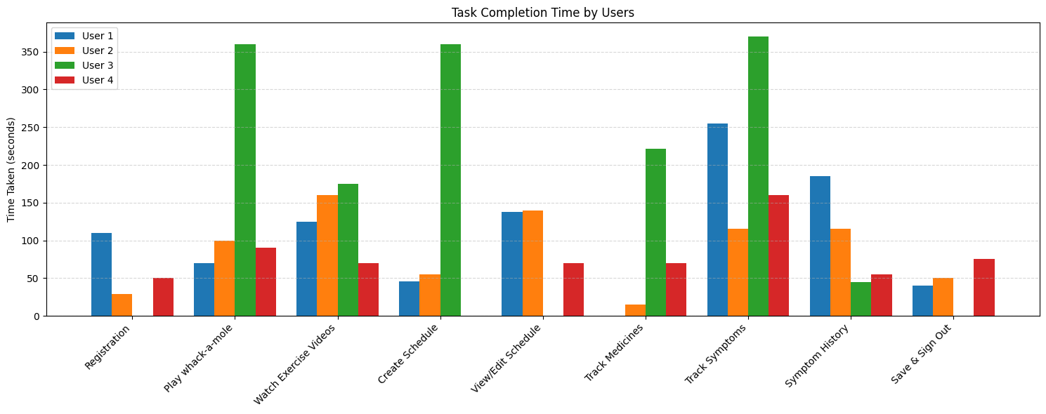

Average Time Taken:
Task No. | Task Title | Average Time Taken
1 | Registration | 1m 10s
2.1 | Play whack-a-mole | 2m 20s
3 | Watch Exercise Videos | 2m 20s
4.1 | Create Schedule | 2m 30s
4.2 | View/Edit Schedule | 1m 30s
4.3 | Track Medicines | 1m 42s
5.1 | Track Symptoms | 3m 35s
5.2 | Symptom History | 1m 30s
6 | Save & Sign Out | 1m 10s

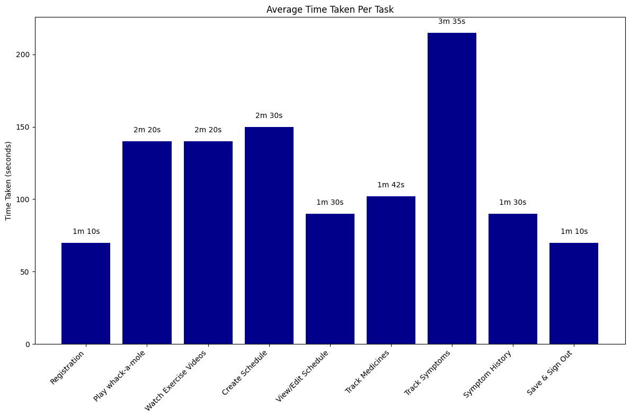

5. Results (Findings)
The evaluation phase of our research revealed a few prominent design gaps and highlighted things that could be improved or modified in certain ways. There are a few things we discovered from our app testing. given that the user group was small lets break it down according to our features:
- Brain games.
- Exercise and Therapy.
- Symptom Logging.
- Medication Manage.
From these major features, we inferred that ‘Brain Games’ was the easiest for participants to navigate while they had the most trouble with ‘Medication Manager’.

Brain Games
Most people found this interesting and were able to navigate through it easily. There were very few clicks needed to reach the games and the instructions given were clear. Participants 4, 5 and 6 particularly enjoyed the feature during the testing and while they were unclear of its purpose, found it as a good side feature in the app.
However, almost all the participants did not read the game instructions that were displayed. Participant 1 skipped the instructions and were confused as to how to play the game, and had to be assisted by the moderator. They were able to go back and re-read the instructions and continue with the game. It was interactive and posed as a break from the usual features. Also, participant 1 and 2 did not exactly follow the instructions in the testbook and they tried to play the tile matching game (which was non-functional) instead of whack-a-mole, and we had to instruct them to go back to the brain games screen and choose whack-a-mole instead.
The name of the feature was not liked by 50% of the participants, they didn’t see how it would relate to mental health. It took some of them a while to realize that the ‘play again’ button did not in-fact stop the game, and that to leave an ongoing game, they needed to use the navigation buttons on the top of the screen.

Exercise and Therapy
This was the second easiest feature for participants to use, primarily because all major functions they could perform were clearly laid out on a single page. The categories (‘Balance and gait’, ’Flexibility and Strength’ etc) were all easy to navigate. Interacting with the video content felt natural and familiar to users, as it mimicked the standard YouTube format, making it intuitive to click and play.
However, the Recommended Videos section caused some confusion. While the video thumbnails were visually prominent, they unintentionally drew attention away from the accompanying text. As a result, users didn’t realize that a certain video corresponded with a specific symptom or condition they were experiencing. Moreover, participant 2 was confused and he actually attempted to do the actual exercise by reading the instructions.

Symptom Tracking
Symptom tracking was moderately easy to use but required clearer instructions. When going to log their symptoms for the first time, some of them hesitated as the only two buttons visible were “View” and “Edit”. However, once they reached the logging screen, the actual logging was easy to do and most users completed the task with high accuracy. They were also able to easily recall, once they entered the ‘Log Your Symptoms’ and filled in their symptoms for the day, where the symptom history page was which was not well expected.
In the symptom history feature, the integrated calendar for viewing daily symptom entries was well-received, as its familiar event-based phone calendar layout made tracking symptoms over time intuitive and straightforward. However, some users, like Participant 1, did not immediately realize that each day of a month was clickable until we gave them the specific task to “view the log for 12th April”.

Medication Manager
This feature was perceived as essential by some, but it had mixed usability outcomes. The feature had been designed keeping in mind the already existing apps but these apps are rarely used by our demographic, which caused some hiccups durings testing. The feature was overly complex for over 80% of our participants. The clicks required to enter a medication or to understand what ‘frequency’ and ‘dosage’ were referring to was particularly challenging.
Moreover, ‘create new schedule’ and ‘view/edit schedule’ posed a challenge for some users as they were unable to identify where to go if you already have a medicine schedule and where to add a new schedule (considering they are a first time user).
Participant 2 further mentioned during the testing that the dosage option was unnecessary, as any medicine they took always had the constant dosage of 1 pill/tablet. Almost all participants struggled to identify the Add Medicine option within the ‘edit/view schedule’ screen. When they clicked on Edit and were prompted to add another medication, they unintentionally overlooked the ‘Add Medicine’ icon, as it had replaced the original Edit button, an interaction pattern that was not immediately obvious to most users.
While making a schedule to set up for reminders was difficult, Participant 4 noted in her post-testing questionnaire that this feature is essential for any lifestyle app designed for individuals with Parkinson’s disease. The use of checkboxes to select medication days was found to be intuitive and user-friendly. While some users initially experienced mild complexity when setting up their schedules, it became evident that familiarity with the flow significantly reduced confusion after just a few interactions with the Medication Manager feature.

General Observations
Apart from the feedback we received on individual features, there were some overall patterns and behaviors that stood out during testing. None of the participants currently used any healthcare app for medication reminders. They either relied on family members or household help, or managed it themselves. Consequently, some of them did not feel the need for this feature, while others appreciated how it would decrease their reliance on caregivers.
Secondly, having all the major features displayed on the main screen was much appreciated by users. It created ease of use and visibility of every function that they could perform in the app without having to click or swipe to change screens and discover new hidden features. This reduced the complexity and gave them a single access point.
While the major features could be seen visibly, when asked to ‘Sign Out’ from the app, some users, like Participant 1, did not realize that they needed to go to Settings, so they remained stuck on the home screen until we guided them. Participant 4, similarly clicked on the profile icon expecting the sign out feature to be located there.
One participant, Participant 3, was someone who does not own a smartphone. Throughout testing, they faced difficulty with the navigation buttons at the top of the screen, not realizing what the back arrow and home icon meant. Similarly, they did not immediately recognize the Settings and Profile icon. Their time to complete tasks was noticeably longer than other participants, and such the averages for time taken per task were skewed.
Participants had conflicting views about if they would require technical support to use the application. In the SUS document after the testing, some participants found the interface difficult to use while others disagreed. The SUS results were varied and no clear conclusion could be drawn from those findings given the small user group that we tested on.
It must also be noted that users often hesitate to accept that they find the interface of an application difficult to use and participant 1 mentioned many times, when they got stuck that it was due to their eye problems which was hindering how well she could use the app, even at times when the interface was genuinely confusing them. There was hence a disconnect in what the users mentioned in their SUS documents to what was observed in the testing. The SUS document however, did end up revealing how well integrated they found the app. Most agreed that given some time they would be able to use the application with less difficulty.

6. Discussion (about evaluation)
It has been suggested by past literature that technology can be a powerful tool when it comes to aiding people with PD to become more independent. Most of these apps that exist today, are made for the western audience and people in Pakistan and South Asia generally rely on old methods, and family to help them with basic everyday tasks or activities such as exercise, giving them their medications or taking them out etc. In the user research phase we identified four major issues faced by the Pakistani people diagnosed with PD:
- lack of physiotherapy,
- lack of independence,
- emotional and mental toll,
- trouble remembering symptoms when they visited the doctor.
This research set out to design an application that is easily accessible for the Pakistani/South Asian audience diagnosed with early to mid stage PD and caters to their needs. Throughout our design we made sure to use larger icons, keep the text in large readable font and also add accessibility features so that a wider audience can use the application. The results clearly showed that while the app used clear icons and color combinations that supported recognition. Users with PD benefit from larger, more noticeable icons on each page, and due to memory challenges, a more memorable home icon is essential. The design also included the option to select a language (Urdu or English) and had specific instructions on the main screen to turn on accessibility settings such as read aloud and voice commands.
During our testing, the main focus was to figure out the usability and acceptability of the app and how relevant the participants found the various features. The results showed a disconnect in many features from what we had expected to how people reacted to these. We broke our results down feature wise to gain a better understanding of what exact problems the testee’s faced. From the results we found a hierarchy of difficulty that the users faced: Features like Exercise and Therapy and Symptom Tracking performed well due to their familiar interaction patterns and simple, linear flows. In contrast, features such as the Medication Manager demonstrated clear usability gaps, particularly in areas requiring users to navigate multiple step processes.
Findings from the usability testing also suggest that repeated exposure to the application plays a critical role in improving user interaction, particularly for individuals with Parkinson’s Disease (PD). While initially users found it difficult to interact with the interface, some of which was due to technical difficulties of the application through which we were testing, once they figured out where different icons were, the app became easier to use; for instance, participant 6 found the home button accessible once discovered. This trend highlights the importance of familiarity and repetition in facilitating ease of use.
Notably, participants who were provided with brief instructions or who had prior exposure to similar apps demonstrated a better understanding of its structure and features during later interactions. At first, some parts of the navigation were confusing, but they became easier once users remembered where the main icons were and what they did. Although the need for multiple attempts may not align with conventional expectations of intuitive design, where first-time usability is often prioritized, it holds particular significance in the context of applications where the user group has motor or cognitive impairments.
The results demonstrate more of a first-use experience rather than long term use where they weren't given a demo or a manual for the application. These results underscore the potential value of incorporating onboarding aids, such as a simple instruction manual or a brief tutorial mode, to bridge the gap between initial confusion and eventual proficiency. While this may not eliminate all accessibility barriers, it can serve as a vital step in making digital tools more inclusive and supportive of user needs over time.
One important finding was that familiar design patterns don’t always work well, especially for people with PD. This was clear in the problems users had with the Medication Manager feature. Many found it confusing and hard to use. Even though the feature was designed like other common apps, participants still struggled to enter how often they take medicine, the dosage, and how to create a new schedule.. This suggests that design for this user group should prioritize accessibility and adopt a more, step-by-step approach that has more feedback and instructions at every step. However, it must be noted here that medication schedules for this user group are rarely updated or set from scratch, hence the users can ask their doctors or family to input this until it is further needed to be edited. This as well can be countered by the onboarding aids/manuals.
Another key insight we got from the findings was the importance of plain language, visual hierarchy, and consistent feedback. Participants found the app more accessible when it featured larger icons, clear labels, and familiar structures such as calendars and the back button. Conversely, when the context of a button changed, such as an 'edit' button turning into an 'add' icon, or when icons lacked text such as the home, profile and settings icons, users found navigation more challenging. These findings reinforce the value of simplicity, clarity, and alignment with familiar iconography and color schemes in enhancing usability.
The overall app, despite its flaws in design or incomplete mental models in some places, does show some promising results. As some participants mentioned that their families had to remind them to take medications through calls or by hiring caretakers, the app is a significant step up and a major step towards people with PD gaining a level of independence. The symptom tracking feature was also well appreciated for its convenience for participants' doctor visits and how it would streamline and shorten the process.
While the study yielded valuable outcomes, it must be noted that our research had several limitations. A major limitation was a lack of sufficient users for the testing of our application. To ensure that our findings are generalizable it is imperative that we test the app with a broader, more diverse audience. Another limitation that we encountered was that due to the limited time slots and the users getting tired, alot of the testing was skipped or rushed by the participants themselves. In future, more flows of the application should be tested, with participants being given even more minimal instructions and let the app be used in a natural environment rather than a specific testing environment.

7. Conclusion
ParkinsonPal was developed as a lifestyle support tool for persons diagnosed with early to mid stage Parkinson’s disease. Its aim is to promote independence and improve day-to-day health tracking. The app brings together features like Brain Games, exercise and therapy videos, symptom tracking, and medication reminders to support the various day-to-day needs of people living with Parkinson’s.
While we designed the interface with simplicity and accessibility in mind, making use of large buttons and high-contrast icons, testing revealed areas where further simplification is required. Complex features such as the medication manager highlighted the need of step-by-step guidance, clearer labelling and more intuitive flows within certain features. These kinds of challenges are expected when designing for people with cognitive or motor difficulties, and they highlight how important it is to provide clear guidance and build familiarity into the design
Importantly, the user testing revealed that different participants were drawn to different features. Not every user will use every feature that our app has to offer. We saw that some users liked the medication manager while others felt that it was unnecessary. Some were very impressed by the recommended therapies but others did not give it much thought.
In conclusion, the app still needs some improvements, but it has strong potential to support people with Parkinson’s in Pakistan. It can cater to a wide audience having features useful for everyone. By making the interface easier to use and adding better guidance for new users, the app can help users become more independent and take better control of their health.

Appendices
References
[1] Lee, J., Yeom, I., L Chung, M., & Kim, Y. (2022). Use of mobile apps for self-care in people with parkinson disease: Systematic review. JMIR mHealth and uHealth. https://mhealth.jmir.org/2022/1/e33944
[2] Landers, M. R., & Ellis, T. D. (2020, October 5). A mobile app specifically designed to facilitate exercise in parkinson disease: Single-Cohort Pilot Study on feasibility, safety, and signal of efficacy. JMIR mHealth and uHealth. https://mhealth.jmir.org/2020/10/e18985/
[3] Motolese, F., Magliozzi, A., Puttini, F., Rossi, M., Capone, F., Karlinski, K., Stark-Inbar, A., Yekutieli, Z., Di Lazzaro, V., & Marano, M. (2020, September 2). Parkinson’s disease remote patient monitoring during the COVID-19 lockdown. Frontiers. https://www.frontiersin.org/journals/neurology/articles/10.3389/fneur.2020.567413/full
[4] Afshari, M., Yang, A., & Bega, D. (2017). Motivators and barriers to exercise in parkinson’s disease. Journal of Parkinson’s Disease, 7(4), 703–711. https://journals.sagepub.com/doi/10.3233/jpd-171173
[5] Bollu, P. C., & Sahota, P. (2017). Sleep and Parkinson Disease. Missouri medicine. https://pmc.ncbi.nlm.nih.gov/articles/PMC6140184/#sec2
[6] Desotell, N. (2022, July 7). Is it Worth It? Insomnia-Curing App – Sleepio Review. gentwenty. February 28, 2025, https://gentwenty.com/sleepio-review/
[7] Mascheroni, A., Kyoung Choe, E., Luo, Y., Marazza, M., Ferlito, C., Caverzasio, S., Mezzanotte, F., Kaelin-Lang, A., Faraci, F., Puiatti, A., & Luca Ratti, P. (2021, June 8). The SleepFit tablet application for home-based clinical data collection in parkinson disease: User-centric development and usability study. JMIR mHealth and uHealth. https://mhealth.jmir.org/2021/6/e16304
[8] Triantafyllidis, A., Segkouli, S., Zygouris, S., Michailidou, C., Avgerinakis, K., Fappa, E., Vassiliades, S., Bougea, A., Papagiannakis, N., Katakis, I., Mathioudis, E., Sorici, A., Bajenaru, L., Tageo, V., Camonita, F., Magga-Nteve, C., Vrochidis, S., Pedullà, L., Brichetto, G., … Tzovaras, D. (2023, March 23). Mobile app interventions for parkinson’s disease, multiple sclerosis and stroke: A systematic literature review. MDPI. https://www.mdpi.com/1424-8220/23/7/3396
[9] Peng, W., Kanthawala, S., Yuan, S., & Hussain, S. A. (2016, November 14). A qualitative study of user perceptions of mobile health apps - BMC public health. BioMed Central. https://bmcpublichealth.biomedcentral.com/articles/10.1186/s12889-016-3808-0#Sec16
[10] Lee, JuHee et al. “A Mobile App for Comprehensive Symptom Management in People With Parkinson's Disease: A Pilot Usability Study.” Computers, informatics, nursing : CIN vol. 42,4 289-297. 1 Apr. 2024, doi:10.1097/CIN.0000000000001089
[11] Big Health (Sleepio & daylight) is rated “poor” with 2 / 5 on Trustpilot. Trustpilot. (2024, September 12). https://www.trustpilot.com/review/sleepio.com
[12] Kim1, Aram, et al. “Exercise Management Using a Mobile App in Patients with Parkinsonism: Prospective, Open-Label, Single-Arm Pilot Study.” JMIR mHealth and uHealth, JMIR Publications Inc., Toronto, Canada, mhealth.jmir.org/2021/8/e27662. Accessed 3 May 2025.

