ParkinsonPal

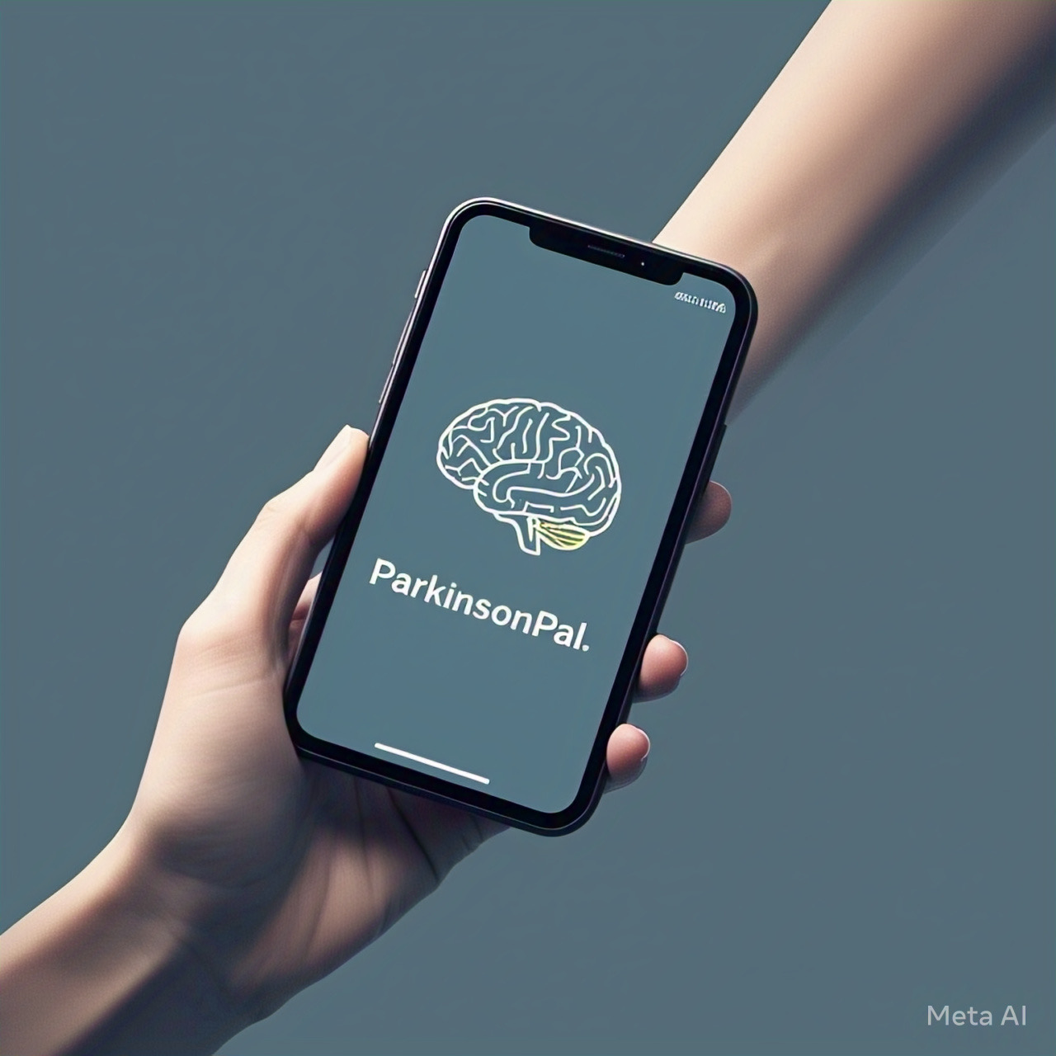

Group Number: 08
Group Name: UXperts
Group Representative: Hussain Sulaiman Zia 26100011@lums.edu.pk
Project Phase: Phase 2 - Design

Contribution of Individuals
Name | Contribution statement | Picture
Azaan Imran | - All | 
Name
Hussain Sulaiman Zia | - All | 
Name
Muhammad Talha Muneer | - All | 
Name
Rumaan Mujtaba | - All | 
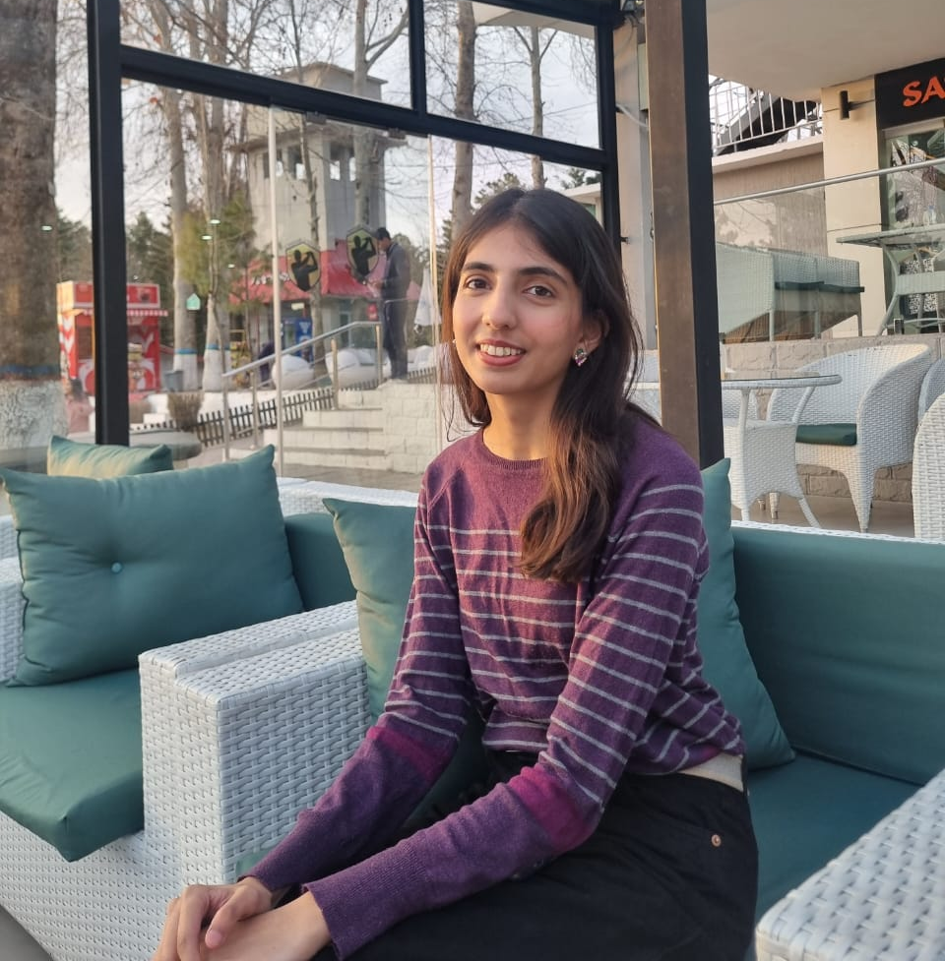
Zainab Humayun 1.All

Submission

You can submit your phase 2 via WeTransfer. Follow these steps:
- Create a folder with your group no - exactly like this (read 01 not 1 and read - not _, read D capital, not small) ->"Group01-Design"
- In that folder, create five folders ->
  - "1-Documents" (for the main Word and PDF file),
  - "2-AudioVisual" (for videos, pics, audios, if any),
  - "3-Design Docs " (All PDFs: for questionnaires, sketches, design alternatives, storyboards, etc.),
  - "4-Lofi prototype"
    - the complete screen flow video
    - all screens in pdf,
    - testing videos, etc.
  - “5-HiFi Prototype”
    - a high-quality pdf consisting of all final screens
    - a read-me file explaining the flow of the prototype and any extra details which are important. The readme file should have a link to your Figma and anything about your prototype you would like to highlight (vertical flows, decisions made, any cool implementation we must see, flows we should not click, etc.)
    - The Figma (source) file
    - functional demo of your prototype (if any)
    - video demo of your prototype.
  - "6-Consent Forms" (the name of the audio/video should match with the respective consent file name)
- Compress the "Group01-Design" folder. (max file 1 GB with an error margin of 300MB)
- Upload it on Wetransfer
- Send it to suleman.lums@gmail.com before the deadline. It must arrive in my inbox before the deadline – 1 minute late is late.
- Do not share your videos/audios with TAs. You do not have the consent for that.
- Sharing 1GB via Wetransfer may take an hour. Please ensure that you start uploading on time.

-----

Honor Code:
As participants in the group project, we recognize the importance of integrity, originality, and ethical conduct in academic and creative pursuits. This honor code serves as a commitment to uphold these values throughout the project.

- Respect for Originality: We will endeavor to create original work for all submissions related to the project. When inspiration is drawn from existing sources, appropriate recognition and citation will be given.
- Acknowledgment of External Assistance: If we seek and receive help from external sources, including online resources, texts, experts, or artificial intelligence tools like ChatGPT, we will transparently acknowledge this assistance in our submissions.
- Collaborative Integrity: As this project involves group work, we commit to contributing fairly and honestly to our team's efforts. We will openly communicate our ideas, respect the ideas of others, and ensure that all members' contributions are duly recognized in the contribution statement. In the case of unfair or unequal contributions by member(s), we will highlight this in the contribution statement section.
- Adherence to Guidelines: We will adhere to all the guidelines and requirements set forth for the project, understanding that these are in place to ensure a fair and equitable experience for all participants.
- Consequences for Non-Compliance:
  - First Violation: Failure to adhere to any part of this honor code will result in an automatic failure for the project phase in which the violation occurred.
  - Repeat Violation: A second violation will result in a failure for the entire project and referral to the disciplinary committee for further action.
- Digital Signature Commitment: By digitally signing this document, we individually affirm our commitment to these principles. We understand that failure to adhere to this honor code may result in consequences as determined by the teaching team and the university.
Digital Signature:
By typing our names below, we digitally sign and commit to the Honor Code of this course/project.
- Member 1: Hussain Sulaiman Zia 4/04/25
- Member 2: Azaan Imran 4/04/25
- Member 3: Zainab Humayun 4/04/25
- Member 4: Rumaan Mujtaba 4/04/25
- Member 5: Muhammad Talha Muneer 4/04/25

Table of Contents

Improved Findings Section <If any>

1. Problem statement (The Final One) <Max 300 words>
After the interviews and observations of the patients and the doctors the new problem statement that we devised is that there exists a need for technological solutions to address disease management and progression tracking. Currently the interactions between the doctors and the patients is largely manual and inconsistent given that patients do not go for regular appointments and only end up going when they have some serious issue. This coupled with Doctor Khalid Jamil’s complaint about patients not being able to explain how they are doing goes to show that these irregular appointments mean that any self medication (homeopath, changing dosage without consultation) or other changes in mobility, gait etc that are not recent get left out of the conversation.
From the literature review, we have seen that there are no apps currently that take a one stop approach to the lifestyle apps designed for parkinson patients. Each app has its own shortcomings or even though these apps are specifically made for the patients, they find the user interface too complex or its features difficult to interact with.
Specifically in the context of Pakistan, technology is an underused resource and while many assistive and lifestyle apps do exist in many parts of the world, these have not yet made their way into Pakistan. Every patient experiences Parkinson’s in a unique way, facing differing severities of symptoms and requiring individualized medications and therapy routines. However, we do not utilize technology to provide such personalized treatments.

2. Brainstorming (process and ideas) - 3%
After the end of our user research, we held multiple meetings to plan out how we were going to solve the problems we had identified. In the first meeting, we only focused on the problems, listing them all down and trying to group them into categories. Then we brainstormed ideas to address them.
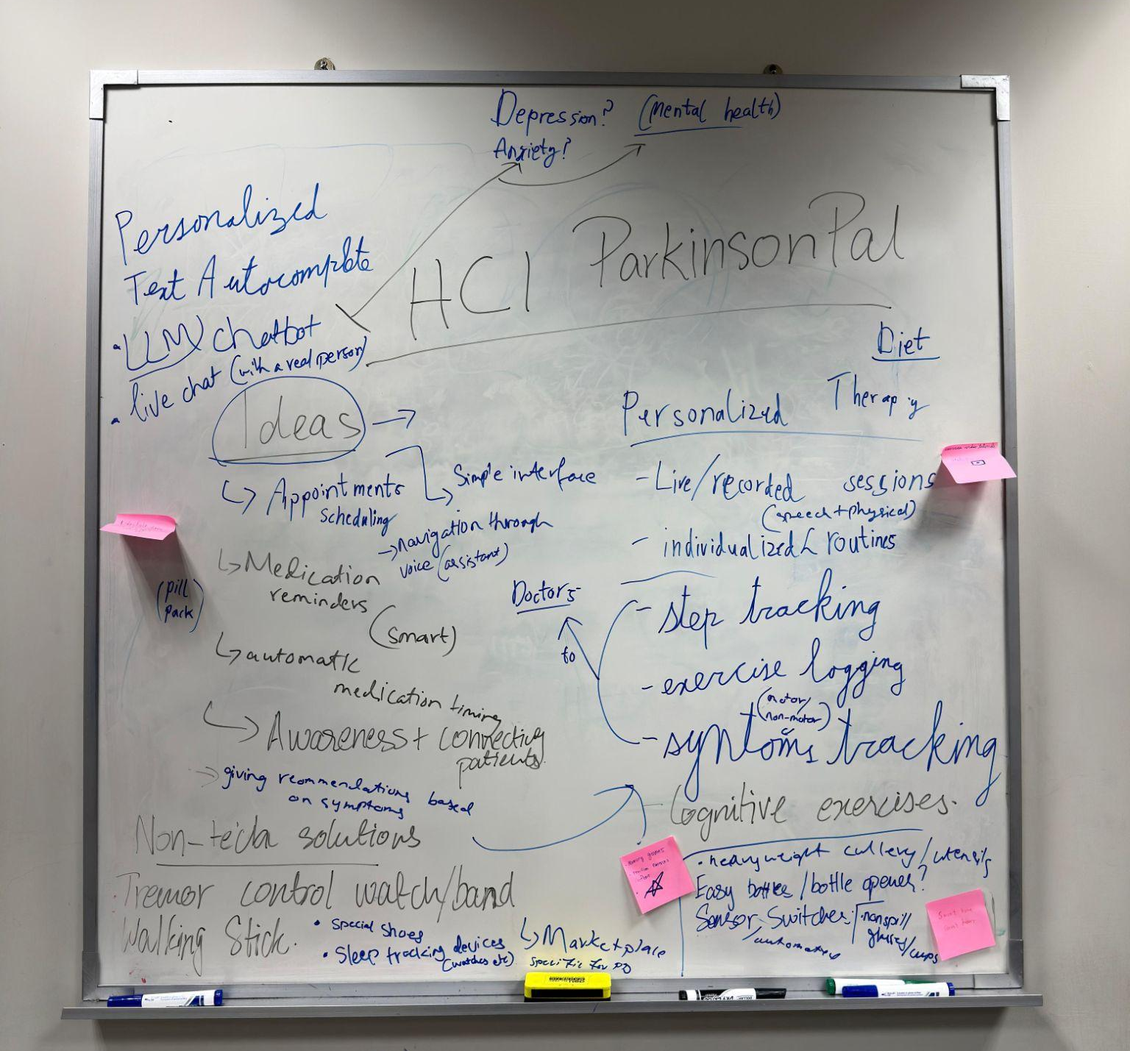
Initially, the ideas were noted down quite haphazardly, without much effort to organize them. Some came directly from the doctors, like tremor control bands and sleep tracking devices. Others emerged from our own reflections after the interviews — ideas like symptom tracking for disease progression, individualized therapy recommendations based on symptom history, and cognitive exercises to help with mental pressure.
Then in our next meeting, we presented these ideas in a more systematic way. For the non-tech solution ideas, we researched related products and grouped them together. Some of them seemed very interesting, which we noted down for later.
For other ideas, we discussed ways in which technology could be used to assist patients, doctors and caregivers.
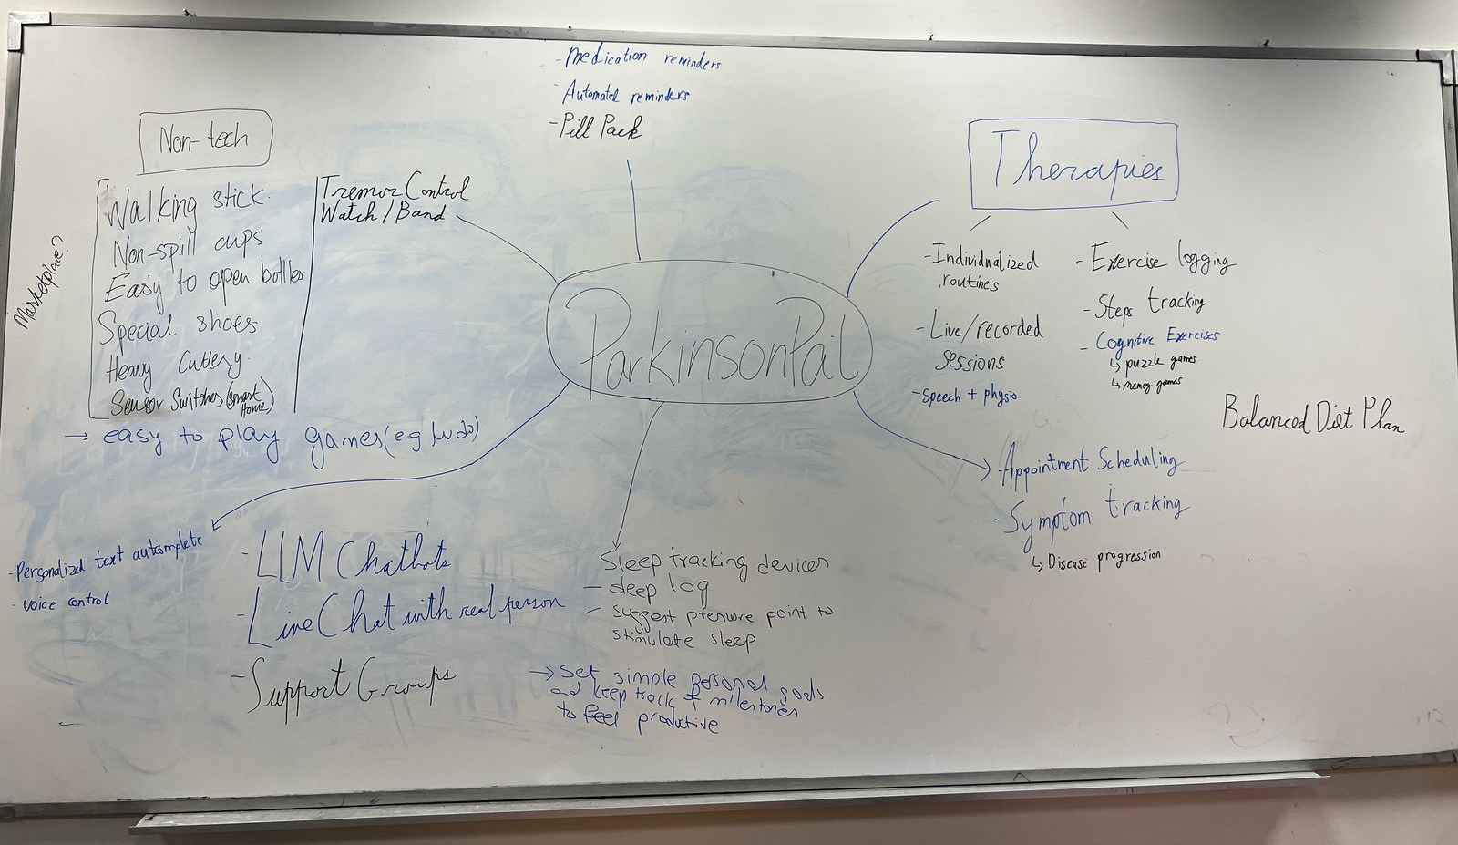
We thought if we were to design a self-care/health app for Parkinson’s patients, what features should we include in it? Some ideas we came up with then were:
- Symptom tracking
- Sleep tracking
- Medication scheduler
- Physiotherapy guides
- Appointments scheduler
- Cognitive exercises
We discussed whether certain ideas warranted a standalone app, or could we group multiple of them together. One common issue we had noticed when doing the literature review for the previous phase was that there were no apps currently that took a one-stop approach to the lifestyle apps designed for parkinson patients.
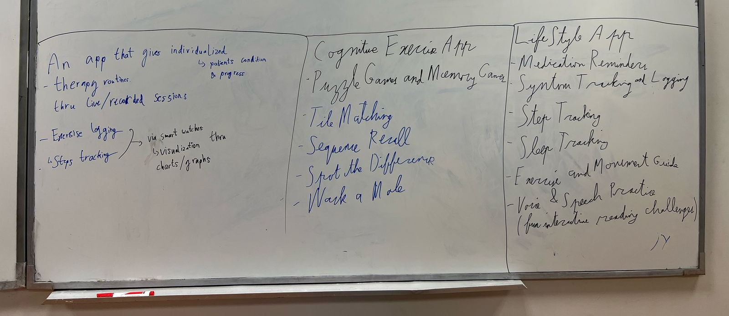

3. Design Alternatives <(± 500 words + visuals)> - 10%

3.1. StrideBeam (Laser-Assisted Walking Stick)

Tagline: “Light your next step.”

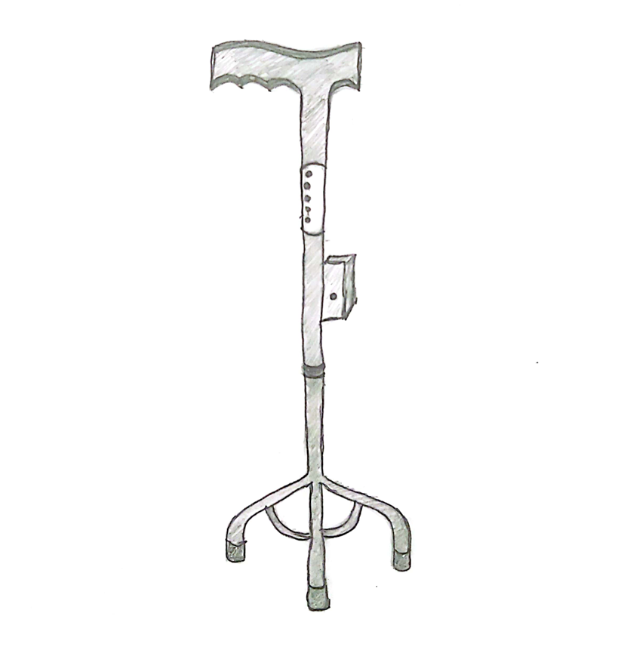
Key Idea
A majority of Parkinson’s patients experience difficulty in walking because their gait usually freezes. StrideBeam projects a bright laser line on the ground, creating a visual cue that enables them to start walking. The light acts as a small obstacle to step over, overriding the brain's freeze response that allows the user to continue their walk.
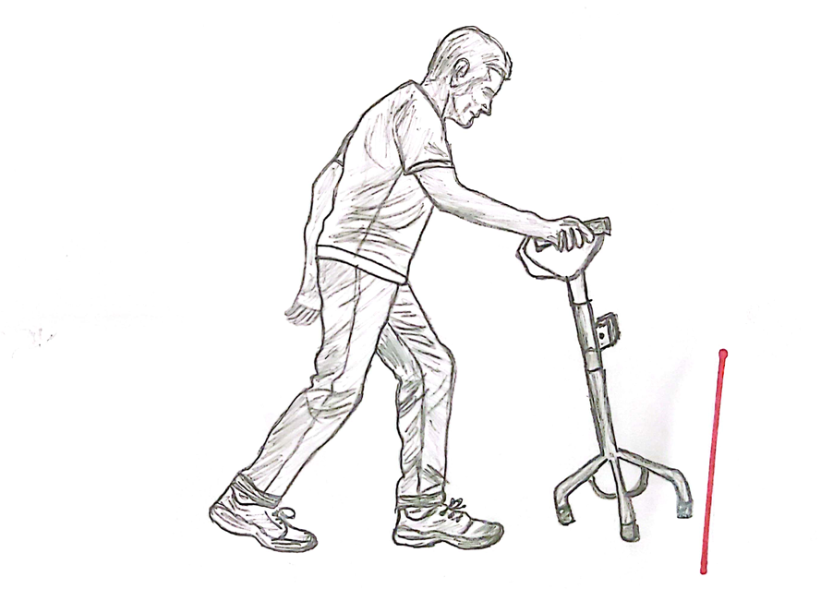
Features & Rationale
- Laser Projection: A built-in laser projects a horizontal line just ahead of the user's feet. Stepping over the beam can help break up freezing episodes.
- Audio Alerts & Step Counter: An optional buzzer provides an audio cue after a set number of steps (e.g., every 25 steps), encouraging the user to walk regularly.
- Rechargeable Battery: The device charges via standard USB type C charger that lasts up to two weeks on a single charge.
- Ergonomic Design: A comfortable grip and lightweight materials conveniently help older users to carry and its adjustable height accommodates users of various heights.
How It Helps
StrideBeam addresses the hesitation and anxiety that Parkinson's patients experience when their feet start freezing by providing both visual and audio cues. This restores walking rhythm and reduces the risk of falling.

3.2. SteadiBand (Tremor Control Wristband)
Tagline: “Steady hands, steady life.”
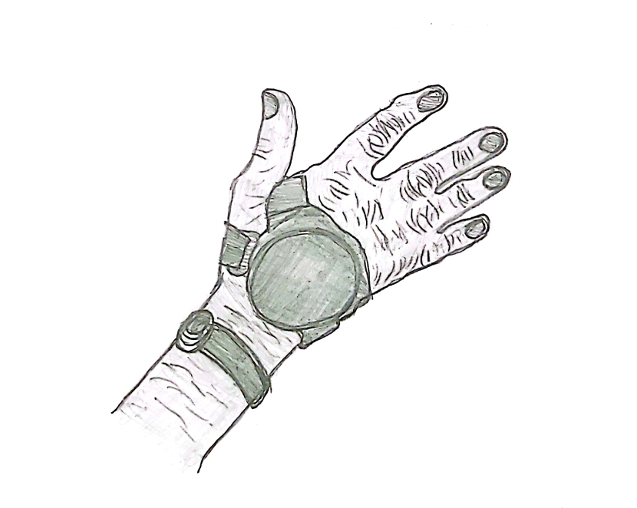
Key Idea
Hand tremors are a common symptom of Parkinson's disease that makes it extremely difficult for the patients to perform daily tasks with ease such as eating, drinking, writing or using a phone. SteadiBand is a simple wristband that stabilizes the hand and wrist tremors by applying mild electrical or vibrational stimulation.
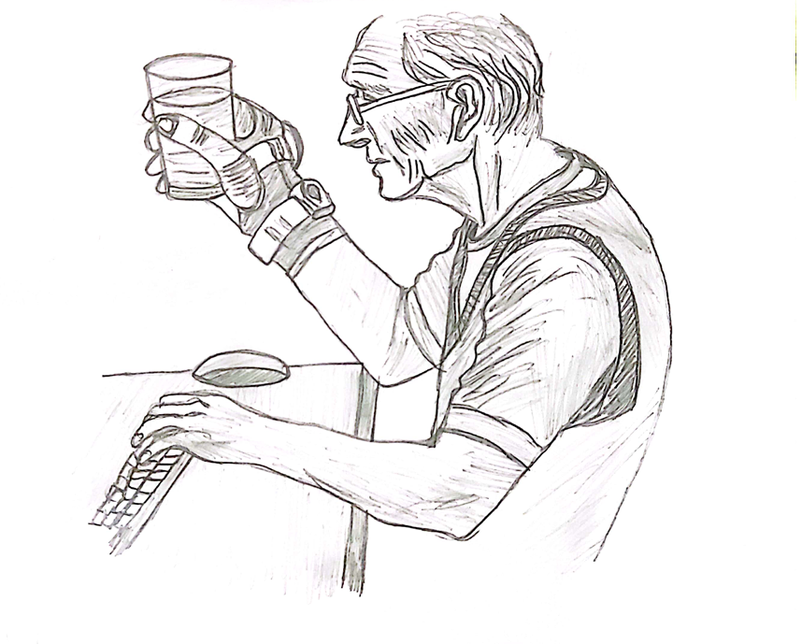
Features & Rationale
- Neuromodulation: SteadiBand targets specific nerves in the forearm with low-level pulses. This interrupts the tremor cycle thus restoring better motor control.
- Lightweight & Battery-Free Option: Designed to be ultra-light in order not to strain the user’s wrist. A battery-free version (using inductive charging) ensures minimal upkeep.
- Adjustable Stimulation: Users can adjust the intensity of pulses to obtain the ideal balance between tremor suppression and comfort.
- Discreet Design: It resembles a fitness tracker that reduces social stigma and can be used regularly on a daily basis.
How It Helps
SteadiBand provides immediate relief from tremors without the need for medication or surgical intervention. It boosts confidence in patients while performing everyday tasks like writing, typing on a phone, eating, pouring tea or drinking water.

3.3. MindfulSole (Dual-Traction Shoes)
Tagline: “Every step with purpose.”
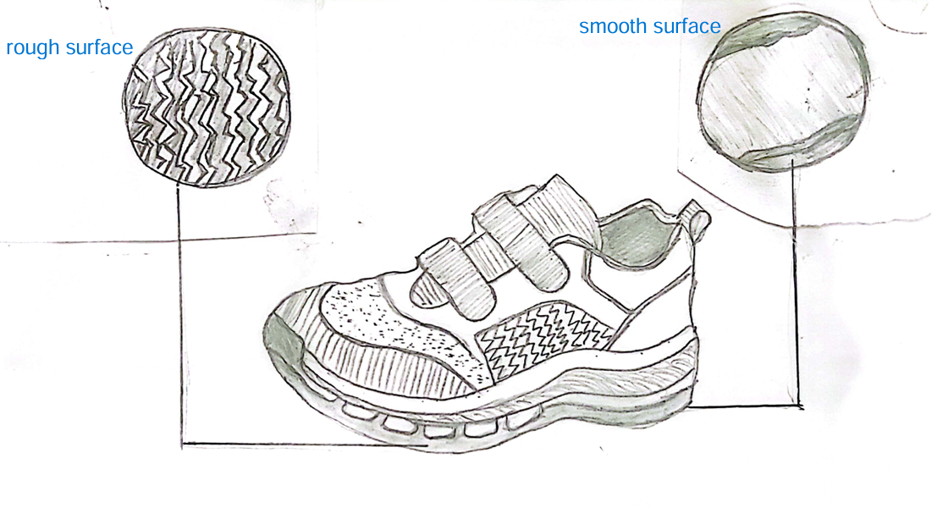
Key Idea
When walking becomes automatic, Parkinson’s symptoms like trembling or freezing can worsen. MindfulSole shoes are designed with a split-surface sole: one half is slightly rough, and the other is smooth. This subtle unevenness forces the user to consciously focus on foot placement, providing cortical reinforcement that can reduce involuntary tremors.
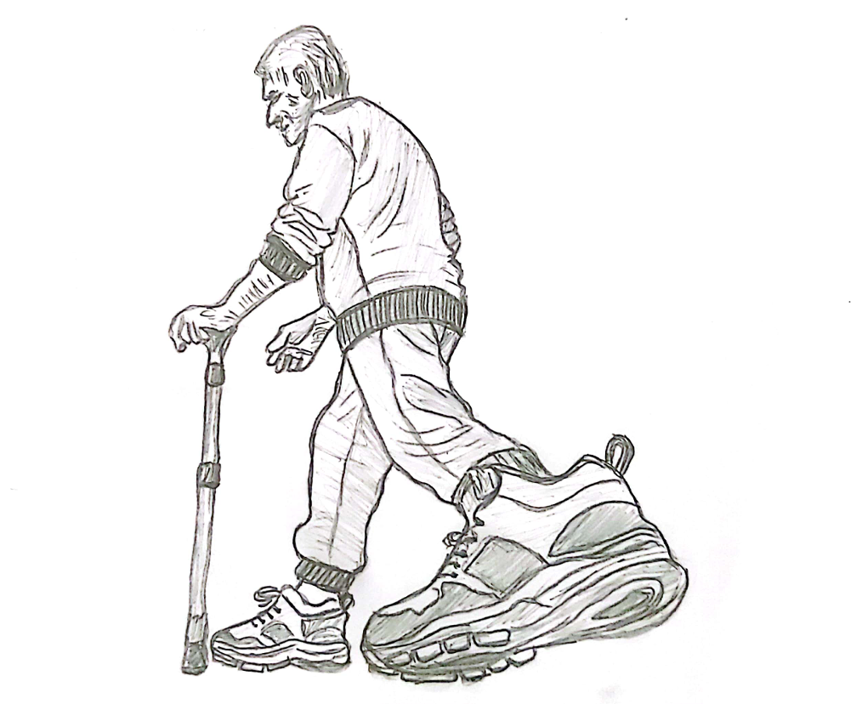
Features & Rationale
- Dual-Traction Sole: The rough part provides friction,enabling the user to be mindful of every step he will take. The smooth part simulates a regular walking experience. This contrast stimulates the brain to focus on balance.
- Lightweight Materials: Reduce fatigue, which is especially important for patients with muscular rigidity.
- Supportive Fit: A fitted yet comfortable design, with good ankle support, to reduce the risk of falling.
- Customizable Grip: Users can choose from different levels of roughness based on their comfort and severity of symptoms.
How It Helps
In order to improve gait and reduce tremors, the rough traction of MindfulSole provides a slight element of danger while walking thus encouraging the brain to stay active and alive before each step. This concept is based on the idea that when patients consciously move, their motor symptoms can be reduced.

3.4. Parkinson Marketplace (One-Stop Shop for Assistive Devices)

Tagline: “All your mobility and comfort solutions in one place.”

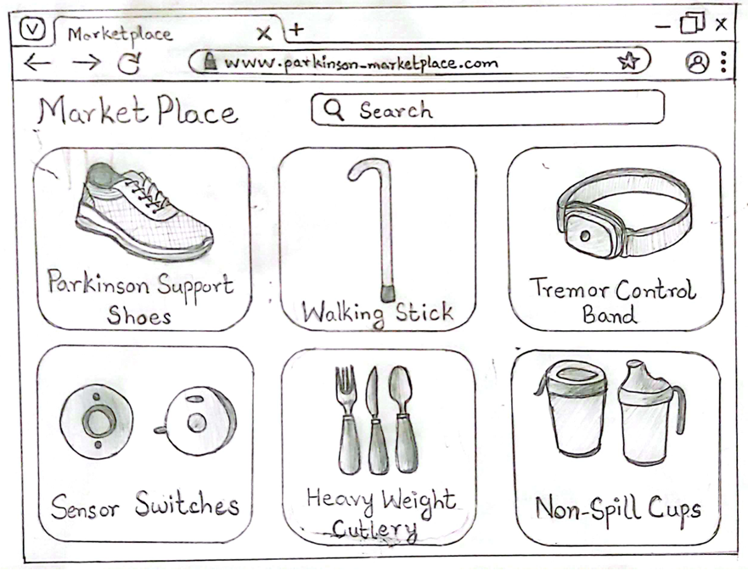Key Idea
Parkinson Marketplace is an online platform where reliable, Parkinson-specific assistive products can be found in one virtual storefront. Instead of browsing multiple stores and websites, patients and caretakers are much relieved because they can get a wide variety of devices here, ranging from walking sticks and specialized shoes, to sensor switches, tremor control bands, weighted cutlery and spill proof cups etc.
Features & Rationale
- Centralized Catalog: In order to simplify the search process, the marketplace provides Parkinson related products that address mobility, daily living and safety concerns.
- Search & Filter: Items can be filtered by category(e.g footwear, dining aids, mobility sticks), symptom severity, or personal preferences.
- User Reviews & Expert Tips: In order to provide reliable guidance from expert therapists and neurologists, each page hosts real user experiences and professional endorsements or tips.
- Adaptive Interface: Patients with tremors and visual impairments can easily navigate through large buttons, clear text and Parkinson-friendly layouts.
How It Helps
Parkinson Marketplace alleviates the burden of endlessly researching niche products. Patients and caregivers feel comfortable selecting items specifically desgined for Parkinson’s symptoms (such as freezing of gait or tremors). By centralizing multiple solutions—support shoes, walking sticks, and meal-time aids—the platform encourages a holistic approach to daily living challenges, ultimately enhancing user autonomy and peace of mind.

4. Literature Review/Other similar products <(± 500 words)> - 3%
In this period of technological advancements and inclusivity, there has been vast research on making the world more accessible for people suffering from Parkinson's. The research focuses on finding out the symptoms of the disease, both motor and non-motor, and accordingly developing mobile apps and wearable devices to help people with Parkinson's. Research papers show that Parkinson’s patients face motor symptoms like cognitive impairment, tremors, voice control, postural instability, gait changes, and clear speech. Other non-motor symptoms include disturbed sleep cycles and behaviors, fatigue, mood changes, sensory impairments, and speech and memory loss.
A study conducted on digital interventions for Parkinson's Disease (Lee et al., 2022) helped gain valuable insights about the existing apps that aim to help patients. This paper explores the various designs and features of the existing apps, thus explaining how most apps are directed towards the self-care of the patients and include medication reminders, exercise tracking, data collection, and visual representations of the data trends. Overall analysis of various research papers shows that apps lack the tracking and monitoring of all aspects and focus on self-care instead of aiding, require more work for the patient themselves, and lack accessibility. For instance, some apps provide physical exercises for the patients, but then they are solely based on the exercise trait and do not feature any other characteristics (Landers & Ellis, 2020).
Some of the existing apps are Sleepio (Desotell, 2022) and SleepFit (Mascheroni et al., 2021) that track sleep patterns and help improve those patterns; however, they lack accessibility. Another app is Parkinson’s ON for medication reminders and to log and track symptoms, and a smart way for scheduling medications, and is based on self-care; however, it lacks basic requirements of giving suggestions or insights for the betterment of the patient’s health. This app primarily just focuses on reminders, and no extra support for a better lifestyle. Similarly, another app to log data is My Moves Matter, used for tracking and logging of symptoms, and includes a feature to track menstrual cycles for female patients. This app lacks a user-friendly interface for patients. Neuro Heroes is an application that features live expert-led classes for physiotherapy sessions for patients, focusing on simple exercises that require no equipment. Another app for the physical health of patients is Beats Medical, which offers therapies and guides regarding physical, speech, and language symptoms to people diagnosed with Parkinson's Disease. Both apps for therapies are not accessible enough; they focus on paid subscriptions and live sessions, and thus, patients cannot refer to the therapies again, or they do not cover all motor and non-motor symptoms. (2025).
These apps, while offering great support, have many drawbacks, including a lack of accessibility, paid/ costly subscriptions, and a complex interface. Moreover, none of the pre-existing apps provides a single platform for both motor and non-motor symptoms. Thus, in conclusion, we aim to take positive aspects from previous research and existing apps to develop Pakistan’s first-ever complete app for patients diagnosed with Parkinson’s disease, in the hope of improving their quality of life and ensuring better care for the patients.

5. The final design (name of your product /system/concept name) – 15%
Name of product: ParkinsonPal
ParkinsonPal was chosen keeping in mind the context of the app, which encompasses many features within it to make life easier for people diagnosed with Parkinson's, and its friendly connotation.
System:
ParkinsonPal is a lifestyle app designed for patients diagnosed with early to mid stage parkinsons. The app requires a stable internet connection to access videos from youtube and also to create personalized recommendations and send reminders.
Concept name:
“Own your every step”
Our app is a well rounded platform for people diagnosed with Parkinson’s disease. It offers a complete support system and various features such as symptom tracking, medication reminders, exercise and therapy and games.
The features of the app have been designed carefully through communicating and understanding the needs and wants of the users. Throughout our screens we made sure that all the buttons were relatively larger to avoid any accidental clicks due to tremors and convenience considering that our user group is elderly people based in Pakistan/South Asia.
We chose to make an app instead of our design alternatives as in this era of technology it is one of the most efficient problem solving ways. While the sticks, watch bands etc. are particularly helpful for people with PD, these products either already exist in the market or are very costly and so would not benefit the larger audience. The watchband that we mentioned sells for almost $600 on online marketplaces and is also not readily available in Pakistan as of now. In contrast, almost every person now has a smartphone and a wifi connection hence making apps such as ours more accessible to a wider audience.
Features:
Registration/ Sign In:
The initial screen has 2 options either to register or to sign in. Once a user is registered they can opt to stay signed in and similar is the case when a user signs in.Considering our demographic the very first screen also allows the user to choose either Urdu or English as the primary language so that all information and text is then displayed in that.
Symptom tracking:
During the user research phase a major issue we identified was that since people went on doctors visits very infrequently, they often only were able to recall the most recent things they have experienced. The symptom tracker allows the users to log in their symptoms on a daily basis. The user rates predefined metrics on the app, including motor symptoms such as tremors and involuntary movements, and non-motor symptoms like sleep disturbances, dementia, and overall mental well-being etc. Each symptom is rated on a scale of 1 to 5 based on how it was experienced throughout the day. Users can also add any additional symptoms or experiences they may have encountered. The users also have the option to edit their yesterday’s symptoms so that if they miss the 24 hour window, they still have the option to view or edit their yesterday’s log.
These symptoms are then compiled into charts and can also be viewed individually through dates. To view the individual symptom history of one day, we have a calendar where you can click on any date and it will open the symptom history for that day. The calendar also has colored dots which shows the average rating of all symptoms on that day. The graphical representation shows a clean and more clear representation of the overall month. This information (per month) can also then be downloaded as a pdf.
Medication Reminder/Tracking:
It is extremely difficult for people diagnosed with parkinsons to remember their entire medicine schedule and normally a family member or caretaker has to take on the responsibility of providing timely medication, specially when the disease progresses to the mid stage. This, coupled with the desire to maintain independence, can take a significant toll on a person's mental health.
The medication reminder therefore allows the users to schedule their medication with ease and get pop up alerts whenever it is time for their medicine. App users can make a whole new schedule as well or choose to view/edit their existing schedule (i.e add, delete or change dosage). The pop up alert asks the user to select a checkbox or skip the medication therefore keeping a track of which medications they have taken or missed.
All information is tracked in the medication tracker option whereby the users can download a monthly summary, like the the total monthly dosage of any specific medication and also the starting and ending dates of each medicine. This can be extremely helpful for people with PD specifically in Pakistan as they often change their dosage or start self medicating once they have been taking a medicine for long. Since the report can be downloaded and viewed as a pdf, it is easier for doctors to also track which medication may have had side effects coupled with their symptom history and what medications or dosage to change.

Exercise and Therapy:
People with PD in Pakistan often do not go to physiotherapy since they find it either ineffective or feel that they have felt worse during the period that they did go to physiotherapy. However, staying active and exercising is absolutely necessary for people with PD to ensure that their body does become rigid. While some individuals do go on walks or try to stay active on their own, it may not be sufficient, as one of the physiotherapists highlighted during our research. They might go days without moving a specific body part, which can lead to stiffness and pain.
The exercise and therapy option in our app tracks the symptoms and the medication dosages and recommends the users with mild exercises that they can do on their own. Each exercise has instructions and video tutorials on what to do and how. These exercises make sure that they do not need help from anyone else and are not intense to make sure that the users do not end up hurting themselves. Other than the recommended exercises, the users also have the option to view specific categories such as:
  - Flexibility & Strength
  - Balance & Gait
  - Coordination
  - Breathing & Voice Therapy

Other than physical exercises, the app also focuses on speech therapy and the mental well-being of the users. Speech therapy offers vocal exercises that improve vocal loudness, speech clarity and overall communication. Furthermore many users suffer from anxiety and depression which is a symptom of PD and are often hesitant in acknowledging this given the stigma that still exists regarding anxiety and depression. Hence there are several breathing exercises on the app that could help relieve stress and anxiety and overall improve the users mental health.
Brain Games:
This feature, while may seem unimportant, is a powerful tool to boost cognition and mental health. During the user research there was a clear pattern that people with PD who stayed active and involved in activities that stimulated their brain, slowed down the progression of the disease and overall felt better. Brain games has 4 easy to play games, all of which only require tapping on the screen.
- Tile Matching
- Sequence Matching
- Whack-a-Mole
- Spot the Difference

The game board sizes are enlarged to prevent accidental clicks and enhance readability. These games set the highest scores every time a user surpasses their previous score and hence boosts their mood by setting a goal for them.
Brain games also boost mental health as most games lead to the release of dopamine and uplift their mood. Having games instead of a category labelled as “mental health” allows the users to interact more organically with the tasks without feeling like they’re performing a mental health task. This works better for our demographic considering the stigma around mental health in Pakistan and most of South Asia.

Accessibility Settings:
We wanted to make our app with accessibility and the cultural context in mind. Considering that a large population of elderly in Pakistan have trouble reading or prefer using voice controls.
Since the application is mobile based and all iphones and androids have the accessibility feature of VoiceOver or read aloud, hence instead of including an inbuilt read aloud feature we just facilitate the user to navigate to their setting where the controls are turned on automatically.
Despite trying to minimize the text fields, in some places it was absolutely necessary for personalization and privacy, hence we require a speech-to-text feature. Similar to the read aloud, all keyboards used for typing have a microphone speech-to-text option which allows users who prefer not to type to still be able to enter their details with ease.

6. Sketches – 3% 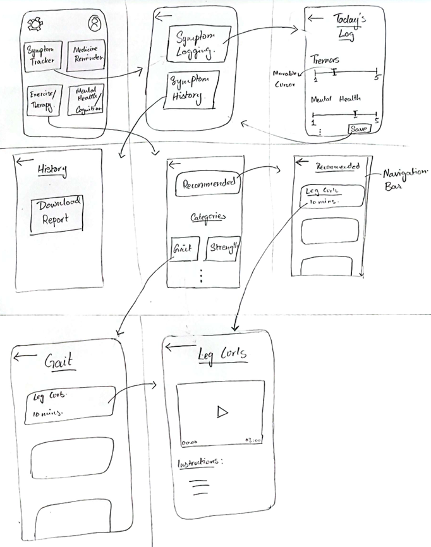

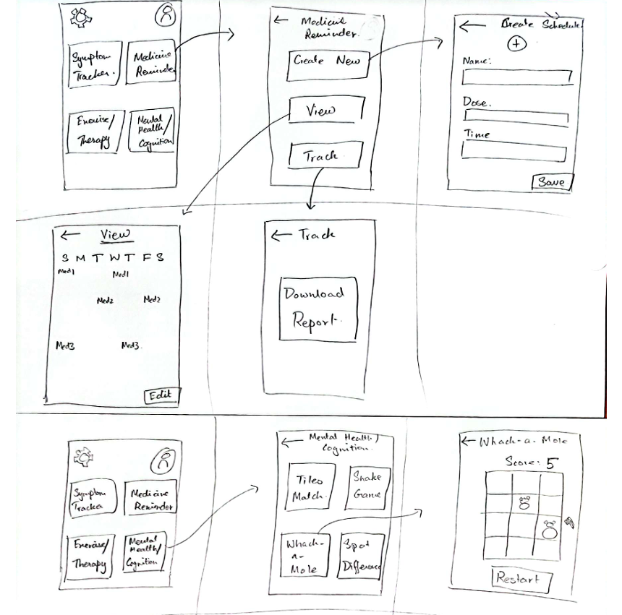

7. Scenarios – 7%
- A Parkinson's patient wants to track their symptoms so that they can show their progression to the doctor in the next visit. They open the app, navigate to the symptom logging option and rate how they have been in the given categories. The tracker allows them to add additional/uncommon symptoms as text. The record is made which is added to the monthly history which the patient can view. The app allows the user to view the symptoms history where they can view what they have logged everyday or view the charts. The app also allows the user to download their report.
- A Parkinson's patient does not go to physiotherapy as they find it inconvenient and don’t think it helps. They have felt some rigidity lately and want to get some exercise in. They open the ParkinsonPal app and navigate to the exercise and therapy feature. He opens the recommended exercises one by one that the app has compiled considering their symptoms lately. The app shows only mild exercises that can cause no harm and have video tutorials to show how to perform each exercise and the duration for which these need to be performed. The app also allows the user to view any specific exercises if they want to focus on flexibility/strength etc.
- The user has been feeling down lately and feel like they are experiencing signs of depression and anxiety. They open the app and navigate to the brain games section, upon opening one of the games such as tile matching, there is a relatively larger screen with different tiles. The user plays the game for a while and after some time they instantly feel a shift in their mood as the game and their scores help them get a sense of achievement leading to increased dopamine. The app allows them to play four different games, each easy to play and interactive. They also have a high-score set so the games have a goal where they can continue to want to beat their high-score.
- A Parkinson’s patient has felt a decline in their memory and often forgets to take their medications. This has led them to experience a loss of independence and over-reliance on others around them which makes them uncomfortable. They open the ParkinsonPal app and navigate to the medication reminder section and go to ‘Create New Schedule’. They enter their medicines and their dosages one by one and ‘Save Schedule’. After doing so the app sends a reminder for their medications and tracks which medication they have taken but asking the user to select a checkbox to verify that they took the medication in the alert it sends. The app also allows the user to view/edit their current schedule, make a completely new schedule and also track all their medications that they have taken in the past with a complete history of when they started taking the medication to when they stopped and the dosage that they were taking, in case they want to show their doctor any medication or dosage changes they made on their own between their doctor appointments.

8. Storyboards – 7%
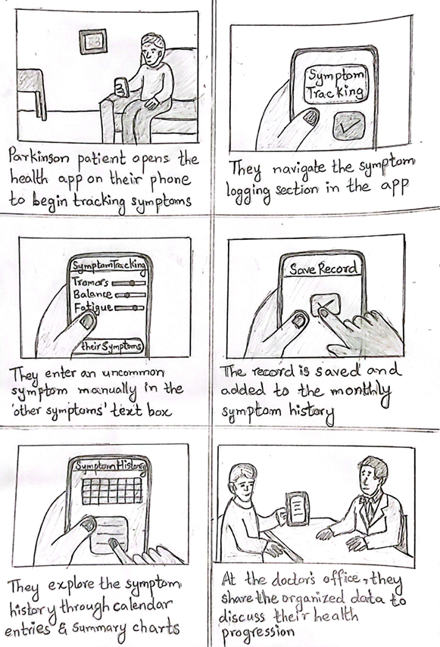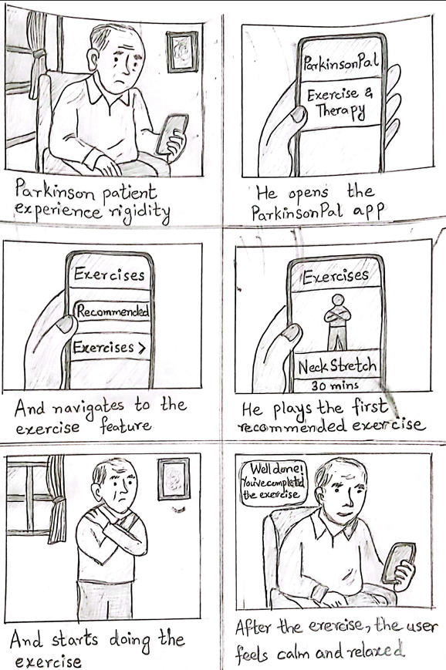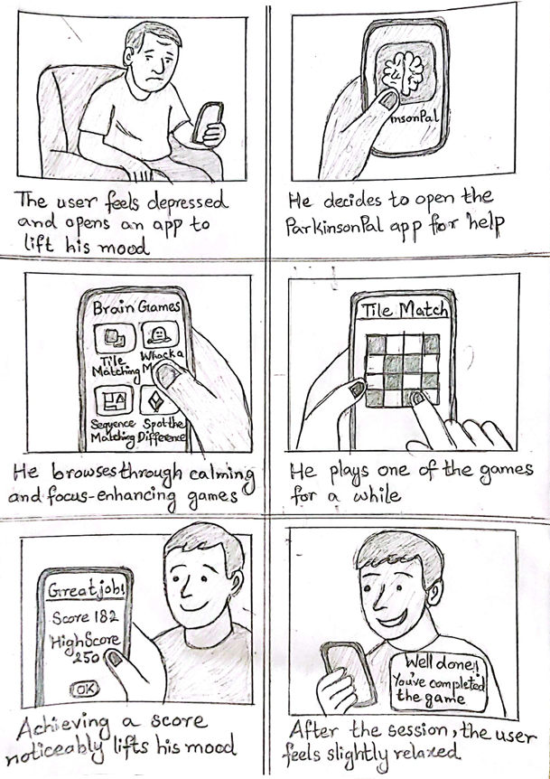
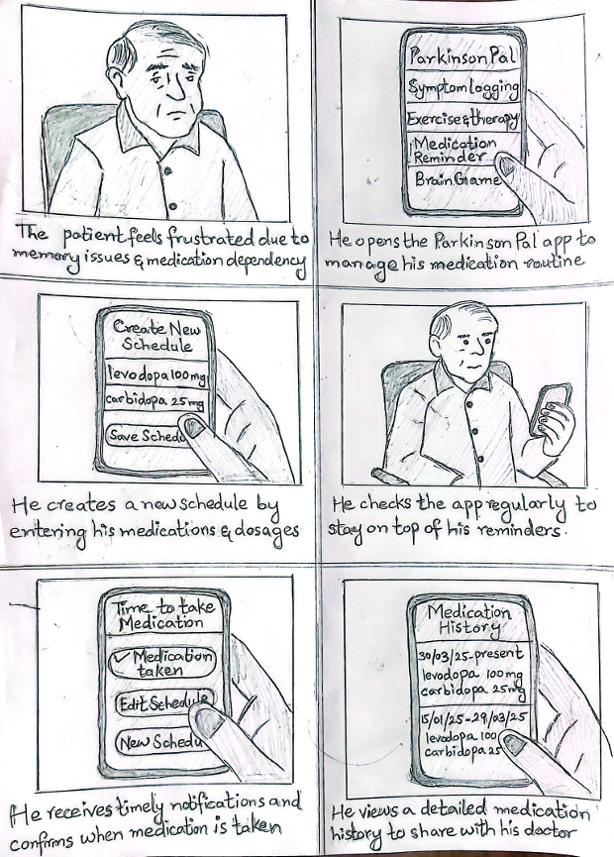
9. Low-fi prototyping (Process) – 15%
We designed the low-fi prototype keeping in mind the horizontal and vertical functionalities. The main focus of our low-fi was to focus and test the functionality and not really on the aesthetics. Similarly screens that were generally known such as settings and profile were not added in the low-fi and only shown in the nav bars. The buttons and anything that had to be clicked was however, made to size so that we can test that pressing these was not difficult and there weren't any accidental clicks.
Vertical Flows:
- Register
- Log In
- Track You Symptoms
- Medication Tracking
- Exercise and Therapy
- Brain Games

Horizontal Flows:
- Settings
- Profile
- Download Report (in ‘Track Your Symptoms’)
- Download Monthly Report (in ‘Medication Tracker)

Explanation of the prototype flow:
**NOTE:** The flow of the low-fi is from left to right.
Initial screen:
This is the main screen where a user lands when they open the app. They can either Register or Log In if they already have an account. All the dropdowns for the registration screen are shown.
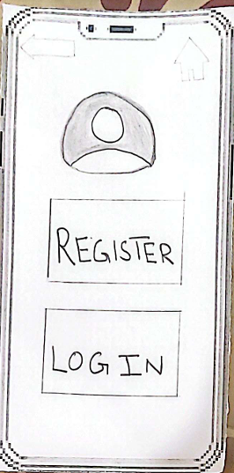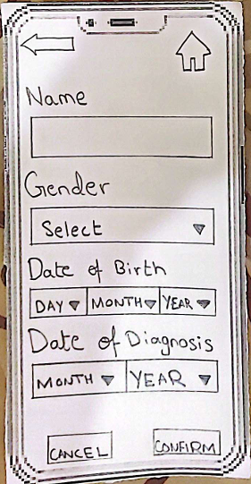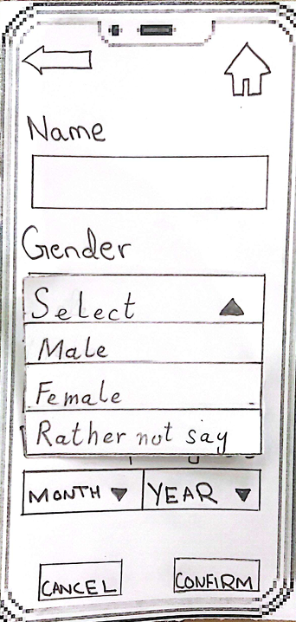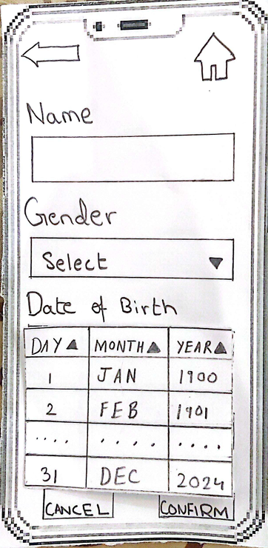

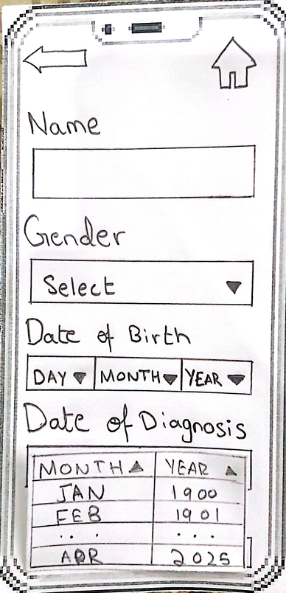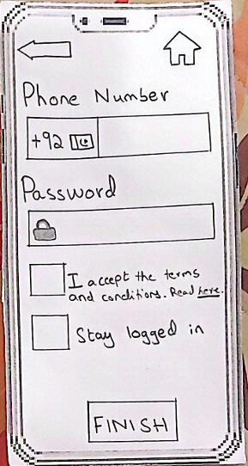

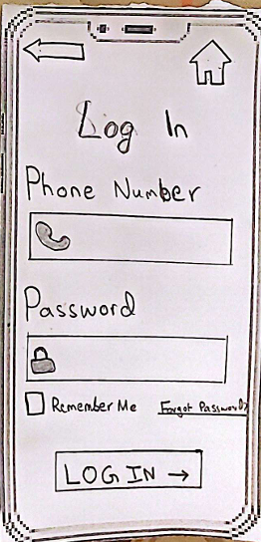

Main Landing Page:
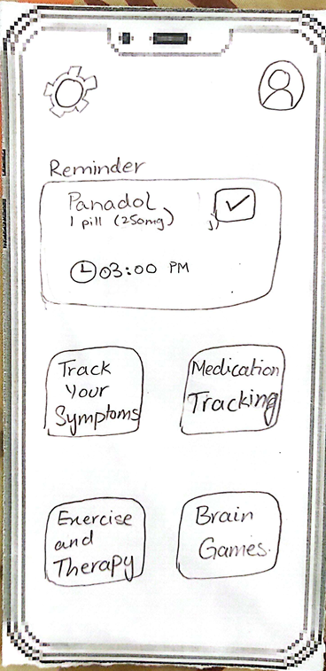

Track Your Symptoms flow:
- The landing page for this has 2 options: Symptom Logging and Symtpom History
- Symptom Logging allows users to track all their symptoms by rating the predefined categories and/or adding any additional symptoms.
- You can add your today’s or yesterday’s log in case you crossed the 2 hour mark.
- Symptom History allows users to view the history of their symptoms day wise or graphically (month wise).
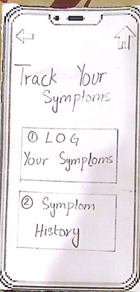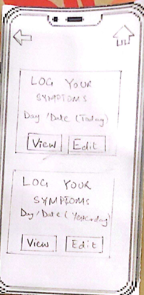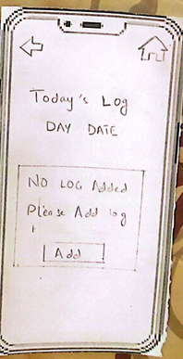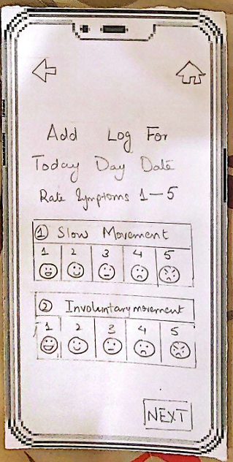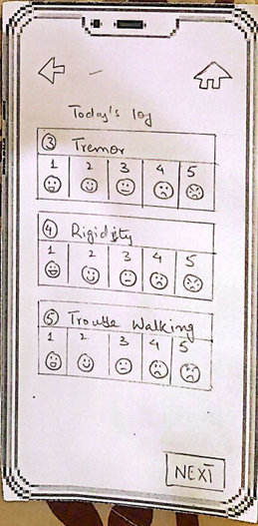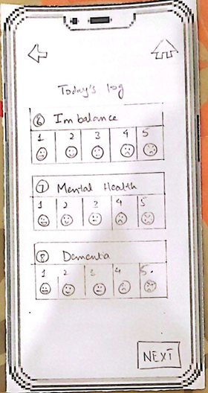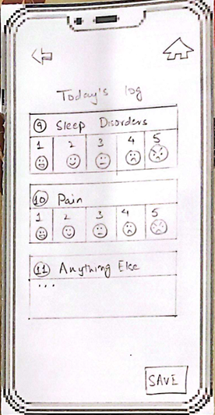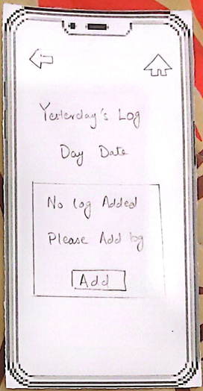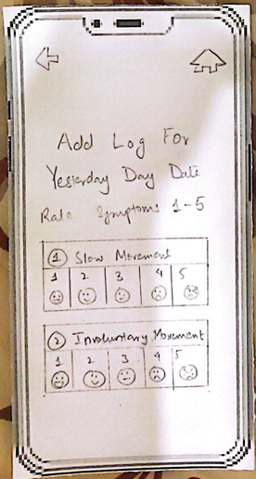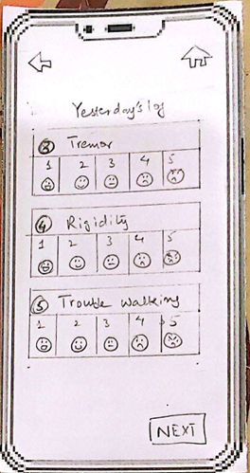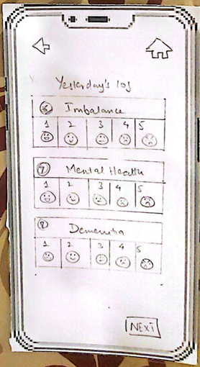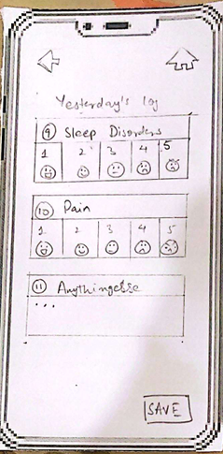

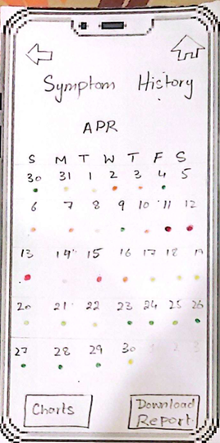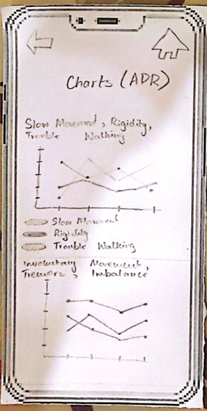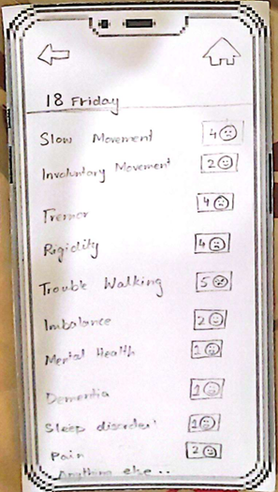

Medication Manager:
- This allows users to create a new schedule and also edit their existing schedule
- The ‘add new medicine’ in the ‘view medicine schedule’ → ‘Edit’ leads to the second image below and allows users to add a new medicine the same way they created a schedule (however they can't add multiple medicines at the same time).
- Track Medicine Schedule allows you to download the report (also not shown eact document that downloads).

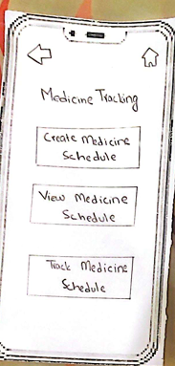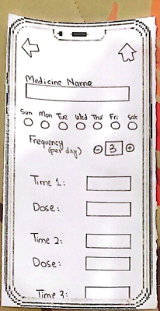
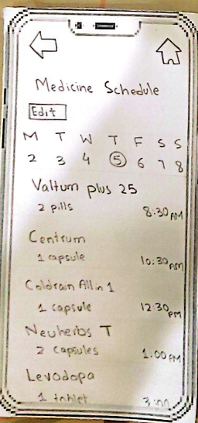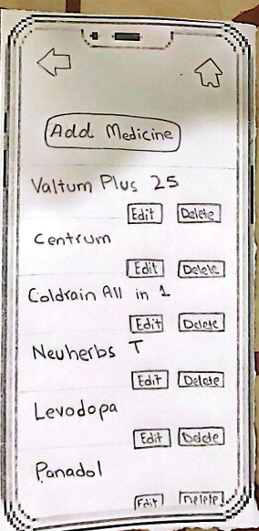

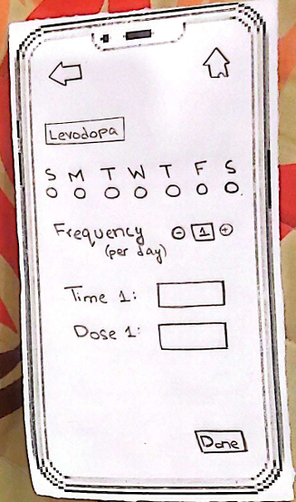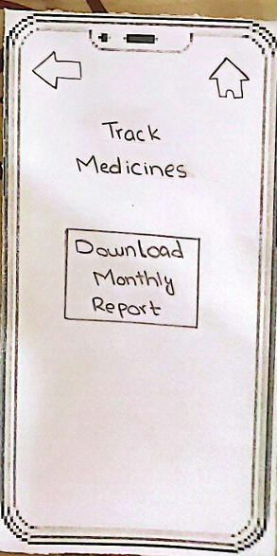
Exercise and therapy:
Note: did NOT make low-fi for every exercise and the video player screen WILL show RELEVANT exercise when clicked
- The main screen for this is scrollable as shown in the first 2 images below.
- The user can click on any of the recommended exercises and it leads to the video screen as done in image 3 (after selecting ‘high knee marching’ from the recommended section)
- The user can also choose a specific category and view the relevant exercises in the same way

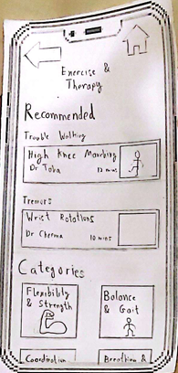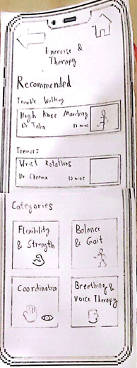
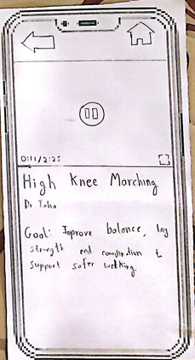

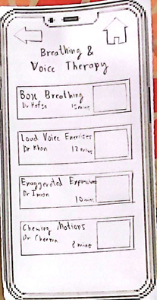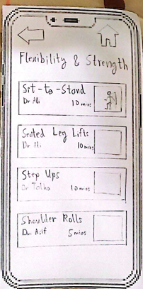

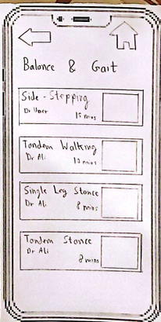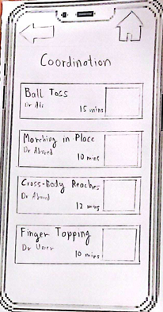
Brain Games:
- 4 games are available for users to play.
- each game leads to its instructions and the play button leads to the main game screen
- Back button leads to main Brain Games screen
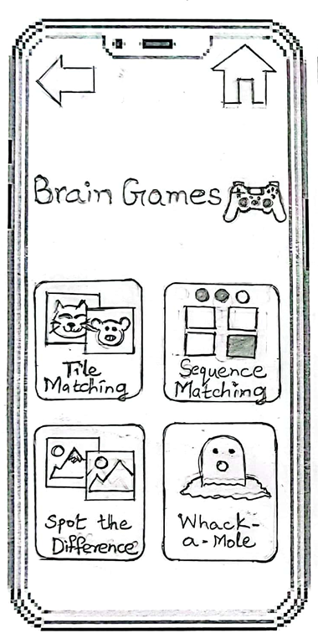

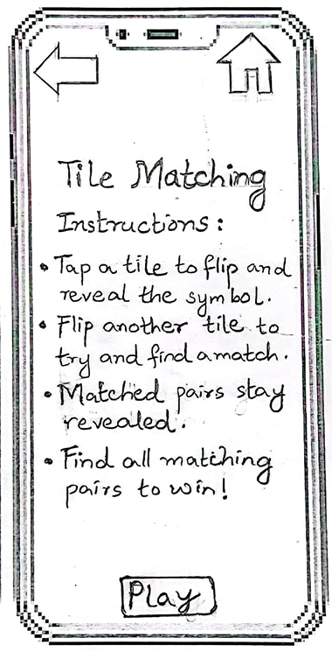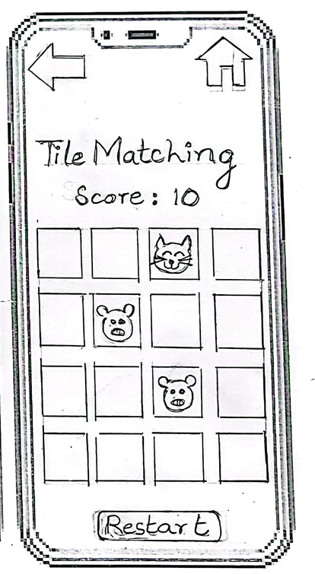
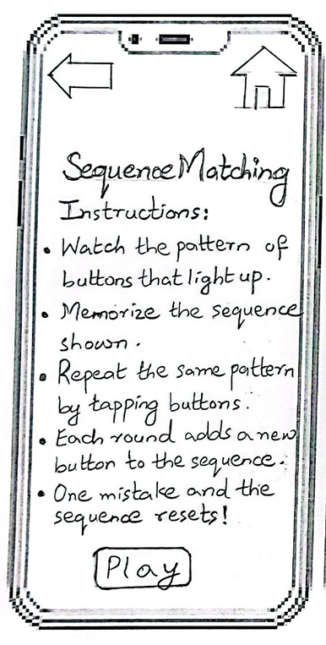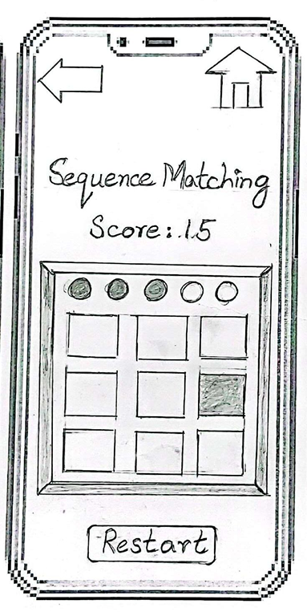
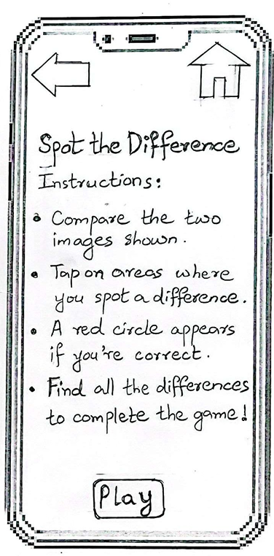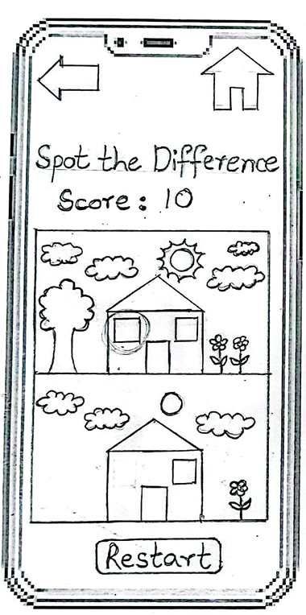

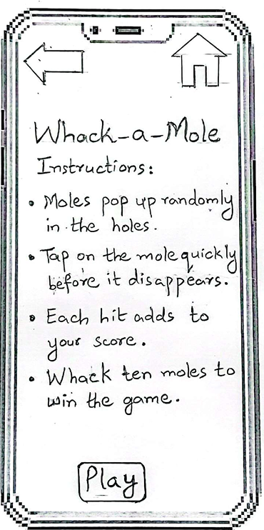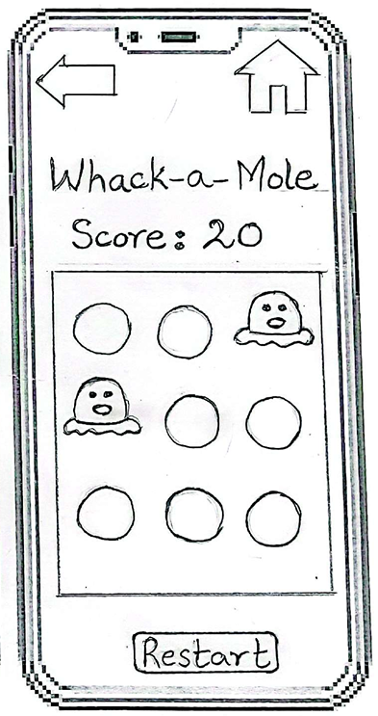

Notification Alert:
This is the alert for medication reminders. The tick button can be clicked if the user has taken the medication otherwise the pop up disappears after set time.
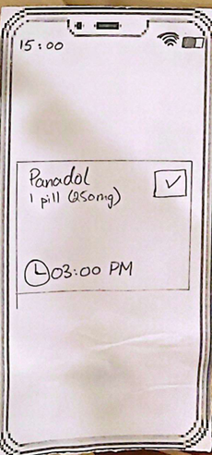

10. Results of paper prototype testing – 5%
- Naming of buttons was not ideal. ‘Medication Scheduler’ was difficult to comprehend. Changing it to ‘Medication Tracking’ was also not ideal since when told to set a medication reminder, most people got confused.
- Incorrect positioning of the buttons in ‘Create New Schedule’. When asked to add 3 medicines, people first clicked on save schedule and then on add medication as they were side by side and assumed that save schedule meant that they were saving the current medicine and would be provided the option to add another medicine later. Placing the buttons at different locations would help such as in google forms.
- There was a Back vs. Home button confusion as a lot of people, when asked to add their medication schedule after adding their symptoms after adding their symptoms, pressed the Back button instead of Home to return to the main screen. However, those who did use the Home button found the navigation very convenient.
- The circular buttons for selecting days were confusing to users. Hence, we decided to switch to square checkboxes as they provide a more intuitive and familiar conceptual model.
- Users found the term “Medicine Tracking” confusing. We decided to rename it to “Medication Manager”, as it was more descriptive of its purpose.
- Symptom tracking was generally well-received, though some users initially struggled to find their symptom history when asked to view it as the term Symptom Tracking did not imply a history view. However, since first-time users don’t have any symptom history, they instinctively explored the Track Your Symptoms feature and saw the two options: Log Your Symptoms and Symptom History. This helped improve navigation after minimal exploration.
- “Brain Games” was easy to use, required very few clicks and the instructions were also clear.
- Exercise and therapy sections, similar to Brain Games, were also easy to navigate and required a few clicks.
- The Recommended heading on top of the Exercise and Therapy screen confused one person. When asked to select a recommended exercise, they clicked on the Recommended label instead of the actual exercise boxes below. Adding shaded boxes around the exercises helped resolve the issue and improved clarity.

11. Final (hi-fidelity) Interface – 32%

Vertical Flows:
- Register
- Sign In
- Register (in urdu)
- Sign In (in Urdu)
- Track Your Symptoms
- Medication Manager
- Exercise and Therapy
- Brain Games
Horizontal Flows:
- Download (in ‘Track Your Symptoms → Symptom History’)
- Download Monthly Report (in ‘Medication Manager → Track Medicines’)
- Settings
- Profile
- Urdu Screens
- Accessibility Features (inbuilt iphone accessibility)
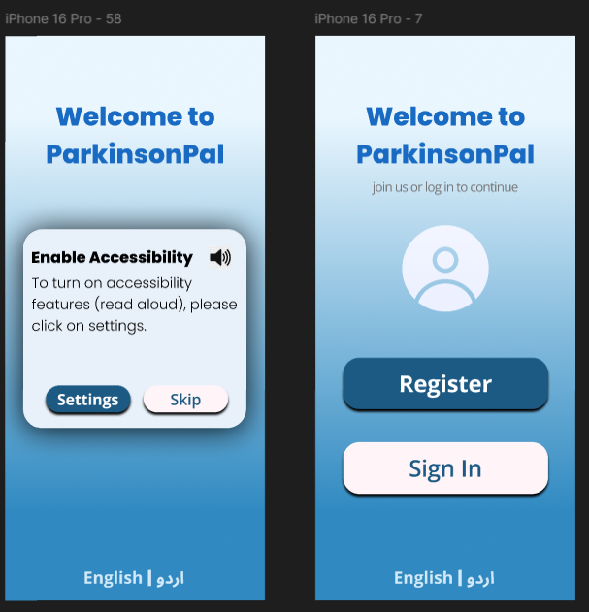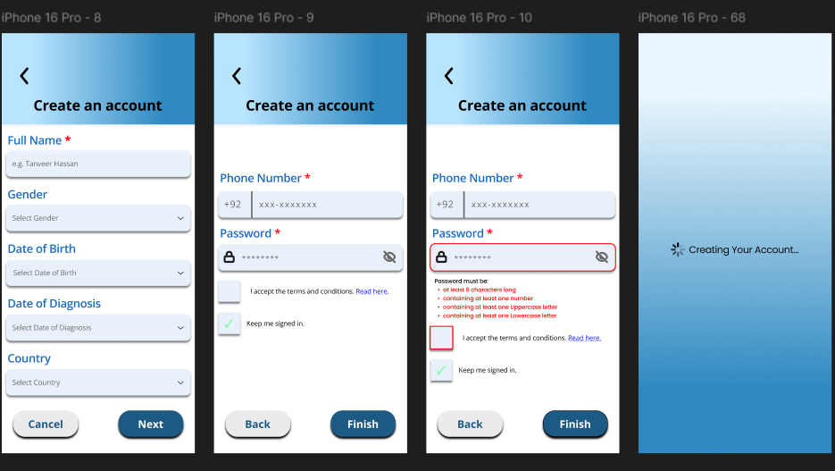
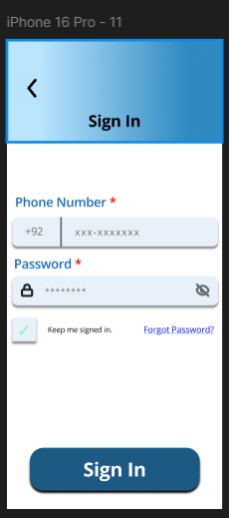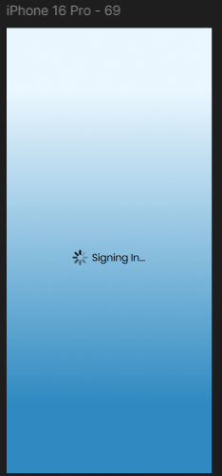
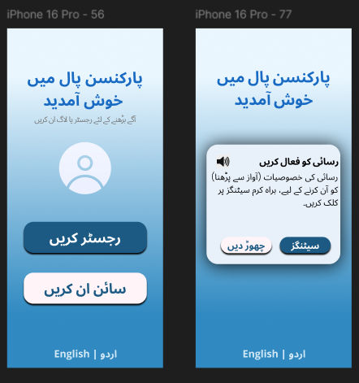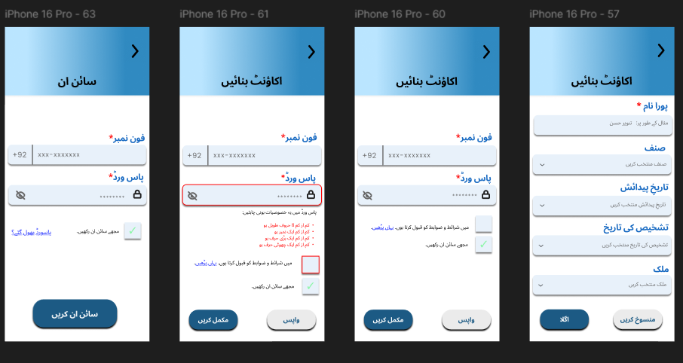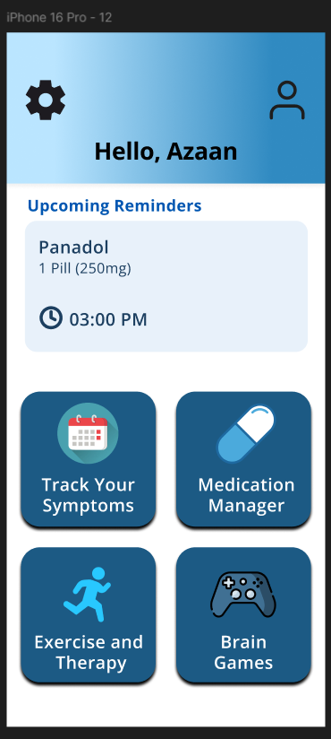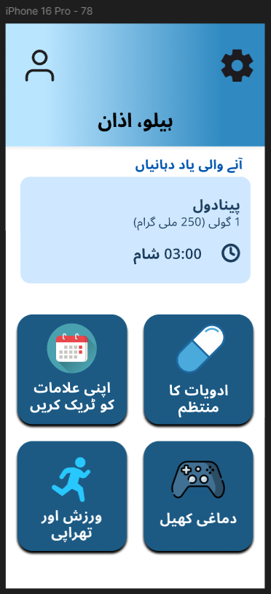
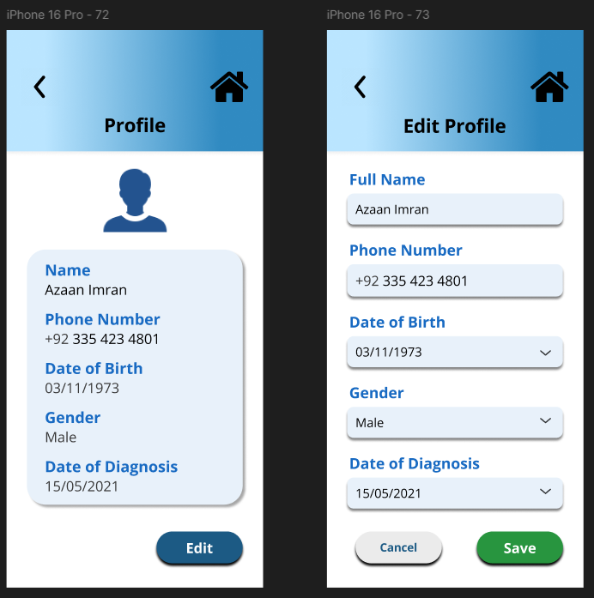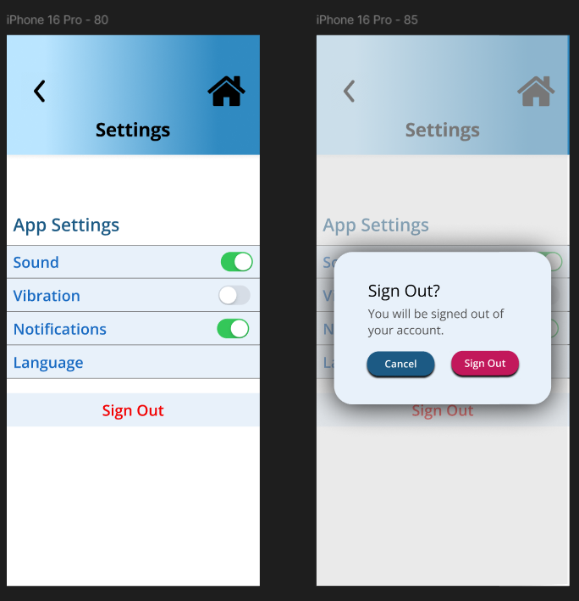
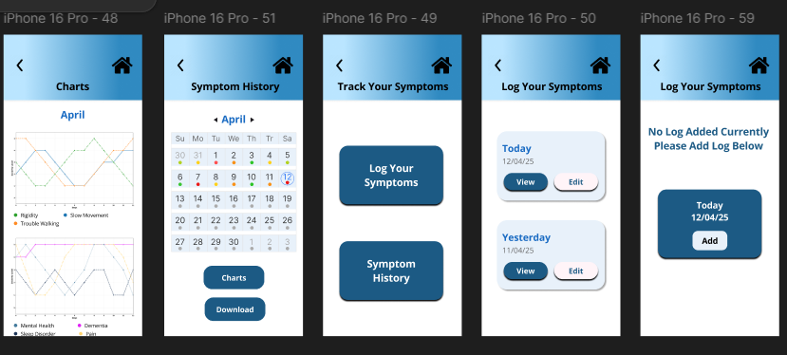
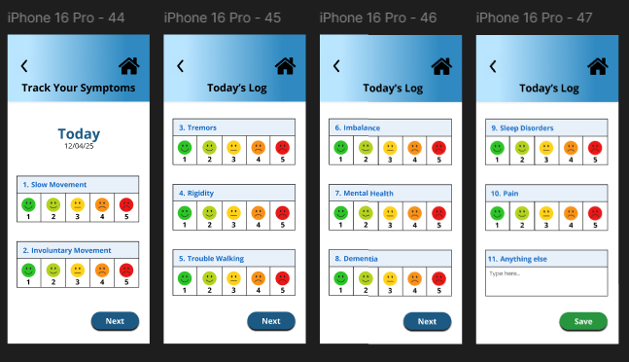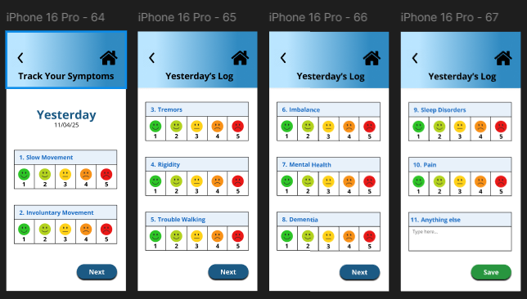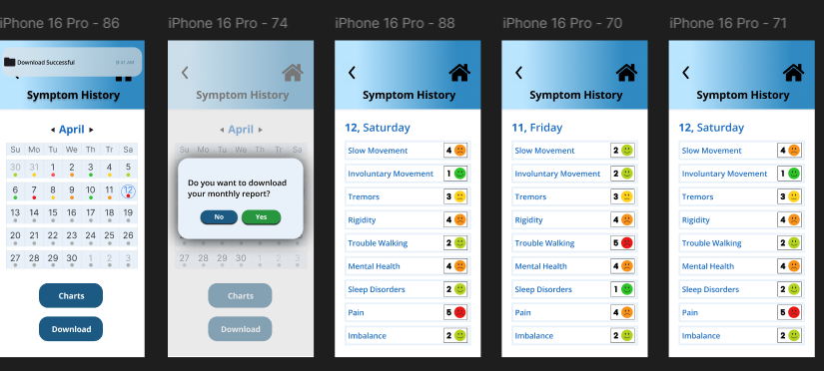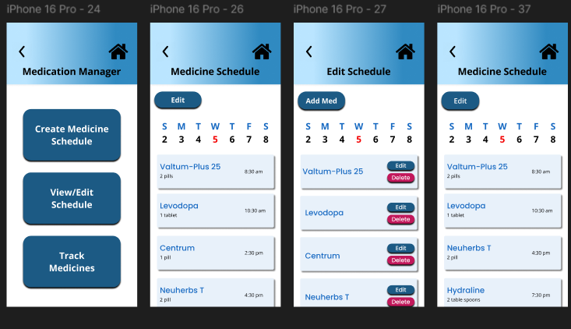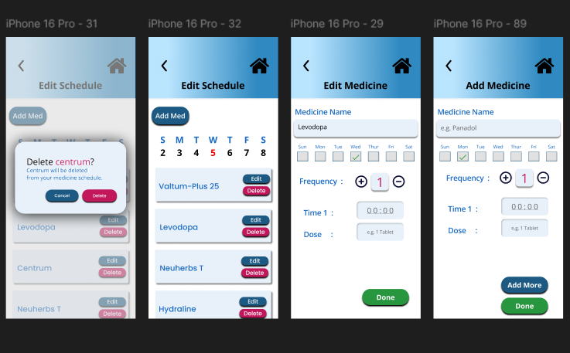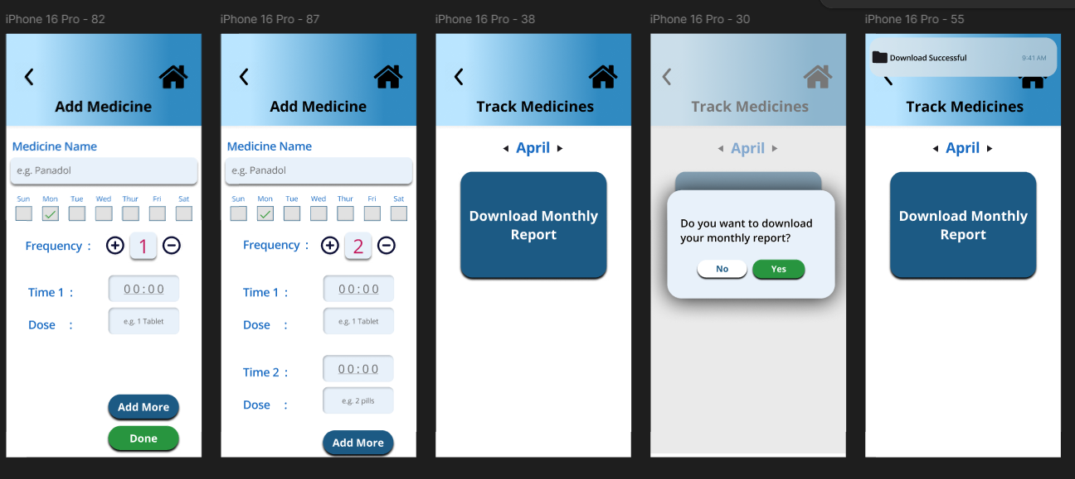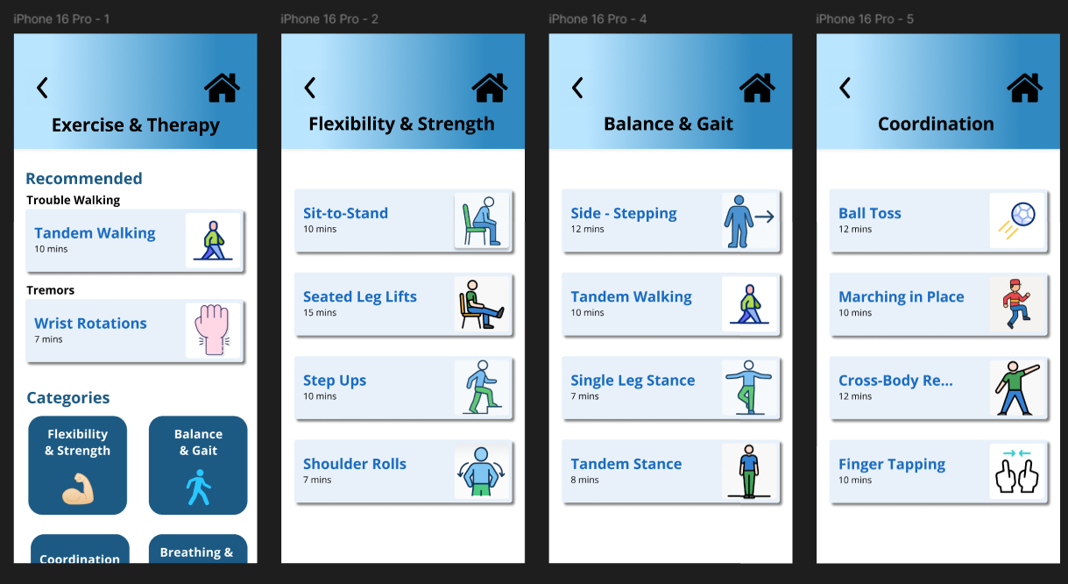
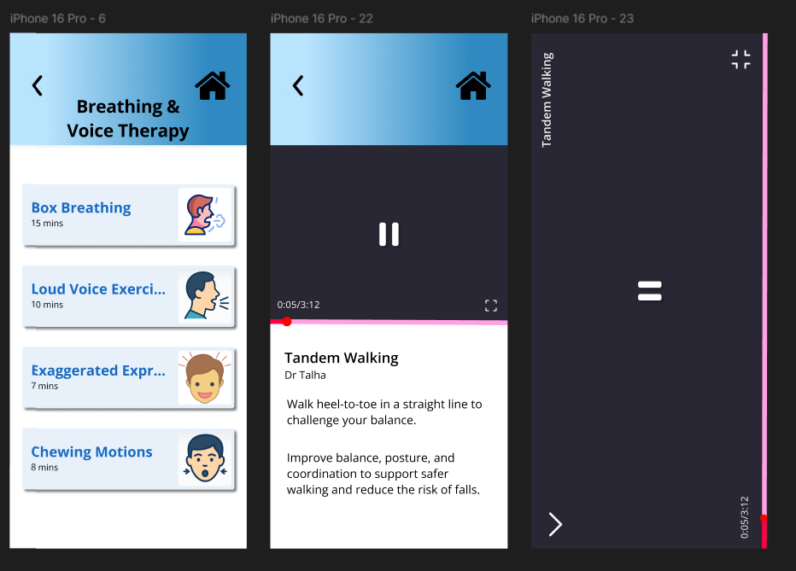
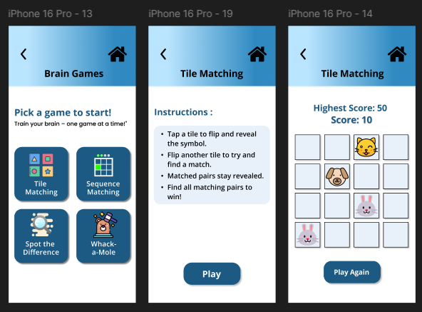
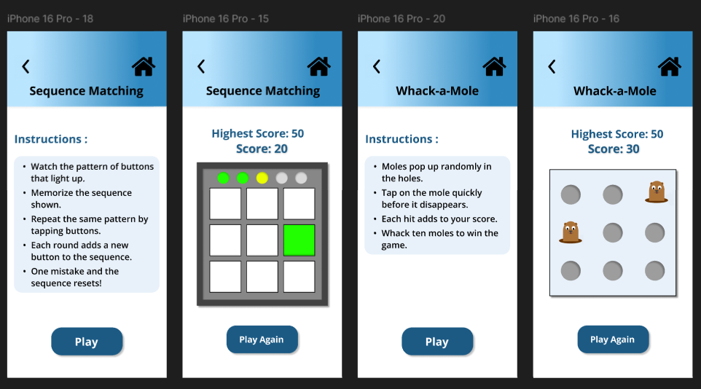
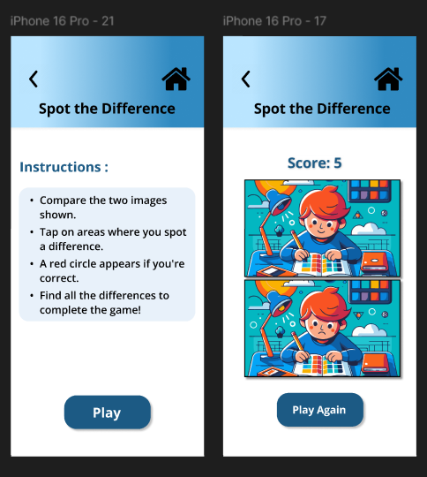

Visual Design Guidelines
Color Scheme:
- Primary Color: #1C5A84
- Secondary Color: #E8F1FA
- Accent Color: #186AC2


We chose the above colors for our screen as they are vibrant yet not too bright. They were also chosen by keeping the Pakistani/ South Asian context in mind. Initially, we had opted for shades of pink and a brighter red. However, considering our target demographic, we found those choices to be less suitable and decided to go with a more balanced palette. The colors create a good contrast specifically with black and white text in some places to highlight the important things
Green (#28953F) in different places to highlight when the user decides to submit a form or finish adding details.
Red (#C2185B) to signify caution. Highlights delete or remove buttons.

Typography:
Font type: Open Sans
We used Open Sans as a Sans-Serif font which is ideal for elderly since the font is easier to read with bright screens. The letters are more spaced out and each letter is not as narrowly spaced. The font has wider letter spacing and clear character shapes, making each letter easier to distinguish.
Font Size:
All fonts are above 14 which is the minimum ideal font for elderly.
Headings (header bar): 30 (Bold)
Buttons: Mixed

Principles of Graphic Design
- Simplicity
- Clutter-free screens to prevent the user from getting intimidated.
- Recognizable icons (back, home, profile, plus and minus for frequency) for transfer of knowledge in head vs knowledge in the world.
- Consistent design for easy usage.
- Soft colour scheme (blues) to reduce visual pressure.
- Contrast
- Use of different colours to highlight buttons (e.g. red for “delete”, green for “yes”, separate colours for moods in symptom tracking).
- Use of different font sizes (eg. larger font for headings, smaller for regular text) so headings can be differentiated.
- Use of bold to highlight important text.
- One-click only for important functions (e.g. home, profile, settings).
- Inner shadow in buttons to show text can be entered (eg. bos on right side of Dose)
- White Space
- Used to form groups (e.g. Time 1 and Dose placed close together to show that they are related).
- Used to leave margin
- Used to prevent crowding of controls (e.g. Add Med button on Edit schedule
- Balance
  - Left aligned content for easy structure
  - Layouts are mostly symmetric to evenly divide visual weight
  - Asymmetric layouts are catered to with colours or contrast elements to balance visual weight
  - Reading flow maintained (e.g. top left to bottom right for English screens and top right to bottom left for Urdu screens)
- Alignment
  - Same baseline for labels and buttons (e.g. frequency and its button)
  - Left aligned for English screens as text is left aligned
  - Right aligned for Urdu screens
  - Controls are aligned on left and right sides to maintain visual order (e.g. back and home buttons)
- Consistency
  - same rules for design are followed across screens
  - same button styles across different screen (e.g. “Next” )
  - same colours used (e.g. green for “Yes” and “Done” buttons)
  - same font used across all screens (Open Sans)

UI Documentation

Overview

The app’s user interface (UI) is designed with a focus on accessibility, simplicity, and user-friendliness — especially for elderly users or individuals with Parkinson’s Disease. It follows a minimalist and consistent layout, ensuring low cognitive load and smooth interaction across screens.

Design System

Typography

- Primary Font: Open Sans (Sans-serif)
- Reason: Highly legible, well-spaced, and accessible for older users. Clean character shapes help reduce reading fatigue and misinterpretation.
- Usage:
- Headings: Bold, 20–24 pt
- Body Text: Regular, 16–18 pt
- Buttons & Inputs: Semi-bold, 16 pt

Color Scheme

Color Role | Color (Example) | Purpose
Primary | #6A5ACD (Soft Indigo) | Used for buttons, highlights, key actions
Secondary | #B0C4DE (Light Steel Blue) | Used for secondary actions or support text
Accent | #F08080 (Muted Coral) | Alerts, warnings, or emotional cues
Background | #FFFFFF / #F8F9FA | Light backgrounds to improve readability
Text | #000000 / #333333 | High contrast text colors for legibility

Core Screens & Components

Welcome & Accessibility Prompt

· Displays a prompt for accessibility settings before the registration screen.
· One-click redirects the user to the respective accessibility settings of the operating systems. VoiceOver for iOS, TalkBack for Android.
· Choice of the user to either skip the prompt or redirect to the accessibility settings.

Home Screen

· Central homepage with large and labeled buttons for navigating through the various features.
· Icon-labeled features on the buttons that include Medication Manager, Symptom Tracker, Brain Games and Exercises & Therapy.
· Home icon on all screens to easily return to the home screen.

Medication Manager

· Allows users to log daily medication and create a schedule by easily ticking checkboxes for the days and the prescribed medicines.
· Entries store the Name, Time and Dosage of the respective medicine and allows tracking of the pill count on a monthly basis.
· Simple input options for ease of use for the users.

Track Your Symptoms

· Users can log their symptoms (motor & non-motor) on a 1-5 scale with color-coded emojis for better understandability.
· Green – Good, Yellow – Moderate, Red – Severe
· Allows user to add other logs as well via the text/microphone input boxes.

Brain Games

· Choice of games for cognition exercise.
· Simple, labeled and high contrast visuals games.
· Game progress visualized clearly.

Exercise & Therapy

· Categories of video exercises to aid in physical activity and therapy.
· Recommended videos based on user’s symptom history.
· In-App video player to eliminate external redirections.

Interaction & Behavior

Feature | Implementation Highlights
Button Size | Minimum 100x40 pt
Touch Target Padding | At least 12–24 pts between interactive elements
Voice Input | Native iOS/Android microphone support for logging data
Font Scaling | Compatible with Dynamic Type / OS-level text scaling
Reduce Motion Support | No flashing lights or rapid animations
Home Shortcut | Available on all screens to reduce navigation complexity

Device Support

Platform | Support Notes
iOS | Full support for VoiceOver, Siri Shortcuts, Read Aloud
Android | Supports TalkBack, Switch Access, and voice input
Tablets | Responsive layout with scalable UI elements

Final Notes

All visual elements have been tested with accessibility inspectors and contrast checkers. We continue to iterate the design based on user feedback, especially from elderly test users.

Accessibility in Our App

We firmly believe that the advantages of technology should be enjoyed by everyone, regardless of their physical, visual, cognitive, or auditory abilities. As a result, we designed our application with inclusiveness and ease of use at its core, including accessibility features that ensure a seamless and comfortable experience for all users, including those living with diseases such as Parkinson's disease.
Key Accessibility Features

Intuitive & Effortless Navigation

- A Home icon is present on every screen, minimizing the number of taps needed to return to the main dashboard.
- Navigation follows predictable, familiar patterns to reduce cognitive load and ensure ease of use.
- Buttons are clearly labeled and actions are simple, with minimal need for multi-step gestures or hidden functionality.

Cognitive & Motor-Friendly Design

- All buttons and touch targets are large that reduce the chances of accidental taps — especially helpful for users that experience tremors or have limited dexterity.
- UI elements are appropriately spaced out to prevent clutter and enable users focus on one task at a time.
- We minimize fast-moving or animated elements to accommodate those with motion sensitivity or cognitive impairments.

iPhone Read Aloud Support (VoiceOver)

- Before users register, they are redirected to their iPhone’s Accessibility Settings, where they have the option to enable features like VoiceOver, Speak Screen, or other iOS-native read-aloud options.
- For users with low vision, the app uses standard system components to ensure full compatibility with VoiceOver and similar Android screen readers, allowing to navigate the app independently.

Voice Input via Microphone

- The app supports Apple’s built-in microphone input for iOS and Google voice input for Android, letting users fill forms or log data using voice — especially useful for those with limited fine motor control.
- We ensure microphone permissions are requested clearly and only when necessary, respecting user privacy and control.

Readable, Clean Typography

- We use Open Sans, a highly legible sans-serif font, chosen for its readability on bright screens and suitability for elderly users.
- The font features wide spacing and distinct character shapes to reduce misreading and eye strain.

Visual Accessibility

- The app uses high-contrast colors and avoids relying solely on color to convey meaning.
- Emojis and visual indicators are paired with colors to help users with color blindness or visual challenges interpret feedback effectively.

Designed to Adapt

Our app supports and respects the accessibility features users enable at the system level:
- VoiceOver, AssistiveTouch, and Full Keyboard Access on iOS
- TalkBack and Switch Access on Android
- Reduce Motion settings are automatically supported by minimizing excessive animations and avoiding motion-based transitions.

Summary of Accessibility Enhancements

Feature | Accessibility Benefit
Large buttons & generous spacing | Reduces accidental taps; supports limited dexterity
Sans-serif font (Open Sans) | Improves readability for elderly and low-vision users
VoiceOver & Screen Reader support | Enables use without needing to see the screen
System microphone input | Supports voice-based input to reduce typing strain
Home icon on every screen | Reduces navigation complexity
Visual indicators + color coding | Helps those with color vision deficiency

Major Design Decisions:
General:
- Added a home button to each screen to make it easier for the users to navigate back to the main screen when done with a task, this allows for fewer clicks to reach a screen.
- Kept the back button to make sure that users can go back to the previous screen where necessary.
- Made sure to use scrolling sparingly across the screens and mostly navigate through clicking, as scrolling becomes more difficult with the progression of age and the tremors.
- Decided to use inbuilt accessibility features but decided to redirect the users to their settings. All phones have keyboards with builtin microphones so while we also used text fields sparingly, they can use their microphone for speech to text.
- Different colored boxes to ensure that the ones that are clickable and the ones that are not are differentiable such as the upcoming reminders box is #E8F1FA while the buttons below which are clickable are in #1C5A84.
- We have not added the complete flow for Urdu screens and have only shown a single flow.
Register/ Sign In:
This screen came about by careful discussion, and while it would have been easier that a user does not have to spend time registering on an app and typing out some of the details, it is necessary for privacy reasons considering that the app records confidential information about the patient's medical history and current reports. It was also necessary to create the sign in option in case a user changes phones, they should not lose any data that they had stored previously.
Register:
- Choosing the gender, date of birth and date of diagnosis is through dropdowns where a user can simply select the date, month and year.
- We used phone numbers instead of emails for registering as most elderly in Pakistan do not have email accounts and prefer using WhatsApp since it's connected to their mobile numbers.
Track Your Symptoms:
- Tracking of symptoms is done through ratings which makes it easier for users to quantify their experienced symptoms. The ratings include color-coded emojis that visually indicate the scale from good to worse.
- Using calendars for symptom history brings in knowledge in the head as in the normal iphone and samsung calendars you can click on different dates and it tells you the events on that day. Similarly, the color coded average ratings of the day is similar to the colors used on the ratings page so they have a general overview of how that day was on average.
Medication Manager:
- We added 3 different categories in the medication manager. Creating a separate create new schedule helps the user in creating a new schedule from scratch if most of their medications have been changed or it's the first time they are entering their schedule. In the hi-fi prototype, we also renamed the medication scheduler to Medication Manager, as it better reflects the feature’s comprehensive functionality, including scheduling, tracking, and reminders.
- In Track Medicines, we used the calendar style changing of month as people generally have the mental model for that. We also added arrows to represent that either by swiping left or right or by clicking on the arrows, we can change the month.
- Whenever a user has to add a new medicine they have clickable text boxes instead of icons to ensure that they know what the button does. Symbols can be confusing for elderly as it relies too much on knowledge in the head.
- First we had the placement of ‘Add More’ and ‘Done’ side by side which was confusing as people have the mental model to save a medication before adding a new one. Placement of the buttons is now done so that the users know that if they want to add more than one medication while creating their schedule they have to click on add more and not save each one simultaneously. The buttons are also colored differently: ‘Done’ is in green as green is conventionally used when something is finalized.
Exercise and Therapy:
- Initially, the exercise and therapy had a button for ‘Recommended’ that when clicked displayed all the recommended exercises. This however did increase the clicks hence we ended up removing that and displaying all the recommended exercises on the main screen.
- We also had a lot of discussion over having the categories or not in the hi-fi, as some of us wanted to only keep the recommended section, but we ended up keeping them in case someone wants to use the app to exercise everyday apart from the recommended ones.
Brain Games:
- Initially we had named this mental health/cognition. However, considering the stigma around depression and anxiety in Pakistan/South Asian countries made it more feasible. Naming it brain games shifted the focus from ‘therapy’ to something that intrinsically improves mental health and activity.
- We also were not sure if the instructions should show each time that the player clicked on a game or just have a separate button where they can view the instructions on the main screen. Considering that elderly with PD often report forgetting stuff we decided that the instruction should show up every time before the user plays a game. While it increases clicks, it avoids any confusion in the game or any clicks or clutter on the game screen.

References
Desotell, N. (2022, July 7). Is it worth it? Insomnia-curing app – Sleepio review. GenTwenty. https://gentwenty.com/sleepio-review/
Enabled. (n.d.). Chalte Raho – Parkinson’s patients walking stick. https://enabled.in/wp/chalte-raho-parkinsons-patients-walking-stick/
Landers, M. R., & Ellis, T. D. (2020, October 5). A mobile app specifically designed to facilitate exercise in Parkinson disease: Single-cohort pilot study on feasibility, safety, and signal of efficacy. JMIR mHealth and uHealth, 8(10), e18985. https://mhealth.jmir.org/2020/10/e18985/
Lee, J., Yeom, I., Chung, M. L., & Kim, Y. (2022). Use of mobile apps for self-care in people with Parkinson disease: Systematic review. JMIR mHealth and uHealth, 10(1), e33944. https://mhealth.jmir.org/2022/1/e33944
Mascheroni, A., Choe, E. K., Luo, Y., Marazza, M., Ferlito, C., Caverzasio, S., Mezzanotte, F., Kaelin-Lang, A., Faraci, F., Puiatti, A., & Ratti, P. L. (2021, June 8). The SleepFit tablet application for home-based clinical data collection in Parkinson disease: User-centric development and usability study. JMIR mHealth and uHealth, 9(6), e16304. https://mhealth.jmir.org/2021/6/e16304
My Moves Matter. (2025a, February 10). Parkinson’s UK Tech Guide. https://techguide.parkinsons.org.uk/catalogue/my-moves-matter#trustedReviews
Neuro Heroes. (2025, February 6). Parkinson’s UK Tech Guide. https://techguide.parkinsons.org.uk/catalogue/neuro-heroes
Orozco, J. L., Valderrama-Chaparro, J. A., Pinilla-Monsalve, G. D., Molina-Echeverry, M. I., Pérez Castaño, A. M., Ariza-Araújo, Y., Prada, S. I., & Takeuchi, Y. (2020, July 10). Parkinson’s disease prevalence, age distribution and staging in Colombia. Neurology International, 12(2), 47–55. https://pmc.ncbi.nlm.nih.gov/articles/PMC7378539/
Parkinson’s On. (2025b, February 6). Parkinson’s UK Tech Guide. https://techguide.parkinsons.org.uk/catalogue/parkinsons-on
Pacific Neuroscience Institute. (n.d.). Wrist band helps control hand tremors in essential tremor patients. https://www.pacificneuroscienceinstitute.org/blog/essential-tremor/wrist-band-helps-control-hand-tremors-in-essential-tremor-patients/
Steadiwear. (n.d.). https://steadiwear.com/
Utility stick for Parkinson’s patient. (n.d.). National Innovation Foundation – India. https://nif.org.in/innovation/utility-stick-for-parkinsons-patient/886
Amazon India. (n.d.). Atharva Concepts Easy Walk Parkinson’s. https://www.amazon.in/Atharva-Concepts-Easy-Walk-Parkinsons/dp/B0785NS36J

