**NATIONAL UNIVERSITY OF COMPUTER AND EMERGING SCIENCES-FAST**

**KARACHI CAMPUS**



**COURSE INSTRUCTOR(s):**

**Sir Farukh Shahid/Sir Sohail Ahmed**

**AI4002/AL4002-Computer Vision**

**TITLE:  
 Classification of Radiological Images using EfficientNetB0 with Transfer Learning**

**SUBMITTED BY:**

**20K-0141(Ali Iqbal)**

**20K-1099(Ahmad Azaan)**

**20K-1801(Mujtaba Ahmed)**

**SECTION: Bs (AI)-7A**

**Acknowledgement**

We came up with this idea with the help of our course teachers Sir Farukh Shahid & Sir Sohail Ahmed and some web search. Stack overflow and Kaggle website had many different ideas related to the project that we could work on and basically provided us with some core Image Classification ideas that we could modify and then implement so we as a group decided to go for it since it was quite comprehensive. Apart from efforts of all the team members, the section of this project report topic depends largely on the encouragement and guidance provided by our teachers. We take this opportunity to express our gratitude to the teachers who have been instrumental in the approval of this topic.

**1. Introduction**

**1.1 Background**

The computer vision project aims to address the challenges associated with medical image classification, specifically in the domain of radiology. The focus is on leveraging state-of-the-art convolutional neural networks (CNNs) and transfer learning to enhance the accuracy and efficiency of image classification tasks.

**1.2 Objectives**

* Implement a deep learning solution for medical image classification.
* Utilize transfer learning with EfficientNetB0 pre-trained on ImageNet.
* Train the model to classify images into three categories: brain, chest, and lung.
* Evaluate model performance using various metrics.
* Users can leverage a Django-based user interface featuring widgets for easy image uploads and instant result viewing.
* Enhance understanding of CNNs, transfer learning, and practical application in healthcare.

**2. Dataset**

**2.1 Data Collection**

**2.1 Dataset Collection/Definition:** The dataset used in this computer vision project, termed "Radiology," was collected and organized into two main subsets: "train" and "test." These subsets contain medical images categorized into three classes: brain (MRI), chest (X-ray), and lung (CT scan). The dataset was obtained from the Kaggle environment, and it is a curated collection representing real-world medical scenarios.

* **Source:** Kaggle
* **Folders:**
  + Train
    - Brain (MRI)
    - Chest (X-ray)
    - Lung (CT Scan)
  + Test
    - Brain (MRI)
    - Chest (X-ray)
    - Lung (CT Scan)
* **Total Images:** 8300
* **Total Size:** 812 MB

**2.2 Data Preprocessing**

The preprocessing steps for the dataset were crucial to ensure the effectiveness of the computer vision model. The following preprocessing steps were applied:

* **Image Loading:**
  + Images were loaded using the OpenCV library.
  + Resizing: Images were resized to a standardized dimension (150x150) to maintain consistency.
* **Labeling:**
  + Labels were assigned to each image based on the folder structure.
  + Three classes: Brain, Chest, Lung.
* **Shuffling:**
  + The dataset was shuffled to introduce randomness and prevent the model from learning the order of images.
* **Train-Test Split:**
  + The dataset was split into training and testing sets using the **train_test_split** function from scikit-learn.
* **Normalization:**
  + Pixel values of images were normalized to a range between 0 and 1 to facilitate model convergence.
* **One-Hot Encoding:**
  + Categorical labels were converted into one-hot encoded vectors for model training.

These preprocessing steps laid the foundation for effective model training, ensuring that the images were appropriately formatted and the labels were suitable for a multi-class classification task.

**3. Methodology**

**3.1 EfficientNetB0 Transfer Learning**

EfficientNetB0, a state-of-the-art deep learning model, was chosen as the backbone for this computer vision project. Transfer learning was employed to leverage the knowledge gained by EfficientNetB0 from the ImageNet dataset. The model was fine-tuned for the specific task of classifying medical images into three categories: Brain (MRI), Chest (X-ray), and Lung (CT Scan).

**3.2 Computer Vision Model**

The computer vision model architecture was constructed by adding custom layers on top of the pre-trained EfficientNetB0. The key components of the model include:

* **GlobalAveragePooling2D:**
  + Spatial dimensions were reduced using global average pooling.
* **Dropout Layers:**
  + Dropout layers were incorporated to prevent overfitting. Neurons were omitted at random during training.
* **Dense Layers:**
  + Dense layers with ReLU activation were added for feature extraction.
* **Output Layer:**
  + The output layer with SoftMax activation categorized the images into the three classes.

This architecture allowed for effective feature extraction and classification, capitalizing on the pre-trained weights of EfficientNetB0.

**3.3 Model Training and Evaluation**

The model was trained using the training dataset with callbacks, including TensorBoard for visualization, ModelCheckpoint for saving the best model, ReduceLROnPlateau for dynamically adjusting the learning rate, and EarlyStopping to prevent overfitting. The training process involved 12 epochs, batch size=32, and 14 steps per epoch.

Following training, the model was evaluated on the testing dataset. Predictions were generated using the **argmax** function to identify the index associated with the predicted class. The model's performance was assessed using classification metrics, including accuracy, precision, recall, and F1-score. Additionally, a confusion matrix was visualized to gain insights into the model's classification tendencies.

This methodology ensured a robust and well-evaluated computer vision model for the classification of medical images.

**4. Results**

**4.1 Model Performance**

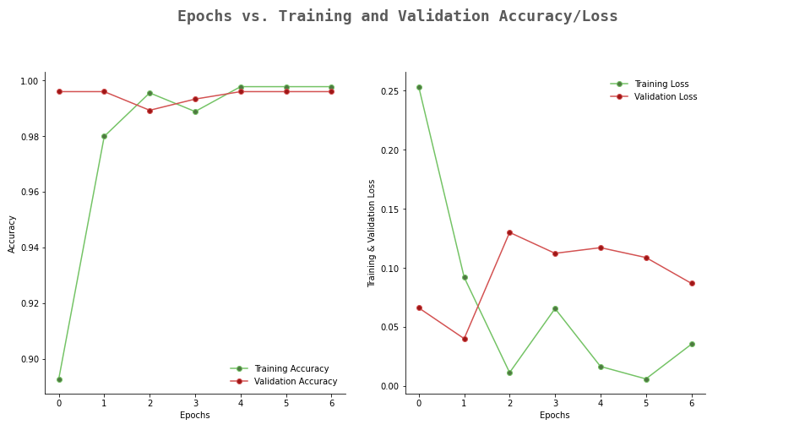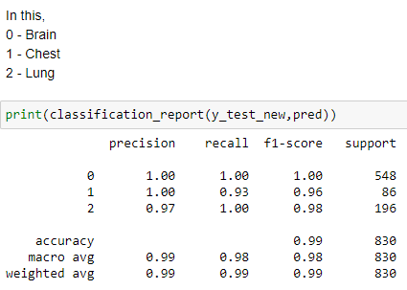The accuracy and other relevant metrics for each algorithm are summarized below:

**Testing an image**

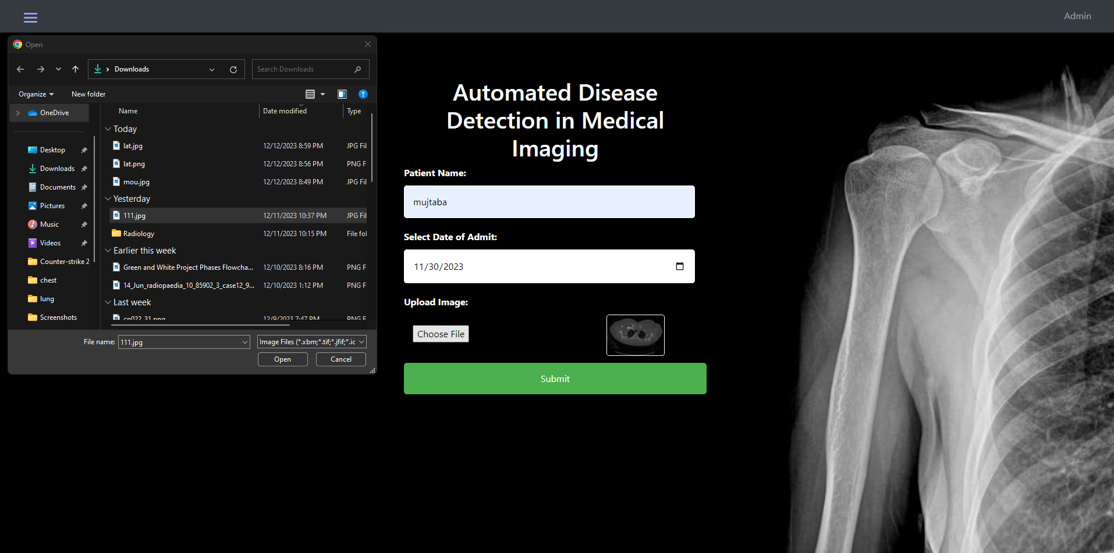 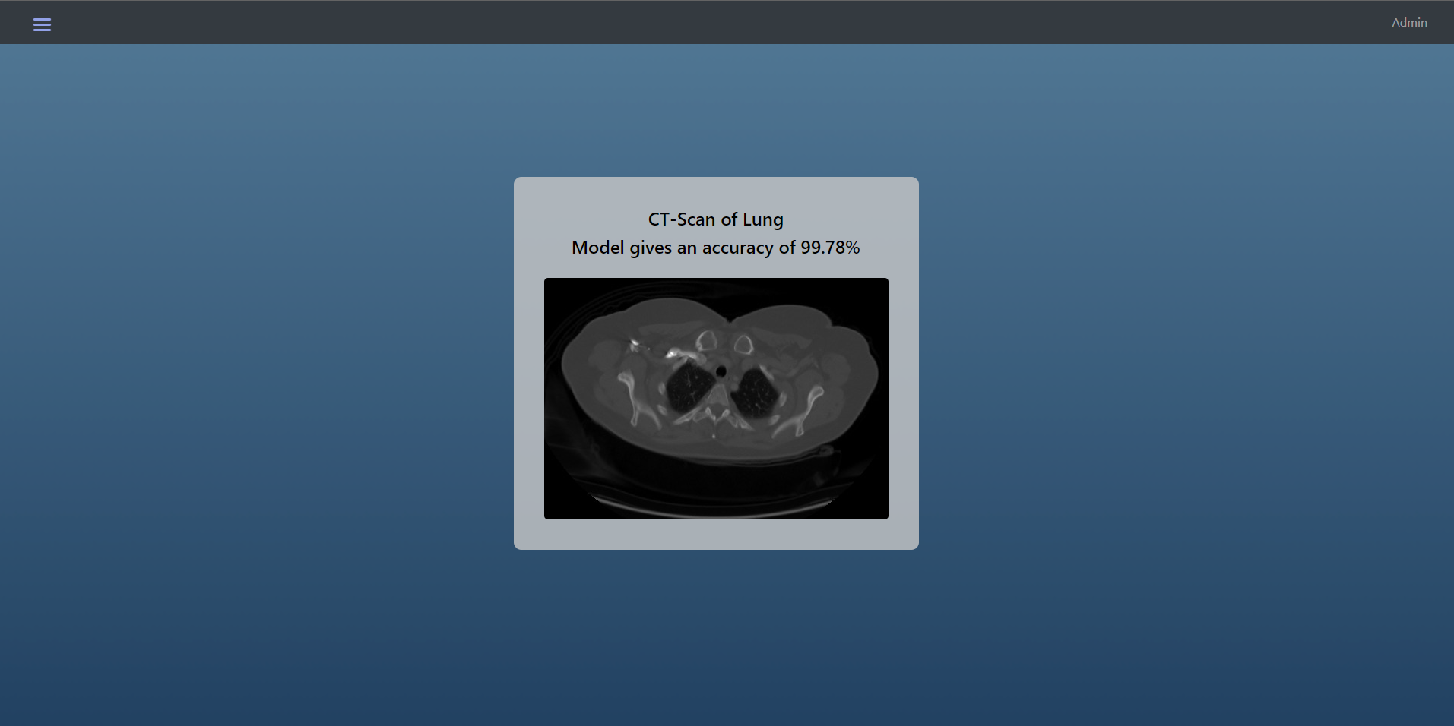

**5. Conclusion**

In summary, this project successfully harnessed the power of EfficientNetB0 transfer learning for robust medical image classification—discerning between Brain (MRI), Chest (X-ray), and Lung (CT Scan). The training process, fortified by callback functions, meticulously configured epochs, and a defined batch size, yielded a highly effective model.

Post-training evaluation showcased the model's prowess through critical metrics—accuracy, precision, recall, and F1-score. The accompanying confusion matrix provided insights into classification tendencies, further refining the model's performance.

This project stands as a valuable contribution to medical image analysis, offering a practical and accurate tool for radiological image differentiation. The real-world dataset and transfer learning underscore the model's relevance and efficacy. Future avenues may explore fine-tuning, alternative architectures, and integration into clinical settings.

**6. Practical Application in Healthcare**

As a part of our final year project, the computer vision model can be a valuable addition to healthcare systems. It's designed to make things easier by helping identify medical images like MRI scans of the brain, CT scans of the lungs, and X-rays of the chest.

Picture this: the model becomes a part of the healthcare system, and users—like doctors and nurses—can smoothly upload medical images. Once uploaded, the model does a cool trick—it quickly figures out what kind of image it is! It's like having a smart assistant for healthcare professionals, making their work faster and more straightforward, especially for those who aren't experts in reading radiology images.

To see how well it works, we check how much time it saves in understanding and diagnosing the images. But that's not all, we also want to know what the users think! Their feedback is super important to make the model even better, so it becomes really handy in real hospitals and clinics.

So, the big idea here is that this computer vision model can be a game-changer, making it easier and faster to identify medical images. It's like a super helpful tool that could really improve how things are done in healthcare places.

**7. Limitations and Important Information:**

* Image Resolution: The model may encounter challenges when predicting high-resolution images. For optimal results, consider using images with moderate resolutions preferably below 100kb.
* Prediction Accuracy: If the model's prediction accuracy is below 97%, a special feature prevents classification to indicate potential inaccuracies. Users are advised to double-check results in such cases.
* Predictive Confidence: The percentage value provided represents the confidence level of the model's prediction. Higher percentages indicate more confidence in the result.
* Feedback and Improvements: We welcome user feedback to enhance model performance. Feel free to report any issues or share your insights to contribute to ongoing improvements.

**THANK YOU**