5/16/2026
ICT511: Artificial Intelligence Assessment 3 Technical Report

Student Name:
Student ID:
AI-Based Spam and Phishing Detection Using NLP and DistilBERT

Table of Contents

Objectives/Goal 2
Introduction 2
Methodology and LLM/NLP Modelling 2
Recommendations 6
Conclusion 7
References 7

Objectives/Goal
This case study aims to design and assess a system utilizing Artificial Intelligence (AI) and Natural Language Processing (NLP) techniques and automate the detection of spam and phishing content. This study will examine a classic machine learning technique (TF-IDF + Multinomial Naive Bayes) and a transformer-based model (DistilBERT) to evaluate classification performance and practical applicability in the context of cybersecurity.

Introduction
Cyber attacks involving spam and phishing are among the most pervasive threats to individuals and organizations in the cybersecurity landscape. Criminals continuously manipulate language in messages and emails to lure recipients into disclosing sensitive data, and to deliver malicious payloads and software. Evolving patterns of attacks and the manipulation of language leave traditional rule-based filters ineffective. Consequently, systems based on artificial intelligence and Natural Language Processing (NLP) are increasingly being deployed for the automation of threat detection (Vaswani et al., 2017).
This case study examines transformer-based language models and machine learning for spam detection. This research utilizes the UCI SMS Spam Collection dataset. The dataset contains both spam and ham messages. In this study, spam messages are classified as phishing content. In this case study, ham messages are classified as legitimate messages. The project consists of preprocessing messages, feature extraction, baseline classification, fine-tuning DistilBERT, and model evaluation and analysis.

Methodology and LLM/NLP Modelling
The dataset was imported into Google Colab using Python libraries such as Pandas, Scikit-learn, Transformers, and PyTorch. After data loading, duplicate and missing records were removed to improve dataset quality and reliability. Labels were encoded numerically where ham messages were assigned 0 and spam messages were assigned 1.

Table 1: Dataset Summary
Dataset Information | Value
Total Messages | 5169
Ham Messages | 4516
Spam Messages | 653
Training Split | 80%
Testing Split | 20%
The dataset distribution analysis showed that ham messages significantly outnumbered spam messages. This imbalance highlights the importance of using evaluation metrics such as precision, recall, and F1-score instead of relying only on accuracy.
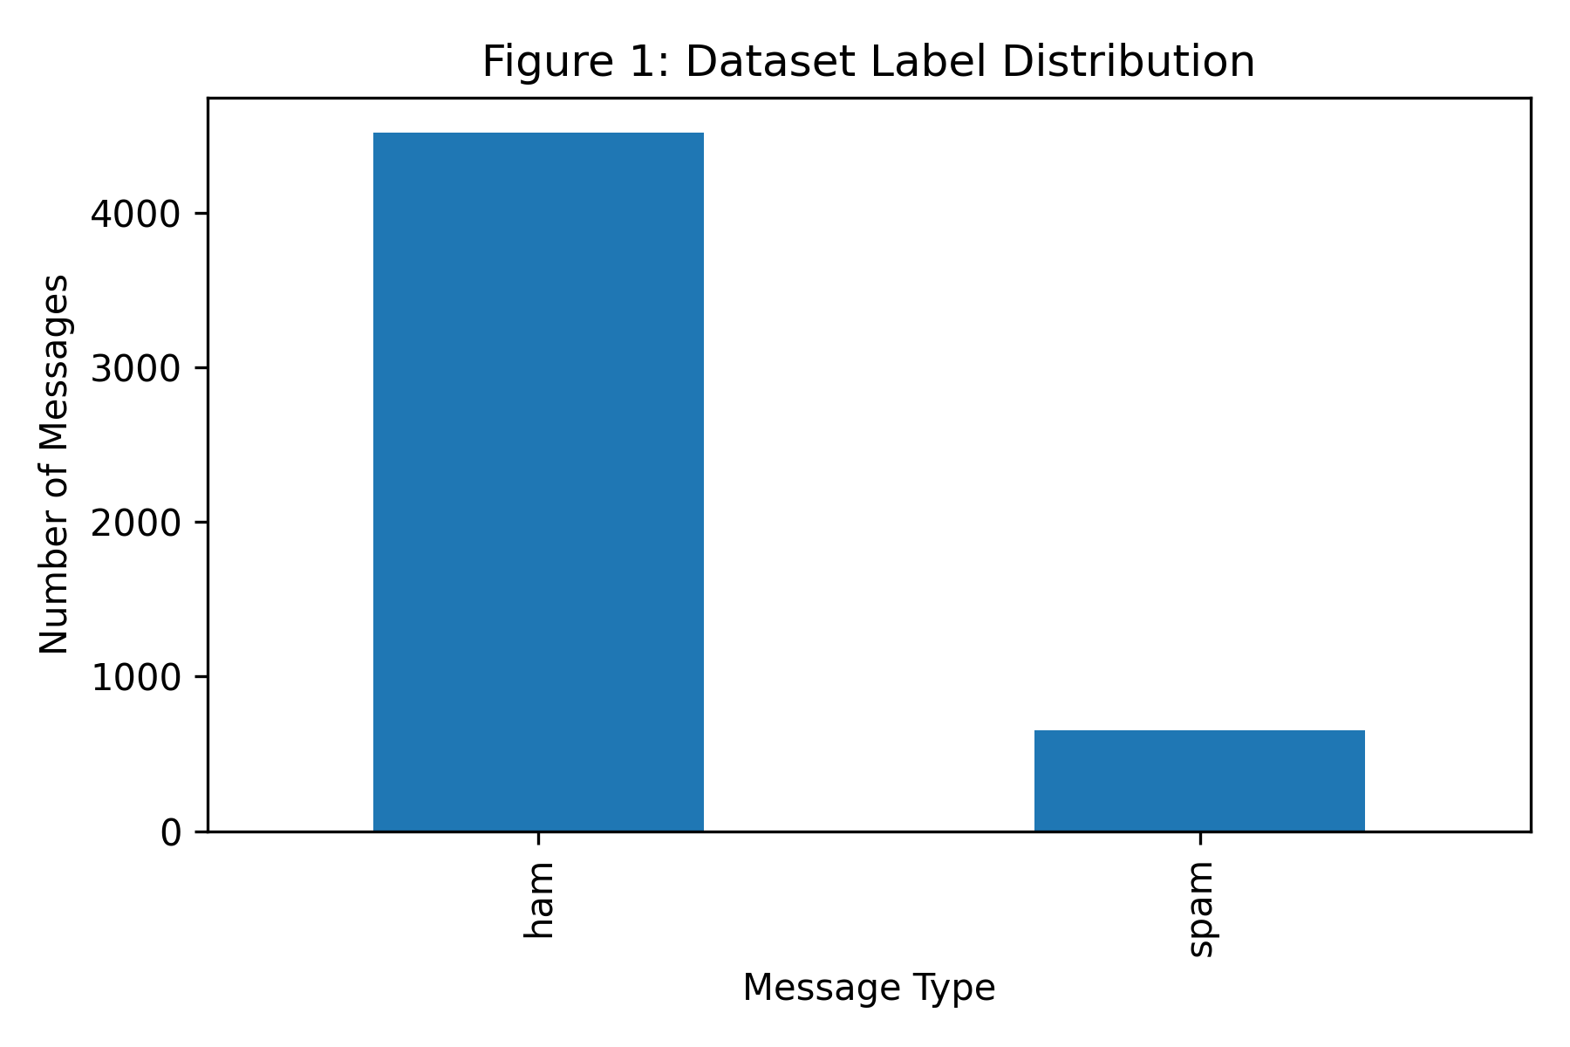
Figure 1: Distribution of ham and spam messages within the dataset.
Figure 1 illustrates the imbalance between legitimate and spam messages used during model training and evaluation.
For the baseline model, TF-IDF vectorisation was used to transform textual messages into numerical feature vectors. TF-IDF measures the importance of words within a document while reducing the influence of frequently occurring common terms (Jurafsky & Martin, 2023). The extracted features were then classified using the Multinomial Naive Bayes algorithm because of its effectiveness and computational efficiency for text classification problems.
The baseline model achieved an accuracy of 97.10%, precision of 99.03%, recall of 77.86%, and F1-score of 87.18%. Although the model performed well overall, the recall value indicated that some spam messages were incorrectly classified as legitimate messages.
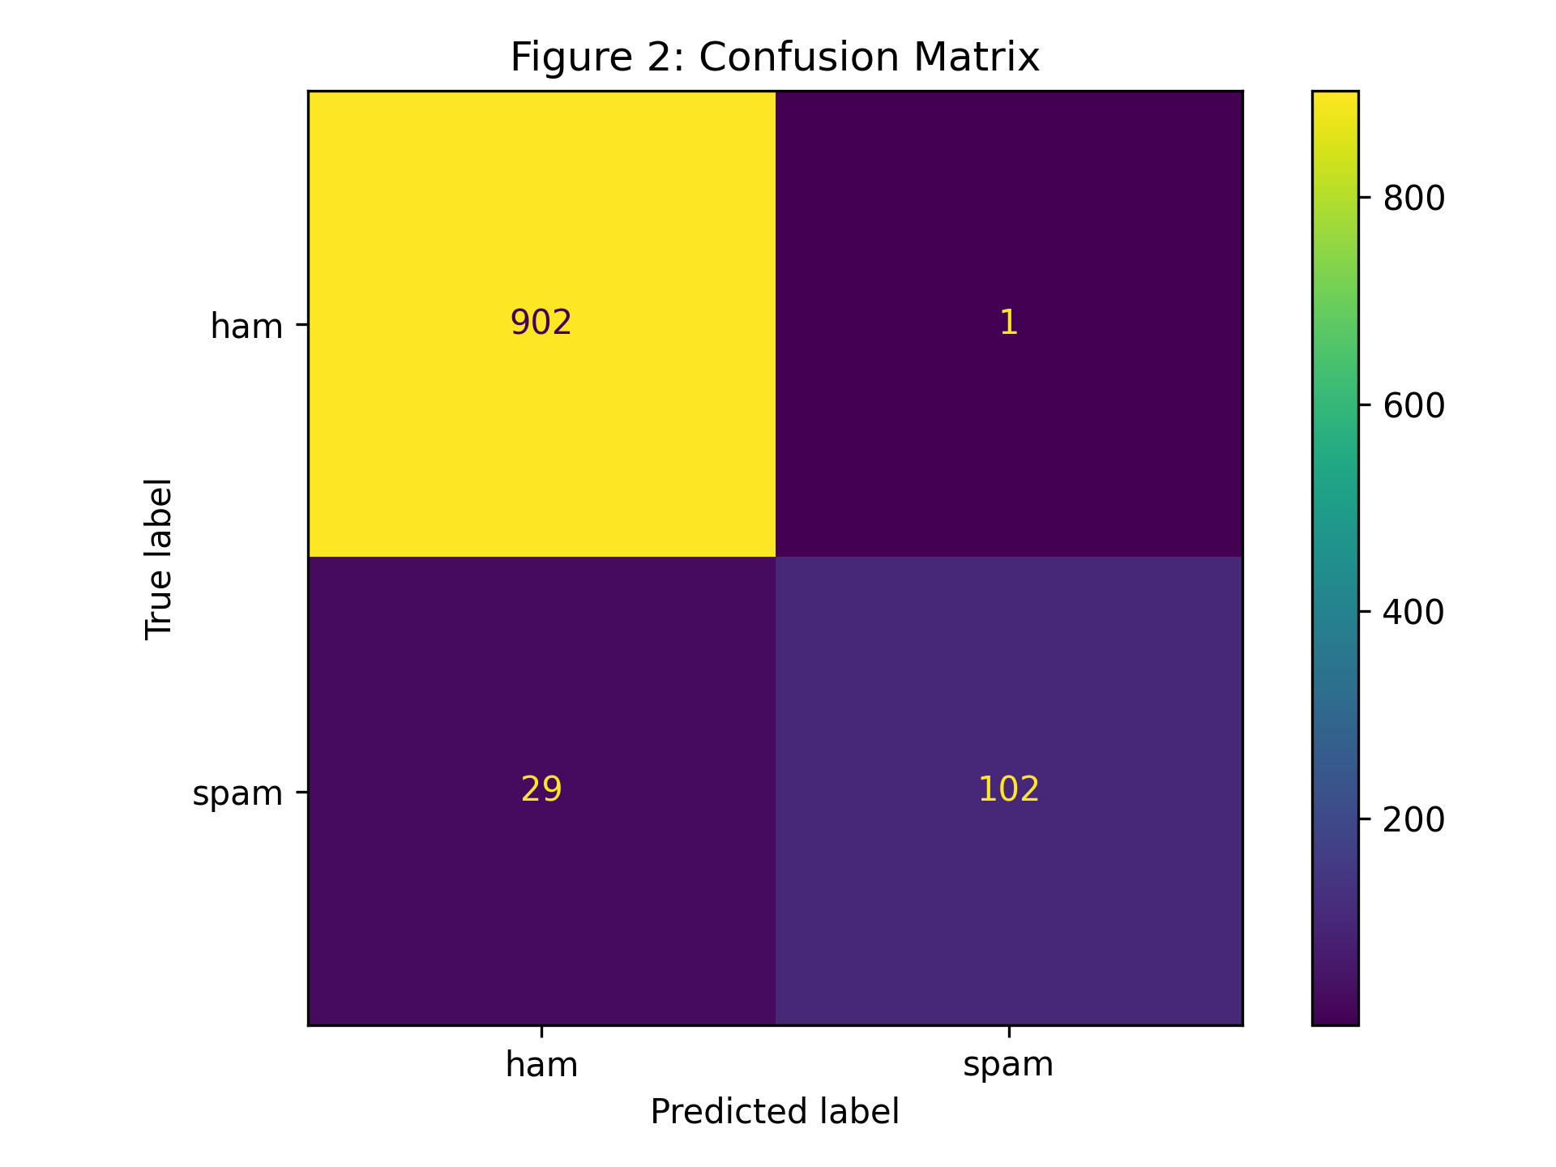
Figure 2: Confusion matrix for TF-IDF and Multinomial Naive Bayes classifier.
Figure 2 demonstrates classification performance of the baseline model using predicted and actual spam and ham labels.
To improve contextual understanding and detection capability, a pretrained DistilBERT transformer model was fine-tuned using the same dataset. DistilBERT is a lightweight transformer architecture derived from BERT that provides strong language understanding with reduced computational complexity (Sanh et al., 2019). Tokenisation and sequence preparation were performed using the Hugging Face Transformers library.
The DistilBERT model outperformed the baseline model quite significantly. The model reached 99.13% accuracy, with 98.41% precision, 94.66% recall, and an F1-score of 96.50%. The recall score indicates that the transformer model was better at identifying malicious spam messages without classifying legitimate messages as spam.
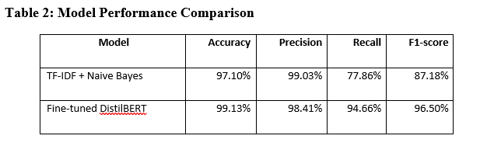
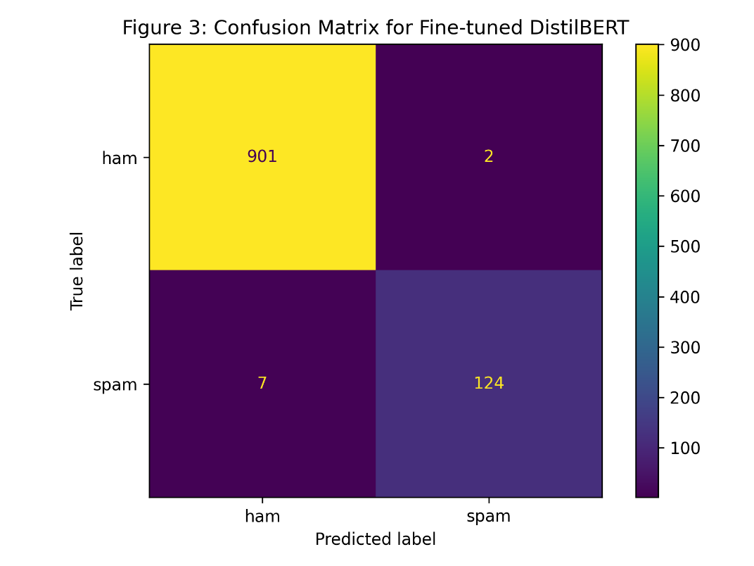
Figure 3: Confusion matrix for the fine-tuned DistilBERT model.
Figure 3 highlights improved spam detection accuracy achieved through transformer-based contextual language understanding and fine-tuning.
The DistilBERT confusion matrix showed fewer false negatives compared to the baseline model. This improvement is highly important in cybersecurity because undetected phishing messages may expose users to credential theft or malware infections.
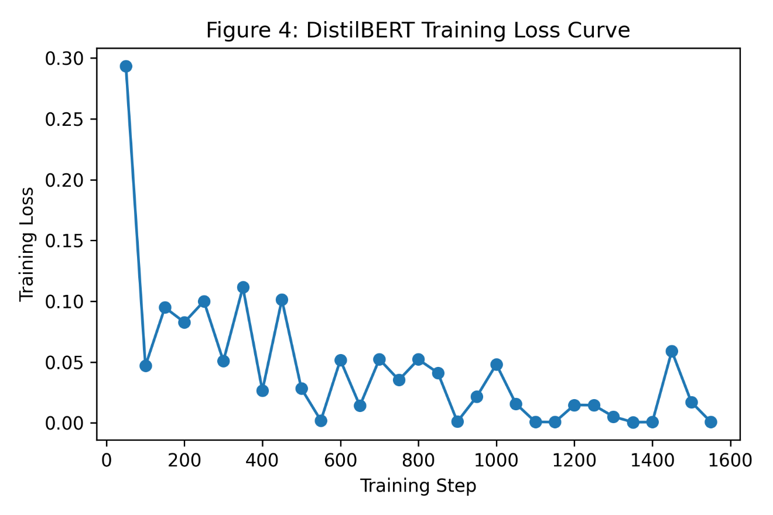
Figure 4: Training loss curve of the DistilBERT model during fine-tuning.
Figure 4 presents the reduction in training loss during DistilBERT optimisation across multiple training iterations.
The training loss curve demonstrated stable convergence during fine-tuning, indicating that the transformer model learned meaningful language patterns from the dataset.

Recommendations
Organisations should integrate transformer-based spam filtering systems with traditional email security controls such as URL analysis, sender reputation verification, and attachment scanning. Continuous retraining should also be implemented because phishing attacks frequently evolve and adapt to bypass detection systems. Furthermore, explainable AI techniques such as SHAP and LIME can be integrated to improve transparency and trust in AI-based cybersecurity systems.

Conclusion
This study demonstrated the effectiveness of NLP and transformer-based machine learning techniques for detecting spam and phishing-style messages. While the TF-IDF and Naive Bayes model provided strong baseline performance, the fine-tuned DistilBERT model significantly improved spam detection capability and contextual understanding. The results highlight the growing importance of transformer architectures in modern cybersecurity defence systems. Future research can explore multilingual phishing detection, real-time deployment, and explainable AI integration to further enhance intelligent threat detection systems.

References
Jurafsky, D., & Martin, J. H. (2023). Speech and language processing (3rd ed.). Pearson.
Sanh, V., Debut, L., Chaumond, J., & Wolf, T. (2019). DistilBERT, a distilled version of BERT: Smaller, faster, cheaper and lighter. arXiv. https://arxiv.org/abs/1910.01108
UCI Machine Learning Repository. (2012). SMS spam collection dataset. https://archive.ics.uci.edu/dataset/228/sms+spam+collection
Vaswani, A., Shazeer, N., Parmar, N., et al. (2017). Attention is all you need. Advances in Neural Information Processing Systems, 30.

Appendix
