OOP ASSIGMENT 1

LIBRARY MANAGEMENT SYSTEM

- MUHAMMAD AZAN SIDDIQ
- CMS:371850
GITHUB:https://github.com/azaans23/oop-assignemnt1

SYSTEM DESCRIPTION:
Project Description:

The Library Management System is a Java-based application designed to streamline and automate various tasks related to managing a library's inventory and user interactions. This system offers a user-friendly graphical interface built using Java Swing, providing ease of access and navigation for both librarians and patrons.

Key Features:

1. Book Management: Librarians can add new books to the system, specifying details such as title, author, and genre. Books can also be checked out by users and returned when they are no longer needed.

2. User Management: Users can be added to the system with their name and contact information. The system keeps track of which books each user has borrowed.

3. Search Functionality: Users and librarians can search for books based on title or author, enabling quick access to desired materials.

4. Inventory Display: Librarians can view the entire inventory of books, including details such as title, author, genre, and availability status.

5. User Display: Librarians can also view the list of users along with their contact information and the books they have borrowed.

6. Data Persistence: The system saves book and user information to files (`books.txt` and `users.txt`), ensuring data persistence between sessions.

Technical Details:

The system is implemented using object-oriented principles in Java, making use of classes and inheritance to represent books and users. It utilizes Swing components to create a graphical user interface, enhancing usability and visual appeal. Error handling is implemented to ensure robustness, with runtime exceptions and error messages displayed via JOptionPane.

Overall, the Library Management System provides an efficient and organized solution for managing library resources, facilitating smooth operations and enhancing the user experience for both librarians and patrons.

TEST CASES:
- ADD USER:

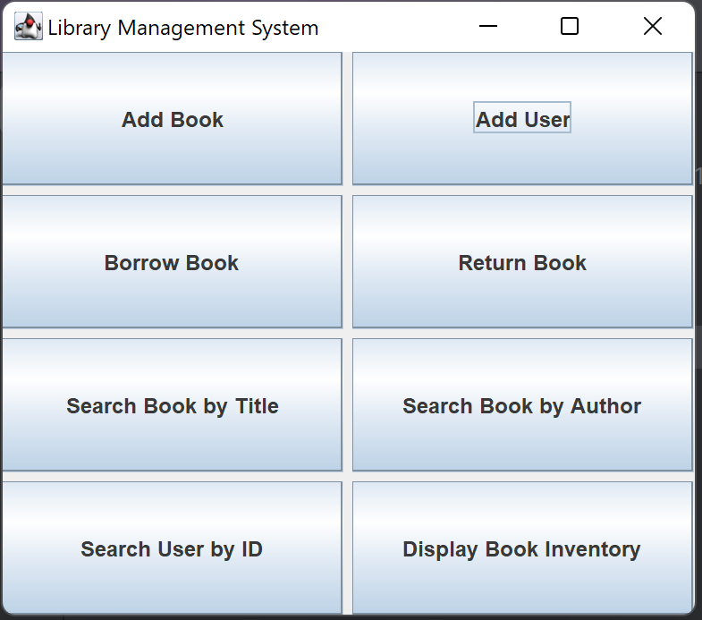
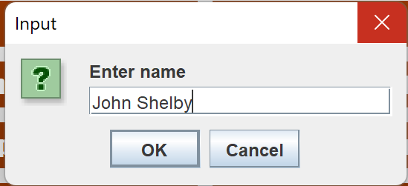
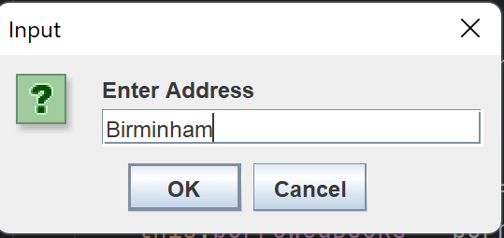

ERROR HANDLING:

ADD BOOK:
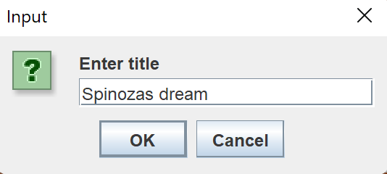
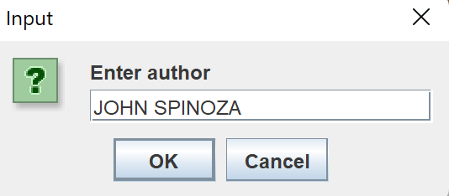
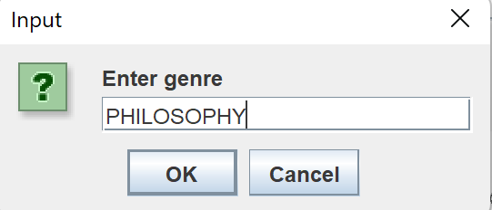
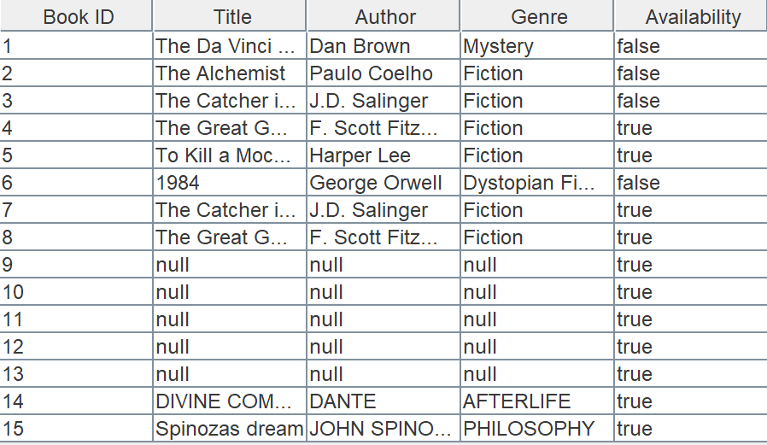

BORROW BOOK:
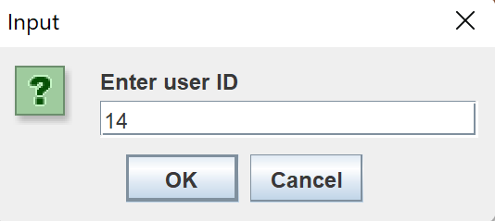
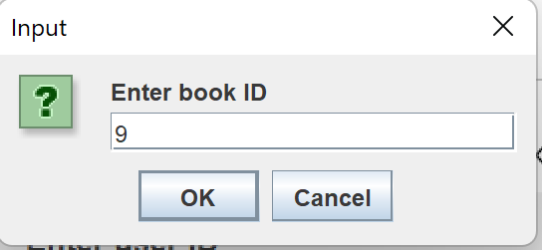
ERROR HANDLING:
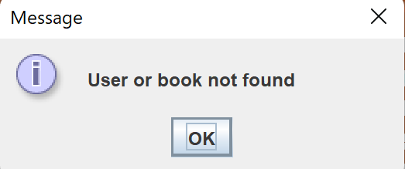
AVAILABLE BOOKS:

