

**LAB REPORT**

**Course Name : Database System Sessional**

**Course Code : CSE-2408**

**Lab No : 1, 2 & 3**

**Submitted To:**

Md. Shahidul Islam Khan

Associate Professor

Computer Science and Engineering

**Submitted By:**

**Name :** Md. Salah Uddin

**Metric ID :** C161069

**Semester** : 4th

**Section :** 4AM

**Department** : Computer Science and Engineering

**Date of Allotment :**

**Date of Submission : 12.08.2018**

**Remarks**



**Lab 01:**

**Objectives:** At 1st lab we learn how to select one or more specific column from one specific table. Here we also learn that how to select some specific column within given range

**Task1:** Select * from tabs

**Task2:** select table_name,status,num_rows from tabs

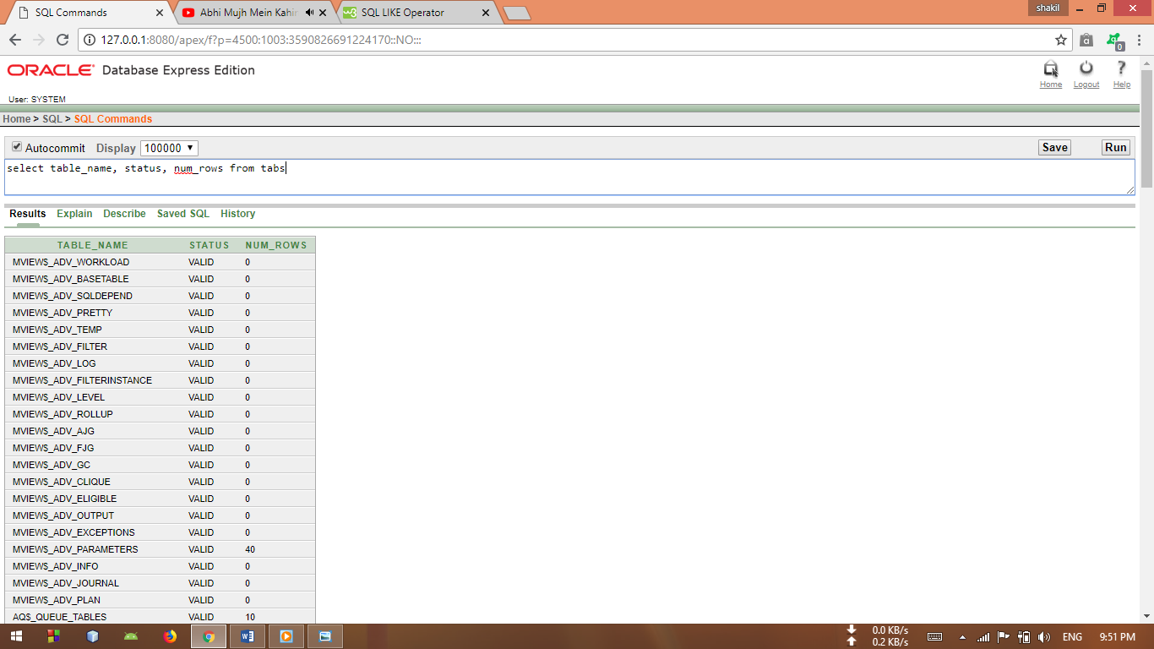

**Task 3:** select table_name,status,num_rows from tabs where num_rows>100

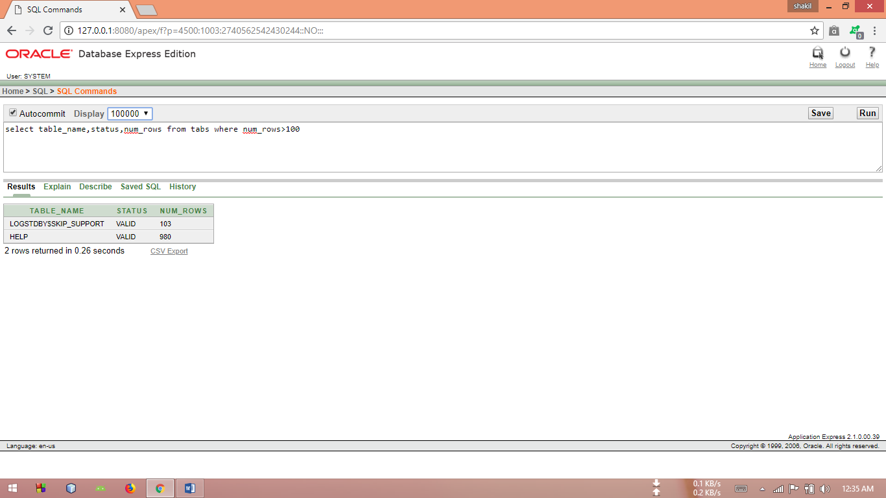

**Task 4:** select table_name,status,num_rows+10 from tabs where num_rows>100

**Task 5:** select table_name, status, num_rows + 10 from tabs where num_rows>999

**Task 6:** select (MAX_EXTENTS-(NUM_ROWS+BLOCKS+SAMPLE_SIZE))net_income

from tabs

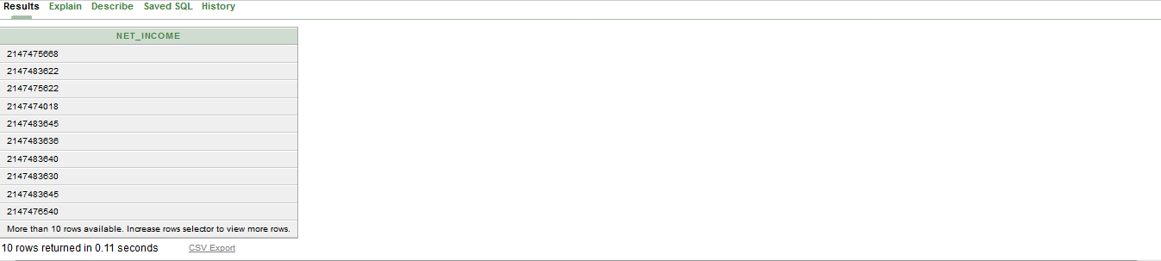

**Task 7:** select table_name,status,num_rows+10,(status||'-'||num_rows)new from tabs where num_rows>100

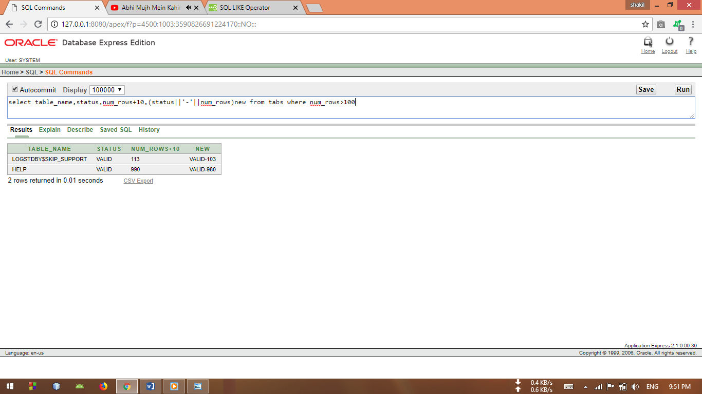

**Task 8:** select table_name,(MAX_EXTENTS-(NUM_ROWS+BLOCKS+SAMPLE_SIZE))

from tabs where table_name like '%C%'

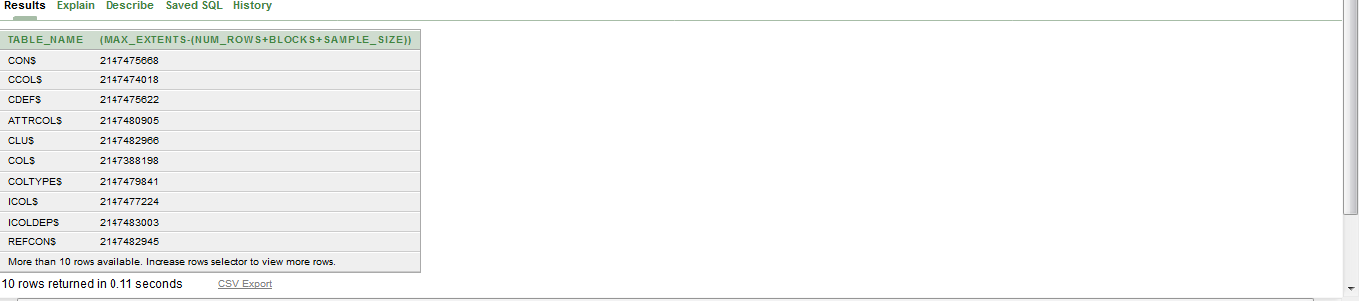

**Lab 02:**

**Objectives:** At 2nd lab we learnt a new thing that is how can I create an own table. Inserting data into new table. Selecting column within range from new table.

**Task 1:** create table students

(students_no varchar(8),name varchar(25),dept varchar(4),CGPA numeric(4,2));

**Task 2:** describe students

**Task 3:** insert into students values('C163001','Javed Bin Mahbub','CSE','9.75');

insert into students values('C163002','Yeasin Tanim','EEE','9.60');

insert into students values('C163003','Jawad Bin Farook','CSE','9.80');

insert into students values('C163004','Nabhid Imtiaj','ELL','8.50');

insert into students values('C163005','Wasif Alam','ETE','9.50');

**Task 4:**  select * from students

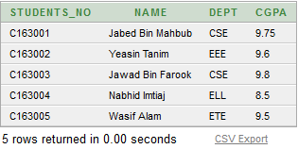

**Task 5:**  select count(name) from students

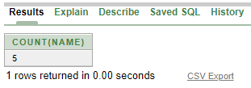

**Task 6:**  select name,dept,CGPA from students Where dept = 'CSE'

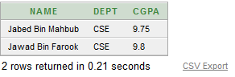

**Task 7:**  select name,dept,CGPA from students Where dept like '%E'

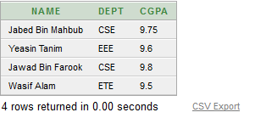

**Task 8:**  select * from students order by students_no

**Task 9:**  select * from students order by CGPA desc

**Task 10:**  select * from students where dept ='CSE' and cgpa>9.5

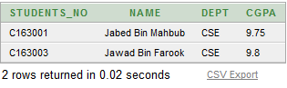

**Task 11:**  select name,cgpa from students Where cgpa between 8.5 and 9.0

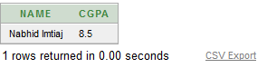

**Lab 03:**

**Objectives:** At 3rd lab we learnt a new thing that is how can I create an employee table. Inserting data into new table. Selecting column within range from new table.

**Task 1**: Create table Employee

**Task 2:** (Employee_No varchar(8),Emlpoye_Name varchar(25),Department varchar(5),

Rank varchar(10),Salary numeric(10,2),Hiring_Date Date);

**Task 3:**  describe employee

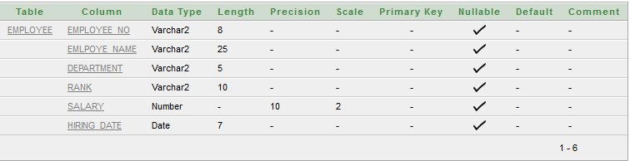

**Task 4:** Insert into Employee values('C163001','Javed Bin Mahbub','CSE','Lecturer',25000,'20-Jul-2014');

Insert into Employee values('C163002','Yeasin Tanim','EEE','A.Lecturer',20000,'20-Mar-2017');

Insert into Employee values('C163003','Jawad,'CSE','A.Professor',20000,'25-Feb-2016');

**Task 5:** select * from Employee

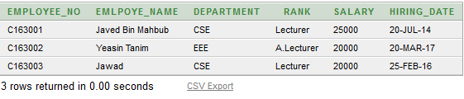

**Task 6:**  select EMLPOYE_NAME,Rank,Department,(sysdate-Hiring_Date)/7 "Week of Employee" from employee;

select EMLPOYE_NAME,Rank,Department,(sysdate-Hiring_Date)/365 "Year of Employee" from employee;

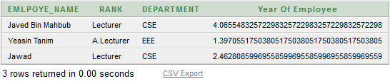

**Task 7:**  select * from Employee where hiring_date>'18-Mar-2016'

